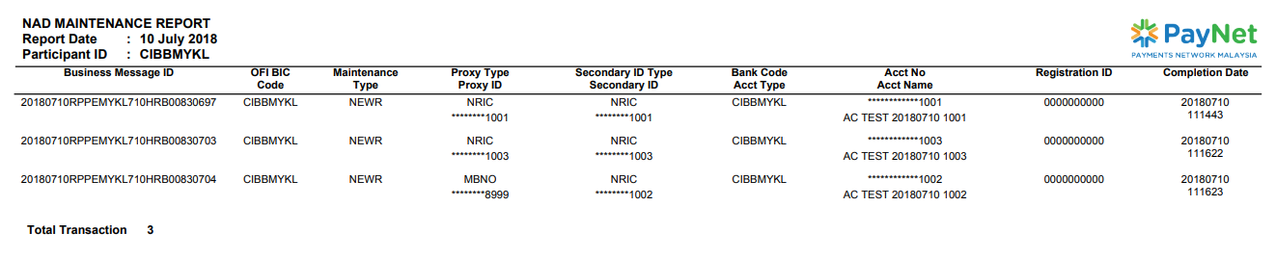

**This is not the message id sent by me**

3

2

1

1st record: Registration ID is not correct, No value for Account Type

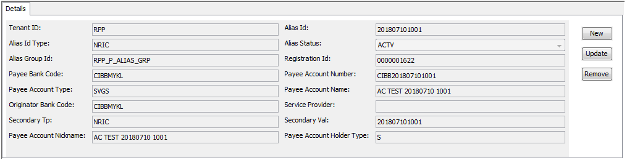

2nd record: Registration ID is not correct, No value for Account Type

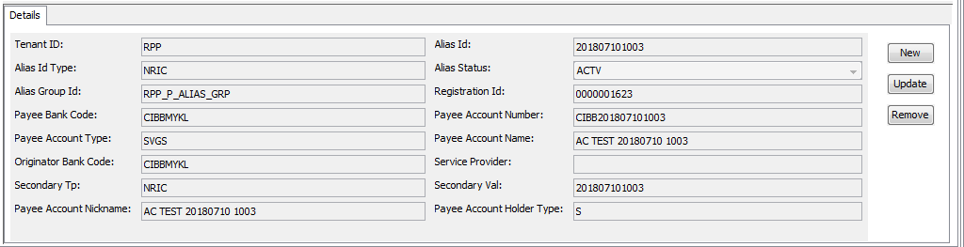

3rd record: Registration ID is not correct, No value for Account Type, Account Name is not correct.

