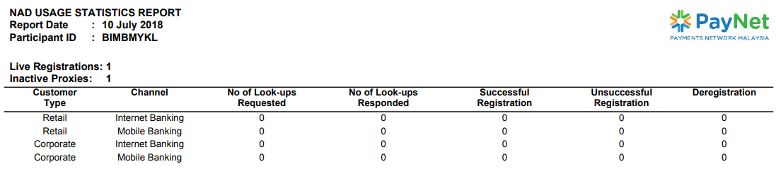

**Total record not correct**

According to Platform Manager:

ICTV (Inactive) = 2 records

ACTV (Active) = 2 records

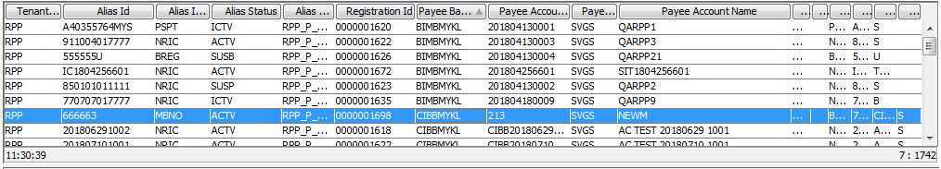

Retested on 27/7/2018:

