Issue Form (PROD)
Originator's Name: Chooi So Fun  Project: Internet Banking  Project Manager: Malarvili / Chris Gunn  Module : Internet Banking  Date Raised: 14.03.2011  Phase : Phase 2 – Internet Banking  Functional Area : BVMC | Issue ID Number: C11-007  Related Issue ID Number: HD00010478  Classification:  Priority: Critical/High/Medium/Low  Assigned to: Vendor / IT / PMO SA / UPA  Actual Closed Date:
Status: Open/Assigned/Investigated/Resolved/Approved/Deferred/No Action (Circle one)
Description :  1 successful Prepaid Trx (RM20) on 11.3.11 not found in:  - Internet Trx Report  - Mobile Reload Report  - Epay Recon File | Impact:
Findings/Root Caused (Description): | Resolution:
Estimated Impact :

Recommendation:

Accepted :  (Vendor / IT / PMO SA / UPA)  Date: | Accepted (KFHMB Tester):  Date:

Phoenix Report
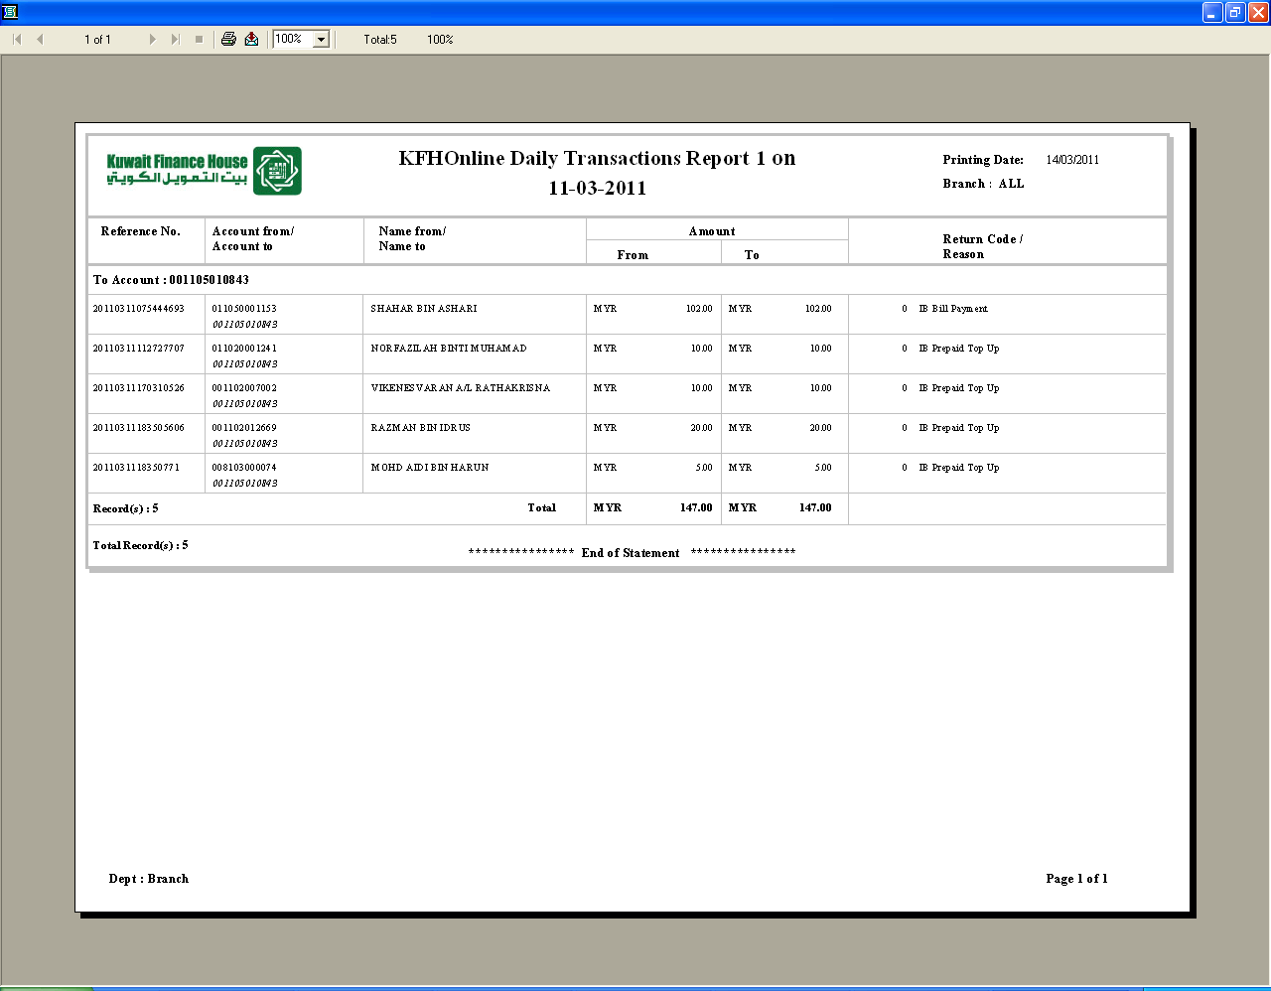

Account Debited
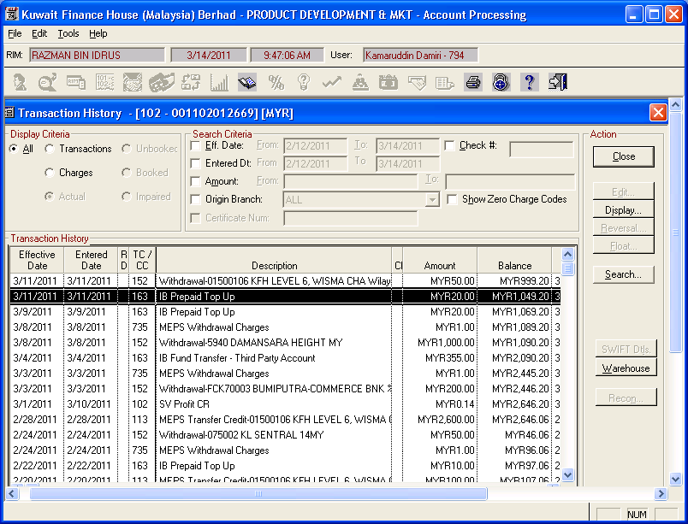

e-Pay Recon File
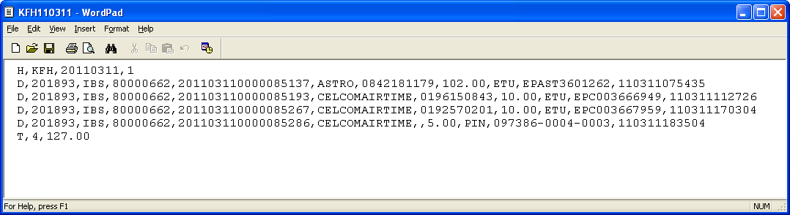
Mobile Reload Report
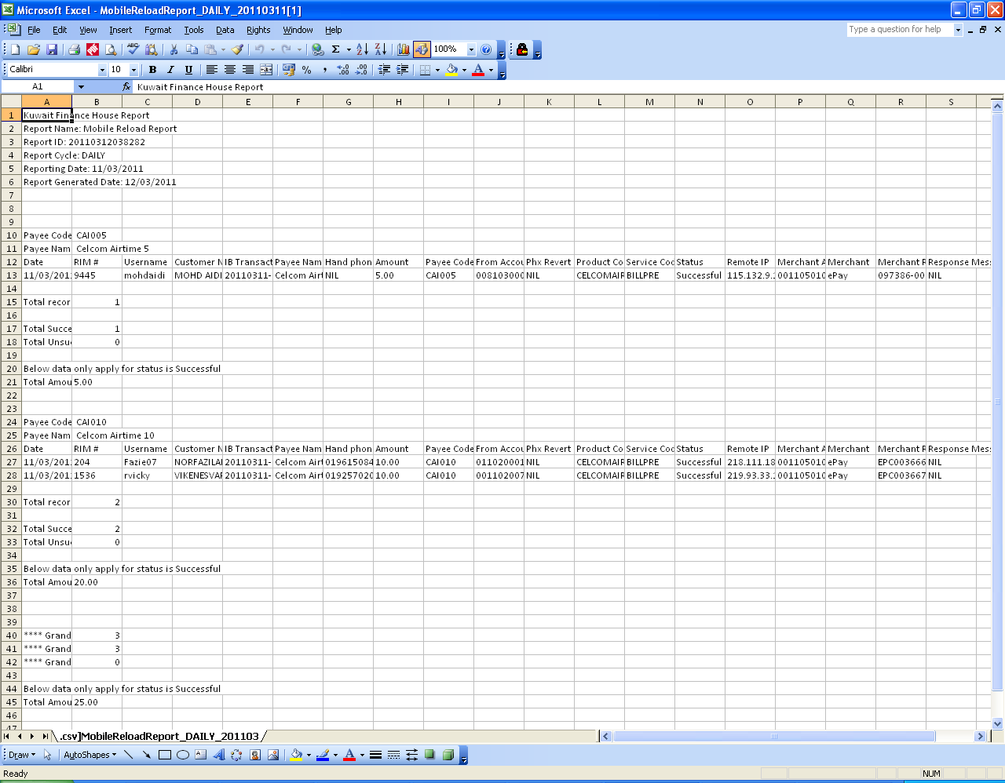

Internet Transaction Report
