

**Issue Form (PROD)**

|  |  |  |
| --- | --- | --- |
| **Originator's Name:** Kamaruddin Damiri  **Project:** Internet Banking  **Project Manager:** Malarvili Muniandy  **Module : Registration Fail**  **Date Raised: 22/03/11**  **Phase :** Consumer Internet Banking  **Functional Area :** | **Issue ID Number:** kd11-003  **Related Issue ID Number:**  **Classification:**  **Priority:** Critical/High/Medium/Low  **Assigned to: Vendor / IT / PMO SA / UPA**  **Actual Closed Date:** | |
| **Status:** Open/Assigned/Investigated/Resolved/Approved/Deferred/No Action  *(Circle one)* | | |
| Account Detail:  1. Add at BVMC “IB Product Filter” with code “110” for International Commodity Murabahah (ICM)” account.  2. KFH Online managed to display the account balance (under Investment Account).  But for Account Detail inquiry, showed as Error “error while performing your request” (as attached). | | **Impact:** |
| **Findings/Root Caused (Description):** | | **Resolution:** |
| **Estimated Impact :** | |  |
| **Recommendation:** | | |
| **Accepted :**  **(Vendor / IT / PMO SA / UPA)**  **Date:** | **Accepted (KFHMB Tester):**  **Date:** | |

Investment Account Inquiry:

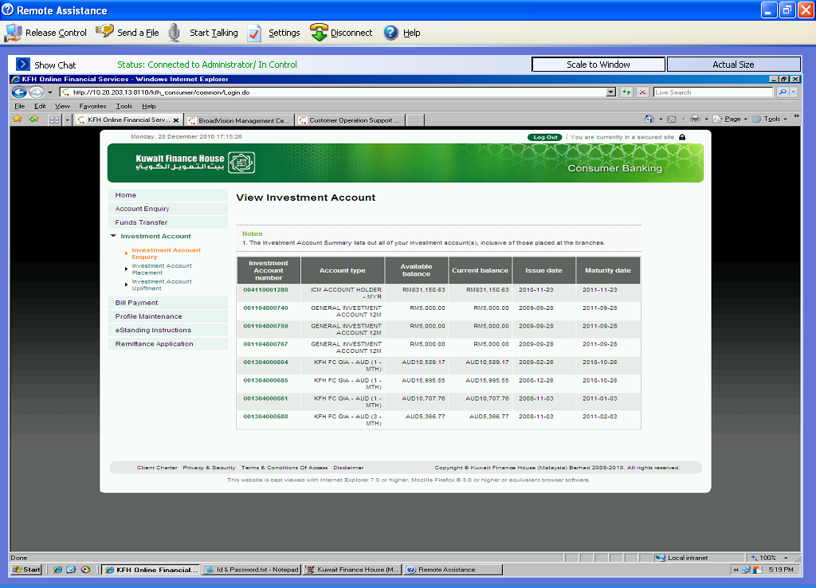

Click on ICM account link:

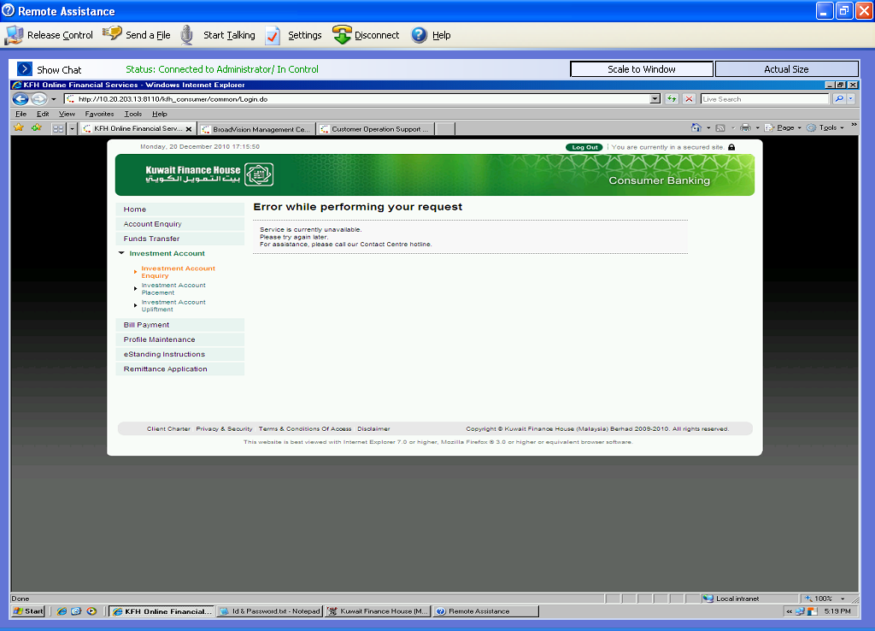

Other GIA Account Detail - OK

