# REMOVE THE ACCOUNT FROM COMPANY – Linked to User

Scenario:

1. Edit User (Pending maker checker)
2. Edit Account Management

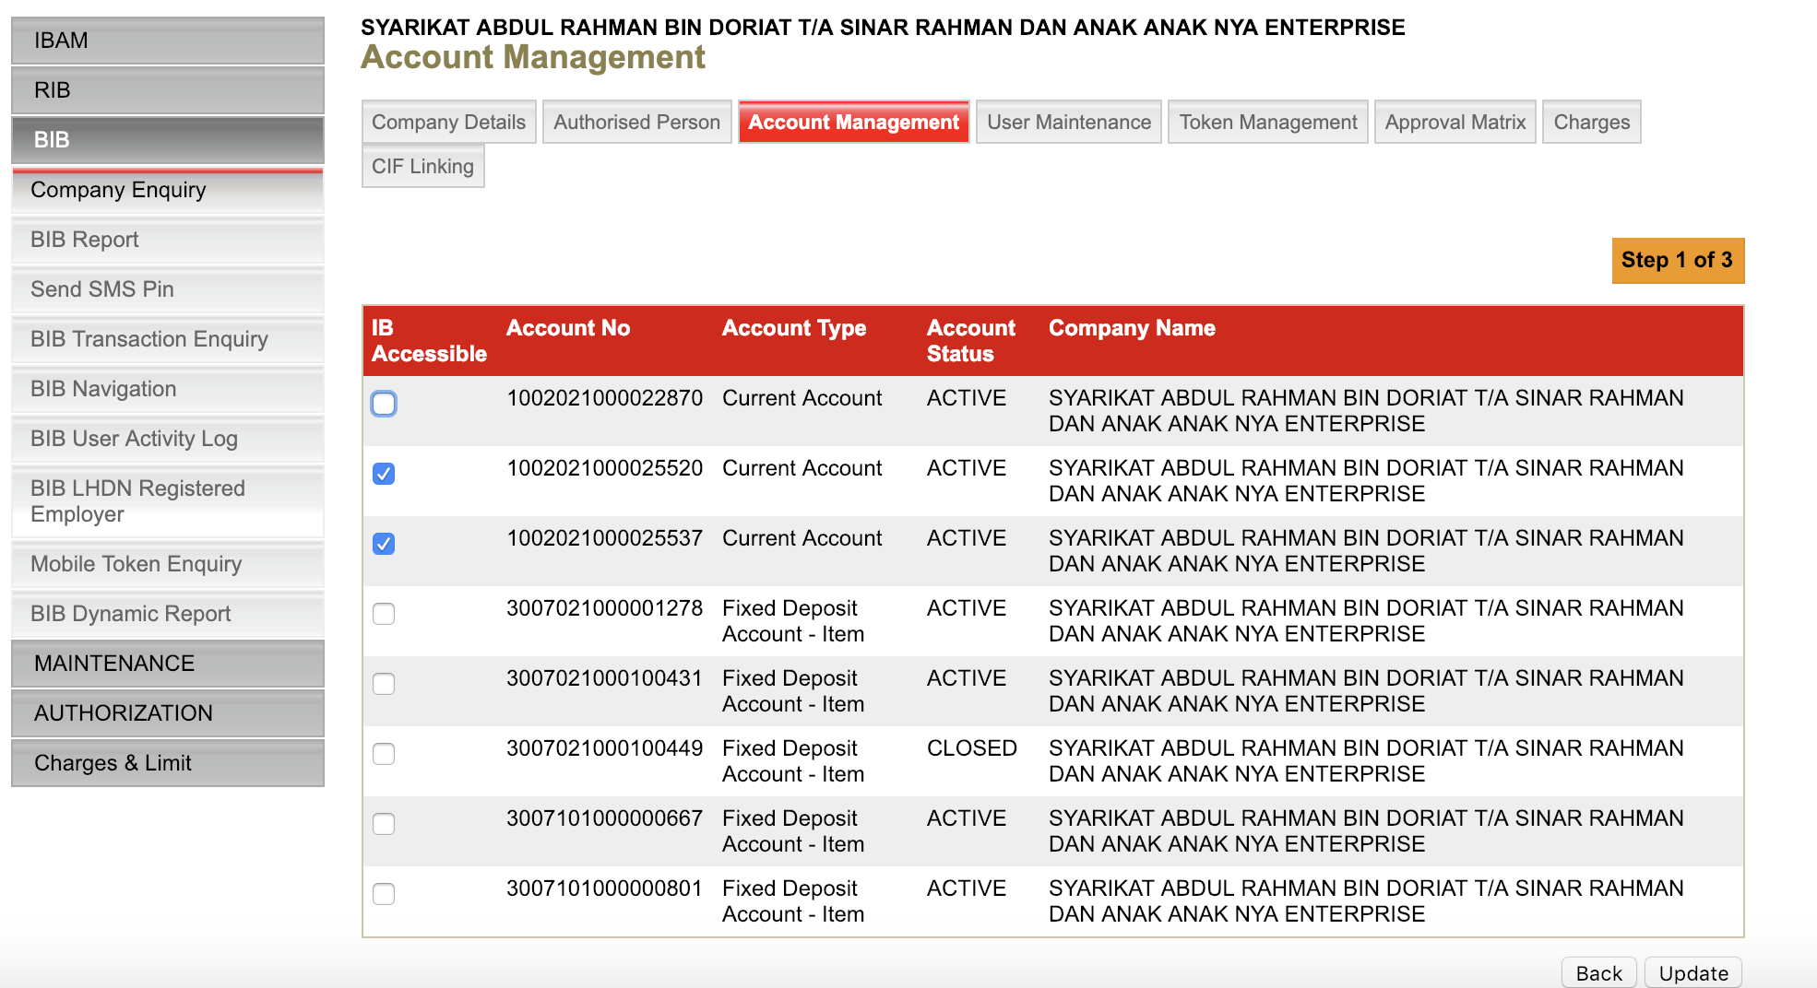

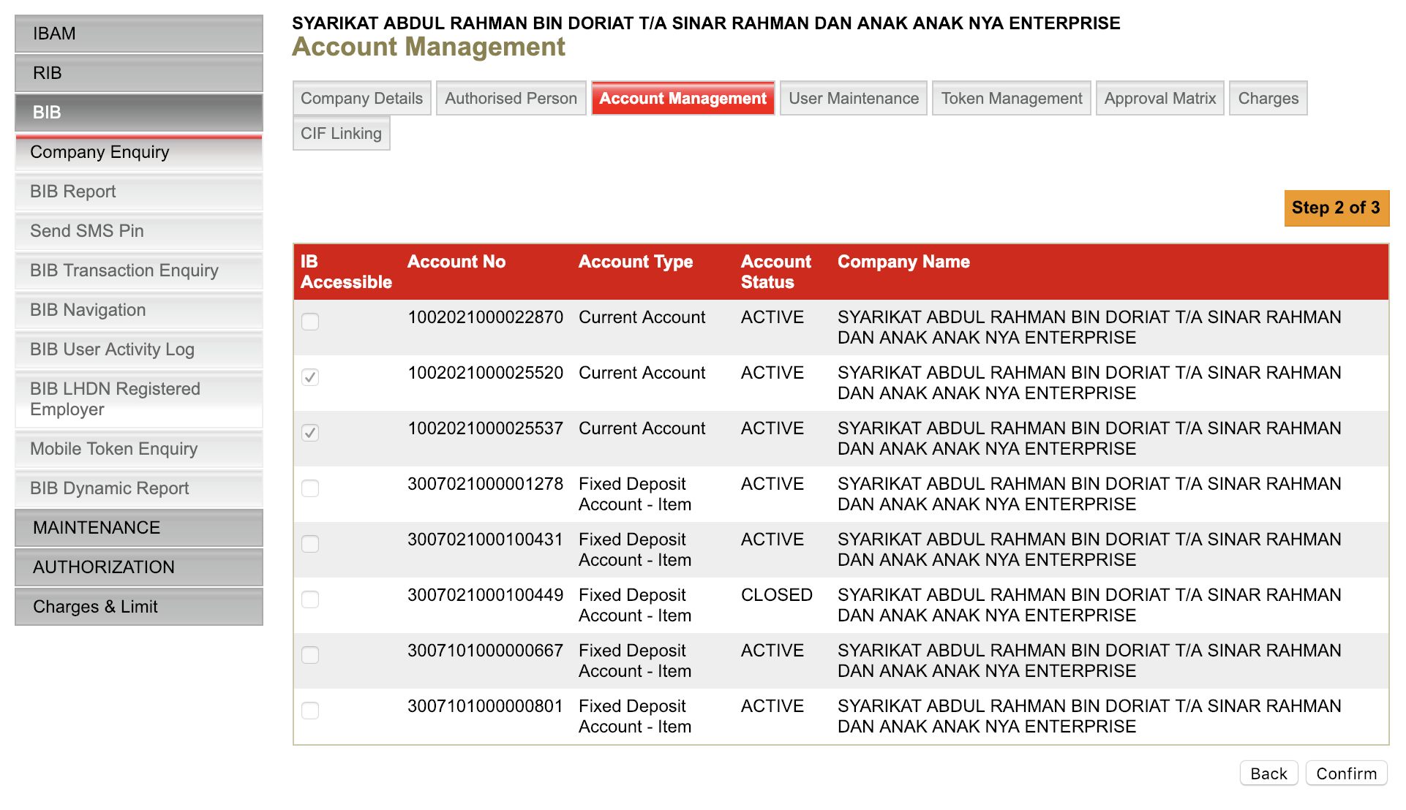

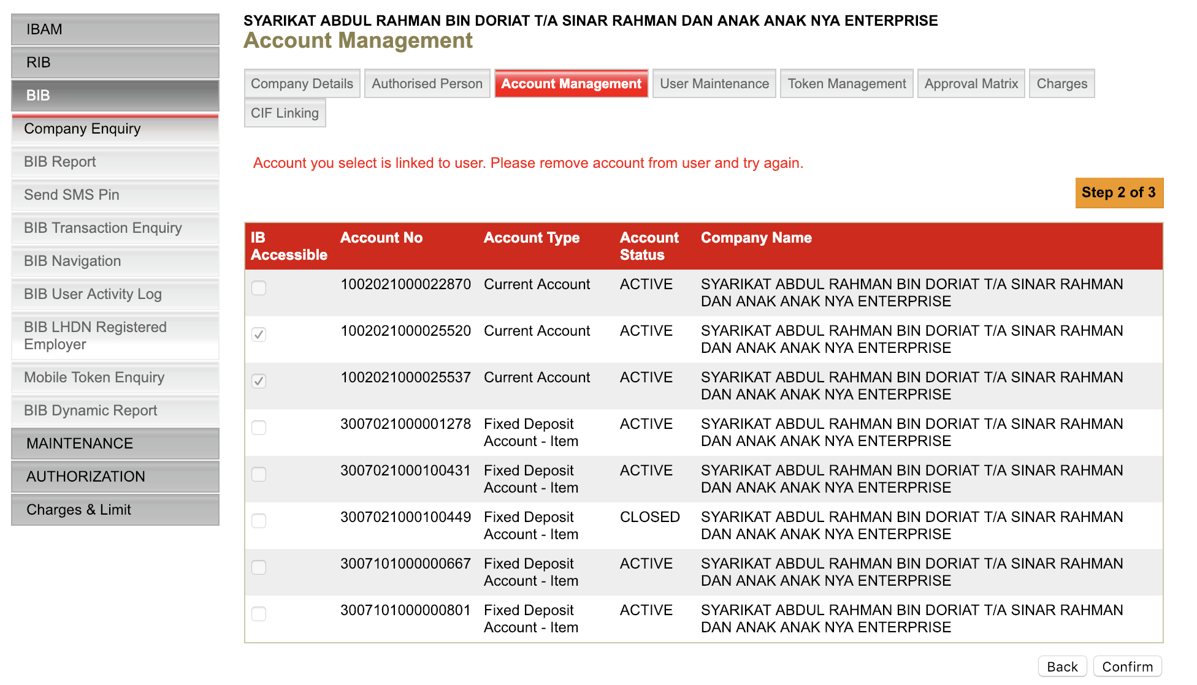

# REMOVE THE ACCOUNT FROM COMPANY

Scenario:

1. Edit Account Management (Pending maker checker)
2. Create / Edit/ Delete/ Suspend user

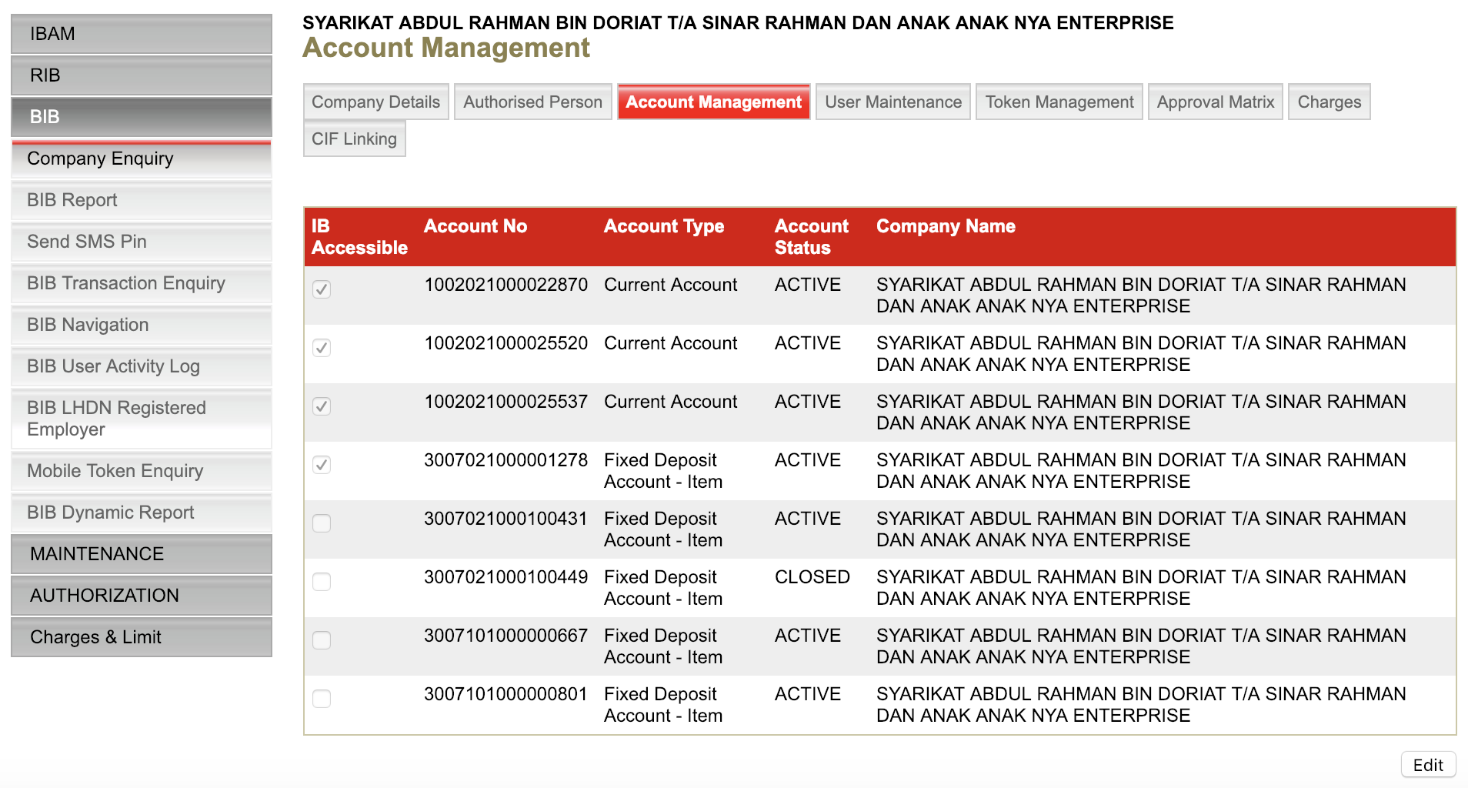

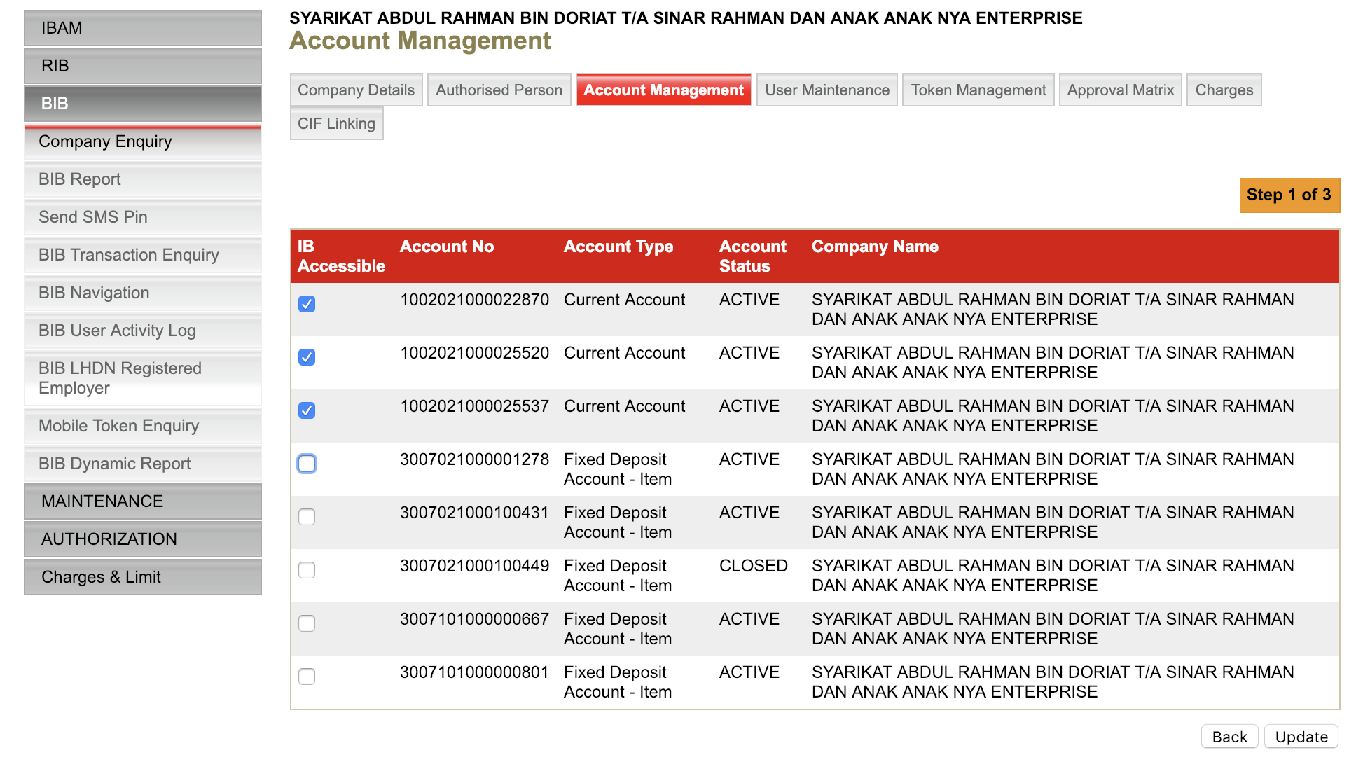

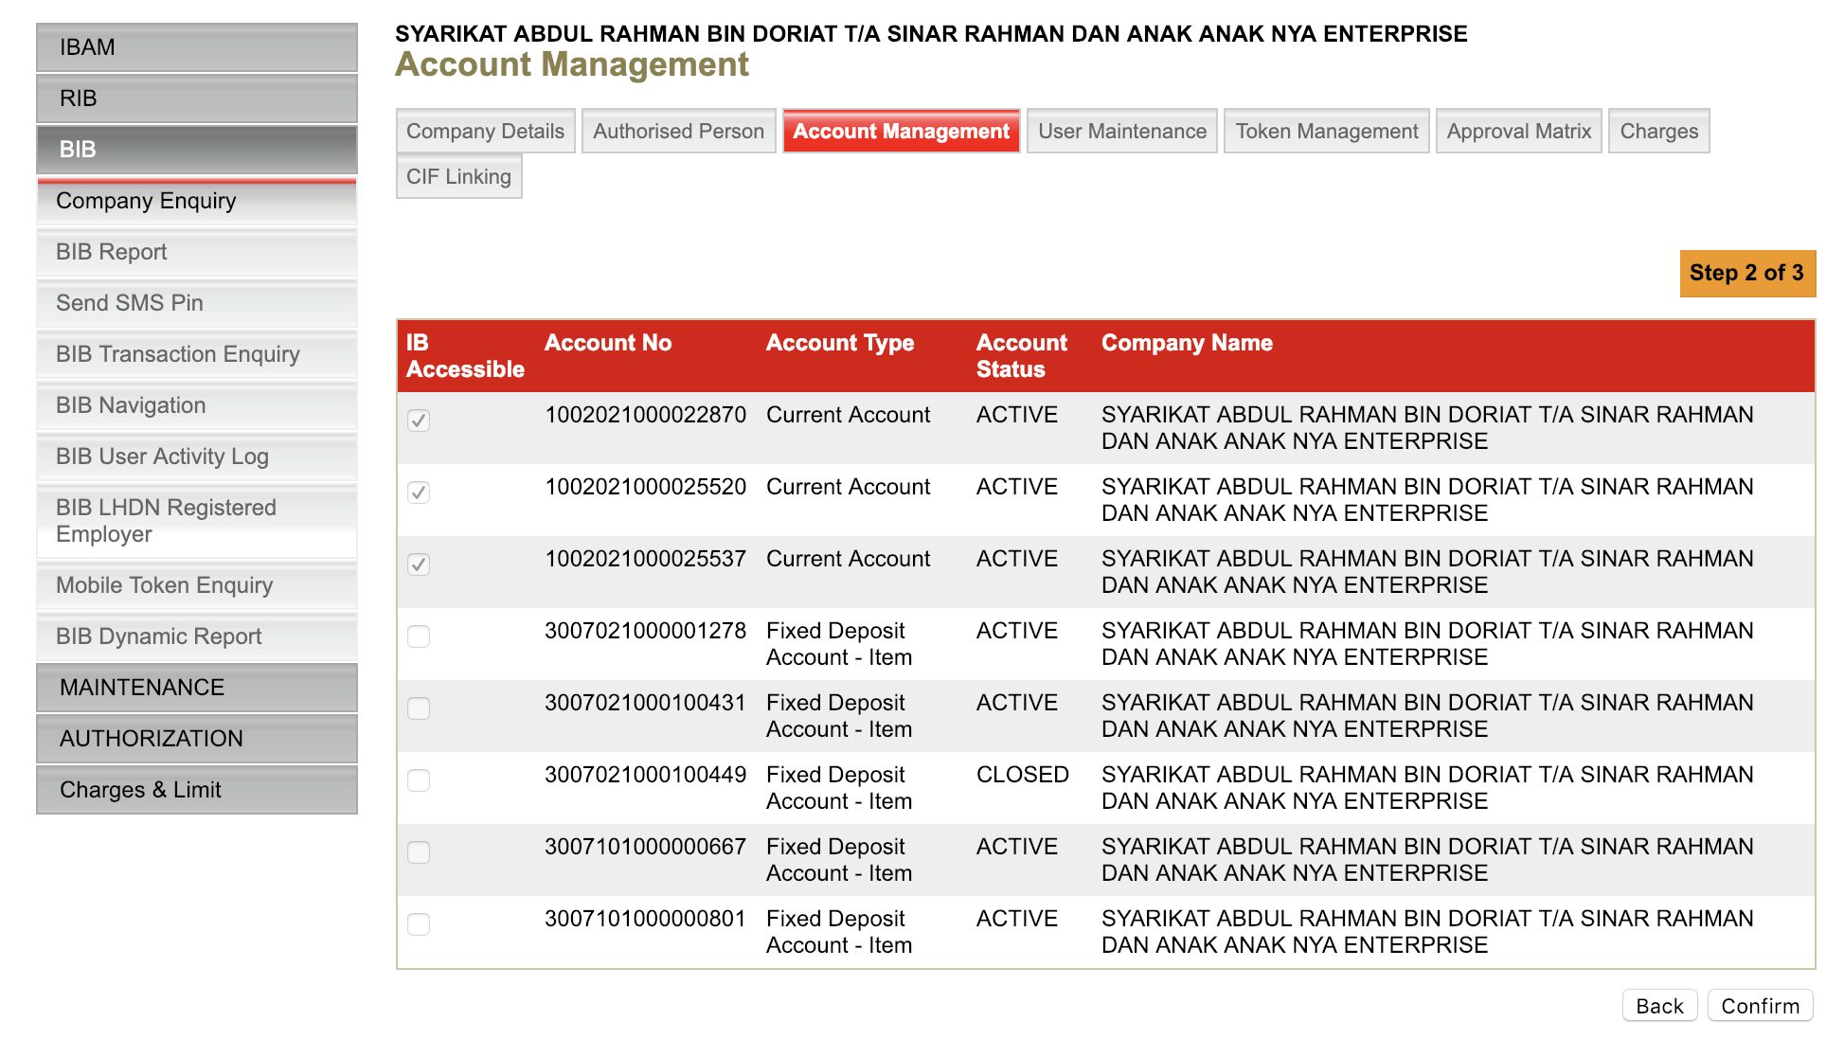

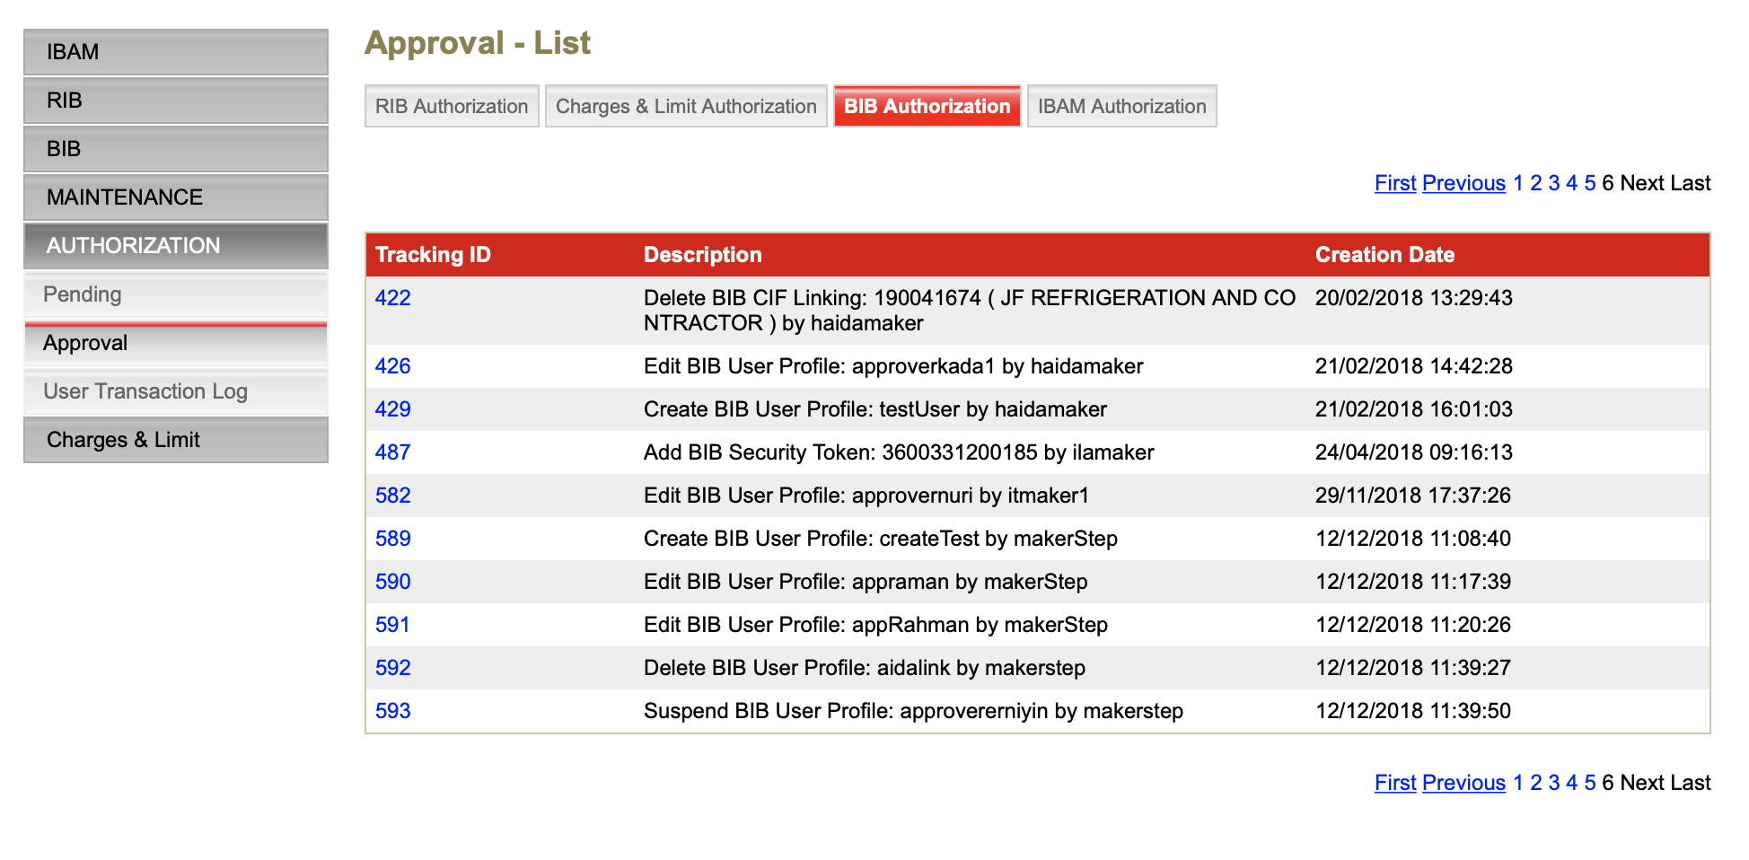

MAKER CHECKER – CREATE USER

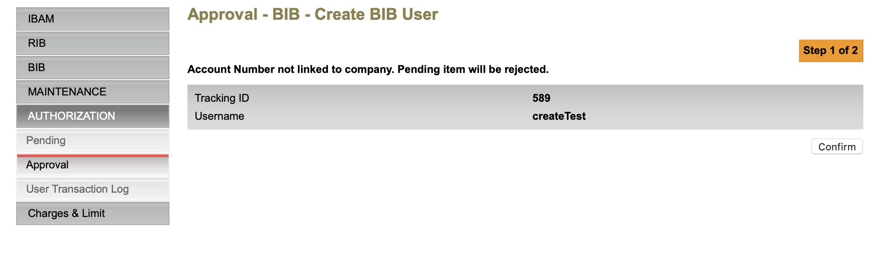

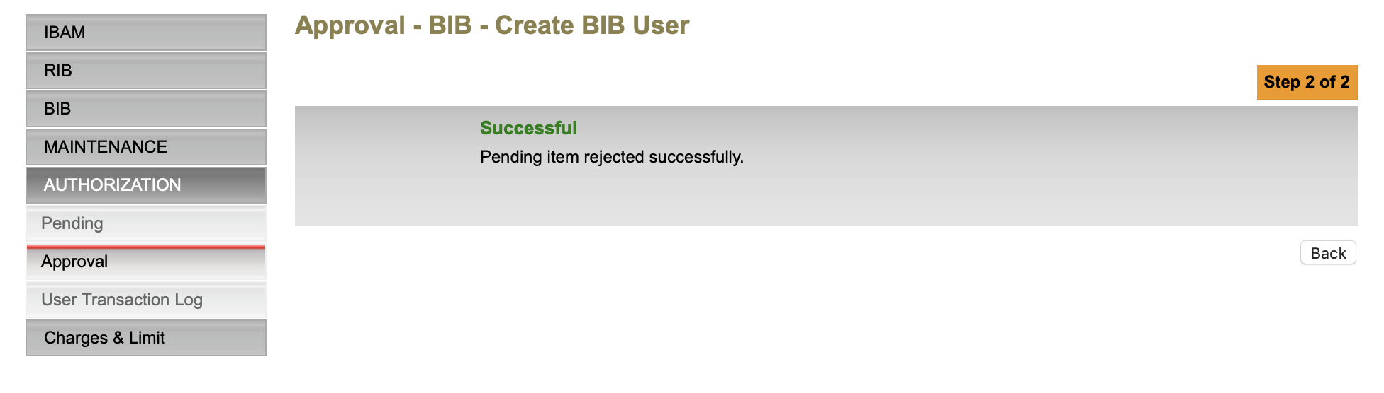

MAKER CHECKER – EDIT BIB USER

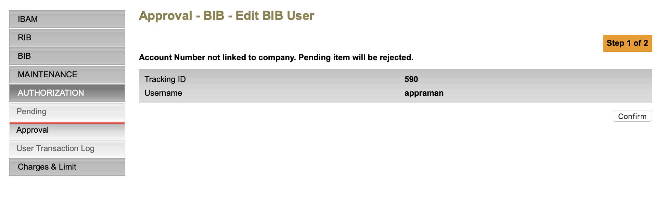

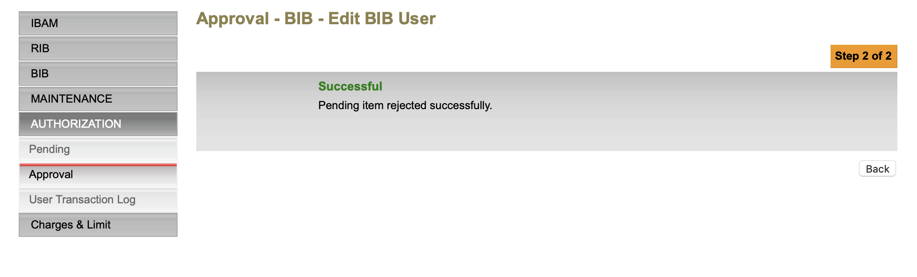

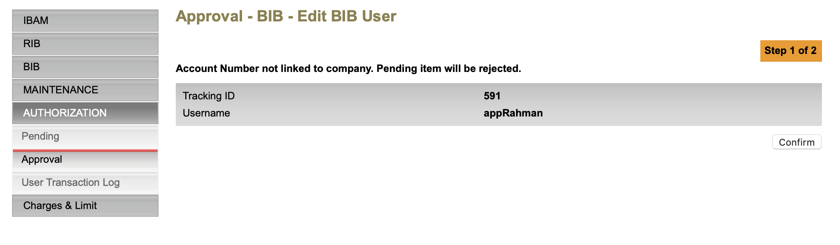

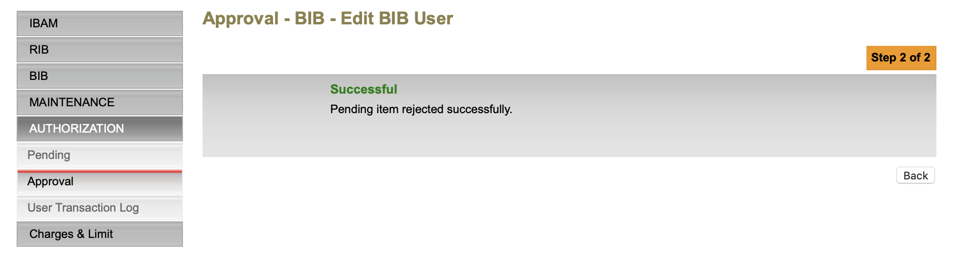

DELETE

