Authorization > Pending - Create Application Form

For Create , Please display Current - NIL

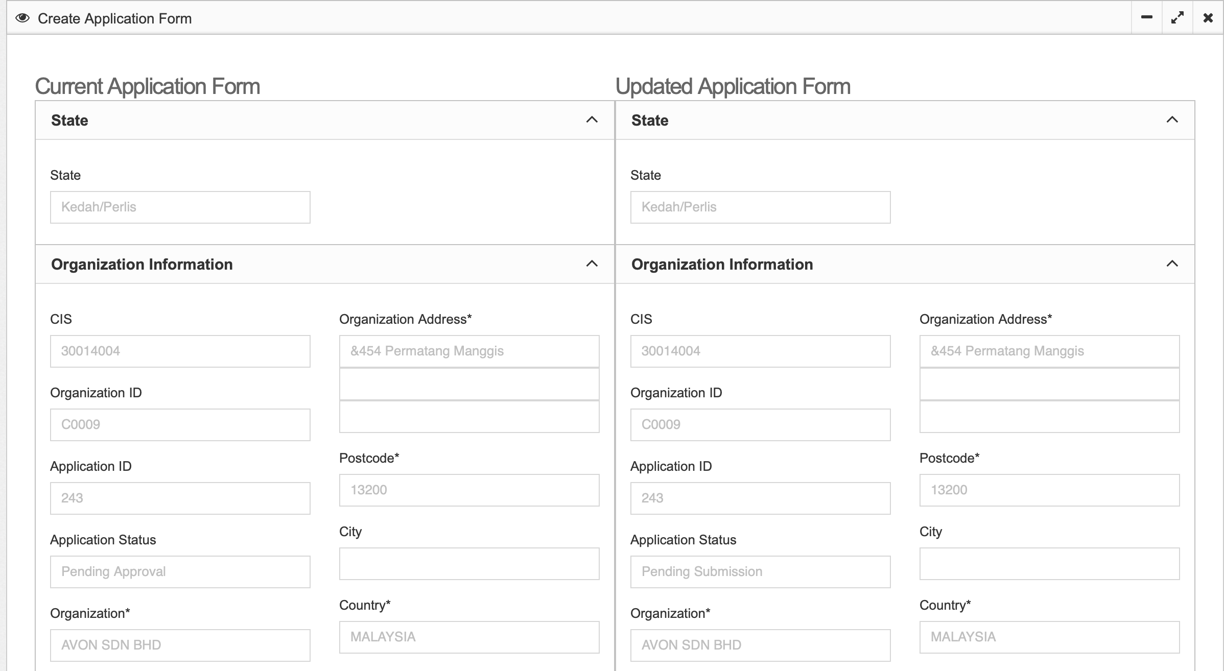

Remove asterisk at Contact Person 2

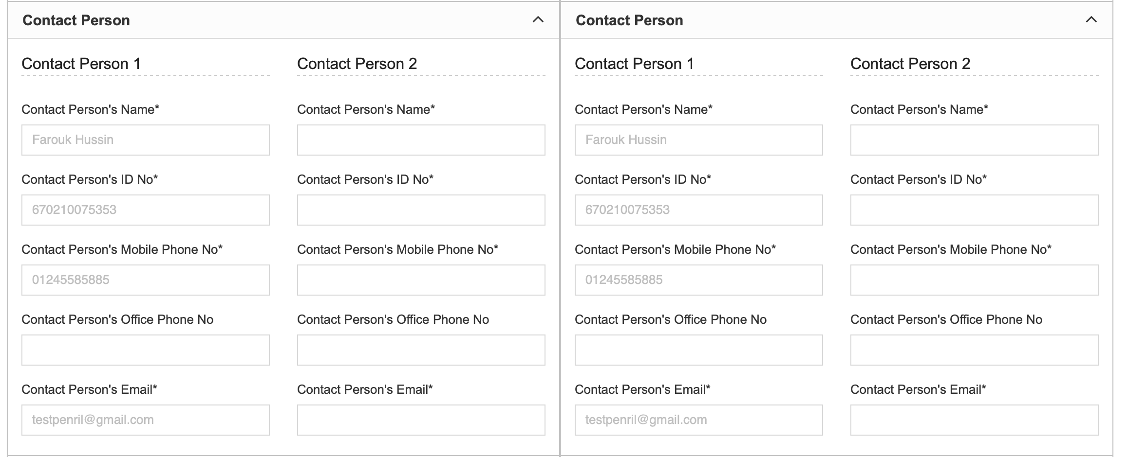

Not Select service but select only account number

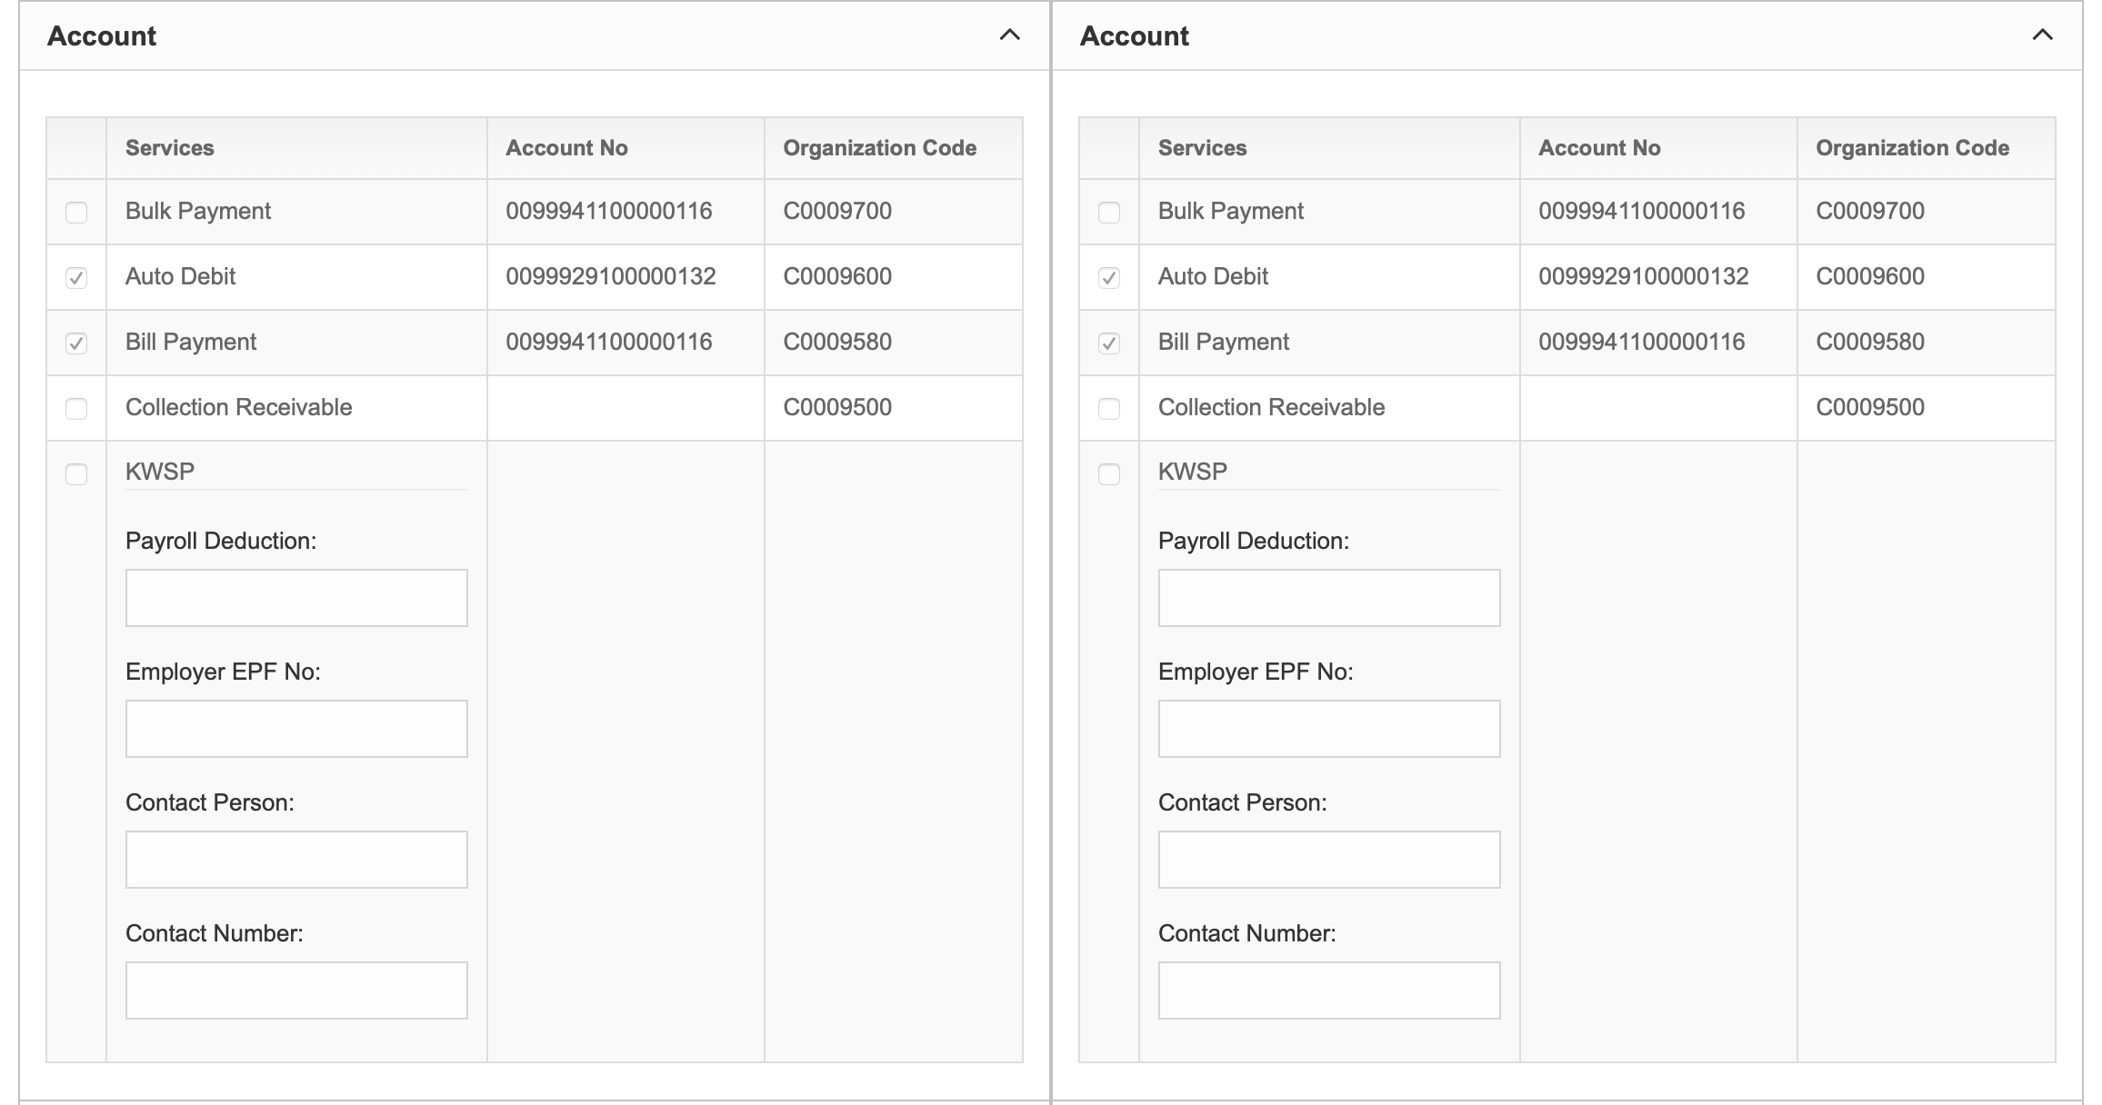

* Subscription
* Service Charges is not Display
* Remarks from Maker not display

