Issue Form (PROD)
Originator's Name: Chooi So Fun  Project: Internet Banking  Project Manager: Malarvili / Chris Gunn  Module : Internet Banking  Date Raised: 29.4.11  Phase : Phase 2 – Internet Banking  Functional Area : Consumer | Issue ID Number: C11-018  Related Issue ID Number: HD00010873  Classification:  Priority: Critical/High/Medium/Low  Assigned to: Vendor / IT / PMO SA / UPA  Actual Closed Date:
Status: Open/Assigned/Investigated/Resolved/Approved/Deferred/No Action (Circle one)
Description :  Should not have the “IB-IBG Fee revert description” displayed for unsuccessful transaction.  (please refer to attachment for further details) | Impact:
Findings/Root Caused (Description): | Resolution:
Estimated Impact :

Recommendation:

Accepted :  (Vendor / IT / PMO SA / UPA)  Date: | Accepted (KFHMB Tester):  Date:

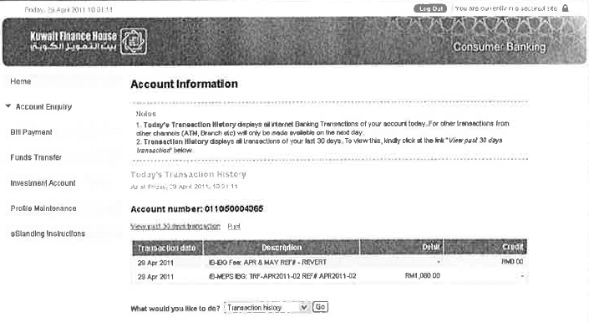

Staff Salary Account
Why there’s an “IB-IBG Fee revert description” amounting RM0.00 displayed for unsuccessful transaction?

Transaction Status: Unsuccessful
