**Agrobank**

**Internet Banking System**

**Data Dictionary**

28 April 2011

Reference: AGRO/TECH/IBDD/20110428/v2.0

**Prepared By:**



Penril Datability (SEA) Sdn Bhd (384550-U)

Suite A-07-07 Plaza Mon’t Kiara

No. 2, Jalan Kiara, Mon’t Kiara

50480 Kuala Lumpur, Malaysia

Tel: (603) 6201 2622 Fax: (603) 6201 7622

Contents

**1** **Document Purpose** 4

**2** **IBSS Data Catalog** 5

2.1 Overall Entity Relationship Diagram 5

2.2 IBSS_APPLICATION 7

*Table: Application Attributes* 7

2.3 IBSS_AUDIT_LOG 7

*Table: Audit Logging Attributes* 7

2.4 IBSS_CATEGORY 7

*Table: User Category Attributes* 7

2.5 IBSS_ORG_APPL 7

*Table: Organization and Application Conjunction Attributes* 7

2.6 IBSS_ORGANIZATION 8

*Table: Organization Attributes* 8

2.7 IBSS_ROLE 8

*Table: User Role Attributes* 8

2.8 IBSS_ROLE_APPL 8

*Table: User Role and Application Conjunction Attributes* 8

2.9 IBSS_USER_PROFILE 8

*Table: User Profile Attributes* 9

2.10 TB_AM_USERMAS 9

*Table: User Master Attributes* 9

2.11 TB_AM_USER 9

*Table: User Attributes* 10

2.12 IBSS_GROUP 10

*Table: Group Attributes* 10

2.13 IBSS_NAVIGATION 10

*Table: Navigation Attributes* 10

2.14 IBSS_NAVIGATION_GROUP 10

*Table: Navigation Group Attributes* 11

2.15 IBSS_SERVICE_INFO 11

*Table: Service Info Maintenance Attributes* 11

2.16 IBSS_PRODUCT_TYPE 11

*Table: Product Type Maintenance Attributes* 12

2.17 IBSS_SERVICE_LIST 12

*Table: Product List Maintenance Attributes* 12

2.18 IBSS_CURRENCY_CODE 12

*Table: Currency Code Maintenance Attributes* 12

2.19 IBSS_PAYEE 12

*Table: Payee Maintenance Attributes* 13

2.20 IBSS_BANCNET_LIST 13

*Table: Bancnet List Maintenance Attributes* 13

2.21 IBSS_TD_PRODUCTS 13

*Table: Time Deposits Product Maintenance Attributes* 13

2.22 IBSS_TD_TERM 13

*Table: Time Deposits Account Term Maintenance Attributes* 14

2.23 IBSS_BANK_BRANCH 14

*Table: Bank Branch Maintenance Attributes* 14

2.24 IBSS_CONTENT_TYPE 14

*Table: Content Type Maintenance Attributes* 14

2.25 IBSS_CONTENT_CATEGORY 14

*Table: Content Category Maintenance Attributes* 14

3 History Data Catalog 15

3.1 Overall Entity Relationship Diagram 15

3.1 IB_USER_TRANSACTION_HISTORY 16

*Table: User Transaction History Attributes* 16

3.8 IB_USER_PRINT_RECEIPT 16

*Table: User Print History Attributes* 16

1. **Document Purpose**

This document contains a description of the Agrobank Internet Banking Data Warehousing Dictionary. Data dictionary is served as a comprehensive reference for maintenance division and is documented subsequent to application data design lifecycle. It provides the technical details on entity relationship, data element description and its defined convention.

As relational database design architecture, this document focuses primarily on the overall data warehousing model tailored for MPI. This document will be kept up-to-date throughout the life of this project to serve as a reference for all data aspects of the application.

**Glossary**

*IBSS - Internet Banking Support System.*

*TB –UPASS Database Table*

1. **IBSS Data Catalog**

## 2.1 Overall Entity Relationship Diagram

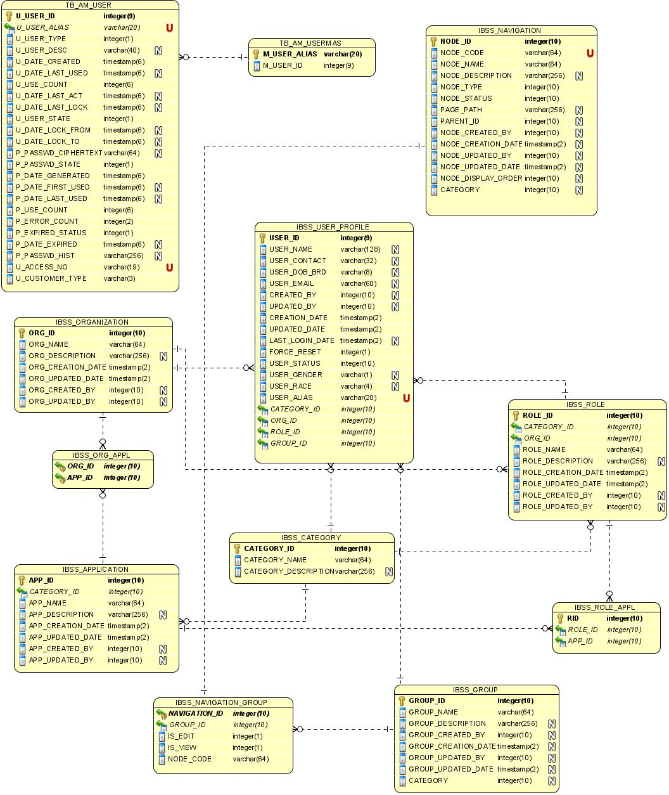

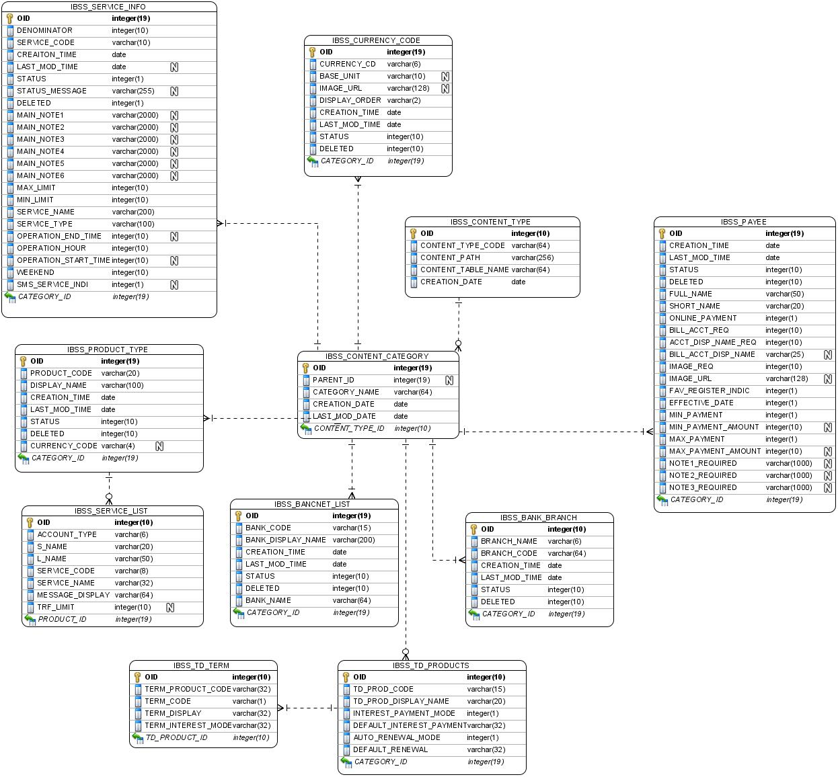

## 2.2 IBSS_APPLICATION

|  |  |  |  |  |  |  |  |
| --- | --- | --- | --- | --- | --- | --- | --- |
| **Column name** | **Data type** | **Unique** | **Len** | **Null?** | **Description** | **Default** | **PK** |
| APP_ID | NUMBER | Yes |  | NOT NULL | Application ID No |  | Yes |
| CATEGORY_ID | NUMBER |  |  | NOT NULL | Category ID No |  |  |
| APP_NAME | VARCHAR2 |  | 64 | NOT NULL | Application Name |  |  |
| APP_DESCRIPTION | VARCHAR2 |  | 256 | YES | Application Description |  |  |
| APP_CREATION_DATE | TIMESTAMP |  | 2 | NOT NULL | Application Creation Date | SYSDATE |  |
| APP_UPDATED_DATE | TIMESTAMP |  | 2 | NOT NULL | Application Updated Date | SYSDATE |  |
| APP_CREATED_BY | NUMBER |  |  | YES | Created by |  |  |
| APP_UPDATED_BY | NUMBER |  |  | YES | Updated by |  |  |

### *Table: Application Attributes*

## 2.3 IBSS_AUDIT_LOG

|  |  |  |  |  |  |  |  |
| --- | --- | --- | --- | --- | --- | --- | --- |
| **Column name** | **Data type** | **Unique** | **Len** | **Null?** | **Description** | **Default** | **PK** |
| LOG_ID | NUMBER | Yes |  | NOT NULL | Log ID No |  | Yes |
| AUDIT_CATEGORY_ID | NUMBER |  |  | NOT NULL | Audit Category ID |  |  |
| LOG_DESCRIPTION | VARCHAR2 |  | 256 | NOT NULL | Log Description |  |  |
| LOG_CREATION_DATE | TIMESTAMP |  | 2 | NOT NULL | Log Creation Date | SYSDATE |  |
| LOG_STATUS | NUMBER |  |  | YES | Log Status |  |  |
| LOG_REASON | VARCHAR2 |  | 256 | YES | Log Reason if Fail |  |  |
| LOG_CREATED_BY | VARCHAR2 |  | 64 | YES | Log Created By Alias |  |  |
| LOG_ROLE_ID | NUMBER |  |  | YES | Log Role ID No |  |  |
| LOG_GROUP_ID | NUMBER |  |  | YES | Log Group ID No |  |  |

### *Table: Audit Logging Attributes*

## 2.4 IBSS_CATEGORY

|  |  |  |  |  |  |  |  |
| --- | --- | --- | --- | --- | --- | --- | --- |
| **Column name** | **Data type** | **Unique** | **Len** | **Null?** | **Description** | **Default** | **PK** |
| CATEGORY_ID | NUMBER | Yes |  | NOT NULL | Category ID No |  | Yes |
| CATEGORY_NAME | VARCHAR2 |  | 64 | NOT NULL | Category Name |  |  |
| CATEGORY_DESCRIPTION | VARCHAR2 |  | 256 | YES | Category Description |  |  |

### *Table: User Category Attributes*

## 2.5 IBSS_ORG_APPL

|  |  |  |  |  |  |  |  |
| --- | --- | --- | --- | --- | --- | --- | --- |
| **Column name** | **Data type** | **Unique** | **Len** | **Null?** | **Description** | **Default** | **PK** |
| ORG_ID | NUMBER | Yes |  | NOT NULL | Organization ID No |  | Yes |
| APP_ID | NUMBER | Yes |  | NOT NULL | Application ID No |  | Yes |

### *Table: Organization and Application Conjunction Attributes*

## 2.6 IBSS_ORGANIZATION

|  |  |  |  |  |  |  |  |
| --- | --- | --- | --- | --- | --- | --- | --- |
| **Column name** | **Data type** | **Unique** | **Len** | **Null?** | **Description** | **Default** | **PK** |
| ORG_ID | NUMBER | Yes |  | NOT NULL | Organization ID No |  | Yes |
| ORG_NAME | VARCHAR2 |  | 64 | NOT NULL | Organization Name |  |  |
| ORG_DESCRIPTION | VARCHAR2 |  | 256 | YES | Organization Description |  |  |
| ORG_CREATION_DATE | TIMESTAMP |  | 2 | NOT NULL | Organization Creation Date | SYSDATE |  |
| ORG_UPDATED_DATE | TIMESTAMP |  | 2 | NOT NULL | Organization Updated Date | SYSDATE |  |
| ORG_CREATED_BY | NUMBER |  |  | YES | Organization Created By |  |  |
| ORG_UPDATED_BY | NUMBER |  |  | YES | Organization Updated By |  |  |

### *Table: Organization Attributes*

## 2.7 IBSS_ROLE

|  |  |  |  |  |  |  |  |
| --- | --- | --- | --- | --- | --- | --- | --- |
| **Column name** | **Data type** | **Unique** | **Len** | **Null?** | **Description** | **Default** | **PK** |
| ROLE_ID | NUMBER | Yes |  | NOT NULL | Role ID No |  | Yes |
| CATEGORY_ID | NUMBER |  |  | NOT NULL | Category ID No |  |  |
| ORG_ID | NUMBER |  |  | YES | Organization ID No |  |  |
| ROLE_NAME | VARCHAR2 |  | 64 | NOT NULL | Role Name |  |  |
| ROLE_DESCRIPTION | VARCHAR2 |  | 256 | YES | Role Description |  |  |
| ROLE_CREATION_DATE | TIMESTAMP |  | 2 | NOT NULL | Role Creation Date | SYSDATE |  |
| ROLE_UPDATED_DATE | TIMESTAMP |  | 2 | NOT NULL | Role Updated Date | SYSDATE |  |
| ROLE_CREATED_BY | NUMBER |  |  | YES | Role Created By |  |  |
| ROLE_UPDATED_BY | NUMBER |  |  | YES | Role Updated By |  |  |

### *Table: User Role Attributes*

## 2.8 IBSS_ROLE_APPL

|  |  |  |  |  |  |  |  |
| --- | --- | --- | --- | --- | --- | --- | --- |
| **Column name** | **Data type** | **Unique** | **Len** | **Null?** | **Description** | **Default** | **PK** |
| RID | NUMBER | Yes |  | NOT NULL | DB auto roll sequence no |  | Yes |
| ROLE_ID | NUMBER |  |  | NOT NULL | Role ID No |  |  |
| APP_ID | NUMBER |  |  | NOT NULL | Application ID No |  |  |

### *Table: User Role and Application Conjunction Attributes*

## 2.9 IBSS_USER_PROFILE

|  |  |  |  |  |  |  |  |
| --- | --- | --- | --- | --- | --- | --- | --- |
| **Column name** | **Data type** | **Unique** | **Len** | **Null?** | **Description** | **Default** | **PK** |
| USER_ID | NUMBER | Yes |  | NOT NULL | User ID No |  | Yes |
| USER_NAME | VARCHAR2 |  | 128 | YES | User Name |  |  |
| USER_DOB_BRD | VARCHAR2 |  | 32 | YES | User DOB/Registration Date |  |  |
| USER_IDENTIFICATION | VARCHAR2 |  | 32 | YES | User Identification No. |  |  |
| USER_EMAIL | VARCHAR2 |  | 60 | YES | User Email |  |  |
| CREATED_BY | NUMBER |  |  | YES | Created By |  |  |
| UPDATED_BY | NUMBER |  |  | YES | Updated By |  |  |
| CREATION_DATE | TIMESTAMP |  | 2 | NOT NULL | Creation Date | SYSDATE |  |
| UPDATED_DATE | TIMESTAMP |  | 2 | NOT NULL | Updated Date | SYSDATE |  |
| LAST_LOGIN_DATE | TIMESTAMP |  | 2 | YES | Last Login Date |  |  |
| FORCE_RESET | INTEGER |  |  | NOT NULL | Force Reset | 1 |  |
| CATEGORY_ID | NUMBER |  |  | NOT NULL | Category ID No | NULL |  |
| ORG_ID | NUMBER |  |  | YES | Organization ID No |  |  |
| ROLE_ID | NUMBER |  |  | YES | Role ID No |  |  |
| GROUP_ID | NUMBER |  |  | YES | Group ID No |  |  |
| USER_STATUS | NUMBER |  |  | NOT NULL | User Status |  |  |
| USER_GENDER | VARCHAR2 |  | 1 | YES | User Gender |  |  |
| USER_RACE | VARCHAR2 |  | 4 | YES | User Race Code |  |  |
| USER_ALIAS | VARCHAR2 |  | 20 | NOT NUMM | User Login ID |  |  |

### *Table: User Profile Attributes*

## 2.10 TB_AM_USERMAS

|  |  |  |  |  |  |  |  |
| --- | --- | --- | --- | --- | --- | --- | --- |
| **Column name** | **Data type** | **Unique** | **Len** | **Null?** | **Description** | **Default** | **PK** |
| M_USER_ALIAS | VARCHAR2 | Yes | 20 | Not null | User Alias |  | Yes |
| M_USER_ID | NUMBER |  | 9 | Not null | User ID No |  |  |

### *Table: User Master Attributes*

## 2.11 TB_AM_USER

|  |  |  |  |  |  |  |  |
| --- | --- | --- | --- | --- | --- | --- | --- |
| **Column name** | **Data type** | **Unique** | **Len** | **Null?** | **Description** | **Default** | **PK** |
| U_USER_ID | NUMBER | Yes | 9 | NOT NULL | User ID No |  | YES |
| U_USER_ALIAS | VARCHAR2 |  | 20 | NOT NULL | User Alias |  |  |
| U_USER_TYPE | NUMBER |  | 1 | NOT NULL | User Type | 2 |  |
| U_USER_DESC | VARCHAR2 |  | 40 | YES | User Description |  |  |
| U_DATE_CREATED | TIMESTAMP |  | 6 | NOT NULL | User Date Creation | SYSTIMESTAMP |  |
| U_DATE_LAST_USED | TIMESTAMP |  | 6 | YES | User Date Last Used |  |  |
| U_USE_COUNT | NUMBER |  | 6 | NOT NULL | User Use Count | 0 |  |
| U_DATE_LAST_ACT | TIMESTAMP |  | 6 | YES | User Date Last Active |  |  |
| U_DATE_LAST_LOCK | TIMESTAMP |  | 6 | YES | User Date Last Lock |  |  |
| U_USER_STATE | NUMBER |  | 1 | NOT NULL | User Starte | 1 |  |
| U_DATE_LOCK_FROM | TIMESTAMP |  | 6 | YES | User Date Lock From |  |  |
| U_DATE_LOCK_TO | TIMESTAMP |  | 6 | YES | User Date Lock To |  |  |
| P_PASSWD_CIPHERTEXT | VARCHAR2 |  | 64 | YES | Password in Ciphertext |  |  |
| P_PASSWD_STATE | NUMBER |  | 1 | NOT NULL | Password State | 0 |  |
| P_DATE_GENERATED | TIMESTAMP |  | 6 | NOT NULL | Password Date Generated | SYSTIMESTAMP |  |
| P_DATE_FIRST_USED | TIMESTAMP |  | 6 | YES | Password Date First Used |  |  |
| P_DATE_LAST_USED | TIMESTAMP |  | 6 | YES | Password Date Last Used |  |  |
| P_USE_COUNT | NUMBER |  | 6 | NOT NULL | Password Use Count | 0 |  |
| P_ERROR_COUNT | NUMBER |  | 2 | NOT NULL | Password Error Count | 0 |  |
| P_EXPIRED_STATUS | NUMBER |  | 1 | NOT NULL | password Expired Status | 1 |  |
| P_DATE_EXPIRED | TIMESTAMP |  | 6 | YES | Password Date Expired |  |  |
| P_PASSWD_HIST | VARCHAR2 |  | 256 | YES | Password History. |  |  |
| U_ACCESS_NO | VARCHAR2 |  | 19 | YES | CIF of banking customer |  |  |
| U_CUSTOMER_TYPE | VARCHAR2 |  | 3 | NOT NULL | User application type |  |  |

### *Table: User Attributes*

## 2.12 IBSS_GROUP

|  |  |  |  |  |  |  |  |
| --- | --- | --- | --- | --- | --- | --- | --- |
| **Column name** | **Data type** | **Unique** | **Len** | **Null?** | **Description** | **Default** | **PK** |
| GROUP_ID | NUMBER | Yes |  | NOT NULL | Group Id |  | YES |
| GROUP_NAME | VARCHAR2 |  | 64 | NOT NULL | Group Name |  |  |
| GROUP_DESCRIPTION | VARCHAR2 |  | 256 | YES | Group Description |  |  |
| GROUP_CREATED_BY | NUMBER |  |  | YES | Created By |  |  |
| GROUP_CREATION_DATE | TIMESTAMP |  | 2 | YES | Creation time | SYSDATE |  |
| GROUP_UPDATED_BY | NUMBER |  |  | YES | Updated By |  |  |
| GROUP_UPDATED_DATE | TIMESTAMP |  | 2 | YES | Last Modified Time | SYSDATE |  |
| CATEGORY | NUMBER |  |  | YES | Category ID No |  |  |

### *Table: Group Attributes*

## 2.13 IBSS_NAVIGATION

|  |  |  |  |  |  |  |  |
| --- | --- | --- | --- | --- | --- | --- | --- |
| **Column name** | **Data type** | **Unique** | **Len** | **Null?** | **Description** | **Default** | **PK** |
| NODE_ID | NUMBER | YES |  | NOT NULL | Node ID No |  | Yes |
| NODE_CODE | VARCHAR2 |  | 64 | NOT NULL | Node Code |  |  |
| NODE_NAME | VARCHAR2 |  | 64 | NOT NULL | Node Name |  |  |
| NODE_DESCRIPTION | VARCHAR2 |  | 256 | YES | Node Description |  |  |
| NODE_TYPE | NUMBER |  |  | NOT NULL | Node Type |  |  |
| NODE_STATUS | NUMBER |  |  | NOT NULL | Status |  |  |
| PAGE_PATH | VARCHAR2 |  | 256 | YES | Page Path |  |  |
| PARENT_ID | NUMBER |  |  | YES | Parent ID No |  |  |
| NODE_CREATED_BY | NUMBER |  |  | YES | Created By |  |  |
| NODE_CREATION_DATE | TIMESTAMP |  | 2 | YES | Creation Time | SYSDATE |  |
| NODE_UPDATED_BY | NUMBER |  |  | YES | Last Modified by |  |  |
| NODE_UPDATED_DATE | TIMESTAMP |  | 2 | YES | Last Modified Time | SYSDATE |  |
| NODE_DISPLAY_ORDER | NUMBER |  |  | YES | Display Order |  |  |
| CATEGORY | NUMBER |  |  | YES | Category ID No |  |  |

### *Table: Navigation Attributes*

## 2.14 IBSS_NAVIGATION_GROUP

|  |  |  |  |  |  |  |  |
| --- | --- | --- | --- | --- | --- | --- | --- |
| **Column name** | **Data type** | **Unique** | **Len** | **Null?** | **Description** | **Default** | **PK** |
| NAVIGATION_ID | NUMBER | Yes |  | NOT NULL | Navigation ID No |  | Yes |
| GROUP_ID | NUMBER |  |  | NOT NULL | Group ID No |  |  |
| IS_EDIT | NUMBER |  |  | NOT NULL | Is Edited | 1 |  |
| IS_VIEW | NUMBER |  |  | NOT NULL | Is Viewed | 1 |  |
| NODE_CODE | VARCHAR2 |  | 64 | NOT NULL | Node Code ID No |  |  |

### *Table: Navigation Group Attributes*

## 2.15 IBSS_SERVICE_INFO

|  |  |  |  |  |  |  |  |
| --- | --- | --- | --- | --- | --- | --- | --- |
| **Column name** | **Data type** | **Unique** | **Len** | **Null?** | **Description** | **Default** | **PK** |
| OID | NUMBER | YES |  | NOT NULL | DB Sequence No |  | YES |
| DENOMINATOR | NUMBER |  |  | NOT NULL | Denominator |  |  |
| SERVICE_CODE | VARCHAR2 |  | 10 | NOT NULL | Service Code |  |  |
| CREATION_TIME | DATE |  |  | NOT NULL | Creation Time |  |  |
| STATUS | NUMBER |  |  | NOT NULL | Status |  |  |
| STATUS_MESSAGE | VARCHAR2 |  | 200 | YES | Display message for status |  |  |
| DELETED | NUMBER |  |  | NOT NULL | Deleted |  |  |
| LAST_MOD_TIME | DATE |  |  | YES | Last Modified Time |  |  |
| SERVICE_NAME | VARCHAR2 |  | 200 | NOT NULL | Service Name |  |  |
| SERVICE_TYPE | VARCHAR2 |  | 100 | NOT NULL | Service Type |  |  |
| MAIN_NOTE1 | VARCHAR2 |  | 2000 | YES | Note in Step 1 |  |  |
| MAIN_NOTE2 | VARCHAR2 |  | 2000 | YES | Note in Step 2 |  |  |
| MAIN_NOTE3 | VARCHAR2 |  | 2000 | YES | Note in Step 3 |  |  |
| MAIN_NOTE4 | VARCHAR2 |  | 2000 | YES | Note in Step 4 |  |  |
| MAIN_NOTE5 | VARCHAR2 |  | 2000 | YES | Note in Step 5 |  |  |
| MAIN_NOTE6 | VARCHAR2 |  | 2000 | YES | Note in Step 6 |  |  |
| MAX_LIMIT | NUMBER |  |  | NOT NULL | Maximum Limit |  |  |
| MIN_LIMIT | NUMBER |  |  | NOT NULL | Minimum Limit |  |  |
| OPERATION_HOUR | NUMBER |  |  | NOT NULL | Operation Hour |  |  |
| OPERATION_START_TIME | VARCHAR2 |  | 4 | YES | Operation Start Date |  |  |
| OPERATION_END_TIME | VARCHAR2 |  | 4 | YES | Operation End Date |  |  |
| WEEKEND | NUMBER |  |  | NOT NULL | Weekend |  |  |
| CATEGORY_ID | NUMBER |  |  | NOT NULL | Category ID No |  |  |
| SMS_SERVICE_INDI | VARCHAR2 |  | 256 | YES | SMS Service Indicator |  |  |

### *Table: Service Info Maintenance Attributes*

## 2.16 IBSS_PRODUCT_TYPE

|  |  |  |  |  |  |  |  |
| --- | --- | --- | --- | --- | --- | --- | --- |
| **Column name** | **Data type** | **Unique** | **Len** | **Null?** | **Description** | **Default** | **PK** |
| OID | NUMBER | YES |  | NOT NULL | DB Sequence No |  | YES |
| PRODUCT_CODE | VARCHAR2 |  | 20 | NOT NULL | Product Code |  |  |
| CREATION_TIME | DATE |  |  | NOT NULL | Creation Time |  |  |
| STATUS | NUMBER |  |  | NOT NULL | Status |  |  |
| LAST_MOD_TIME | DATE |  |  | NOT NULL | last Modified Time |  |  |
| DISPLAY_NAME | VARCHAR2 |  | 100 | NOT NULL | Product Display Name |  |  |
| CATEGORY_ID | NUMBER |  |  | NOT NULL | Category ID No |  |  |
| DELETED | NUMBER |  |  | NOT NULL | Deleted |  |  |
| CURRENCY_CODE | VARCHAR2 |  | 4 | NOT NULL | Currency for each product |  |  |

### *Table: Product Type Maintenance Attributes*

## 2.17 IBSS_SERVICE_LIST

|  |  |  |  |  |  |  |  |
| --- | --- | --- | --- | --- | --- | --- | --- |
| **Column name** | **Data type** | **Unique** | **Len** | **Null?** | **Description** | **Default** | **PK** |
| OID | NUMBER | YES |  | NOT NULL | DB Sequence No |  | YES |
| PRODUCT_ID | VARCHAR2 |  | 6 | NOT NULL | Product Code |  |  |
| ACCOUNT_TYPE | VARCHAR2 |  | 6 | NOT NULL | Account Type |  |  |
| S_NAME | VARCHAR2 |  | 20 | NOT NULL | Short Name |  |  |
| L_NAME | VARCHAR2 |  | 50 | NOT NULL | Long Name |  |  |
| SERVICE_CODE | VARCHAR2 |  | 8 | NOT NULL | Transaction services |  |  |
| SERVICE_NAME | VARCHAR2 |  | 32 | NOT NULL | Service name |  |  |
| MESSAGE_DISPLAY | VARCHAR2 |  | 64 | NOT NULL | Display message for service |  |  |
| TRF_LIMIT | NUMBER |  |  | YES | Transfer Limit |  |  |

### *Table: Product List Maintenance Attributes*

## 2.18 IBSS_CURRENCY_CODE

|  |  |  |  |  |  |  |  |  |  |
| --- | --- | --- | --- | --- | --- | --- | --- | --- | --- |
| **Column name** | **Data type** | **Unique** | **Len** | **Null?** | **Description** | **Validation** | **Default** | **Label** | **PK** |
| OID | NUMBER | YES |  | NOT NULL | DB Sequence No |  |  |  | YES |
| CURRENCY_CD | VARCHAR2 |  | 6 | NOT NULL | Currency Code |  |  |  |  |
| CREATION_TIME | DATE |  |  | NOT NULL | Creation Time |  |  |  |  |
| STATUS | NUMBER |  |  | NOT NULL | Status |  |  |  |  |
| DELETED | NUMBER |  |  | NOT NULL | Deleted |  |  |  |  |
| LAST_MOD_TIME | DATE |  |  | NOT NULL | Last Modified Time |  |  |  |  |
| DISPLAY_ORDER | VARCHAR2 |  | 2 | NOT NULL | Display Order |  |  |  |  |
| BASE_UNIT | NUMBER |  |  | YES | Base Unit |  |  |  |  |
| IMAGE_URL | VARCHAR2 |  | 128 | YES | Image Uploaded URL |  |  |  |  |
| CATEGORY_ID | NUMBER |  |  | NOT NULL | Category ID |  |  |  |  |

### *Table: Currency Code Maintenance Attributes*

## 2.19 IBSS_PAYEE

|  |  |  |  |  |  |  |  |
| --- | --- | --- | --- | --- | --- | --- | --- |
| **Column name** | **Data type** | **Unique** | **Len** | **Null?** | **Description** | **Default** | **PK** |
| OID | NUMBER | YES |  | NOT NULL | DB Sequence No |  | YES |
| CREATION_TIME | DATE |  |  | NOT NULL | Creation Time |  |  |
| STATUS | NUMBER |  |  | NOT NULL | Status |  |  |
| DELETED | NUMBER |  |  | NOT NULL | Deleted |  |  |
| LAST_MOD_TIME | DATE |  |  | NOT NULL | Last Modified Time |  |  |
| FULL_NAME | VARCHAR2 |  | 50 | NOT NULL | Full Name |  |  |
| SHORT_NAME | VARCHAR2 |  | 20 | NOT NULL | Short Name |  |  |
| ONLINE_PAYMENT | VARCHAR2 |  | 1 | NOT NULL | Online Payment |  |  |
| BILL_ACCT_REQ | NUMBER |  |  | NOT NULL | Bill Account Required |  |  |
| ACCT_DISP_NAME_REQ | NUMBER |  |  | NOT NULL | Account Display Name Required |  |  |
| BILL_ACCT_DISP_NAME | VARCHAR2 |  | 25 | YES | Bill Account Display Name |  |  |
| IMAGE_REQ | NUMBER |  |  | NOT NULL | Image Required |  |  |
| IMAGE_URL | VARCHAR2 |  | 128 | YES | Image URL |  |  |
| FAV_REGISTER_INDIC | NUMBER |  |  | NOT NULL | Register Indicator |  |  |
| EFFECTIVE_DATE | NUMBER |  |  | NOT NULL | Effective Date |  |  |
| MIN_PAYMENT | NUMBER |  |  | NOT NULL | Min Payment |  |  |
| MIN_PAYMENT_AMOUNT | NUMBER |  |  | YES | Min Payment Amount |  |  |
| MAX_PAYMENT | NUMBER |  |  | NOT NULL | Max Payment |  |  |
| MAX_PAYMENT_AMOUNT | NUMBER |  |  | YES | Max Payment Amount |  |  |
| NOTE1_REQUIRED | VARCHAR2 |  | 1000 | YES | Note 1 Required |  |  |
| NOTE2_REQUIRED | VARCHAR2 |  | 1000 | YES | Note 2 Required |  |  |
| NOTE3_REQUIRED | VARCHAR2 |  | 1000 | YES | Note 3 Required |  |  |
| CATEGORY_ID | NUMBER |  |  | NOT NULL | Category Id |  |  |

### *Table: Payee Maintenance Attributes*

## 2.20 IBSS_BANCNET_LIST

|  |  |  |  |  |  |  |  |
| --- | --- | --- | --- | --- | --- | --- | --- |
| **Column name** | **Data type** | **Unique** | **Len** | **Null?** | **Description** | **Default** | **PK** |
| OID | NUMBER | YES |  | NOT NULL | DB Sequence No |  | YES |
| BANK_CODE | VARCHAR2 |  | 15 | NOT NULL | Bank Code |  |  |
| BANK_DISPLAY_NAME | VARCHAR2 |  | 200 | NOT NULL | Bank Display Name |  |  |
| CREATION_TIME | DATE |  |  | NOT NULL | Creation Time |  |  |
| STATUS | NUMBER |  |  | NOT NULL | Status |  |  |
| DELETED | NUMBER |  |  | NOT NULL | Deleted |  |  |
| LAST_MOD_TIME | DATE |  |  | NOT NULL | Last Modified Time |  |  |
| CATEGORY_ID | NUMBER |  |  | NOT NULL | Category ID |  |  |
| BANK_NAME | VARCHAR2 |  | 64 | NOT NULL | Branch Name |  |  |

### *Table: Bancnet List Maintenance Attributes*

## 2.21 IBSS_TD_PRODUCTS

|  |  |  |  |  |  |  |  |
| --- | --- | --- | --- | --- | --- | --- | --- |
| **Column name** | **Data type** | **Unique** | **Len** | **Null?** | **Description** | **Default** | **PK** |
| OID | NUMBER | YES |  | NOT NULL | DB Sequence No |  | YES |
| TD_PROD_CODE | VARCHAR2 | YES | 15 | NOT NULL | TD Code |  | YES |
| TD_PROD_DISPLAY_NAME | VARCHAR2 |  | 32 | NOT NULL | TD Display Name |  |  |
| INTEREST_PAYMENT_MODE | NUMBER |  |  | NOT NULL | Interest Payment Mode |  |  |
| DEFAULT_INTEREST_PAYMENT | VARCHAR2 |  | 32 | NOT NULL | Default Interest Payment Mode |  |  |
| AUTO_RENEWAL_MODE | NUMBER |  |  | NOT NULL | Auto Renewal Mode |  |  |
| DEFAULT_RENEWAL | VARCHAR2 |  | 32 | NOT NULL | Default Auto Renewal Mode |  |  |
| CATEGORY_ID | NUMBER |  |  | NOT NULL | Category ID |  |  |

### *Table: Time Deposits Product Maintenance Attributes*

## 2.22 IBSS_TD_TERM

|  |  |  |  |  |  |  |  |
| --- | --- | --- | --- | --- | --- | --- | --- |
| **Column name** | **Data type** | **Unique** | **Len** | **Null?** | **Description** | **Default** | **PK** |
| OID | NUMBER | YES |  | NOT NULL | DB Sequence No |  | YES |
| TD_PRODUCT_ID | NUMBER |  |  |  | Parent Product ID |  |  |
| TERM_PRODUCT_CODE | VARCHAR2 |  | 3 | NOT NULL | Product Code by Term |  |  |
| TERM_CODE | VARCHAR2 |  | 1 | NOT NULL | Month or Days of Term |  |  |
| TERM_DISPLAY | VARCHAR2 |  | 32 | NOT NULL | Term Display |  |  |
| TERM_INTEREST_MODE | VARCHAR2 |  | 32 | NOT NULL | Interest Payment Mode for Term |  |  |

### *Table: Time Deposits Account Term Maintenance Attributes*

## 2.23 IBSS_BANK_BRANCH

|  |  |  |  |  |  |  |  |
| --- | --- | --- | --- | --- | --- | --- | --- |
| **Column name** | **Data type** | **Unique** | **Len** | **Null?** | **Description** | **Default** | **PK** |
| OID | NUMBER | YES |  | NOT NULL | DB Sequence No |  | YES |
| BRANCH_CODE | VARCHAR2 |  | 6 | NOT NULL | Branch Code |  |  |
| CREATION_TIME | DATE |  |  | NOT NULL | Creation Time |  |  |
| STATUS | NUMBER |  |  | NOT NULL | Status |  |  |
| DELETED | NUMBER |  |  | NOT NULL | Deleted |  |  |
| LAST_MOD_TIME | DATE |  |  | NOT NULL | Last Modified Time |  |  |
| BRANCH_NAME | VARCHAR2 |  | 64 | NOT NULL | Branch Name |  |  |
| CATEGORY_ID | NUMBER |  |  | NOT NULL | Category ID |  |  |

### *Table: Bank Branch Maintenance Attributes*

## 2.24 IBSS_CONTENT_TYPE

|  |  |  |  |  |  |  |  |
| --- | --- | --- | --- | --- | --- | --- | --- |
| **Column name** | **Data type** | **Unique** | **Len** | **Null?** | **Description** | **Default** | **PK** |
| OID | NUMBER | YES | 19 | NOT NULL | DB Sequence No |  | YES |
| CONTENT_TYPE_CODE | VARCHAR2 |  | 64 | NOT NULL | Content Type Code |  |  |
| CONTENT_PATH | VARCHAR2 |  | 256 | NOT NULL | Content Path |  |  |
| CONTENT_TABLE_NAME | VARCHAR2 |  | 64 | NOT NULL | Content Table Name |  |  |
| CREATION_DATE | DATE |  |  | NOT NULL | Creation Date |  |  |

### *Table: Content Type Maintenance Attributes*

## 2.25 IBSS_CONTENT_CATEGORY

|  |  |  |  |  |  |  |  |
| --- | --- | --- | --- | --- | --- | --- | --- |
| **Column name** | **Data type** | **Unique** | **Len** | **Null?** | **Description** | **Default** | **PK** |
| OID | NUMBER | YES | 19 | NOT NULL | DB Sequence No |  | YES |
| PARENT_ID | NUMBER |  | 19 | YES | Parent Category ID |  |  |
| CONTENT_TYPE_ID | NUMBER |  | 19 | NOT NULL | Content Type ID |  |  |
| CATEGORY_NAME | VARCHAR2 |  | 64 | NOT NULL | Category Name |  |  |
| CREATION_DATE | DATE |  |  | NOT NULL | Creation Date |  |  |
| LAST_MOD_DATE | DATE |  |  | NOT NULL | Last Modified Date |  |  |

### *Table: Content Category Maintenance Attributes*

# History Data Catalog

## Overall Entity Relationship Diagram

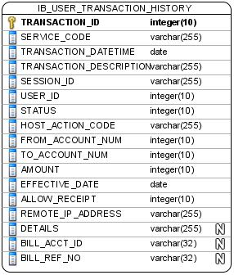

## 3.1 IB_USER_TRANSACTION_HISTORY

|  |  |  |  |  |  |  |  |
| --- | --- | --- | --- | --- | --- | --- | --- |
| **Column name** | **Data type** | **Unique** | **Len** | **Null?** | **Description** | **Default** | **PK** |
| TRANSACTION_ID | NUMBER | Yes | 24 | NOT NULL | Transaction ID |  | Yes |
| SERVICE_CODE | VARCHAR2 |  | 10 | NOT NULL | Service Code |  |  |
| TRANSACTION_DATETIME | DATE |  |  | NOT NULL | Transaction Date and Time |  |  |
| TRANSACTION_DESCRIPTION | VARCHAR2 |  | 256 | NOT NULL | Transaction Description |  |  |
| SESSION_ID | VARCHAR2 |  | 32 | NOT NULL | Session ID |  |  |
| USER_ID | NUMBER |  | 10 | NOT NULL | User ID |  |  |
| STATUS | NUMBER |  | 1 | NOT NULL | Status |  |  |
| HOST_ACTION_CODE | VARCHAR2 |  | 3 | NOT NULL | Host Action Code |  |  |
| FROM_ACCOUNT_NUM | NUMBER |  | 20 | NOT NULL | From Account Number |  |  |
| TO_ACCOUNT_NUM | NUMBER |  | 20 | NOT NULL | To Account Number |  |  |
| AMOUNT | NUMBER |  | 15,2 | NOT NULL | User Transaction Amount |  |  |
| EFFECTIVE_DATE | DATE |  |  | NOT NULL | Transaction Effective Date and Time |  |  |
| ALLOW_RECEIPT | NUMBER |  | 1 | NOT NULL | Allow Print Receipt |  |  |
| REMOTE_IP_ADDRESS | VARCHAR2 |  | 64 | NOT NULL | Remote Ip Address |  |  |
| DETAILS | VARCHAR2 |  | 255 | YES | Additional details for transaction |  |  |
| BILL_ACCT_ID | VARCHAR2 |  | 32 | YES | Bill account no. for bill payment |  |  |
| BILL_REF_NO | VARCHAR2 |  | 32 | YES | Bill reference no for bill payment |  |  |

### *Table: User Transaction History Attributes*

## 3.8 IB_USER_PRINT_RECEIPT

|  |  |  |  |  |  |  |  |
| --- | --- | --- | --- | --- | --- | --- | --- |
| **Column name** | **Data type** | **Unique** | **Len** | **Null?** | **Description** | **Default** | **PK** |
| TRANSACTION_ID | NUMBER | YES | 24 | NOT NULL | Transaction ID No |  | YES |
| SERVICE_CODE | VARCHAR2 |  | 10 | NOT NULL | Service Code |  |  |
| TRANSACTION_DATETIME | DATE |  |  | NOT NULL | Transaction Date and Time |  |  |
| USER_ID | NUMBER |  | 10 | NOT NULL | User ID No |  |  |
| RECIPIENT_DETAILS_MAP_KEYS | VARCHAR2 |  | 1024 | NOT NULL | Recipient Details Map Keys |  |  |
| RECIPIENT_DETAILS_MAP_VALUE | VARCHAR2 |  | 1024 | NOT NULL | Recipient Details Map Value |  |  |

### *Table: User Print History Attributes*

---------- END ----------