Kuwait Finance House (Malaysia) Berhad

Banker’s Cheque & Demand Draft Application Form

Business Requirement Specification (BRS)
PART B

21 May 2010
Reference: KFH/KFH20100409/BRS/APPL1.0

Prepared By:



Penril Datability (M) Sdn Bhd (816792-X)
Suite A-07-07 Plaza Mon’t Kiara
No. 2, Jalan Kiara, Mon’t Kiara
50480 Kuala Lumpur, Malaysia
Tel: (603) 6201 2622 Fax: (603) 6201 7622

Document Administration
Document Amendment Log
Version No | Date Updated | Description of Change | Updated By  <Name, Dept> | Reviewed By  <Name, Dept> | Approved By <Name, Dept>
1.0 | 01/04/2010 | Initial Creation | Shuhaida, Penril  Ayu, Penril
1.1 | 14/05/2010 | Updated | Shuhaida, Penril  Ayu, Penril
1.2 | 21/05/2010 | Updated | Bernard Wong, Penril
1.3 | 04/06/2010 | Updated screenshots & content  Added email message template | Bernard Wong,  Penril

Table of Contents
1 Introduction 4
1.1 Objective 4
1.2 Features Covered 4
2 Demand Draft and Banker’s Cheque Application 5
2.1 Feature Description 5
2.1.1 Process Flow 5
2.1.2 Page Flows Diagram 6
2.2 Remittance Application 7
2.3 Banker’s Cheque Application 7
2.3.1 Process Flow 7
2.3.2 Process Flow 7
2.4 Demand Draft Application 14
2.4.1 Process Flow 14
2.4.2 Screen Designs 15
2.5 Application Form Enquiry 21
2.5.1 Process Flow 21
2.5.2 Screen Designs 21
2.6 Banker’s Cheque and Demand Draft Application Digital File 22
2.6.1 Digital File Download 25
2.7 Reports 26
2.7.1 Reports Retrieval 31
3 Appendix A - Terms & Conditions 32

Table of Figures
Figure 1 Application Forms Listing Page 7
Figure 2 Banker’s Cheque Application Terms and Conditions Screen 8
Figure 3 Banker’s Cheque Application Input Screen 1 9
Figure 4 Banker’s Cheque Application Input Screen 2 10
Figure 5 Banker’s Cheque Application Confirmation Screen 11
Figure 6 Banker’s Cheque Application Result Screen 12
Figure 7 Banker’s Cheque Application Printing Format 13
Figure 8 Demand Draft Application Terms and Conditions Screen 15
Figure 9 Demand Draft Application Input Screen 1 16
Figure 10 Demand Draft Application Input Screen 2 17
Figure 11 Demand Draft Application Confirmation Screen 18
Figure 12 Demand Draft Application Result Screen 19
Figure 13 Demand Draft Application Print Format 20
Figure 14 Application Form Enquiry Screen 21
Figure 15 Sample Banker’s Check Application file download 25
Figure 16 Sample Demand Draft Application file download 25
Figure 17 Sample Banker’s Cheque report download 31
Figure 18 Sample Demand Draft report download 31

Introduction
This document describes the feature and process flow of the screen design of Banker’s Cheque & Demand Draft application forms for KFHOnline Consumer Internet Banking (CIB) in detail.

Objective
The objective of this document is to capture user requirements for the Banker’s Cheque & Demand Draft application form of CIB. This document shall facilitate development and implementation of the mentioned feature of CIB for Kuwait Finance House Malaysia Berhad (“KFHMB”).
The base line features description, process flows and screen designs shall become a reference blueprint for the development team to further develop the feature. Hence, it is crucial that all stakeholders need to ensure the correctness and adequacy of the requirements captured in this document.
All stakeholders involved are expected to review and sign off this document before the development start. By signing off the document, the stakeholder has endorsed the correctness, accuracy and adequacy of the requirements documented in this document.

Features Covered
The following Personalization features shall be captured in this BRS document:-
- Banker Cheque application form
- Demand Draft application form
- Application Form Enquiry
- Reports

Demand Draft and Banker’s Cheque Application
This document describes the feature and process flow of the screen design of Banker’s Cheque & Demand Draft application forms for KFHOnline Consumer Internet Banking (CIB) in detail.

Feature Description
This feature allows IB Users to make following application:
- Banker’s Cheque Application
- Demand Draft Application

Process Flow

Page Flows Diagram

Remittance Application
A new menu item, Remittance Application, shall be added to CIB for the Banker’s Cheque and Demand Draft applications. All the service notes for all the new pages shall be maintained at BVMC.

Banker’s Cheque Application
Banker’s Cheque only accepts the Malaysia Ringgit currency (MYR). The commission and stamp duty charges shall be maintained in a properties file.

Process Flow
Step 1:
- IB User accesses to Banker’s Cheque Application screen through Application Form listing page, see Figure 1.
- CIB System shall prompt for Banker’s Cheque Application Terms and Conditions screen, see Figure 2.
- IB User shall read and accept the Banker’s Cheque Application Terms and Conditions clicking on the Agree button; otherwise click on the Cancel button to go back to the previous page.

Step 2:
- After IB User accepts the terms and conditions, CIB System shall display Banker’s Cheque Application Input Screen with pre-fill user profile, see Figure 3 and Figure 4.
- After IB User fills in all the details, IB User shall click on the Next button to go to the confirmation screen.

Step 3:
- CIB System shall display the confirmation screen, see Figure 5.
- IB User shall confirm the application submission by clicking on the Confirm button.
- CIB System saves the Banker’s Cheque Application into the system and emails the application form to designated collection bank branch.
- The Result Screen shall be displayed after successful processing, see Figure 6.
- IB User can print submitted application form by clicking on the Print button, please see Figure 7 for the printing format.

Process Flow
Step 1:
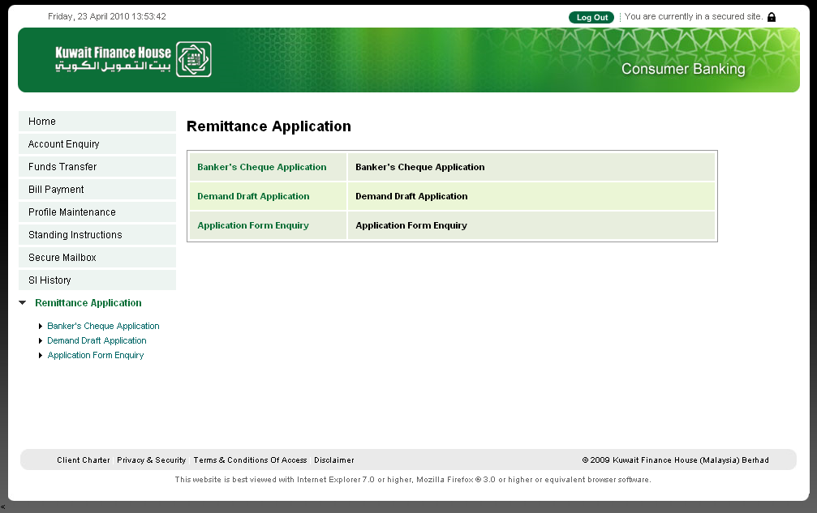
Figure 1 Application Forms Listing Page
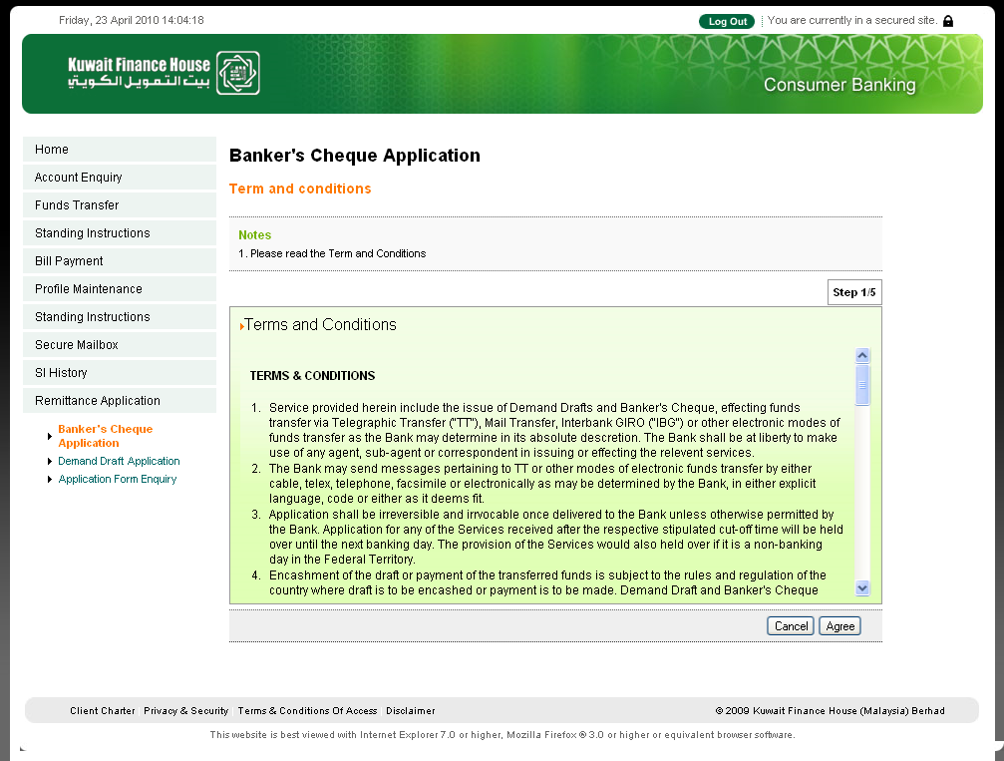
Figure 2 Banker’s Cheque Application Terms and Conditions Screen
- IB User accesses to Banker’s Cheque Application Screen.
- CIB System displays Banker’s Cheque Application Terms and Conditions Screen.
- IB User reads and accepts Banker’s Cheque Application Terms and Conditions.
Step 2:
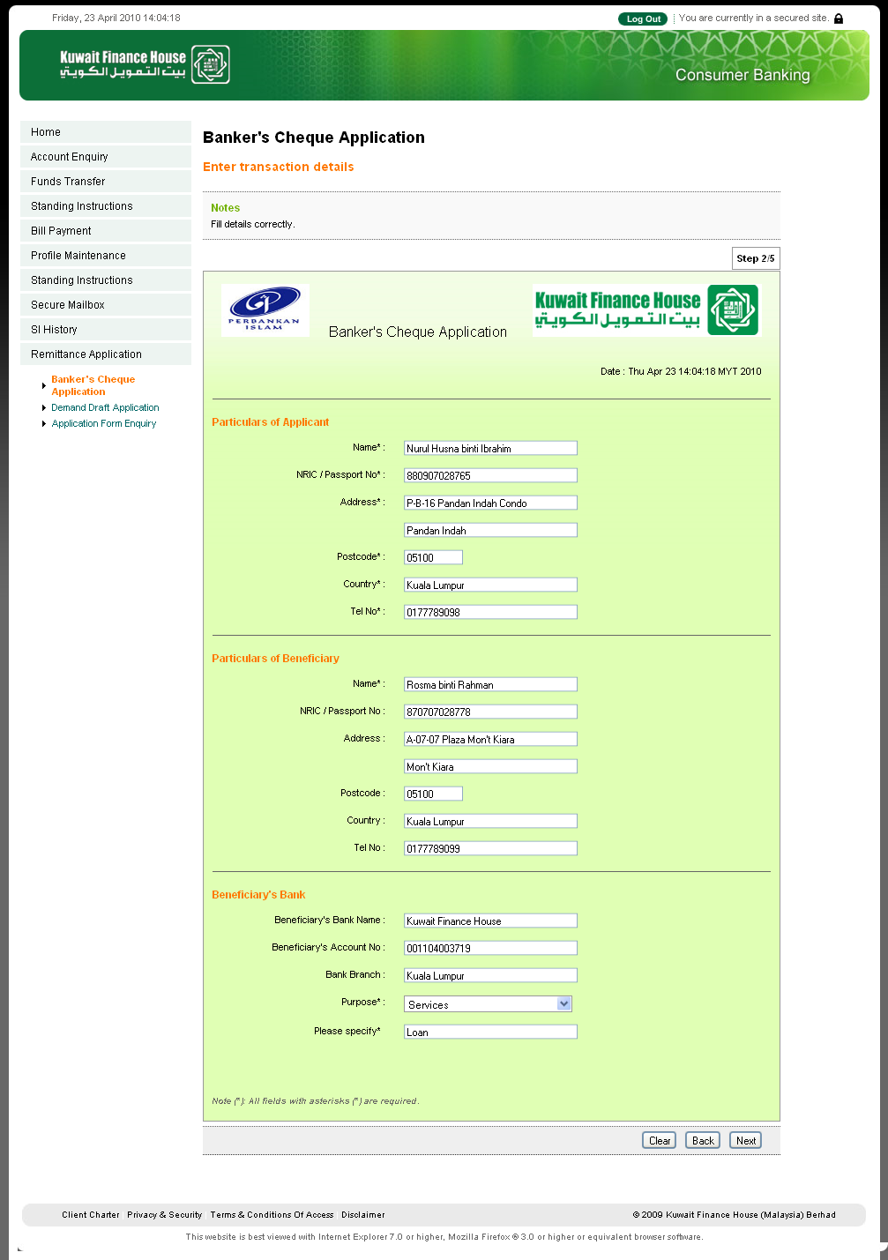

Figure 3 Banker’s Cheque Application Input Screen 1
- CIB System displays Banker’s Application Input Screen with pre-filled applicant profiles as much information can be obtained from the system. All fields are editable. IB User is allowed to make any changes.
- IB User inputs required to input beneficiary name and purpose of the transaction.

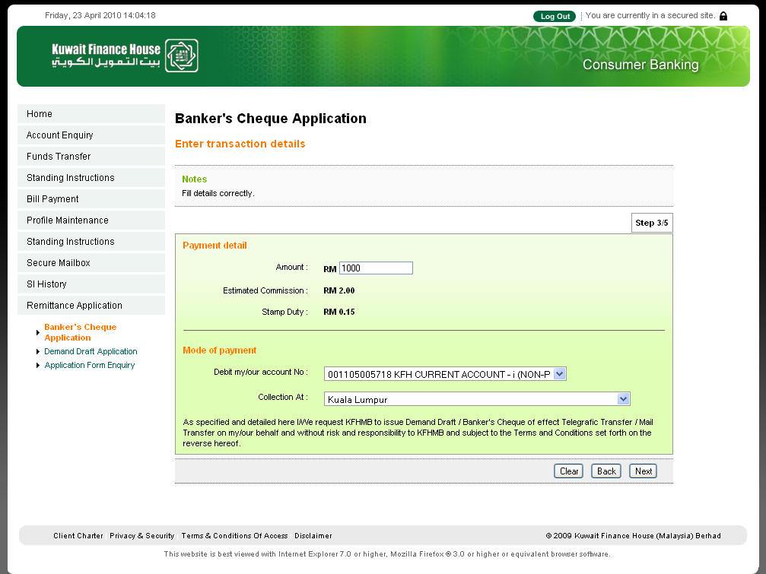
Figure 4 Banker’s Cheque Application Input Screen 2
- IB User inputs Banker’s Cheque Application details.
- Branch name and branch email address are set in BVMC (IB Branch Info)
- Since Commission and Stamp Duty are not always changing, both values will be stored in IBBusinessOptionResources.properties file. Both Commission and Stamp Duty are in MYR currency.

Step 3: 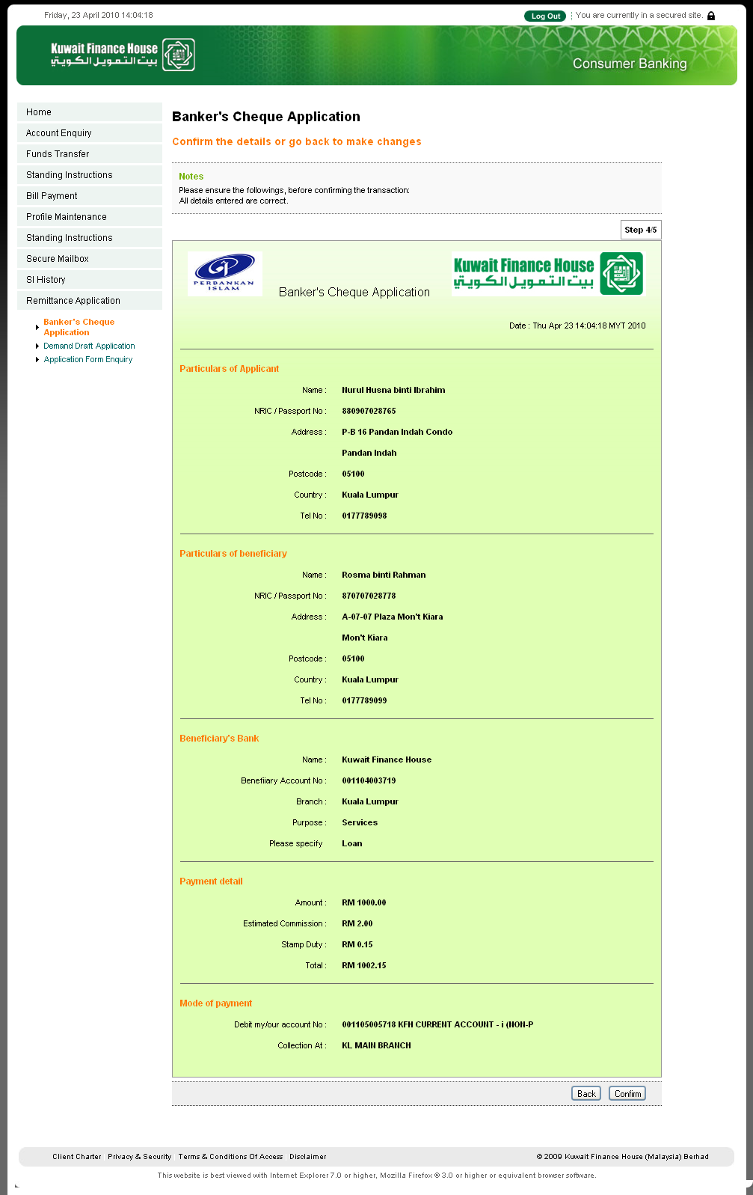
Figure 5 Banker’s Cheque Application Confirmation Screen
- CIB System displays Banker’s Cheque Application Confirmation Screen.
- IB User confirms Banker’s Cheque Application.

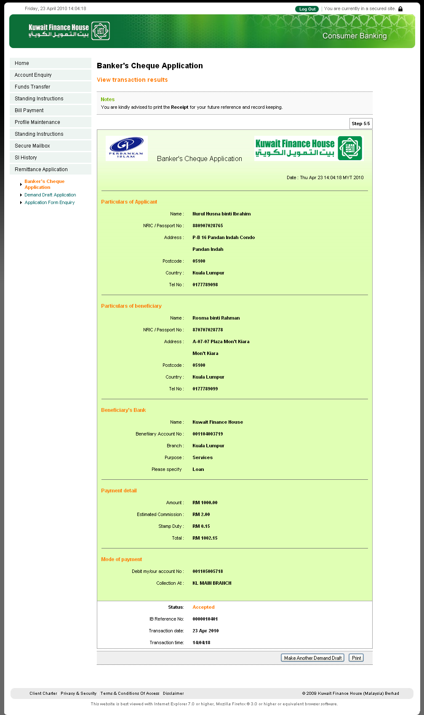
Figure 6 Banker’s Cheque Application Result Screen
- CIB System saves the Banker’s Cheque Application into the system and displays the Result Screen.
- IB User can print the submitted Banker’s Cheque Application Form by click Print button. The printing format is as Figure 7.
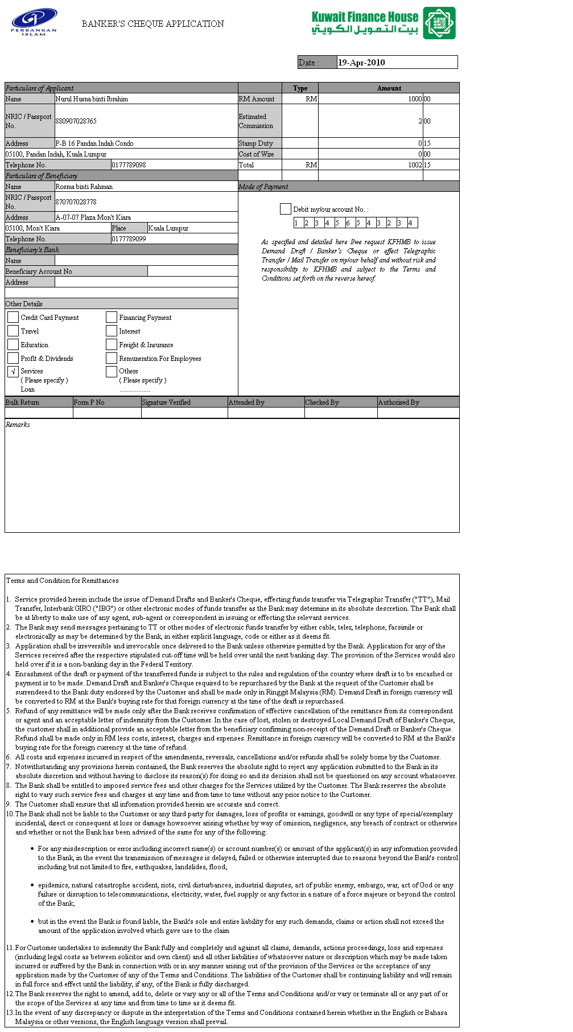
Figure 7 Banker’s Cheque Application Printing Format

Demand Draft Application
Demand Draft shall accept all supported currencies except Malaysian Ringgit (MYR). Upon submission, the current Forex rate shall be used to do estimation for the commission. If the submission falls on a weekend, then the Friday’s rate shall be used.

The commission charges shall be maintained at properties file.

Process Flow
Step 1:
- IB User accesses Demand Draft Application screen through Application Form listing page, see Figure 1.
- CIB System shall prompt for Demand Draft Application Terms and Conditions screen, see Figure 8.
- IB User shall read and accepts the Demand Draft Application Terms and Conditions clicking on the Agree button; otherwise click on the Cancel button to go back to the previous page.

Step 2:
- After IB User accepts the terms and conditions, CIB System shall display Demand Draft Application Input Screen with pre-fill user profile, see Figure 9 and Figure 10.
- After IB User fills in all the details, IB User shall click on the Next button to go to the confirmation screen.

Step 3:
- CIB System shall display the confirmation screen, see Figure 11.
- IB User shall confirm the application submission by clicking on the Confirm button.
- CIB System saves the Demand Draft Application into the system and emails the application form to designated bank staff.
- The Result Screen shall be displayed after successful processing, see Figure 12.
- IB User can print submitted application form by clicking on the Print button, please see Figure 13 for the printing format.

Screen Designs

Step 1:
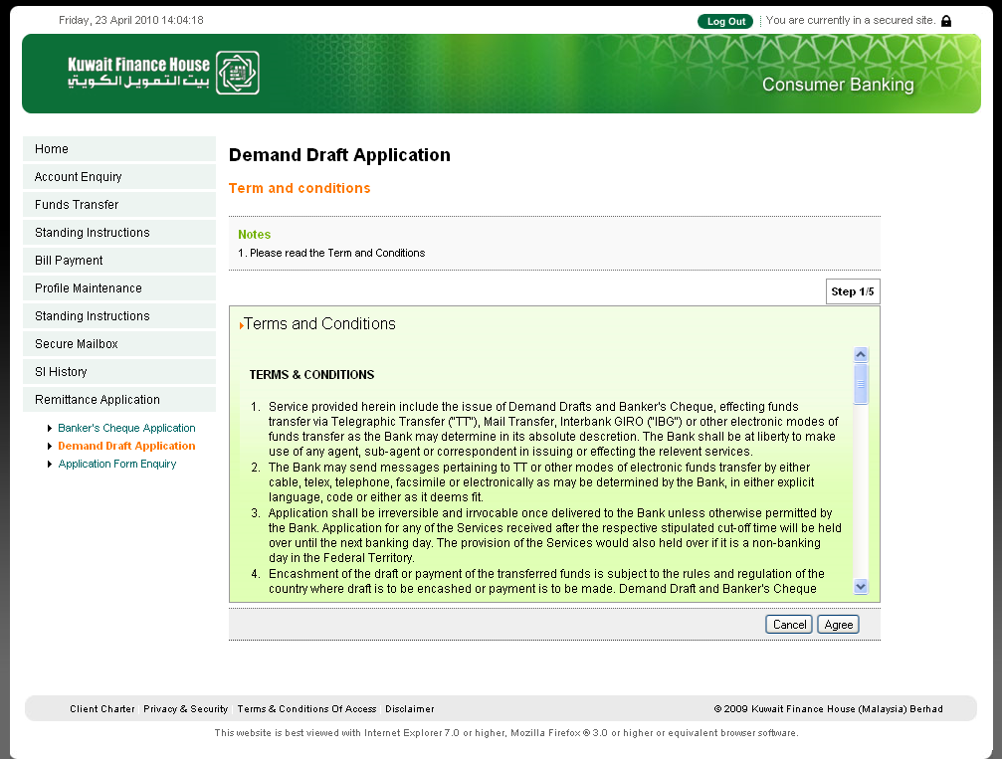
Figure 8 Demand Draft Application Terms and Conditions Screen
- IB User accesses to Demand Draft Application Screen, see Figure 1.
- CIB System displays Demand Draft Application Terms and Conditions Screen.
- IB User reads and accepts Demand Draft Application Terms and Conditions.
Step 2:
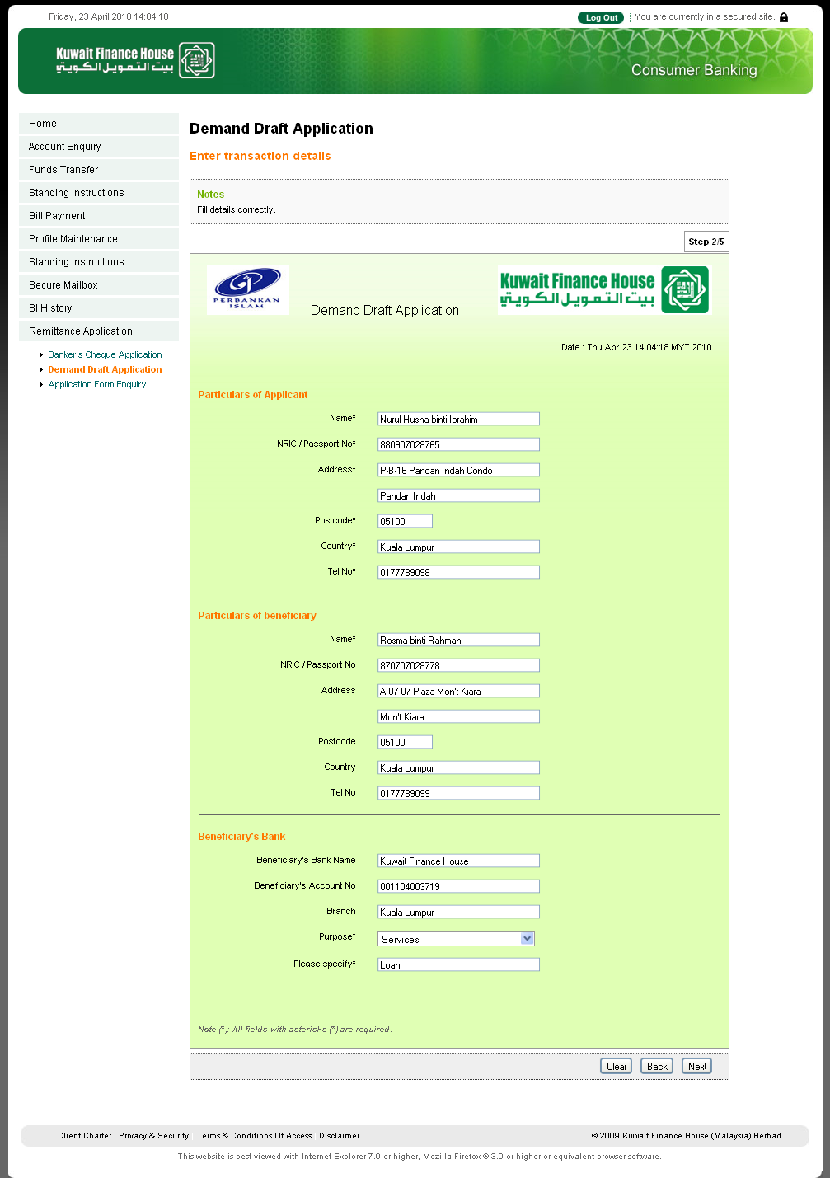
Figure 9 Demand Draft Application Input Screen 1
- CIB System displays Banker’s Application Input Screen with pre-filled applicant profiles as much information can be obtained from the system. All fields are editable. IB User is allowed to make any changes.
- IB User inputs required to input beneficiary name and purpose of transaction.
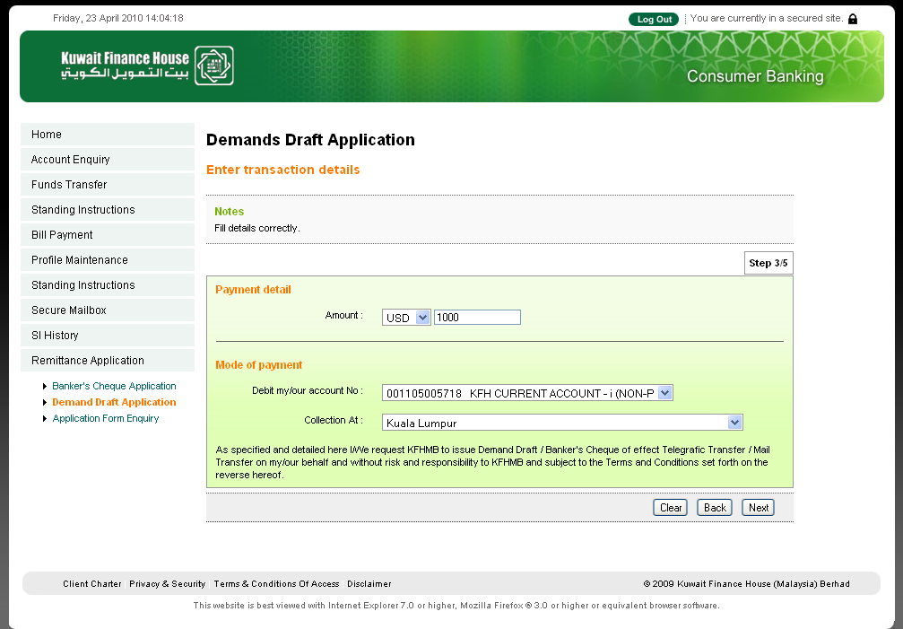

Figure 10 Demand Draft Application Input Screen 2

- IB User inputs Demand Draft Application details.
- Branch name and branch email address are set in BVMC (IB Branch Info)
- Commission and Stamp Duty values shall be store in the IBBusinessOptionResources.properties file.
- Rules:
  - If Amount is <= RM5000, Commission=RM12, Stamp Duty=RM0
  - If Amount is > RM5000, Commission=RM10, Stamp Duty=RM0
  - If Amount is in other currency, estimated similar RM value shall be calculated and estimate the Commission and Stamp Duty based on the same day currency rate using the above rules.
Step 3:
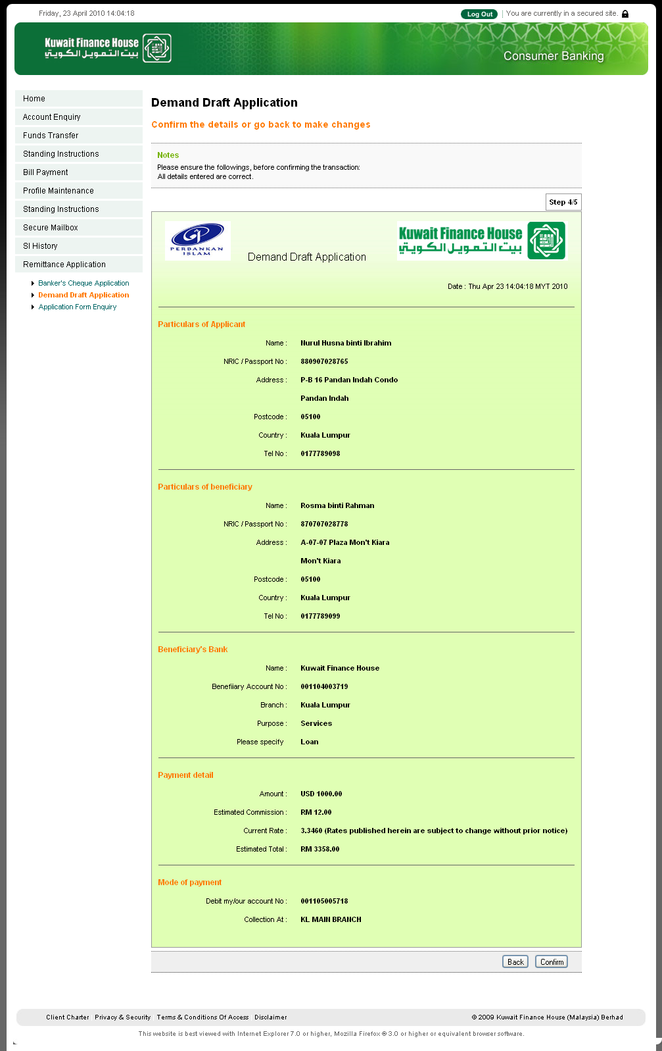
Figure 11 Demand Draft Application Confirmation Screen
- CIB System displays Demand Draft Application Confirmation Screen.
- IB User confirms Demand Draft Application.
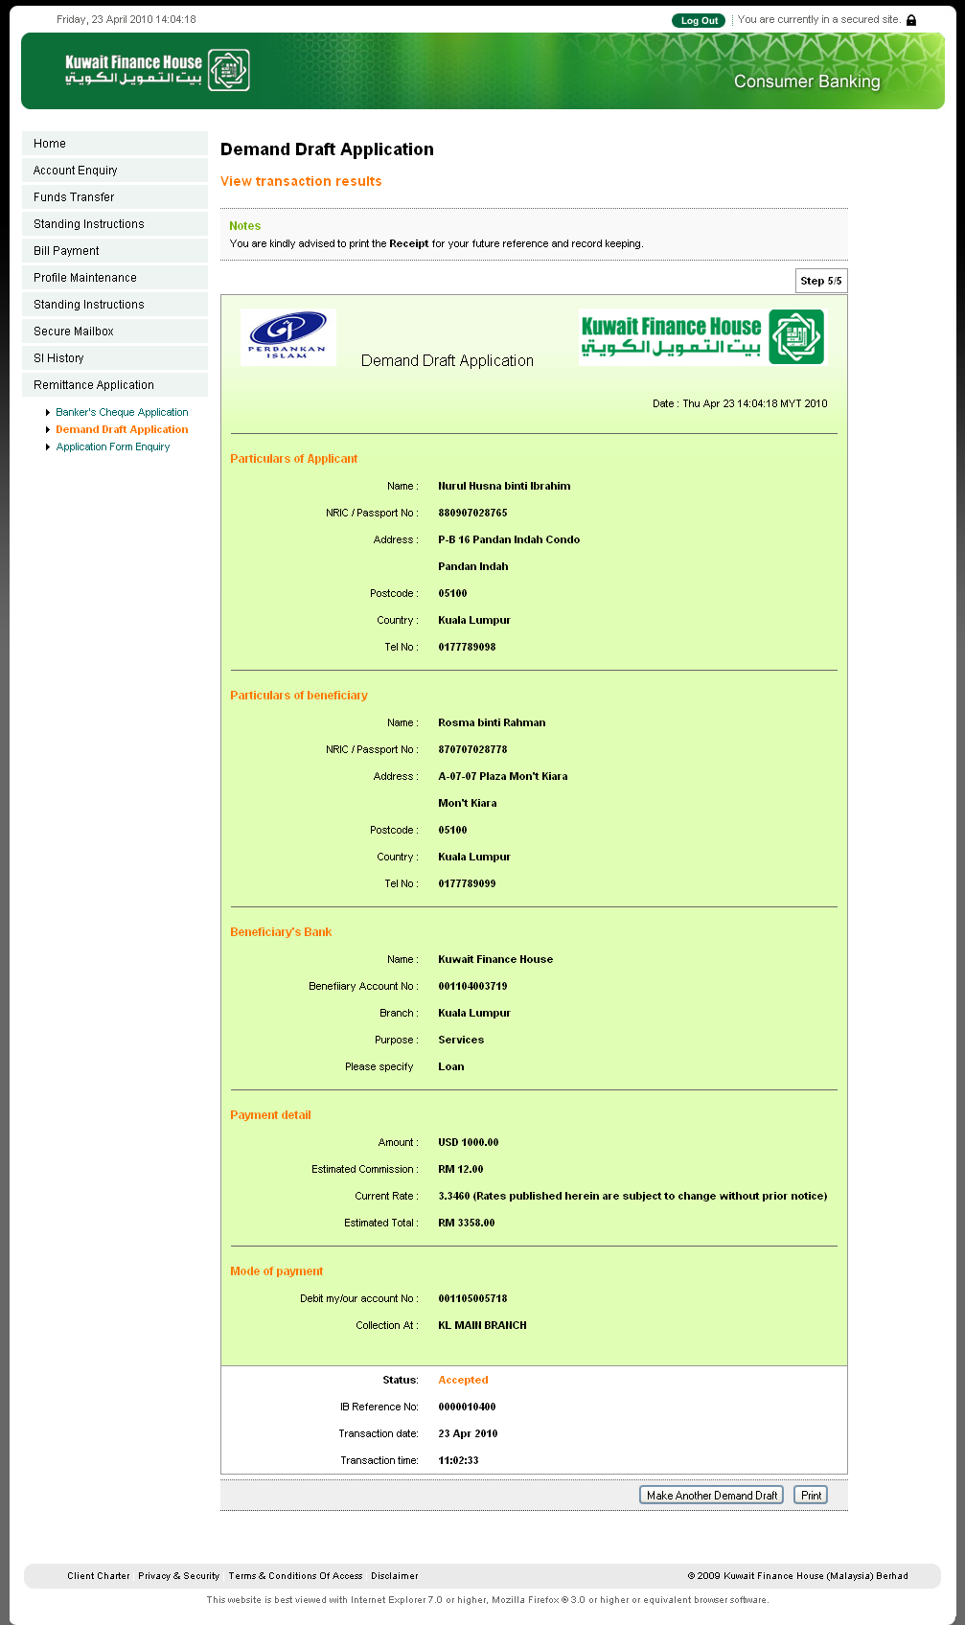
Figure 12 Demand Draft Application Result Screen
- CIB System saves the Demand Draft Application into the system and shows the Result Screen.
- IB User views Demand Draft Application Result Screen.
- IB User can print the submitted Demand Draft Application Form by clicking on the Print button. The printing format is as Figure 13.
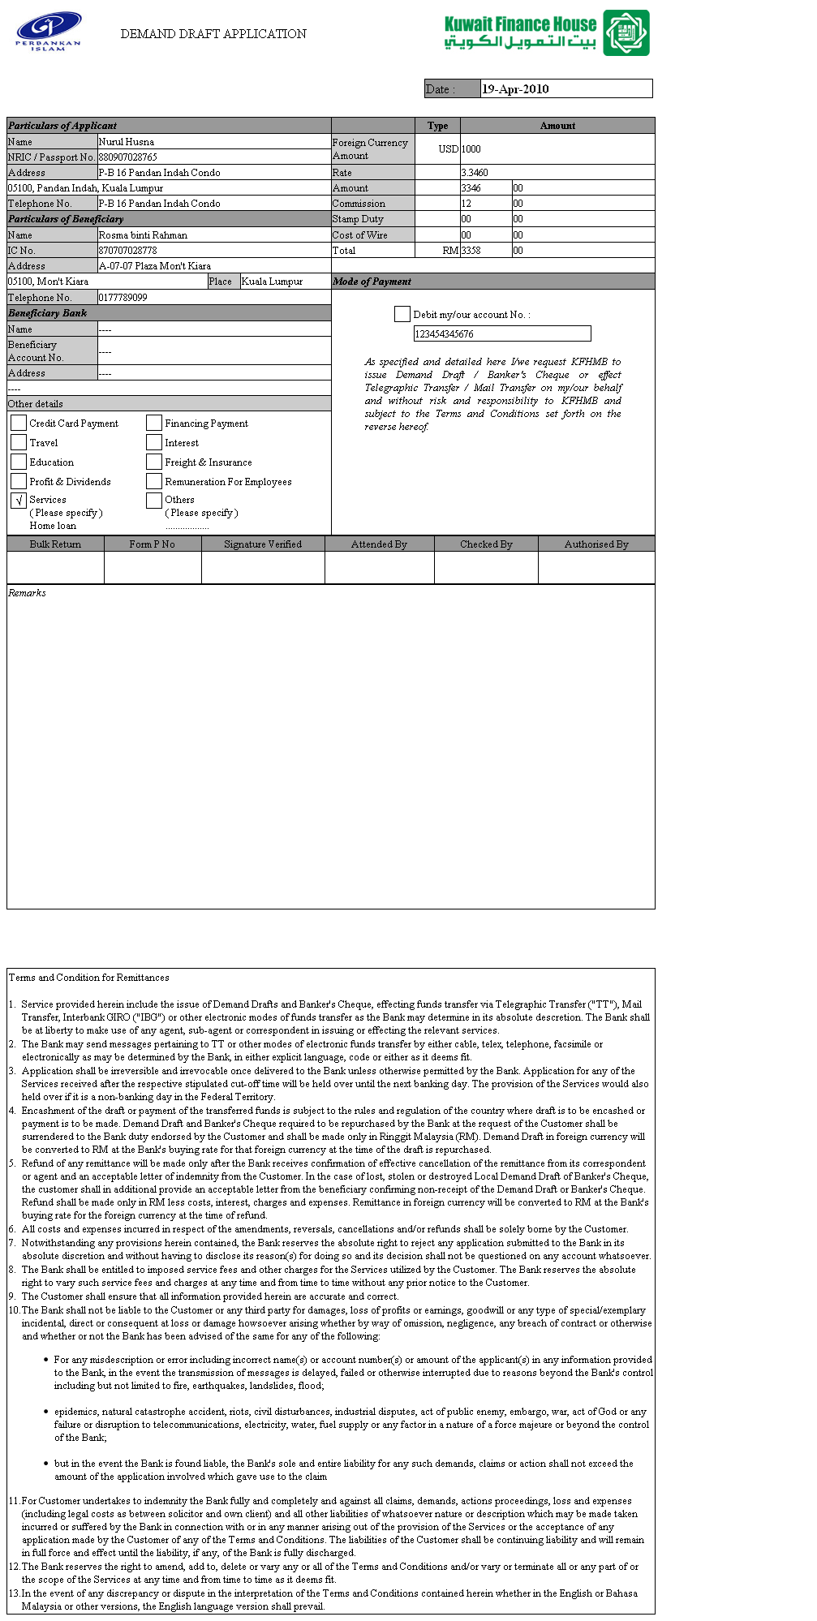
Figure 13 Demand Draft Application Print Format

Application Form Enquiry

Process Flow
Step 1:
- IB User accesses to Application Form Enquiry Screen through the Application Form listing page, see Figure 1.
- CIB System displays Application Form Enquiry Screen, see Figure 14.
Step 2:
- IB User can click on Reprint button to print the form.
- CIB System shall display the selected application form before printing, see Figure 7 and Figure 13 for the sample printing format of both Banker’s Cheque and Demand Draft application form respectively.

Screen Designs

Step 1:
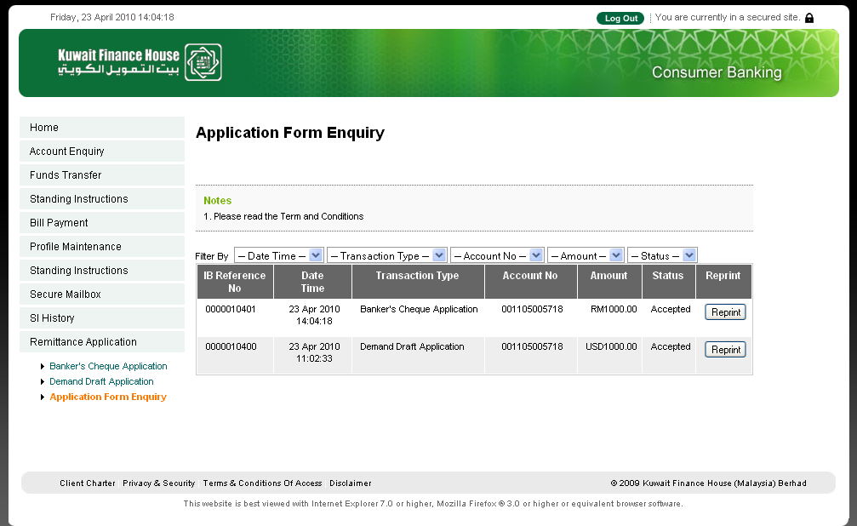
Figure 14 Application Form Enquiry Screen
- IB User accesses to Application Form Enquiry Screen.
- CIB System displays Application Form Enquiry Screen.

Banker’s Cheque and Demand Draft Application Digital File

All the digital applications are tagged to the applicant home branch. The content of the digital file is emailed to the collection branch.
Sample digital application format for Banker’s Cheque:-
Bankers Cheque Application Date : Fri Apr 23 14:14:18 MYT 2010

Particulars of Application

Rim No : 968
Name : Nurul Husna binti Ibrahim
I/C No : 880907028765
Address : P-B 16 Pandan Indah Condo
: Pandan Indah
Postcode : 05100
Country : Kuala Lumpur
Tel No : 0177789098

Particulars of Beneficiary

Name : Rosma binti Rahman
I/C No : 870707028778
Address : A-07-07 Plaza Mon't Kiara
: Mon't Kiara
Postcode : 05100
Country : Kuala Lumpur
Tel No : 0177789099

Beneficiary Bank
Name : Kuwait Finance House
Beneficiary Account No : 001104003719
Branch : Kuala Lumpur
Purpose : Service
Please specify : Loan

Payment Details

Amount : MYR 1000
Estimated Commission : MYR 2.00
Stamp Duty : MYR 0.15
Total : To be debited by branch

Mode of Payment

Debit Account No : 001105005718
Collection At : KL MAIN BRANCH

Sample digital format for Demand Draft:-
Demand Draft Application Date : Fri Apr 23 14:14:18 MYT 2010

Particulars of Application

Rim No : 968
Name : Nurul Husna binti Ibrahim
I/C No : 880907028765
Address : P-B 16 Pandan Indah Condo
: Pandan Indah
Postcode : 05100
Country : Kuala Lumpur
Tel No : 0177789098

Particulars of Beneficiary

Name : Rosma binti Rahman
I/C No : 870707028778
Address : A-07-07 Plaza Mon't Kiara
: Mon't Kiara
Postcode : 05100
Country : Kuala Lumpur
Tel No : 0177789099

Beneficiary Bank
Name : Kuwait Finance House
Beneficiary Account No : 001104003719
Branch : Kuala Lumpur
Purpose : Service
Please specify : Loan

Payment Details

Amount : USD 1000
Estimated Commission : MYR 12
Total : To be debited by branch

Mode of Payment

Debit Account No : 001105005718
Collection At : KL MAIN BRANCH

Sample of Email content of Digital Form:-

Subject: | Banker's Cheque Application thru KFH Online or Demand Draft Application thru KFH Online
Content: | Below Banker's Cheque Application thru KFH Online or Demand Draft Application thru KFH Online for your Branch's further action.  Bankers Cheque Application Date : Fri Apr 23 14:14:18 MYT 2010  Particulars of Application  Rim No : 968  Name : Nurul Husna binti Ibrahim  I/C No : 880907028765  Address : P-B 16 Pandan Indah Condo  : Pandan Indah  Postcode : 05100  Country : Kuala Lumpur  Tel No : 0177789098  Particulars of Beneficiary  Name : Rosma binti Rahman  I/C No : 870707028778  Address : A-07-07 Plaza Mon't Kiara  : Mon't Kiara  Postcode : 05100  Country : Kuala Lumpur  Tel No : 0177789099  Beneficiary Bank  Name : Kuwait Finance House  Beneficiary Account No : 001104003719  Branch : Kuala Lumpur  Purpose : Service  Please specify : Loan  Payment Details  Amount : MYR 1000  Estimated Commission : MYR 2.00  Stamp Duty : MYR 0.15  Total : To be debited by branch  Mode of Payment  Debit Account No : 001105005718  Collection At : KL MAIN BRANCH  Please proceed to process the above application and DEBIT customer's account (including commission/stamp duty).  Kindly note that branch will process application at below time:-  Time Process by branch  a) sent by 12 noon same working day.  b) sent after 12 noon next working day
Signature: | *Please do not reply this email.  Disclaimer: This is a computer generated email. No signature is required.  This message is brought to you by KUWAIT FINANCE HOUSE (MALAYSIA) BERHAD.

Digital File Download
All the digital files can be downloaded through BVMC.
Report Type: New Banker’s Cheque Application
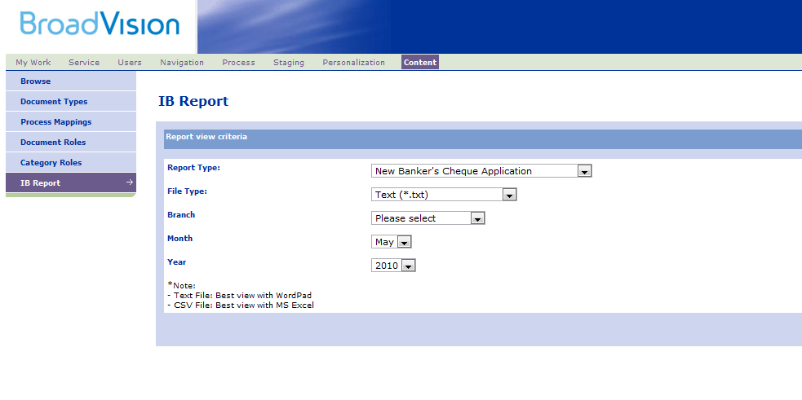
Figure 15 Sample Banker’s Check Application file download

Report Type: New Demand Draft Application
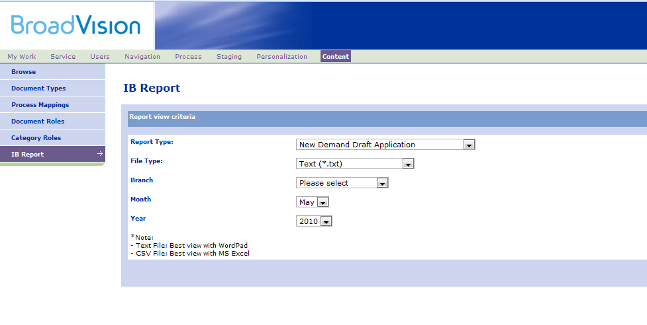
Figure 16 Sample Demand Draft Application file download

Reports
Two types of report format will be given; comma delimited (csv) and fixed length (txt).

Report frequency:-
- Daily

New reports to be generated:-
- BankerChequeApplicationReport_DAILY_{date}.txt
- BankerChequeApplicationReport_DAILY_{date}.csv
- BankerChequeApplicationReport_DAILY_{date}_{branch}.txt
- BankerChequeApplicationReport_DAILY_{date}_{branch}.csv
- DemandDraftApplicationReport_DAILY_{date}.txt
- DemandDraftApplicationReport_DAILY_{date}.csv
- DemandDraftApplicationReport_DAILY_{date}_{branch}.txt
- DemandDraftApplicationReport_DAILY_{date}_{branch}.csv

Updating existing reports:-
- ConsolidatedCustomerRequestAtBranchReport_DAILY_{date}.txt(csv)
  - Add new line for number of Banker’s Cheque applications
  - Add new line for number of Demand Draft applications
- ConsolidatedCustomerRequestAtBranchReport_MONTHLY_{date}.txt(csv)
  - Add new line for number of Banker’s Cheque applications
  - Add new line for number of Demand Draft applications
- InternetTransactionReport_DAILY_{date}.txt(csv)
  - Add new line for number of Banker’s Cheque applications
  - Add new line for number of Demand Draft applications

Sample report format for fixed length and comma delimited:-

Sample report format for: -
BankerChequeApplicationReport_DAILY_{date}.txt, BankerChequeApplicationReport_DAILY_{date}.csv, DemandDraftApplicationReport_DAILY_{date}.txt and DemandDraftApplicationReport_DAILY_{date}.csv

header
Branch Name: SHAH ALAM BRANCH
title
body
trailer

Branch Name: KLANG BRANCH
title
body
trailer

Branch Name: KUCHING BRANCH
title
body
trailer

Branch Name: JOHOR BAHRU BRANCH
title
body
trailer
…
…
….

Report Fields

Particulars of Application (Title)

Body
No | Field
 | Transaction ID
 | RIM Number
 | Customer Name
 | Customer I/C No
 | Customer Address
 | Customer Postcode
 | Customer Country
 | Customer Tel No
 | Beneficiary Name
 | Beneficiary I/C No
 | Beneficiary Address
 | Beneficiary Postcode
 | Beneficiary Country
 | Beneficiary Tel No
 | Beneficiary Bank Name
 | Beneficiary Account No
 | Beneficiary Bank Branch
 | Purpose
 | Please specify
 | Amount
 | Estimated Commission
 | Total
 | Debit Account No
 | Delivery

Trailer
No | Field
 | Total Record
 | Total Successful Record
 | Total Unsuccessful Record
 | Grand Total Record
 | Grand Total Successful Record
 | Grand Total Unsuccessful Record

Sample report format for: -
BankerChequeApplicationReport_DAILY_{date}_{branch}.txt , BankerChequeApplicationReport_DAILY_{date}_{branch}.csv , DemandDraftApplicationReport_DAILY_{date}_{branch}.txt and DemandDraftApplicationReport_DAILY_{date}_{branch}.csv

Header

title
body
…
…
…

trailer

Report Fields

Body
No | Field
 | Transaction ID
 | RIM Number
 | Customer Name
 | Customer I/C No
 | Customer Address
 | Customer Postcode
 | Customer Country
 | Customer Tel No
 | Beneficiary Name
 | Beneficiary I/C No
 | Beneficiary Address
 | Beneficiary Postcode
 | Beneficiary Country
 | Beneficiary Tel No
 | Beneficiary Bank Name
 | Beneficiary Account No
 | Beneficiary Bank Branch
 | Purpose
 | Please specify
 | Amount
 | Estimated Commission

Trailer
No | Field
 | Total Record
 | Total Successful Record
 | Total Failed Record

Reports Retrieval
All reports can be retrieved from BVMC. Please see below for the example.

Report Type: Banker’s Chequet Application Report
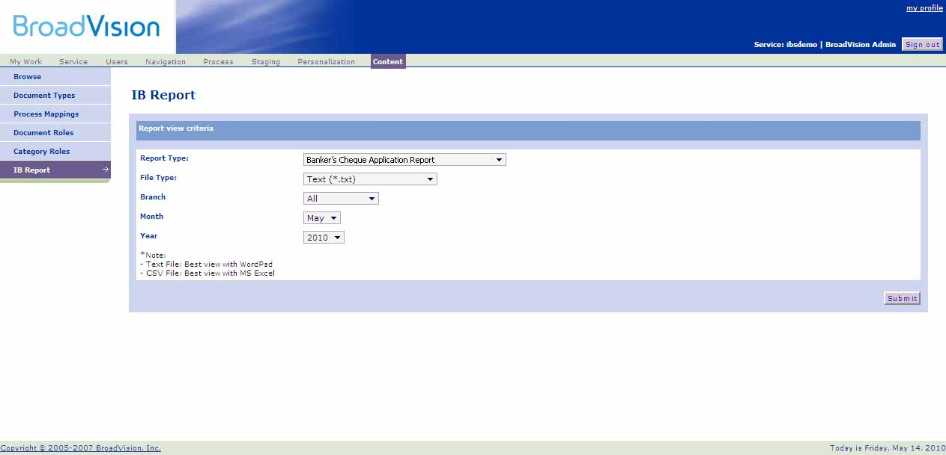
Figure 17 Sample Banker’s Cheque report download

Report Type: Demand Draft Application Report

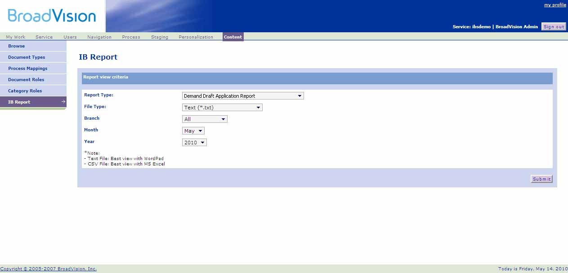
Figure 18 Sample Demand Draft report download

Appendix A - Terms & Conditions
1.
Service provided herein include the issue of Demand Drafts and Banker's Cheque, effecting funds transfer via Telegraphic Transfer (“TT”), Mail Transfer, Interbank GIRO ("IBG") or other electronic modes of funds transfer as the Bank may determine in its absolute descretion. The Bank shall be at liberty to make use of any agent, sub-agent or correspondent in issuing or effecting the relevant services.

2.
The Bank may send messages pertaining to TT or other modes of electronic funds transfer by either cable, telex, telephone, facsimile or electronically as may be determined by the Bank, in either explicit language, code or either as it deems fit.

3.
Application shall be irreversible and irrevocable once delivered to the Bank unless otherwise permitted by the Bank. Application for any of the Services received after the respective stipulated cut-off time will be held over until the next banking day. The provision of the Services would also held over if it is a non-banking day in the Federal Territory.

4.
Encashment of the draft or payment of the transferred funds is subject to the rules and regulation of the country where draft is to be encashed or payment is to be made. Demand Draft and Banker's Cheque required to be repurchased by the Bank at the request of the Customer shall be surrendered to the Bank duty endorsed by the Customer and shall be made only in Ringgit Malaysia (RM). Demand Draft in foreign currency will be converted to RM at the Bank's buying rate for that foreign currency at the time of the draft is repurchased.

5.
Refund of any remittance will be made only after the Bank receives confirmation of effective cancellation of the remittance from its correspondent or agent and an acceptable letter of indemnity from the Customer. In the case of lost, stolen or destroyed Local Demand Draft of Banker's Cheque, the customer shall in additional provide an acceptable letter from the beneficiary confirming non-receipt of the Demand Draft or Banker's Cheque. Refund shall be made only in RM less costs, interest, charges and expenses. Remittance in foreign currency will be converted to RM at the Bank's buying rate for the foreign currency at the time of refund.

6.
All costs and expenses incurred in respect of the amendments, reversals, cancellations and/or refunds shall be solely borne by the Customer.

7.
Notwithstanding any provisions herein contained, the Bank reserves the absolute right to reject any application submitted to the Bank in its absolute discretion and without having to disclose its reason(s) for doing so and its decision shall not be questioned on any account whatsoever.

8.
The Bank shall be entitled to imposed service fees and other charges for the Services utilized by the Customer. The Bank reserves the absolute right to vary such service fees and charges at any time and from time to time without any prior notice to the Customer.

9.
The Customer shall ensure that all information provided herein are accurate and correct.

10.
The Bank shall not be liable to the Customer or any third party for damages, loss of profits or earnings, goodwill or any type of special/exemplary incidental, direct or consequent at loss or damage howsoever arising whether by way of omission, negligence, any breach of contract or otherwise and whether or not the Bank has been advised of the same for any of the following:
- For any misdescription or error including incorrect name(s) or account number(s) or amount of the applicant(s) in any information provided to the Bank, in the event the transmission of messages is delayed, failed or otherwise interrupted due to reasons beyond the Bank's control including but not limited to fire, earthquakes, landslides, flood;

- epidemics, natural catastrophe accident, riots, civil disturbances, industrial disputes, act of public enemy, embargo, war, act of God or any failure or disruption to telecommunications, electricity, water, fuel supply or any factor in a nature of a force majeure or beyond the control of the Bank;

- but in the event the Bank is found liable, the Bank's sole and entire liability for any such demands, claims or action shall not exceed the amount of the application involved which gave use to the claim

11.
For Customer undertakes to indemnity the Bank fully and completely and against all claims, demands, actions proceedings, loss and expenses (including legal costs as between solicitor and own client) and all other liabilities of whatsoever nature or description which may be made taken incurred or suffered by the Bank in connection with or in any manner arising out of the provision of the Services or the acceptance of any application made by the Customer of any of the Terms and Conditions. The liabilities of the Customer shall be continuing liability and will remain in full force and effect until the liability, if any, of the Bank is fully discharged.

12.
The Bank reserves the right to amend, add to, delete or vary any or all of the Terms and Conditions and/or vary or terminate all or any part of or the scope of the Services at any time and from time to time as it deems fit.

13.
In the event of any discrepancy or dispute in the interpretation of the Terms and Conditions contained herein whether in the English or Bahasa Malaysia or other versions, the English language version shall prevail.

