Issue Form (PROD)
Originator's Name: Chooi So Fun  Project: Internet Banking  Project Manager: Malarvili / Chris Gunn  Module : Internet Banking  Date Raised: 25.05.2011  Phase : Phase 2 – Internet Banking  Functional Area : BVMC | Issue ID Number: C11-022  Related Issue ID Number: HD00011038  Classification:  Priority: Critical/High/Medium/Low  Assigned to: Vendor / IT / PMO SA / UPA  Actual Closed Date:
Status: Open/Assigned/Investigated/Resolved/Approved/Deferred/No Action (Circle one)
Description :  BVMC Report –  All bill payment and prepaid transaction on 24.5.11 were having status “Unsuccessful” with reason as “Invalid Message Format”.  (please refer to attachment for further details) | Impact:
Findings/Root Caused (Description): | Resolution:
Estimated Impact :

Recommendation:

Accepted :  (Vendor / IT / PMO SA / UPA)  Date: | Accepted (KFHMB Tester):  Date:

Bill Payment Report dated 24.5.11
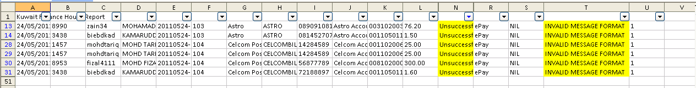

Mobile Reload Report dated 24.5.11
