To remove value date and add Host Tran ID.
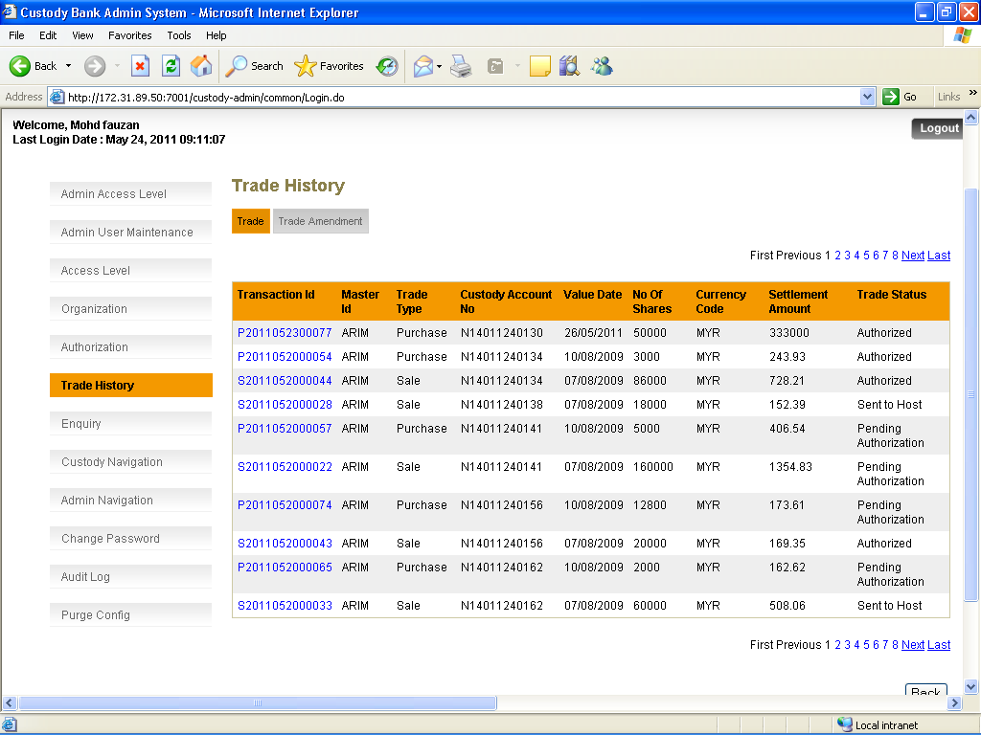
To add transaction ID
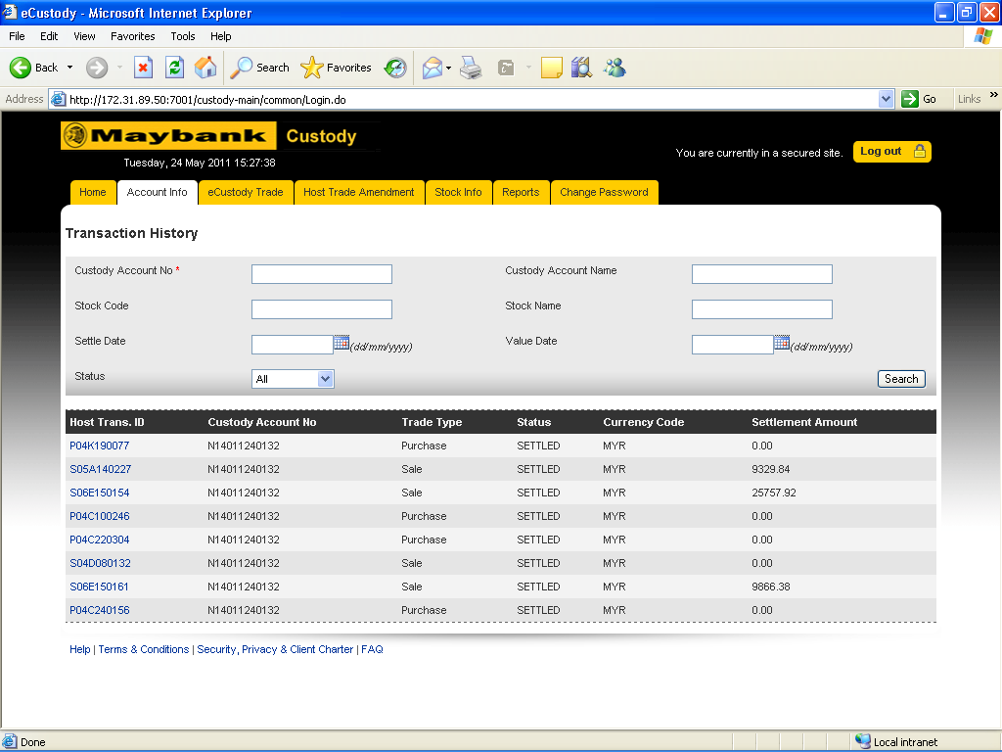

To add VERIFY button (approval for single trade)
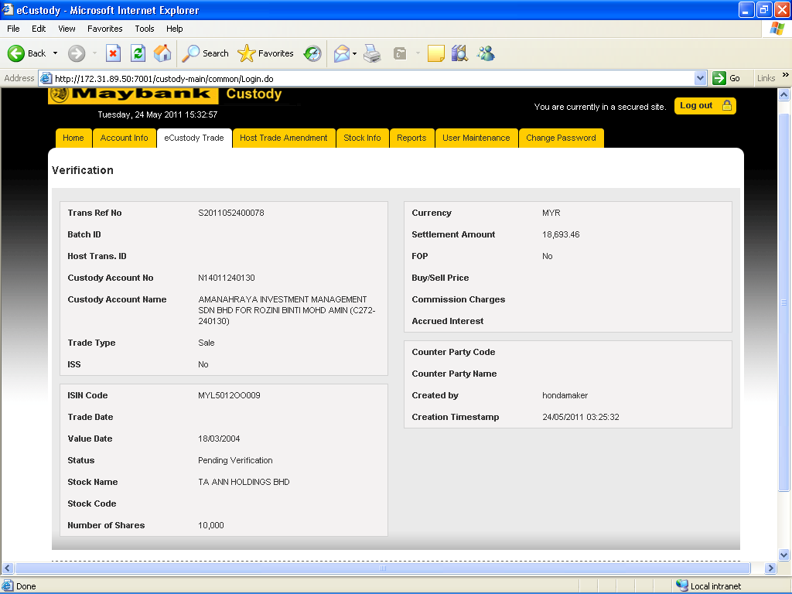

To add AUTHORISED button (together with OPT box)
