Issue Form (PROD)
Originator's Name: Chooi So Fun  Project: Internet Banking  Project Manager: Malarvili / Chris Gunn  Module : Internet Banking  Date Raised: 26.05.2011  Phase : Phase 2 – Internet Banking  Functional Area : BVMC | Issue ID Number: C11-023  Related Issue ID Number: HD00011059  Classification:  Priority: Critical/High/Medium/Low  Assigned to: Vendor / IT / PMO SA / UPA  Actual Closed Date:
Status: Open/Assigned/Investigated/Resolved/Approved/Deferred/No Action (Circle one)
Description :  Prompt "Error while performing your request" after click confirm button at step 2/3 of Bene iPAY Account maintenance. Details as per below:  Bene Bank: EON Bank  Account #: 0018200222076  However, customer managed to add Bene iPAY for Maybank.  Tested okay when add other EON Bank Account.  (please refer to attachment for further details) | Impact:
Findings/Root Caused (Description): | Resolution:
Estimated Impact :

Recommendation:

Accepted :  (Vendor / IT / PMO SA / UPA)  Date: | Accepted (KFHMB Tester):  Date:

Failure when adding bene iPAY for EON Bank:
EON Bank Account: 0018200222076
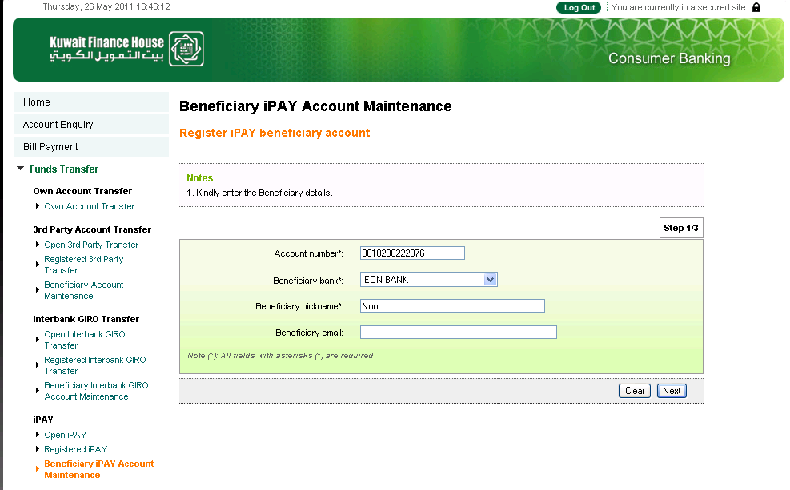
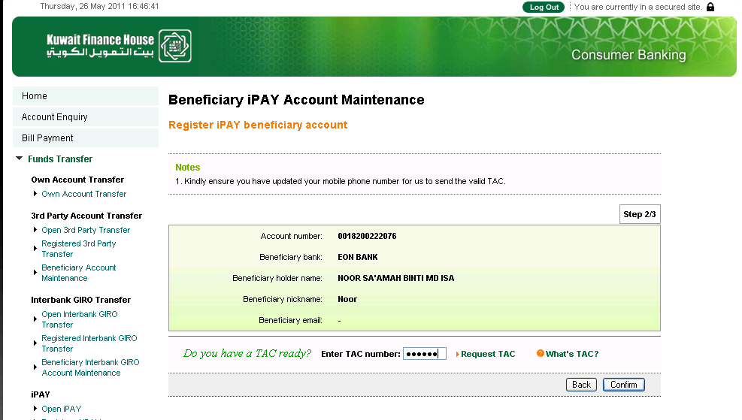
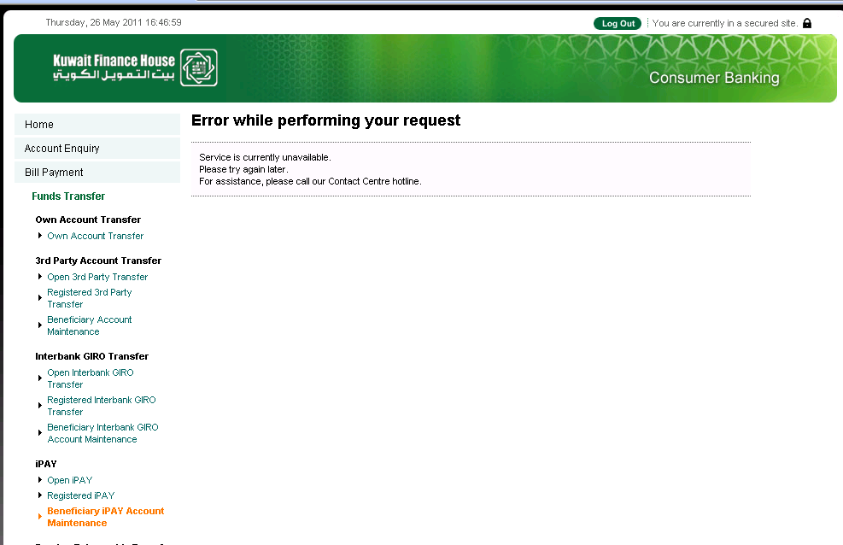

Successful when adding bene iPAY for EON Bank:
EON Bank Account: 0018200098792
