**Windows Server 2008 Installation and Configuration Print Screen**

* one windows update for IE9 installation is not installed afraid it will conflict with internal web server

**IBAPPDEVSVR1**

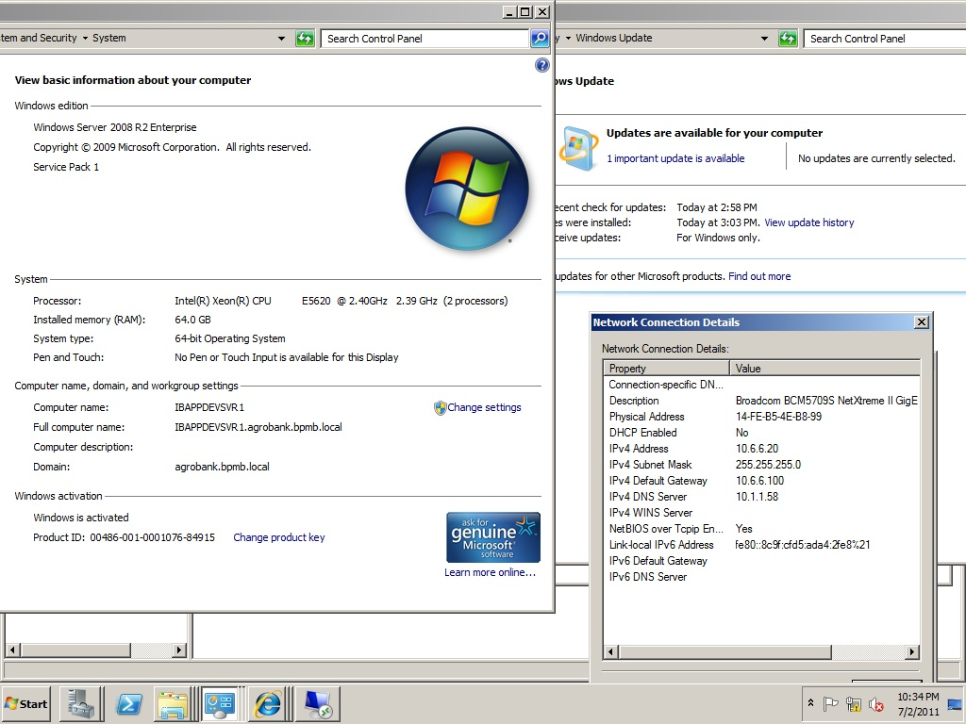

**IBAPPDEVSVR2**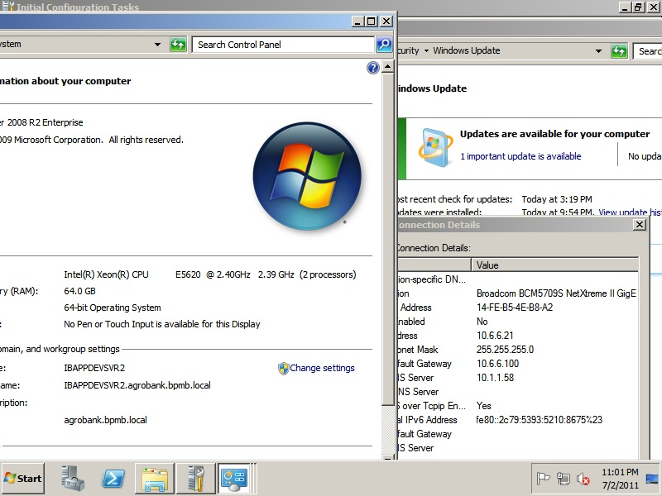

**IBSQLSVR1**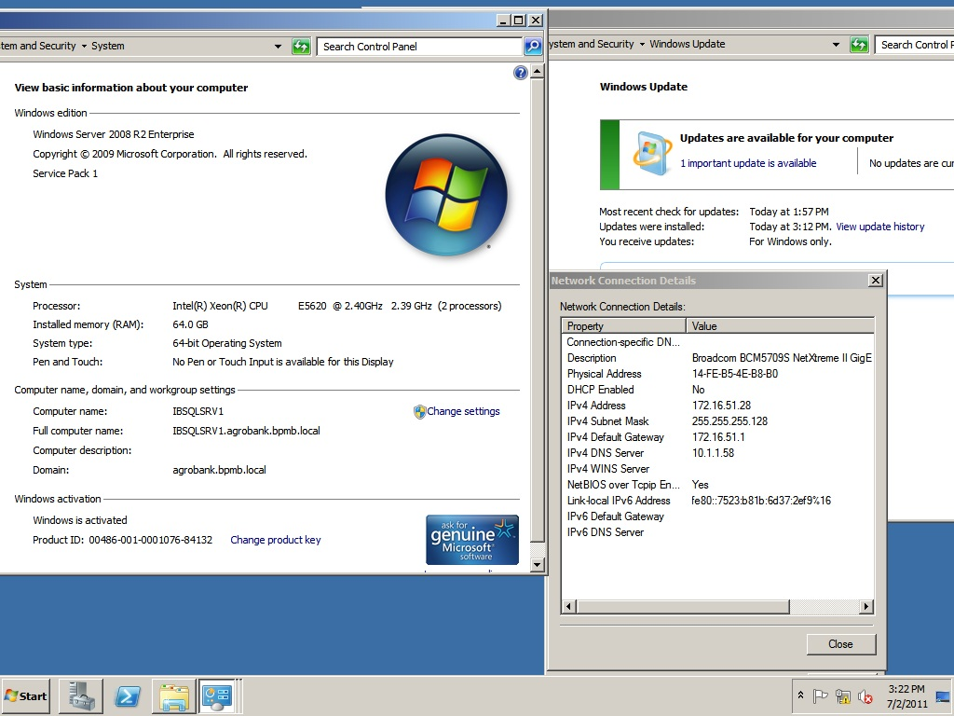

**IBSQLSVR2**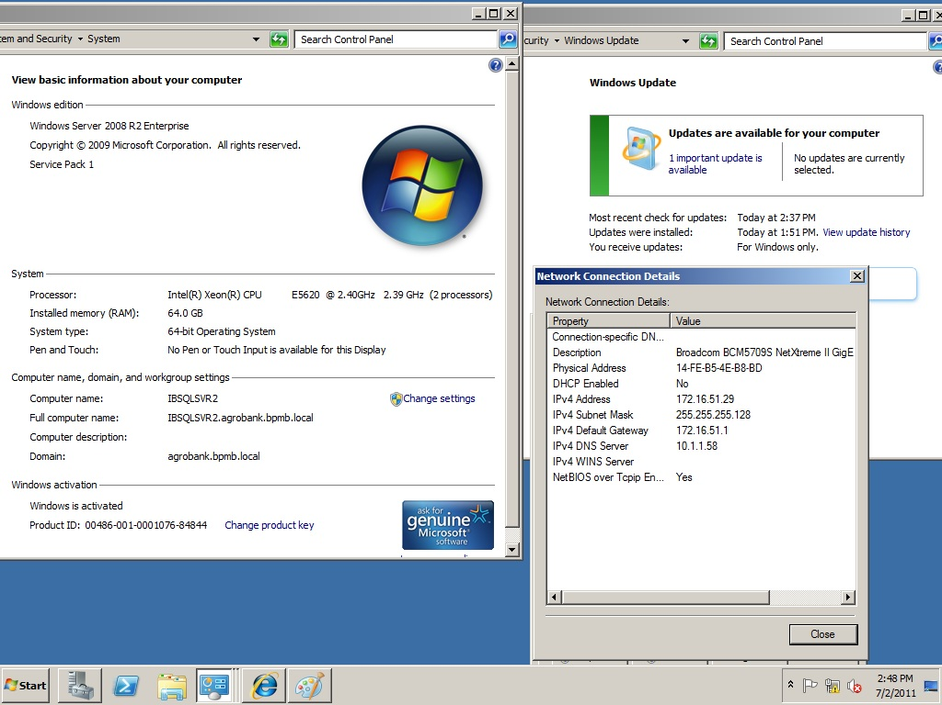

**IBWEBSVR1**

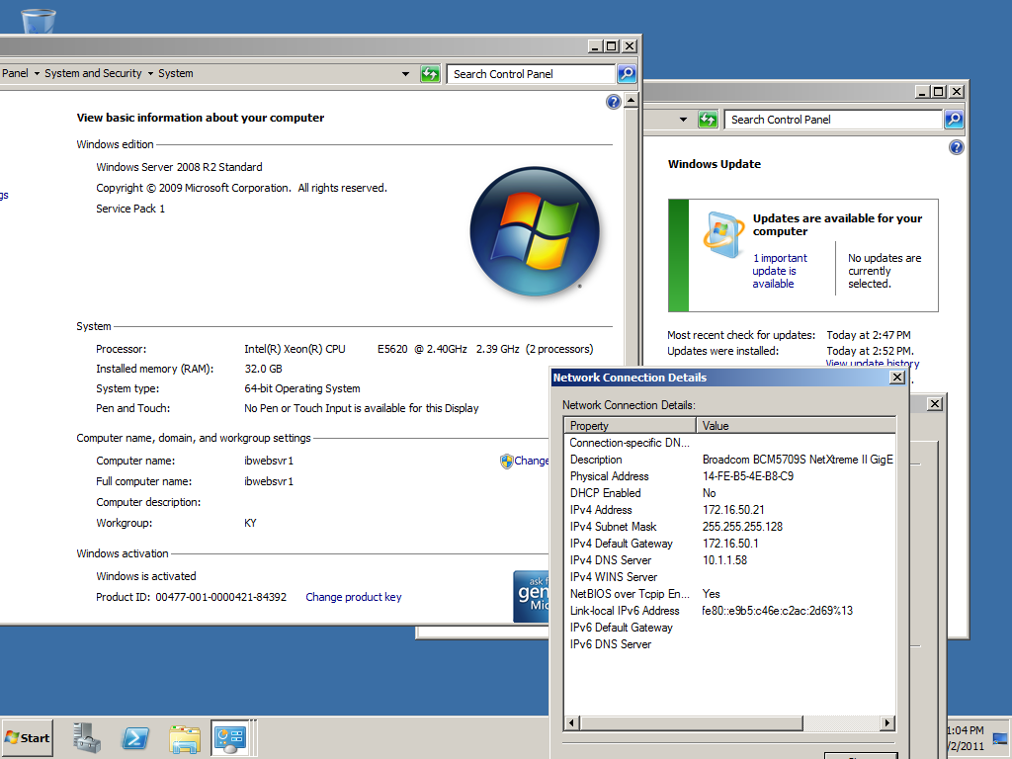

**IBWEBSVR2**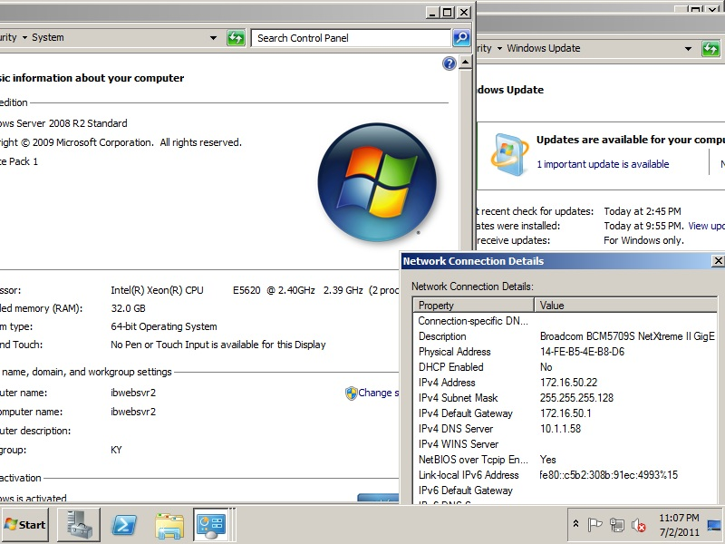

**IBCMSSVR1**

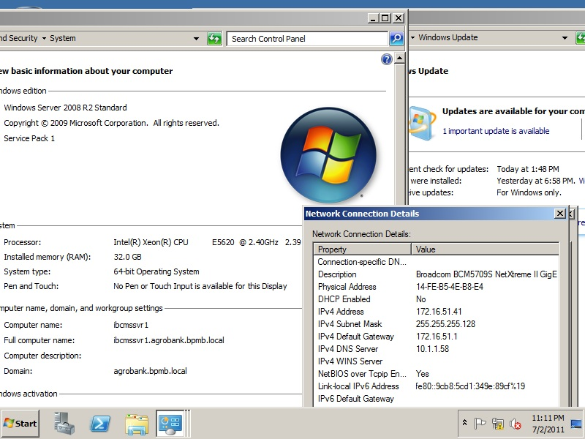

**IBCMSSVR2**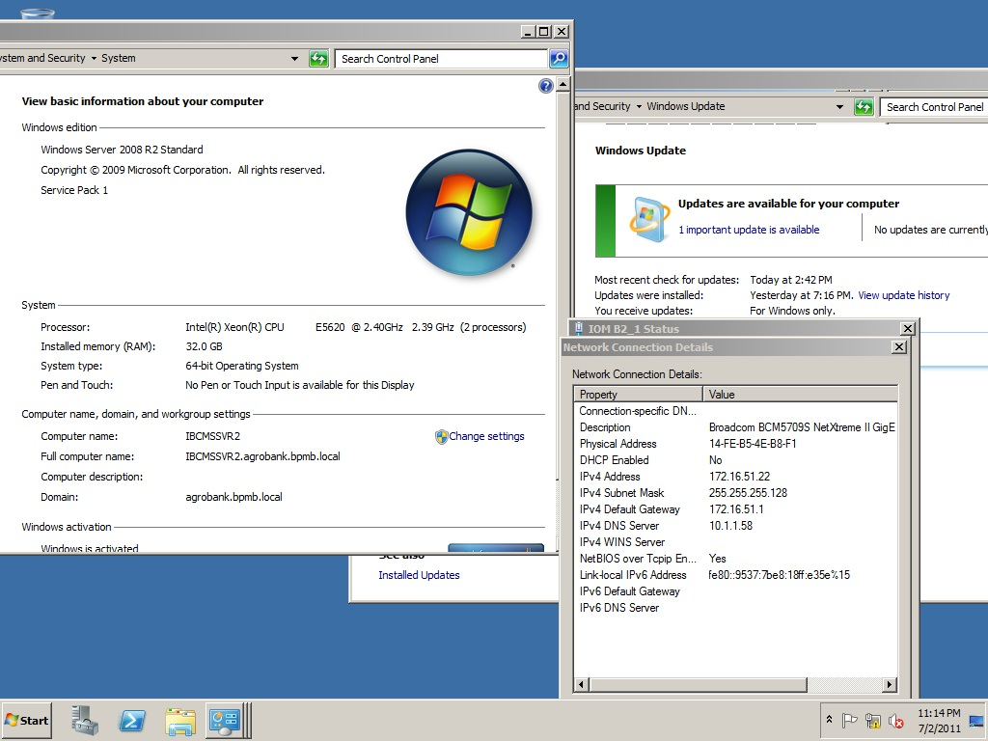\

**IBAPPSVR1**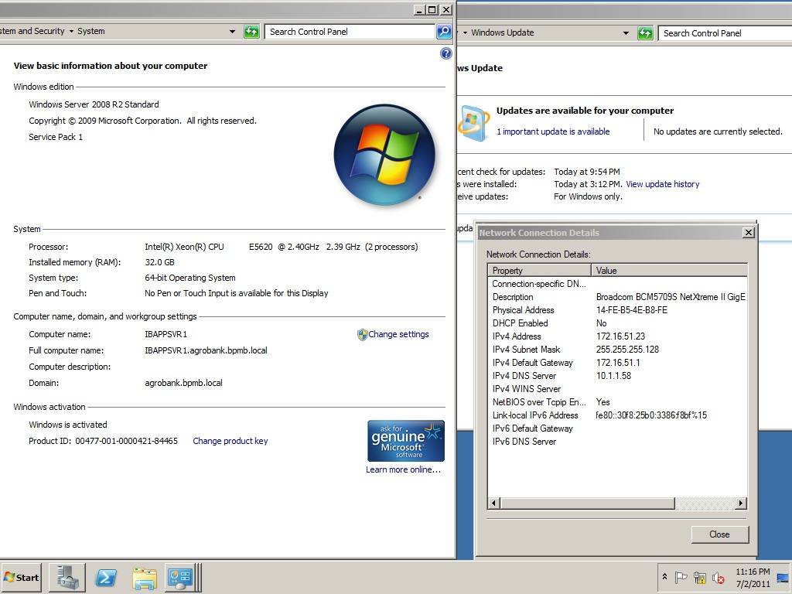

**IBAPPSVR2**

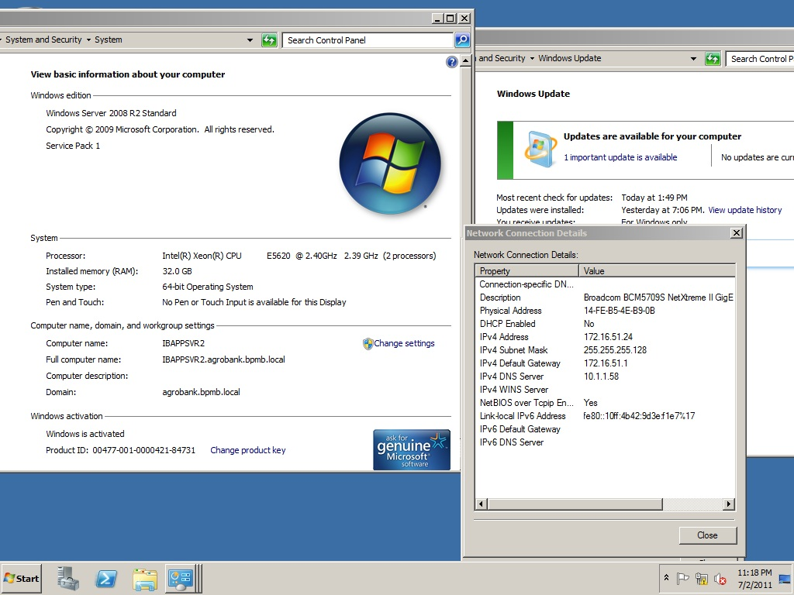

**IBAUTHSVR1**

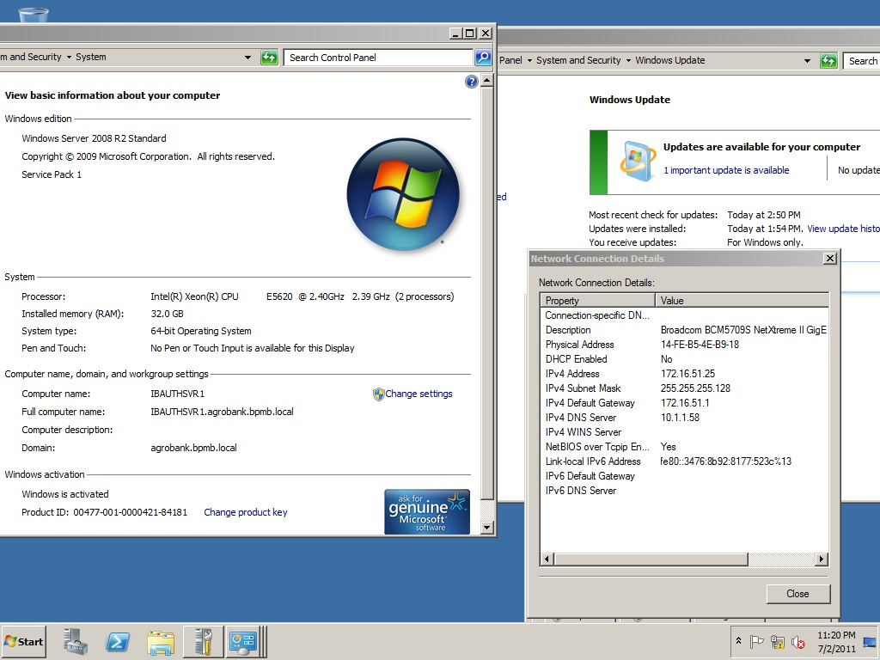

**IBAUTHSVR2**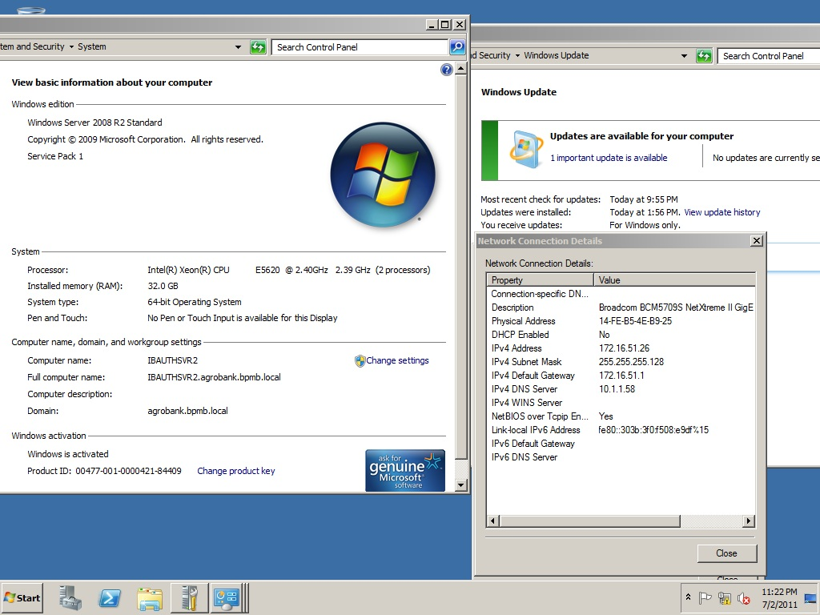

**IBFPTSVR1**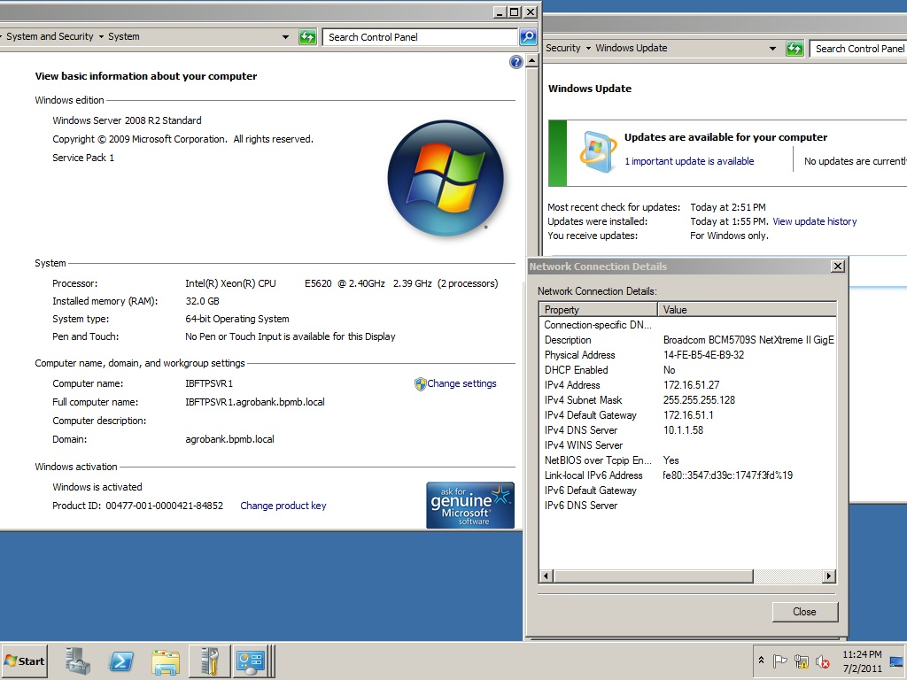

**IBOPMSVR1**

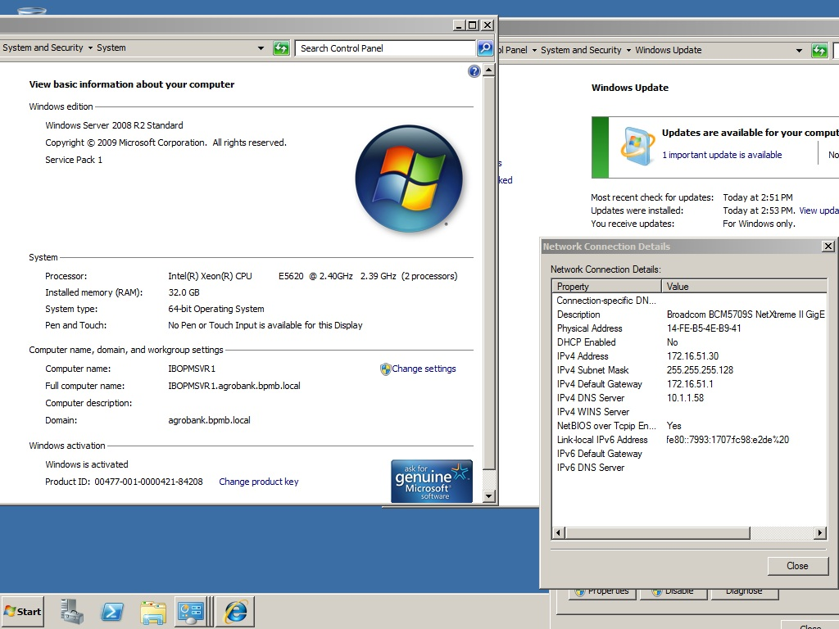

**After Hardening**

