**Issue: cannot delete group profile in IBAM production and development.**

|  |  |  |  |
| --- | --- | --- | --- |
| User group environment | Group Profile Name | Action | Result |
| User group Production | 1. CONTACT CENTRE VIEW 2. CCPR | Delete | Failed - Group is unable to delete because it still has active users |
| User group UAT | 1. TESTIAM | Delete | Failed - Group is unable to delete because it still has active users |

1. Checking if got user tied to TESTIAM GROUP and the result is No User(s) Found.

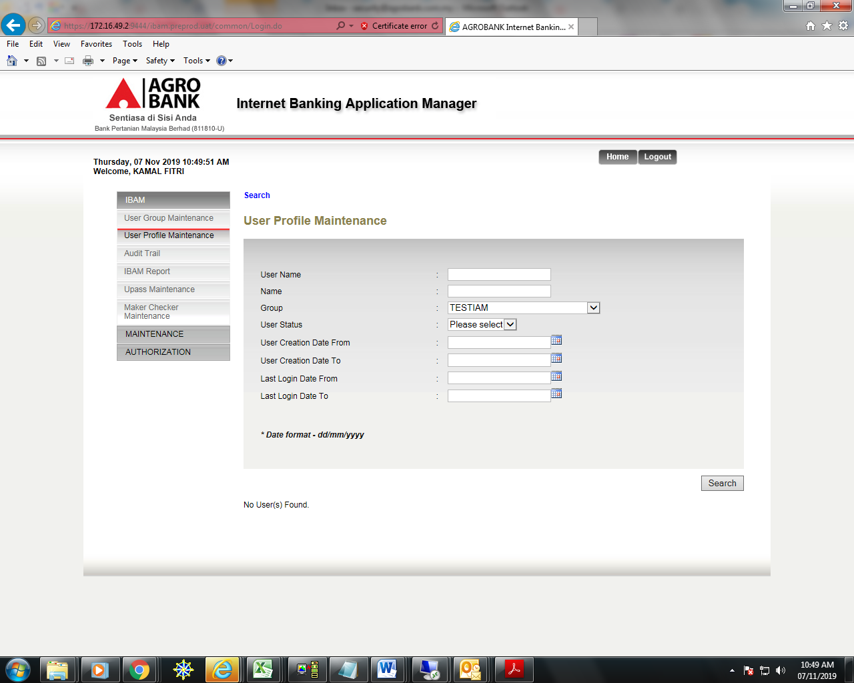

1. Go to User Group Maintenance > select group name ”TESTIAM” then click button Delete.

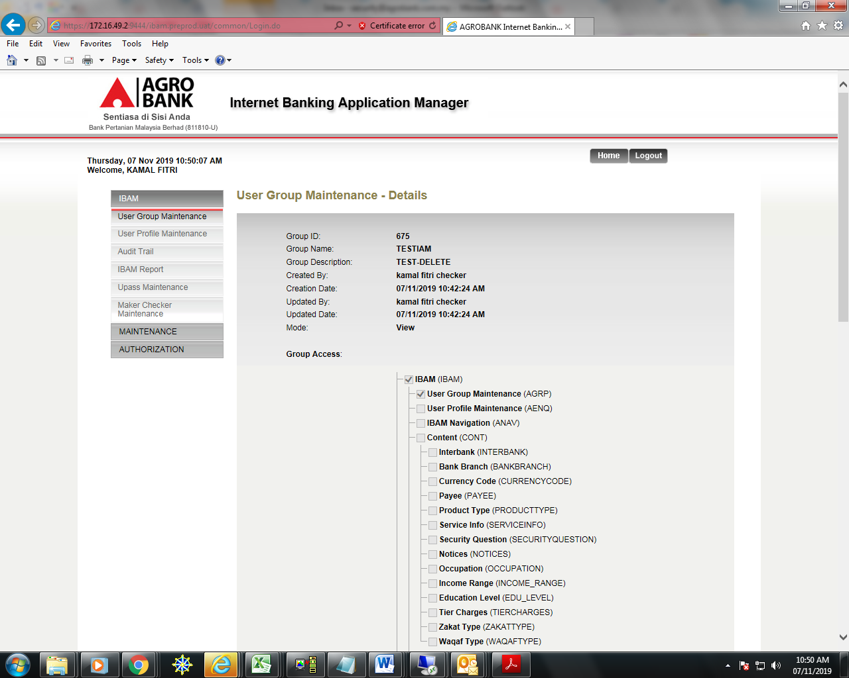

Deletion failed – got red message “Group is unable to delete because it still has active users”.

