1. Web Server – Set Static Page on Server error 500,404, 403. D:\IBM\HTTP\conf\httpd.conf

Copy 500.html, 404.html, 403.html to D:\IBM\HTTP\error\

Insert : ErrorDocument 505 /error/500.html, save and restart web server.

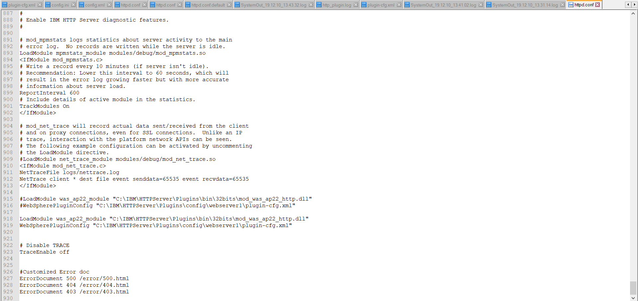

1. Web Server – Increase TimeOut from client 🡪D:\IBM\HTTP\conf\httpd.conf

Search for “Timeout” increase to 300, saved and restart web server.

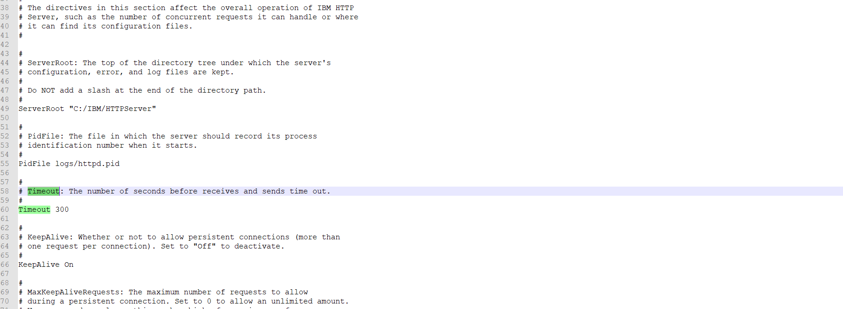

1. WebSphere – Increase Timeout From Web Server : Servers 🡪 WebSphere Application Servers 🡪 Server_name 🡪Container Services 🡪 Transaction service

Set “Total transaction lifetime timeout” to 120, save and restart server instances.

