Login to Websphere, Under Resources 🡪 Data sources 🡪 Select Data sources name that wanted to update.

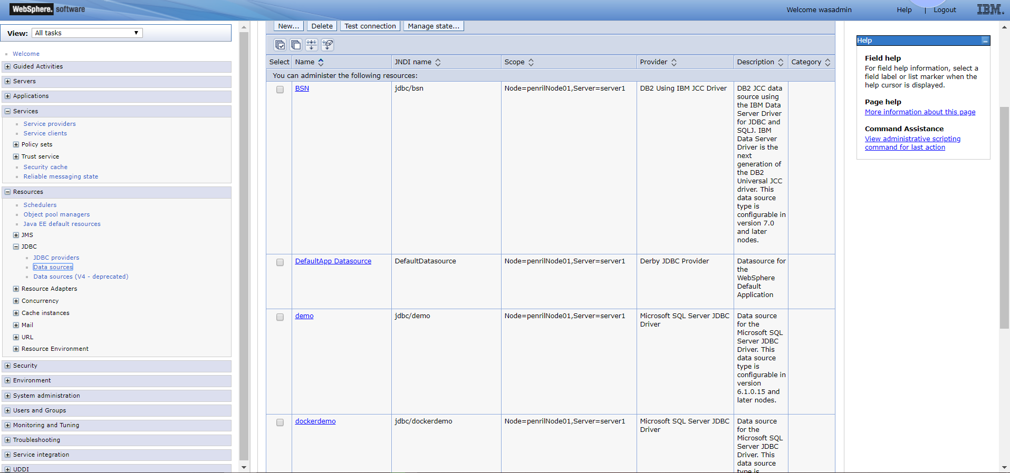

Select Custom Properties

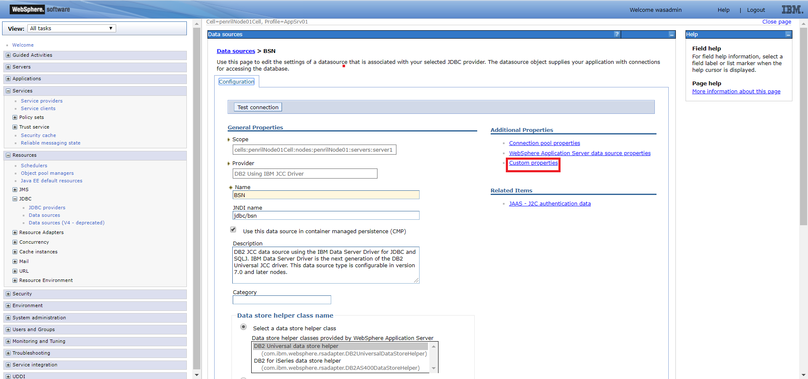

Look for “[webSphereDefaultQueryTimeout](https://192.168.1.69:9043/ibm/console/j2EEResourcePropertyCollection.do?csrfid=-2000049822&DSEditValue=true&refId=J2EEResourceProperty_1560498585826&contextId=cells%3ApenrilNode01Cell%3Anodes%3ApenrilNode01%3Aservers%3Aserver1&resourceUri=resources.xml&perspective=tab.configuration)” should be in last page(Click new to create if not found)

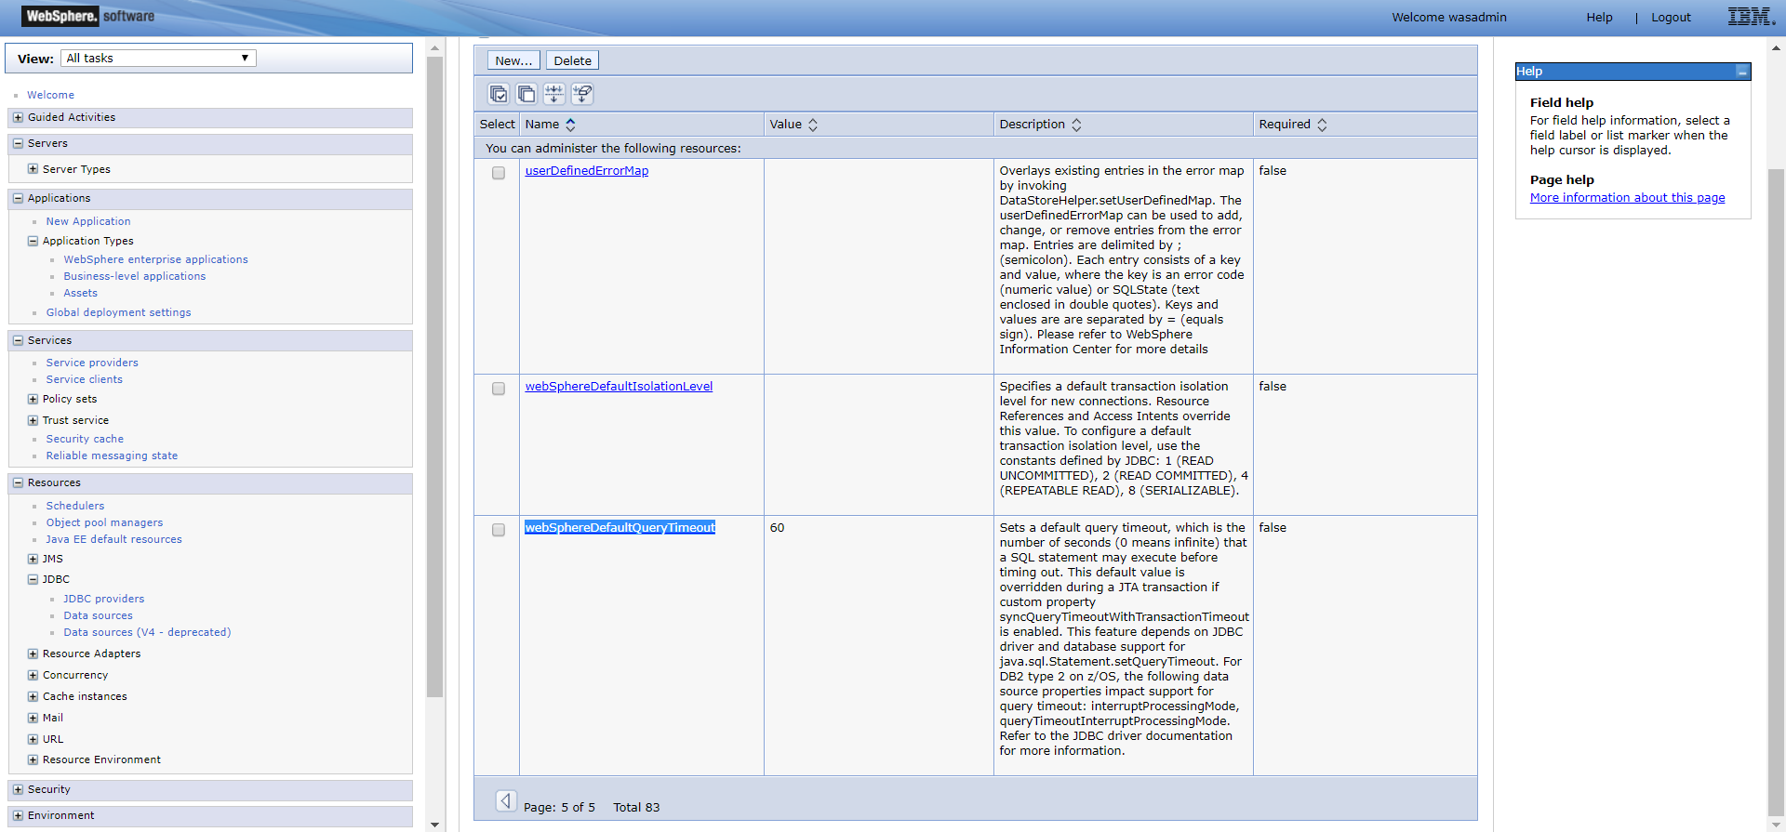

Set Value to 60(1 minute) time out, and Apply.

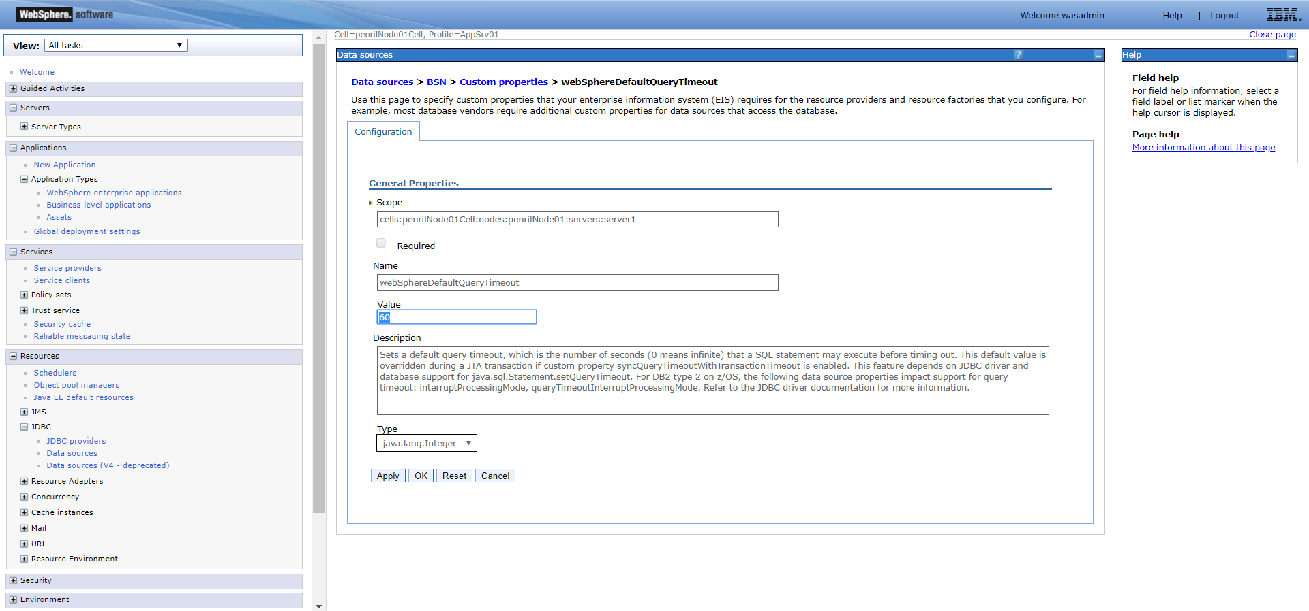

Look for “syncQueryTimeoutWithTransactionTimeout” (create if not available) insert “true” into value, and apply to save.

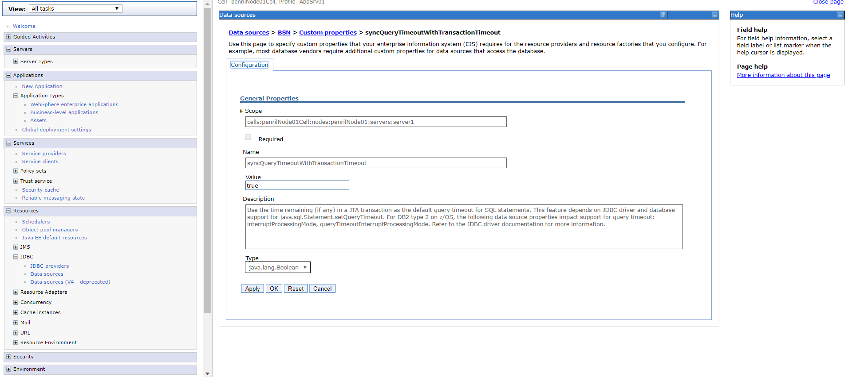

Then restart sit server for settings to take effects.