**2 Bank Back End (BBE)**

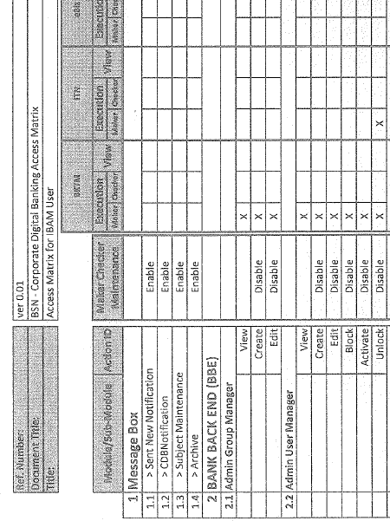

Referring above, Both In IBAM UAT & Pre PROD there is no reset password function in Admin User Manager

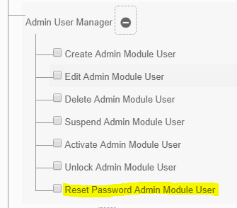

**2.4 Content & 2.4.2 Fee Maintenance**

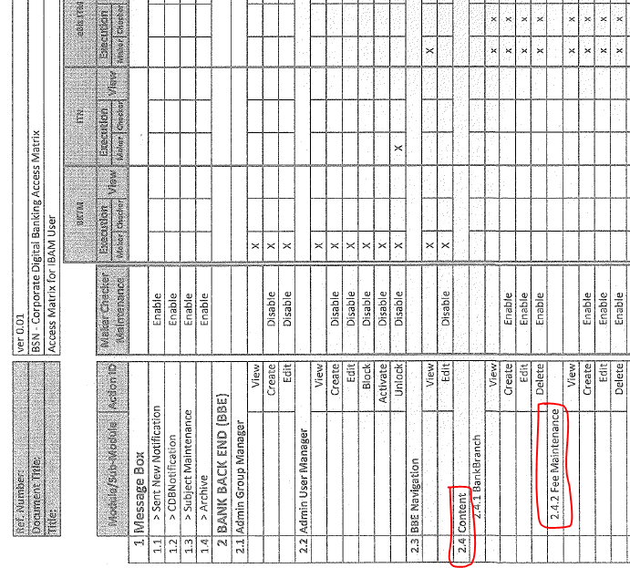

Refer to screenshot below the module content is not sync with user access matrix.

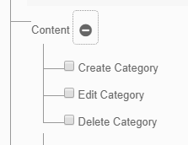

As below screenshot, the module function in Fee Maintenance module missed form the system both UAT & Pre Prod env

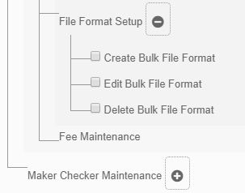

**3.3.7 Security Token Management**

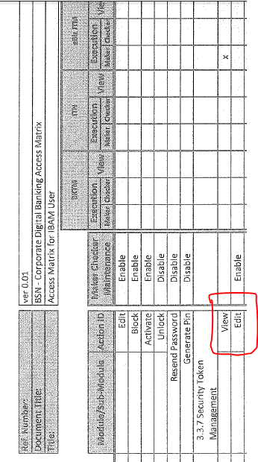

Referring below screenshot, In IBAM UAT & Pre PROD all the function not sync with UAM

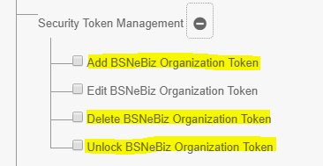

**3.3.10 B2B Setup**

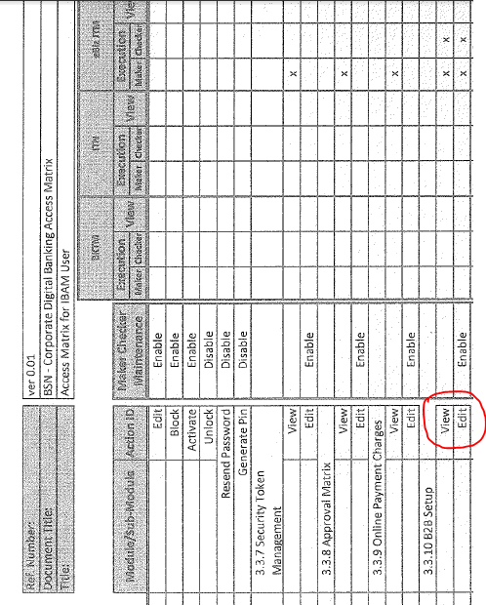

Referring below screenshot, In IBAM UAT & Pre PROD all the function not sync with UAM

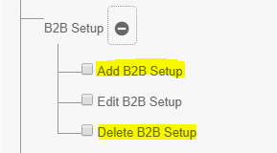

**3.3.11 CIS Linking**

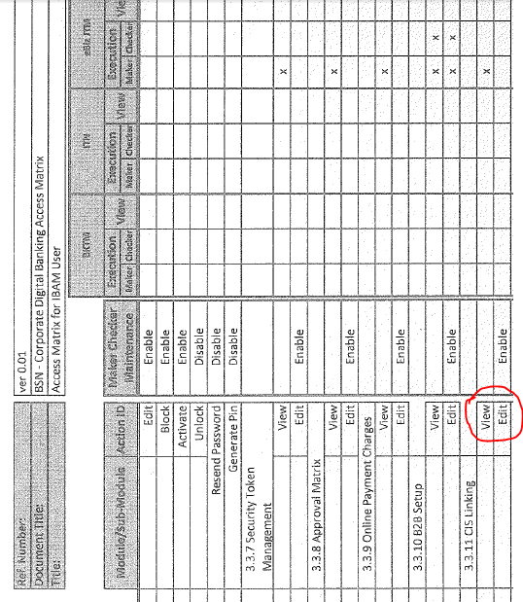

Referring below screenshot, In IBAM UAT & Pre PROD all the function not sync with UAM

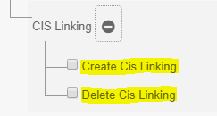

**3.4 Generate PIN**

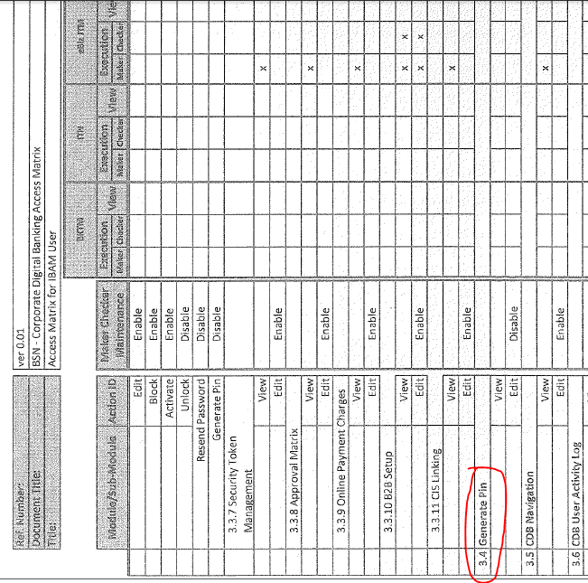

In IBAM Pre PROD

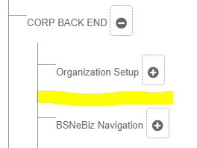

There is no module for Generate PIN in Pre PROD env while exist in UAT env

In IBAM UAT

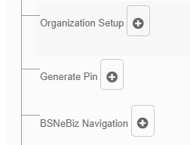

**5 File Processing**

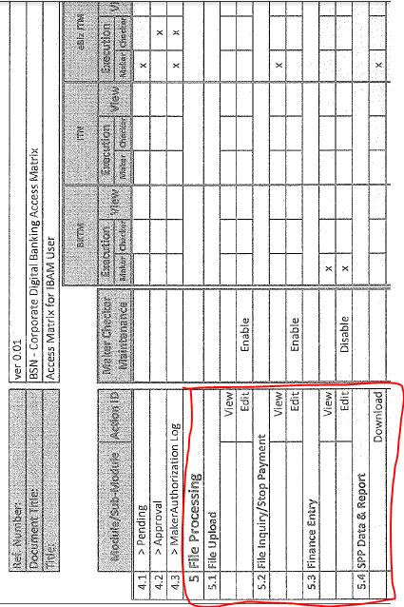

In IBAM Pre PROD

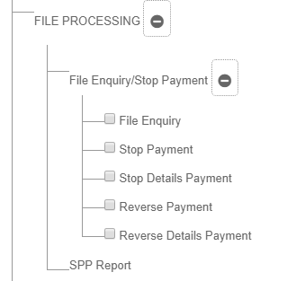

In IBAM UAT

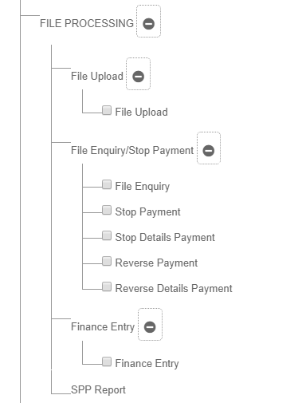

**3 Corporate Back End (CBE)**

In IBAM Pre Prod, there is few module missing compared to UAT env

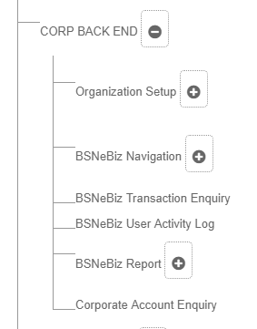

In IBAM UAT

