

Agrobank

Retail Internet Banking System – Phase 1

Business Requirement

06 June 2011
Reference: AGRO/BR/RIB/20110429

Prepared By:



Penril Datability (SEA) Sdn Bhd (384550-U)
Suite A-07-07 Plaza Mon’t Kiara
No. 2, Jalan Kiara, Mon’t Kiara
50480 Kuala Lumpur, Malaysia
Tel: (603) 6201 2622 Fax: (603) 6201 7622
Document Administration
Document Amendment Log
Ver.  No | Date Updated | Description of Change | Updated By  <Name, Dept> | Reviewed By  <Name, Dept> | Approved By <Name, Dept>
1.0 | 29/04/2011 | Initial Release | Amy Chuah, Penril Datability
1.1 | 06/05/2011 | Update Reset Required Login Information | Amy Chuah, Penril Datability
1.2 | 10/05/2011 | Added SI Module | Amy Chuah, Penril Datability
1.3 | 12/05/2011 | Added Transfer Limit  Added Change Security Question  Move Bill Payment features to Phase 2 | Amy Chuah, Penril Datability
1.4 | 16/05/2011 | Added new images and field tables for all features | Amy Chuah, Penril Datability
1.5 | 23/05/2011 | Update images and typo corrections | Amy Chuah, Penril Datability
1.5 | 02/06/2011 | Update images errors, flow diagrams, correction of mistakes and grammer | Amy Chuah, Penril Datability
1.5 | 06/06/2011 | Removed SI and will be included in Phase 2. Updated FD Placement field to at Rate. Amended Loan Account details to the label and remove status. | Tan Lee Yong, Penril Datability
1.6 | 07/22/11 | Removed FD, Request Statement and Request TAC. Updated screen captures. Corrected and changed writing. | Bernard Wong,  Penril Datability

Document Distribution List
Date Sent | Name | Organization/Department | Designation
Table of Contents

1 Introduction 5
1.1 Consumer Banking 6
1.2 Objective 7
1.3 Retail Internet Banking Functions Deliverable 8
1.3.1 Phase 1 8
1.4 System Overview 9
2 Retail Internet Banking 10
2.1 Registration 10
2.1.1 User Login Authentication Rules 10
2.1.2 Register with ATM Card 11
2.2 Login 18
2.2.1 Reset Required Login Information 20
2.2.1.1 Reset Password 21
2.2.1.2 Reset Security Questions/Answers 23
2.2.1.3 Reset Password and Security Questions/Answers 27
2.2.1.4 Retrieve Username 31
2.2.1.5 Unlock Account 32
2.3 Transaction Authorization Code (TAC) 33
2.3.1 Validity of TAC 33
2.4 Account Enquiry 34
2.4.1 Account Summary 34
2.4.1.1 Account Details 35
2.4.1.2 Transaction History 38
2.5 Funds Transfer 43
2.5.1 Own Accounts 43
2.5.2 Third Party Account 47
2.5.2.1 Open Third Party Account Transfer 47
2.5.2.2 Registered 3rd Party Account Transfer 50
2.5.2.3 3rd Party Beneficiary Account Maintenance 53
2.5.3 Interbank Transfer (via IBG) 58
2.5.3.1 Open Interbank Account Transfer 58
2.5.3.2 Registered Interbank Account Transfer 62
2.5.3.3 Beneficiary Interbank Account Maintenance 66
2.6 Bill Payments 72
2.6.1 Open Bill Payments 72
2.6.2 Payment to Registered Payee Corporation 76
2.6.3 Registered Payee Maintenance 79
2.7 Transfer Limit 83
2.8 Services Request 85
2.8.1 Block ATM card 85
2.9 Profile Maintenance 87
2.9.1 Update Profile 87
2.9.2 Change Password 88
2.9.3 Change Security Questions 91
2.10 Message Box 94
2.10.1 Inbox 94
2.10.2 Replay Message 96
2.10.3 Delete Message 97
2.10.4 Sent Messages 98
2.10.5 Trash 99
2.10.6 Restore Message 99
2.11 Retail Internet Banking Demo 101
2.12 Retail Internet Banking Reports 101

Introduction

Internet Banking or e-banking is defined as the automated delivery of new and traditional banking products and services directly to customers through electronic, interactive communication channels. Some of the reasons behind for banks to take advantages of Internet Banking services are as follows: (1) cost savings, (2) increase customer, (3) enable mass customization for e-business services, (4) extend marketing and communication channel, (5) search for new innovation services, (6) explore and development of non-core business.

E-banking includes the systems that enable financial institution customers, individuals or businesses, to access accounts, transact business, or obtain information on financial products and services through a public or private network, including the Internet. Customers access e-banking services using an intelligent electronic device, such as a personal computer (PC), personal digital assistant (PDA), automated teller machine (ATM), kiosk, or Touch Tone telephone. While the risks and controls are similar for the various e-banking access channels, we shall only focus specifically on Internet-based services due to the Internet’s widely accessible public network.

The main purpose behind the launching of online banking services is to provide the customers with an alternative, more responsive and with less expensive business channel option for the bank to interact or acquire new customers. With options just a click away, customers have more control than ever. The customers expect real-time answers and superior usability. The customer also want personal attention and highly customized products and services. The focus of e-business must always be on the customer. On the other hand, the technology and the business structure follow on form the value the bank intend to provide to the customer.

Consumer Banking

The Retail Internet Banking solution targets the individual or joint group of customers. The solution provides a browser-based interface for the Agrobank Online customer to do some of the basic services such as but not limited to account enquiries, transfers and service applications. Customer can make any payment and transaction from their home or office as long as there is an Internet connection.

How we distinguish our self from other transaction banking solutions? Account centric methodology is used to implement our system instead of transaction centric, which is normally used by other financial services. In general, right after login, most users shall review their account first before make any payment and transaction. Therefore, it is makes more sense to allow user to make a payment or transaction in their account detail page. This shall minimize the number of mouse click to complete a task and also improve customer experiences.

Our solution can be interfaced with any core banking solution through an industry standard middle-ware. It provides banking customers real time access to their relationships with the bank such as account inquiries, fund transfers and remittances. It enables them to make payments to individuals or institutions, and other general payments on-line.

Objective

The objective of this Business Requirement is to develop and implement Agrobank Online Retail Internet Banking System (Phase 1). The implementation of Agrobank Online Internet Banking System will be implemented in phases namely Phase 1 and Phase 2. This document shall cover all the deliverable mentioned in the next section 1.3 on Function Deliverable.

We have also included screen wire-frame and flows of the functions. These screen design are produced for the reader ease of understand and to serve as the base template for the entire Internet Banking solution and should not be taken as the final design for the solution.

This requirement document is created with the intention to capture the business user requirements of the Internet Banking System. While every effort has been placed to be as comprehensive as possible, the following areas have not been included and as such will be discussed and can only be confirmed at a later stage.

Retail Internet Banking Functions Deliverable

The following sections listed all the IBS functions to be developed and implemented in the Phase 1.

Phase 1

Registration Module
Register with ATM Card

Login Module
Login
Logout

Account Enquiry
Account Summary
Account Details
Transaction History

Funds Transfer
Own Accounts
Third Party Accounts
Interbank Transfer (MEPS GIRO)

Bill Payments
Open
Registered

Retail Internet Banking Demo

Services Request
Block ATM card

Profile Maintenance
Update Profile
Change Password
Change Security Question

Beneficiary Maintenance
Add/Update/Delete Registered Third Party Account
Add/Update/Delete Registered Interbank Account
Add/Update/Delete Registered Bill Account

Secure Message
Inbox
Sent Messages
Trash

Reports

System Overview

This overview diagram shows the Internet Banking System is not a standalone application. It’s tightly coupled with other components and systems to make it work. The diagram shows IBS shall use the Authentication Services for identity authentication, send an SMS through SMS gateway, retrieve and store information to the database, send request to Host and other 3rd Parties servers through middleware, and also able to send email to a specified back office official and request service to the appointed billing aggregator through Host.

Retail Internet Banking

Registration

The registration process is the first interaction occurs between the customers and Agrobank Online. The purpose of the registration process is to enable the customers to open an account with Agrobank Online. This registration process is designed to provide the convenience for the customers where the entire process is conducted electronically and without going to the bank branches or ATMs to authenticate their identity.

The proposed registrations process is based on the following scenarios:

- User must have ATM card with the bank
- User must have a mobile phone number

Users are required to register as a Agrobank Online Retail Internet Banking user before they can proceed to enjoy the features available in the Agrobank Online Retail Internet Banking system i.e. accounts inquiry, service request like statement request, online payment, online fund transfer, and many other features that makes online banking a convenient features for Agrobank Online banking users.

User Login Authentication Rules

User ID and Password Control | Requirements | Remark
User ID | Single or combination of numeric, alphabet or alphanumeric. Underscore is accepted. 6 – 16 characters . | The rule is not parameterized.
Maximum password expiration | No expiration | System wide support and can be parameterized via the system configuration file
Password | Must be a combination of numeric, lower case alphabet, upper case alphabet and permitted special character. 8 - 12 characters | Permitted special characters:  !, @, #, $, %, ^, &, *, (, ), <, >, =, _
Maximum failed log-in attempts | 3 times. (The User ID will subsequently be locked (disabled)) | The maximum number of attempts can be parameterized via the system configuration file. If the User ID is locked, the user must send a request to the administrator to reset the password. The application will force the user to change their password upon login.
Inactive/Dormant ID | User ID is automatically disabled by the system after 90 days of inactivity. | The number of days can be parameterized via the system configuration file.
Duplicate password control | For a minimum of 6 generations, the same passwords cannot be reused. | The number of generations can be parameterized via the system configuration file.
Last sign on information displayed | The last signed on details will be displayed to the user upon logging into the system | This is a standard feature.
Changing of passwords by user | Users may change their passwords anytime they wish | This is standard feature.
Deletion of User IDs from application | User IDs that are obsolete must be able to be deleted (instead of just suspended) from the application | The same User ID cannot be reused even if restored. The deleted user will not show up on the user enquiry screen, but the record will still be stored in the database.
Password storage | Password is hashed using SHA-1 hashing algorithm | Combination of salt and Password is encrypted using SHA-1 before being stored into Database. The hashed value will be used for authentication

Register with ATM Card

This feature allows the customer to register an Agrobank Online Retail Internet Banking user. The customer will register by using an ATM card issued by Agrobank with the ATM card pin number.

Required information for identity verification:

- Account number
- ATM card number
- ATM pin number

Required information for Internet Banking registration:

- Username
- Password
- Three security questions and answers
- Identity image
- Image phrase
- Mobile number

User shall remember all the information provided above.

Flow Diagram

Sample Screen

Step 1: Term & Condition
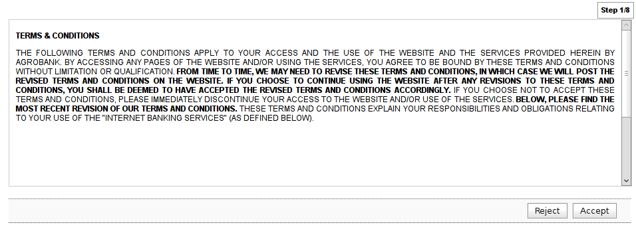

Step 2: Verify
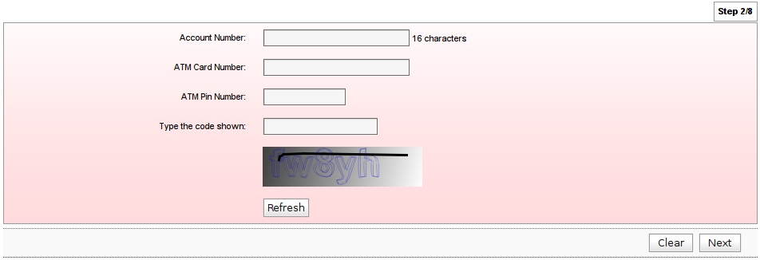
Step 3: Username registration
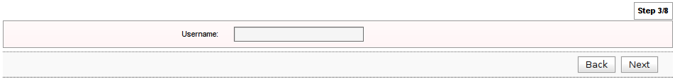

Step 4: Password registration
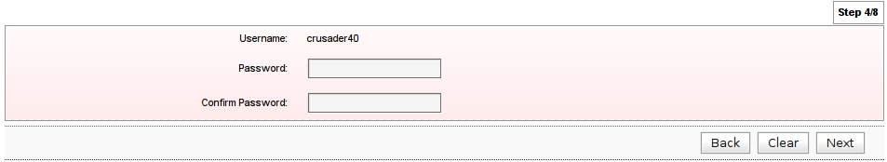

Step 5: Security Questions & Answers registration
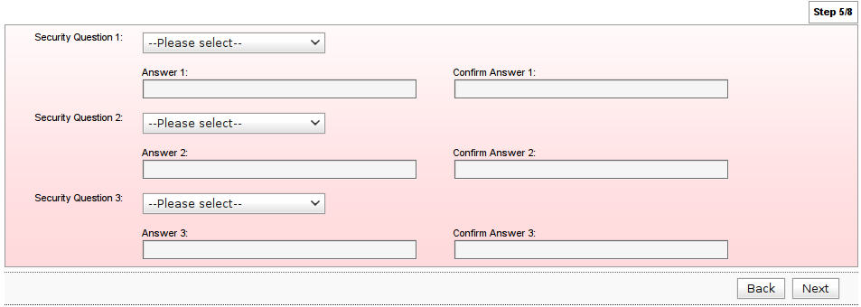

Step 6: Mobile Number registration

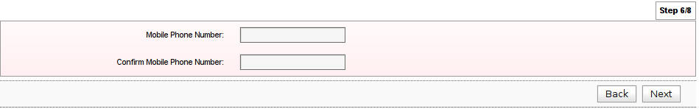

Step 7: Identity Image and Image Phrase
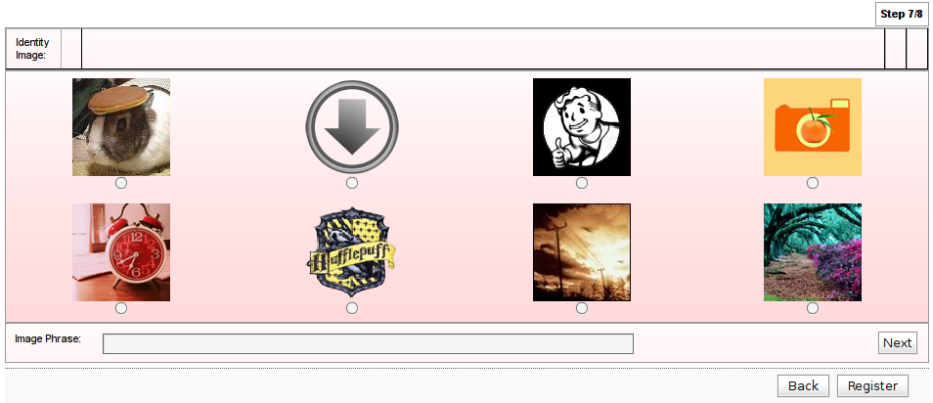
Step 8: Result

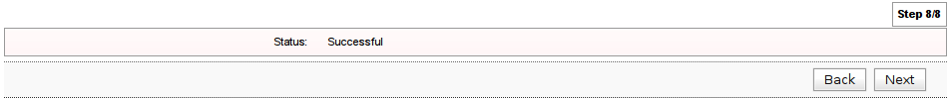
Note: An SMS message will be sent over to user’s mobile phone to acknowledge the confirmation of the registration.

Screen Input Fields

Step | Field Name | Field Type | Rule | Description | Compulsory
2 | Account Number | Text Box | Numeric only. Up to 16 digits | The account number that link to the ATM Card | Yes
2 | ATM Card Number | Text Box | Numeric only. Up to 16 digits | The number appeared in the ATM Card | Yes
2 | ATM PIN Number | Text Box | Numeric only. Up to 6 digits. Masked | PIN number created for the ATM Card | Yes
2 | Type the code shown | Text Box |  | Key in the CapChar text from the image. | Yes
3 | Username | Text Box | Single or combination of numeric, alphabet or alphanumeric. Underscore is accepted. 6 – 16 characters. | The unique personal identifier for the user. Username is unique in the Internet Banking System. | Yes
4 | Password | Text Box | Must be a combination of numeric, lower case alphabet, upper case alphabet and permitted special character. 8 - 12 characters. Masked | This password will be used for login  Permitted special characters:  !, @, #, $, %, ^, &, *, (, ), <, >, =, _ | Yes
4 | Confirm Password | Text Box |  | This password value must be the same to the Password value | Yes
5 | Security Question 1 | Drop Down List |  | User must select a security question which cannot be the same as Security Question 2 and 3 | Yes
5 | Answer 1 | Text Box | Single or combination of numeric, alphabet or alphanumeric. Permitted special characters are allowed. Up to 30 characters. Masked. | User must provide a answer to the above question and remember  Permitted special characters:  _, ., <space> | Yes
5 | Confirm Answer 1 | Text Box | Up to 30 characters. Masked. | To confirm the answer | Yes
5 | Security Question 2 | Drop Down List |  | User must select a security question which cannot be the same as Security Question 1 and 3 | Yes
5 | Answer 2 | Text Box | Single or combination of numeric, alphabet or alphanumeric. Permitted special characters are allowed. Up to 30 characters. Masked. | User must provide a answer to the above question and remember  Permitted special characters:  _, ., <space> | Yes
5 | Confirm Answer 2 | Text Box | Up to 30 characters. Masked. | To confirm the answer | Yes
5 | Security Question 3 | Drop Down List |  | User must select a security question which cannot be the same as Security Question 1 and 2 | Yes
5 | Answer 3 | Text Box | Single or combination of numeric, alphabet or alphanumeric. Permitted special characters are allowed. Up to 30 characters. Masked. | User must provide a answer to the above question and remember  Permitted special characters:  _, ., <space> | Yes
5 | Confirm Answer 3 | Text Box | Up to 30 characters. Masked. | To confirm the answer | Yes
6 | Mobile Phone Number | Text Box | Numeric only. 10-11 numbers. Masked | The user mobile phone that will be used to receive TAC. | Yes
6 | Confirm Mobile Phone Number | Text Box | Up to 11 characters. Masked. | To confirm the given mobile phone number. | Yes
7 | Identity Image | Radio Button |  | To select an identity image. User can click on the Next button to have another random set of images. | Yes
7 | Image Phrase | Text Box | Single or combination of numeric, alphabet or alphanumeric. Permitted special characters are allowed. Up to 60 characters. | To provide a personalized phrase.  Permitted special characters:  _, ., <space> | Yes

Login

After the users have registered successfully, they can use the Login feature to login into Agrobank Online Retail Banking system using their username, password and security answers.

Required field to login:

- Username
- Password
- Security Answer

The user account will be locked should the user fail to login after more than 3 attempts.

Flow Diagram

Sample Screen

Step 1: Username
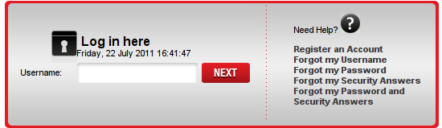

Step 2: Password
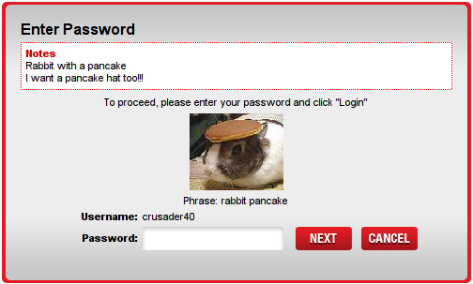

Step 3: Security Question and Answer
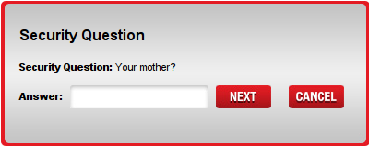

Screen Input Fields

Step | Field Name | Field Type | Rule | Description | Compulsory
1 | Username | Text Box | Single or combination of numeric, alphabet or alphanumeric. Underscore is accepted. 6 – 16 characters. | The unique personal identifier for the user. Username is unique in the Internet Banking System. | Yes
2 | Password | Text Box | Must be a combination of numeric, lower case alphabet, upper case alphabet and permitted special character. 8 - 12 characters. Masked. | This password will be used for login  Permitted special characters:  !, @, #, $, %, ^, &, *, (, ), <, >, =, _ | Yes
3 | Security Answer | Text Box | Up to 30 characters. Masked. | One of the pre-registered security three questions will be random challenged. User need to provide the correct answer to proceed. | Yes

Reset Required Login Information

This section shall explain how to reset all required login information listed below

Fields that can be reset:

- Password
- Security questions/answers

Reset Password

If the users have forgotten their password only, they can reset their password only.

Required identity validation information for this process:

- Username
- ATM card number
- Account number
- ATM pin

Required information to be provided by the user:

- New password

Flow Diagram

Sample Screen

Step 1: Verify
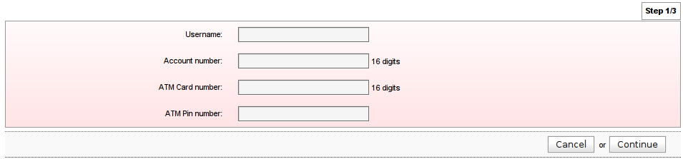

Step 2: Details
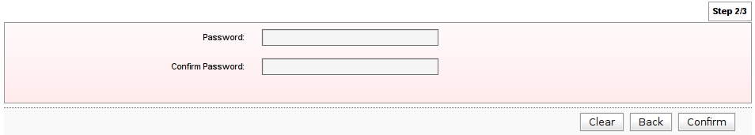
Step 3: Result

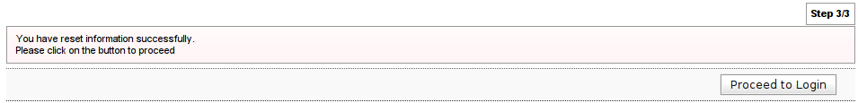

Screen Input Fields

Step | Field Name | Field Type | Rule | Description | Compulsory
1 | Username | Text Box | Single or combination of numeric, alphabet or alphanumeric. Underscore is accepted. 6 – 16 characters. | The unique personal identifier for the user. Username is unique in the Internet Banking System. | Yes
1 | Account Number | Text Box | Numeric only. Up to 16 digits | The account number that link to the ATM Card | Yes
1 | ATM Card Number | Text Box | Numeric only. Up to 16 digits | The number appeared in the ATM Card | Yes
1 | ATM PIN Number | Text Box | Numeric only. Up to 6 digits. Masked | PIN number created for the ATM Card | Yes
2 | Password | Text Box | Must be a combination of numeric, lower case alphabet, upper case alphabet and permitted special character. 8 - 12 characters. Masked. | This password will be the new password used for login  Permitted special characters:  !, @, #, $, %, ^, &, *, (, ), <, >, =, _ | Yes
2 | Confirm Password | Text Box |  | To confirm the password | Yes

Reset Security Questions/Answers

If the users forget their security answers, the users will be required to reset security questions and answers.

Required identity validation information for this process:

- Username
- ATM card number
- Account number
- ATM pin
- Password

Required information to be provided by the user:

- New security questions
- New security answers

Flow Diagram

Sample Screen

Step 1: Verify
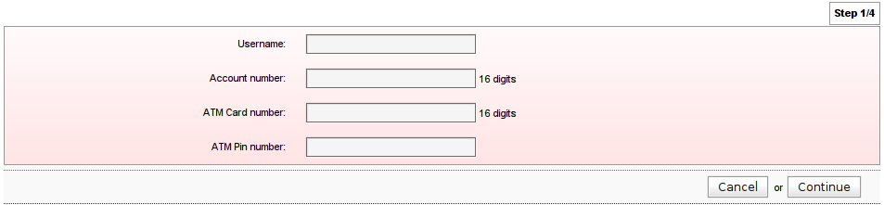
Step 2: Password
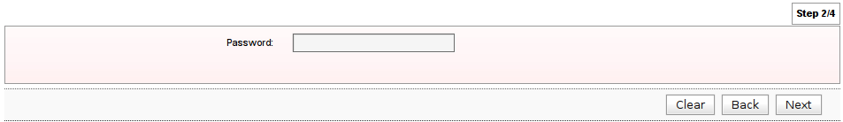

Step 3: Details
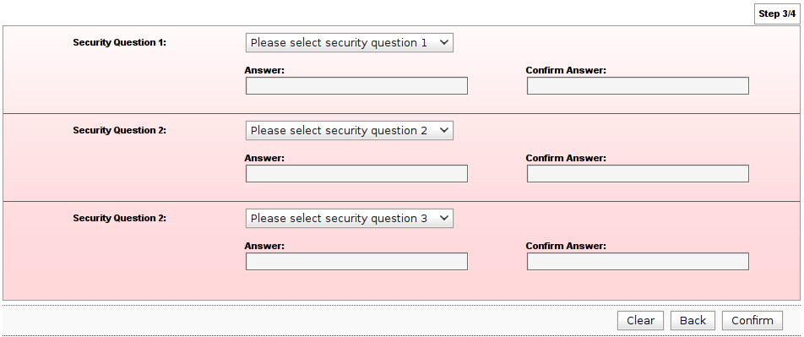
Step 4: Result
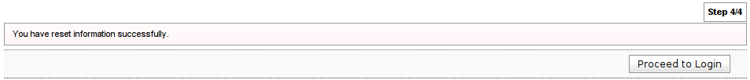
Screen Input Fields

Step | Field Name | Field Type | Rule | Description | Compulsory
1 | Username | Text Box | Single or combination of numeric, alphabet or alphanumeric. Underscore is accepted. 6 – 16 characters. | The unique personal identifier for the user. Username is unique in the Internet Banking System. | Yes
1 | Account Number | Text Box | Numeric only. Up to 16 digits | The account number that link to the ATM Card | Yes
1 | ATM Card Number | Text Box | Numeric only. Up to 16 digits | The number appeared in the ATM Card | Yes
1 | ATM PIN Number | Text Box | Numeric only. Up to 6 digits. Masked | PIN number created for the ATM Card | Yes
2 | Password | Text Box | Must be a combination of numeric, lower case alphabet, upper case alphabet and permitted special character. 8 - 12 characters. Masked. | This password will be the new password used for login  Permitted special characters:  !, @, #, $, %, ^, &, *, (, ), <, >, =, _ | Yes
3 | Security Question 1 | Drop Down List |  | User must select a security question which cannot be the same as Security Question 2 and 3 | Yes
3 | Answer 1 | Text Box | Single or combination of numeric, alphabet or alphanumeric. Permitted special characters are allowed. Up to 30 characters. Masked. | User must provide a answer to the above question and remember  Permitted special characters:  _, ., <space> | Yes
3 | Confirm Answer 1 | Text Box | Up to 30 characters. Masked. | To confirm the answer | Yes
3 | Security Question 2 | Drop Down List |  | User must select a security question which cannot be the same as Security Question 1 and 3 | Yes
3 | Answer 2 | Text Box | Single or combination of numeric, alphabet or alphanumeric. Permitted special characters are allowed. Up to 30 characters. Masked. | User must provide a answer to the above question and remember  Permitted special characters:  _, ., <space> | Yes
3 | Confirm Answer 2 | Text Box | Up to 30 characters. Masked. | To confirm the answer | Yes
3 | Security Question 3 | Drop Down List |  | User must select a security question which cannot be the same as Security Question 1 and 2 | Yes
3 | Answer 3 | Text Box | Single or combination of numeric, alphabet or alphanumeric. Permitted special characters are allowed. Up to 30 characters. Masked. | User must provide a answer to the above question and remember  Permitted special characters:  _, ., <space> | Yes
3 | Confirm Answer 3 | Text Box | Up to 30 characters. Masked. | To confirm the answer | Yes

Reset Password and Security Questions/Answers

If the users forgotten their password and security questions and answers, the user will be required to reset their password and security questions and answers.

Required identity validation information for this process:-

- Username
- ATM card number
- Account number
- ATM pin

Required information to be provided by the user:

- New Password
- New Security Questions
- New Security Answers

Flow Diagram
Sample Screen

Step 1: Verify
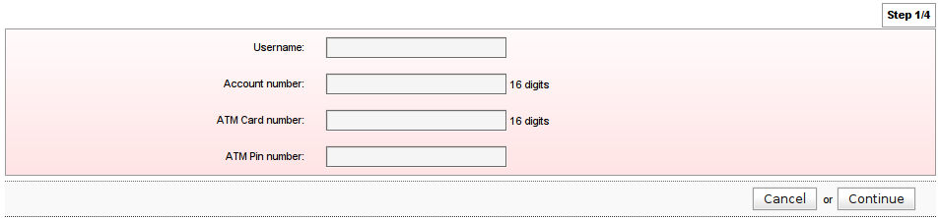

Step 2: New Password
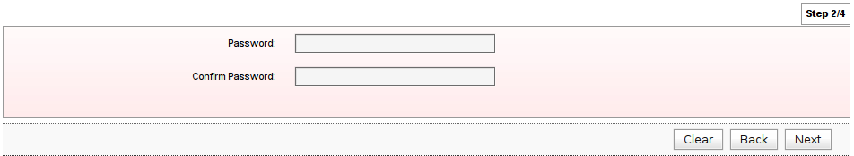

Step 3: New Security Questions and Answers

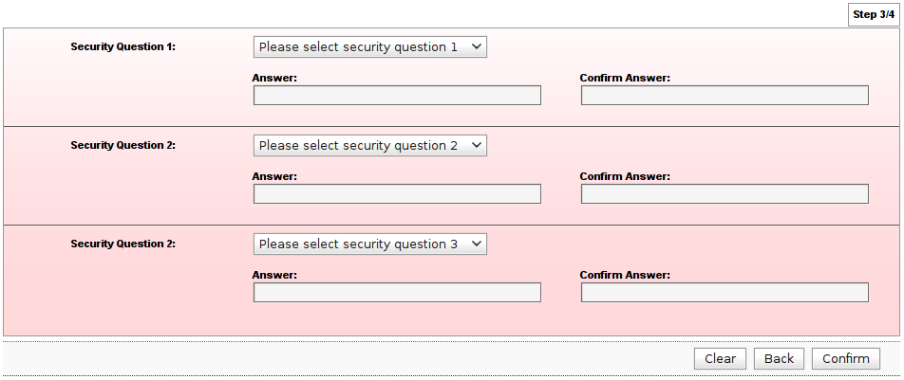

Step 4: Result
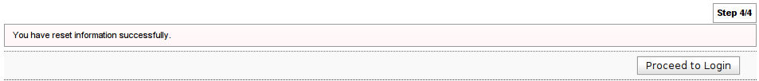
Screen Input Fields

Step | Field Name | Field Type | Rule | Description | Compulsory
1 | Username | Text Box | Single or combination of numeric, alphabet or alphanumeric. Underscore is accepted. 6 – 16 characters. | The unique personal identifier for the user. Username is unique in the Internet Banking System. | Yes
1 | Account Number | Text Box | Numeric only. Up to 16 digits | The account number that link to the ATM Card | Yes
1 | ATM Card Number | Text Box | Numeric only. Up to 16 digits | The number appeared in the ATM Card | Yes
1 | ATM PIN Number | Text Box | Numeric only. Up to 6 digits. Masked | PIN number created for the ATM Card | Yes
2 | Password | Text Box | Must be a combination of numeric, lower case alphabet, upper case alphabet and permitted special character. 8 - 12 characters. Masked. | This password will be the new password used for login  Permitted special characters:  !, @, #, $, %, ^, &, *, (, ), <, >, =, _ | Yes
2 | Confirm Password | Text Box |  | To confirm the password | Yes
3 | Security Question 1 | Drop Down List |  | User must select a security question which cannot be the same as Security Question 2 and 3 | Yes
3 | Answer 1 | Text Box | Single or combination of numeric, alphabet or alphanumeric. Permitted special characters are allowed. Up to 30 characters. Masked. | User must provide a answer to the above question and remember  Permitted special characters:  _, ., <space> | Yes
3 | Confirm Answer 1 | Text Box | Up to 30 characters. Masked. | To confirm the answer | Yes
3 | Security Question 2 | Drop Down List |  | User must select a security question which cannot be the same as Security Question 1 and 3 | Yes
3 | Answer 2 | Text Box | Single or combination of numeric, alphabet or alphanumeric. Permitted special characters are allowed. Up to 30 characters. Masked. | User must provide a answer to the above question and remember  Permitted special characters:  _, ., <space> | Yes
3 | Confirm Answer 2 | Text Box | Up to 30 characters. Masked. | To confirm the answer | Yes
3 | Security Question 3 | Drop Down List |  | User must select a security question which cannot be the same as Security Question 1 and 2 | Yes
3 | Answer 3 | Text Box | Single or combination of numeric, alphabet or alphanumeric. Permitted special characters are allowed. Up to 30 characters. Masked. | User must provide a answer to the above question and remember  Permitted special characters:  _, ., <space> | Yes
3 | Confirm Answer 3 | Text Box | Up to 30 characters. Masked. | To confirm the answer | Yes

Retrieve Username

If the users have forgotten their username, this feature allows them to retrieve their username.

Required identity validation information for this process:

- Account number
- ATM card number
- ATM pin

Flow Diagram

Sample Screen Design

Step 1: Verify
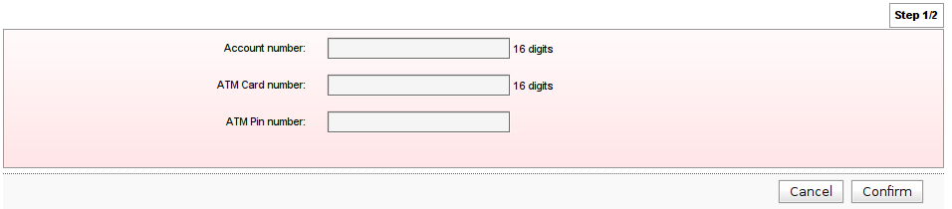

Step 2: Result
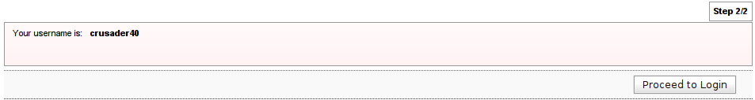

Screen Input Fields

Step | Field Name | Field Type | Rule | Description | Compulsory
1 | Account Number | Text Box | Numeric only. Up to 16 digits | The account number that link to the ATM Card | Yes
1 | ATM Card Number | Text Box | Numeric only. Up to 16 digits | The number appeared in the ATM Card | Yes
1 | ATM PIN Number | Text Box | Numeric only. Up to 6 digits. Masked | PIN number created for the ATM Card | Yes

Unlock Account

If the user account has been locked, the user shall call Customer Service to unlock the account first and the user is required to change the password before s/he can login to the account.

The user can proceed with the necessary functions (reset password, security questions/answers or both) after Customer Service have unlock the account.

Flow Diagram

Transaction Authorization Code (TAC)

TAC is a temporary random six digits security code generated by the authentication server and sent to user by SMS using a SMS gateway. TAC is required as the second level security authentication before committing any bank transactions and user profile updates. The TAC shall be valid for a period of time and will expire thereafter. After the TAC expiration, the user is required to make another request for a new TAC. The bank administrator can change the expiry time of the TAC. TAC can be enabled and disabled for each service by configuration.

Flow Diagram

Sample Screen Design

Step1: Request TAC

Step 2: Result
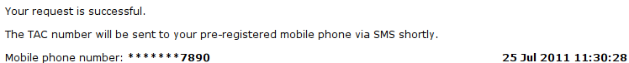

Validity of TAC

- TAC can be used for multiple transactions within the same session of logon.
- Once the user logs out from the session, the requested TAC on the previous session is considered invalid.
- The validity of the TAC will also based on the scenarios below:
- Maximum of three (3) attempts:
- If the user continuously wrongly entered the TAC for three (3) times, the user will be forced logout from the session.
- The user account will be locked.
- The user is required to call the Customer Service to unlock the account
- Customer Service will verify the user and unlock the user account to enable the user to perform subsequent logins

- Within one (1) hour TAC request:
- The user is not allowed to request another TAC within one (1) hour in the same session.
- The user will be prompted with an error message to bar the request if the request is within the one (1) hour in the same session

- One (1) hour Validation:
- If the user is in the session for one (1) hour, the TAC will be no longer valid.

Account Enquiry

Account Enquiry module feature allows the user to view account information. The feature includes view account summary, account details and transaction history.

Account Summary

Account Summary feature shall provide a list of accounts which can be retrieved from the Agrobank back-end host, such as Savings Account, Current Account, Fixed Deposit and Loan Account. The users can use a quick link to perform an action onto the account.

Flow Diagram

Sample Screen

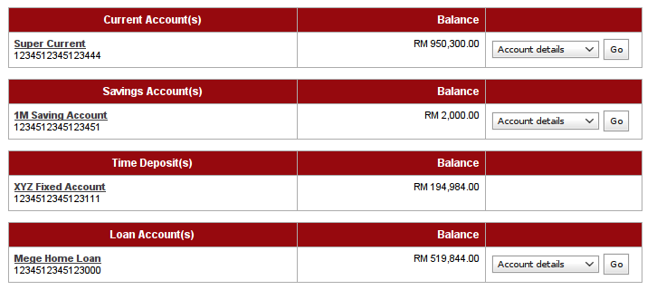

Account Details

Account Details feature shall display the detailed account information based on the selected account number in the Account Summary page.

Flow Diagram

Sample Screen

Sample Screen for CASA

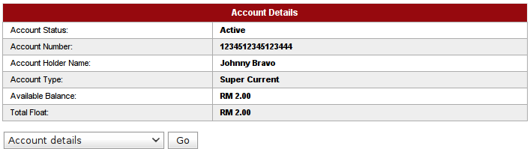

Screen Fields for CASA

No | Field Name | Description
1 | Account Status | The account status
2 | Account Number | The account number
3 | Account Type | This account detailed account type
4 | Account Holder Name | The account holder name
5 | Available Balance | The account available balance that can be used
6 | Total Float Amount | The total floating amount

Sample Screen for Loan

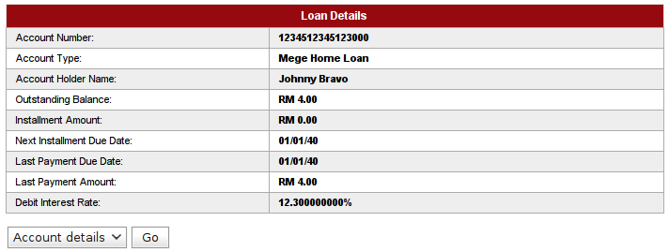

Screen Fields for Loan Account

No | Field Name | Description
1 | Account Number | The account number
2 | Account Type | This account detailed account type
3 | Account Holder Name | The account holder name
4 | Outstanding Balance | The account outstanding balance
5 | Installment Amount | The installment amount
6 | Next Installment Due Date | The installment due date
7 | Last Payment Due Date | The last payment date
8 | Last Payment Amount | The last payment amount
 | Debit Interest Rate | The loan interest rate

Sample Screen for Fixed Deposit

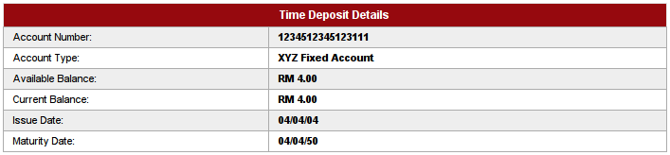

Screen Fields for Fixed Deposit Account

No | Field Name | Description
1 | Account Number | The account number
2 | Account Type | This account detailed account type
3 | Available Balance | The available balance of the FD
4 | Current Balance | The current balance of the FD
5 | Issue Date | The FD issue date
6 | Maturity Date | The FD maturity date

Transaction History

Transaction history shall provide the below transaction history types:

- Transaction History
- Transaction history shall be providing all the transaction completed on the host irrespective of the transaction is submitted through Internet or Conventional Banking.
- This feature shall allow user to print and download the transaction history:
- The user is able to view transaction history from the latest transaction to previous days in host.
- The user is able to view only the last 60 days transactions.

Flow Diagram

- Internet Transaction History
- The Internet transaction history shall provide all transaction completed through Internet Banking system. The user shall be able to view the details of the transactions.
- The historical data of the Internet Transaction is stored in the database server and can be retrieved directly from the database.
- This feature shall allow the user to print and download the transaction history.
- The user is able to view only the last 60 days transactions.
Flow Diagram
Sample Screen Design

Transaction History Page

This page displays an account transaction history.

*Note: Account balance field will be made available if Host is able to provide the information

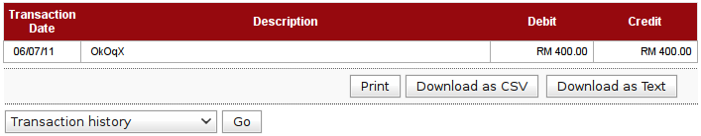

Screen Fields for CASA

No | Field Name | Description
1 | Transaction Date | The account number
2 | Description | The description of the transaction
3 | Debit | The amount debited from the account
4 | Credit | The amount credited into the account

Screen Fields for Loan Account

No | Field | Description
1 | Transaction Date | The account number
2 | Description | The description of the transaction
3 | Debit | The amount debited from the account
4 | Credit | The amount credited into the account

Internet Transaction History Page

This page displays an account Internet transaction history.

*Note: Account balance will not be available for Internet transaction history

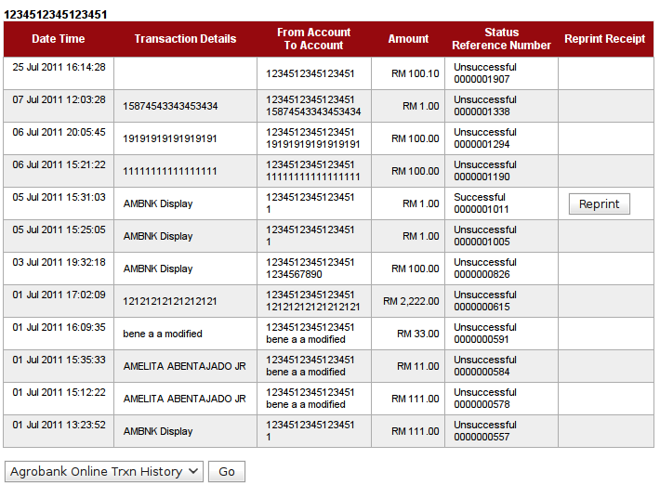

Screen Fields for CASA

No | Field Name | Description
1 | Date Time | The transaction date and time
2 | Transaction Details | The details of this transaction
3 | From Account  To Account | The transfer from account. The transfer to account
4 | Amount | The transaction amount
5 | Status  Reference Number | Transaction status. The transaction reference number in the Internet Banking System
6 | Reprint Receipt | Allow user to reprint the receipt

Screen Fields for Loan Account

No | Field Name | Description
1 | Date Time | The transaction date and time
2 | Transaction Details | The details of this transaction
3 | From Account  To Account | The transfer from account. The transfer to account
4 | Amount | The transaction amount
5 | Status  Reference Number | Transaction status. The transaction reference number in the Internet Banking System
6 | Reprint Receipt | Allow user to reprint the receipt

Funds Transfer

Funds Transfer module provides functionalities to allow the user to make fund transfer from one account to another account. The user can make a transfer from own account to another own account, to third party account at the same bank, via Interbank, and to account located oversea. A print receipt page shall be provided to allow user to print receipt at the result page after each successful transaction.

Own Accounts

Own Account Transfer shall allow users to transfer money within their own accounts.

Required information to be provided by the user:

- From account number
- To account number
- Amount

Flow Diagram

Sample Screen

Step 1: Details
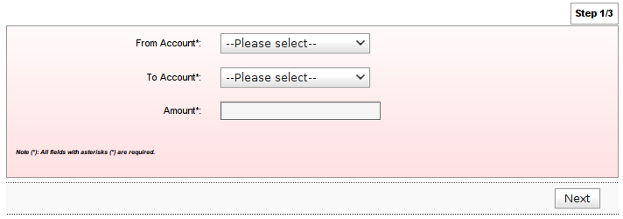
Step 2: Confirm
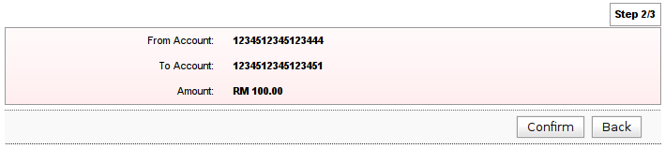

Step 3: Results
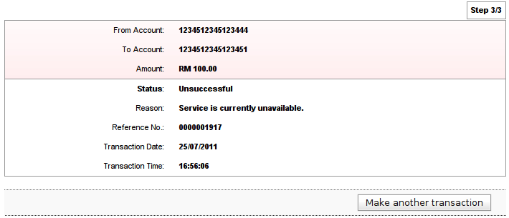

Screen Input Fields

Step | Field Name | Field Type | Rule | Description | Compulsory
1 | From Account | Drop Down List |  | The transfer from account number | Yes
1 | To Account | Drop Down List |  | The transfer to account number | Yes
1 | Amount | Text Box | Must be numeric. Accepts decimals. Allowed value is 0.01 – 9999999999999.99 | The transaction amount | Yes

Third Party Account

Third Party Accounts Transfer shall allow the user to transfer money from their own account to another Agrobank account. This funds transfer function can be made by:

- Open Third Party Account Transfer
- Registered Third Party Account

Open Third Party Account Transfer

This feature shall allow user to make a one-time transfer to a third party account.

Required information to be provided by the user:

- From account number
- To account number
- To account type
- Amount
- TAC

Flow Diagram

Sample Screen

Step 1: Details
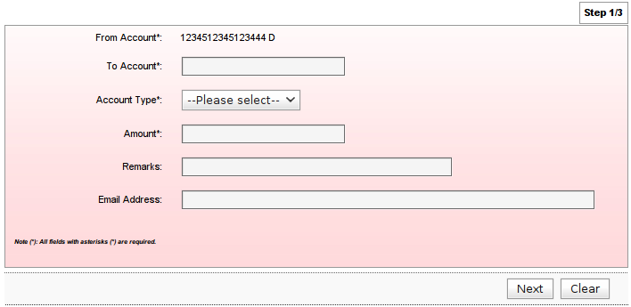

Step 2: Confirm
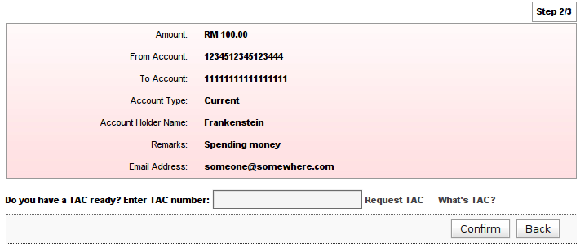

Step 3: Result
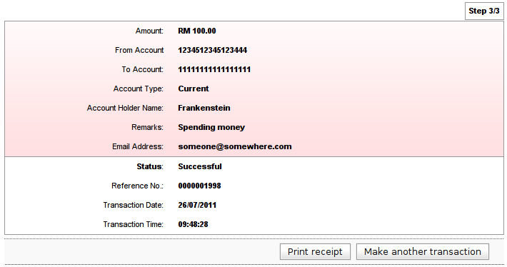

Screen Input Fields

Step | Field Name | Field Type | Rule | Description | Compulsory
1 | From Account | Drop Down List/Text Box | Drop Down if more than one account, Text Field if only one | The transfer from account number | Yes
1 | To Account | Text Box | Must be numeric. 16 – 17 numbers. | The transfer to account number | Yes
1 | Account Type | Drop Down List |  | The account type of the beneficiary | Yes
1 | Amount | Text Box | Must be numeric. Accepts decimals. Allowed value is 0.01 – 9999999999999.99 | The transaction amount | Yes
1 | Remarks | Text Box | Alphanumeric and spaces only. Up to 30 characters | Allow user to make a remark for this transfer | No
1 | Email Address | Text Box | Email format. Up to 60 characters | The email address of the beneficiary | No
2 | TAC | Text Box | Must be 6 characters. Masked | The Transaction Authorization Code | Yes

Registered 3rd Party Account Transfer

This feature allow user to make a transfer to a registered third party account number.

Required information to be provided by the user:

- From account number
- To account number
- Amount

Flow Diagram

Sample Screen

Step 1: Details
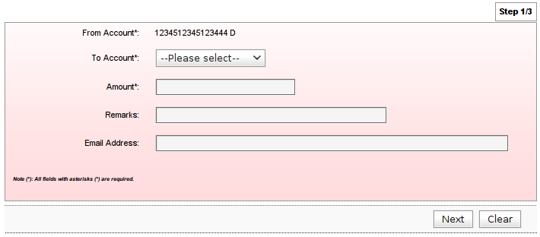

Step 2: Confirm
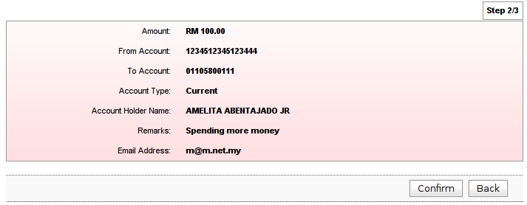

Step 3: Result
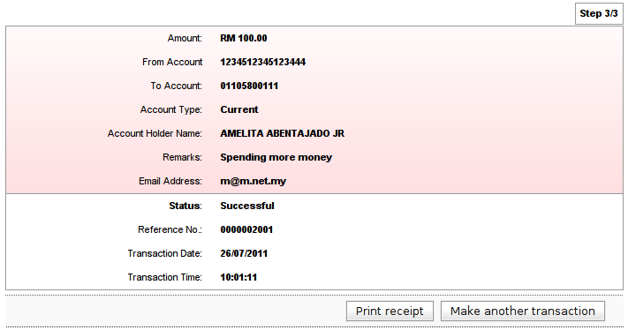

Screen Input Fields

Step | Field Name | Field Type | Rule | Description | Compulsory
1 | From Account | Drop Down List/Text Box | Drop Down if more than one account, Text Field if only one | The transfer from account number | Yes
1 | To Account | Drop Down List/Text Box | Drop Down if more than one account, Text Field if only one | The transfer to account number | Yes
1 | Amount | Text Box | Must be numeric. Accepts decimals. Allowed value is 0.01 – 9999999999999.99 | The transaction amount | Yes
1 | Remarks | Text Box | Alphanumeric and spaces only. Up to 30 characters | Allow user to make a remark for this transfer | No
1 | Email Address | Text Box | Email format. Up to 60 characters | The email address of the beneficiary | No

3rd Party Beneficiary Account Maintenance

This feature shall allows the user to:

- Add a new registered third party account
- Update an existing registered third party account
- Delete a registered third party third party account

Required information to be provided by the user:

- To account number
- Recipient name
- Mobile number
- Recipient email
- TAC

Flow Diagram

Sample Screen

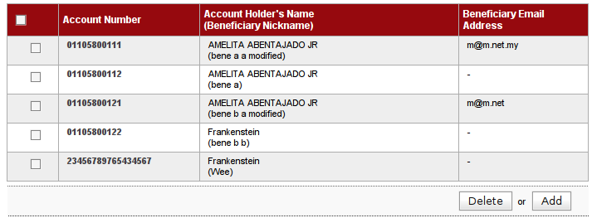

Screen Fields

No | Field Name | Description
1 | Account Number | The transfer from account number
2 | Account Holder's Name | The transfer to account number
3 | Beneficiary Email | The transaction amount

Add Beneficiary Account

Step 1: Details
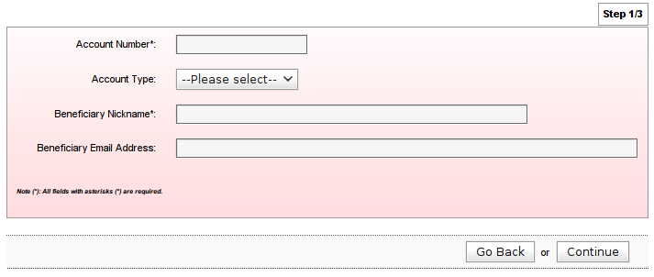

Step 2: Confirm
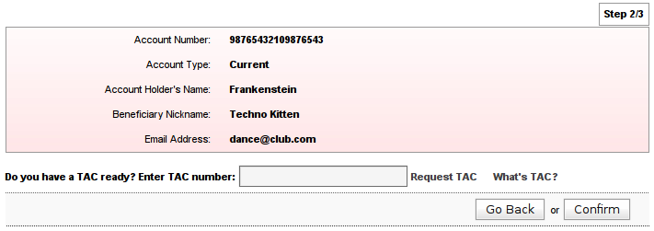

Step 3: Result
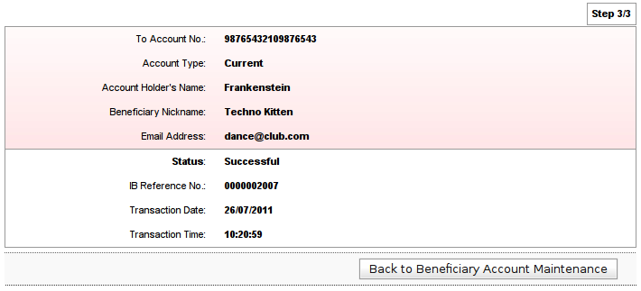

Screen Inputs Fields

Step | Field Name | Field Type | Rule | Description | Compulsory
1 | Account Number | Text Box | Must be numeric. 16 – 17 numbers. | The transfer to account number | Yes
1 | Account Type | Drop Down List |  | The account type of the to account number | Yes
1 | Beneficiary Nickname | Text Box | Alphabets and spaces only. Up to 40 characters | A given beneficiary account identifier | Yes
1 | Beneficiary Email | Text Box | Email format. Up to 60 characters | Allow IB to send email to the To Account holder | No
2 | TAC | Text Box | Must be 6 characters. Masked | The Transaction Authorization Code | Yes

Update Beneficiary Account

Step 1: Details
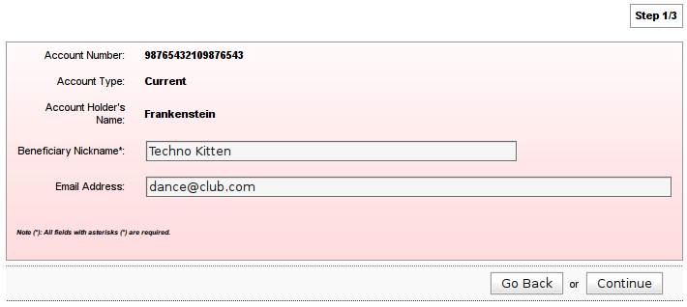

Step 2: Confirm
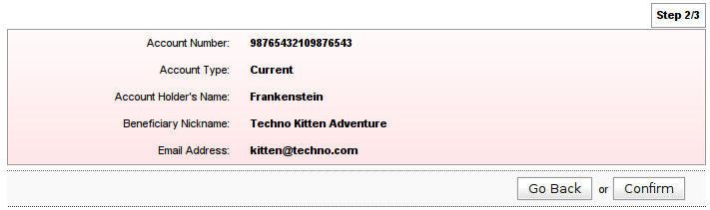

Step 3: Result
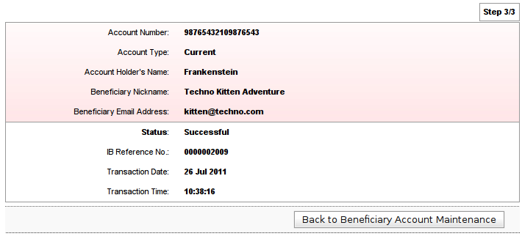
Delete Beneficiary Account

Step 1: Confirm
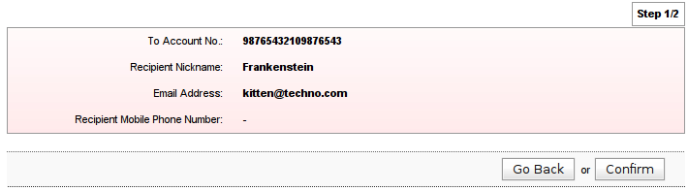

Step 2: Result
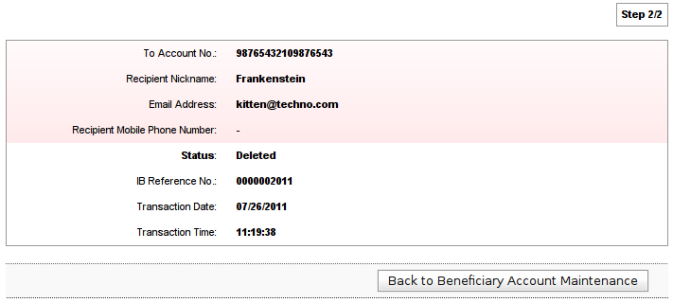

Interbank Transfer (via IBG)

Interbank Transfer shall allow the user to transfer money from their own account to another MEPS member’s bank. This module will be ready to launch on the Internet Banking site subject to the availability or readiness of Agrobank IBG System.

Open Interbank Account Transfer

Required information to be provided by the user:

- From Account
- Amount
- Beneficiary Bank
- Beneficiary Account Number
- Beneficiary Holder Name
- Transaction Reference
- Amount
- Email Address
- TAC

Flow Diagram

Sample Screen

Step 1: Details
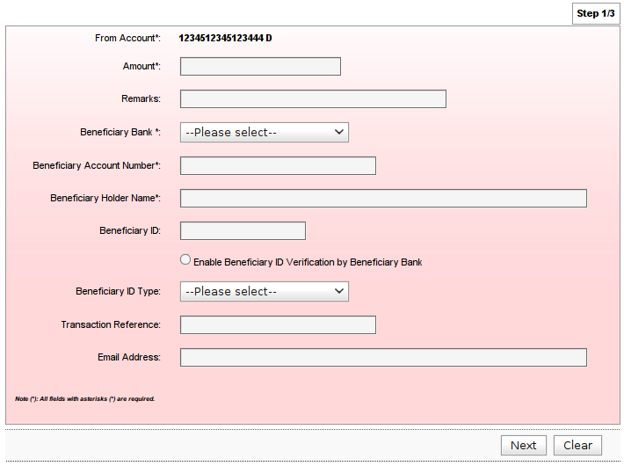

Step 2: Confirm
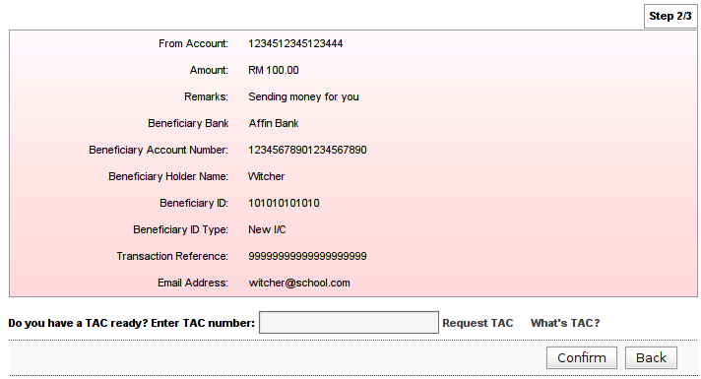

Step 3: Result
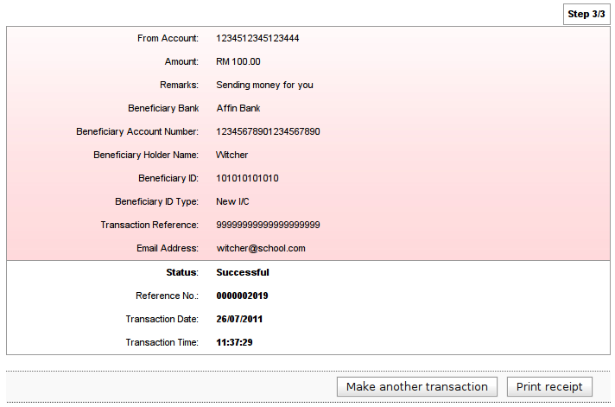

Screen Input Fields

Step | Field Name | Field Type | Rule | Description | Compulsory
1 | From Account | Drop Down List/Text Box | Drop Down if more than one account, Text Field if only one | The transfer from account number | Yes
1 | Amount | Text Box | Must be numeric. Accepts decimals. Allowed value is 0.01 – 9999999999999.99 | The transaction amount | Yes
1 | Remarks | Text Box | Alphanumeric and spaces only. Up to 30 characters | Allow user to make a remark for this transfer | No
1 | Beneficiary Bank | Drop Down List |  | The beneficiary bank in Malaysia | Yes
1 | Beneficiary Account Number | Text Box | Numeric only.  Tie to the beneficiary bank. Up to 20 numbers. | The account number in the recipient bank | Yes
1 | Beneficiary Holder Name | Text Box | Alphabets and spaces only. Up to 50 characters. | The account number beneficiary name in the recipient bank | Yes
1 | Beneficiary ID | Text Box | Alphanumeric and spaces only. Up to 20 characters. | IC, Police/Military ID, etc.. | No
1 | Enable Beneficiary ID Verification by Beneficiary Bank | Check Box |  | Check if required beneficiary bank to verify the ID | No
1 | Beneficiary ID Type | Drop Down List | Required if Beneficiary ID is filled in | The type of the beneficiary ID | Yes/No
1 | Transaction Reference | Text Box | Alphanumeric and spaces only.  Up to 20 characters only | Self reference remarks | No
1 | Email Address | Text Box | Email format. Up to 60 characters | Allow IB to send email to the beneficiary account holder | No
2 | TAC | Text Box | Must be 6 characters. Masked | The Transaction Authorization Code | Yes

Registered Interbank Account Transfer

Required information to be provided by the user:

- From Account
- Amount
- Interbank Transfer To

Flow Diagram

Sample Screen

Step 1: Details
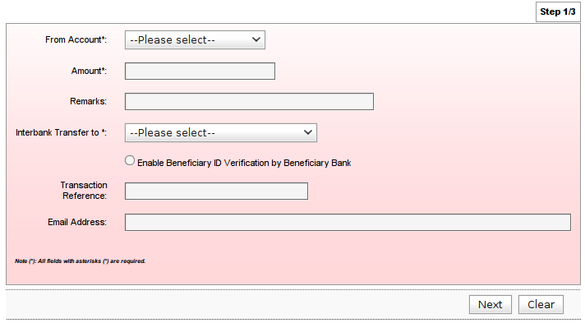

Step 2: Confirm

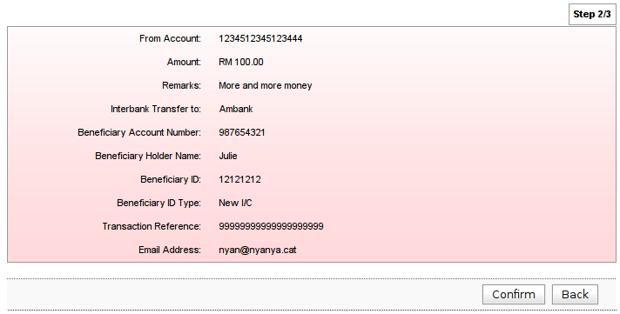

Step 3: Result
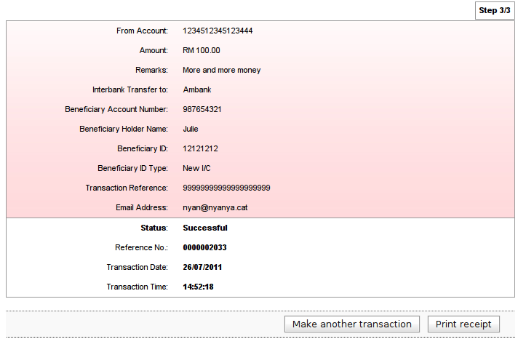

Screen Input Fields

Step | Field Name | Field Type | Rule | Description | Compulsory
1 | From Account | Drop Down List/Text Box | Drop Down if more than one account, Text Field if only one | The transfer from account number | Yes
1 | Amount | Text Box | Must be numeric. Accepts decimals. Allowed value is 0.01 – 9999999999999.99 | The transaction amount | Yes
1 | Remarks | Text Box | Alphanumeric and spaces only. Up to 30 characters | Allow user to make a remark for this transfer | No
1 | Interbank Transfer To | Drop Down List |  | The registered interbank accounts | Yes
1 | Enable Beneficiary ID Verification by Beneficiary Bank | Check Box |  | Check if required beneficiary bank to verify the ID | No
1 | Transaction Reference | Text Box | Alphanumeric and spaces only.  Up to 20 characters only | Self reference remarks | No
1 | Email Address | Text Box | Email format. Up to 60 characters | Allow IB to send email to the beneficiary account holder | No

Beneficiary Interbank Account Maintenance

This feature shall allows the user to:

- Add a new registered interbank account
- Update a registered interbank account
- Remove a registered interbank account

Required information to be provided by the user:

- Beneficiary Bank
- Beneficiary Account Number
- Beneficiary Holder Name

Flow Diagram

Sample Screen

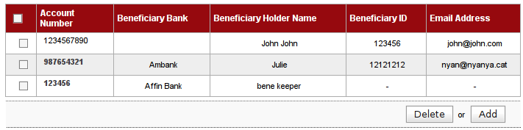
Screen Fields

No | Field Name | Description
1 | Account Number | The transfer To account number
2 | Beneficiary Bank | The transfer to bank
3 | Beneficiary Holder Name | The transfer to account holder name
4 | Beneficiary ID | The transfer to account holder ID
5 | Email | The transaction to account holder email address

Add Registered Interbank

Step 1: Details
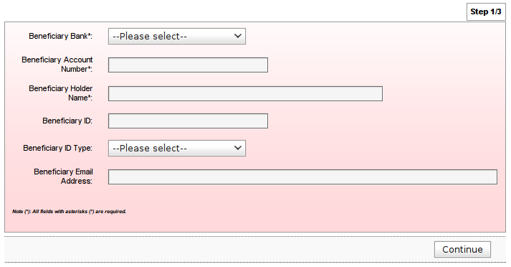

Step 2: Confirm
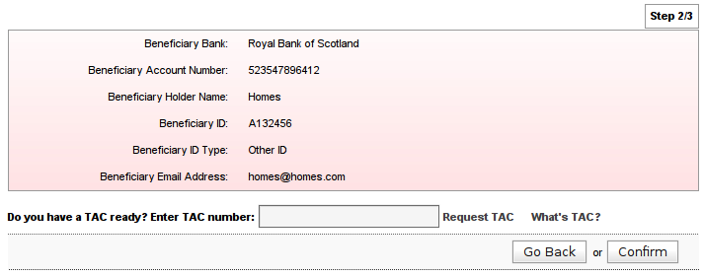

Step 3: Result
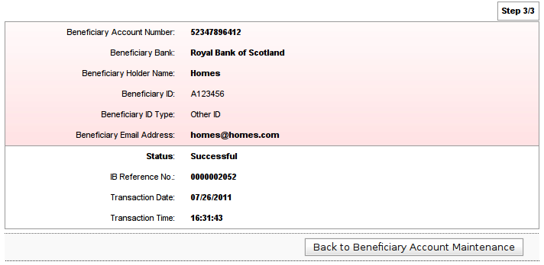

Screen Input Fields

Step | Field Name | Field Type | Rule | Description | Compulsory
1 | Beneficiary Bank | Drop Down List |  | The to account bank | Yes
1 | Beneficiary Account Number | Text Box | Up to 20 characters | The transfer to account number | Yes
1 | Beneficiary Holder Name | Text Box | Alphabets and spaces only. Up to 60 characters | The to account holder name | Yes
1 | Beneficiary ID | Text Box | Alphanumeric only. Up to 20 characters | The to account ID | No
1 | Beneficiary ID Type | Drop Down List | Required if Beneficiary ID is filled in | The beneficiary id type | Yes/No
1 | Beneficiary Email Address | Text Box | Email format. Up to 60 characters | Allow IB to send email to the To Account holder | No
2 | TAC | Text Box | Must be 6 characters. Masked | The Transaction Authorization Code | Yes

Update Registered Interbank

Step 1: Details

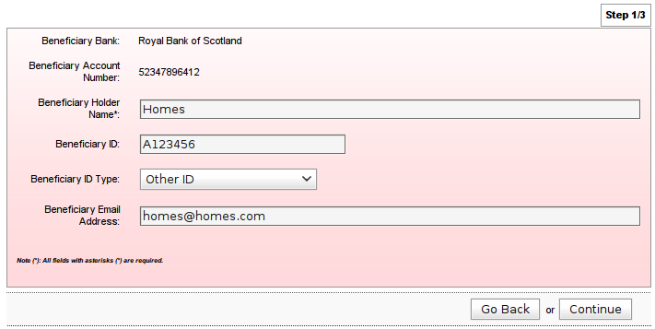

Step 2: Confirm

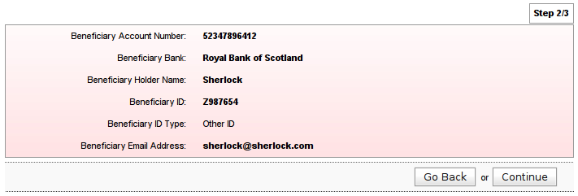

Step 3: Result
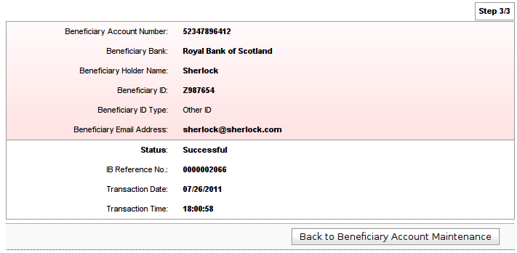

Screen Input Fields

Step | Field Name | Field Type | Rule | Description | Compulsory
1 | Beneficiary Holder Name | Text Box | Alphabets and spaces only. Up to 60 characters | The to account holder name | Yes
1 | Beneficiary ID | Text Box | Alphanumeric only. Up to 20 characters | The to account ID | No
1 | Beneficiary ID Type | Drop Down List | Required if Beneficiary ID is filled in | The beneficiary id type | Yes/No
1 | Beneficiary Email Address | Text Box | Email format. Up to 60 characters | Allow IB to send email to the To Account holder | No

Delete Registered Interbank

Step 1: Confirm
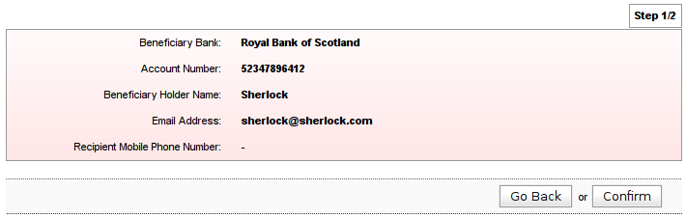

Step 2: Result
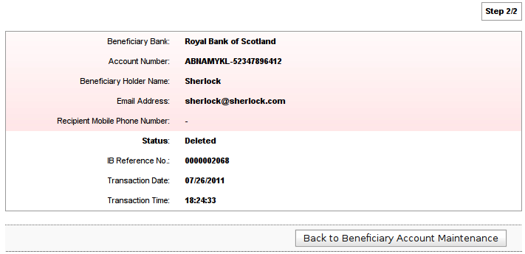

Bill Payments

Bill Payments shall allow the user to make a payment to a payee corporation like Telekom, Tenaga National, etc.

Open Bill Payments

This feature allow the user to make open payment to a payee corporation account.

Required information to be provided by the user:

- Payee Corporation
- From Account
- Bill Account Number
- Amount
- TAC

Due to the fields being different for different payee corporation, the actual input fields will vary. The below is only a sample screen.

All of the input fields that are available for the Details page are as below:

Screen Input Fields

No | Field Name | Field Type | Rule | Description | Compulsory
1 | From Account | Drop Down List/Text Box | Drop Down if more than one account, Text Field if only one | The transfer to account number | Yes
2 | Amount | Text Box | Payee can set a minimum and maximum amount which override default.  Must be numeric. Accepts decimals. Default allowed value is 0.01 – 9999999999999.99 | The transaction amount | Yes
3 | Bill Account Holder | Text Box | Visible if required by payee.  Alphanumeric and spaces only.  Up to 40 characters | The payee code that represent the payee corporation | Yes/No
4 | Bill Account Number | Text Box | Label can be changed by the payee. Visible if required by payee (normally is required) Alphanumeric and spaces only. Up to 30 characters. | The account number from a Payee Corporation | Yes/No
5 | Bill Reference Number 1 | Text Box | Label can be changed by the payee. Visible if required by payee. Can be made as mandatory | Bill Reference Number 1 which is used by payee that require additional input from user for the transaction | Yes/No
6 | Bill Reference Number 2 | Text Box | Label can be changed by the payee. Visible if required by payee. Can be made as mandatory | Bill Reference Number 2 which is used by payee that require additional input from user for the transaction | Yes/No

Flow Diagram

Sample Screen

Step 1: Payee category
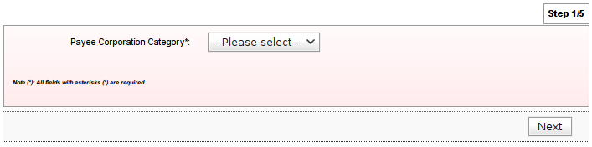

Step 2: Payee
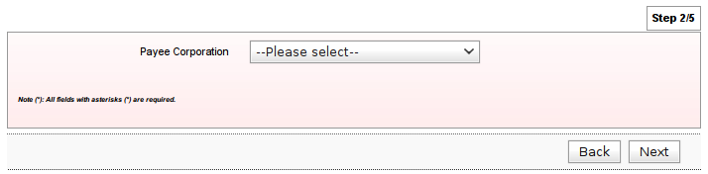

Step 3: Details
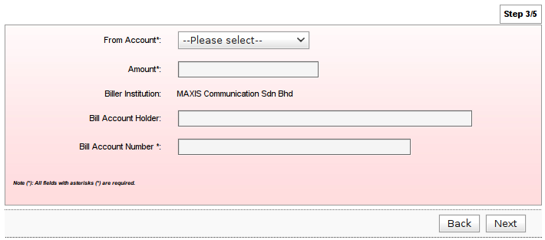

Step 4: Confirm
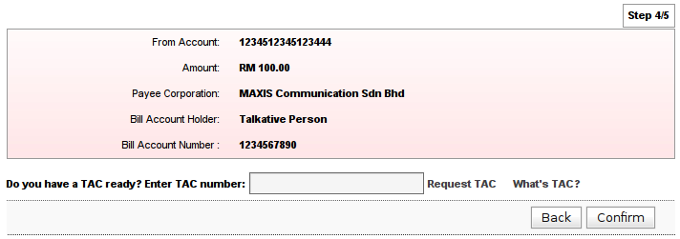

Step 5: Result
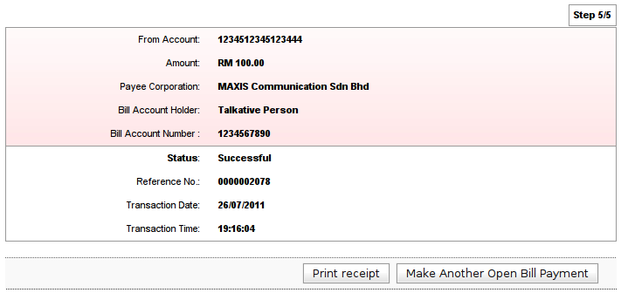
Screen Input Fields

Step | Field Name | Field Type | Rule | Description | Compulsory
1 | Payee Corporation Category | Drop Down List |  | Payee industry categories | Yes
2 | Payee Corporation | Drop Down List |  | A pre-registered Payee | Yes

Payment to Registered Payee Corporation

This feature allow user to make a payment to a registered payee corporation account.

Required information to be provided by the user:

- Payee Corporation
- From Account
- Bill Account Number
- Amount
- TAC

Due to the fields being different for different payee corporation, the actual input fields will be varied. The below is only a sample screen.

All of the input fields that are available for the Details page are above in the Open Bill Payments section.

Flow Diagram

Sample Screen

Step 1: Registered payee
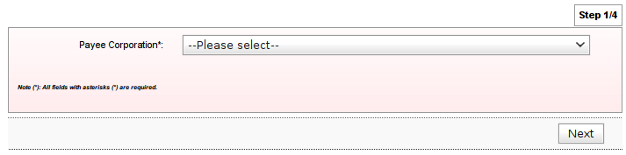

Step 2: Details
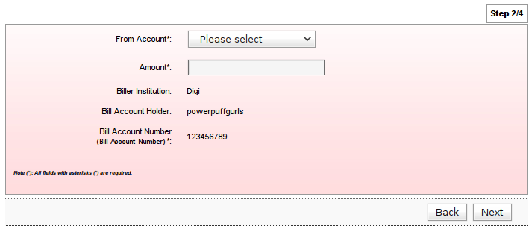

Step 3: Confirm
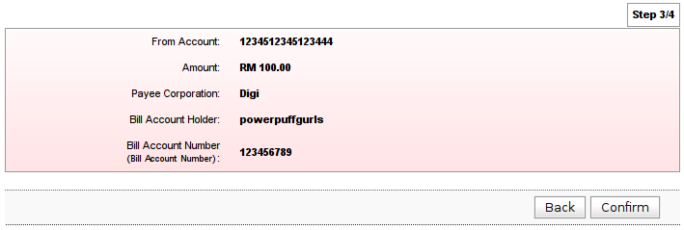

Step 4: Result
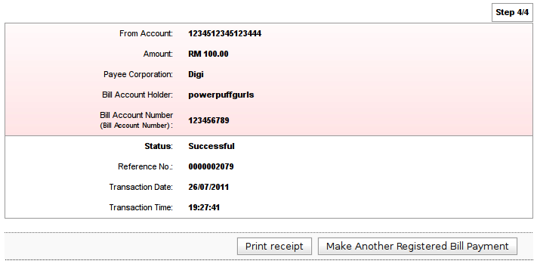

Screen Input Fields

Step | Field Name | Field Type | Rule | Description | Compulsory
1 | Payee Coperation | Drop Down List |  | A registered payee | Yes
2 | From Account | Drop Down List/Text Box | Drop Down if more than one account, Text Field if only one | The transfer to account number | Yes
2 | Amount | Text Box | Payee can set a minimum and maximum amount which override default.  Must be numeric. Accepts decimals. Default allowed value is 0.01 – 9999999999999.99 | The transaction amount | Yes

Registered Payee Maintenance

This feature shall allows the user to:

- Add a new registered payee account
- Remove a registered payee account

Required information to be provided by the user:

- Biller Institution
- Bill Account/Reference Number
- Bill Account Holder Name

Sample Screen Design

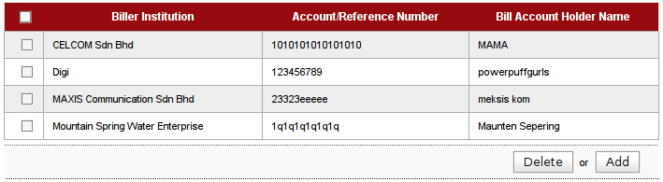

Screen Fields

No | Field | Description
1 | Biller Institution | Biller institution name
2 | Account/Reference Number | Account or reference number of the bill
3 | Bill Account Holder Name | Account subscriber name

Flow Diagram

Sample Screen

Step 1: Payee category
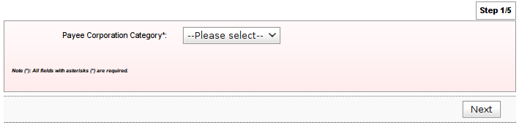

Step 2: Payee
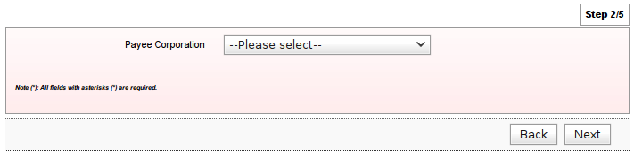

Step 3: Details
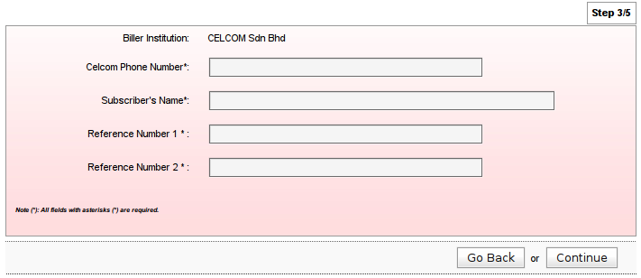

Step 4: Confirm
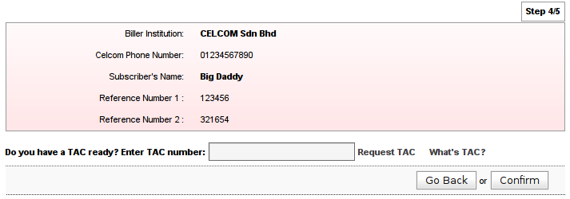

Step 5: Results
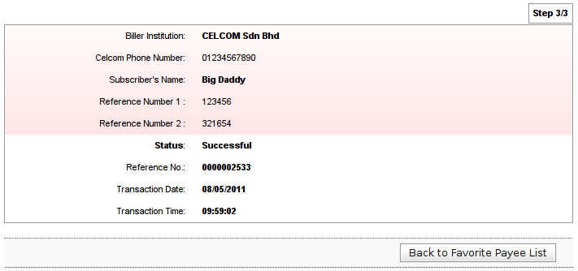

Screen Input Fields

Page | Field Name | Field Type | Rule | Description | Compulsory
1 | Payee Corporation Category | Drop Down List |  | Payee industry categories | Yes
2 | Payee Corporation | Drop Down List |  | A pre-registered Payee | Yes
3 | Please refer to Open Bill Payment section
4 | TAC | Text Box | Must be 6 characters. Masked | The Transaction Authorization Code | Yes

Delete a Registered Payee Account

Step 1: Confirm
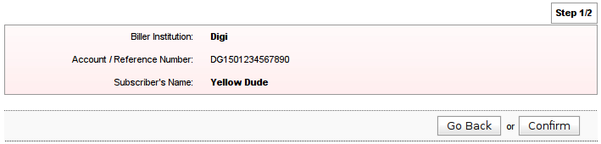

Step 2: Result
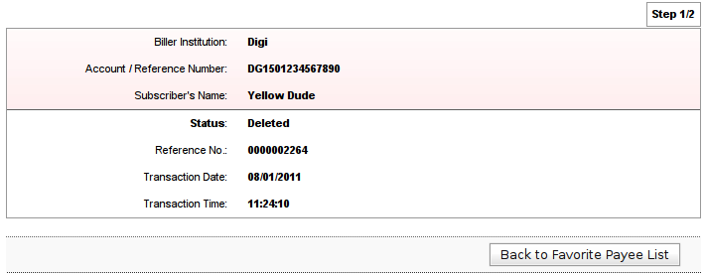

Transfer Limit

This module allows the user to maintain their account transfer limits for third party and interbank transfers.

Flow Diagram

Screen Fields

No | Field Name | Limit Selection (RM)
1 | Open Third Party Transfer | 0, 3000, 6000, 9000, 10000, 15000
2 | Register Third party Transfer | 0, 3000, 6000, 9000, 10000, 15000
3 | Open Interbank Transfer | 0, 1000, 2000, 3000, 4000, 5000
4 | Register Interbank Transfer | 0, 1000, 2000, 3000, 4000, 5000

Sample Screen

Step 1: Details
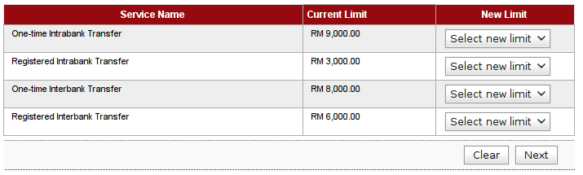

Step 2: Confirm
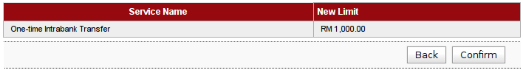

Step 3: Result
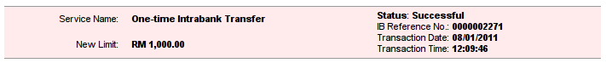

Screen Input Fields

Page | Field Name | Field Type | Rule | Description | Compulsory
1 | New Limit | Drop Down List |  | List of maximum limits for respective transaction | No

Services Request

Services Request module provides a list of services which allow the user to make any service request online. The services currently included is block ATM card. More services shall be added here when new services are offered to the user.

Block ATM card

Users can use this feature to block their ATM card. Once the request is received from the user, the message shall be posted to the ATM server and the requested ATM card shall be blocked immediately.

Flow Diagram

Sample Screen

Step 1: Details
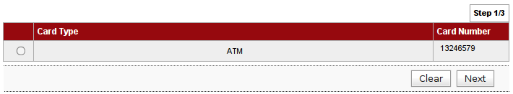

Step 2: Confirm
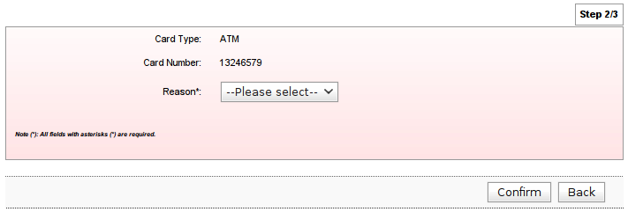

Step 3: Result
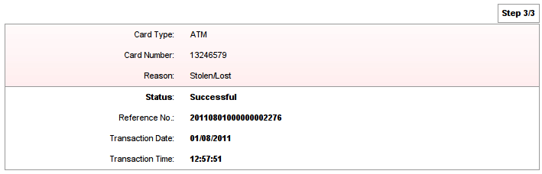

Screen Input Fields

Step | Field Name | Field Type | Rule | Description | Compulsory
2 | Reason | Drop Down List |  | List of maximum limits for respective transaction | No

Profile Maintenance

This maintenance module provides a feature allowing the users to update their profile information.

Update Profile
This feature allows users to update their profile such as display name and marketing information. Some information are for display purposes only and cannot be edited.

Flow Diagram

Sample Screen

Step 1: Details
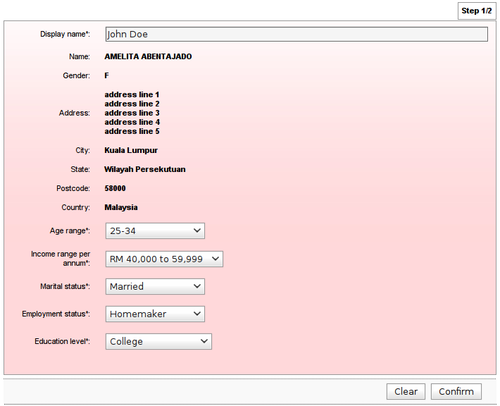

Step 2: Result
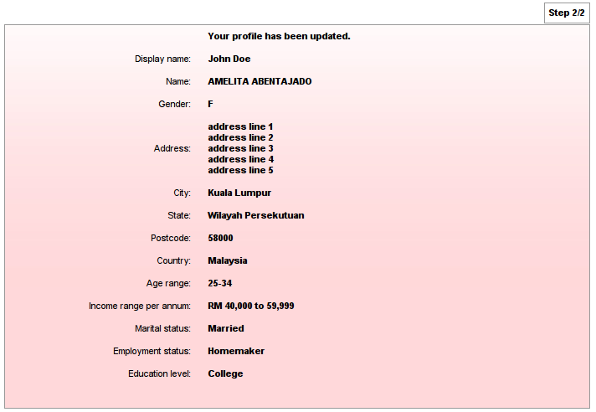

Screen Input Fields

Step | Field Name | Field Type | Rule | Description | Compulsory
1 | Display Name | Text Box | Alphanumeric, spaces and and underscore only. Up to 60 characters | The name that user would like to be seen in the IB page | No
1 | Age range | Drop Down List |  | Age range of the user | No
1 | Income range per annum | Drop Down List |  | The income range that the user makes | No
1 | Marital status | Drop Down List |  | That marital status of the user | No
1 | Employment Status | Drop Down List |  | That employment status of the user | No
1 | Education Level | Drop Down List |  | That education level status of the user | No
2 | TAC | Text Box |  |  | No

Change Password

This feature allows the users to change their password.

Required information to be provided by the user:

- Old password
- New password
- TAC

Flow Diagram

Sample Screen Design

Step 1: Details
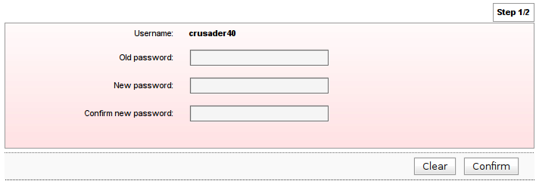

Step 2: Result

Screen Input Fields

Step | Field Name | Field Type | Rule | Description | Compulsory
1 | Old Password | Text Box | Must be a combination of numeric, lower case alphabet, upper case alphabet and permitted special character. 8 - 12 characters. Masked | This password will be used for login  Permitted special characters:  !, @, #, $, %, ^, &, *, (, ), <, >, =, _ | Yes
1 | New Password | Text Box | Must be a combination of numeric, lower case alphabet, upper case alphabet and permitted special character. 8 - 12 characters. Masked | This password will be used for login  Permitted special characters:  !, @, #, $, %, ^, &, *, (, ), <, >, =, _ | Yes
1 | Confirm New Password | Text Box | Must be the same as the new password. Masked | To confirm to the new password | Yes

Change Security Questions

This feature allows the users to change their security questions and answers

Required information to be provided by the user:

- Old Security Answer
- New Security Questions
- New Security Answers

Flow Diagram

Sample Screen

Step 1: Details
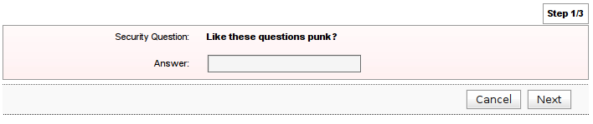

Step 2: Confirm
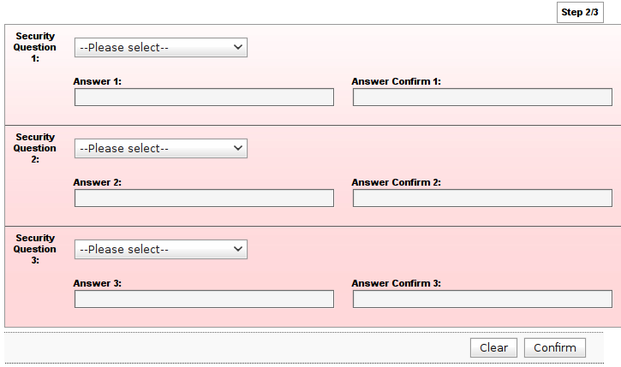

Step 3: Result

Screen Input Fields:

Step | Field Name | Field Type | Rule | Description | Compulsory
1 | Answer | Text Box | Up to 30 characters. Masked. | The preset answer for the displayed security question | Yes
2 | Security Question 1 | Drop Down List |  | User must select a security question which cannot be the same as Security Question 2 and 3 | Yes
2 | Answer 1 | Text Box | Single or combination of numeric, alphabet or alphanumeric. Permitted special characters are allowed. Up to 30 characters. Masked. | User must provide a answer to the above question and remember  Permitted special characters:  _, ., <space> | Yes
2 | Confirm Answer 1 | Text Box | Up to 30 characters. Masked. | To confirm the answer | Yes
2 | Security Question 2 | Drop Down List |  | User must select a security question which cannot be the same as Security Question 1 and 3 | Yes
2 | Answer 2 | Text Box | Single or combination of numeric, alphabet or alphanumeric. Permitted special characters are allowed. Up to 30 characters. Masked. | User must provide a answer to the above question and remember  Permitted special characters:  _, ., <space> | Yes
2 | Confirm Answer 2 | Text Box | Up to 30 characters. Masked. | To confirm the answer | Yes
2 | Security Question 3 | Drop Down List |  | User must select a security question which cannot be the same as Security Question 1 and 2 | Yes
2 | Answer 3 | Text Box | Single or combination of numeric, alphabet or alphanumeric. Permitted special characters are allowed. Up to 30 characters. Masked. | User must provide a answer to the above question and remember  Permitted special characters:  _, ., <space> | Yes
2 | Confirm Answer 3 | Text Box | Up to 30 characters. Masked. | To confirm the answer | Yes

Message Box

This feature enables bank Administrator to send messages to the users and also allow the users to send messages to bank.

Inbox

This feature allow the users to view the list of messages and to read the message details.

Sample Screen

Message Listing Page
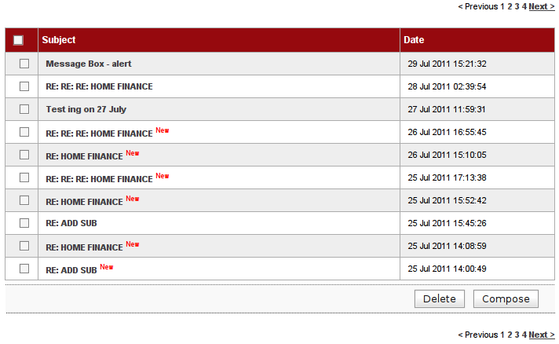

Screen Fields

No | Field Name | Description
1 | Subject | The message subject
2 | Date | The message date

Message Details Page

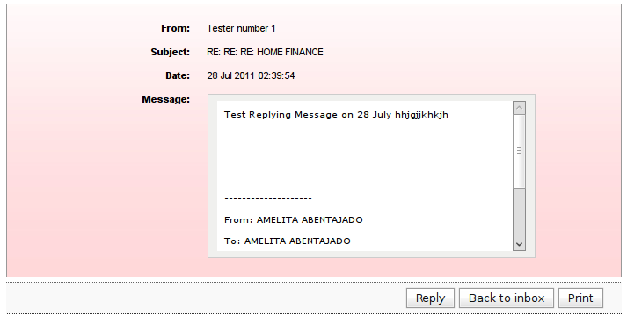

Screen Fields

No | Field Name | Description
1 | From | The sender
2 | Subject | The main subject of the message
3 | Date | The message sent date time
4 | Message | The message

Replay Message

This feature allow the users to create reply a message and send to Customer Support. Not all messages can be replied as determined by the Administrator.

Sample Screen

Step 1: Details
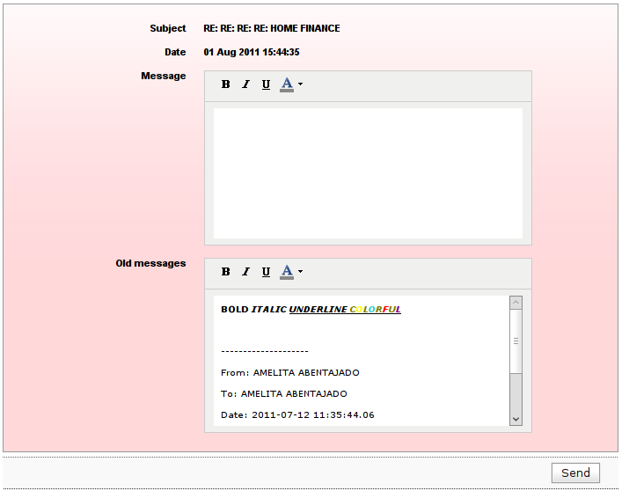

Screen Input Fields

Step | Field Name | Field Type | Rule | Description | Compulsory
1 | Message | Text Box |  | New message text | Yes

Step 2: Confirm
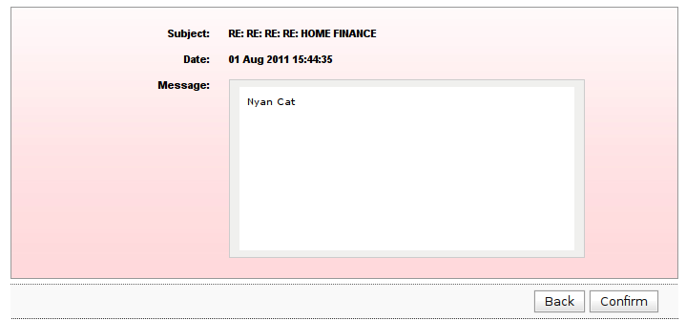

Step 3: Result
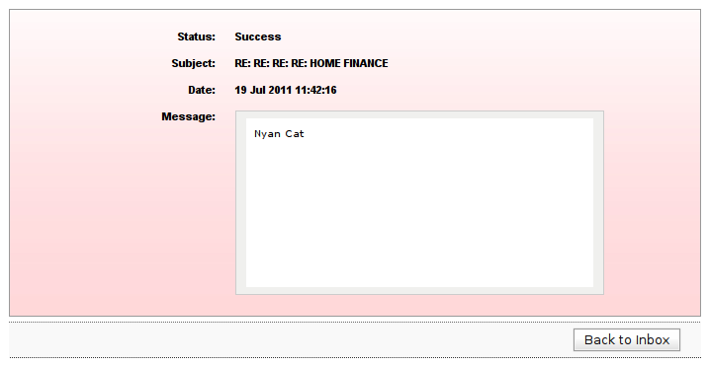

Delete Message

This feature allow the users to delete messages. Messages can be deleted from the Inbox, Sent Box and Trash.

Sample Screen

Step 1: Confirm
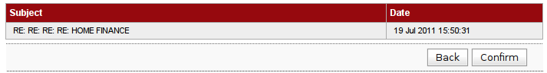

Step 2: Result
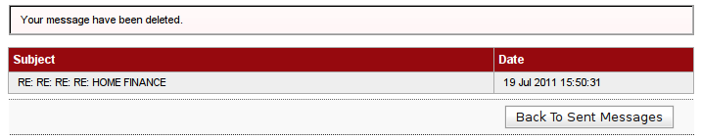

Sent Messages

This feature allow the users to view all the sent messages.

Sample Screen

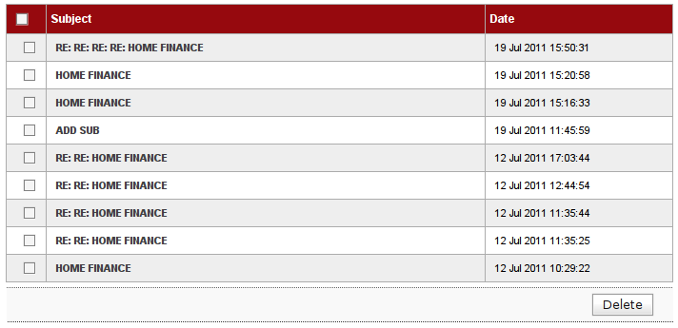

Screen Fields

No | Field Name | Description
1 | Subject | The message subject
2 | Date | The message date

Trash

This feature allow the users to view all the trashed messages. Users can use this feature to clean up messages.

Sample Screen

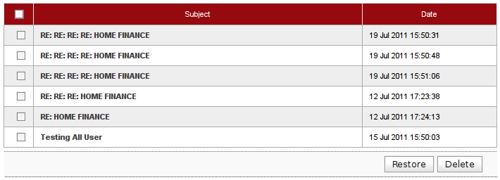

Screen Fields

No | Field Name | Description
1 | Subject | The message subject
2 | Date | The message date

Restore Message

This feature allow the users to restore messages that are in the Trash.

Sample Screen

Step 1: Confirm
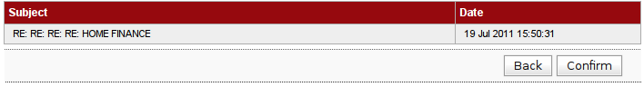

Step 2: Result
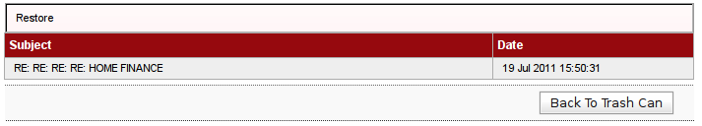

Retail Internet Banking Demo
Retail Internet Banking system demo will be built in HTML format.

Retail Internet Banking Reports
List of reports currently generated from Internet Banking System.

No | Report | Mode | File Type
 | Internet Transaction Report | Daily | txt, csv
 | IB Registration Report | Daily | txt, csv
 | Own Account Funds Transfer Report | Daily | txt, csv
 | Intrabank Funds Transfer Report | Daily | txt, csv
 | Interbank Funds Transfer Report | Daily | txt, csv
 | User Activities Report | Daily | txt, csv
 | Bill Payment Report | Daily | txt, csv
 | TAC Issuance Report | Daily | txt, csv
 | FD Placement Report | Daily | txt, csv
 | FD Upliftment Report | Daily | txt, csv
 | Transaction Time | Daily | txt, csv
 | Consolidated Transaction IB | Daily | txt, csv
 | Block ATM Report | Daily | txt, csv
 | Exception Report | Daily | txt, csv
 | IB Account Opening Report | Daily | txt, csv
 | ITEPS Report (For BNM) | Daily | txt, csv
 | SMS Issuance Report | Daily | txt, csv
 | Consolidated Monthly Transactional Report | Monthly | txt, csv
 | Consolidated Monthly Service Request Report (If applicable) | Monthly | txt, csv
 | ePay Reconciliation File | Daily | txt, csv
 | Audit Trail Report | Daily | txt, csv
 | Security Violation Report | Daily | txt, csv
 | All User Report | Daily | txt, csv
 | Inactivated User Report | Daily | txt, csv

Report format:
Report content format is differing for all different report. But, all comply to the similar template below.

Report Header
Report Date

Report Title

--------------------------------------------------------------------------------------------------------------------------------
Field Header
--------------------------------------------------------------------------------------------------------------------------------
Content

--------------------------------------------------------------------------------------------------------------------------------
Summary (If have)
--------------------------------------------------------------------------------------------------------------------------------

Footer

----------- END -----------

