Error log 2
Indeks No | Test No | Action | Notes
10 | 7 | Upload files via B2B | Company with orgcode 800 upload IBG file to B2B server.  File not process.  Error logs shows orgcode not found.
6 | 4 | IBG data entry | Company with orgcode 800 perform IBG data entry at CDB.  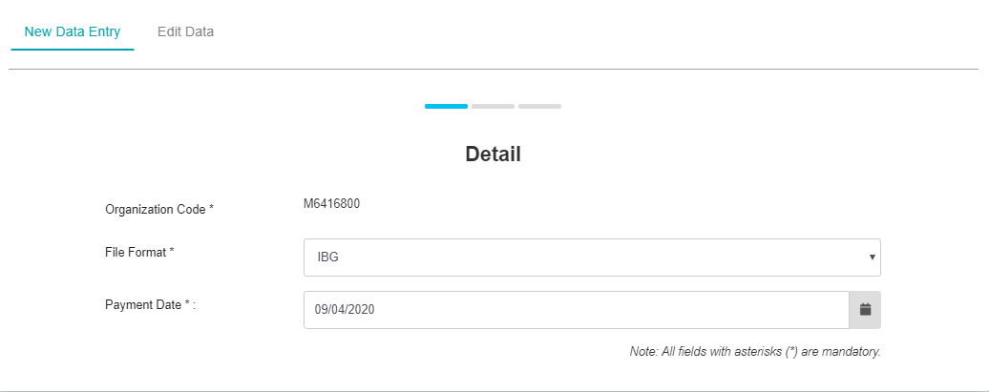  CDB save the file but convert the orgcode to 700. Refer index no 12 Notes number 3 for the impact.  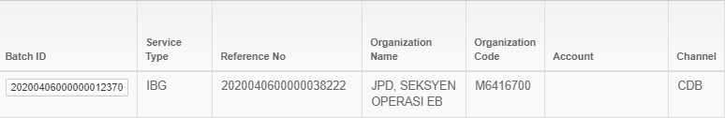
12 | 9 | Run EOD | - Missing service type after EOD complete  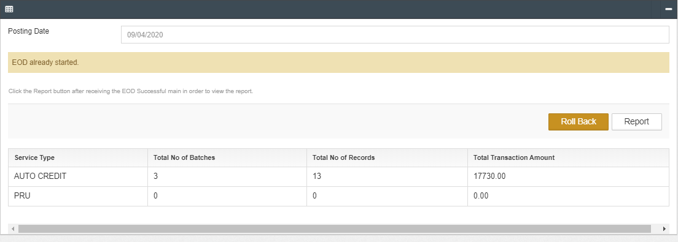  - EOD not process if no input from eBiz.  eg. If eBiz only send file autocredit, cdb will not process and generate file autodebit, agents and auto reg  - EOD not process IBG file submitted by company with orgcode 800.  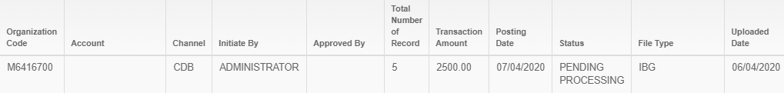  - Missing some details at EOD file  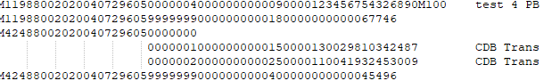  - Inconsistent trans code in AUTO_CR file  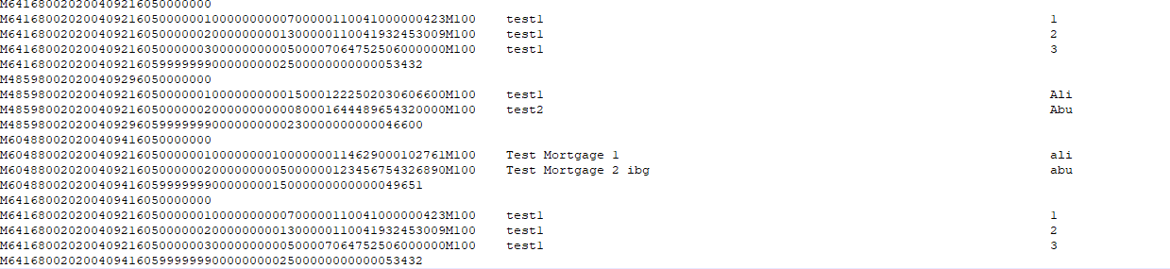  - Bank code and other customer account field display BSN bank code and customer account in AUTO_CR file. Should be left blank if customer select BSN at IBG data entry.  