**RIB Transaction Enquiry**

*Mandatory Field:*

1. *User Name OR Customer Name AND*
2. *Transaction Date From AND Transaction Date To (Range 6 Month) OR*
3. *Effective Date To AND Effective Date to (Range 6 Month)*

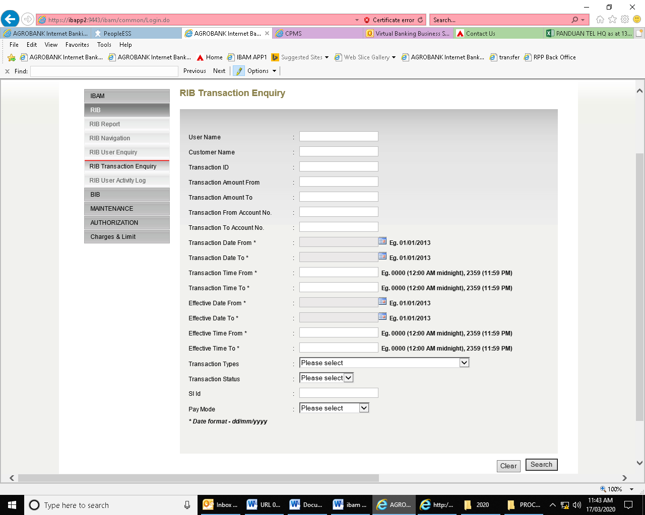

**BIB Transaction Enquiry**

*Mandatory Field:*

1. *CIF Number OR Company Name OR Company ID AND*
2. *Transaction Date From AND Transaction Date To (Range 6 Month) OR*
3. *Effective Date From AND Effective Date to (Range 6 Month)*

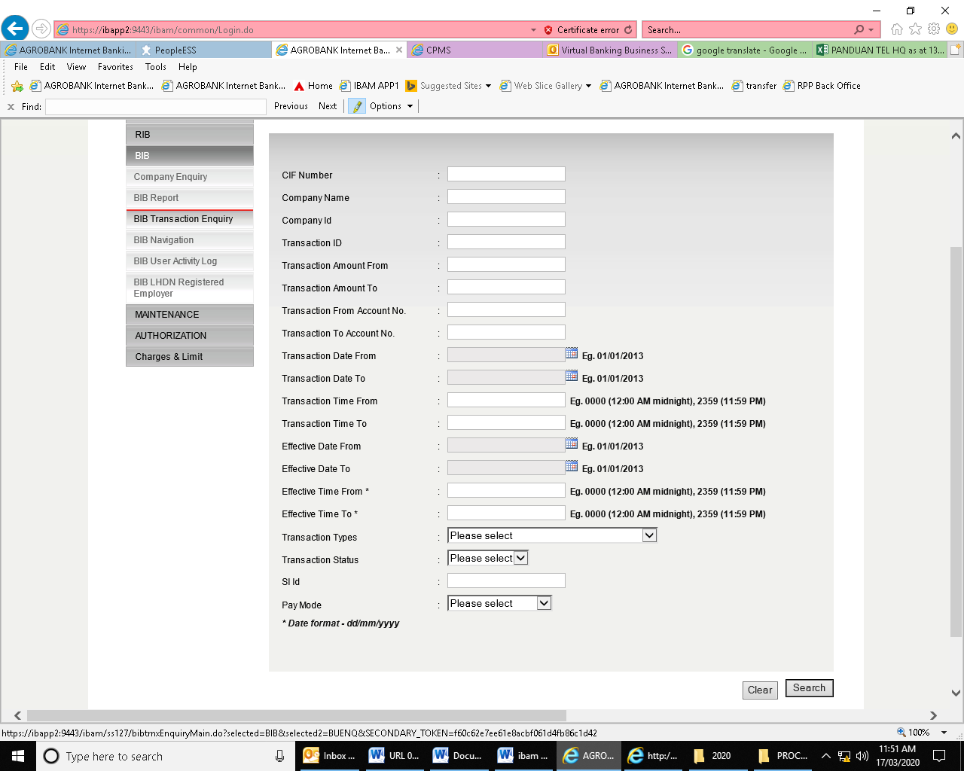

**RIB User Activity Log**

*Mandatory Field:*

1. *~~User Name AND~~*
2. *Date From AND Date to (~~Range 6 Month)(~~ Range 3 months)*

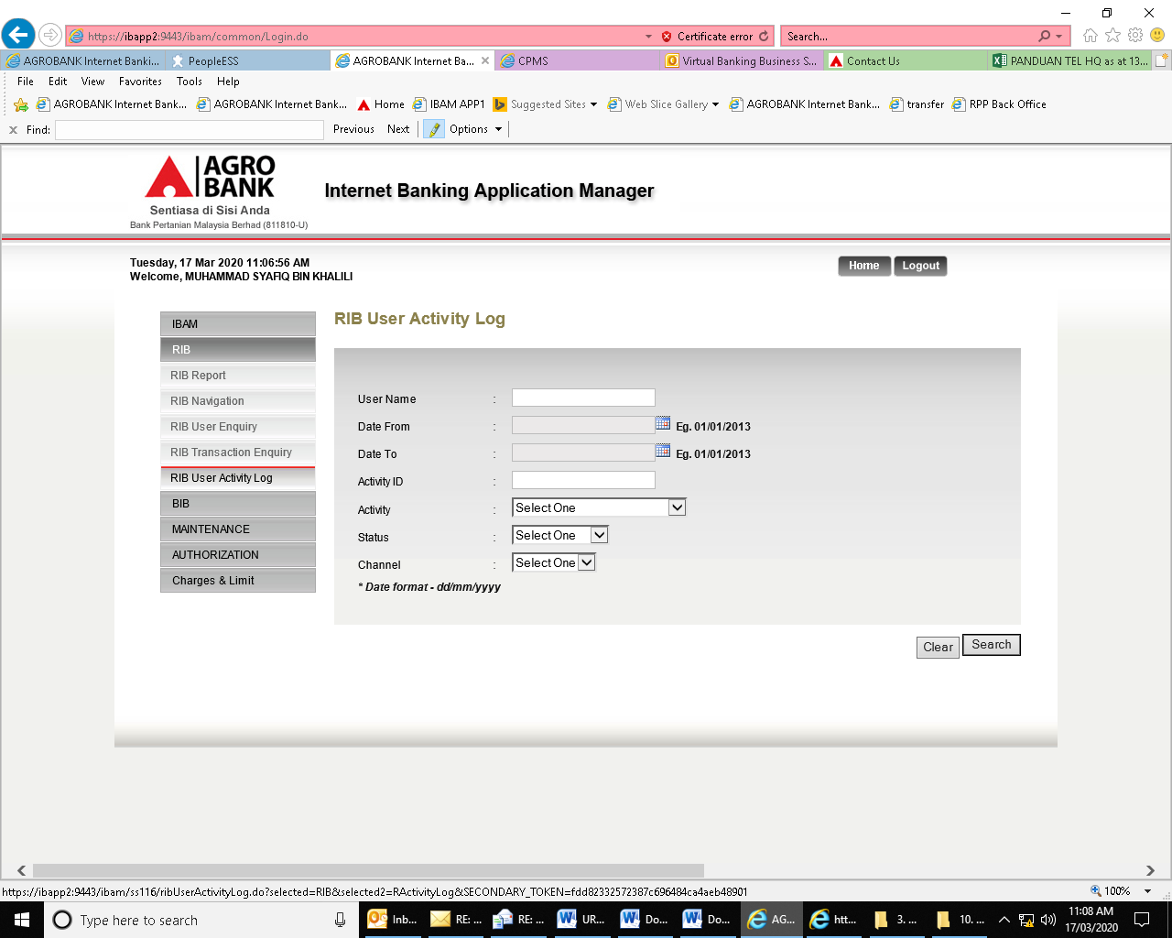

**BIB User Activity Log**

*Mandatory Field:*

1. *~~User Name AND~~*
2. *Date From AND Date To (~~Range 6 Month)(~~ Range 3 months)*

