Appendix B

**Login Screen**

1. To add new hyperlink **“Moratorium Opt-In”** in landing page KFHOnline as below:



1. The above hyperlink will route customer to the next screen as below.
2. To remove the hyperlink after 6 months or whichever period specified by KFH.

**Details Screen**

1. To display the following screen once the “Moratorium Opt-In” hyperlink is clicked.

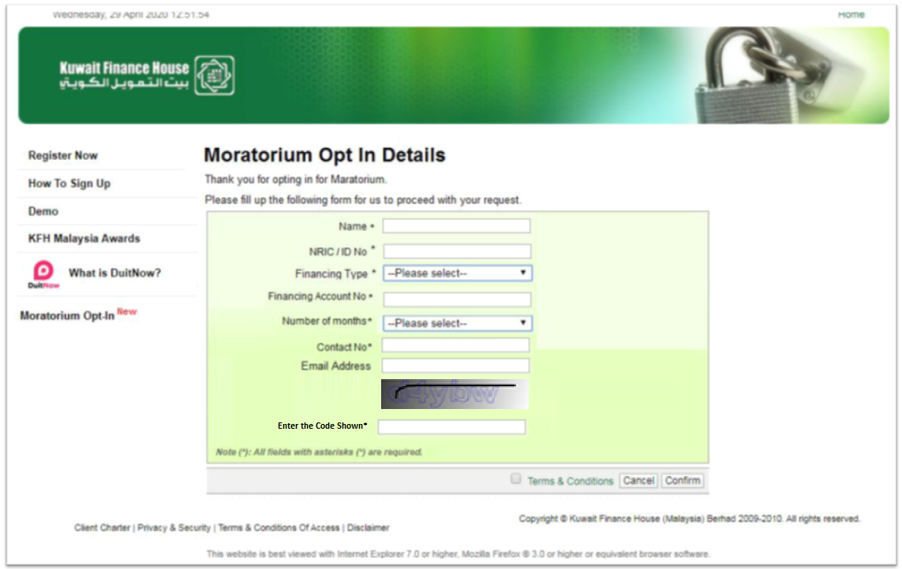

1. To set all the fields as mandatory, except for Email Address
2. To apply existing Email Address format checking
3. User is not allowed to proceed until checked the Terms & Conditions checkbox
4. User must enter the CAPTCHA security code for bot prevention
5. Financing Type dropdown list contain: -

* Personal Financing
* Hire Purchase
* Mortgage

1. Number of month dropdown list contain: -

* 1 month
* 2 months
* 3 months
* 4 months
* 5 months
* 6 months

1. “Cancel” button – Route to KFH Online login page
2. “Confirm” button - Submit the request and to show the following screen.

**Submission Screen**

1. To display the following screen once the “Confirm” button is clicked.



**Moratorium Request Report**

1. To have a daily report on all the request received from KFH Online. This is for Finance team to check on the moratorium request.
2. The report to be available via CORUS under option “Moratorium Request Report” and to be ready on T+1 basis.
3. The report should be able to download/export to EXCEL format.
4. To sort the report by Date and Time
5. To group the output by NRIC/ID No if there is a multiple request from the same NRIC/ID No.
6. Below is the report layout

|  |  |  |  |  |  |  |
| --- | --- | --- | --- | --- | --- | --- |
| Date/Time | Reference No | Name | NRIC/ID No | Financing Type | Financing Account No | Contact Number |
|  |  |  |  |  |  |  |
|  |  |  |  |  |  |  |
|  |  |  |  |  |  |  |

Appendix C - Scope of Work

|  |  |
| --- | --- |
| **CR No:** | **IBSCR20002** |
| **CR Title:** | **Opt in Moratorium via KFH Online** |

| System | Affected Modules | Change Description |
| --- | --- | --- |
| Consumer | Login | 1) Develop Moratorium Opt In submission form  2) Security Measure:   * Use CAPTCHA to prevent bot * Perform SQL Injection validation * Perform data type validation like email format validation, numeric only validation, alphanumeric validation, etc. * Verify duplicated financing account no * Only enable the Confirm button after user checked the Terms & Conditions checkbox |
| Corus & Report Generator | Daily Moratorium Opt in Report | Add new daily report for Moratorium Opt In |
| Database | New tables, columns/Table Mapping | To create new DB table to cater to Moratorium Opt In requirements  Table mapping |
| FSD, SIT & Test Result |  | FSD compilation, perform SIT, compile test result and traceability matrix |