Maybank Amex Secure Site
Personal & Corporate User Guide

Prepared By

Maybank, Malaysia

&



Version: 1.0
Revision

Revision | Amendment | Ref In Doc | Updated By | Date
1.0 | New Document | All | Md Hafizudin Khojali | 21/04/2010
2.0 | - Combine Enrollment Continue Corporate with Enrollment Continue Personal  - Combine Add Card Continue Corporate with Add Card Continue Personal  - Replace Main Page image  - Replace Reward Point Page image  - Replace Remove Card Page image | 1.2.4  5.3.2  5.4.1  6.1  6.2 | Md Hafizudin Khojali | 20/05/2010
3.0 | -Replace all image | All | Md Hafizudin Khojali | 28/06/2010
Table of Contents
1.0 Login/Registration 4
1.0 Login 4
1.1 Main Page 5
1.2 User ID Creation 6
1.2.1 Registration User 6
1.2.2 Registration Result 7
1.2.3 Enrollment 8
1.2.4 Enrollment Continue 9
1.2.5 Enrollment Result 13
1.3 Change Temporary Password 14
1.3.1 Change Password 14
1.3.2 Change Password Result 15
2.0 Recent Charges 16
2.1 Choose Recent Charges 16
2.2 Recent Charges Detail 17
3.0 Current Billed 18
3.1 Choose Current Billed 18
3.2 Current Billed Detail 19
4.0 Other Periods 20
4.1 Choose Other Periods 20
4.2 Choose Periods Date 21
4.3 Other Periods Detail 22
5.0 Manage Account 23
5.1.0 Change Email Address 24
5.1.1 Change Your Email Address 24
5.1.2 Change Email Address Result 25
5.2 Change Password 26
5.2.1 Change Your Password 26
5.2.2 Change Password Result 27
5.3 Add Another Card 28
5.3.1 Add Card 28
5.3.2 Add Card Continue 29
5.3.1 Add Card Result 32
5.4 Remove Card 33
5.4.1 Choose Remove Card Account 33
5.4.2 Remove Card Result 34
6.0 Membership Rewards Online 35
6.1 Choose Membership Reward Account 35
6.2 Membership Reward Result 36

1.0 Login/Registration

Login

To access the system, user is need to login first before can use the system. User can follow the following steps to login.

Step:-

- Enter user id and password in the form
- Click on Go button.
- If passed, it will redirect to Main page

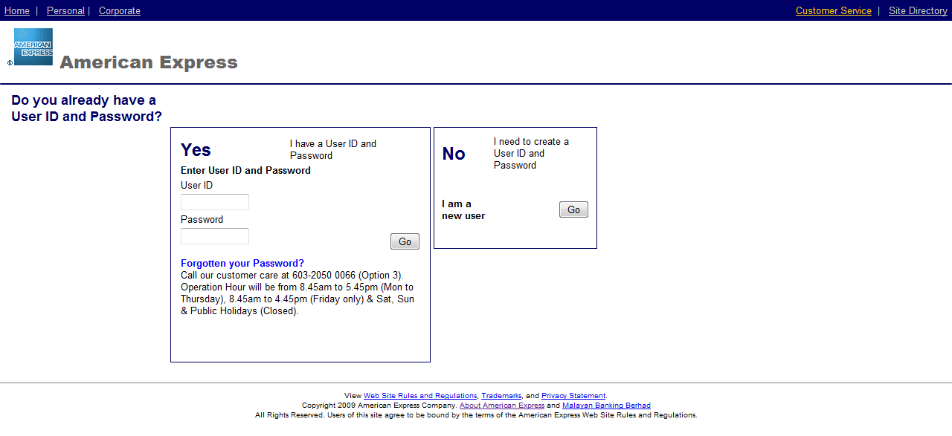

Input requirement
User ID: | - Required  - 6 <= length <= 16 Character  - At least 1 letter  - Not allow special characters such as (&>* ! %) and space.  - Underscore bar and full stop is allowed
Password: | - Required  - 8 <= length <= 12 Character  - At least 1 letter and least 1 number  - must contain special symbol, number, upper and lower characters  - Unsuccessful attempt < 3 times

1.1 Main Page

In the main page, all buttons will redirect to respective page when clicked

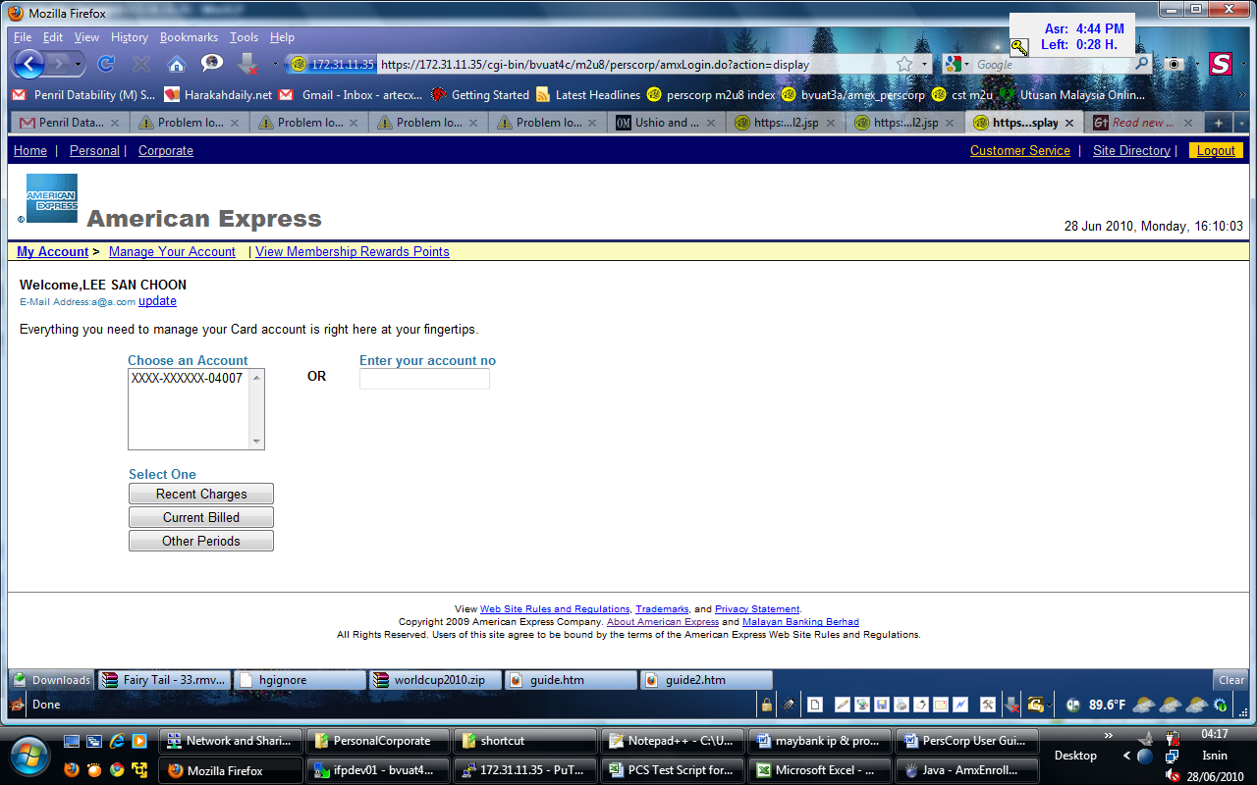

Input requirement
Choose an Account: | - Select an Account or Enter Account Number is Required
Enter Account Number: | - Select an Account or Enter Account Number is Required  - Length - 15 Character  - Numeric

1.2 User ID Creation

1.2.1 Registration User

Click on the Go button in No box at Login page to come to this page. This page is used to create new login ID and password. User can follow the following steps to create user id and password.

Step:-

- Enter user id, password and re-enter password.
- Click Continue button.
- Client and server side validation will be performed.
- If passed, it will redirect to Register Result page.

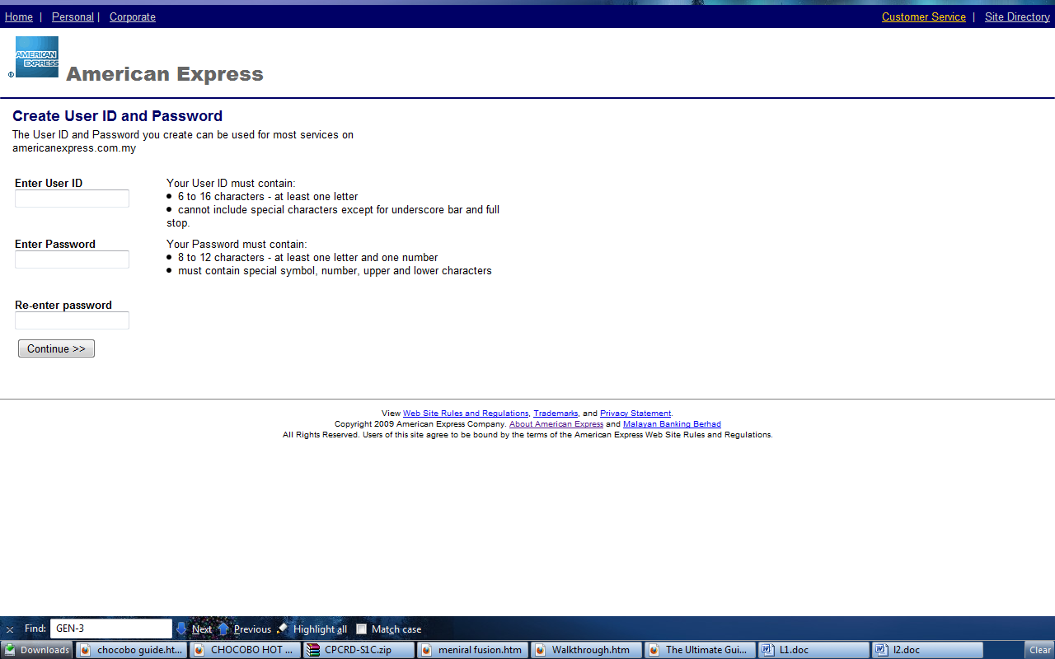

Input requirement
User ID: | - Required  - 6 <= length <= 16 Character  - At least 1 letter  - Not allow special characters such as (&>* ! %) and space.  - Underscore bar and full stop is allowed
Password: | - Required  - 8 <= length <= 12 Character  - At least 1 letter and least 1 number  - must contain special symbol, number, upper and lower characters
Re-enter Password: | - Equal to Password field

1.2.2 Registration Result

After user done with Register page, the Registration Result shall display User ID. This User ID is registered as Corporate or Personal base of which link user entered this side. User can click Continue button to go to enrollment page.

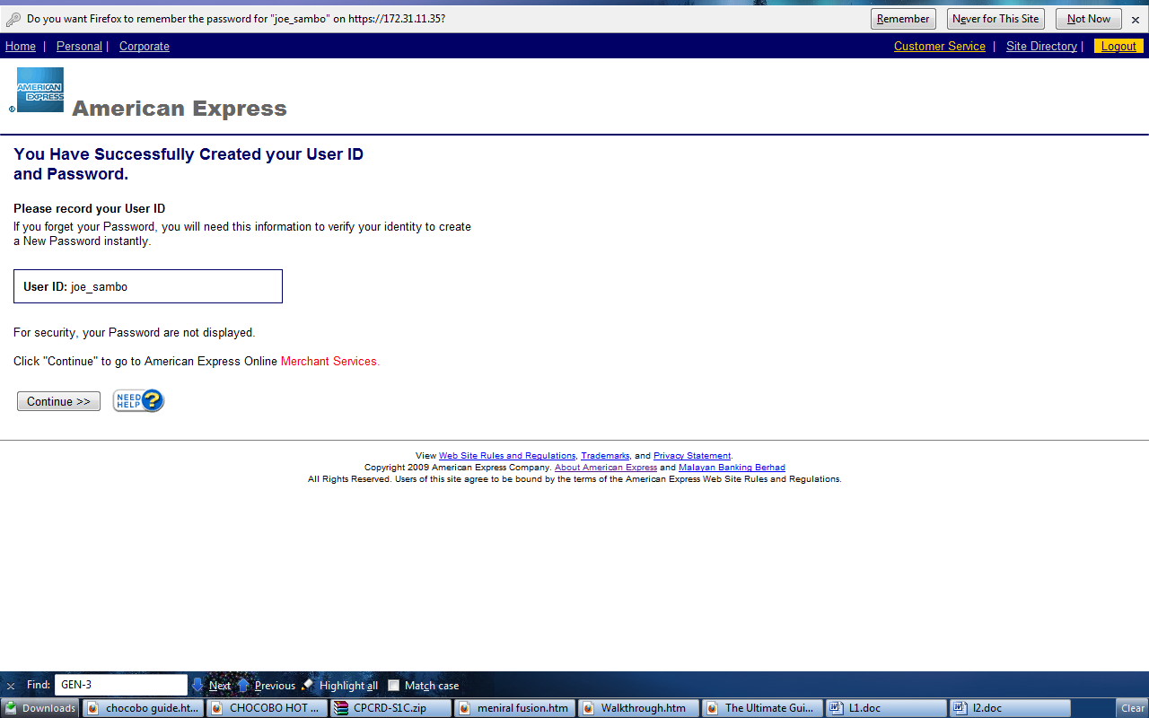

1.2.3 Enrollment

In Enrollment Page, user will enter Credit Card Number and validate entered Number. If Credit Card Number is valid, page will redirect to Enrollment Continue Page. The Credit Card type for entered number must match with user type (Corporate or Personal). User can follow the following steps to enroll Credit Card Number.

Step:-

- Enter Card Account number
- Click Continue button.
- Client and server side validation will be performed.
- If passed, it will redirect to Enrollment Continue page.

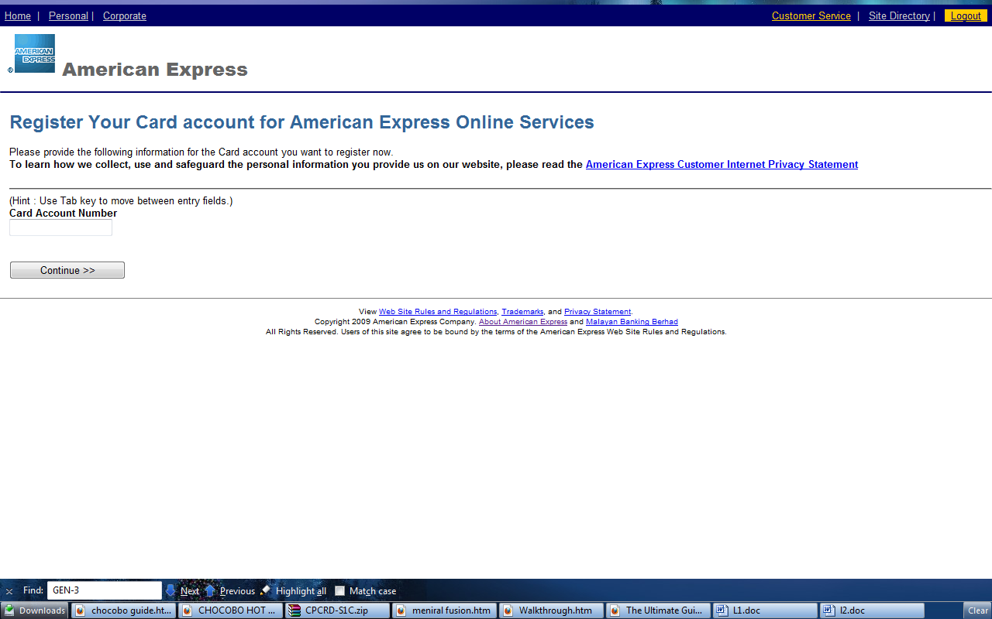

Input requirement
Card Account Number: | - Required  - Length - 15 Character  - Numeric

1.2.4 Enrollment Continue

In Enrollment Continue, page will display base of account type of Credit Card Number. All information user entered will validate to ensure Credit Card Number belong to user. User can follow the following steps to perform Enrollment Continue.

Step:-

- Enter Required Field
- Click Register Now button.
- Client and server side validation will be performed.
- If passed, it will redirect to Enrollment Result Page.

There are two different type of Enrollment Continue page.

- Enrollment Continue Personal
- Enrollment Continue Corporate Virtual

Enrollment Continue Personal & Corporate

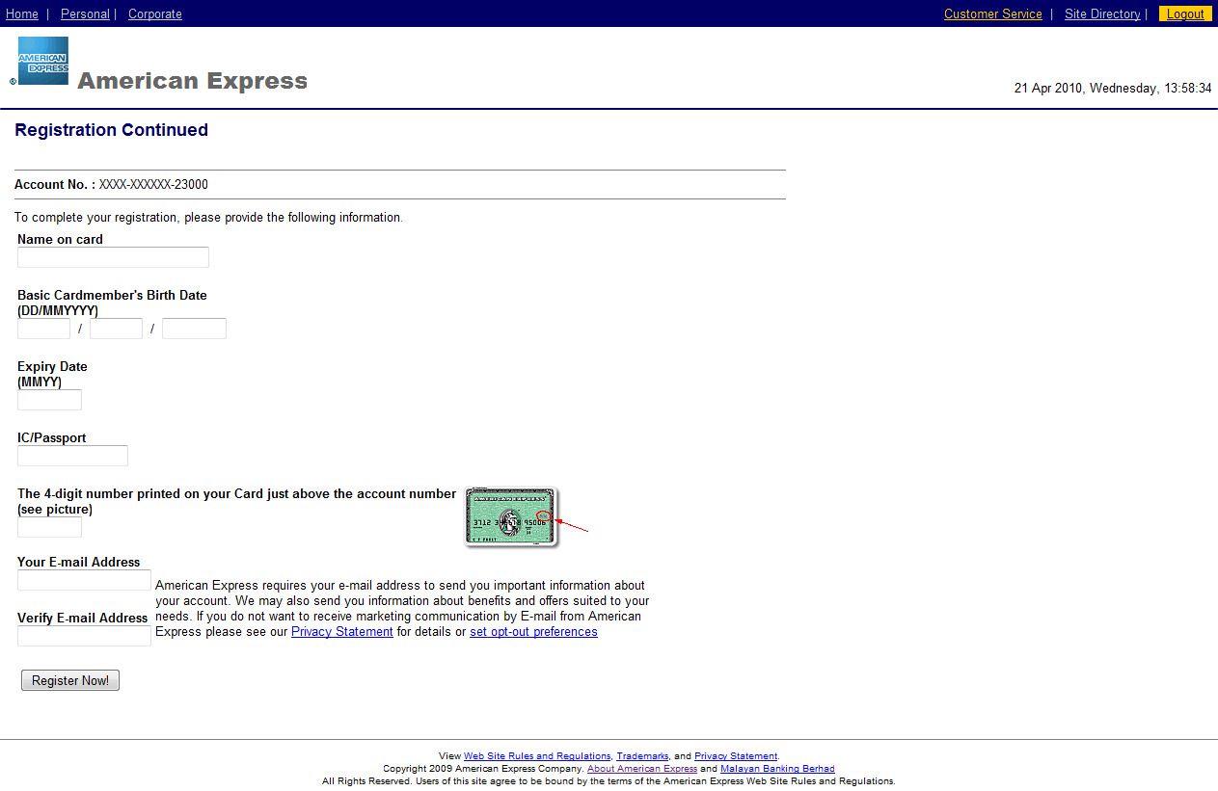

Input requirement
Name on Card: | - Required  - Alphanumeric
Day: | - Required  - Length - 2 Character  - Numeric
Month: | - Required  - Length - 2 Character  - Numeric
Year: | - Required  - Length - 4 Character  - Numeric
Expiry Date: | - Required  - Length – 4 Character  - Numeric
IC/Passport: | - Required  - Alphanumeric
Four Digit: | - Required  - Length – 4 Character  - Numeric
Your Email Address: | - Required  - Email Address
Verify Email Address: | - Match to Your Email Address

Enrollment Continue Corporate Virtual

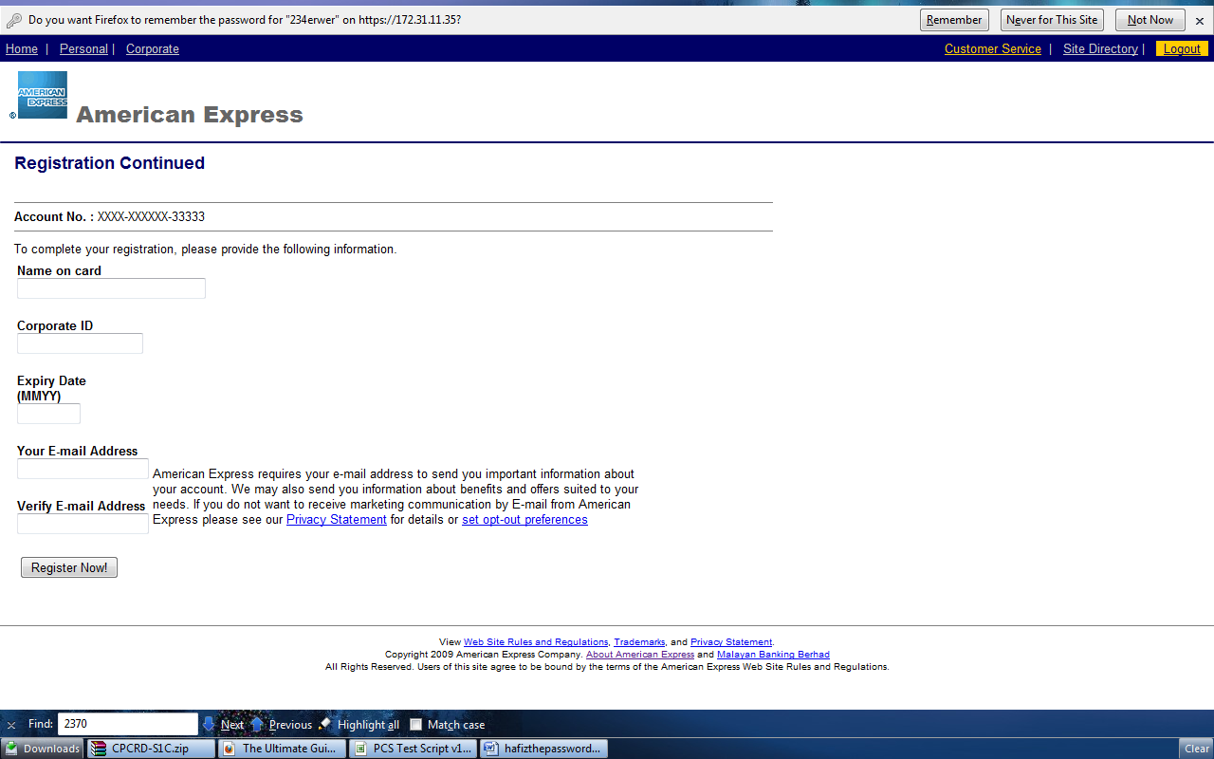

Input requirement
Name on Card: | - Required  - Alphanumeric
Corporate ID: | - Required  - Numeric
Expiry Date: | - Required  - Length – 4 Character  - Numeric
Your Email Address: | - Required  - Email Address
Verify Email Address: | - Match to Your Email Address

1.2.5 Enrollment Result

After user done with Enrollment Continue form, the result shall be displayed as below. All links will redirect to respective page when clicked.

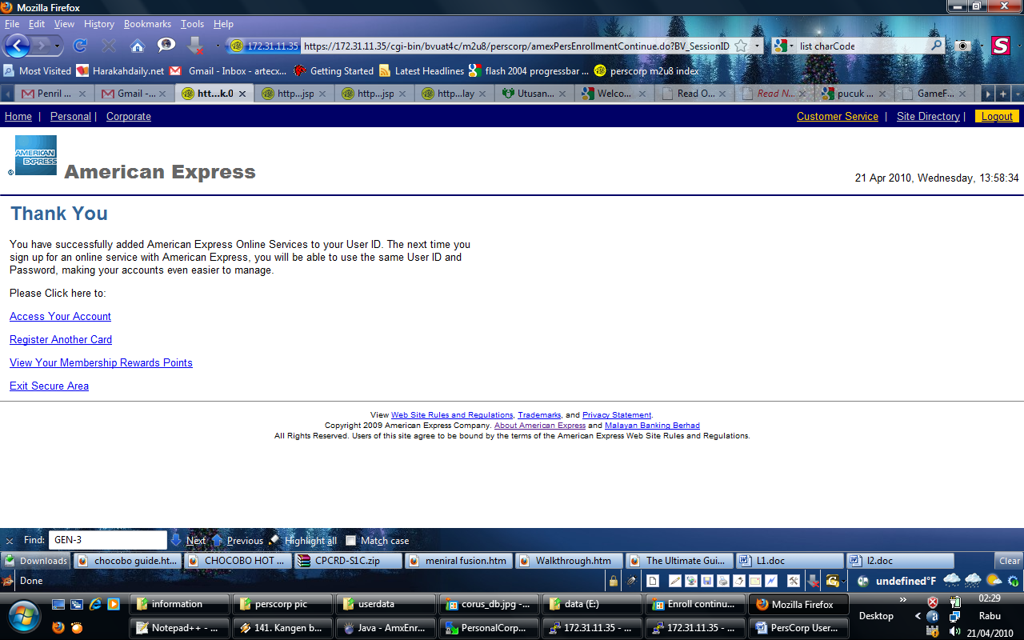

Link Explanation
Access Your Account: | View main page
Register Another Card: | Add new Card for this user
View Your Membership Reward Point: | View Membership Reward Point
Exit Secure Area: | Logout

1.3 Change Temporary Password

1.3.1 Change Password
When user password was made by administrator or expired. User will be force to change their temporary password after login. User can follow the following steps to change Password

Step:-

- Enter Current or Temporary Password
- Enter new Password
- Re-enter Password
- Click Continue button.
- Client and server side validation will be performed.
- If passed, it will redirect to Change Password Result Page.

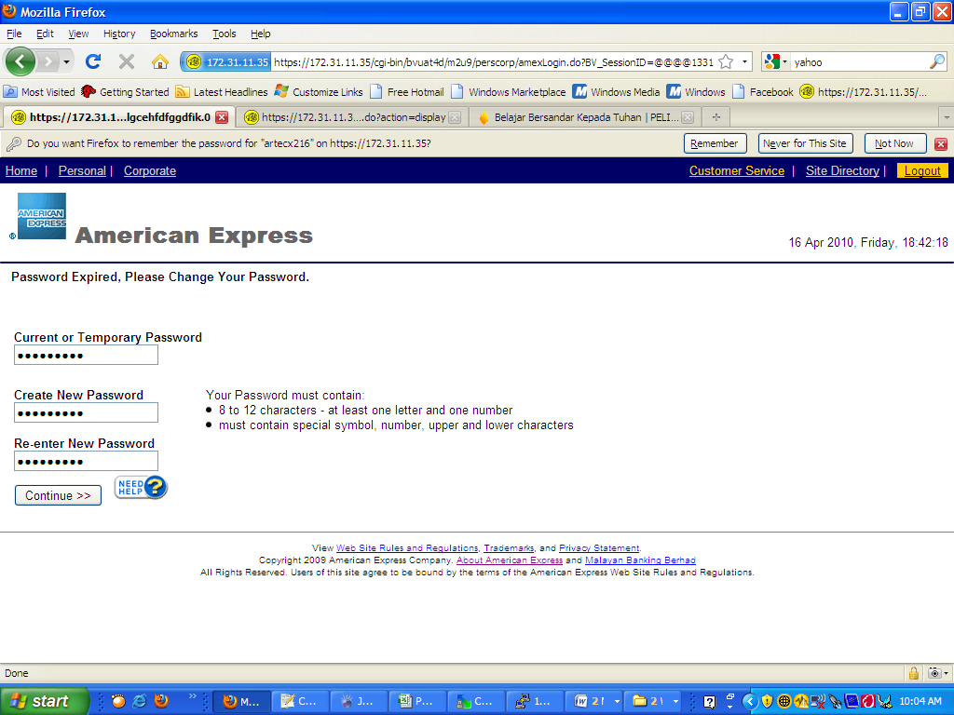

Input requirement
Current or Temporary Password : | - Required  - 8 <= length <= 12 Character  - At least 1 letter and least 1 number.  - must contain special symbol, number, upper and lower characters .
Create New Password : | - Required  - 8 <= length <= 12 Character.  - At least 1 letter and least 1 number  - Must contain special symbol, number, upper and lower characters.
Re-enter new Password : | - Match to Create New Password

1.3.2 Change Password Result

After user done with Change Password Page, the User will be ask to record their new password. Continue button will redirect main page

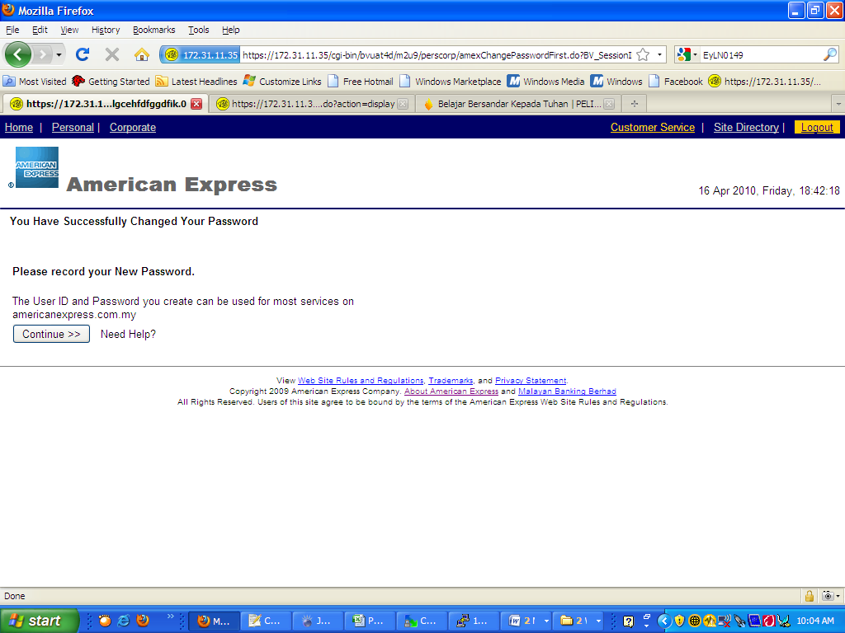

2.0 Recent Charges

2.1 Choose Recent Charges

To view Recent Charges Detail, user can enter from Main Page. User can follow the following steps to view Recent Charges.

Step:-

- Select an Account or Enter Account Number
- Click on Recent Charges button.
- Client and server side validation will be performed.
- If passed, it will redirect to Recent Charges Detail Page.

Input requirement
Choose an Account: | - Select an Account or Enter Account Number is Required
Enter Account Number: | - Select an Account or Enter Account Number is Required  - Length - 15 Character  - Numeric

2.2 Recent Charges Detail

Recent Charges Detail page will view as below. User will see record of Recent Charges.

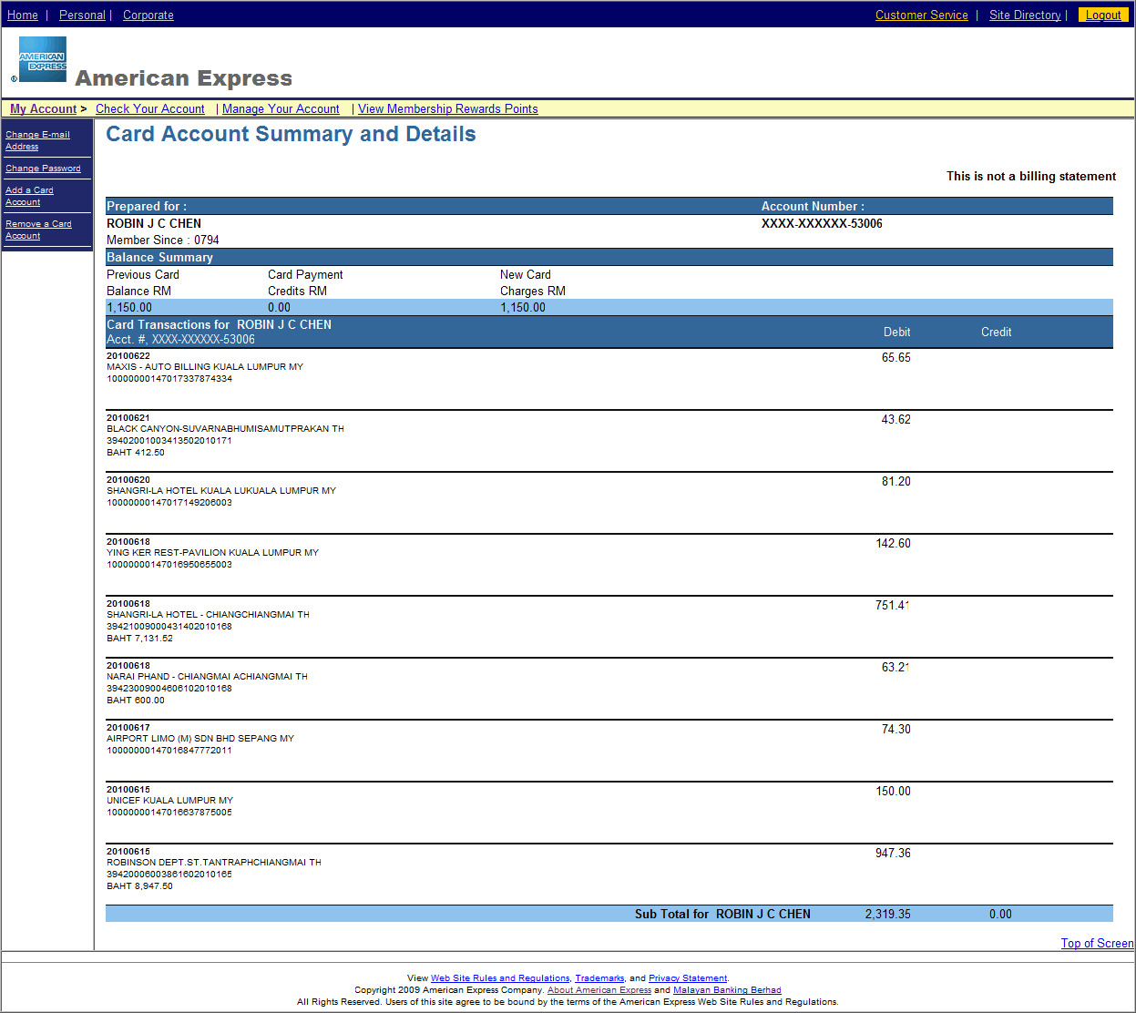

3.0 Current Billed

3.1 Choose Current Billed

To view Current Billed Detail, user can enter from Main Page. User can follow the following steps to view Current Billed Detail.

Step:-

- Select an Account or Enter Account Number
- Click on Current Billed button.
- Client and server side validation will be performed.
- If passed, it will redirect to Current Billed Detail Page.

Input requirement
Choose an Account: | - Select an Account or Enter Account Number is Required
Enter Account Number: | - Select an Account or Enter Account Number is Required  - Length - 15 Character  - Numeric

3.2 Current Billed Detail

Current Billed Detail page will view as below. User will see record of Current Billed.

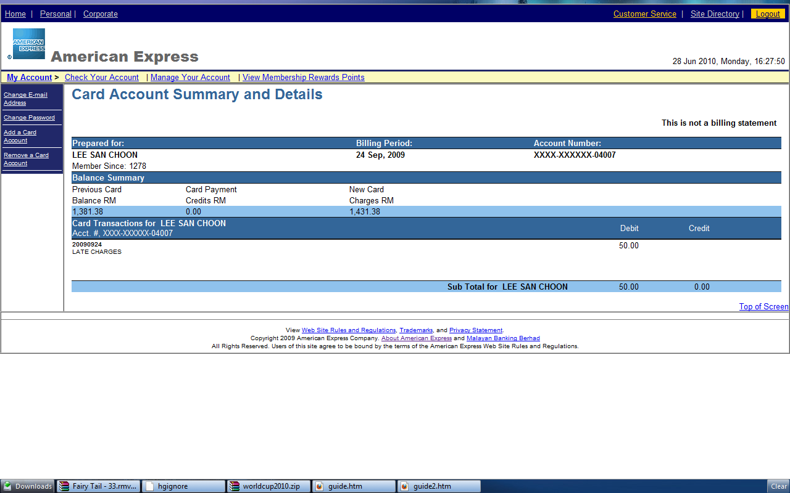

4.0 Other Periods

4.1 Choose Other Periods

To view Choose Periods Date page, user can enter from Main Page. User can follow the following steps to view Choose Periods Date page.

Step:-

- Select an Account or Enter Account Number
- Click on Other Periods button.
- Client and server side validation will be performed.
- If passed, it will redirect to Choose Periods Date page.

Input requirement
Choose an Account: | - Select an Account or Enter Account Number is Required
Enter Account Number: | - Select an Account or Enter Account Number is Required  - Length - 15 Character  - Numeric

4.2 Choose Periods Date

In Choose Period Date page, user must select period date to continue. User can follow the following steps to view Other Periods detail page.

Step:-

- Select periods date
- Click on View Billing Details button.
- Client and server side validation will be performed.
- If passed, it will redirect to Other Periods Detail page.

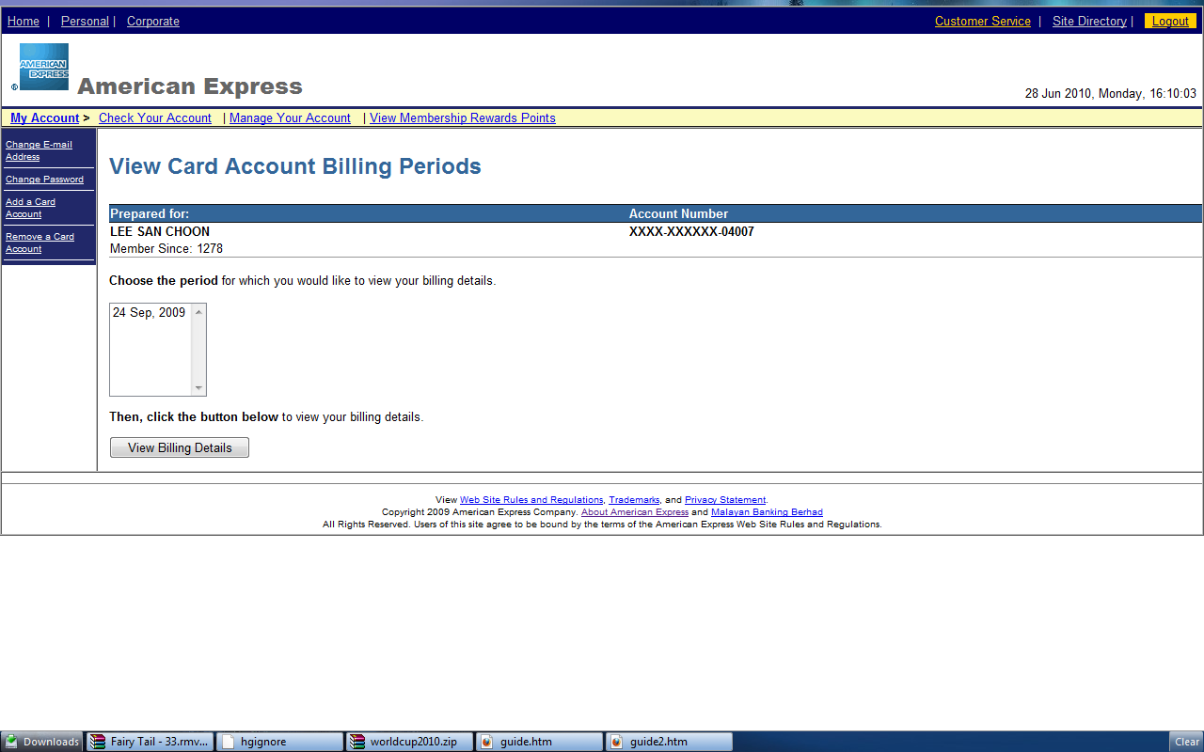

Input requirement
Choose the Periods: | - Required

4.3 Other Periods Detail

Other Periods Detail page will view as below. User will see record of Other Periods.

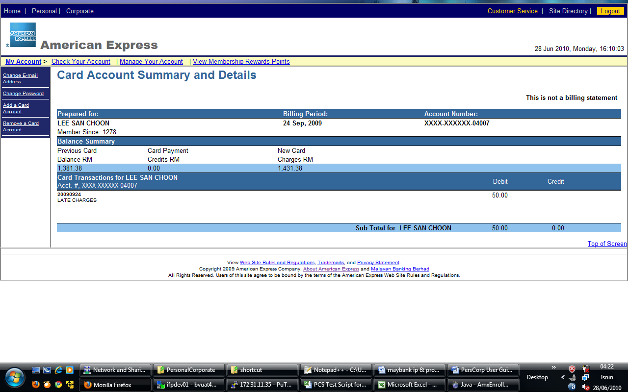

5.0 Manage Account

In the Manage Account page, all links will redirect to respective page when clicked

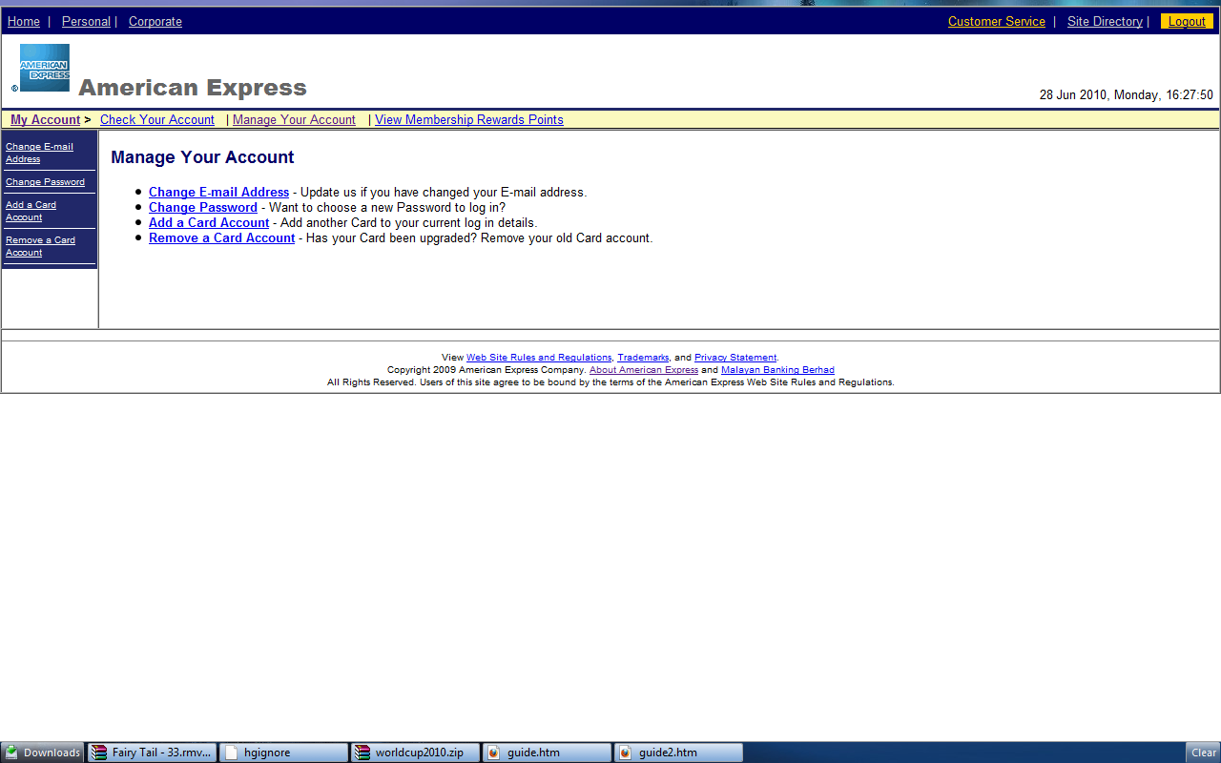

Link Explanation
Change E-mail Address: | Update Email Address
Change Password: | Change to New Password
Add a Card Account: | Add new Card Account
Remove a Card Account: | Remove Existing Card Account

5.1.0 Change Email Address

5.1.1 Change Your Email Address

In Change Your Email Address, user can update new email. User can follow the following steps to update Email Address.

Step:-

- Enter new your Email Address
- Re-enter Email Address.
- Click on Submit button.
- Client and server side validation will be performed.
- If passed, it will redirect to Change Email Address Result page.

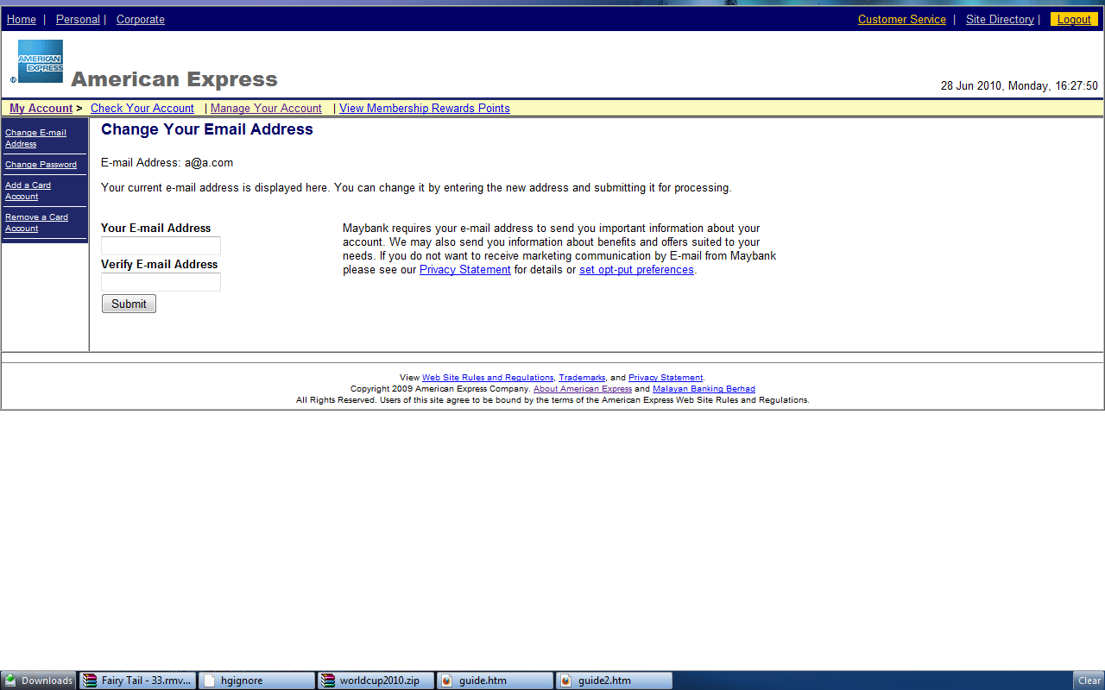

Input requirement
Your E-mail Address: | - Required  - Email address
Verify E-mail Address: | - Match to Your Email Address

5.1.2 Change Email Address Result

After user done with Change Email Address Page, the User will be ask to record their new Email. Continue button will redirect main page.

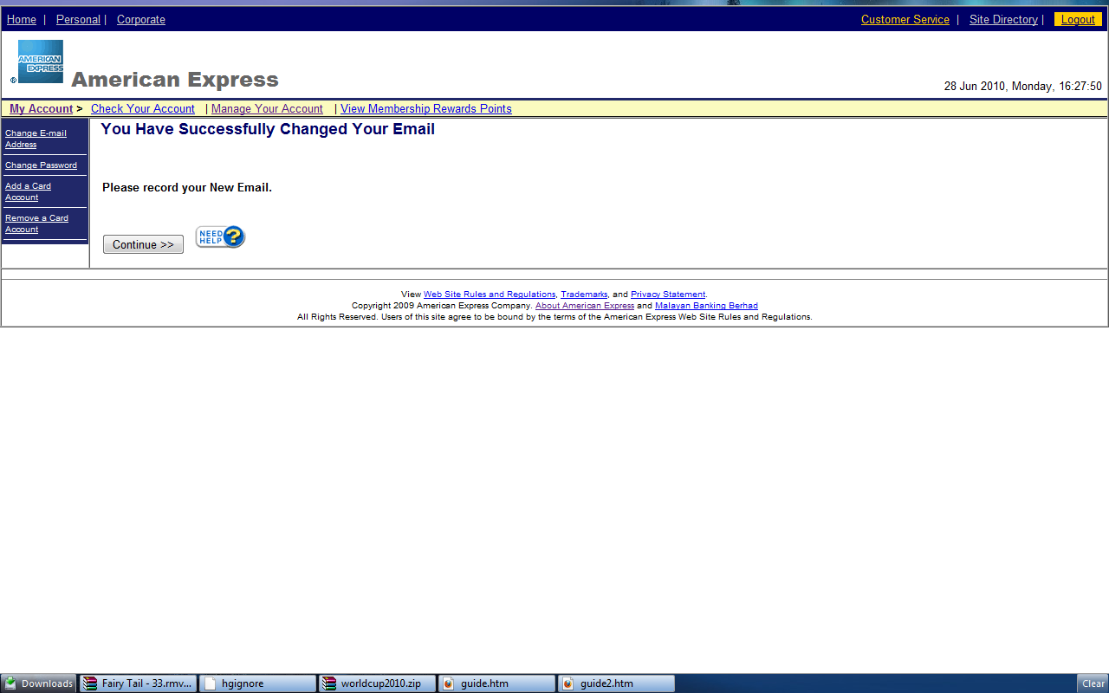

5.2 Change Password

5.2.1 Change Your Password

In Change Your Password, user can change new password. User can follow the following steps to change password.

Step:-

- Enter Current or Temporary Password.
- Enter Password.
- Re-enter Password.
- Click on Continue button.
- Client and server side validation will be performed.
- If passed, it will redirect to Change Password Result page.

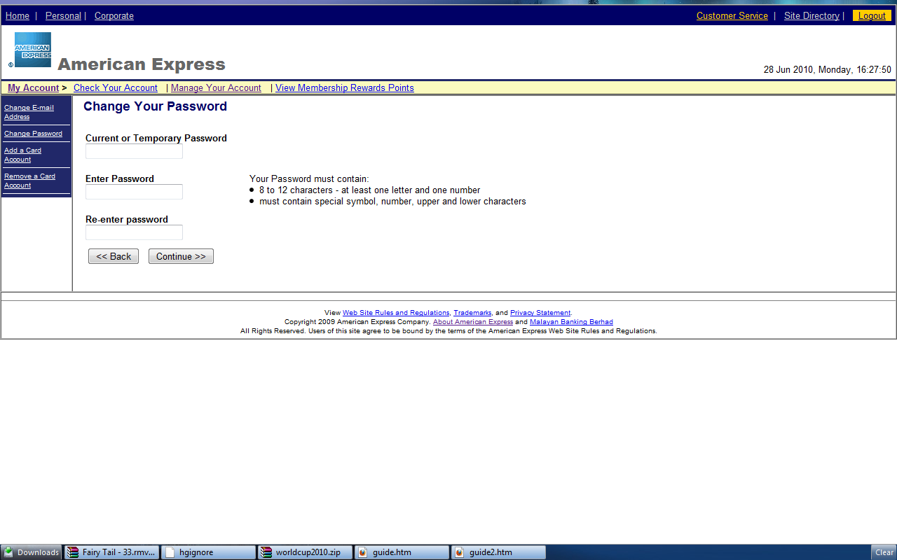

Input requirement
Current or Temporary Password : | - Required  - 8 <= length <= 12 Character  - At least 1 letter and least 1 number.  - must contain special symbol, number, upper and lower characters .
Create New Password : | - Required  - 8 <= length <= 12 Character.  - At least 1 letter and least 1 number  - Must contain special symbol, number, upper and lower characters.
Re-enter new Password : | - Match to Create New Password

5.2.2 Change Password Result

After user done with Change Password Page, the User will be ask to record their new password. Continue button will redirect main page.

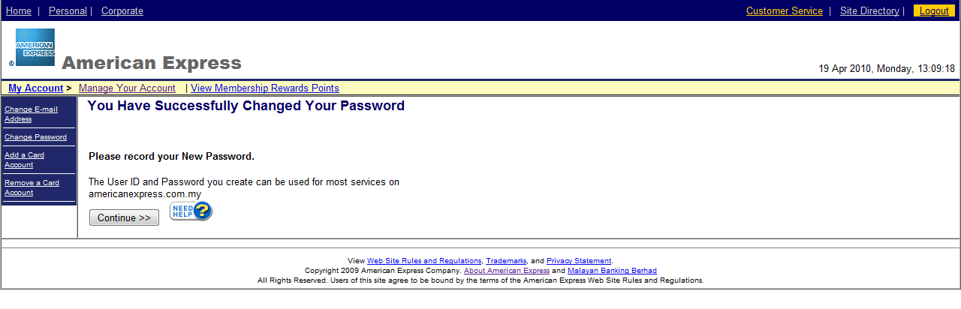
5.3 Add Another Card

5.3.1 Add Card

In Add Card Page, user will enter Credit Card Number and validate entered Number. If Credit Card Number is valid, page will redirect to Add Card Continue Page. The Credit Card type for entered number must match with user type (Corporate or Personal). User can follow the following steps to Add Credit Card Number.

Step:-

- Enter Card Account number
- Click Continue button.
- Client and server side validation will be performed.
- If passed, it will redirect to Enrollment Continue page.

Limit Add Card for user type.

Personal user
- 5 card if user enroll first card is Personal Principal card
- 1 card if user enroll first card is Supplementary card

Corporate user
- 5 card if user enroll first card is Corporate card
- 99 card if user enroll first card is Corporate Virtual card

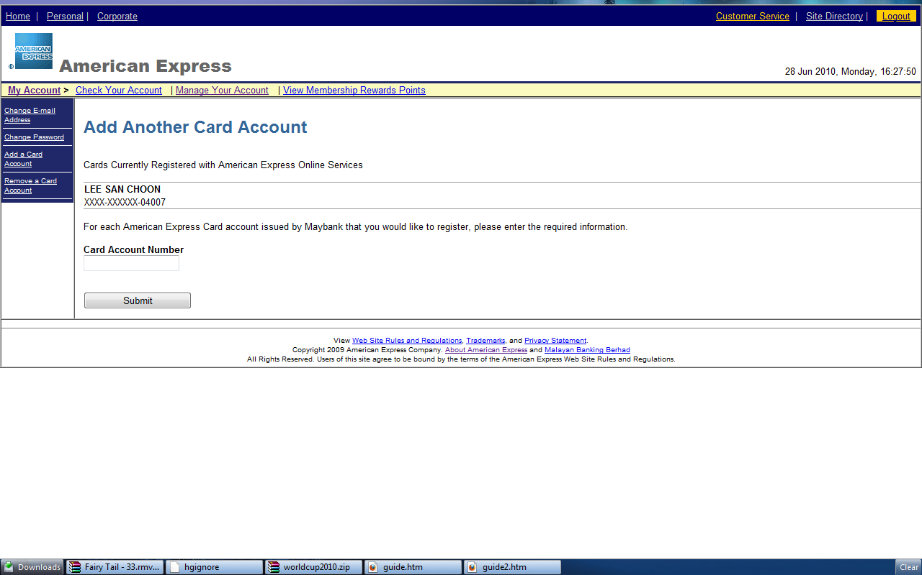

Input requirement
Card Account Number: | - Required  - Length - 15 Character  - Numeric

5.3.2 Add Card Continue

In Add Card Continue, page will display base of account type of Credit Card Number. All information user entered will validate to ensure Credit Card Number belong to user. User can follow the following steps to perform Add Card Continue.

Step:-

- Enter Required Field
- Click Register Now button.
- Client and server side validation will be performed.
- If passed, it will redirect to Enrollment Result Page.

There are two different type of Add Card Continue page.

- Add Card Continue Personal & Corporate
- Add Card Continue Corporate Virtual

Add Card Continue Personal & Corporate

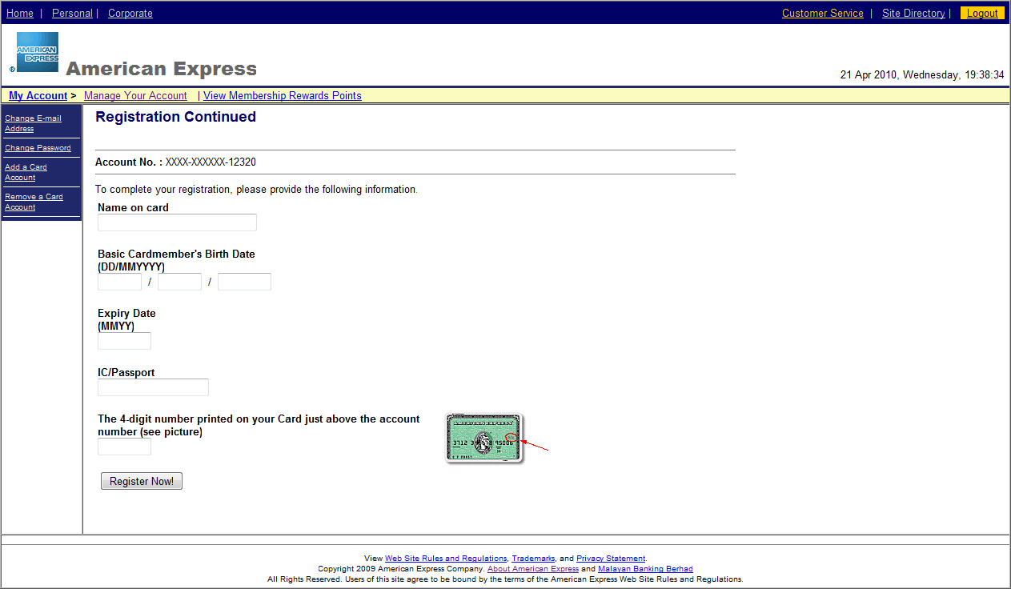

Input requirement
Name on Card: | - Required  - Alphanumeric
Day: | - Required  - Length - 2 Character  - Numeric
Month: | - Required  - Length - 2 Character  - Numeric
Year: | - Required  - Length - 4 Character  - Numeric
Expiry Date: | - Required  - Length – 4 Character  - Numeric
IC/Passport: | - Required  - Alphanumeric
Four Digit: | - Required  - Length – 4 Character  - Numeric

Add Card Continue Corporate Virtual

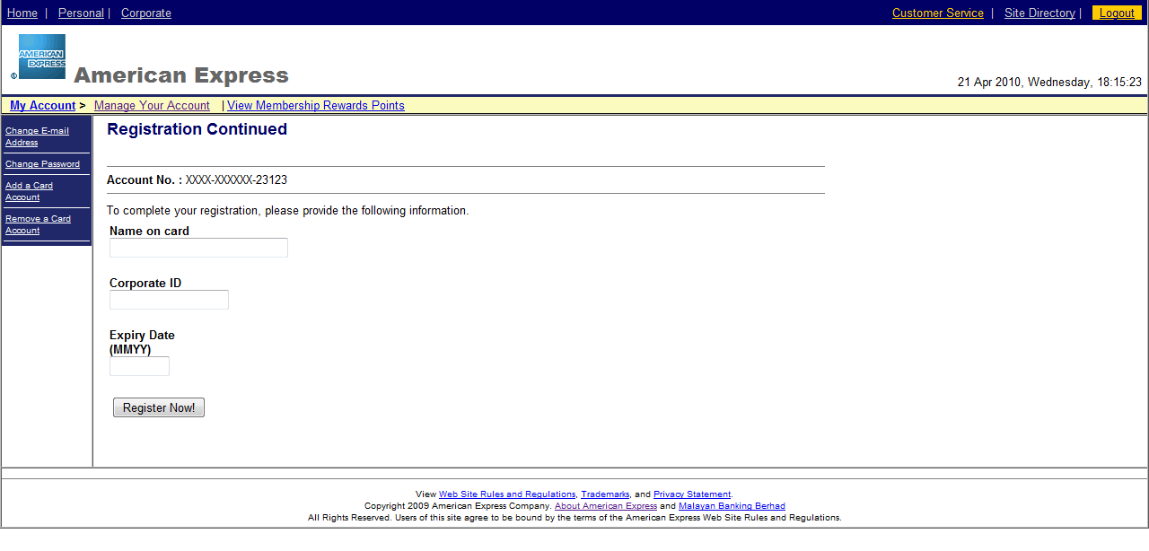

Input requirement
Name on Card: | - Required  - Alphanumeric
Corporate ID | - Required  - Length - 15 Character  - Numeric
Expiry Date: | - Required  - Length – 4 Character  - Numeric

5.3.1 Add Card Result

In the Add card Result page, all buttons will redirect to respective page when clicked

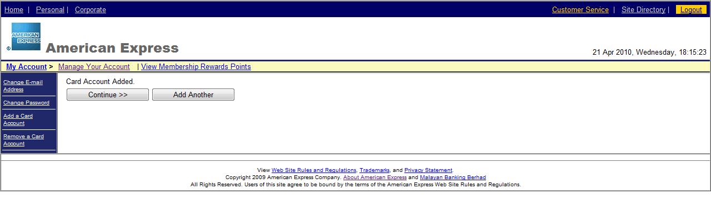

Button Explanations
Continue | Go to Main page
Add Another | Add new card

5.4 Remove Card

5.4.1 Choose Remove Card Account

In Remove Card page, user will select an Account Number or enter Account Number to perform remove card. User can follow the following steps to perform Remove Card.

Step:-

- Select an Account or Enter Account Number
- Click on Remove button.
- Client and server side validation will be performed.
- If passed, it will redirect to Remove Card Result page.

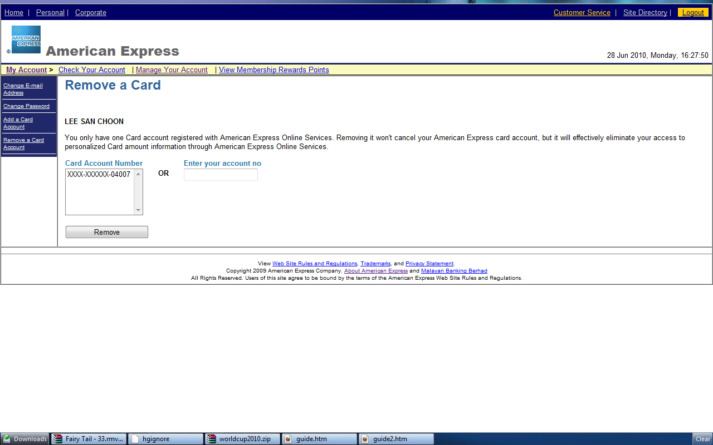

Input requirement
Card Account Number: | - Select an Account or Enter Account Number is Required
Enter Account Number: | - Select an Account or Enter Account Number is Required  - Length - 15 Character  - Numeric

5.4.2 Remove Card Result

In the Add card Result page, all buttons will redirect to respective page when clicked

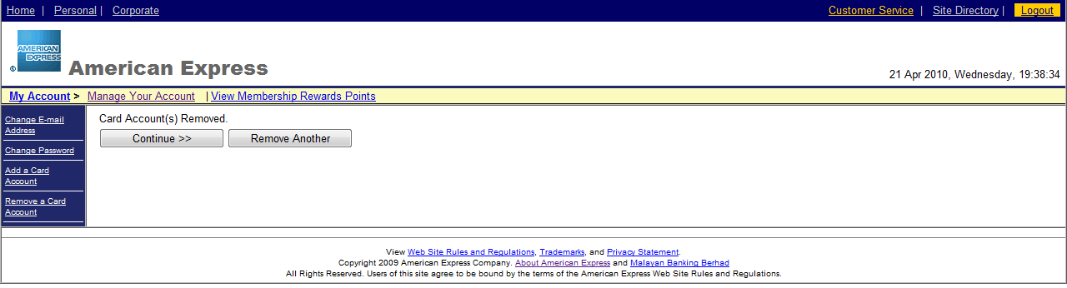

Button Explanations
Continue | Go to Main page
Add Another | Add new card

6.0 Membership Rewards Online

6.1 Choose Membership Reward Account

In Membership Reward page, user will select an Account Number or enter Account Number to display Membership Reward Result. User can follow the following steps to display Membership Reward Result.

Step:-

- Select an Account or Enter Account Number
- Click on Remove button.
- Client and server side validation will be performed.
- If passed, it will redirect to Remove Card Result page.

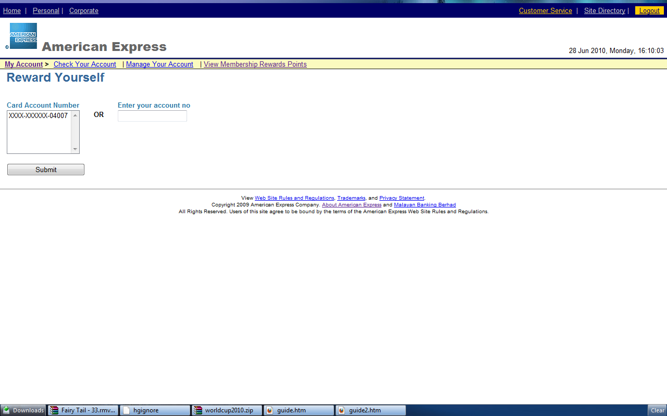

Input requirement
Card Account Number: | - Select an Account or Enter Account Number is Required
Enter Account Number: | - Select an Account or Enter Account Number is Required  - Length - 15 Character  - Numeric

6.2 Membership Reward Result

In Membership Reward Result, page will display information about reward Point. Users also can display another reward point by select other Account Number. User can follow the following steps to display another membership reward point.

Step:-

- Select an Account or Enter Account Number
- Click on Remove button.
- Client and server side validation will be performed.
- If passed, it will redirect to Membership Reward Result page.

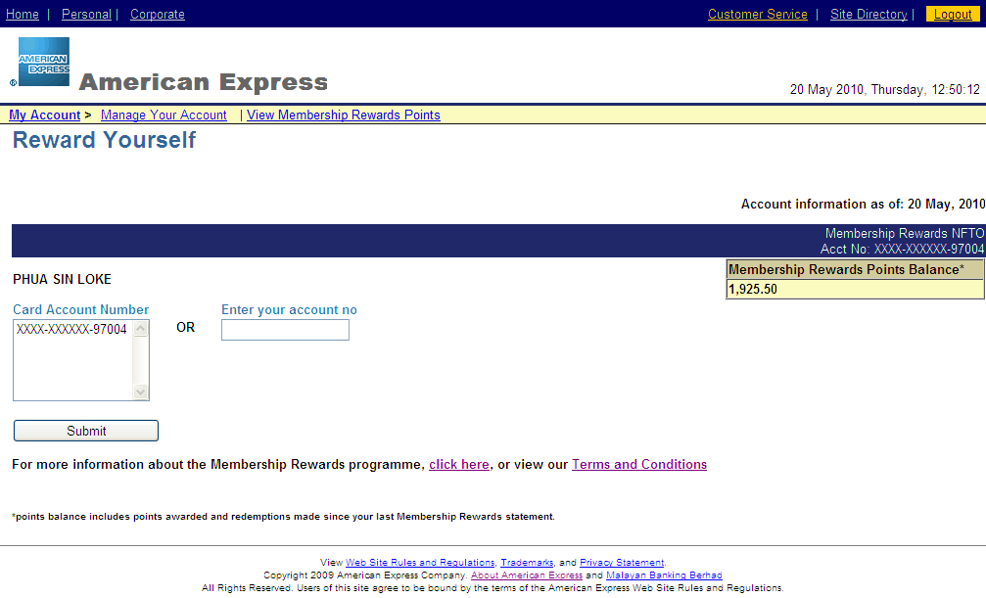

Input requirement
Card Account Number: | - Select an Account or Enter Account Number is Required
Enter Account Number: | - Select an Account or Enter Account Number is Required  - Length - 15 Character  - Numeric

