ISSUE: Unable Add List Favourite JomPAY

BIB: ADD FAVOURITE JOMPAY
TC0001 | STATUS: PASSED
User Alias | initrahmanstep
Biller Code: | 1610
Biller Name: | TEST
Ref 1: | 100016
Screenshot:
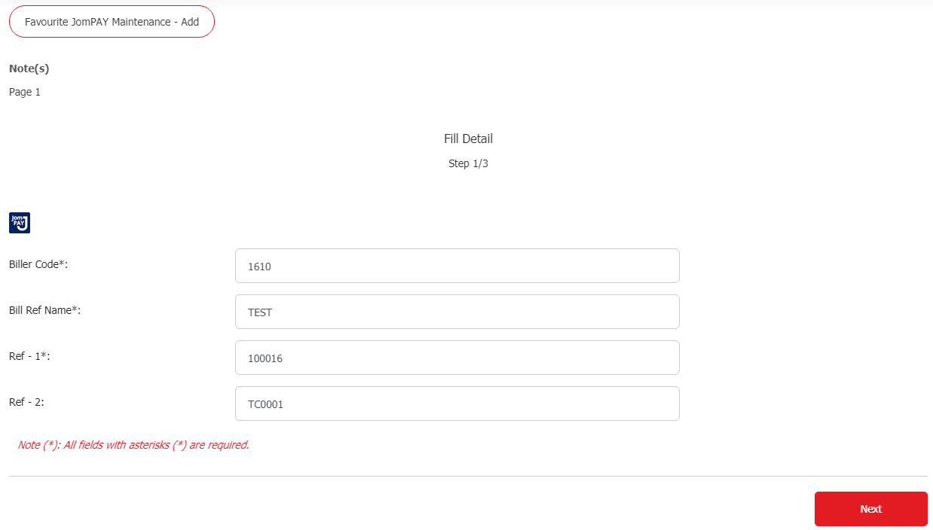
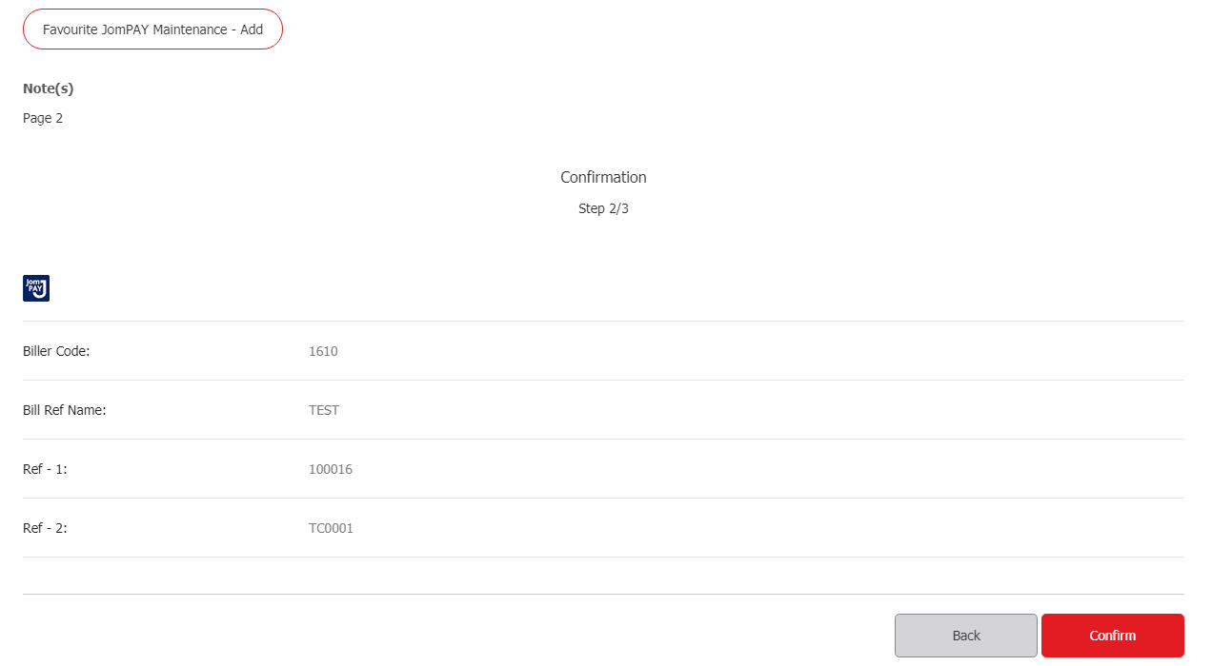
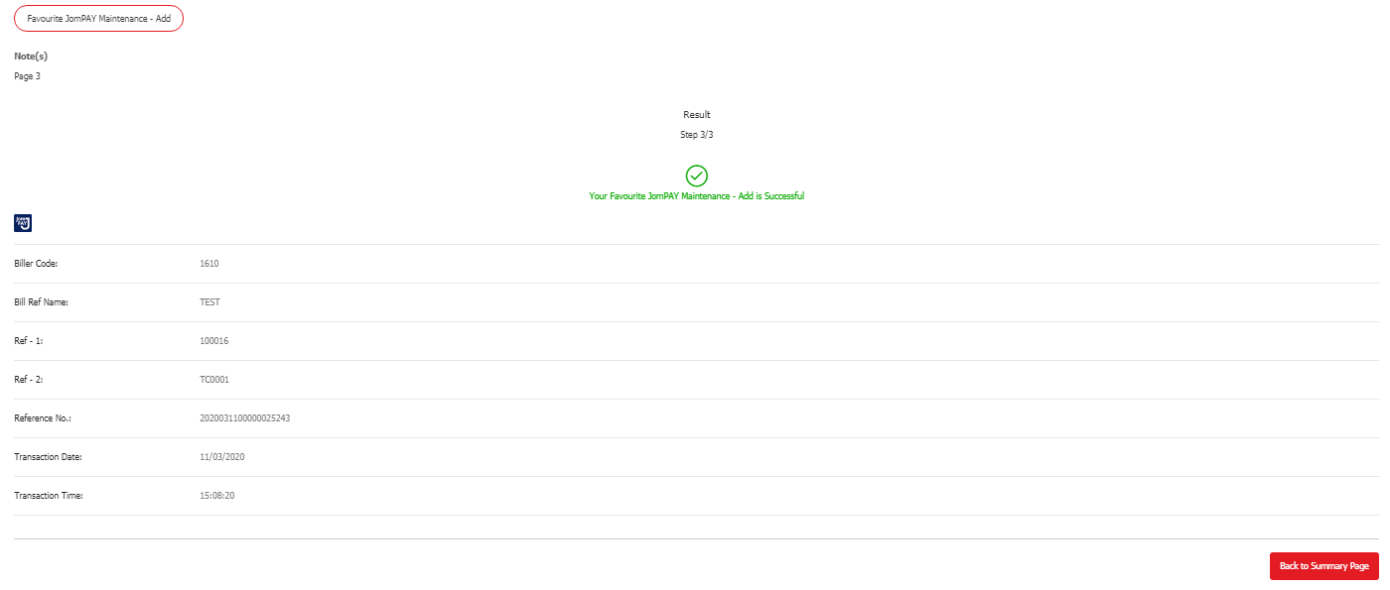
TC0002 | STATUS: PASSED
User Alias | initrahmanstep
Biller Code: | 1610
Biller Name: | TEST
Ref 1: | 122
Screenshot:
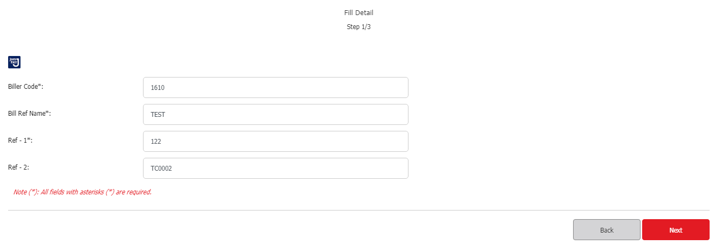
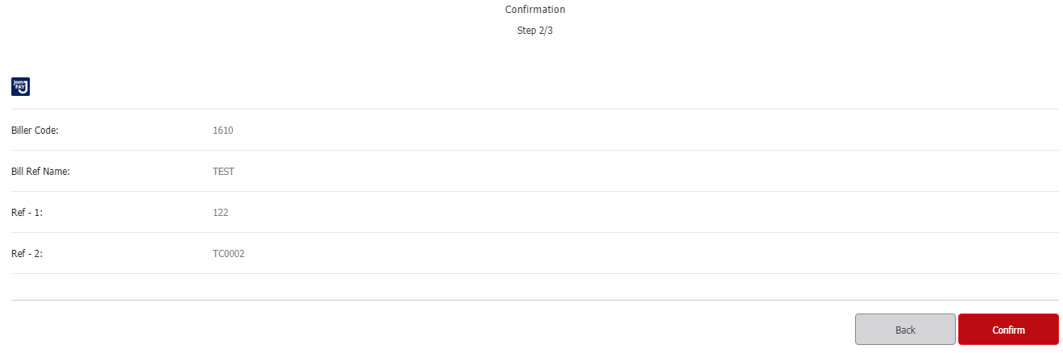
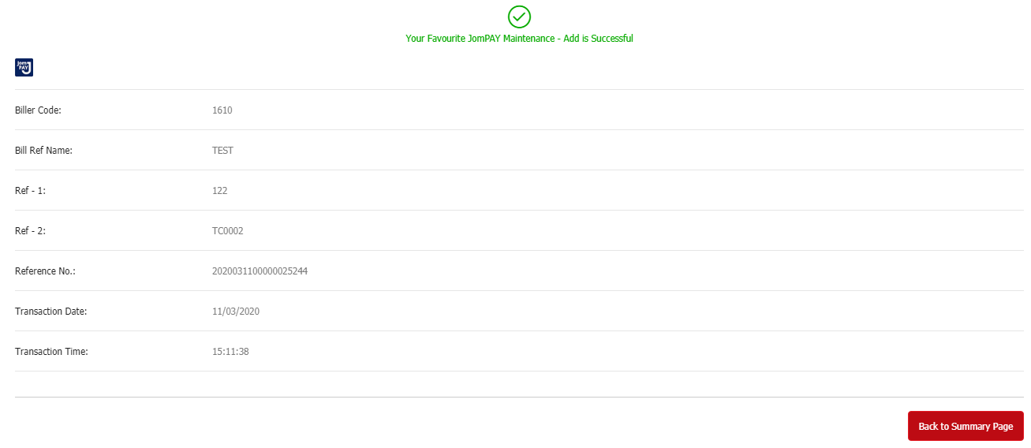
TC0003 | STATUS: TEST CASE NOT VALID
User Alias | initrahmanstep
Biller Code: | 1610
Biller Name: | TESTING
Ref 1: | 100016
Screenshot:

TC0004 | STATUS: PASSED
User Alias | initrahmanstep
Biller Code: | 1121
Biller Name: | TEST
Ref 1: | 100016
Screenshot:
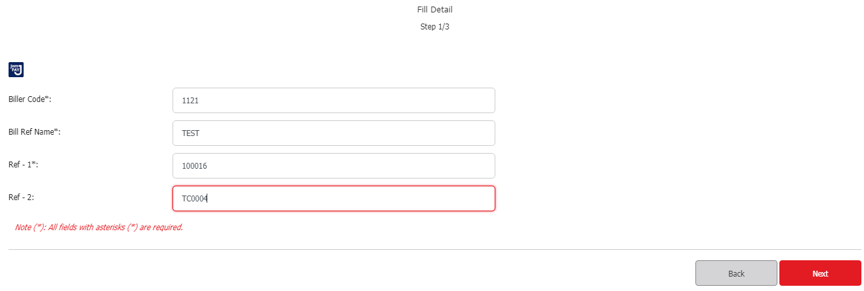
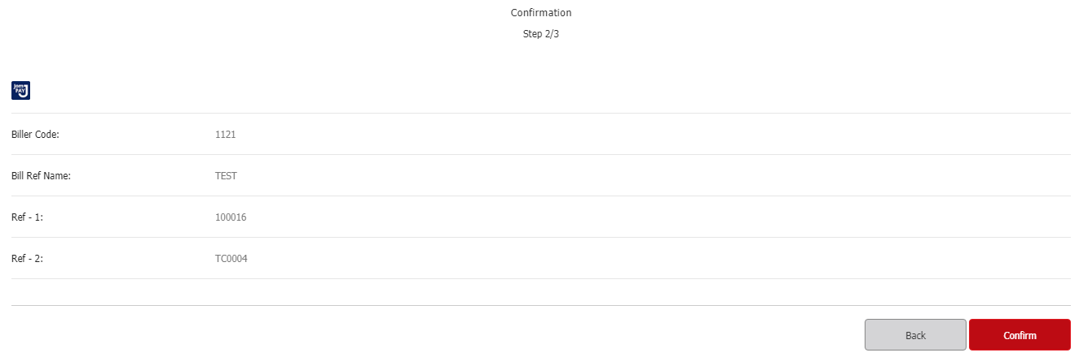
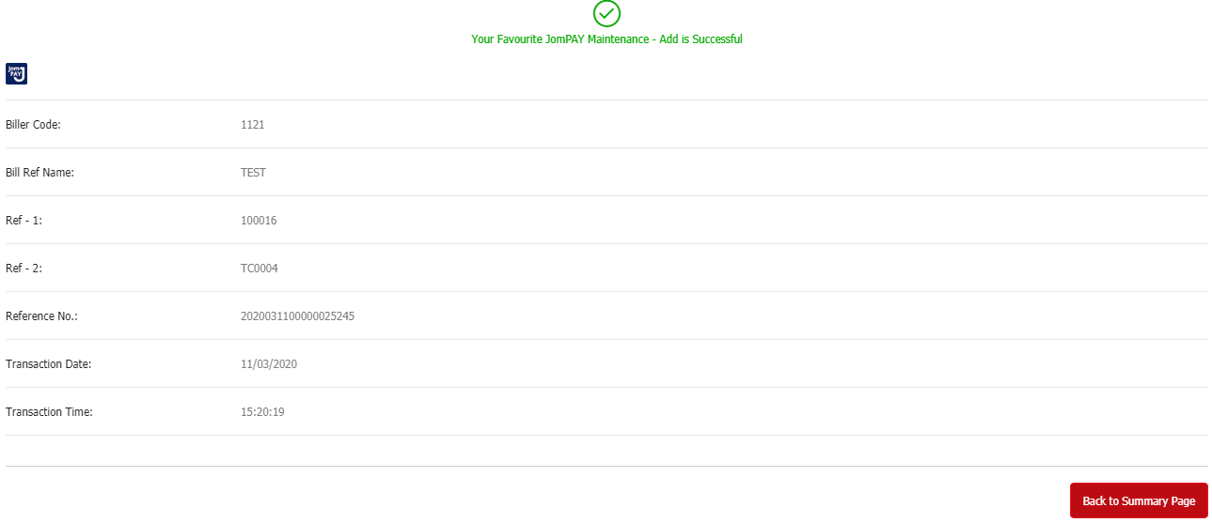
TC0005 | STATUS: PASSED
User Alias | Initrahmanbal
Biller Code: | 1610
Biller Name: | TEST
Ref 1: | 100016
Screenshot:
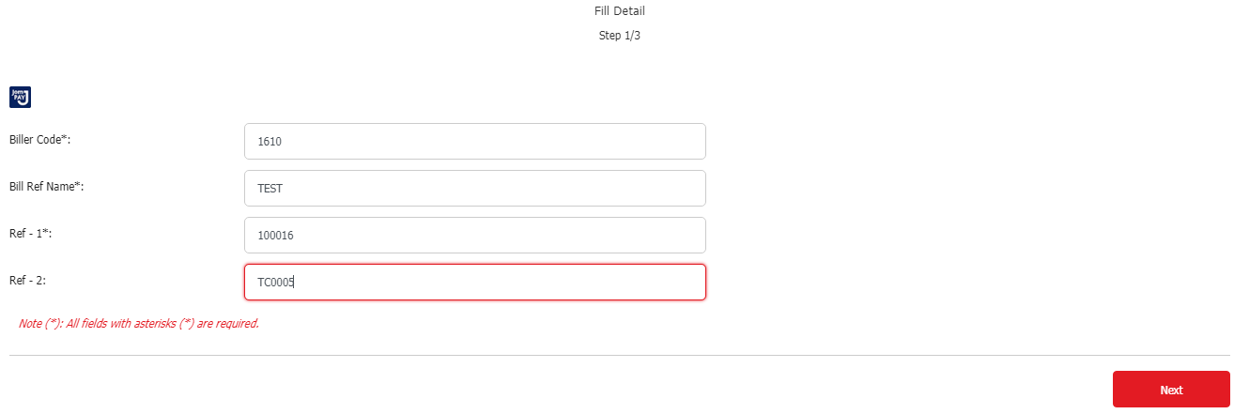
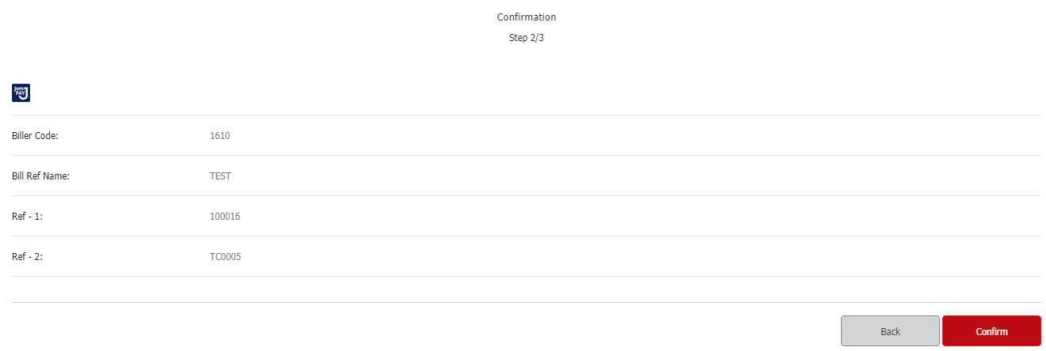
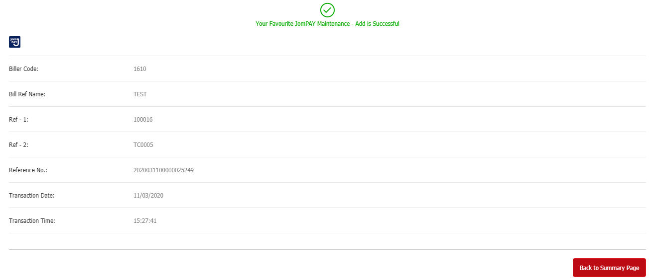

BIB: PERFORM FAVOURITE JOMPAY
TC0001 | STATUS: PASSED
User Alias | initrahmanstep
Biller Code: | 1610
Biller Name: | TEST
Ref 1: | 100016
Screenshot:
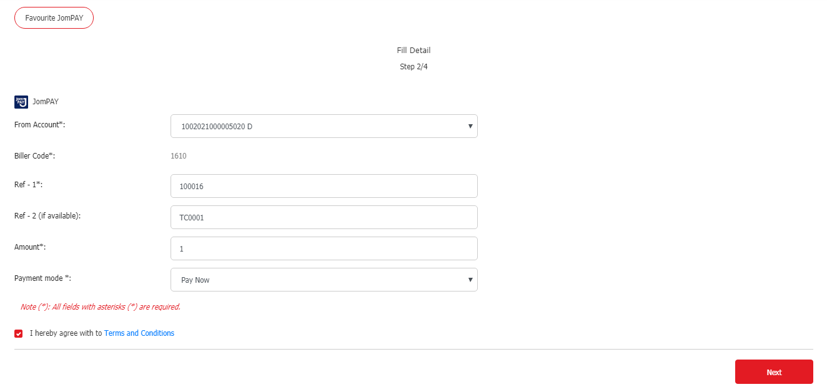
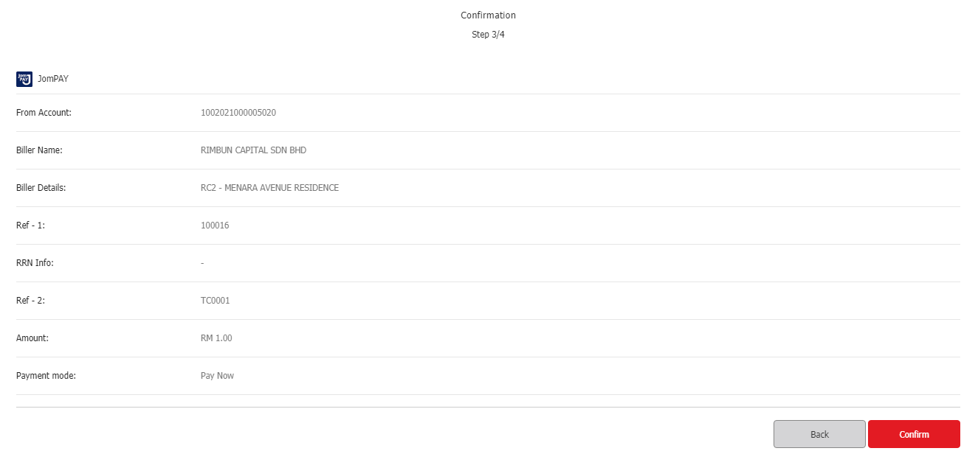
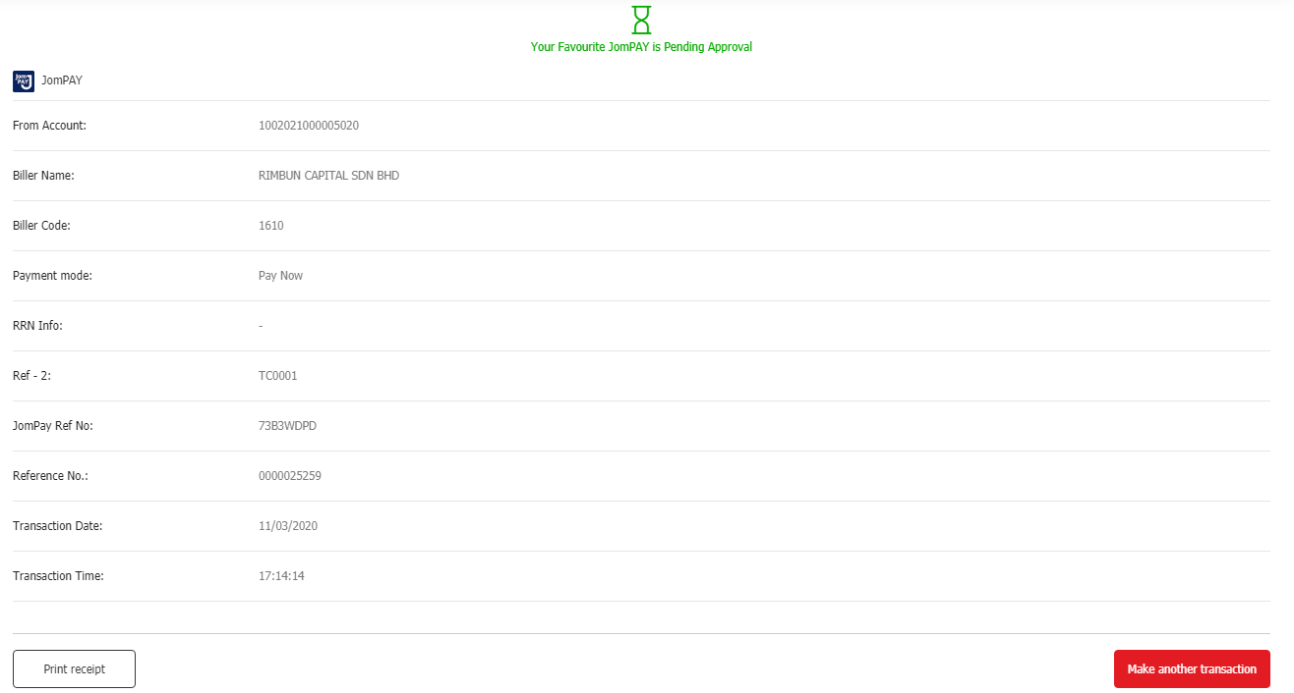
TC0002 | STATUS: PASSED
User Alias | initrahmanstep
Biller Code: | 1610
Biller Name: | TEST
Ref 1: | 122
Screenshot:
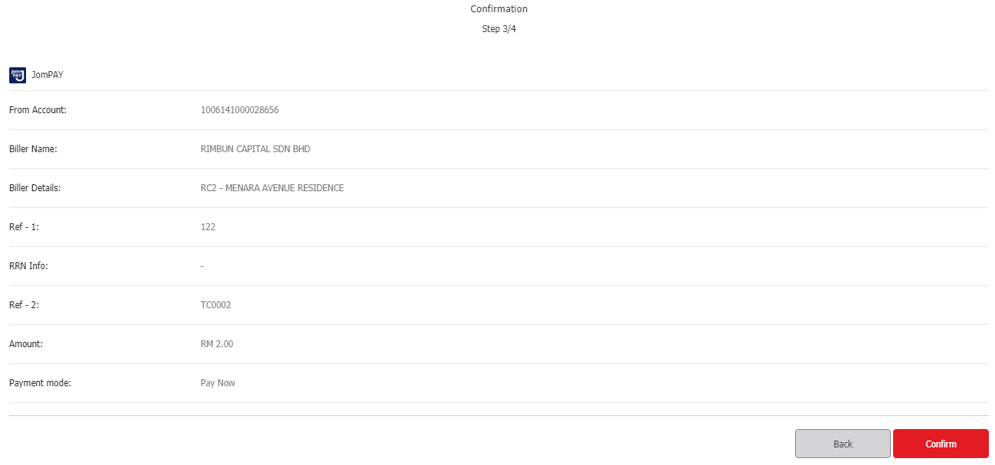
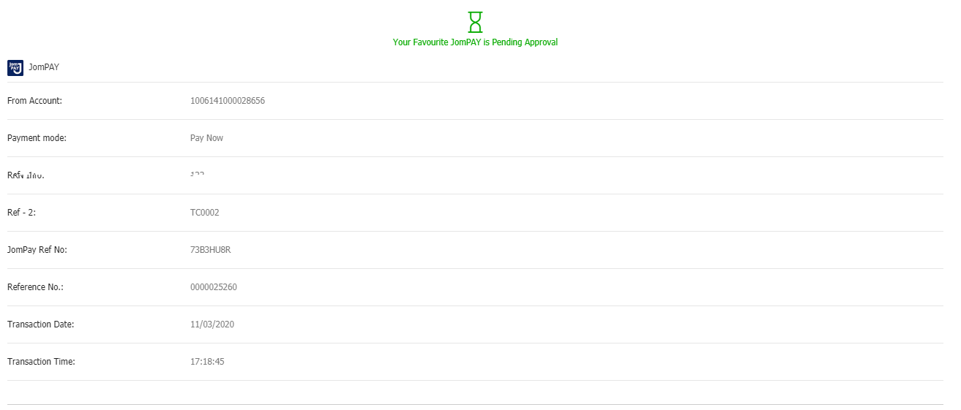
TC0003 | STATUS: TEST CASE NOT VALID
User Alias | initrahmanstep
Biller Code: | 1610
Biller Name: | TESTING
Ref 1: | 100016
Screenshot:

TC0004 | STATUS: PASSED
User Alias | initrahmanstep
Biller Code: | 1121
Biller Name: | TEST
Ref 1: | 100016
Screenshot:
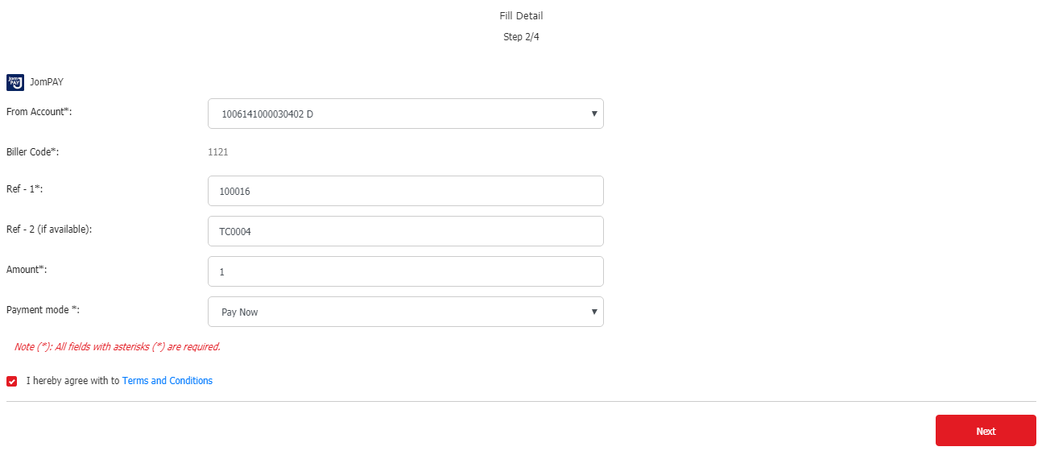
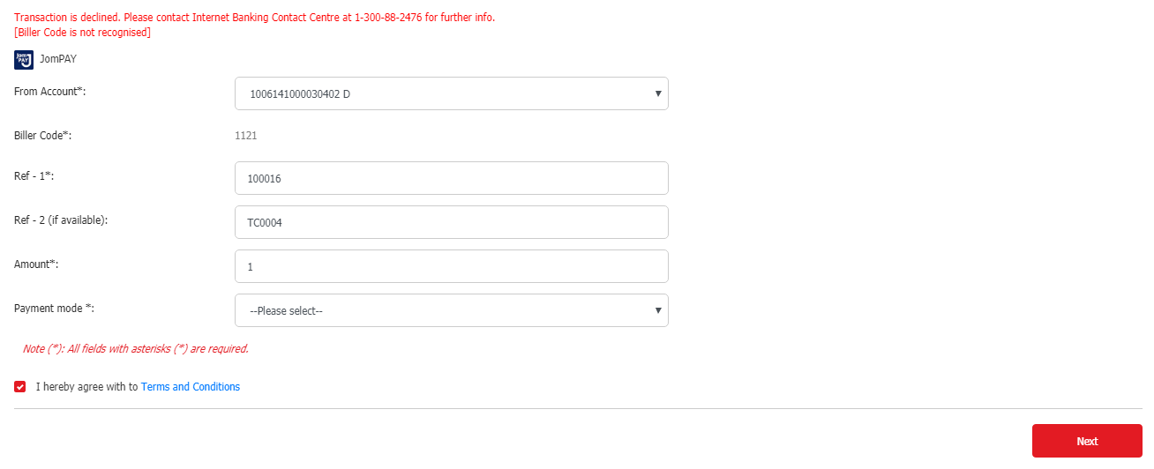
TC0005 | STATUS: PASSED
User Alias | Initrahmanbal
Biller Code: | 1610
Biller Name: | TEST
Ref 1: | 100016
Screenshot:
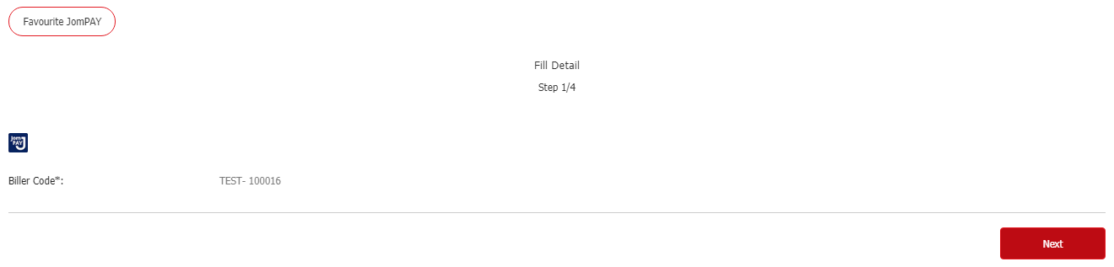
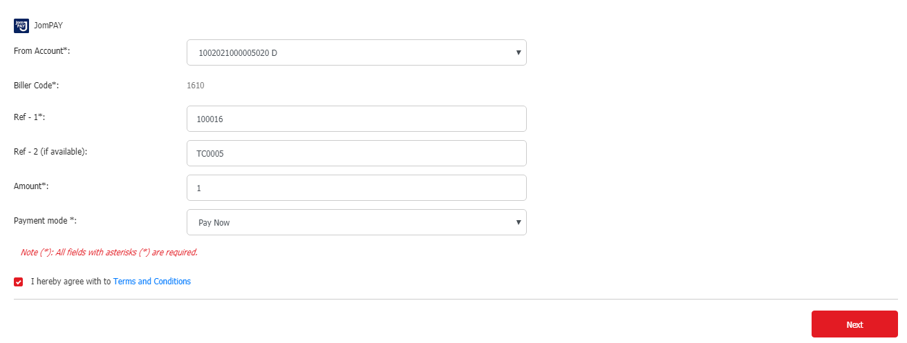
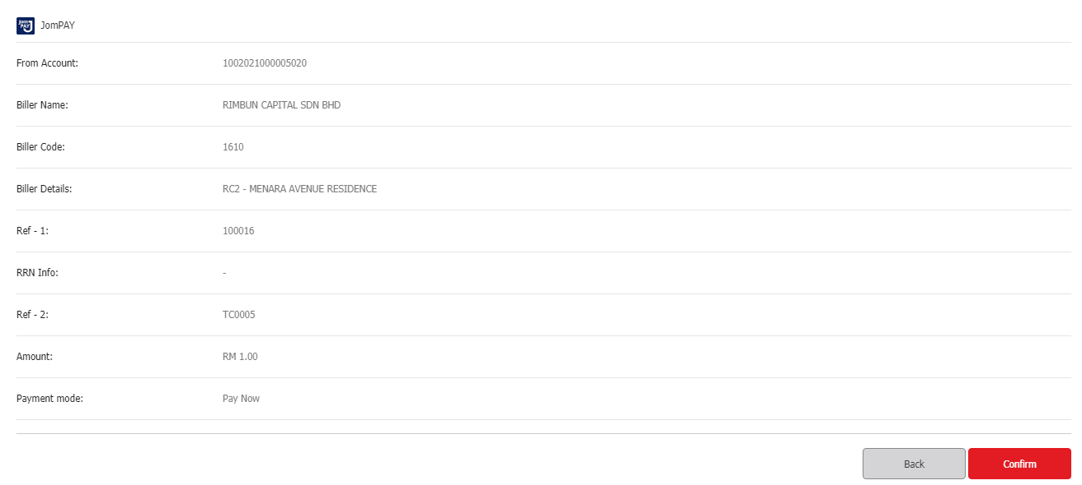
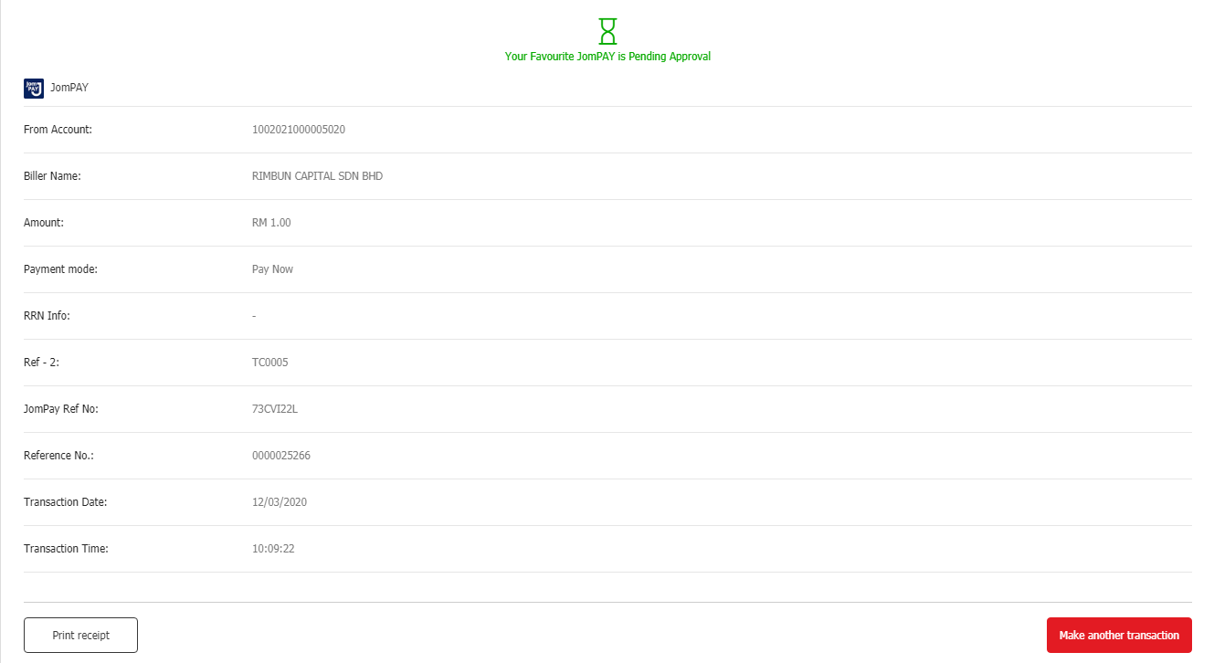

BIB: DELETE FAVOURITE JOMPAY
TC0001 | STATUS: PASSED
User Alias | initrahmanstep
Biller Code: | 1610
Biller Name: | TEST
Ref 1: | 100016
Screenshot:
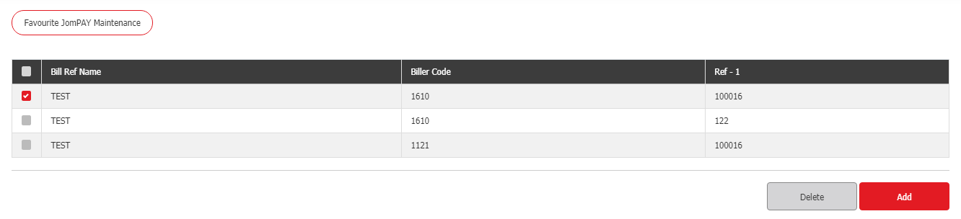
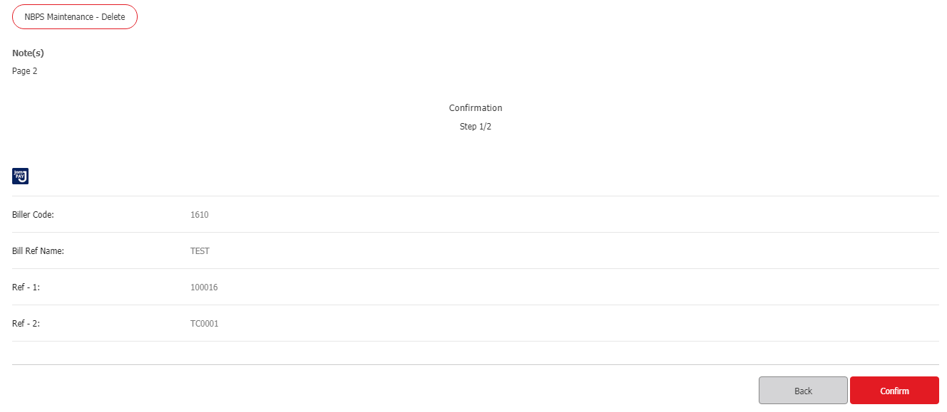
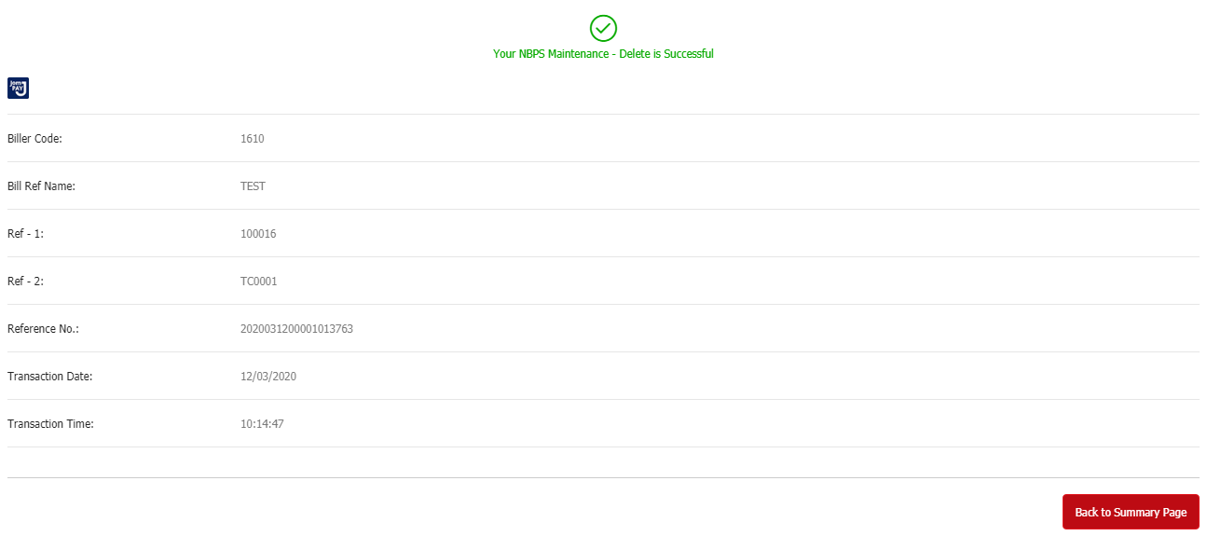
TC0002 | STATUS: PASSED
User Alias | initrahmanstep
Biller Code: | 1610
Biller Name: | TEST
Ref 1: | 122
Screenshot:
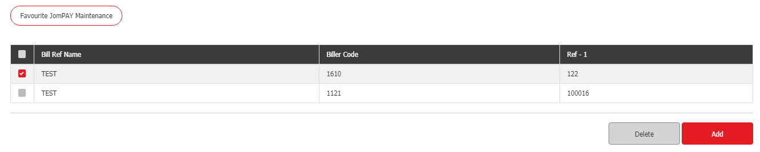
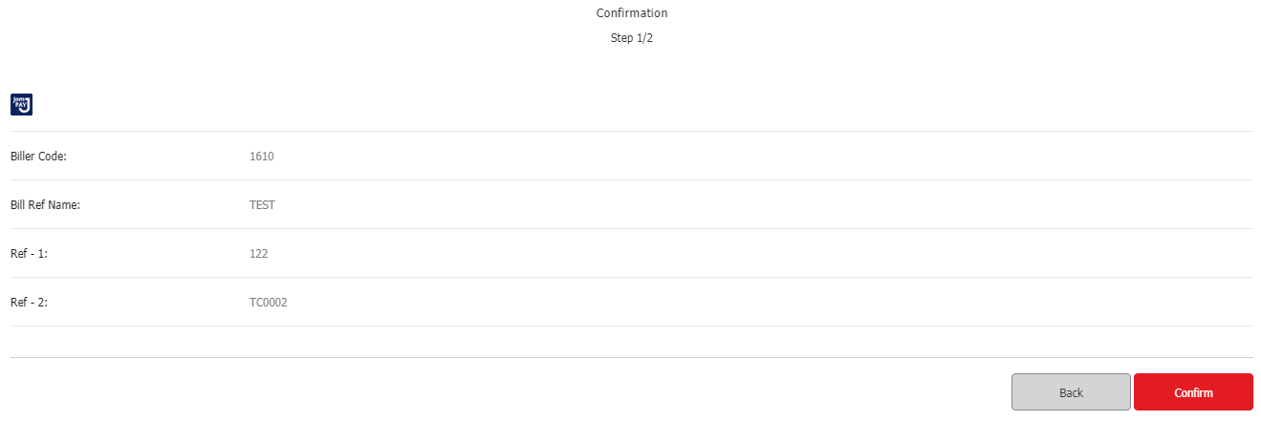
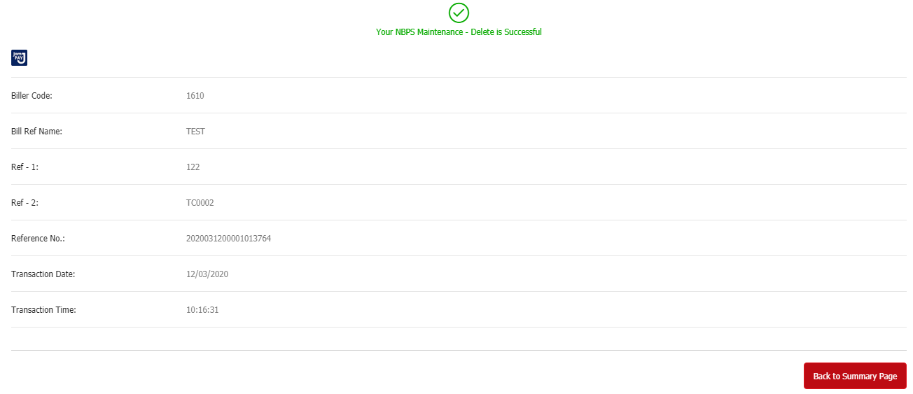
TC0003 | STATUS: TEST CASE NOT VALID
User Alias | initrahmanstep
Biller Code: | 1610
Biller Name: | TESTING
Ref 1: | 100016
Screenshot:

TC0004 | STATUS: PASSED
User Alias | initrahmanstep
Biller Code: | 1121
Biller Name: | TEST
Ref 1: | 100016
Screenshot:
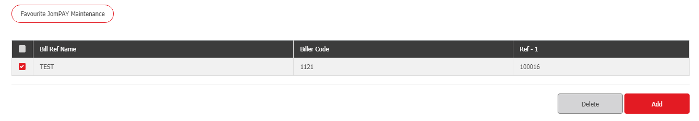
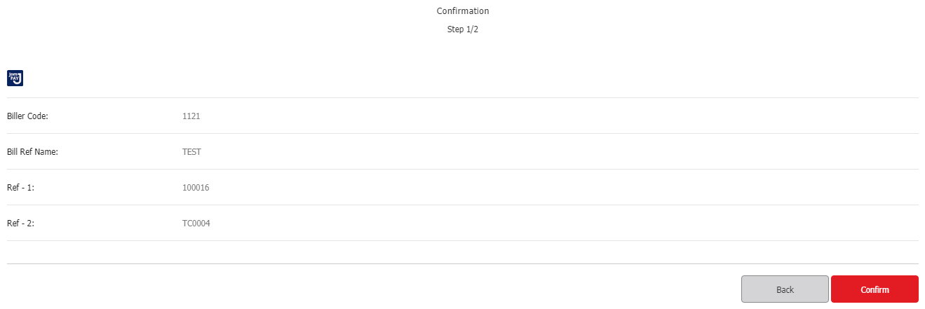
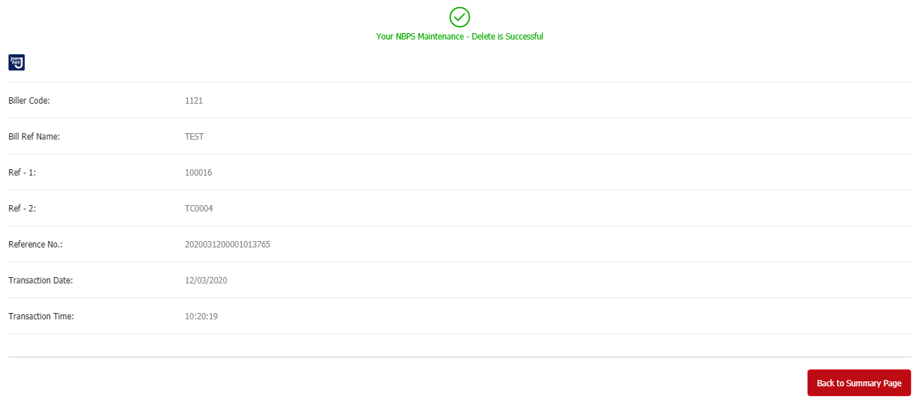
TC0005 | STATUS: PASSED
User Alias | Initrahmanbal
Biller Code: | 1610
Biller Name: | TEST
Ref 1: | 100016
Screenshot:
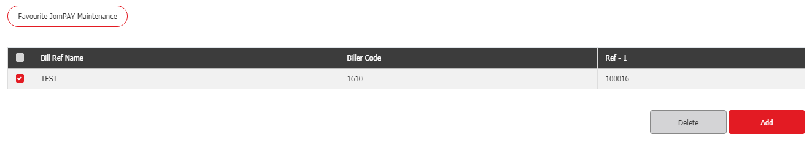
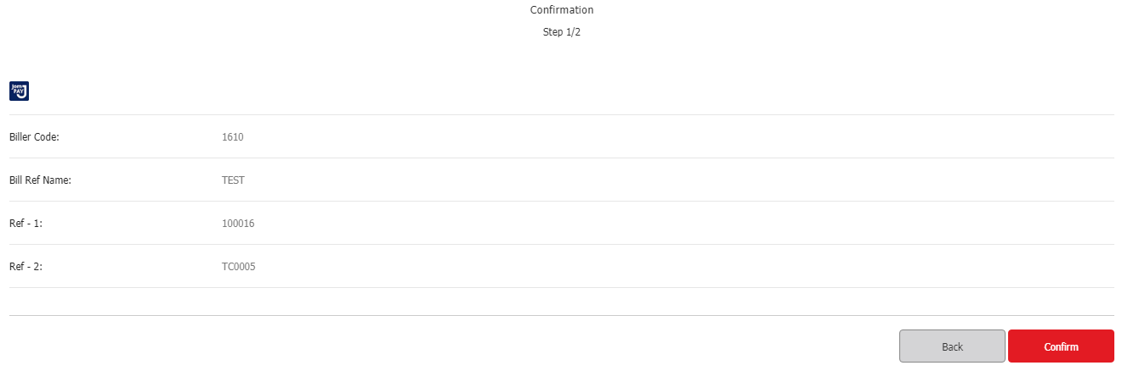
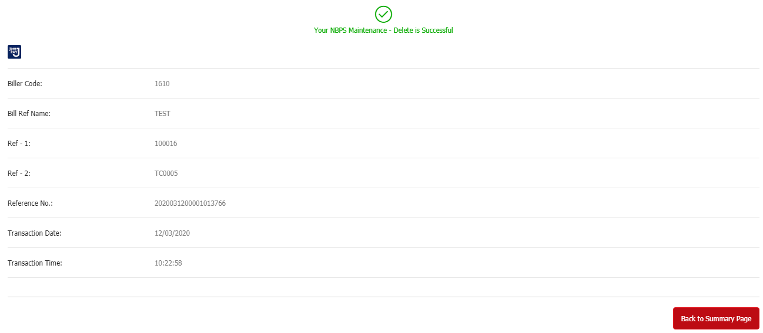

RIB: ADD FAVOURITE JOMPAY
TC0001 | STATUS: PASSED
User Alias | ribuseruat
Biller Code: | 1610
Biller Name: | TEST
Ref 1: | 100016
Screenshot:
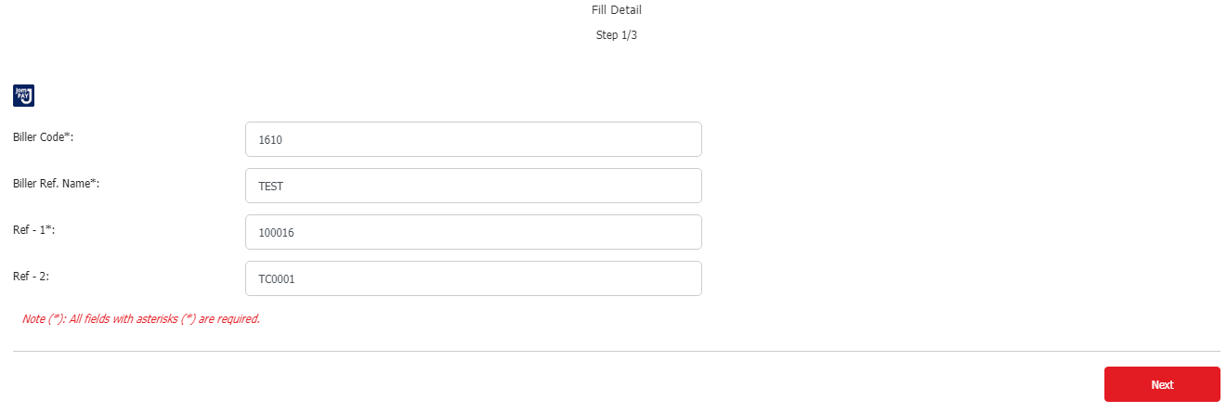
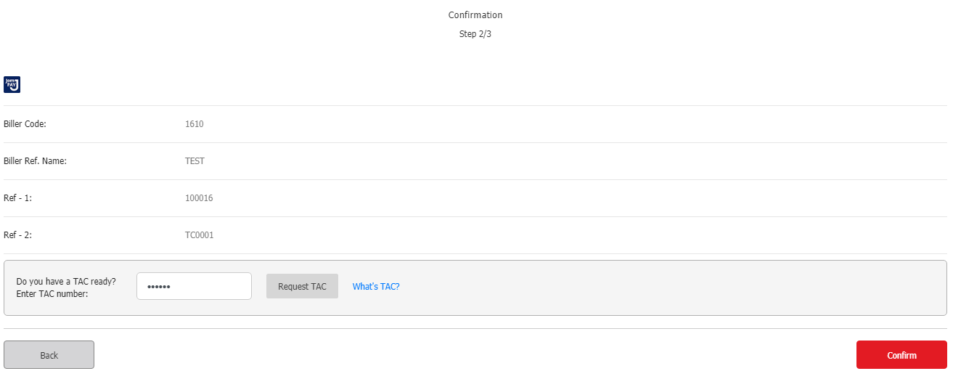
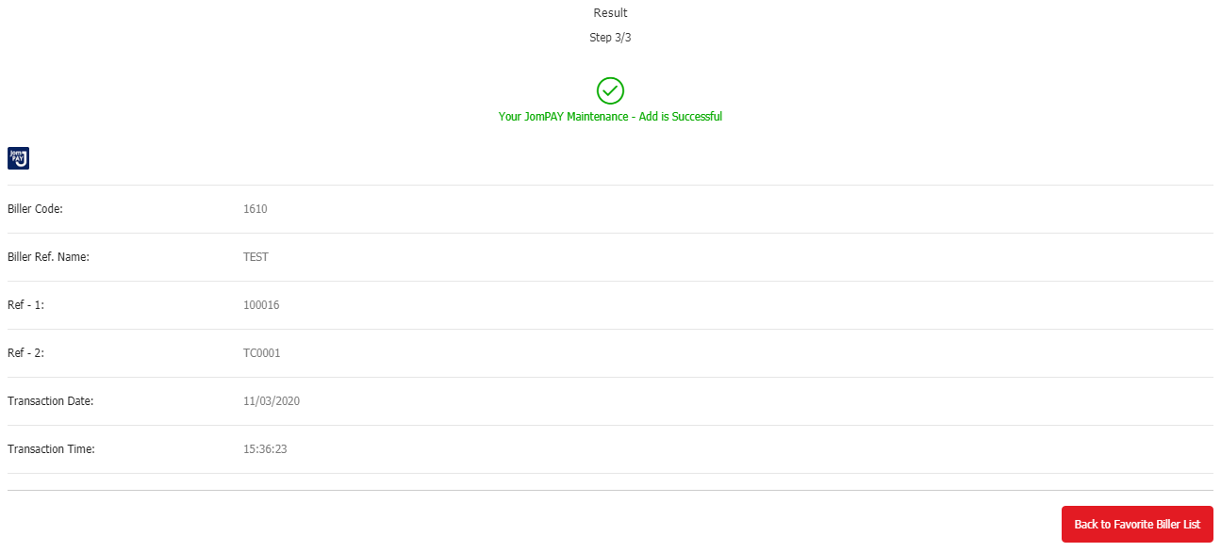
TC0002 | STATUS: PASSED
User Alias | ribuseruat
Biller Code: | 1610
Biller Name: | TEST
Ref 1: | 122
Screenshot:
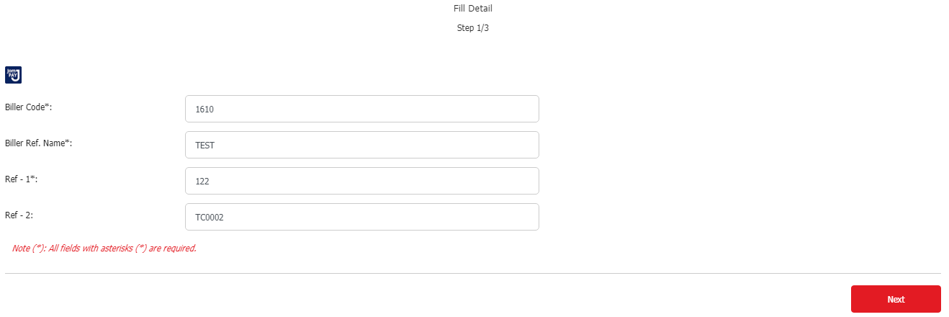
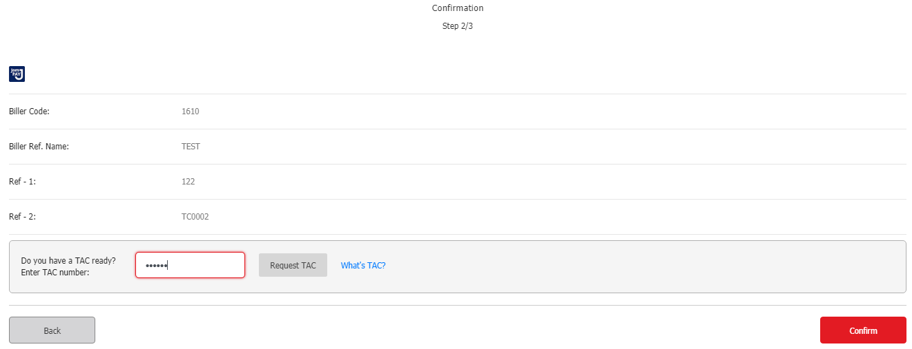
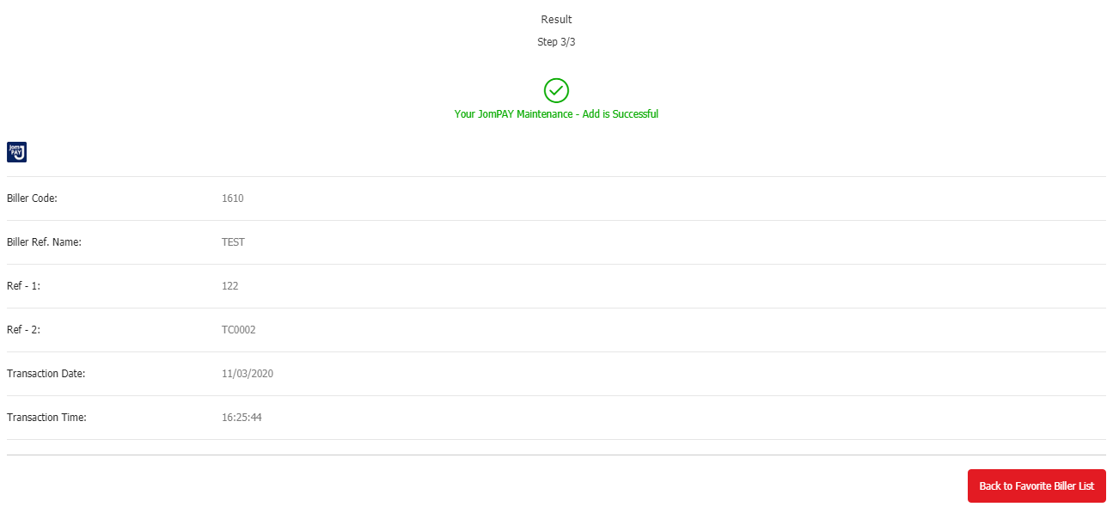
TC0003 | STATUS: TEST CASE NOT VALID
User Alias | ribuseruat
Biller Code: | 1610
Biller Name: | TESTING
Ref 1: | 100016
Screenshot:

TC0004 | STATUS: PASSED
User Alias | ribuseruat
Biller Code: | 1121
Biller Name: | TEST
Ref 1: | 100016
Screenshot:
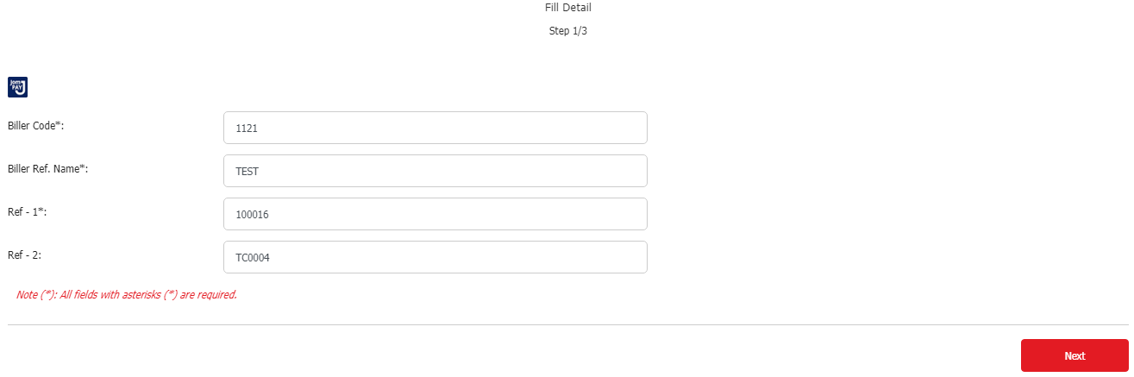
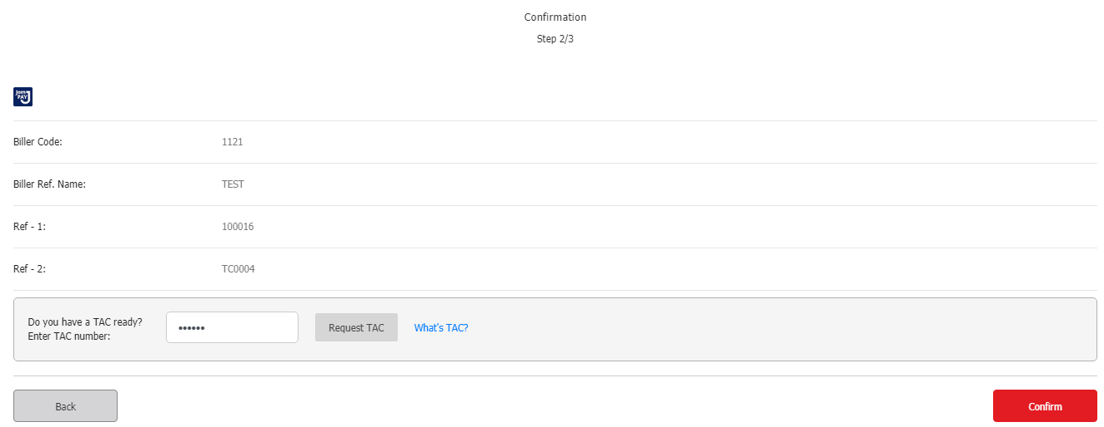
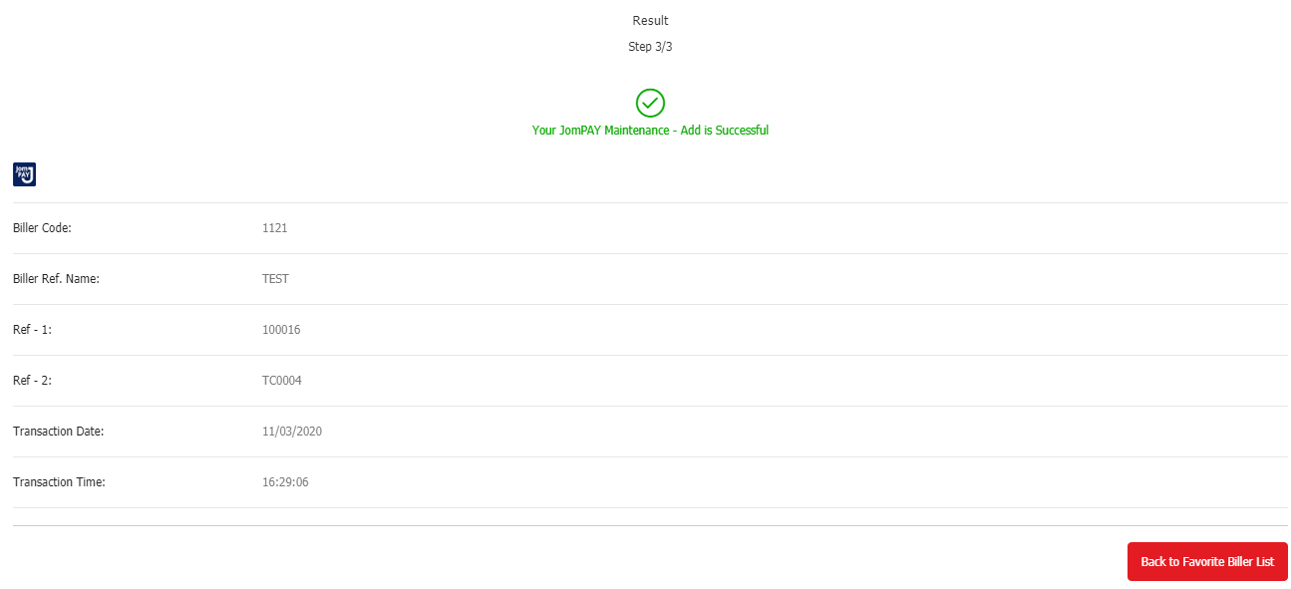
TC0005 | STATUS: PASSED
User Alias | batman
Biller Code: | 1610
Biller Name: | TEST
Ref 1: | 100016
Screenshot:
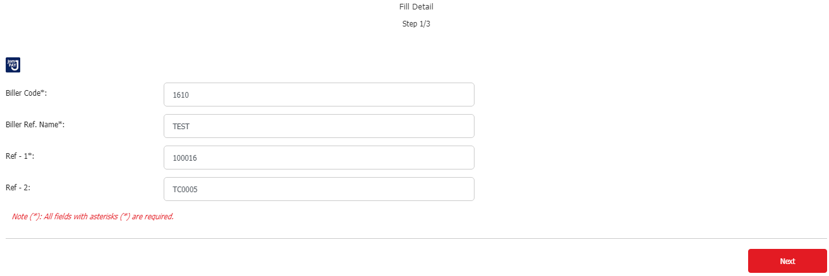
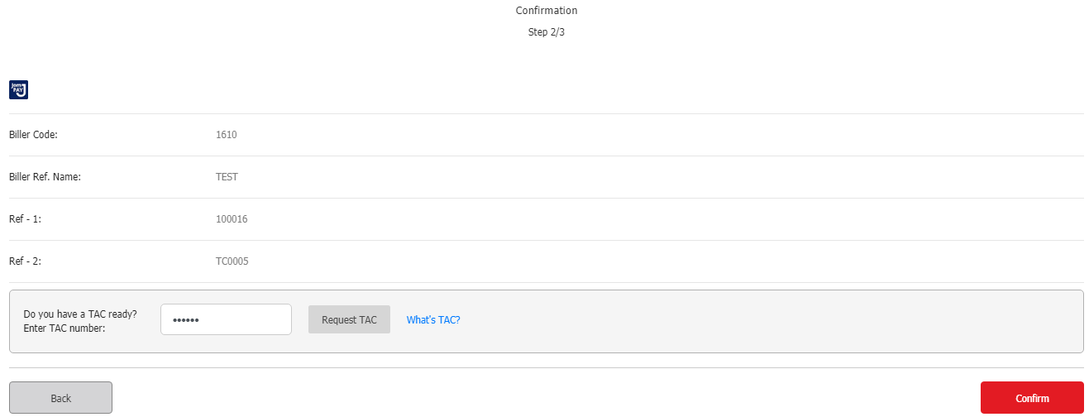
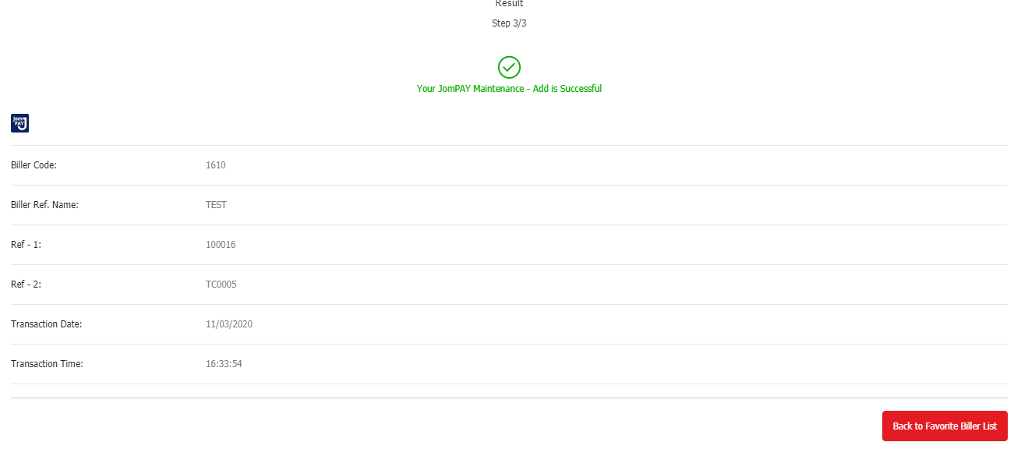

RIB: PERFORM FAVOURITE JOMPAY
TC0001 | STATUS: PASSED
User Alias | ribuseruat
Biller Code: | 1610
Biller Name: | TEST
Ref 1: | 100016
Screenshot:
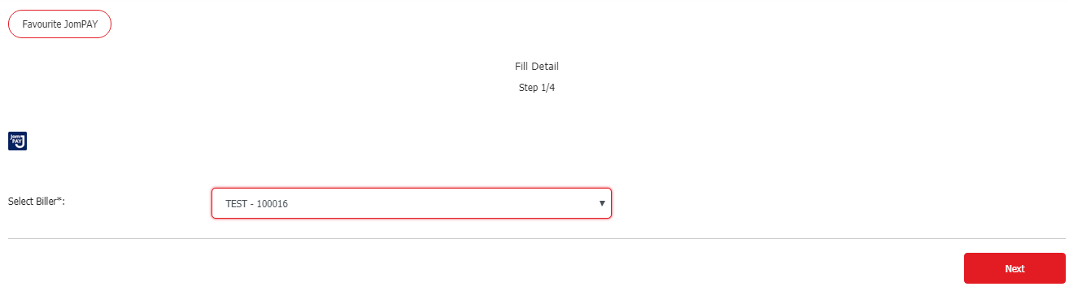
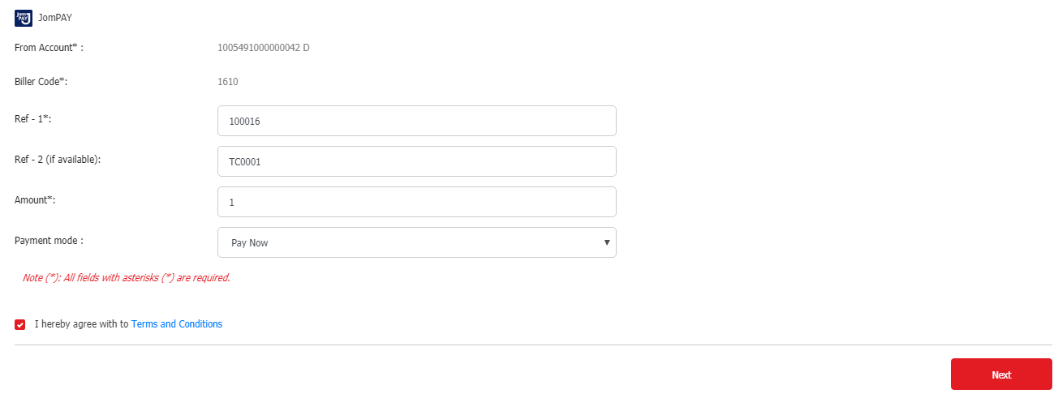
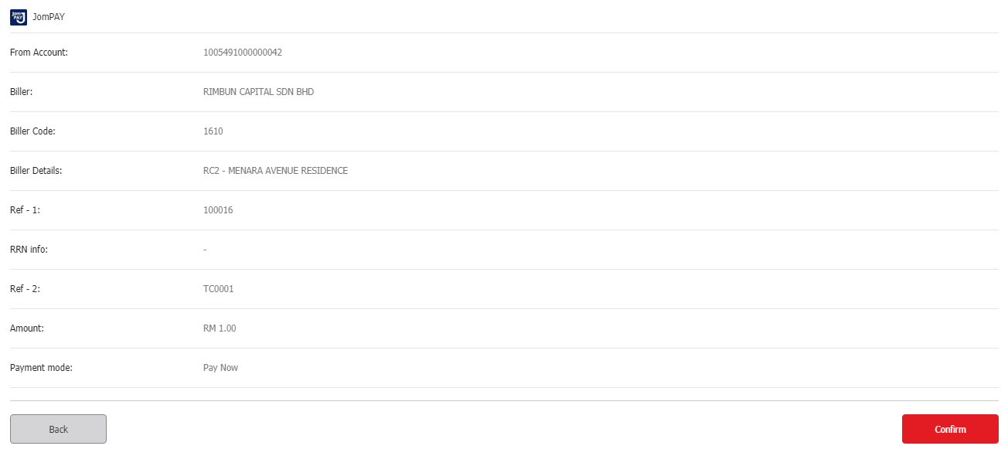
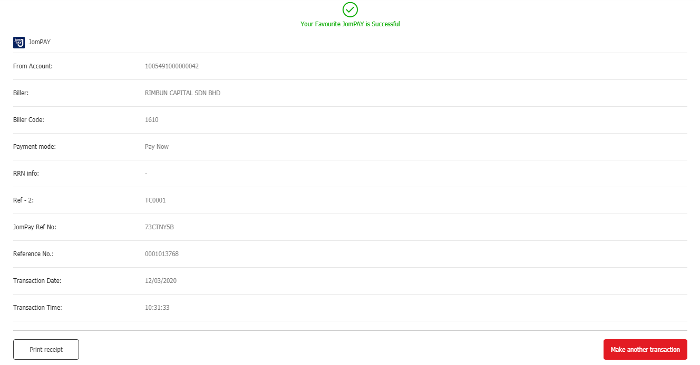
TC0002 | STATUS: PASSED
User Alias | ribuseruat
Biller Code: | 1610
Biller Name: | TEST
Ref 1: | 122
Screenshot:
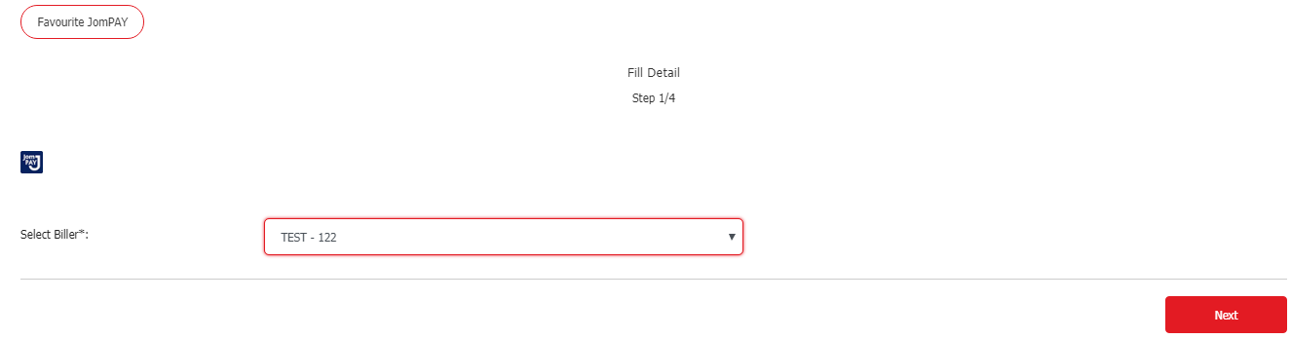
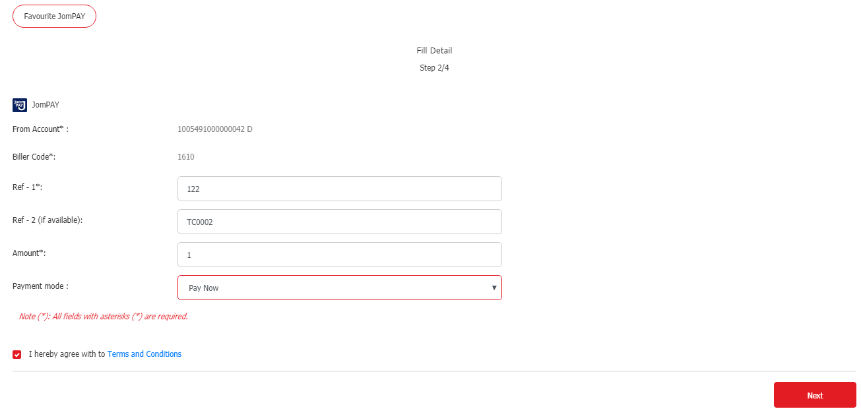
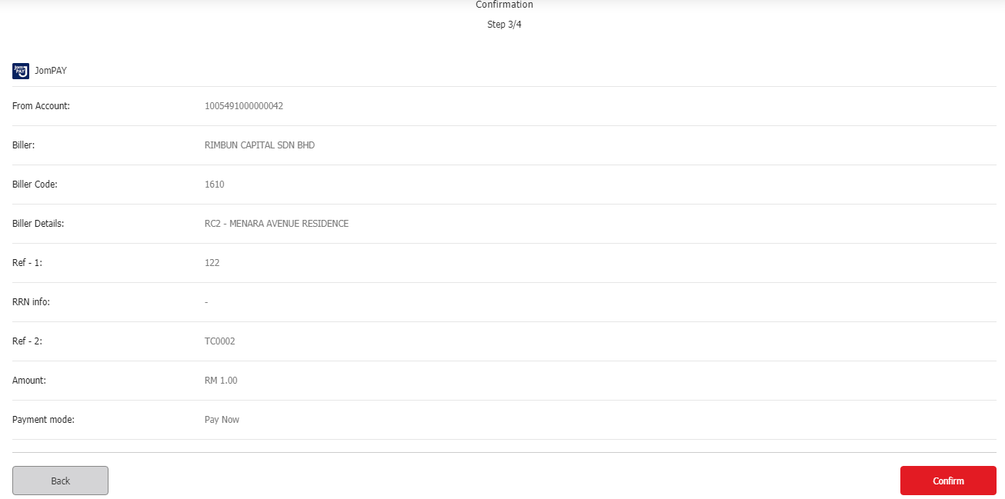
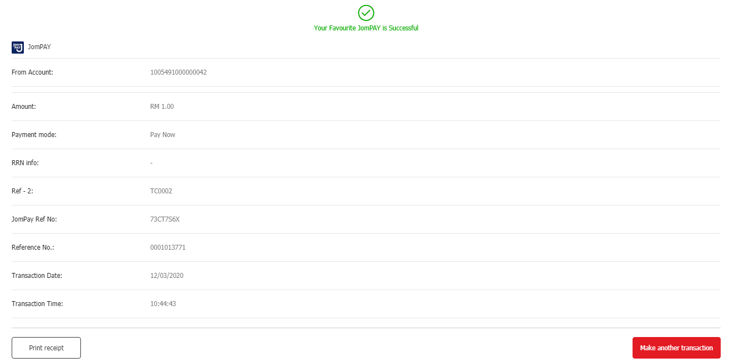
TC0003 | STATUS: TEST CASE NOT VALID
User Alias | ribuseruat
Biller Code: | 1610
Biller Name: | TESTING
Ref 1: | 100016
Screenshot:

TC0004 | STATUS: PASSED
User Alias | ribuseruat
Biller Code: | 1121
Biller Name: | TEST
Ref 1: | 100016
Screenshot:
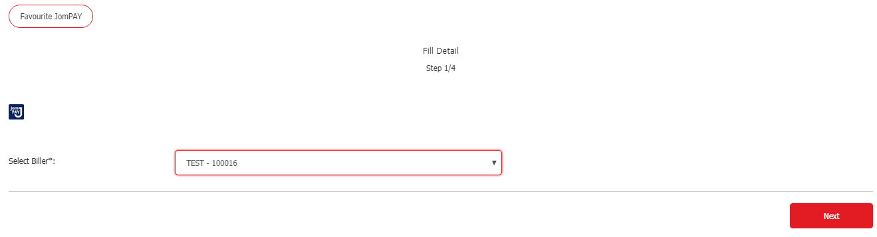
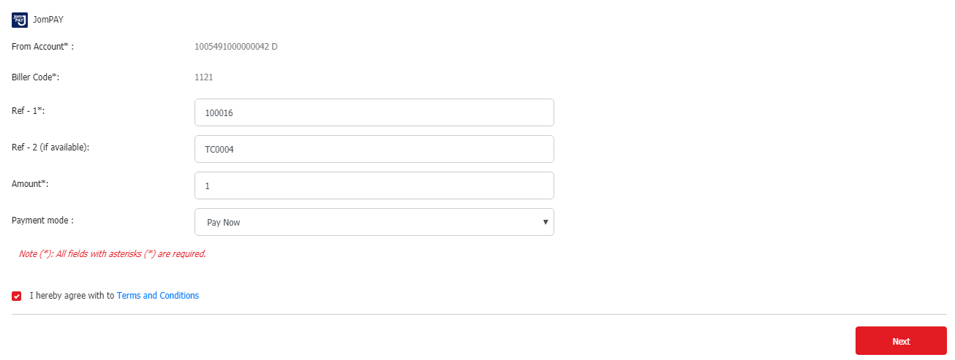
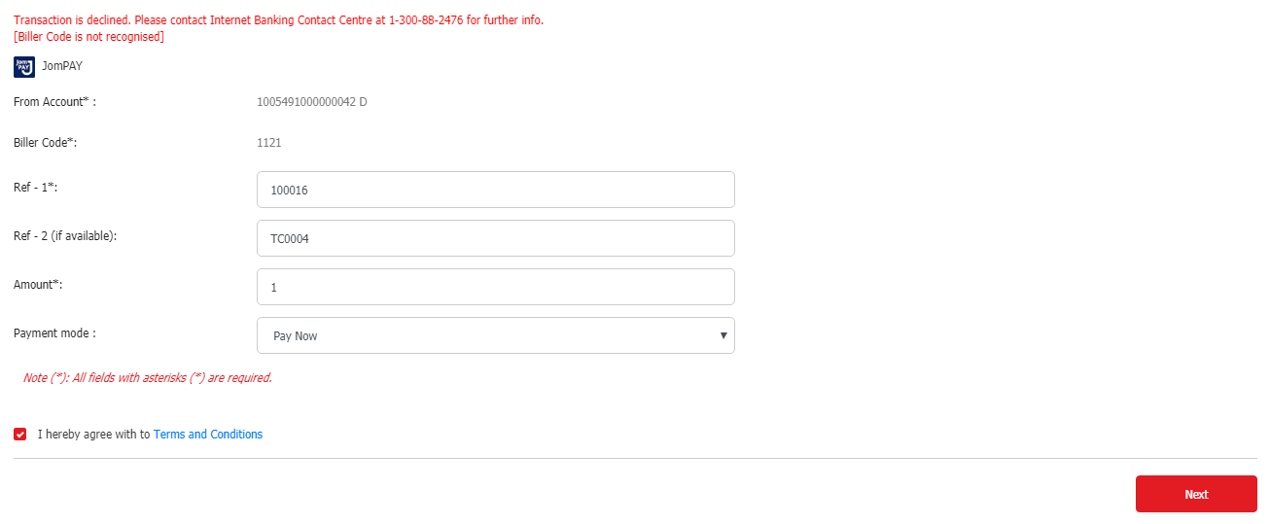
TC0005 | STATUS: PASSED
User Alias | batman
Biller Code: | 1610
Biller Name: | TEST
Ref 1: | 100016
Screenshot:
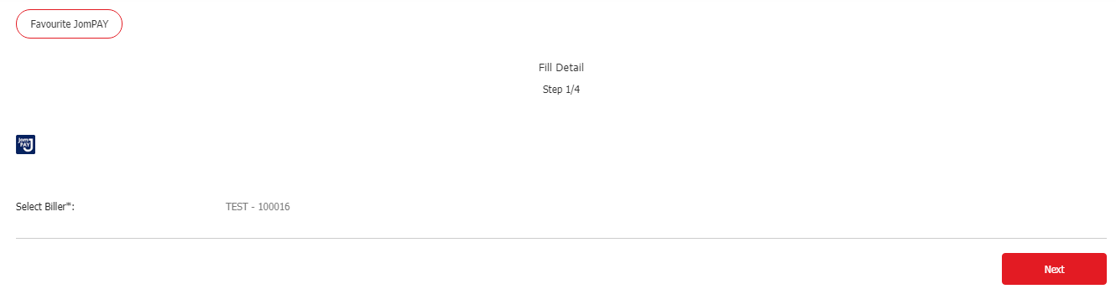
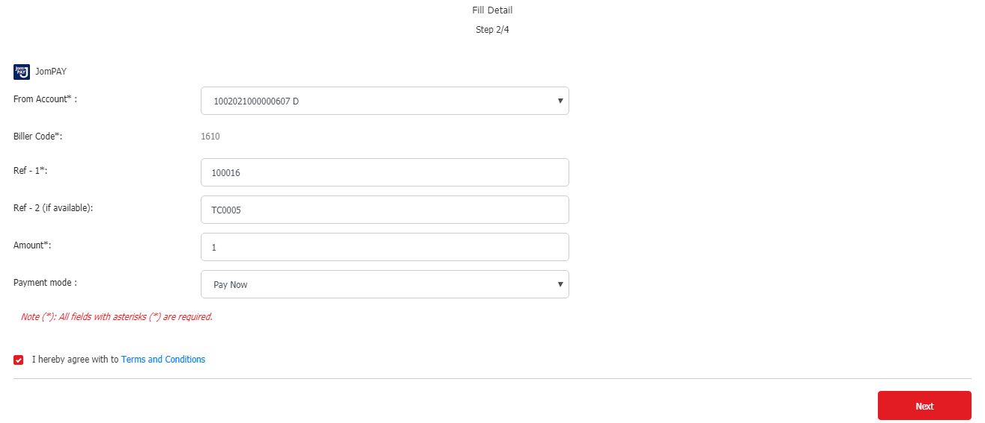
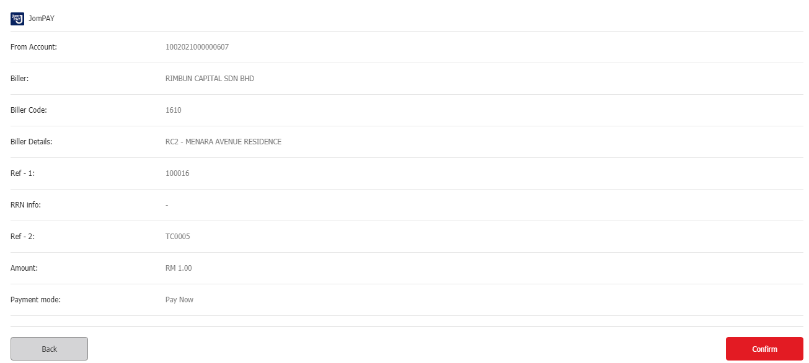
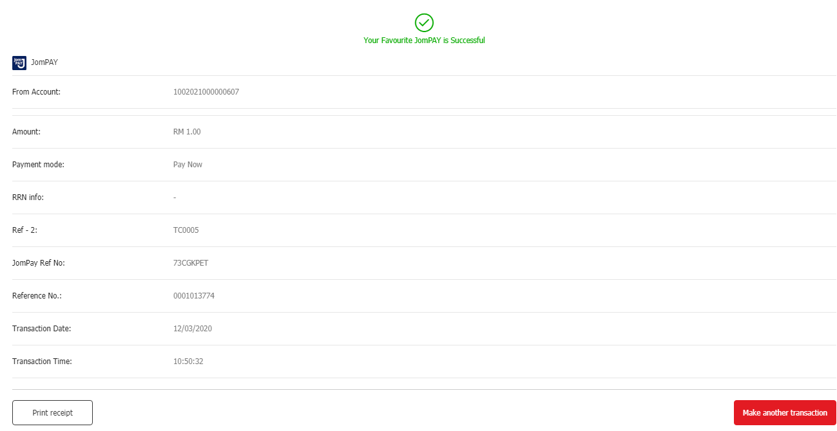

RIB: DELETE FAVOURITE JOMPAY
TC0001 | STATUS: PASSED
User Alias | ribuseruat
Biller Code: | 1610
Biller Name: | TEST
Ref 1: | 100016
Screenshot:
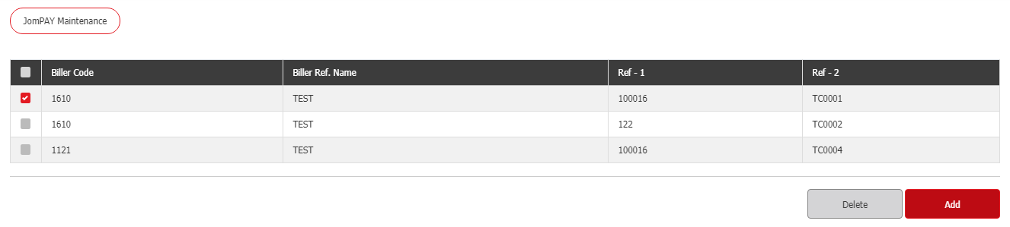
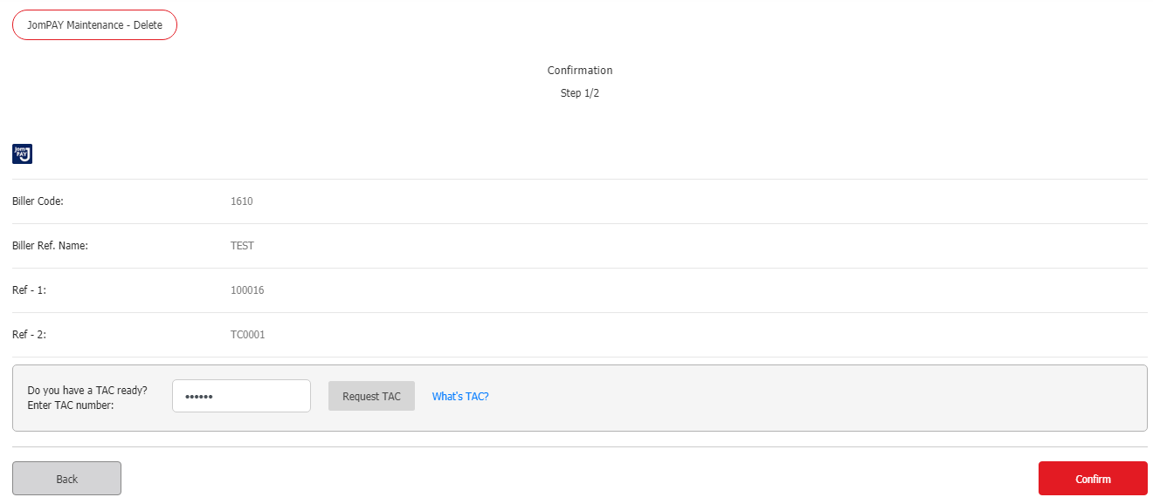
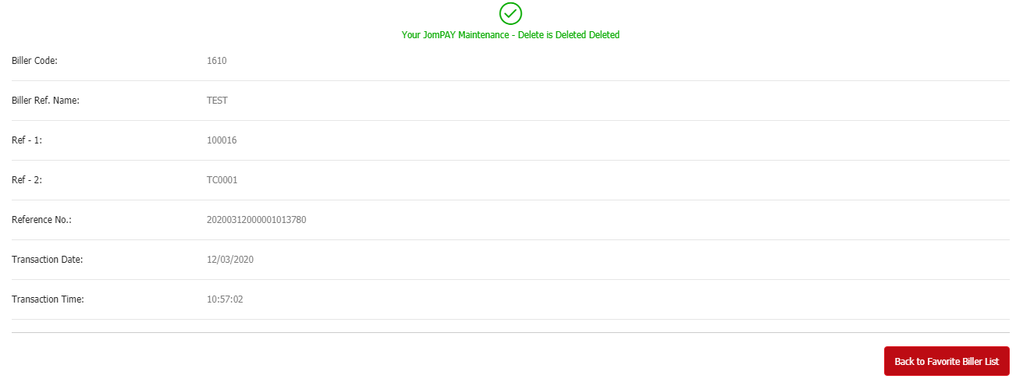
TC0002 | STATUS: PASSED
User Alias | ribuseruat
Biller Code: | 1610
Biller Name: | TEST
Ref 1: | 122
Screenshot:
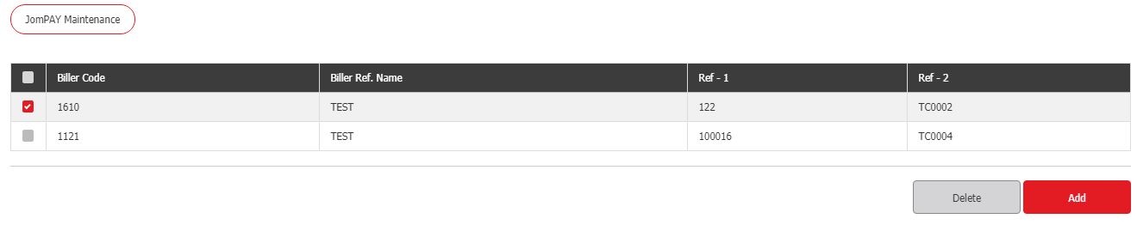
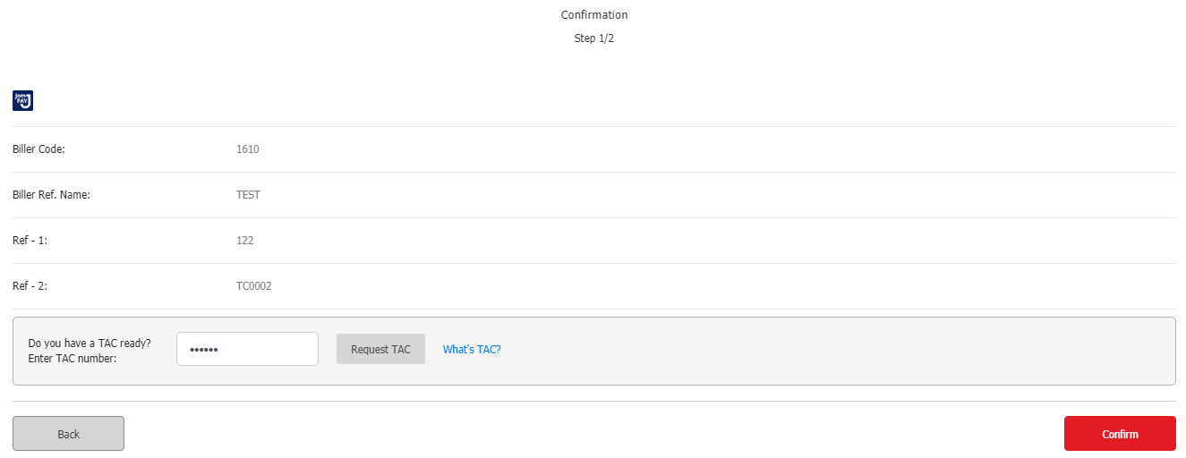
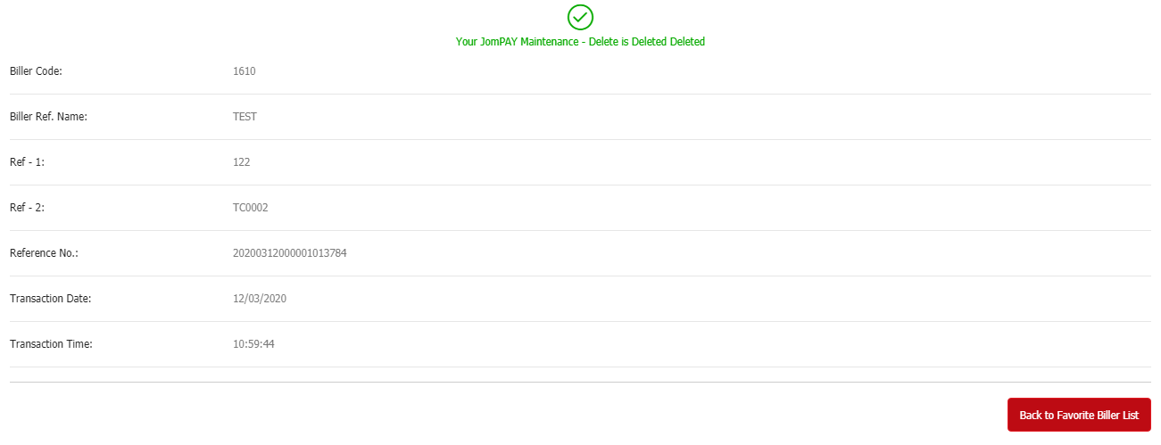
TC0003 | STATUS: TEST CASE NOT VALID
User Alias | ribuseruat
Biller Code: | 1610
Biller Name: | TESTING
Ref 1: | 100016
Screenshot:

TC0004 | STATUS: PASSED
User Alias | ribuseruat
Biller Code: | 1121
Biller Name: | TEST
Ref 1: | 100016
Screenshot:
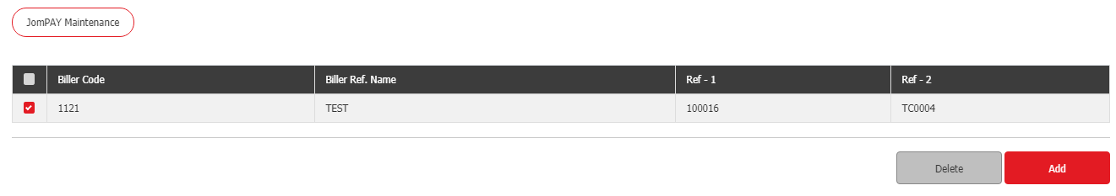
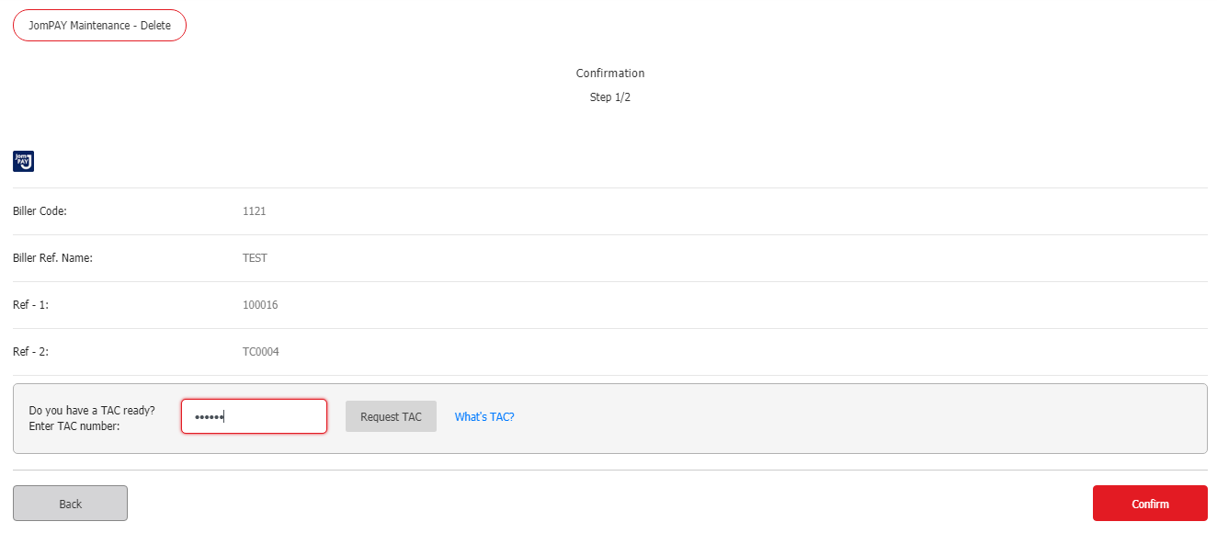
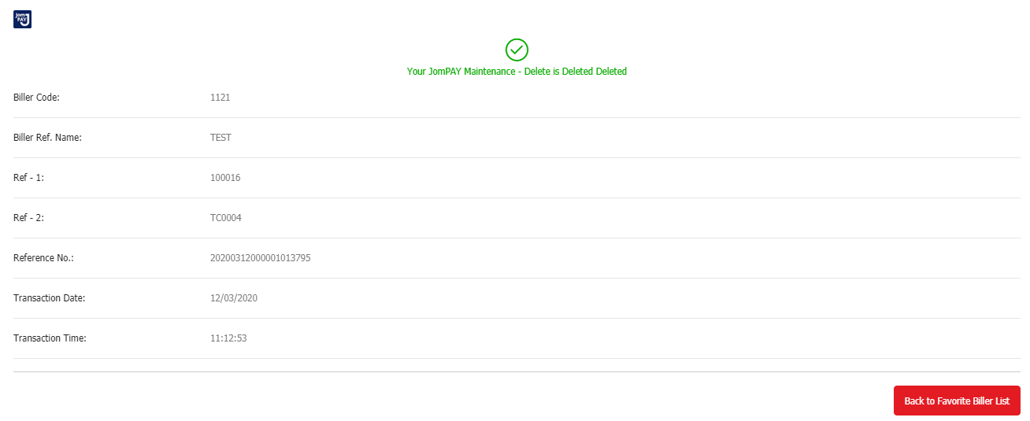
TC0005 | STATUS: PASSED
User Alias | batman
Biller Code: | 1610
Biller Name: | TEST
Ref 1: | 100016
Screenshot:
