- Relocate value to the correct field. Merchant Name value not display
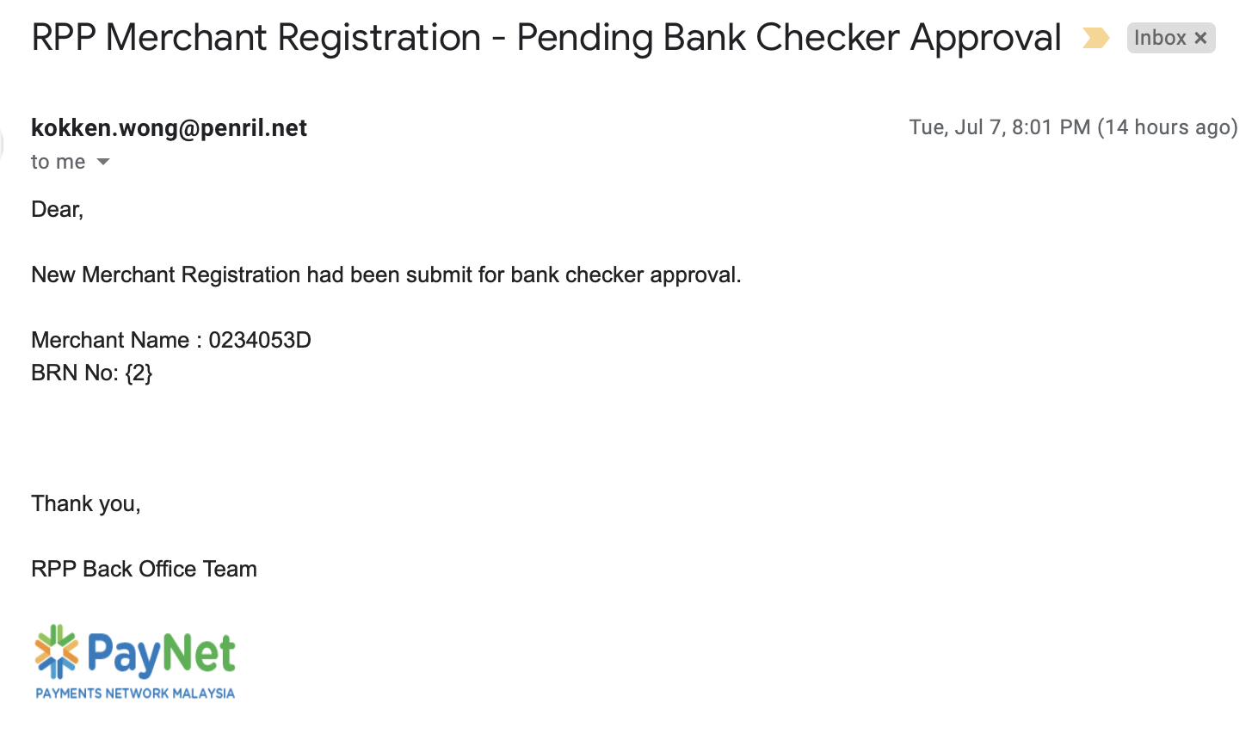
- Relocate value to the correct field. Merchant Name value not display
- Click here hyperlink not active
