Click on back button on step 2

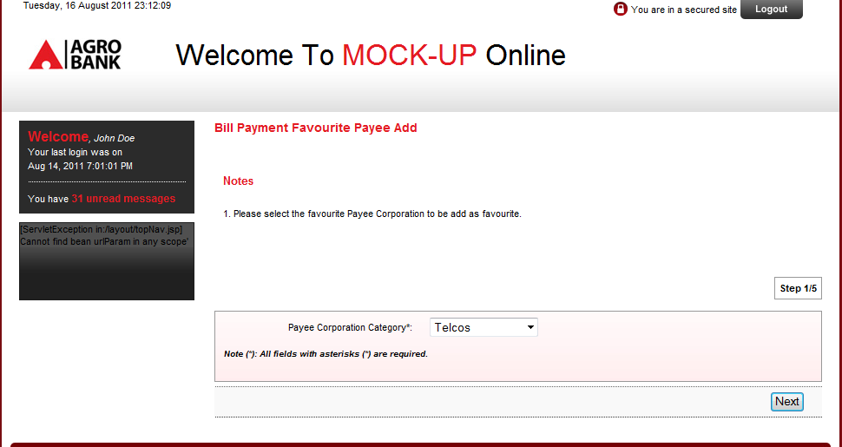

Required Field without Label For MAKRO Enterprise

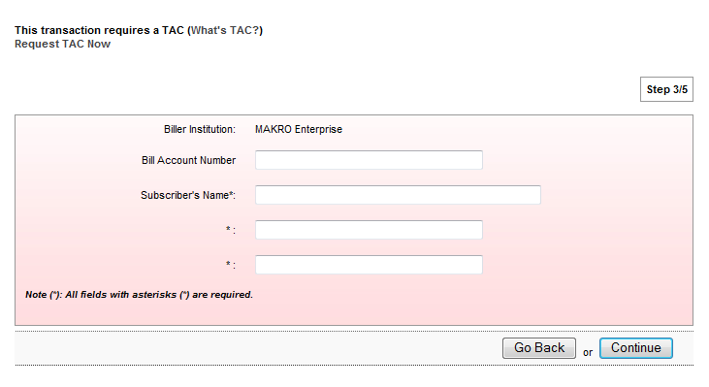

Required Field without Label For MAXIS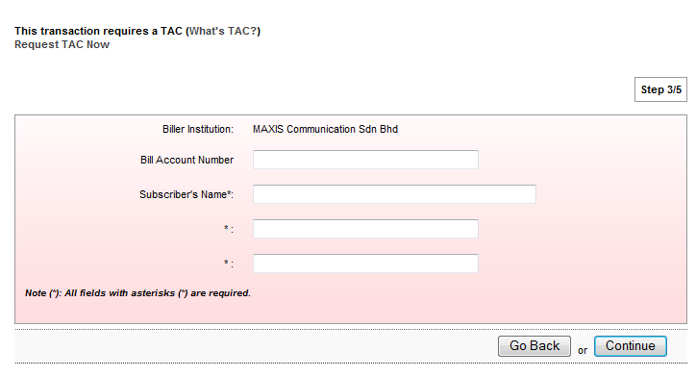

Required Field Label For Digi

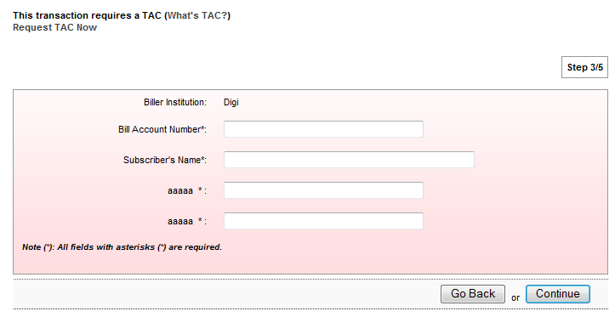

Required Field Label For Telco Test

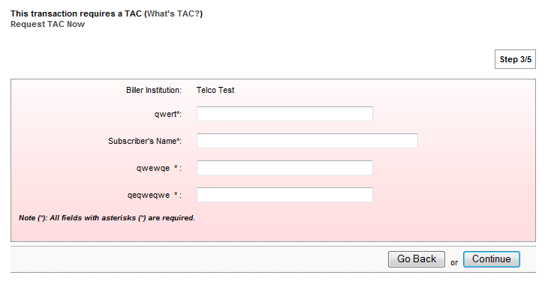

Required Field Label for Mountain Spring Water Enterprise same goes to Uber power

