Click next button with wrong answer

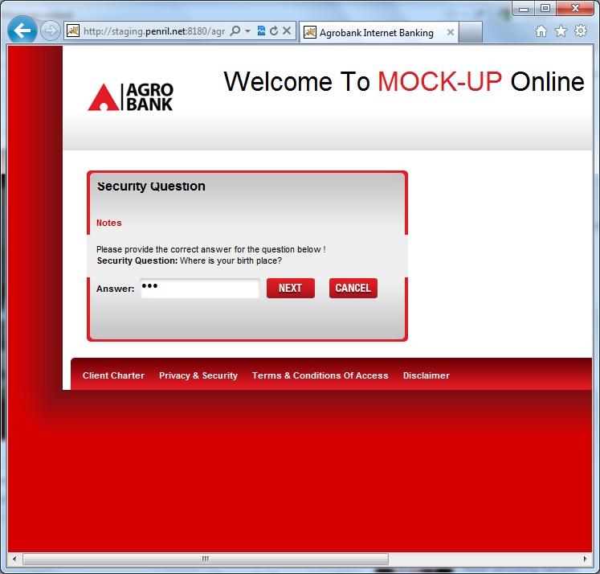

Page forward to Update Mobile Number. It supposes remain with original page with validation error

