Security Question & Answer GUI not follows the margin in BRS

From System

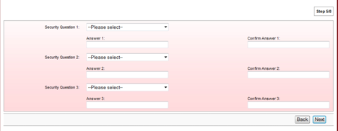

From BRS

