Test scenario:

1. Create a Bulk Payment without account transaction with 2 or more records

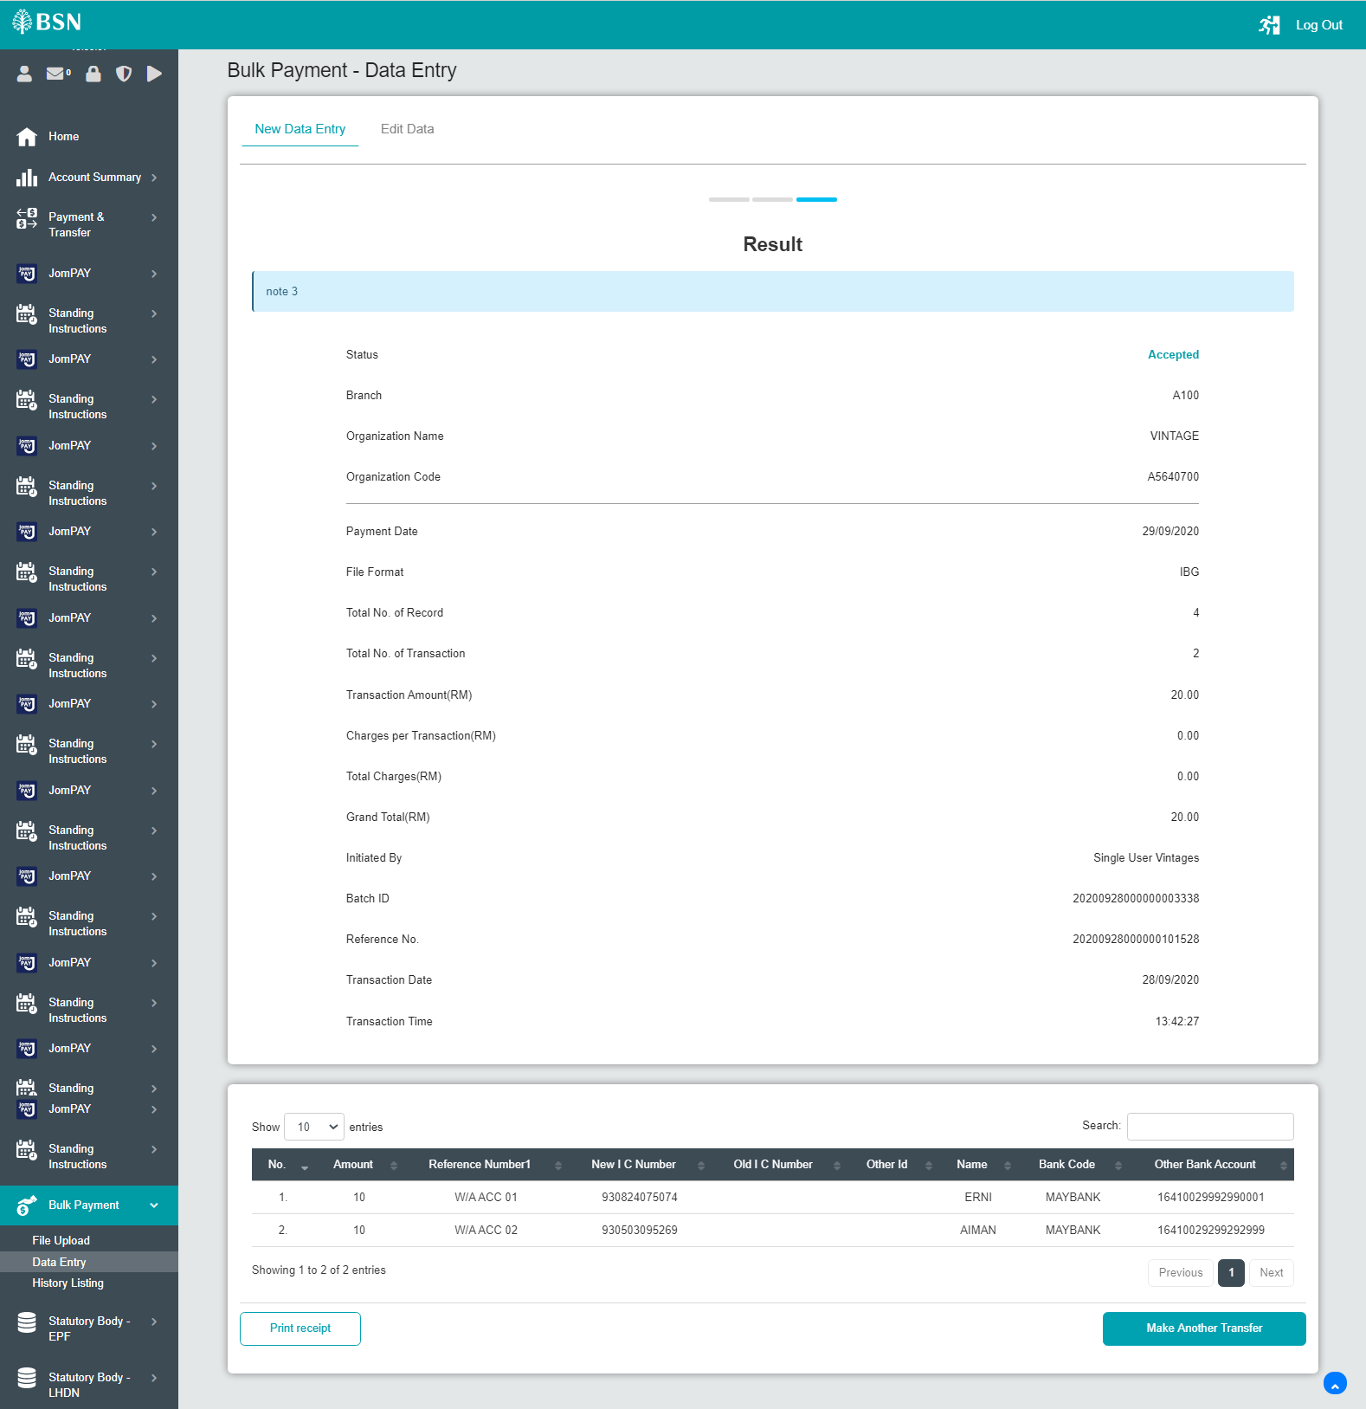

1. Via IBAM ~~or CDB~~, stop 1 record from the Bulk Payment
2. Check the amount display at Finance Entry list, details and stop payment screen
3. Expected result, the amount should be amount-stop amount

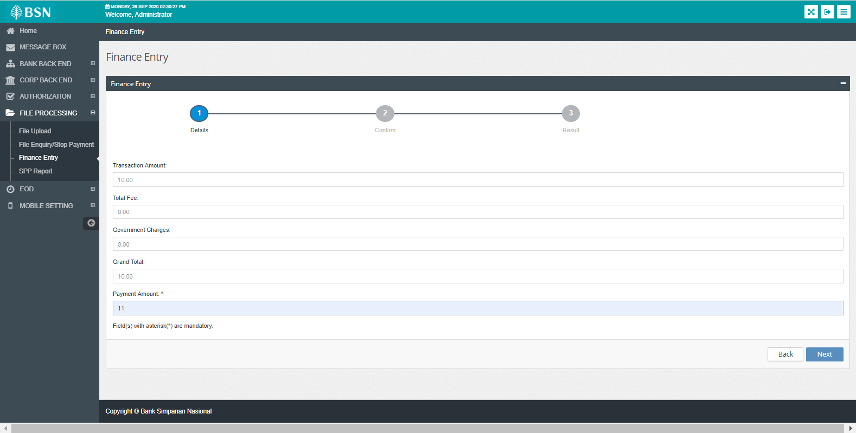

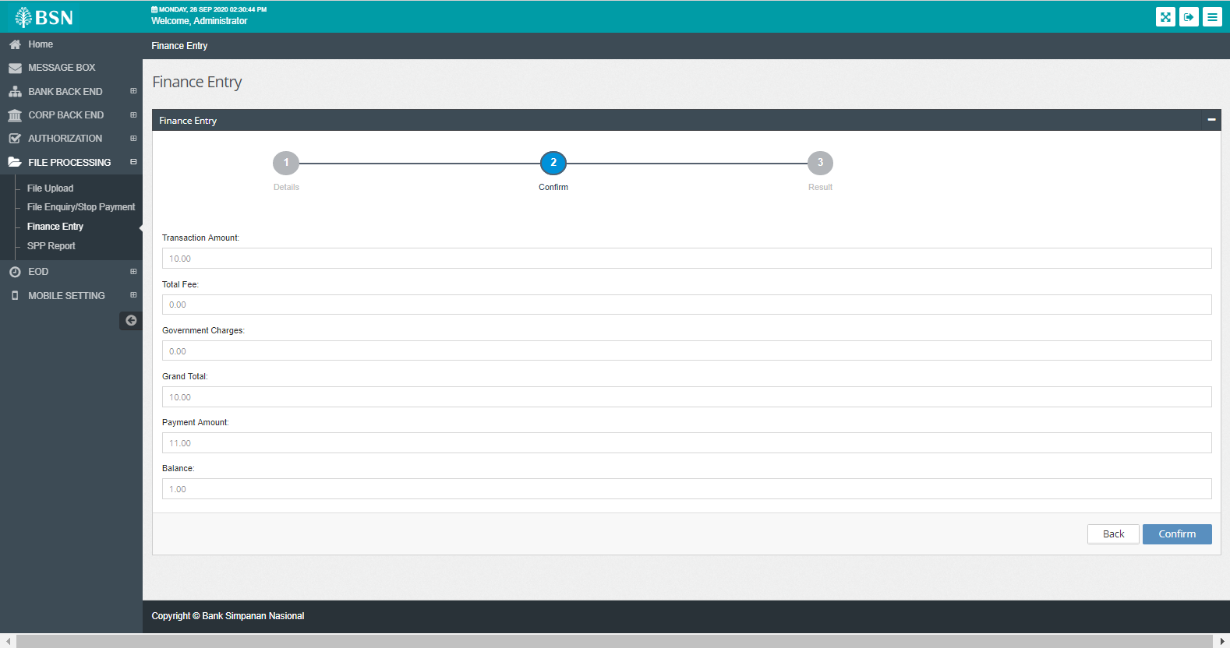

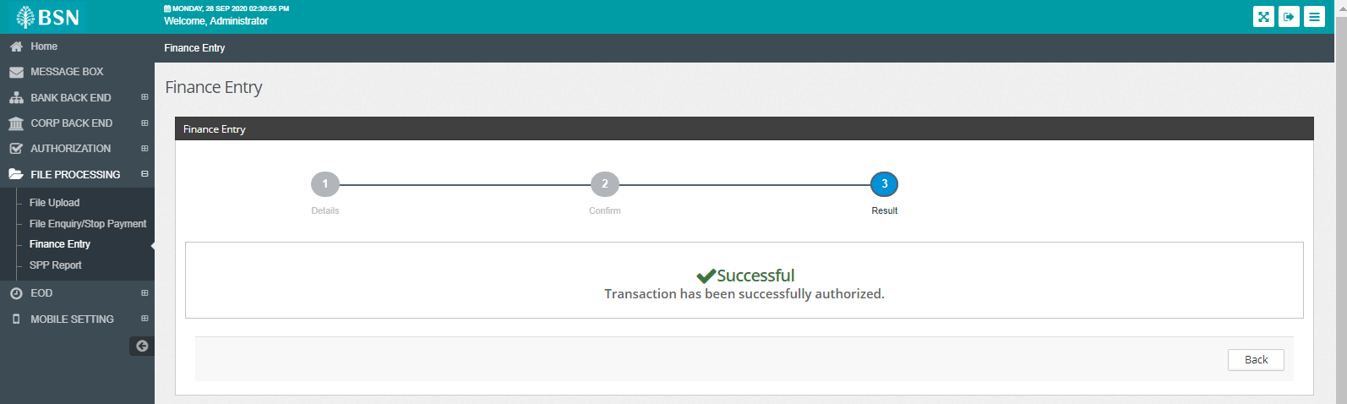

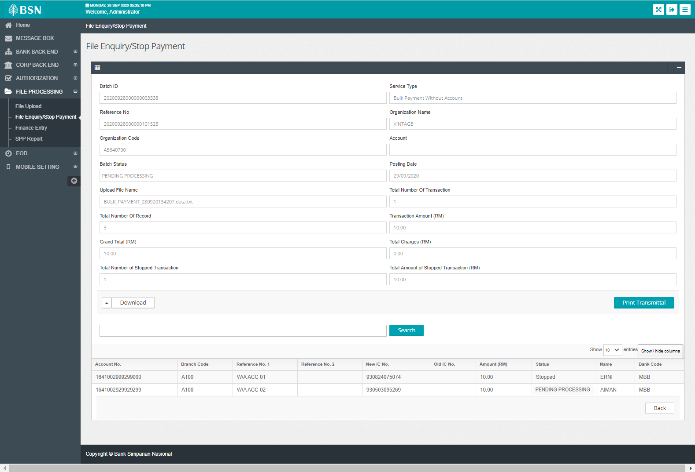

1. Continue enter amount and run EOD

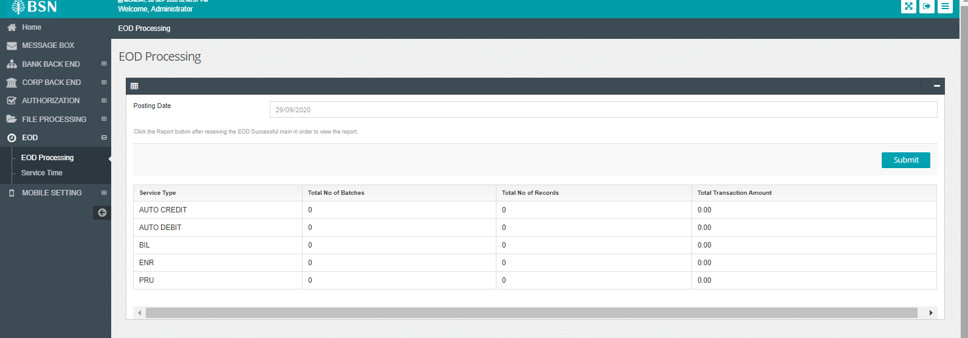

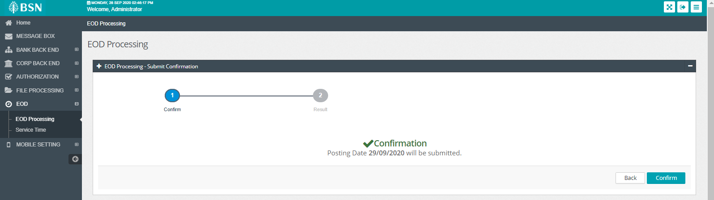

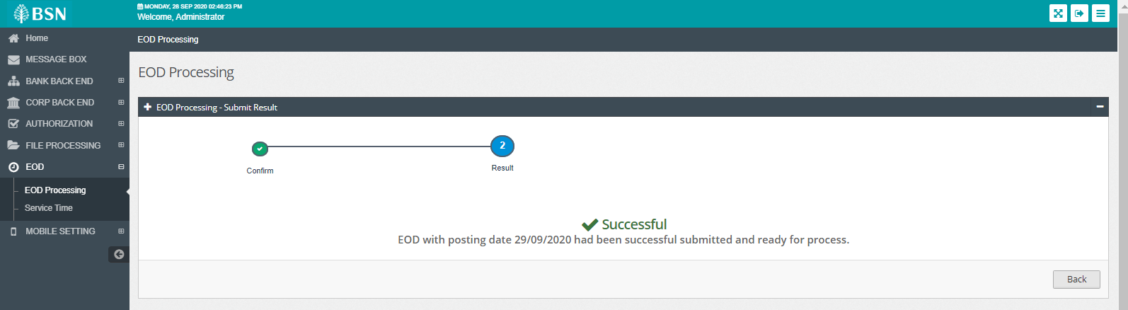

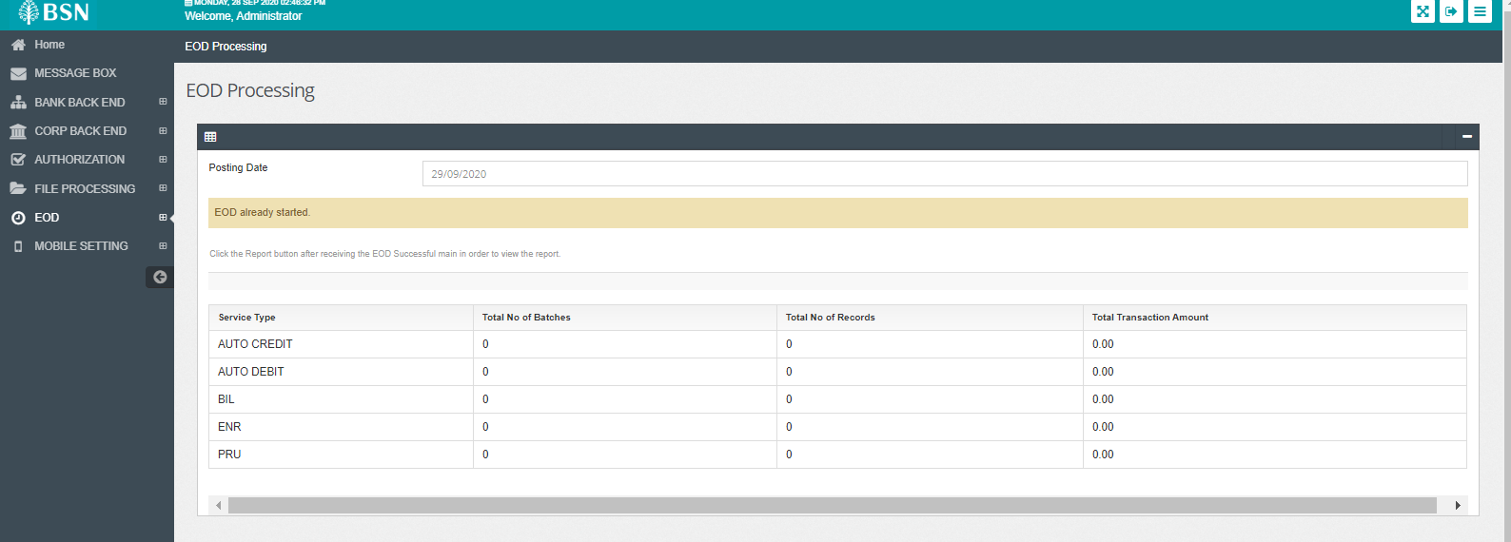

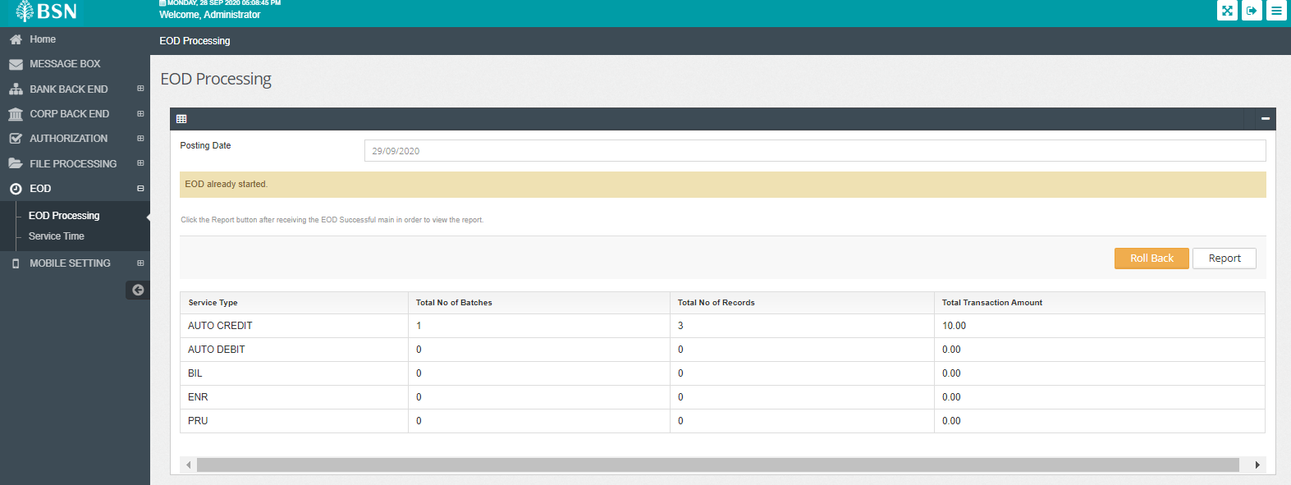

1. Check EOD file. Make sure header, footer and content is correct

