New bugs :

**1. Status not update if UKB stopped transaction at details**

Step :

-UKB click at "Batch ID"  
-UKB select all transaction and stop. [Total amount = RM0]

Result : Status still "Pending Processing" at IBAM and CDB  
Expected : Status update to "Stopped"

1. Status and amount displayed at CDB before STOPPED:

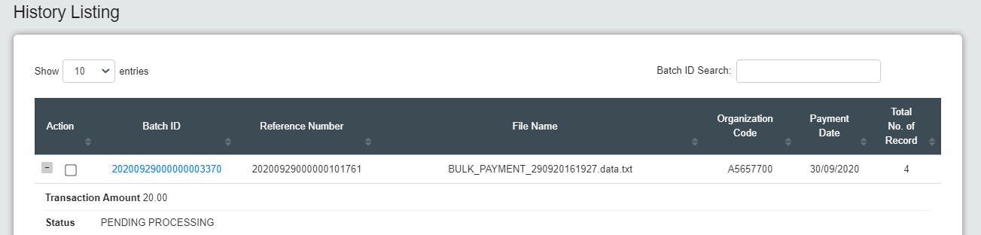

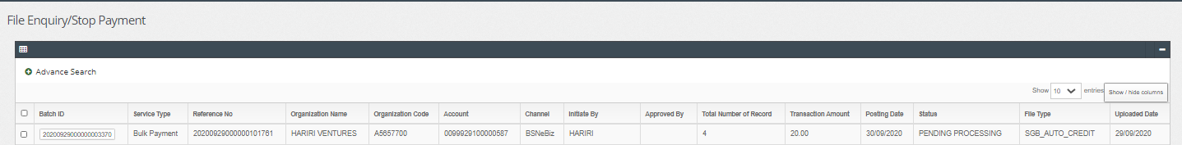

1. STOP all transaction in batch:

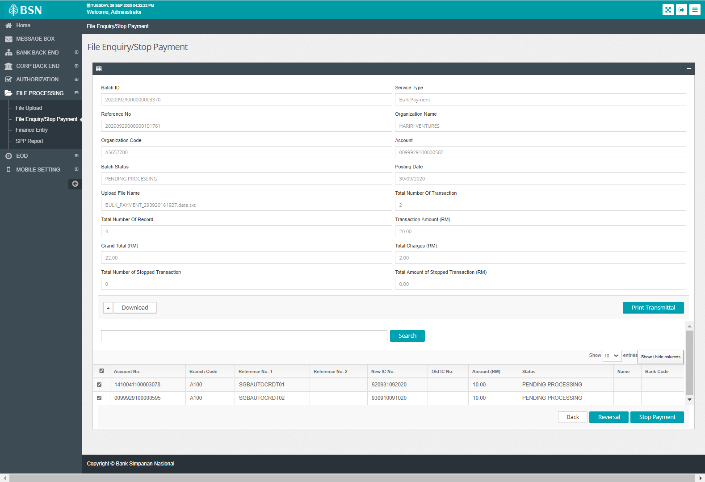

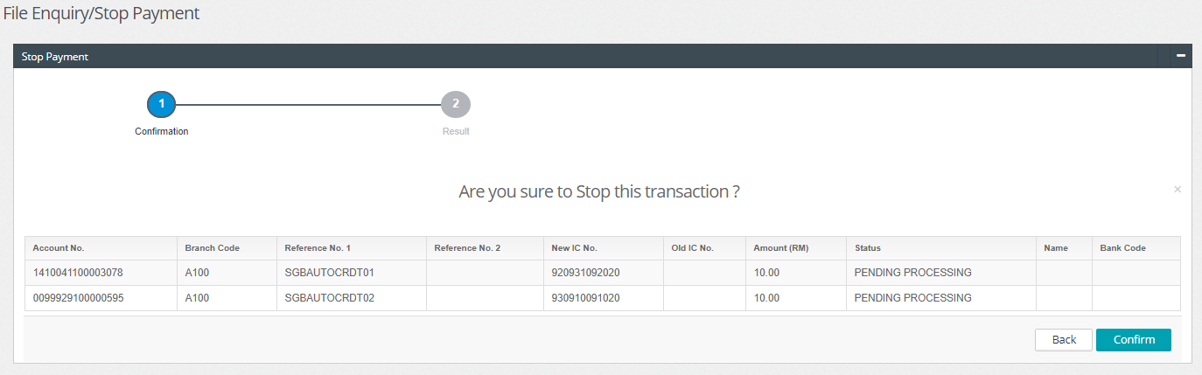

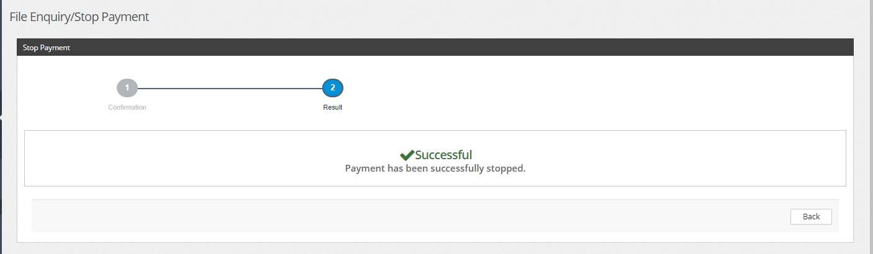

1. Status and amount displayed at IBAM after STOPPED:

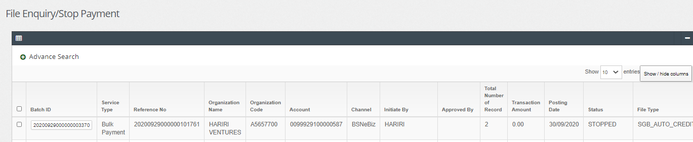

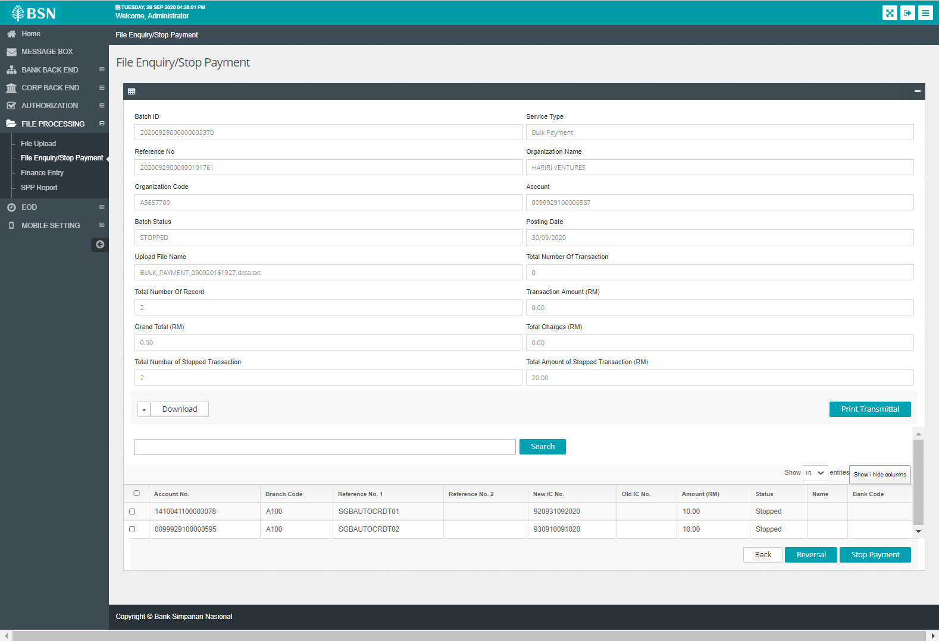

1. Status and amount displayed at CDB after STOPPED:

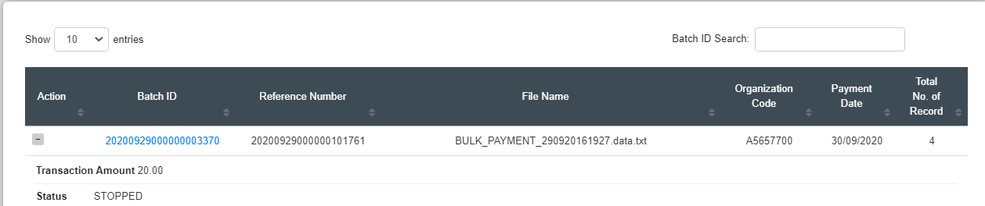

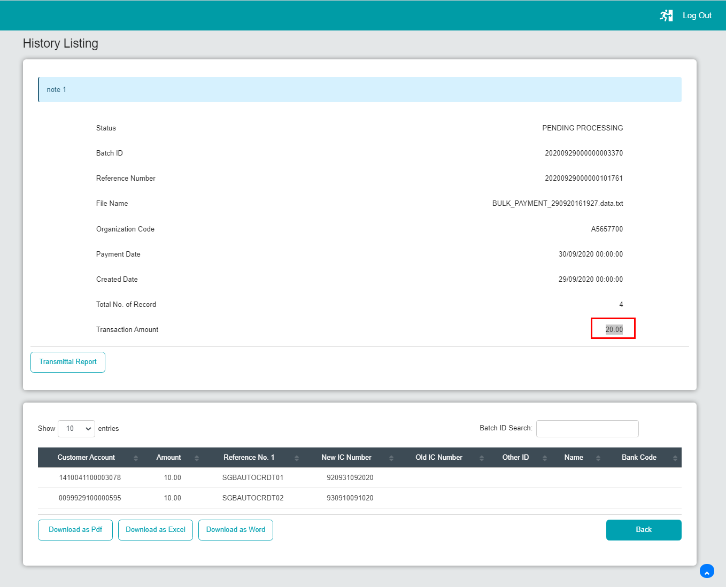

Bug:

Scenario: Perform STOP per item at IBAM, Stop all transaction in one batch

1. Amount not updated at CDB when perform STOP at IBAM

**2. Amount not update at IBAM > File Processing if user stop transaction at CDB**

Step :

- User stop transaction at CDB  
- Status at CDB and IBAM change to "Stopped"

Result : Total amount remain same, no update.  
Expected : System should display the actual amount remain after stopped transaction.

1. STOP one batch at CDB :

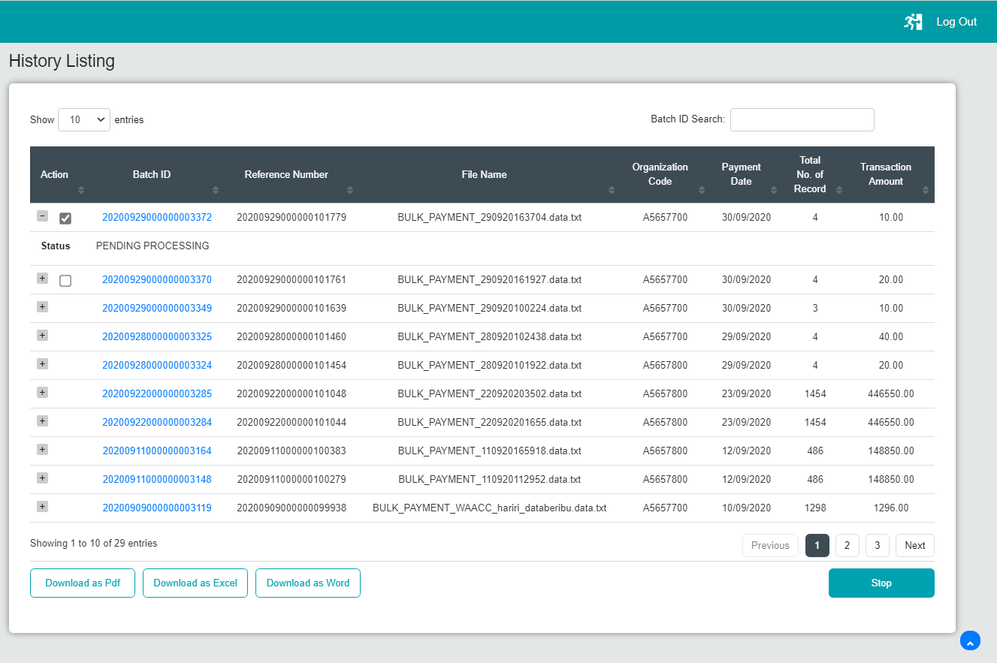

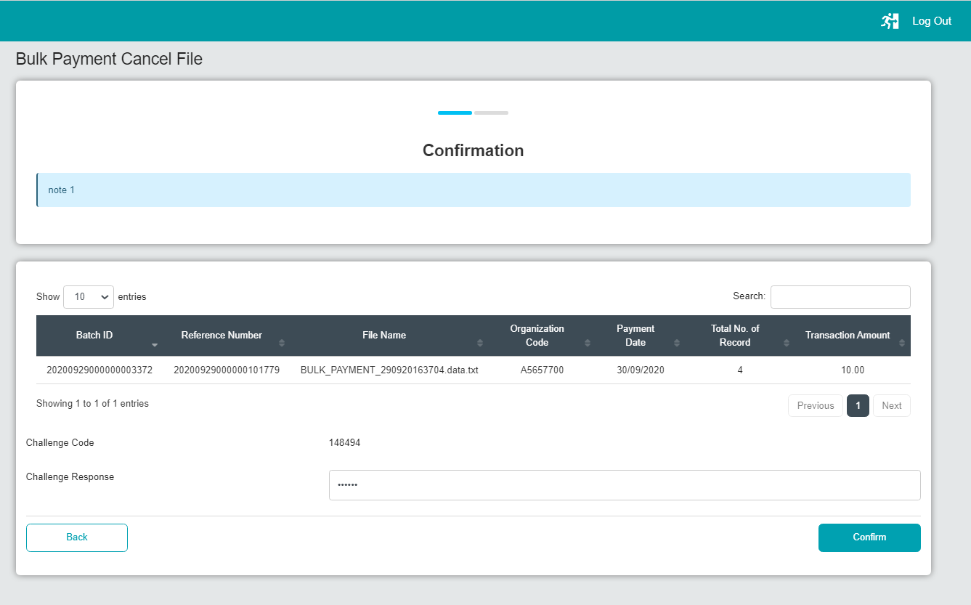

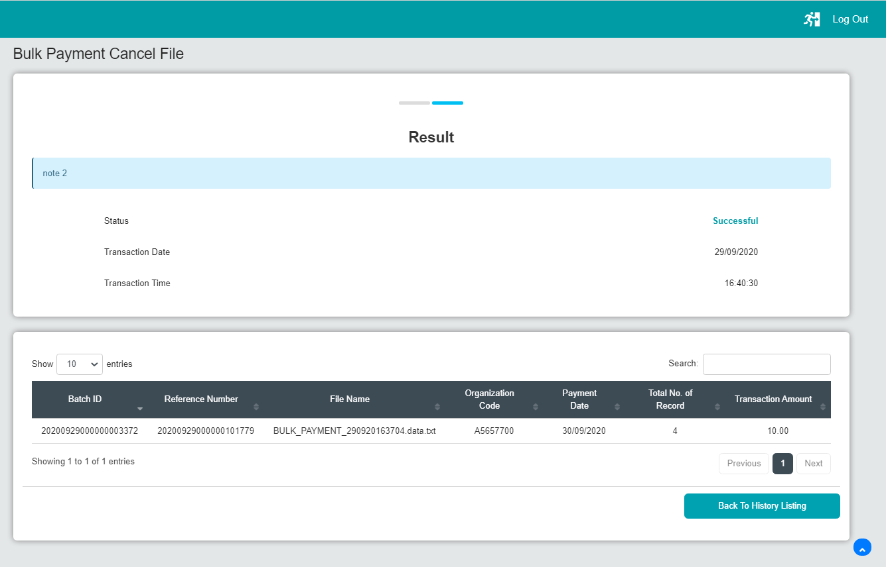

1. Total amount displayed at CDB after stopped:

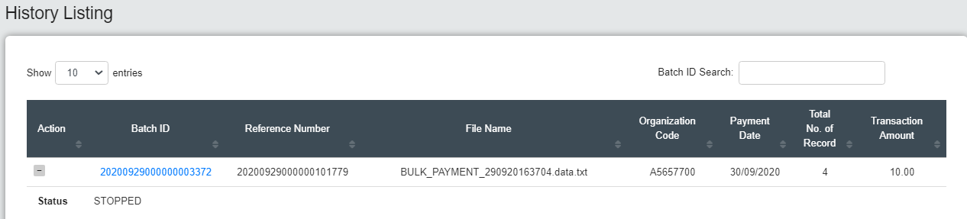

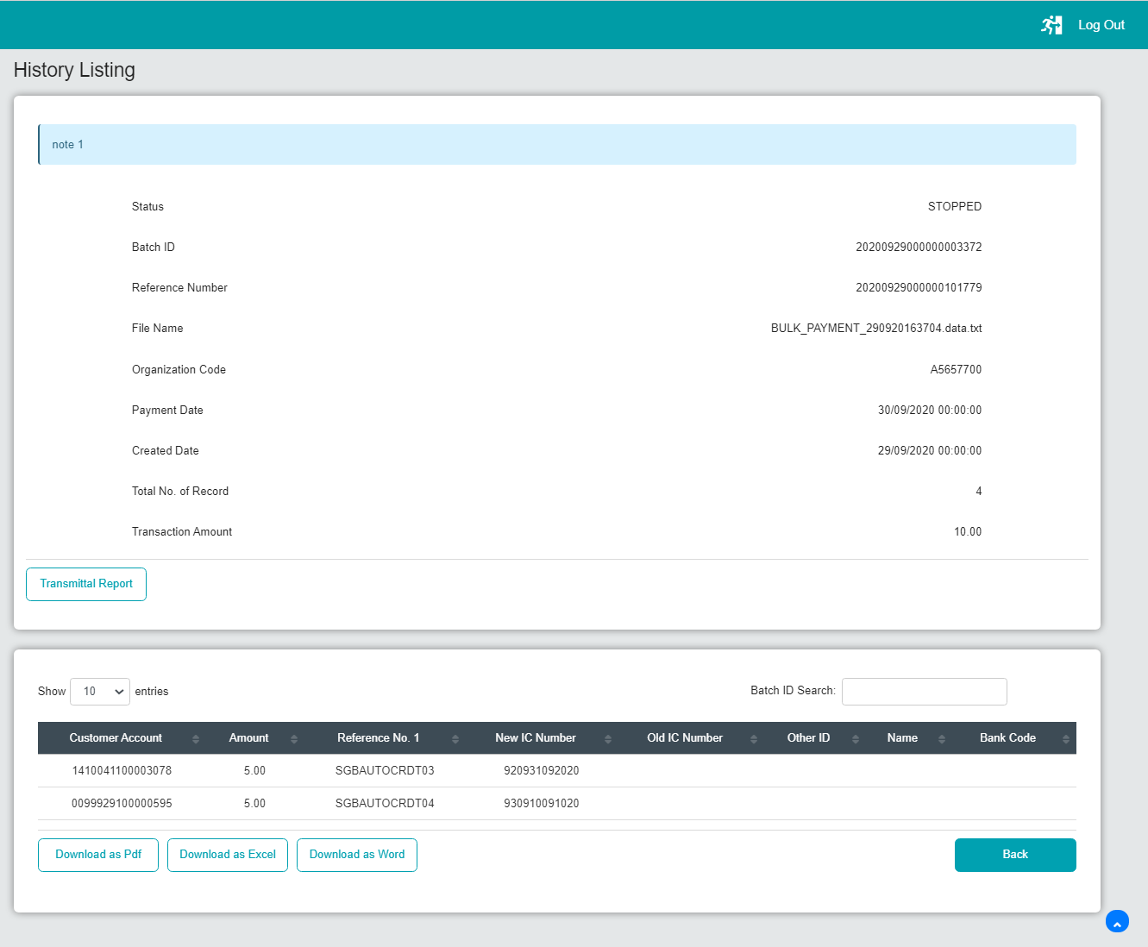

Bug:

Scenario: Perform STOP per batch at CDB

1. Amount not updated at CDB when perform STOP at CDB
2. Total amount displayed at IBAM after stopped:

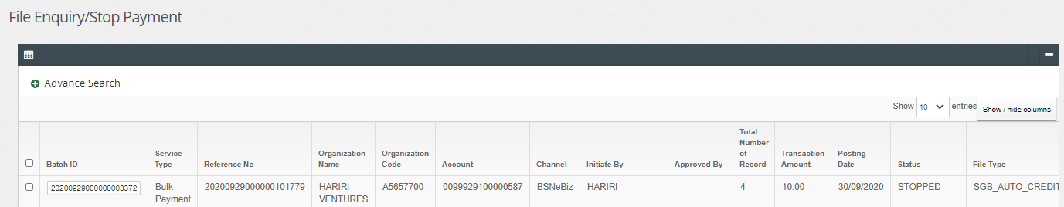

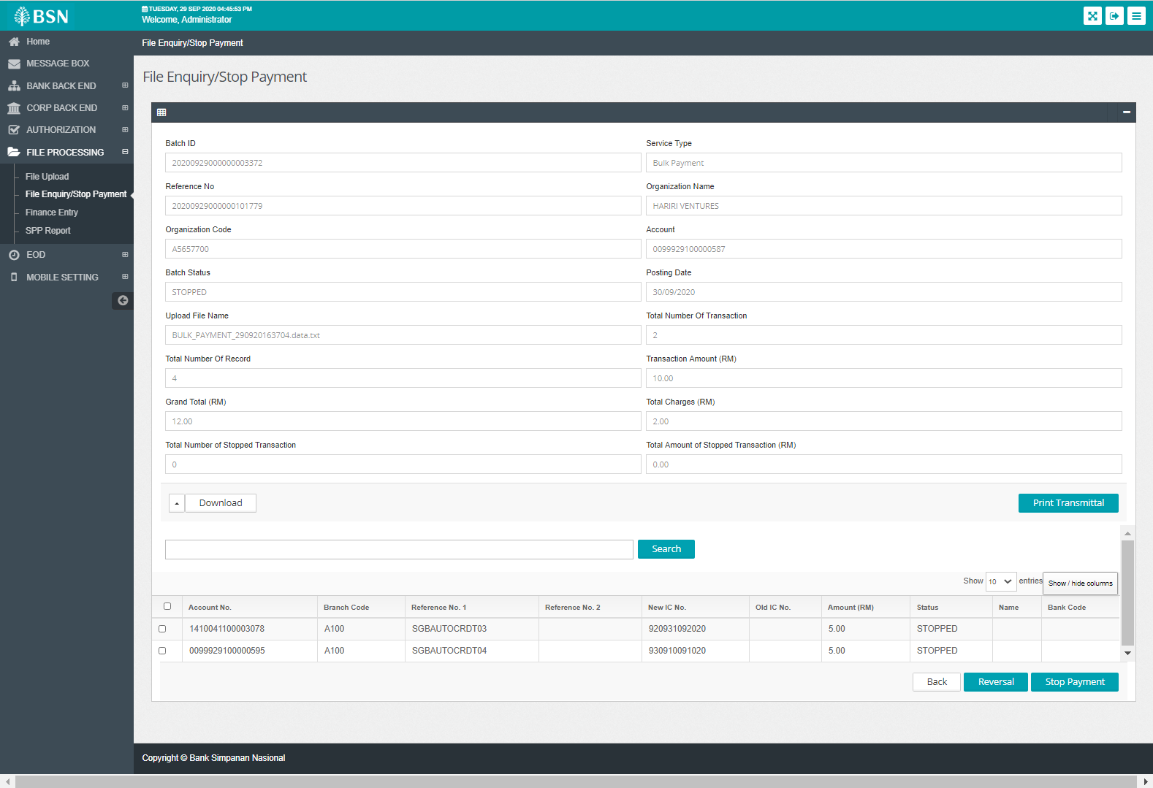

Bug:

Scenario: Perform STOP per batch at CDB

1. Amount not updated at IBAM when perform STOP at CDB