Create bulk payment with 5 record at CDB

Stop 3 details at ibam :

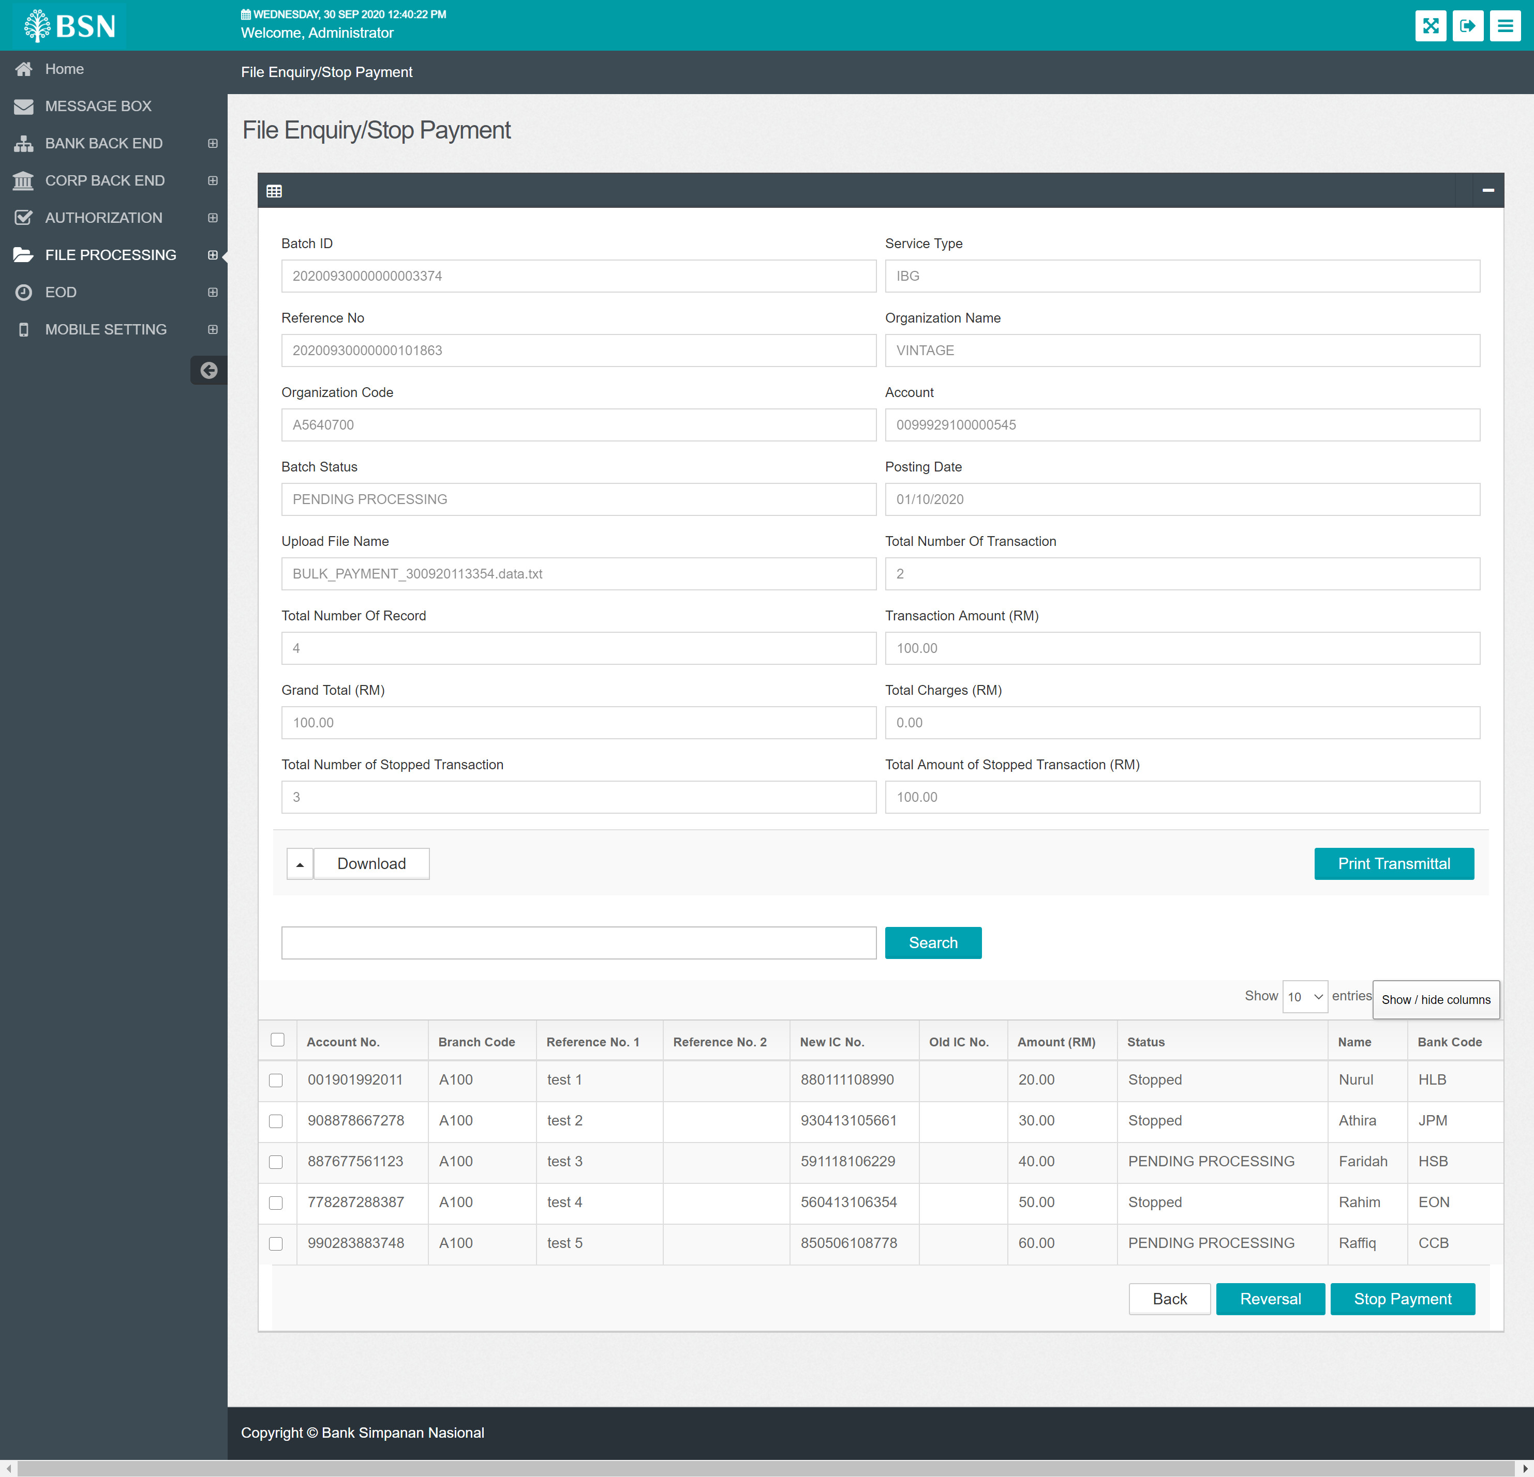

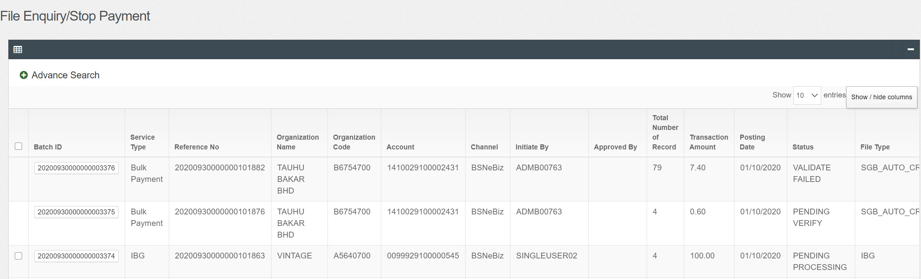

CDB Screen for above transaction :

Front screen cdb

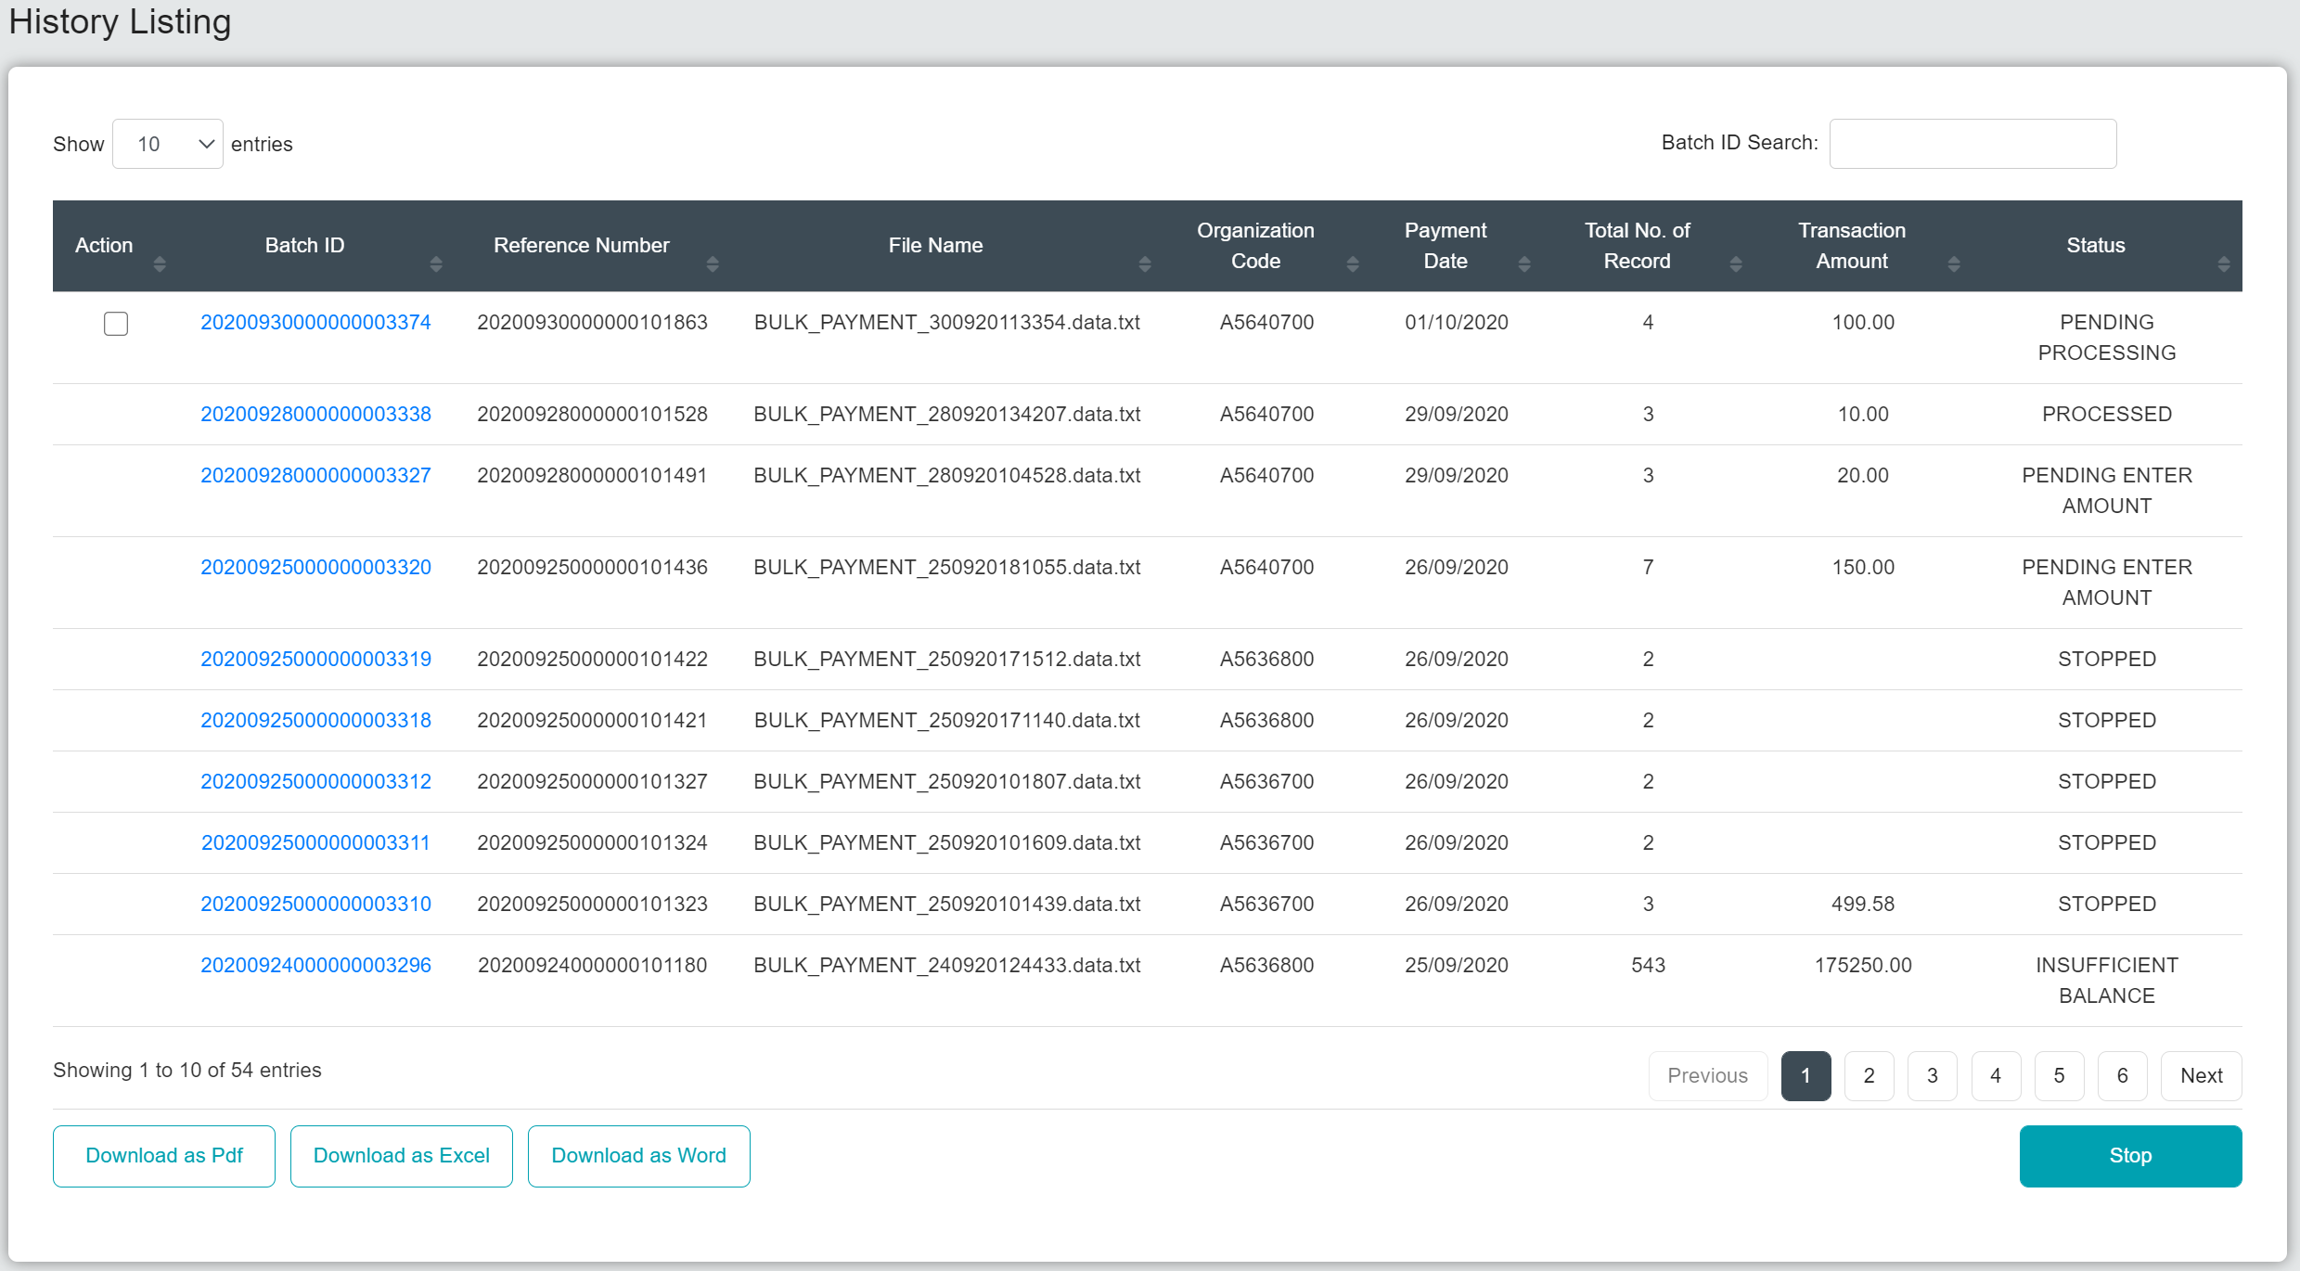

Stop above transaction at CDB.

Total record 2 (Header footer)

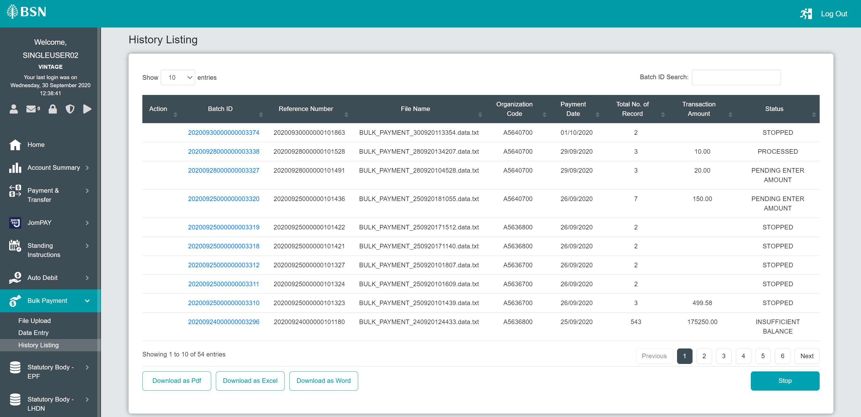

IBAM screen after stop payment at CDB

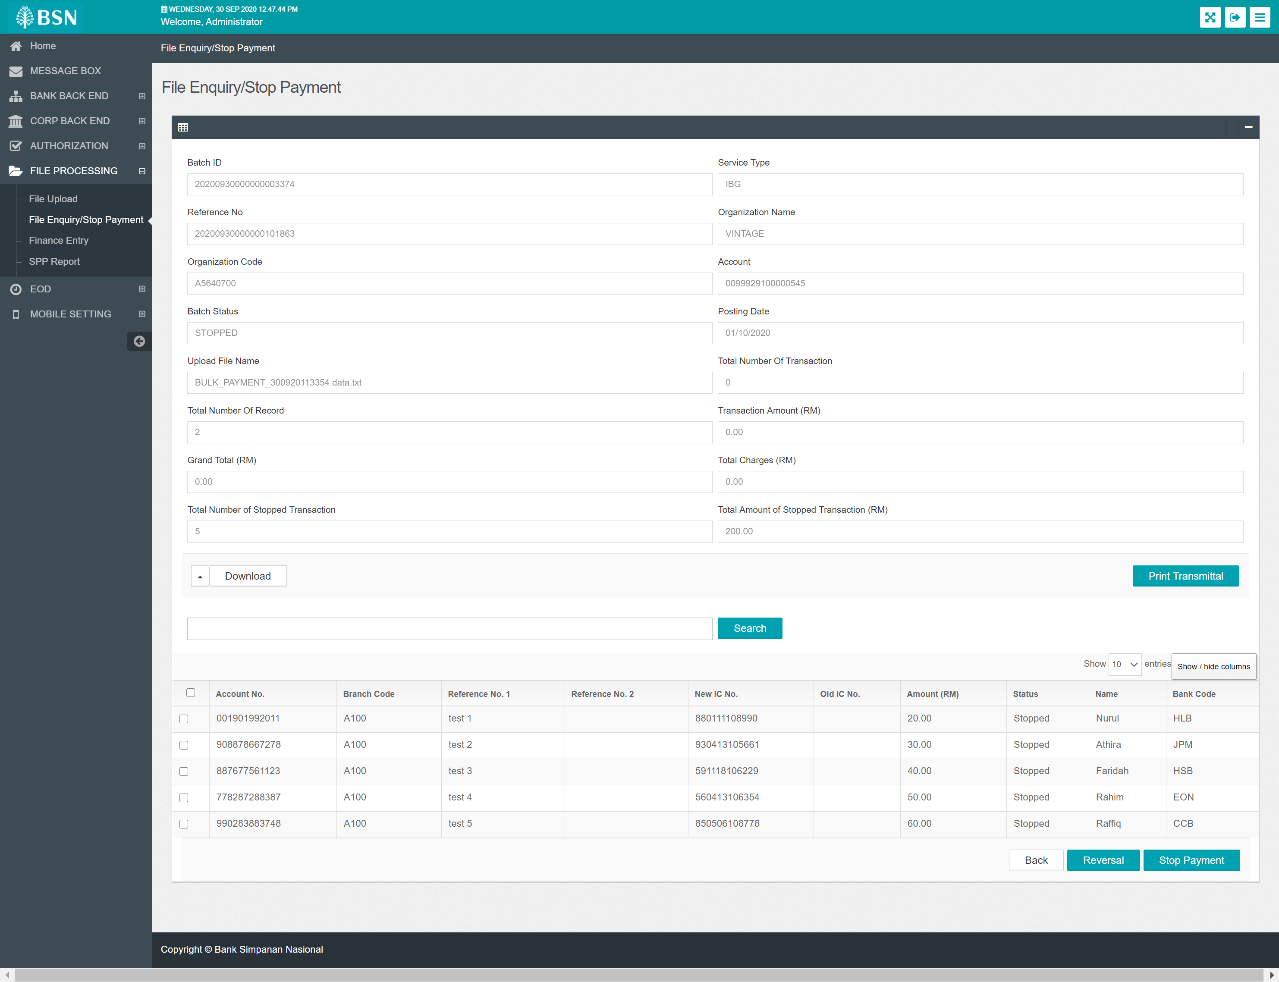

Reverse one transaction

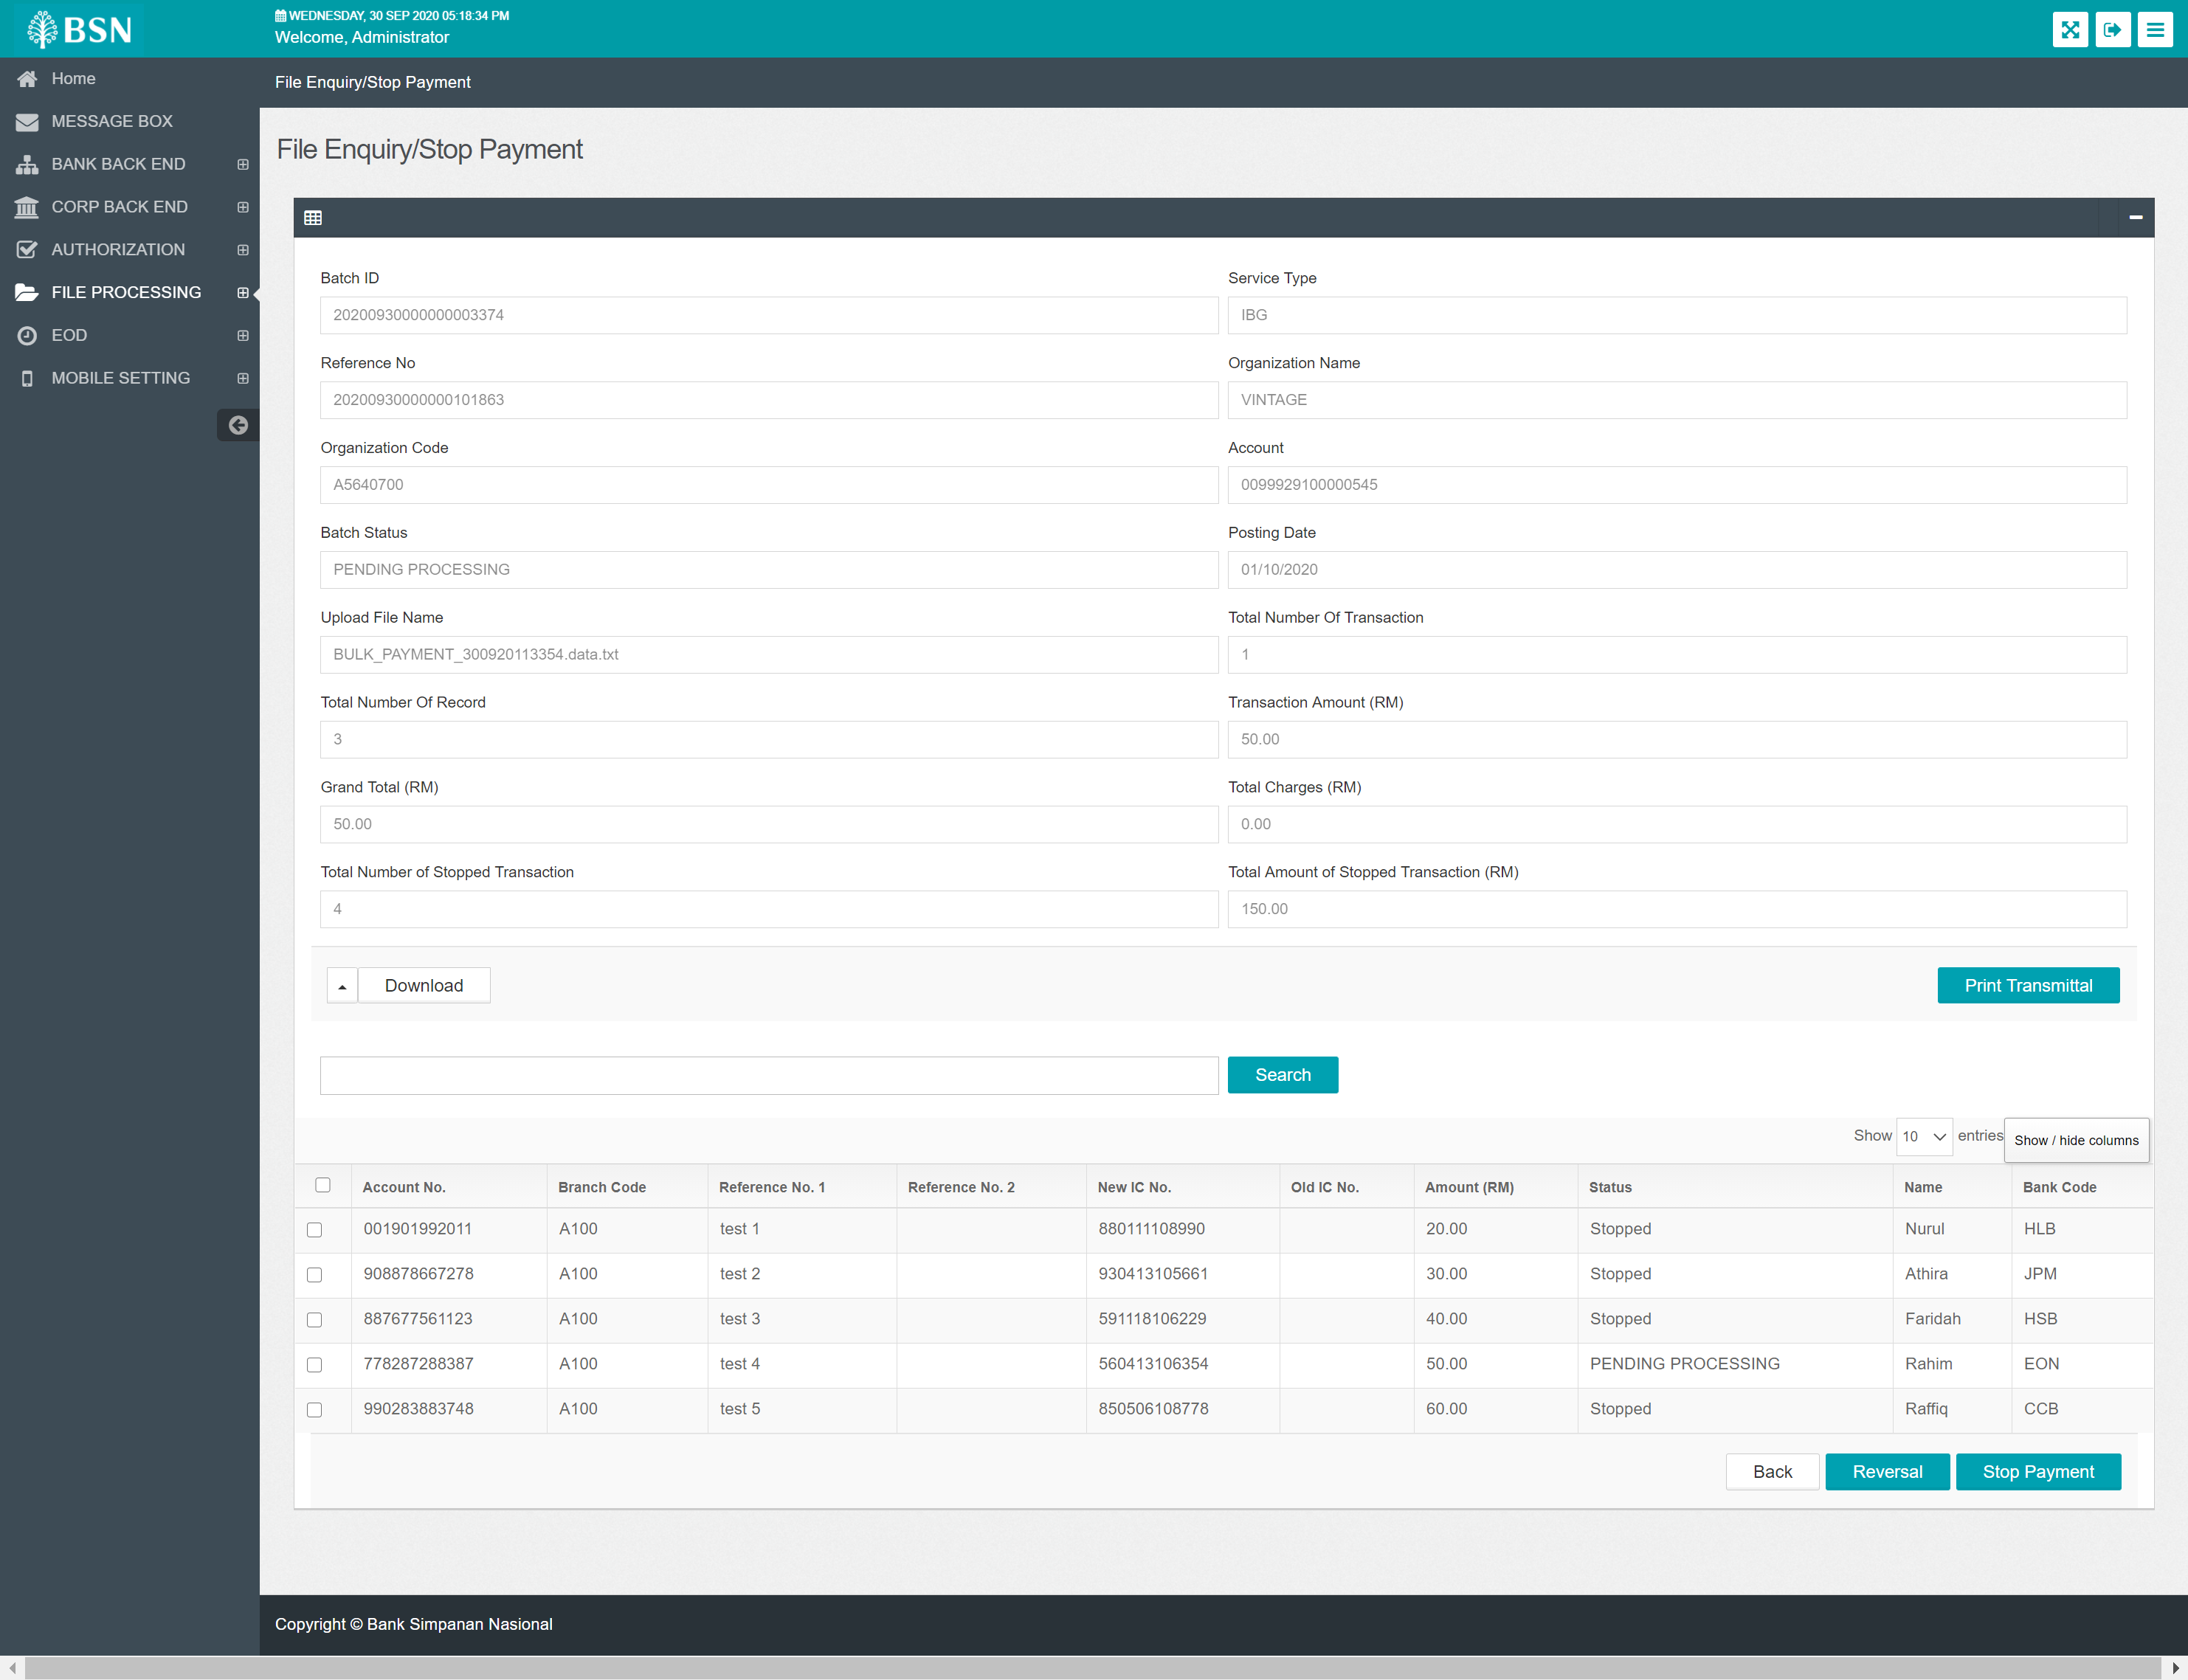

CDB screen after reverse at IBAM

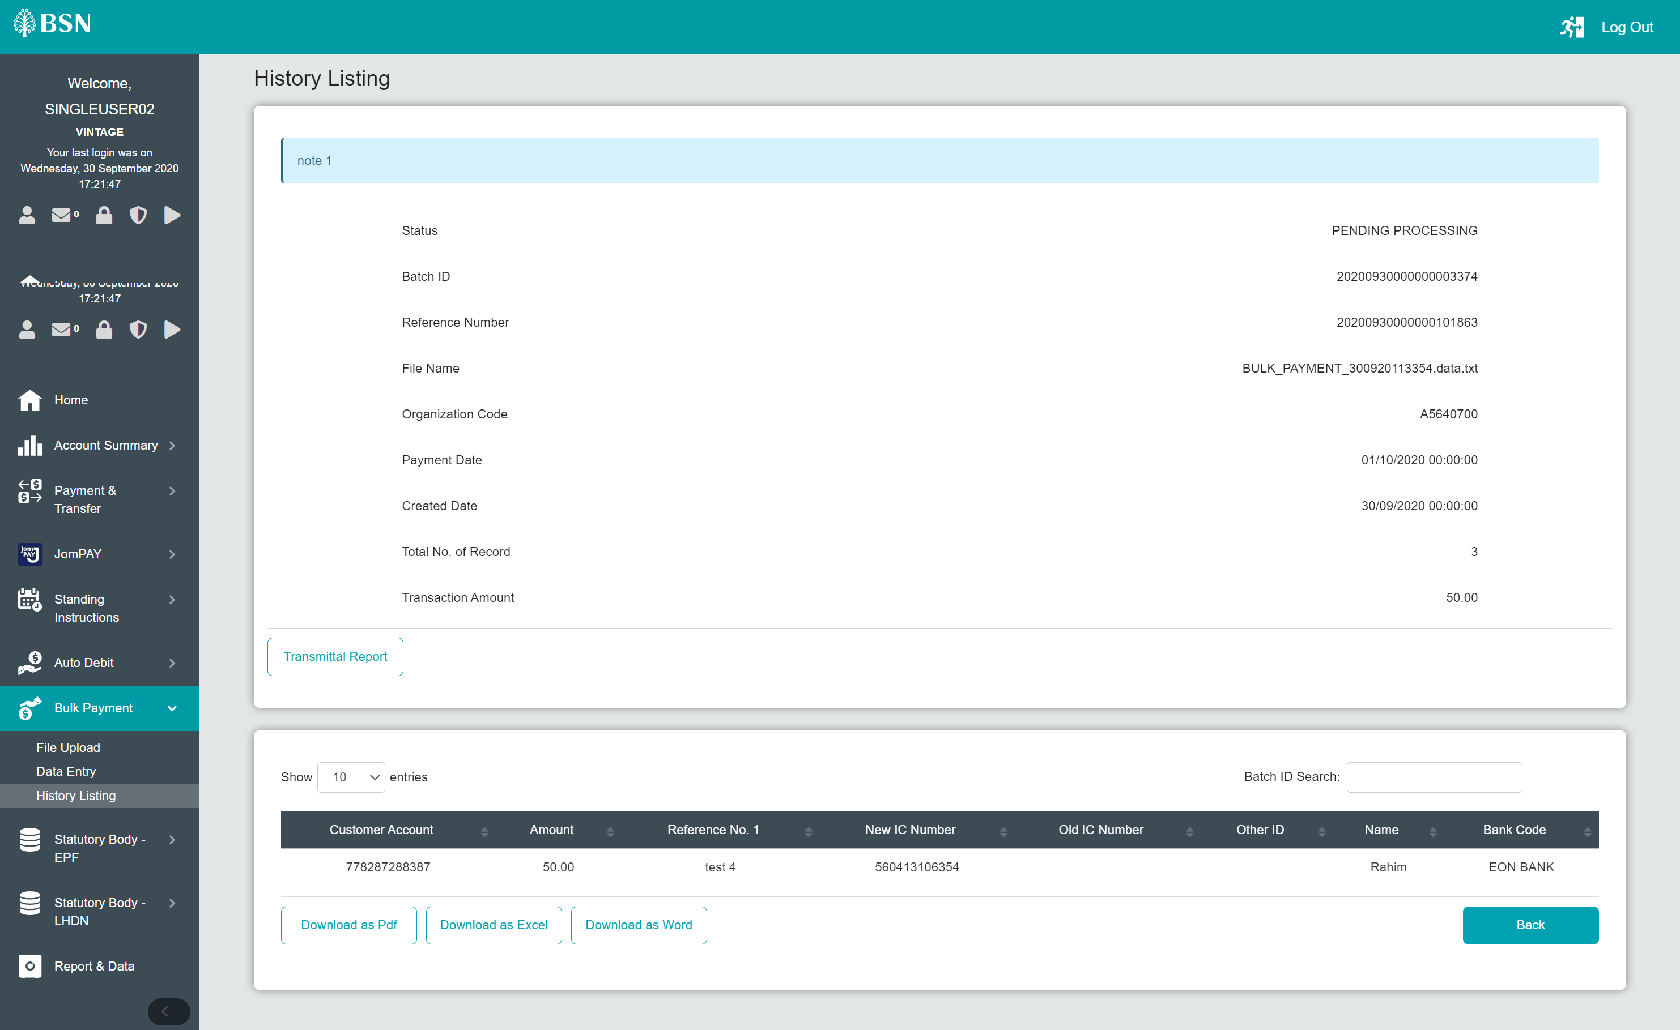

Run EOD

