All Users

* Modify the Expiry Date in same line

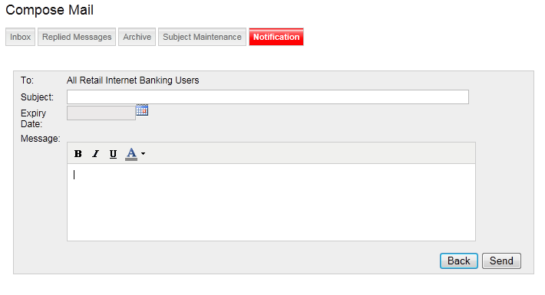

Filter by Criteria

* Title not tally with BRS
* All Message Margin not tally with BRS

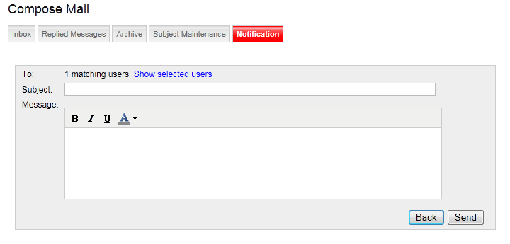

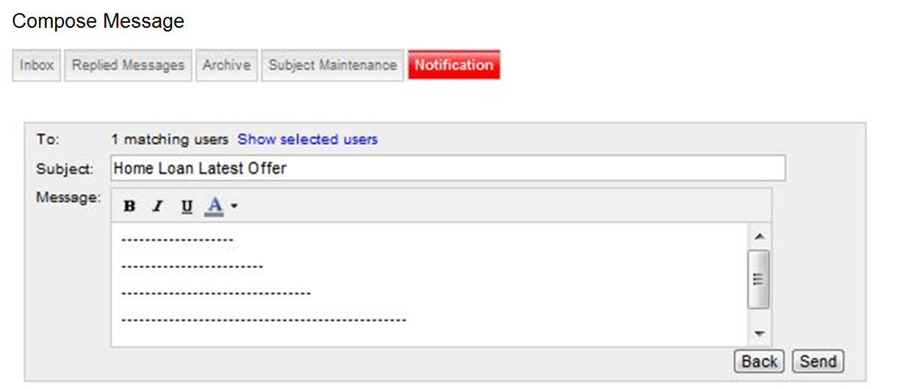

add on text wrap at message box

