Test scenario:

1. As CDB single user, create a Bulk Payment
2. Verify the amount in Bulk Payment history and dashboard

Bulk Payment History:

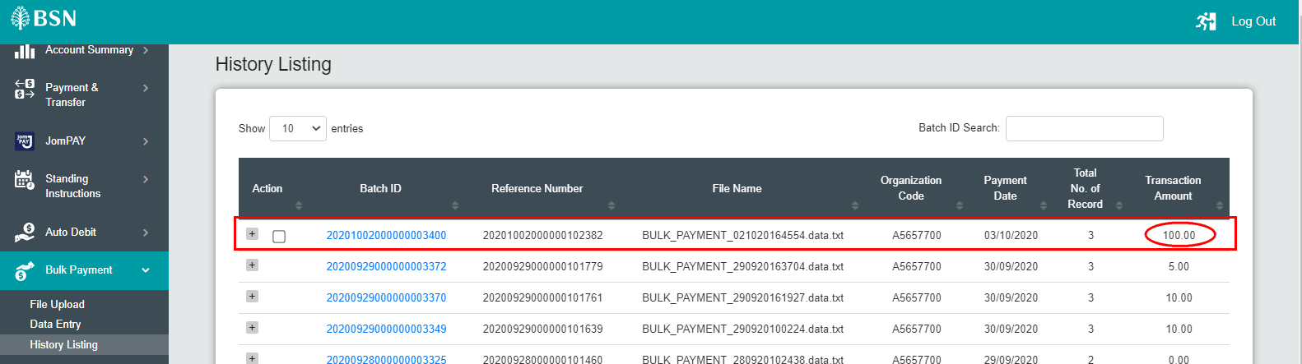

Dashboard:

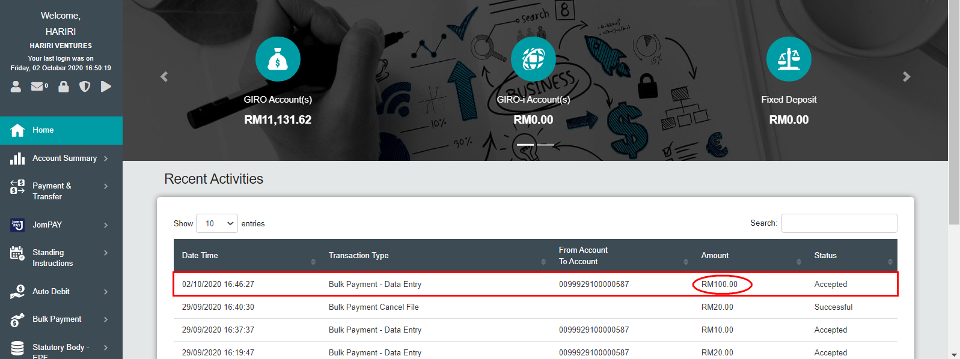

1. Stop the Bulk Payment

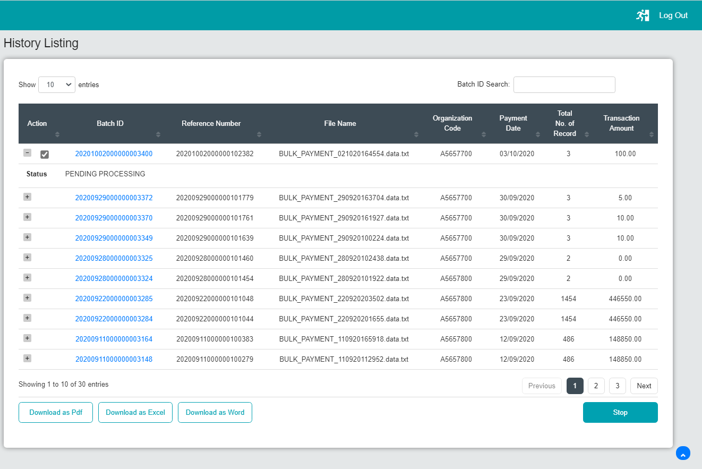

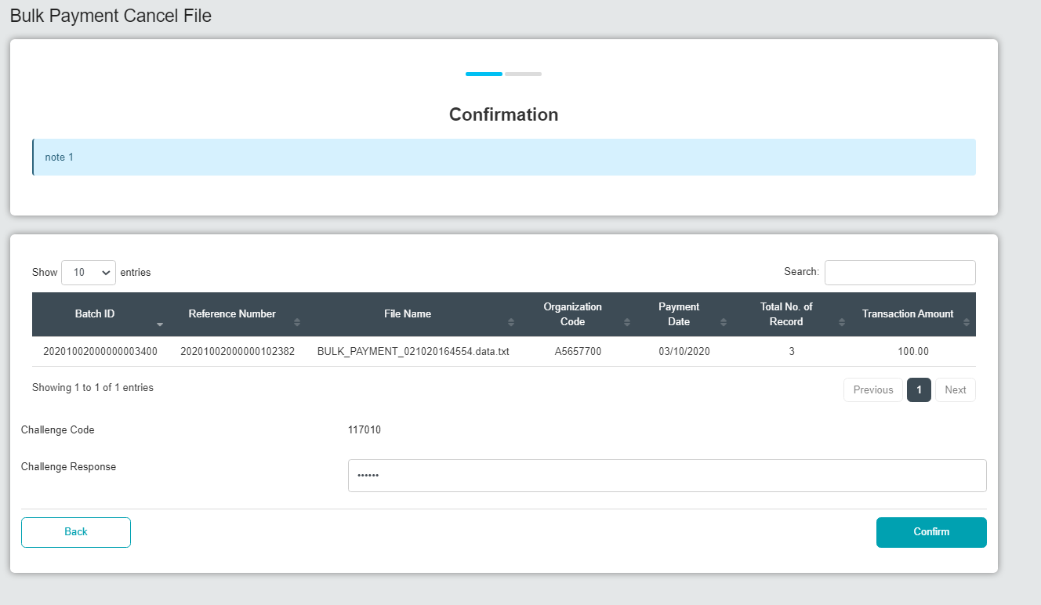

1. Verify the amount in Bulk Payment history and dashboard
2. Expected result, amount in Bulk Payment history and dashboard is the same

Correction: Amount displayed at dashboard should display same amount as initiate

Bulk Payment History:

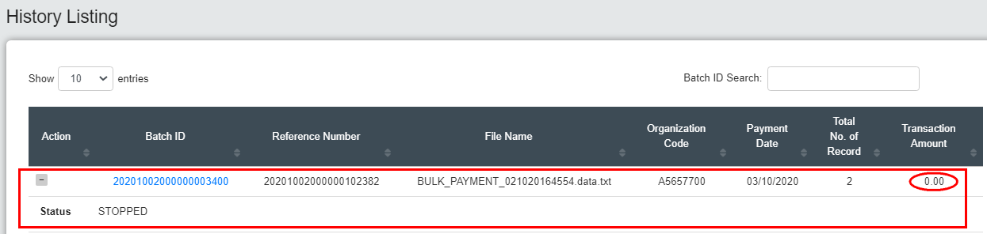

Dashboard:

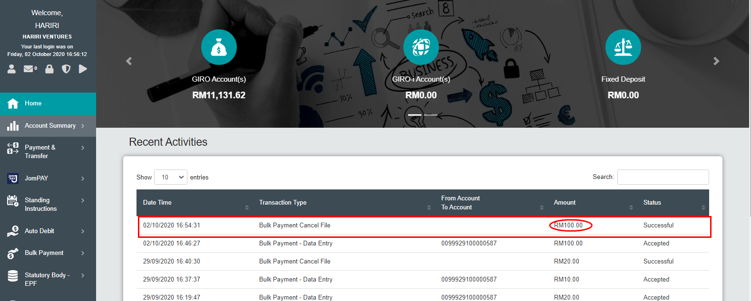

Result:

At Bulk Payment History: The initial amount is RM100, after the transaction been stopped amount displayed “0”,

At Dashboard: Transaction amount that has been stopped displayed the same amount as initial.