# Billing

## Data Entry

1. Upload with .rpt file

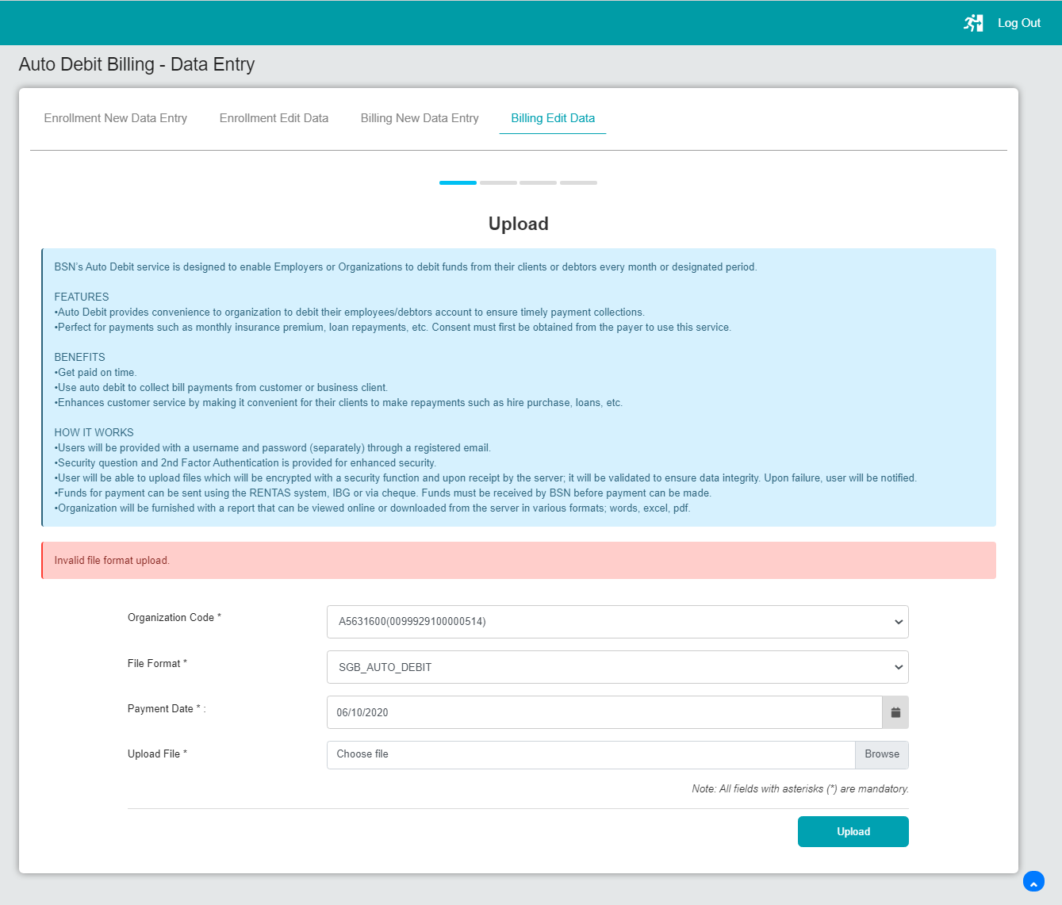

1. Upload with .summ file

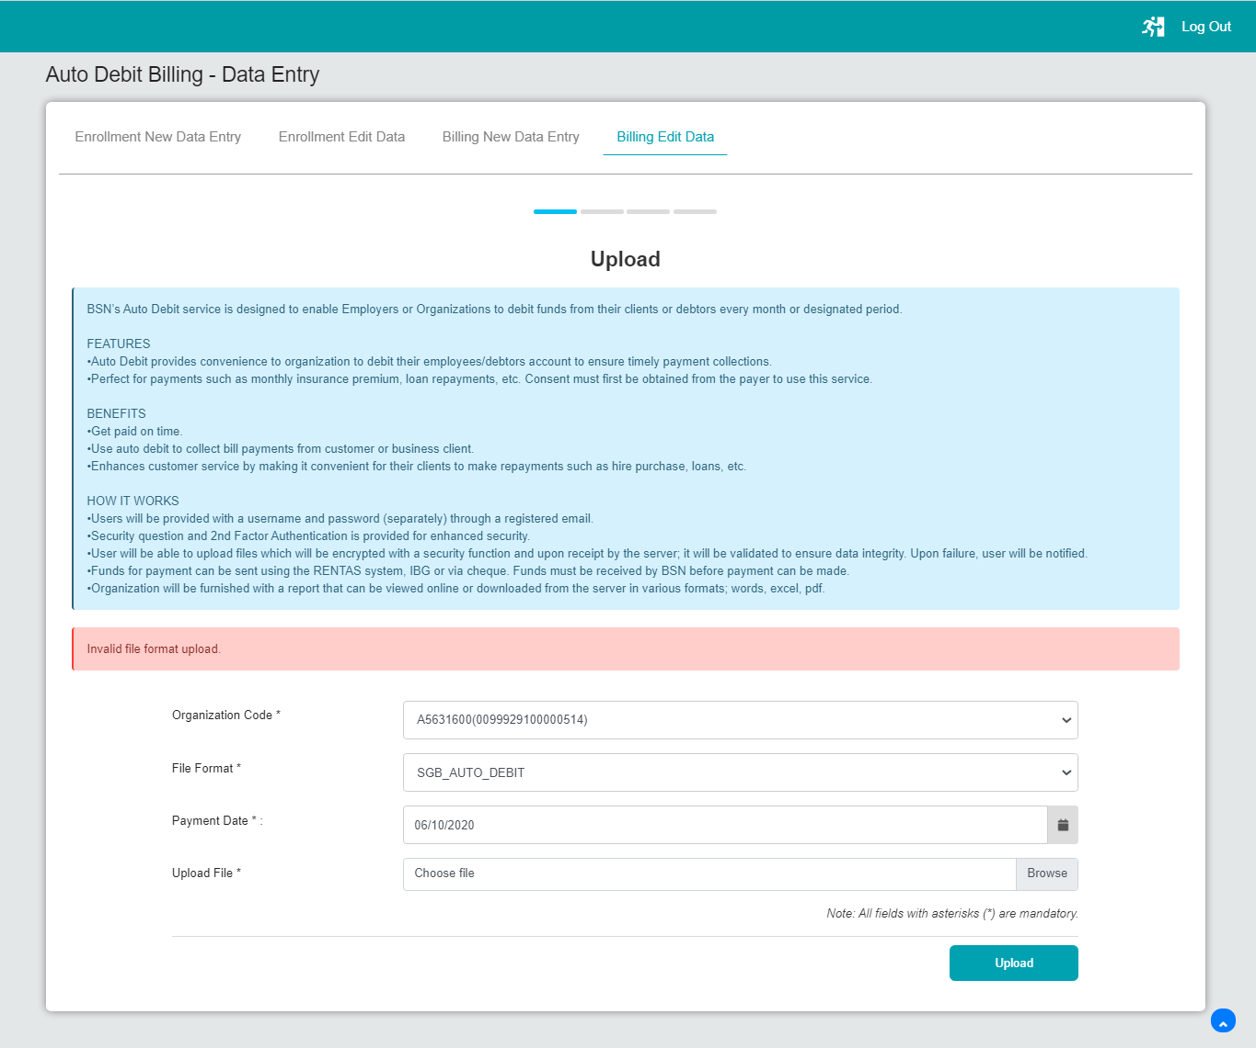

1. Upload with transmittal file

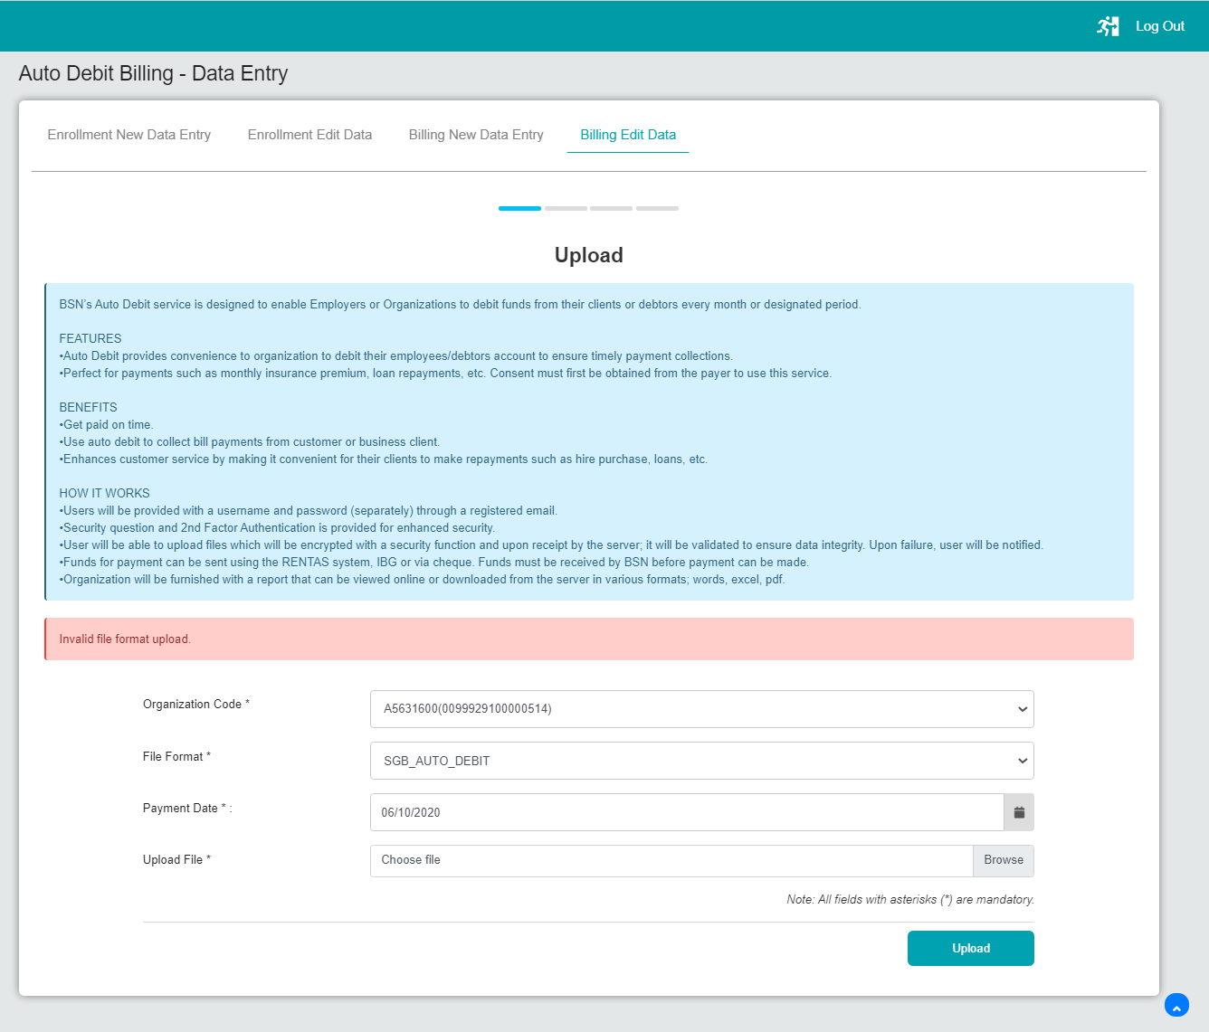

## File Upload

1. Upload with .rpt file

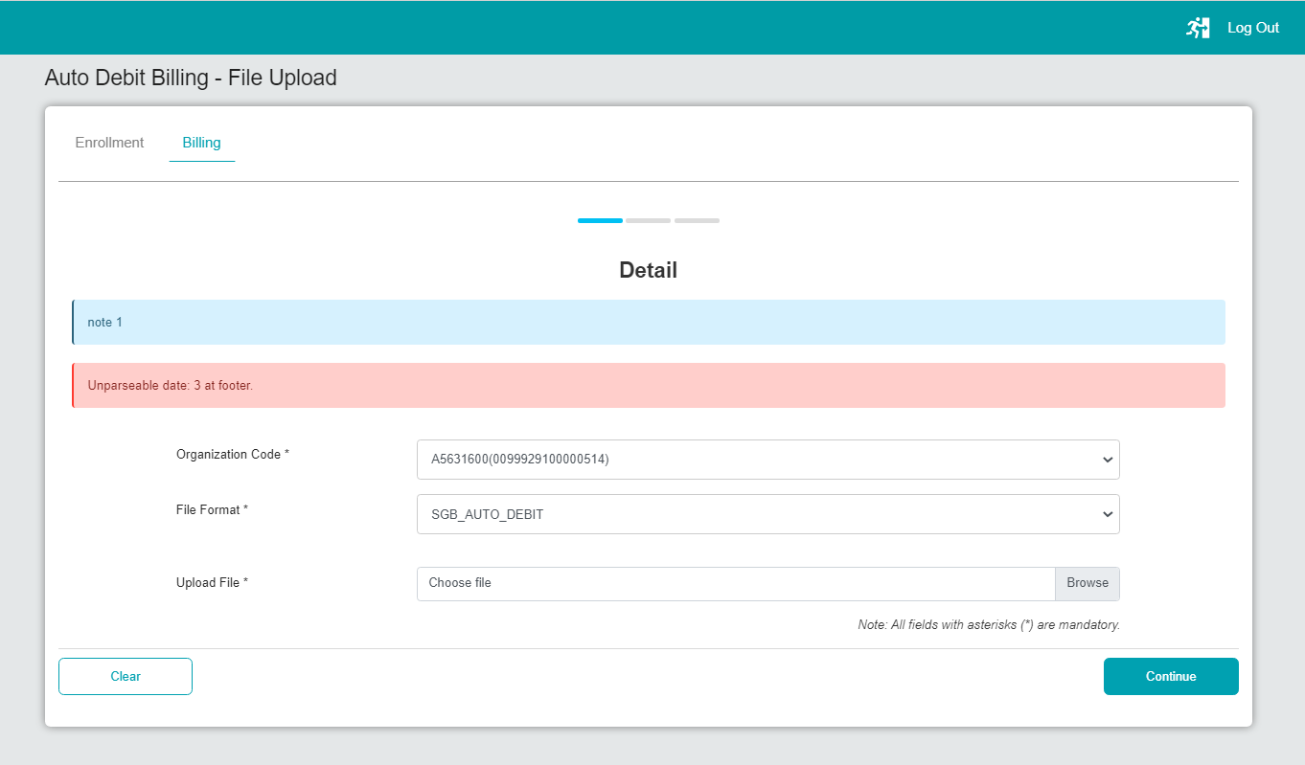

1. Upload with .summ file

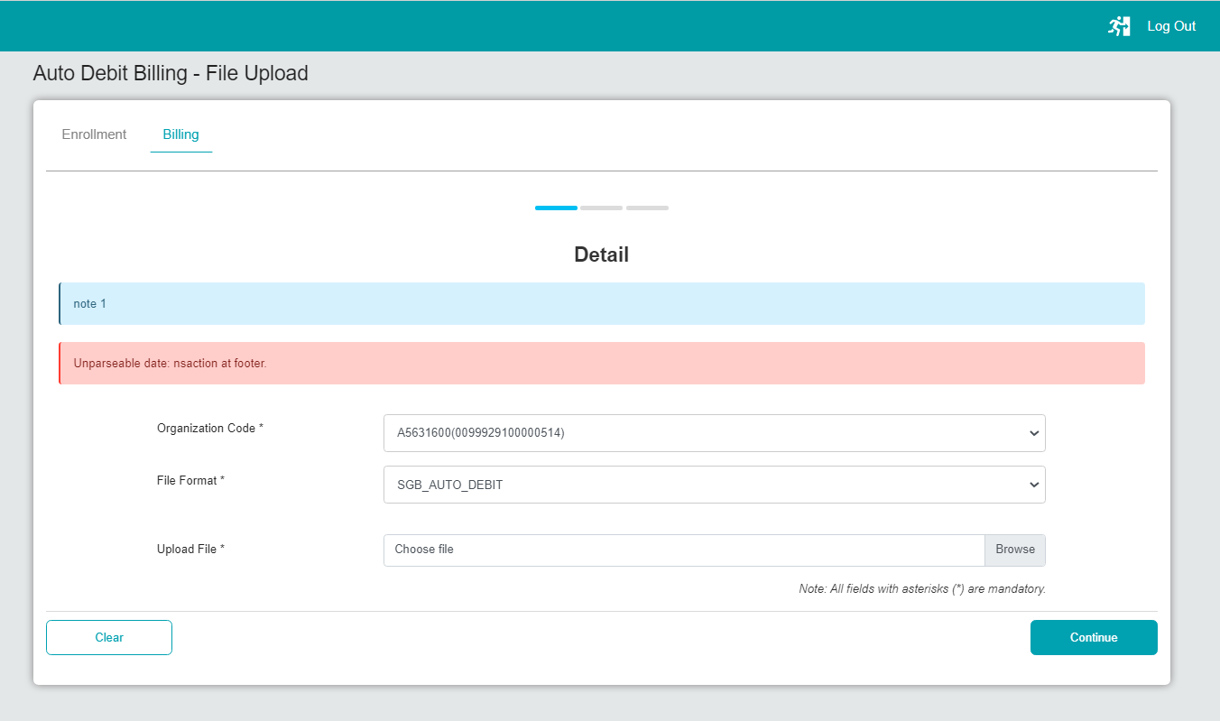

1. Upload with transmittal file

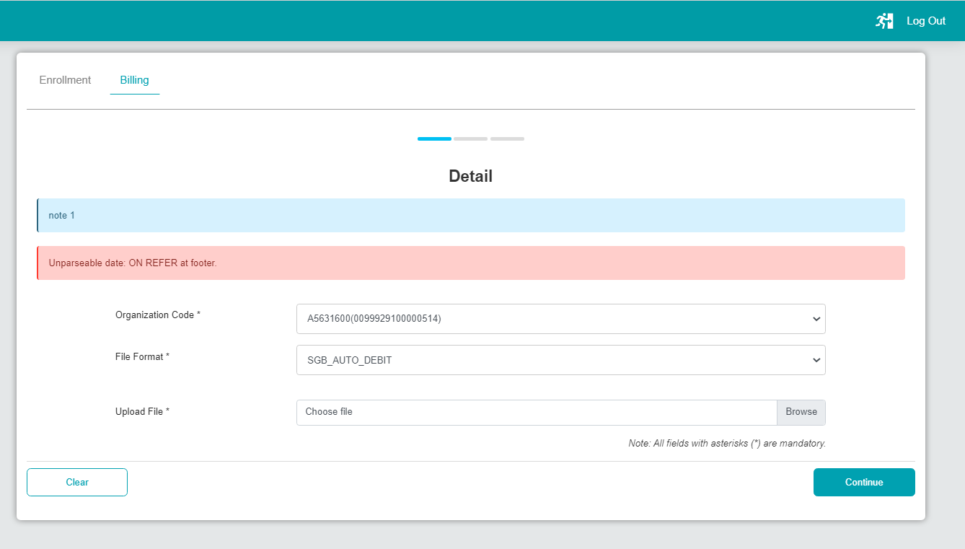

# Bulk Payment

## Data Entry

1. Upload with .rpt file

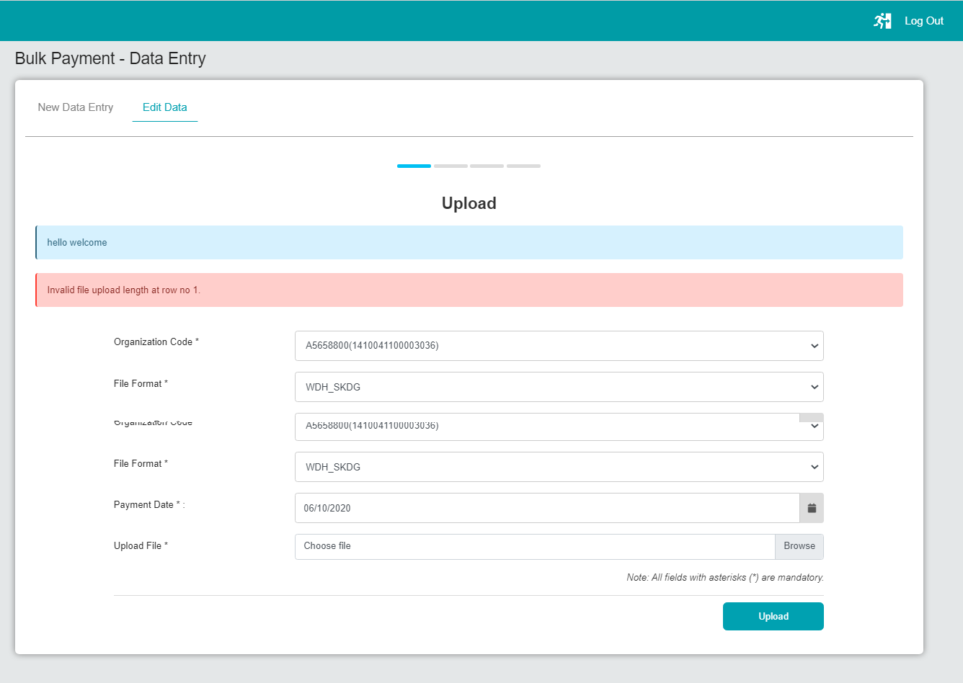

## ERROR 01

1. Upload with .summ file

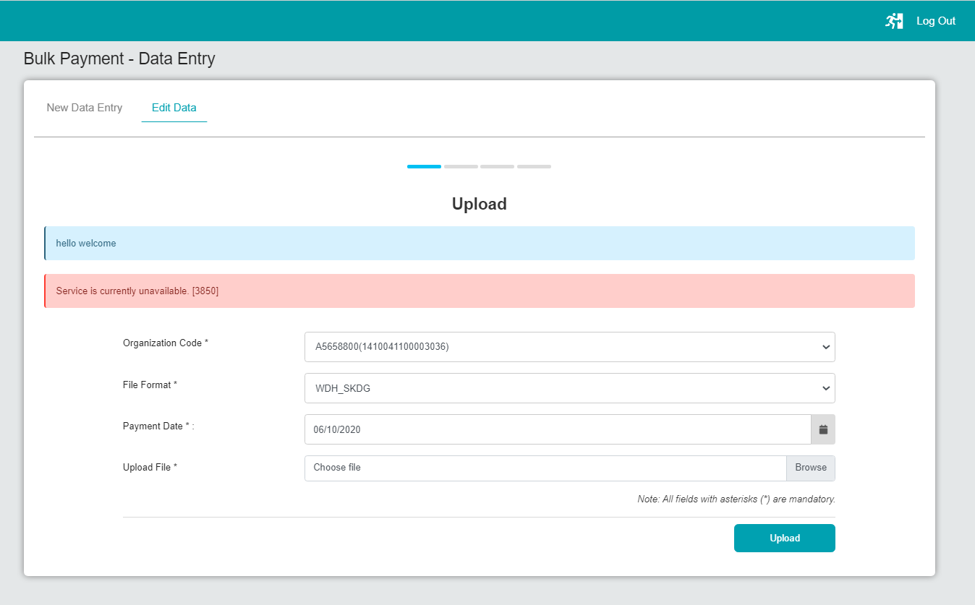

1. Upload with transmittal file

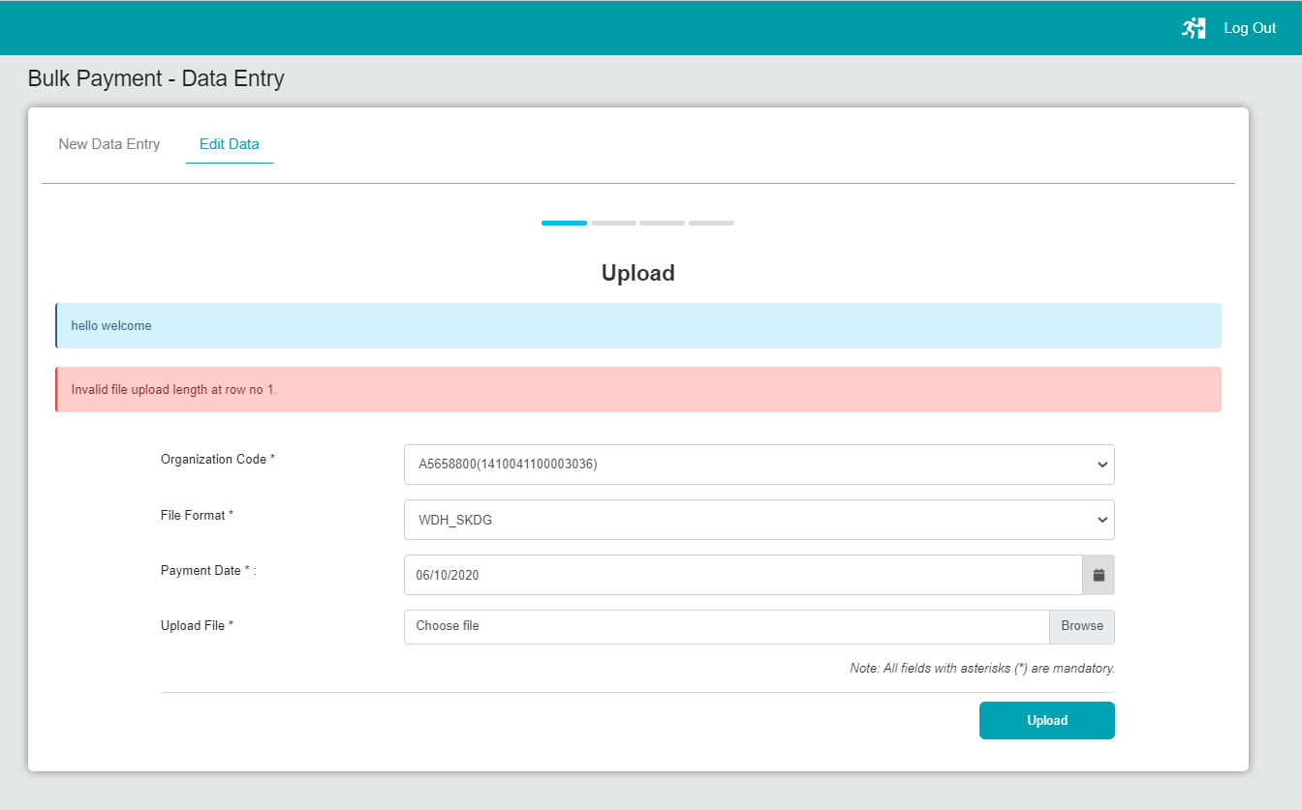

## File Upload

1. Upload with .rpt file

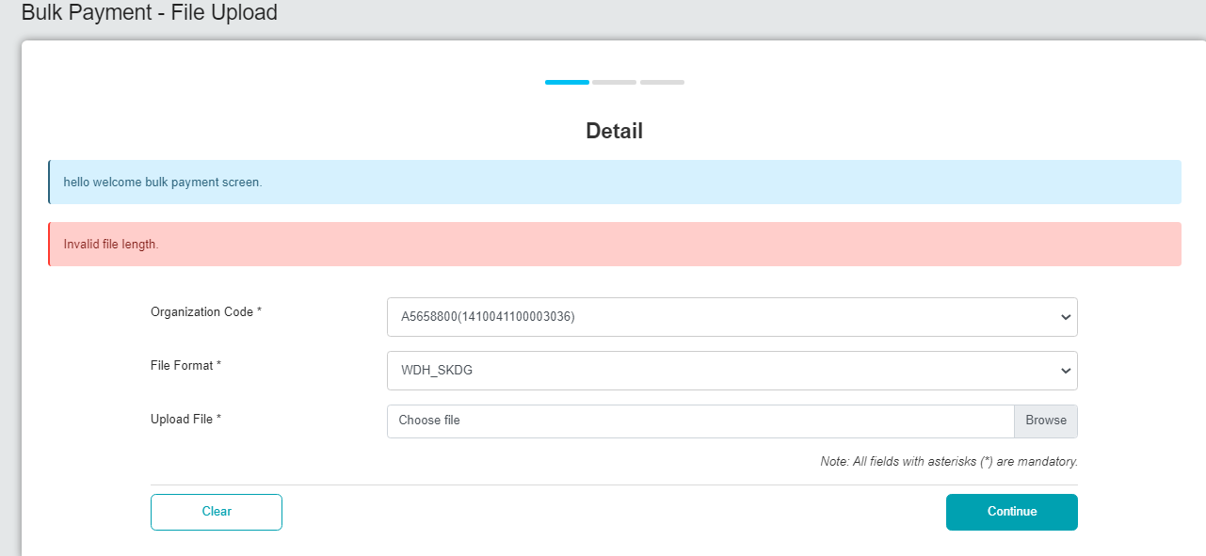

1. Upload with .summ file

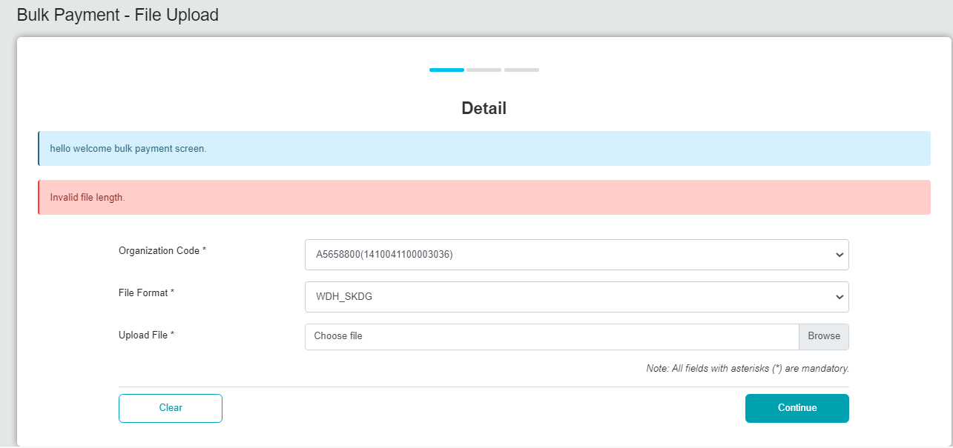

1. Upload with transmittal file

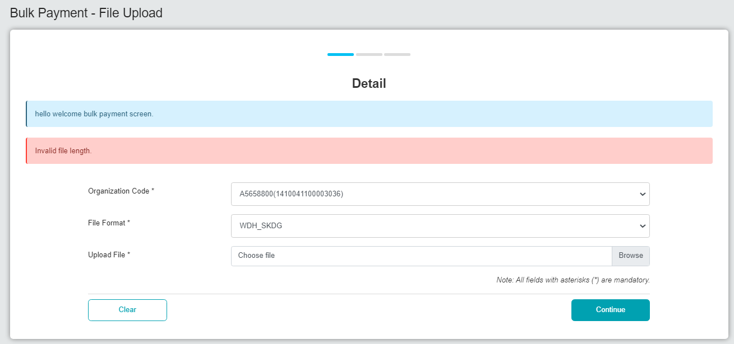

# EPF

## Data Entry

1. Upload with .rpt file

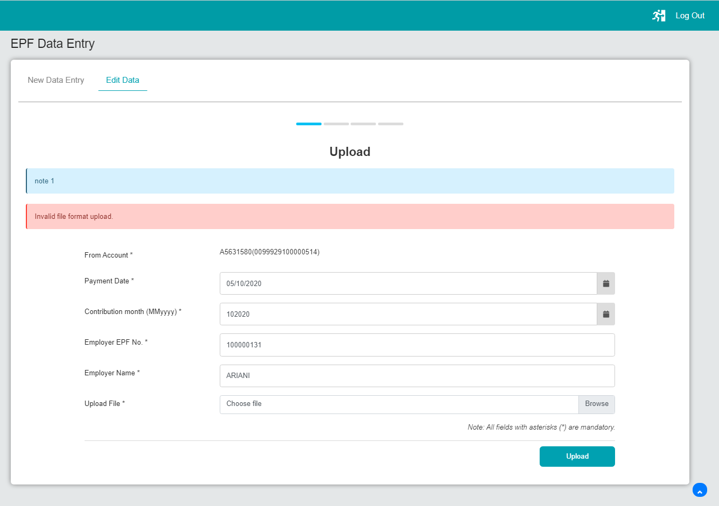

1. Upload with .summ file

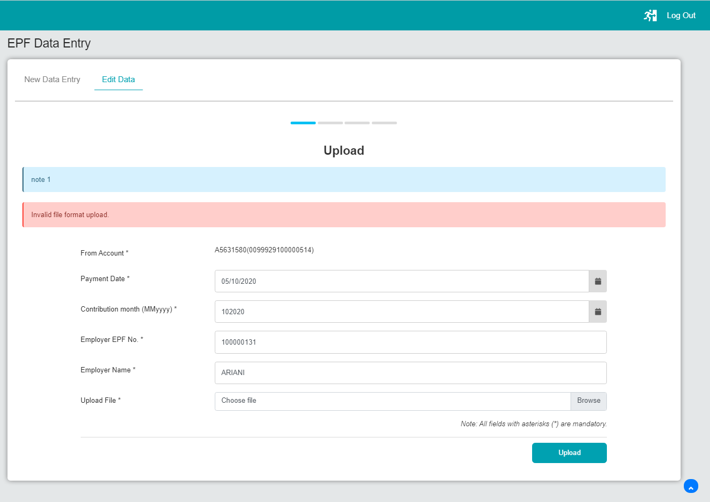

1. Upload with transmittal file

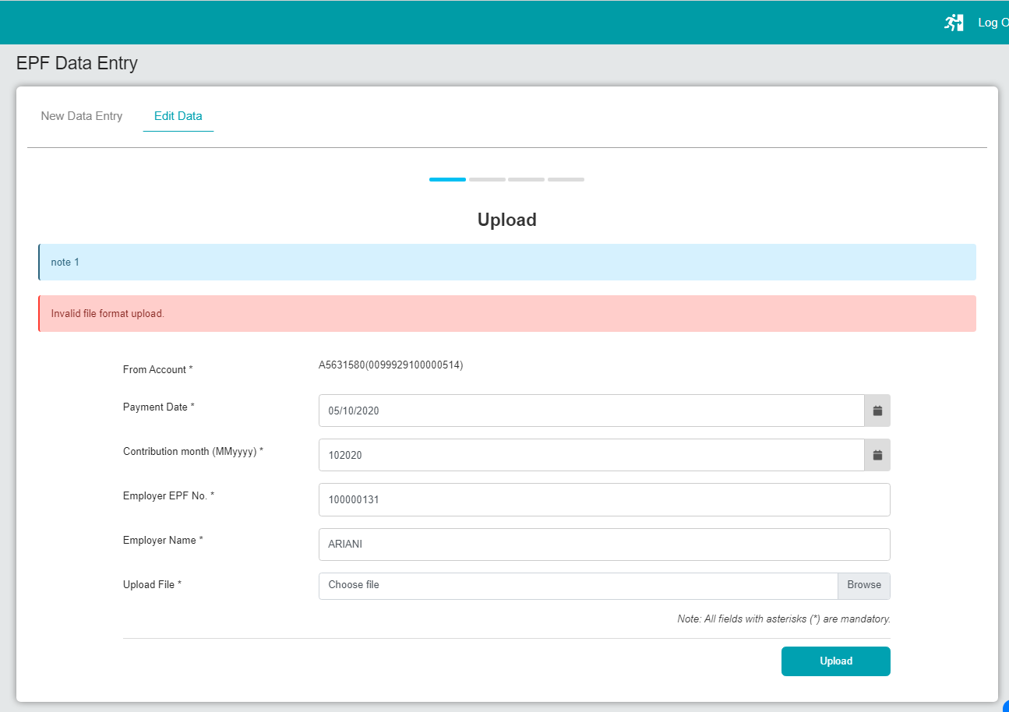

## File Upload

1. Upload with .rpt file

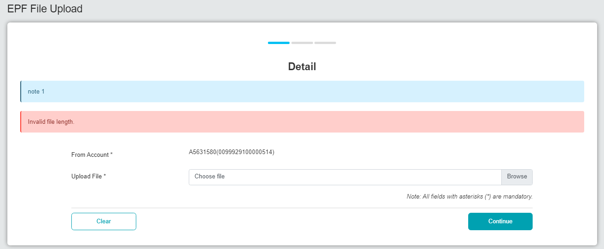

1. Upload with .summ file

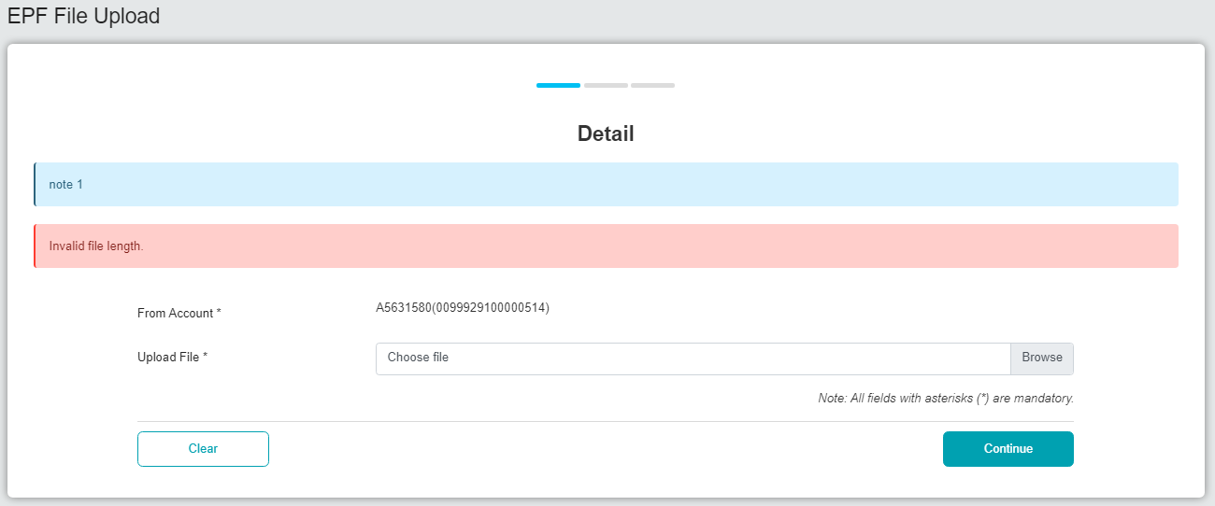

1. Upload with transmittal file

