CDB > New Application

Empty EPF Employer No

Result : Employer No is required

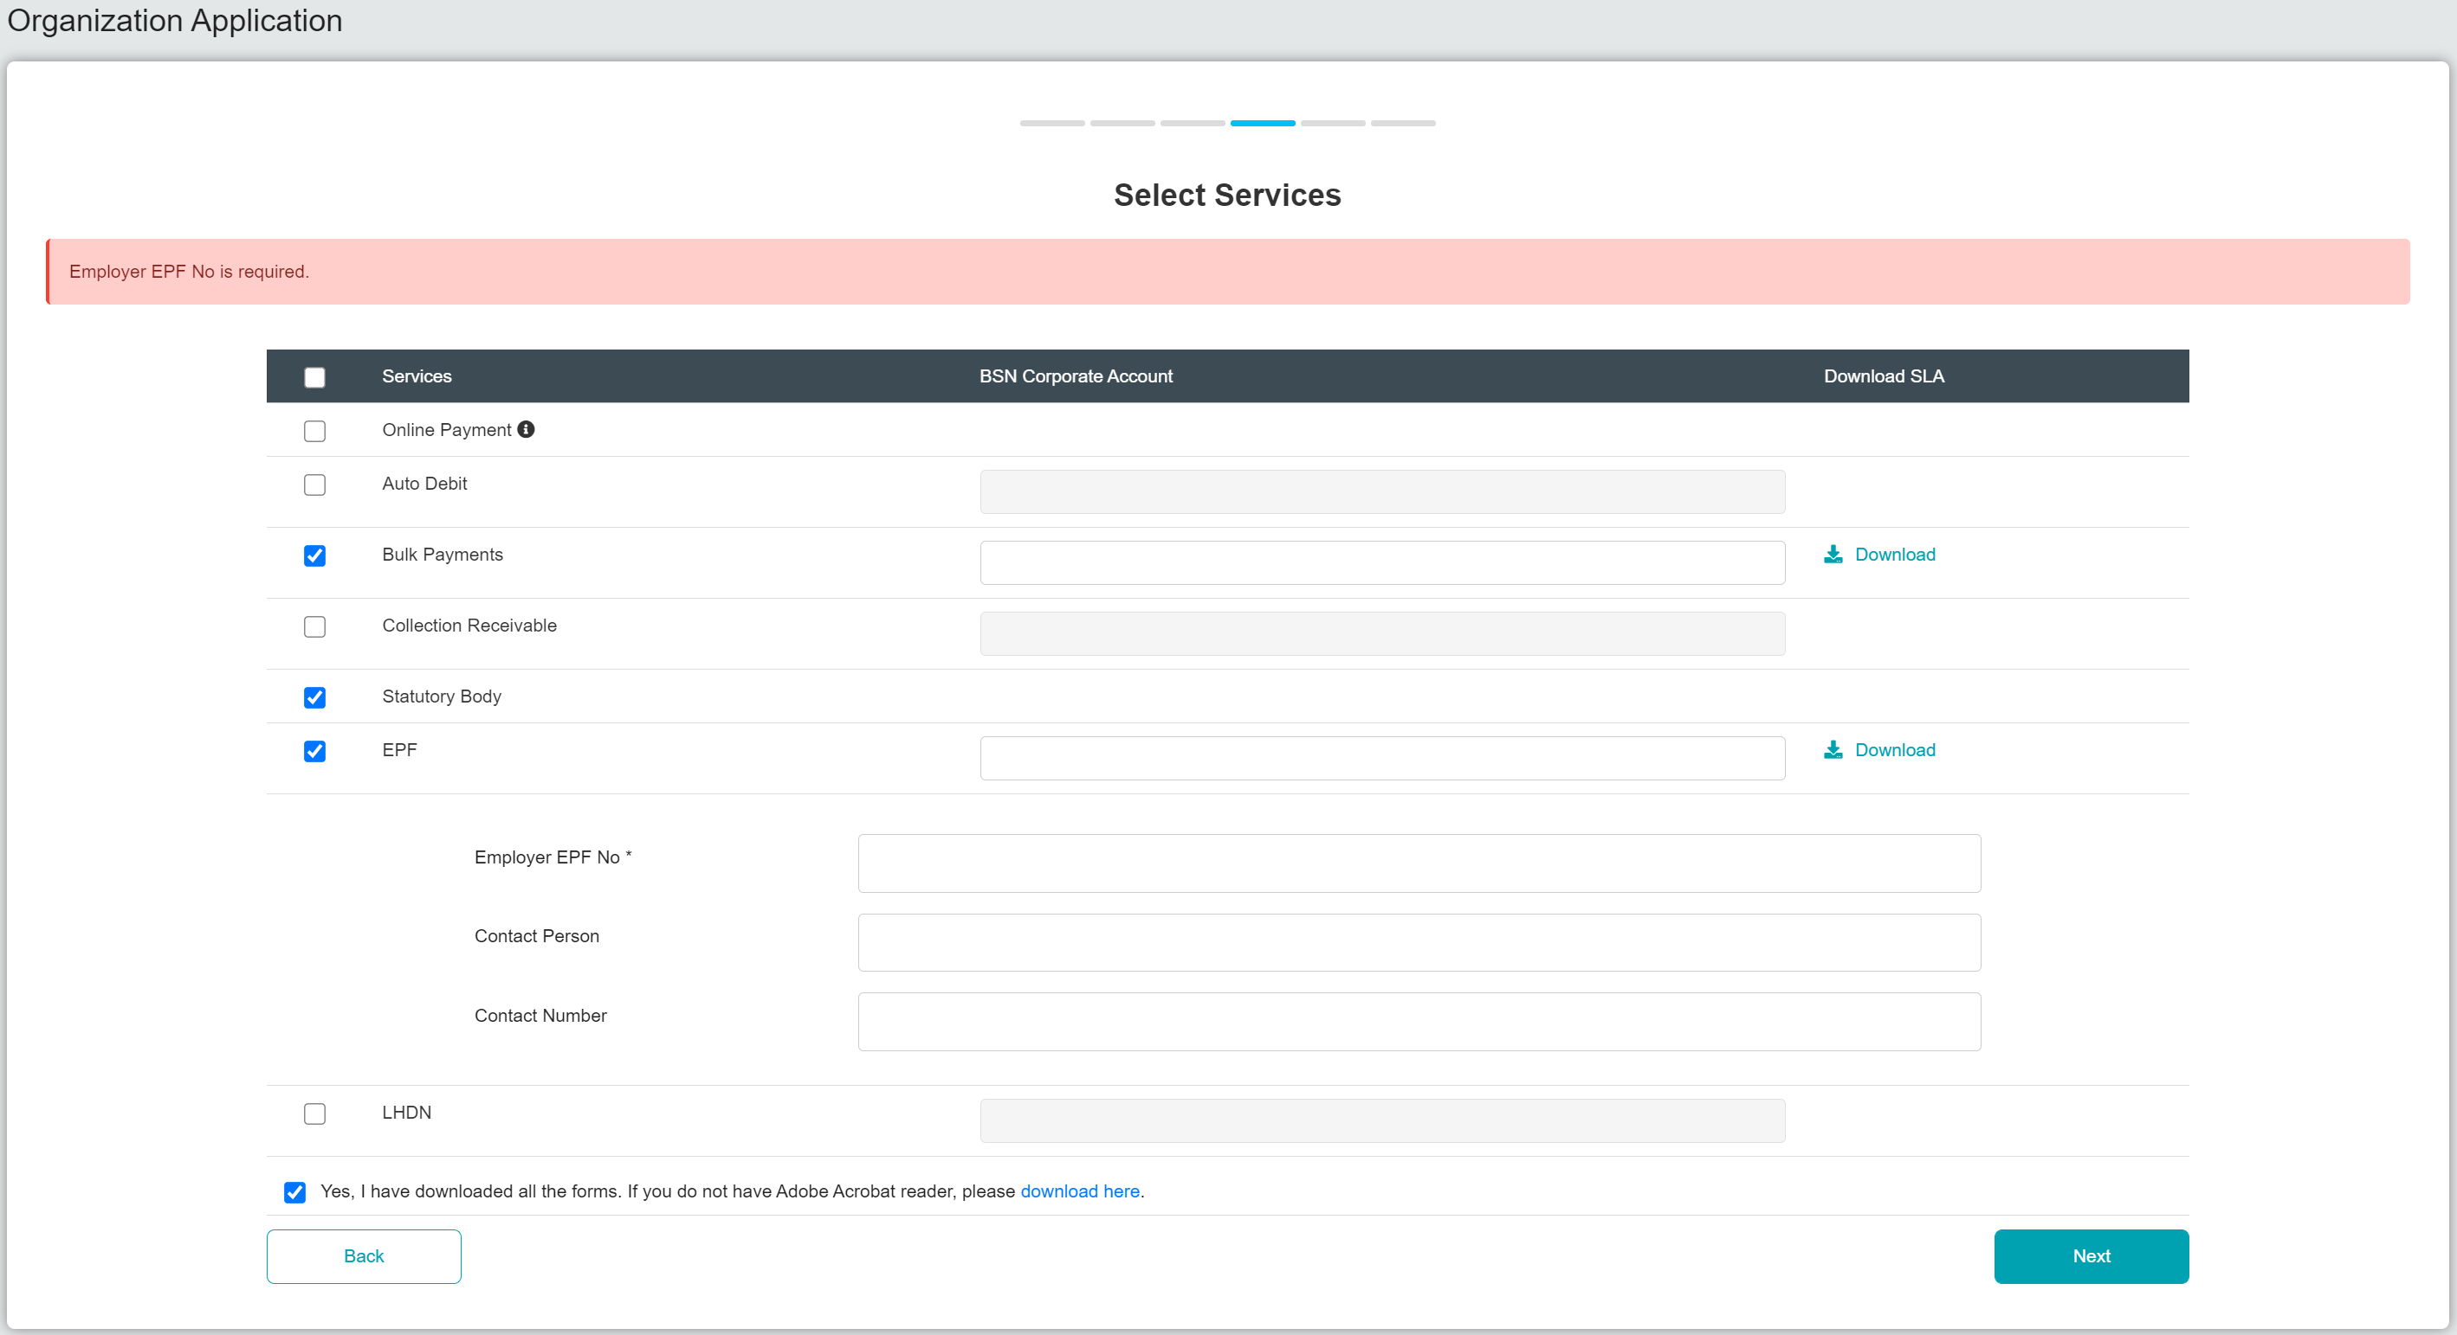

Max Length : 9

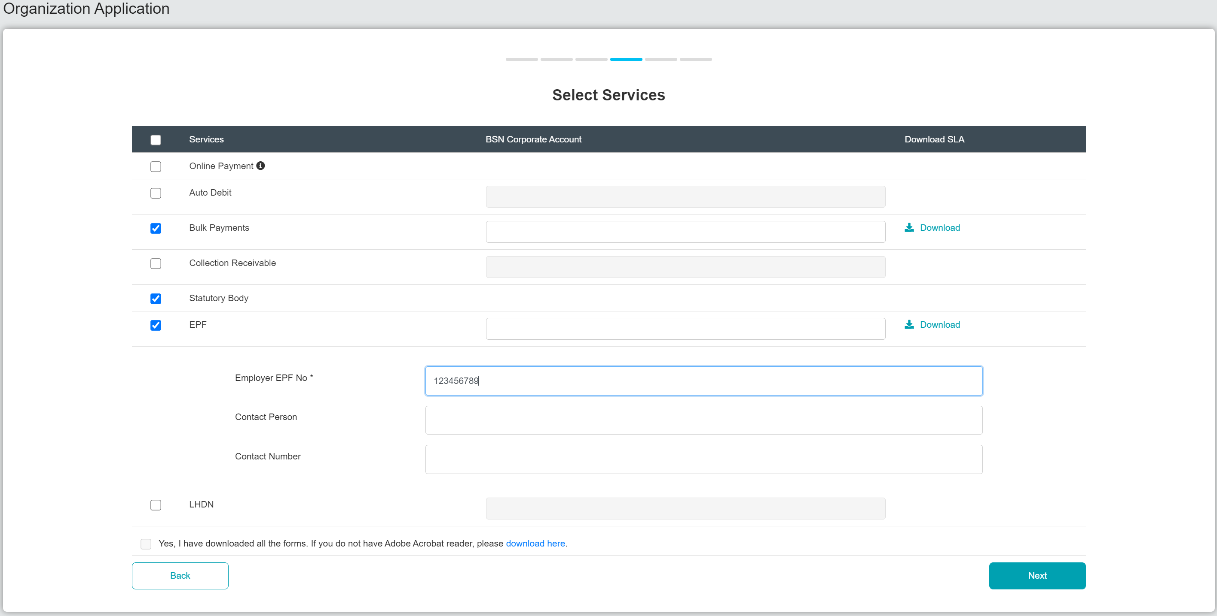

Insert 000000000 / 0 at EPF Employer No field

Result : Invalid Employer No

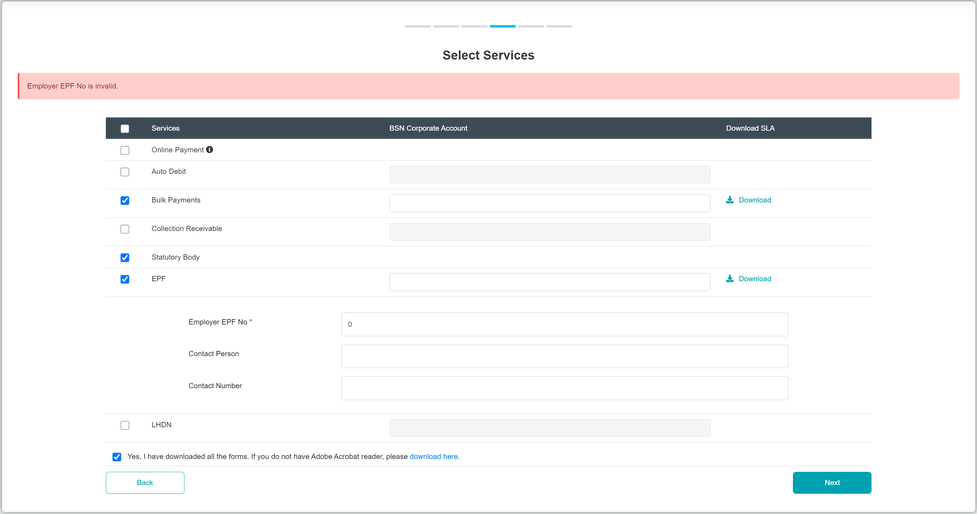

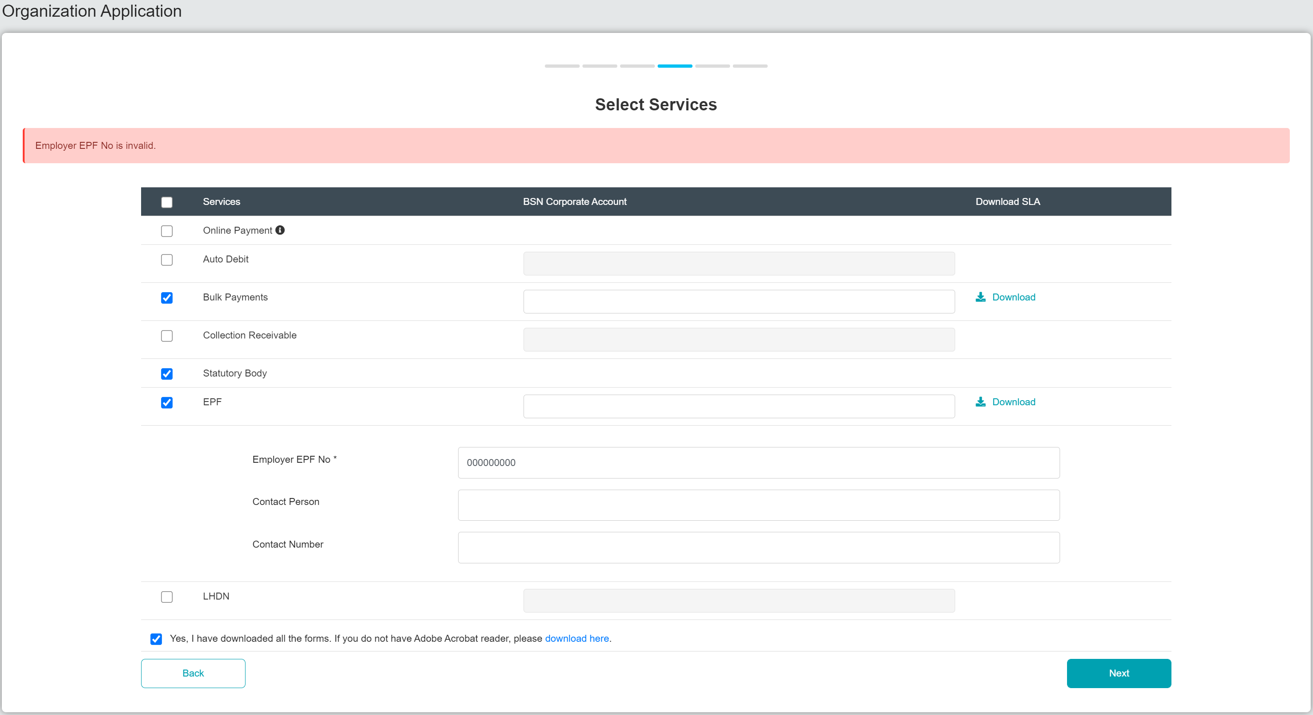

IBAM > Organization Setup> Services

Empty EPF Employer No

Result : Employer No is required

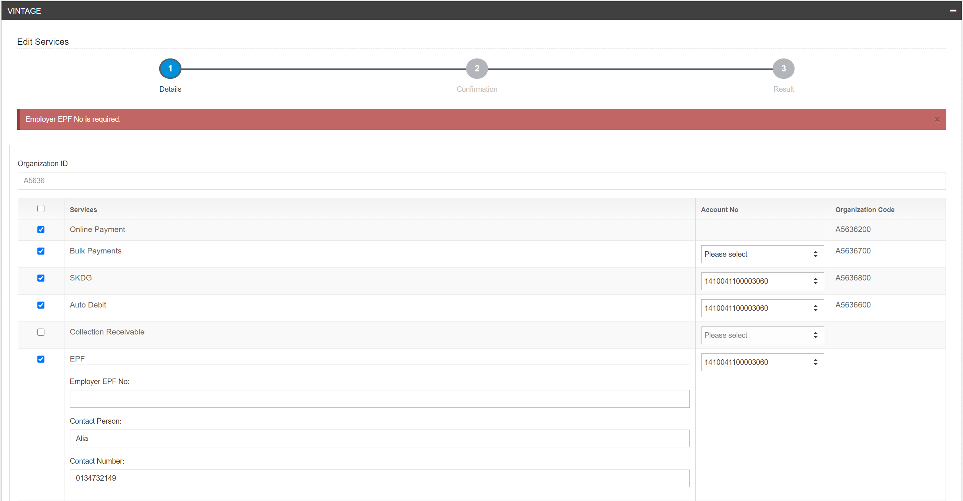

Max Length : 9

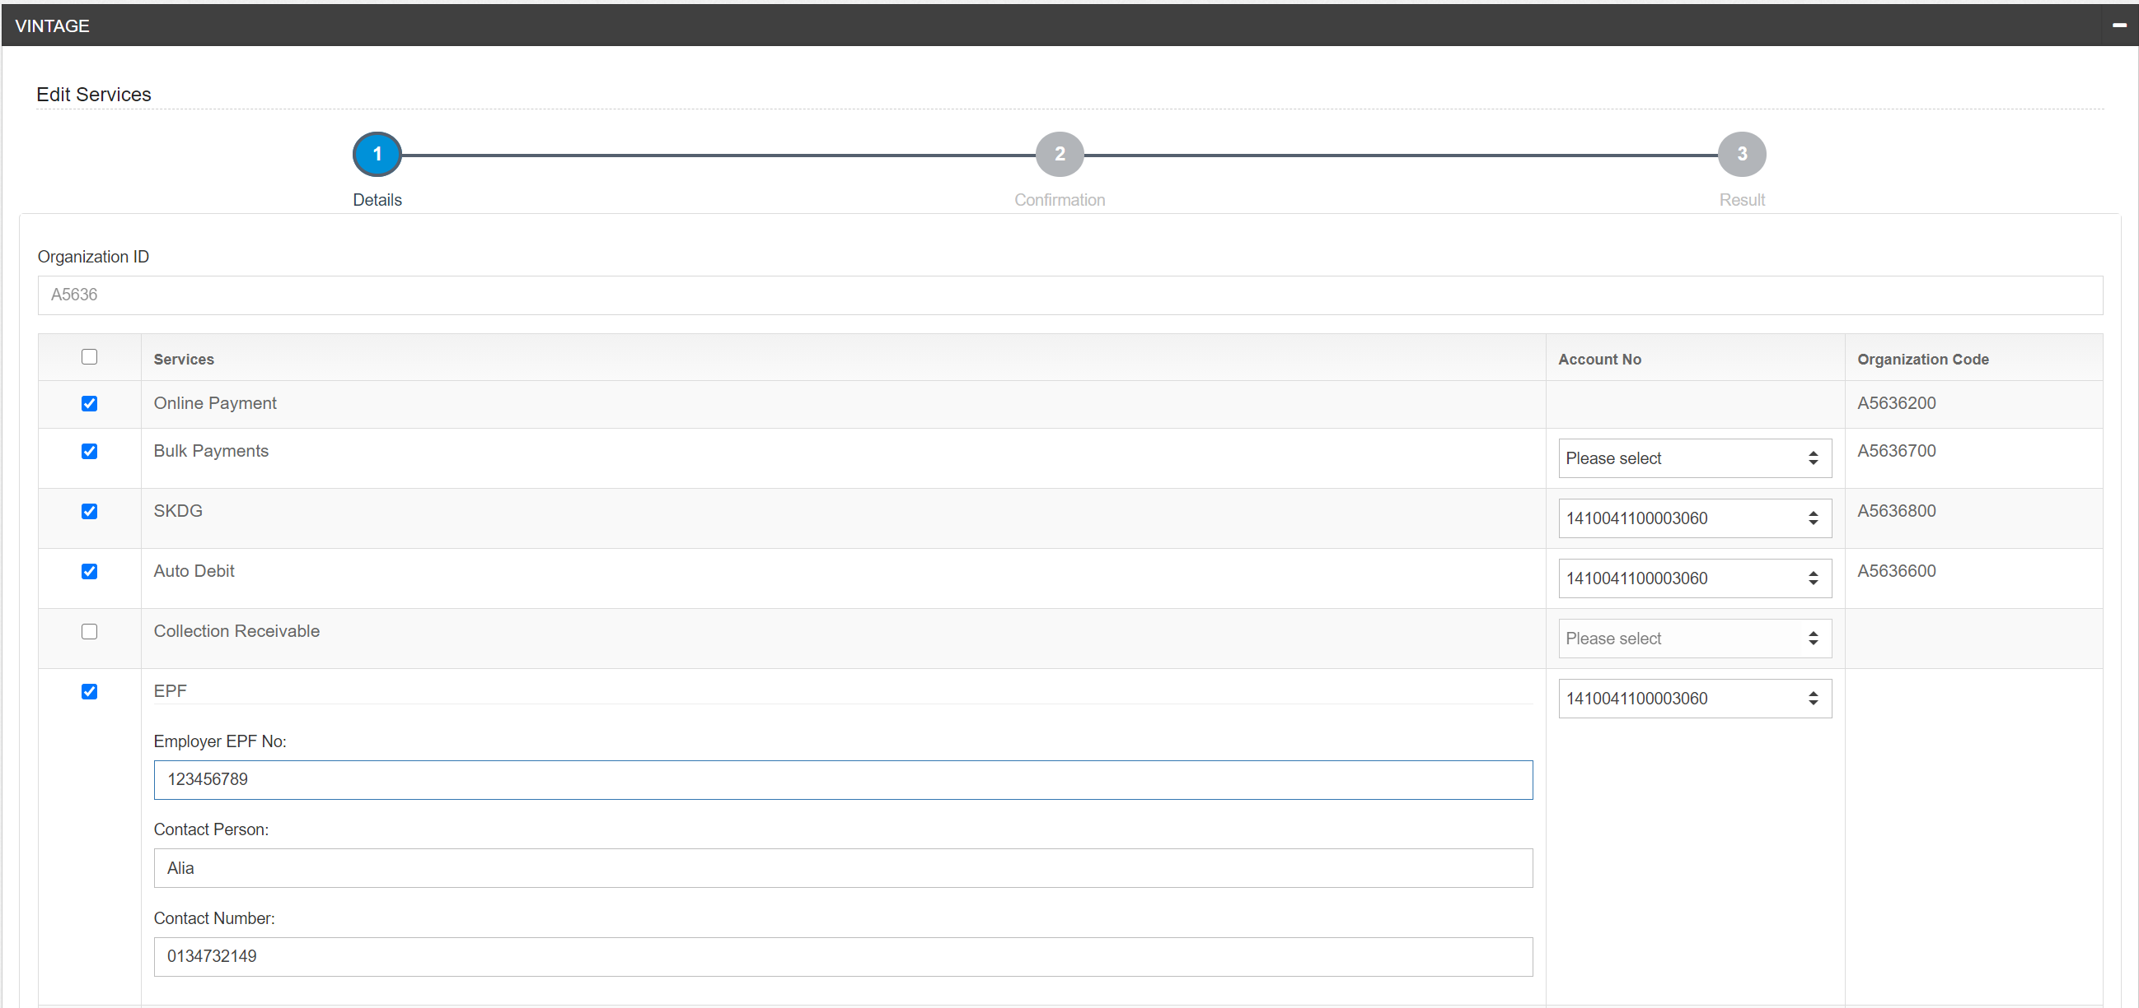

Insert 000000000 / 0 at EPF Employer No field

Result : Invalid Employer No

