Project Name |  |  |  | BSN – Corporate Digital Banking (CDB)
Project Code |  |  |  |  |  |  |  | Doc Ref
BSN URS # |  |  |  |  |  |  |  | BSN CM#
Date |  |  |  | 01/10/2020 |  |  |  | Chg Req #
Change Description
Request:
To add search by Org Code function in below screen:

- Organization Setup
- BSNeBiz Transaction history
- eStatement
- BSNeBiz User Activity Log
- BSNeBiz Report
- Corporate Account inquiry
Resolutions:
Add search by Org Code function on listing module.

Requested By |  |  | Rahmat Bohari  Eksekutif JPD |  |  |  | Initiated By |  |  | Norhaidah Md Dasuki
Impact Analysis
1 |  | IBAM  - Organization Setup  - BSNeBiz Transaction history - Update CDB history to record org code. Only works with future transaction  - eStatement  - BSNeBiz User Activity Log  - Corporate Account inquiry
Exception
1 |  | IBAM  - BSNeBiz Report - Report is not link with org code.
Effort Analysis
# | Resource |  |  | Effort  (man days) |  | Unit Cost (RM) | Cost  (RM) |  |  |  | Description
1 |  |  |  | 10 |  |  |  |  |  |  | Requirement study, Internal testing, Development.
2 |  |  |  | 3 |  |  |  |  |  |  | SIT, UAT, Documentation and migration support
Sub Total
Gov. Charges
Total
Total Cost |  |  |  |  |  |  | 00.00
Approval
Name |  |  |  |  | Role |  |  |  | Signature (Date)
Zamri Omar |  |  |  |  | Pengurus Projek  Jab. Perbankan Digital, BSN
Norhaidah Md Dasuki |  |  |  |  | Project Manager (Penril)

Terms

Payment Schedule

- 10% upon Letter of Acceptance
- 30% upon SIT Sign-Off
- 30% upon UAT Sign-Off
- 20% upon LIVE or 30 days after UAT Sign Off (whichever comes first)
- 10% upon End of Warranty or 60 days after UAT Sign Off (whichever comes first)

Notes: AMC of 20% of the total sum will kick in for the 12-month support. The commencement date of the support period is effective from 30 days after UAT sign-off. Kindly stated in the LOA if required for the AMC.

Payment Terms & Conditions
- All prices are quoted in Malaysian Ringgit unless otherwise stated.
- Customer shall fully settle all invoices issued by Penril Datability (M) Sdn Bhd within thirty (30) days from the date of the invoice received by Customer, failing which late payment interest at the rate of twelve percent (12%) per annum shall be payable by the Customer for all outstanding sums until full payment.
- The Customer agrees that terms and conditions herein is governed by and shall be construed in accordance with the Malaysian laws and agrees to submit the exclusive jurisdiction of the courts of Malaysia.
- Any out of scope changes in specifications shall necessitate a re-quotation mutually agreed by both parties.
- Agreement stamping cost to be borne by Penril.
- For any clarification of this quotation,

For commercial purpose, please contact Koh Mui Tong
Email : mtkoh@penril.net or Mobile : 012 2038087

For technical, scope & schedule, please contact Tan Lee Yong
Email : leeyong.tan@penril.net or Mobile : 019 559 8816

Assumptions

General Assumptions

- Customer will set up a dedicated task-force made by a sufficient number of resources to guarantee that Customer’s required skills are available to the project when required according to the agreed project schedule.
- Customer will make available to Penril staff facilities on site similar to those that Customer makes available to their own staff.
- Customer will respond to all Penril requests for information in a timely manner.
- Customer shall be responsible for timely availability of software, hardware, applications and other necessary assistance required to develop/customize or implement the proposed solution.
- Customer will provide appropriate testing, training and production environment for the proposed solution.
- Customer will fulfill any other request, which may arise and needed to ensure the success of the overall project. Some of the activities shall be done off-site where and when required and Penril project manager will periodically report the progress of these tasks to Customer steering committee and project manager.
- Civil work and Site Preparation are not part of this scope of work.
- Customer will arrange all necessary authorizations on LAN or any other infrastructure for Penril employees to be able to carry out the project.
- Customer has to develop all the suitable test data cases according to the test plan submitted by Penril. The test plan and test cases will be the foundation for accepting the proposed solution.
- Penril will require a mobilization period of 2 weeks starting from the date of signing the contract.

Solution Assumptions

- Customer will be responsible for arrangements with other project parties.

SCOPE OF WORK – SYSTEM ENHANCEMENT
SCP ID: | 5558 | Description: | To add Add Org Code as search parameter IBAM

System | Modules | Description | Dev. Effort (Days)
BSNeBiz | NA | NA
IBAM | Organization setup | - To add search Org Code function at Advance Search section (BSN allow to search company by Org Code) | 1
 | BSNeBiz Transaction history | - To add search Org Code function at Advance Search section (BSN allow to search transaction history by Org Code) | 3  Update CDB history to record org code. Only works with future transaction.
 | eStatement | - To add search Org Code function at Advance Search section (BSN allow to search eStatement by Org Code) | 1
 | BSNeBiz User activity logs | - To add search Org Code function at Advance Search section (BSN allow to search User Activity by Org Code) | 2
 | Corporate account inquiry | - To add search Org Code function at Advance Search section (BSN allow to search Accounty by Org Code) | 1
EOD | NA | NA

PROPOSED DIAGRAM

Organization Setup

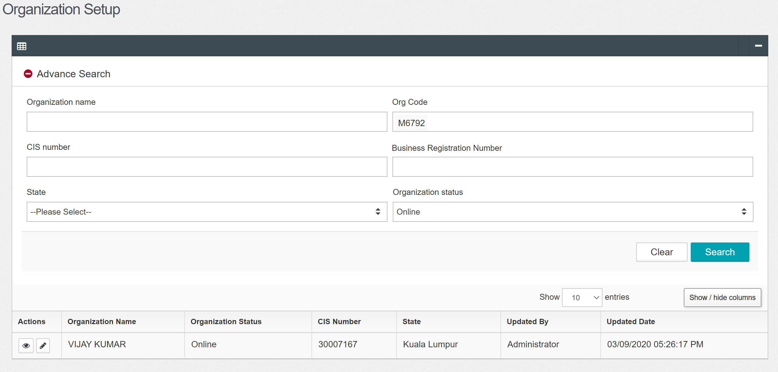

BSNeBiz Transaction History

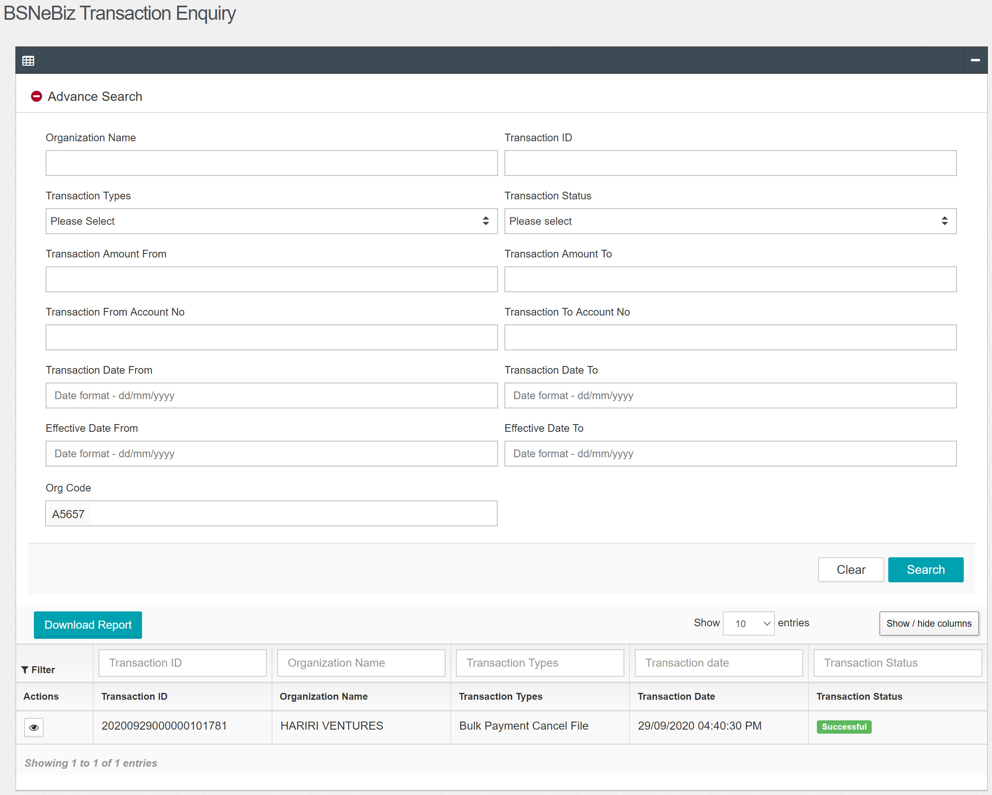

eStatement

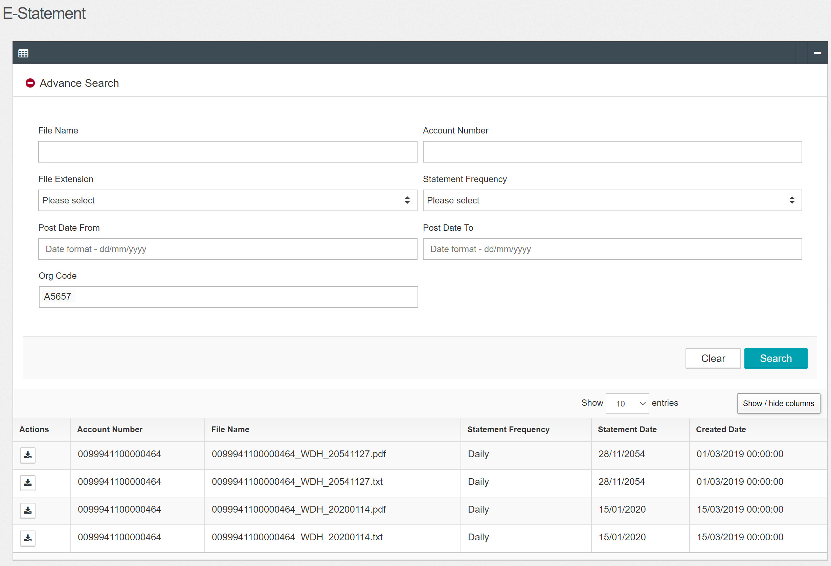

BSNeBiz User Activity Log

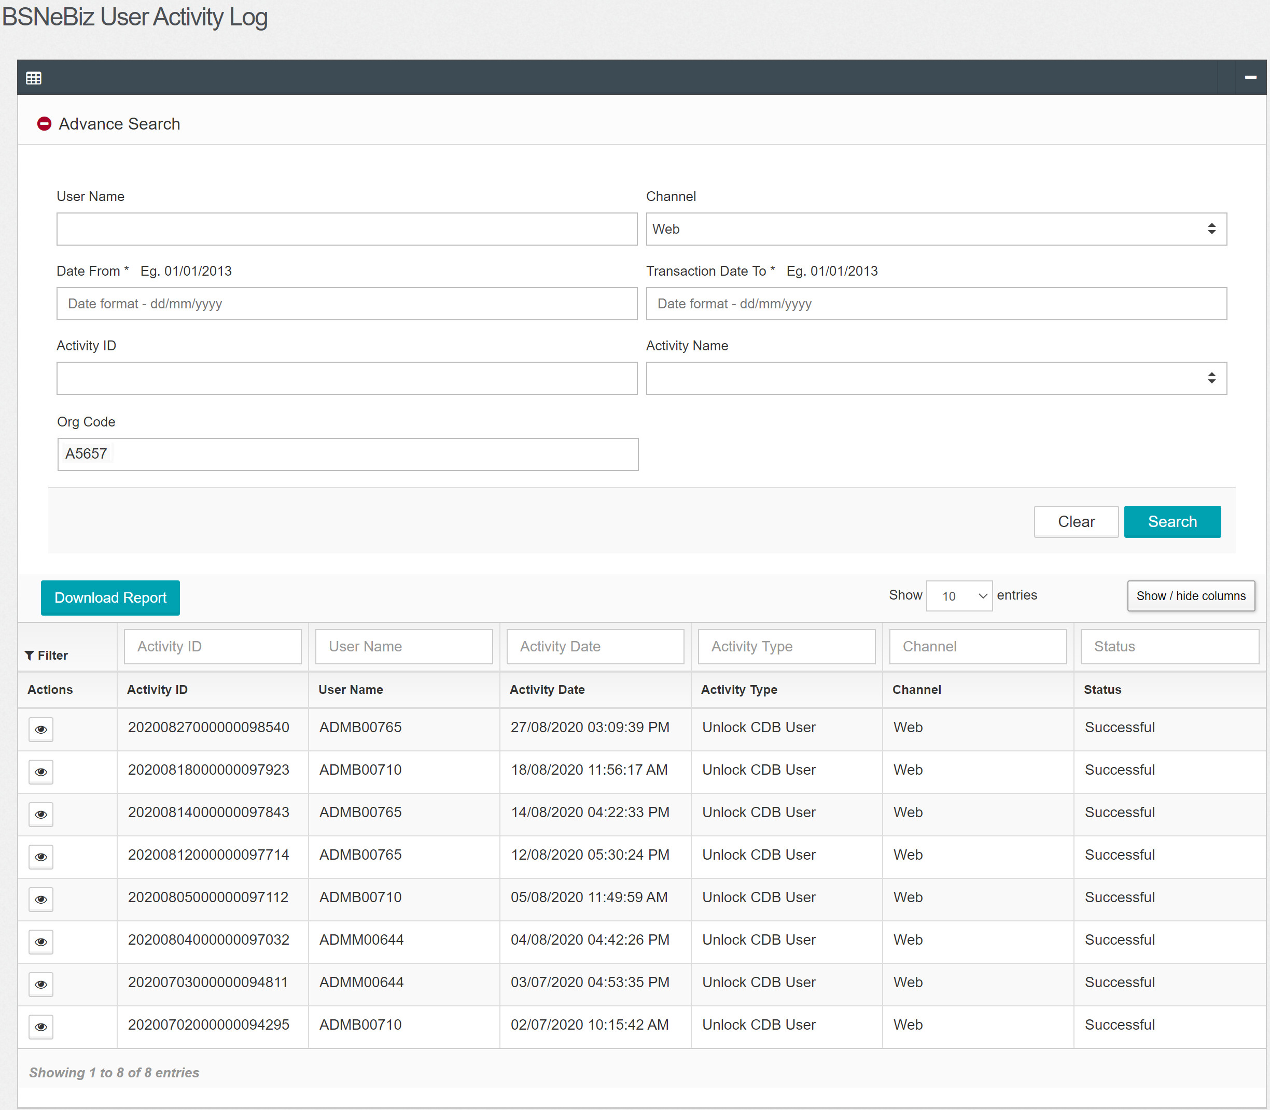

Corporate Account Inquiry

