Mobile app auto update (Force Update – Android & iOS)

Test scenario:

1. Access IBAM>Mobile>Mobile Version
2. Create Mobile Version for Android and iOS and set as active
3. Access Android or iOS apk
4. If the apk version is lower than IBAM version, a notification will appear
5. Repeat testing for Edit, Delete, Maker and Checker

# Create

1. Using user IBAM Maker , access IBAM>Mobile>Mobile Version
2. Create Mobile Version for Android & iOS and set as active

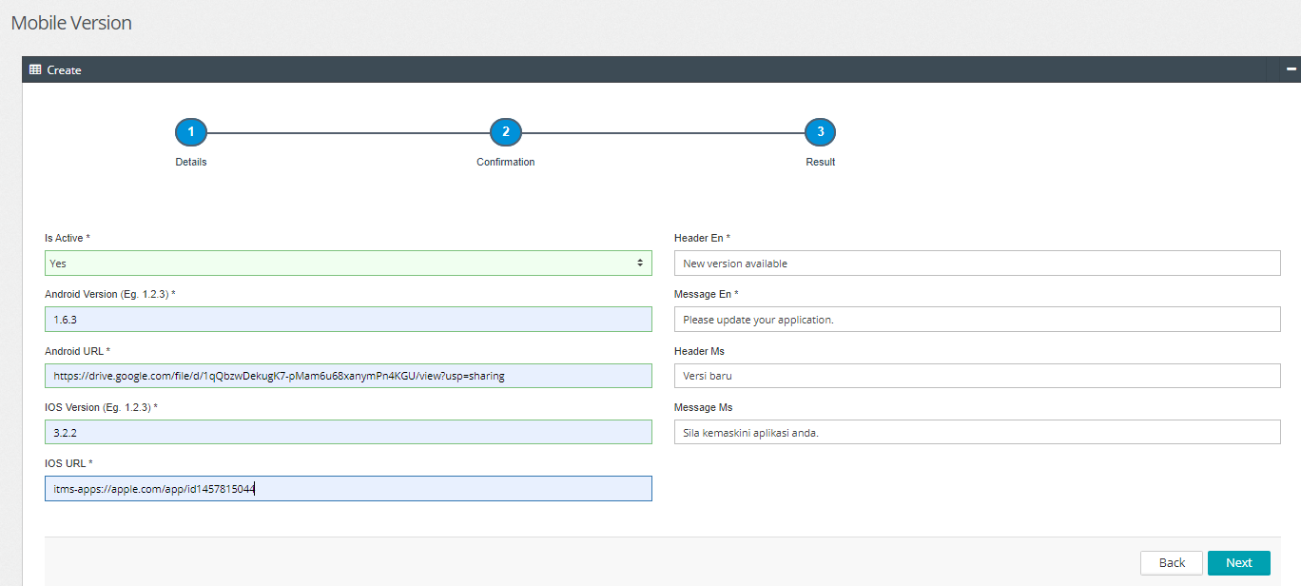

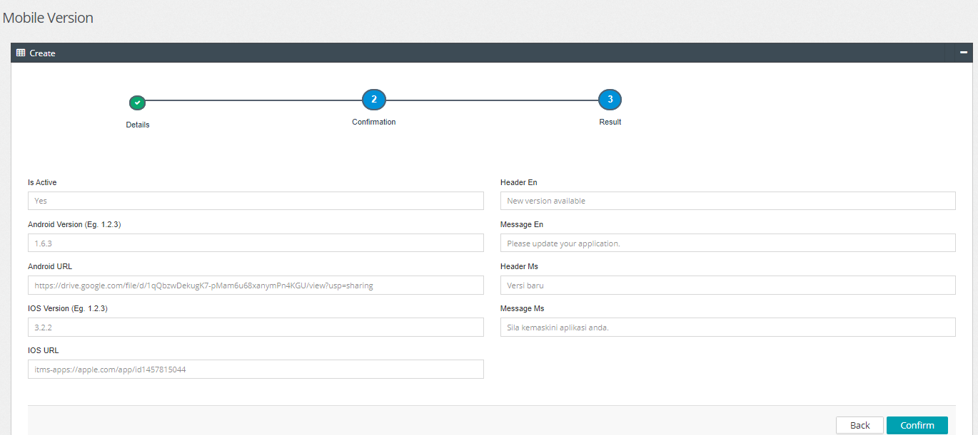

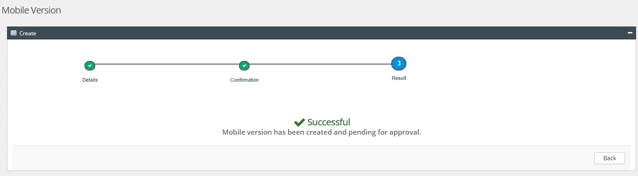

View Pending list:

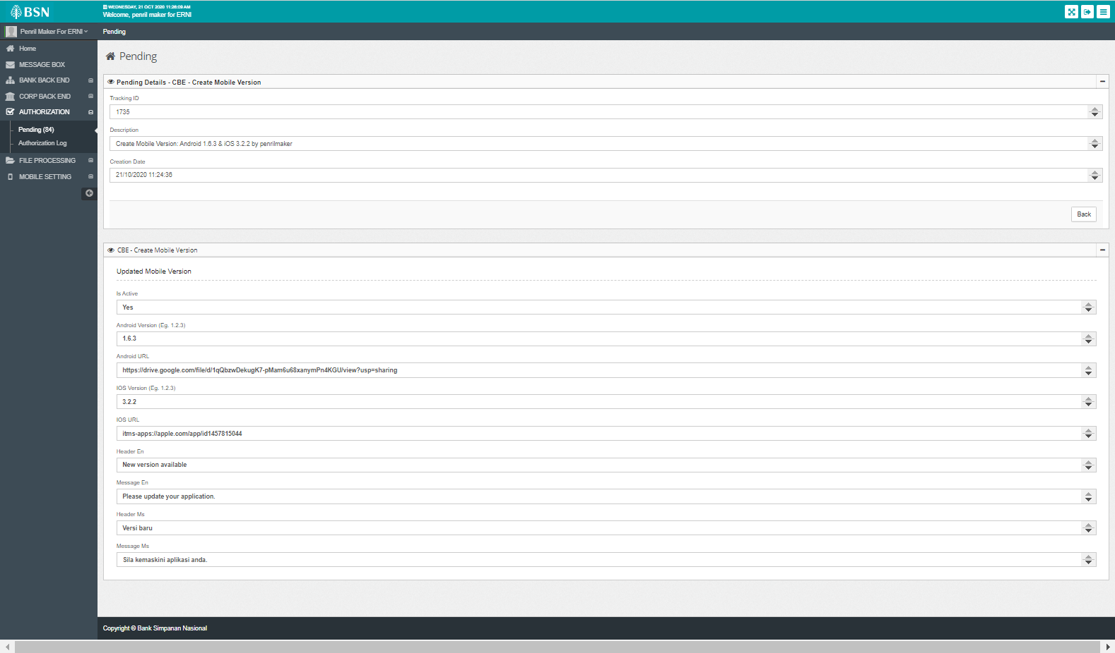

Login as Approver to approve

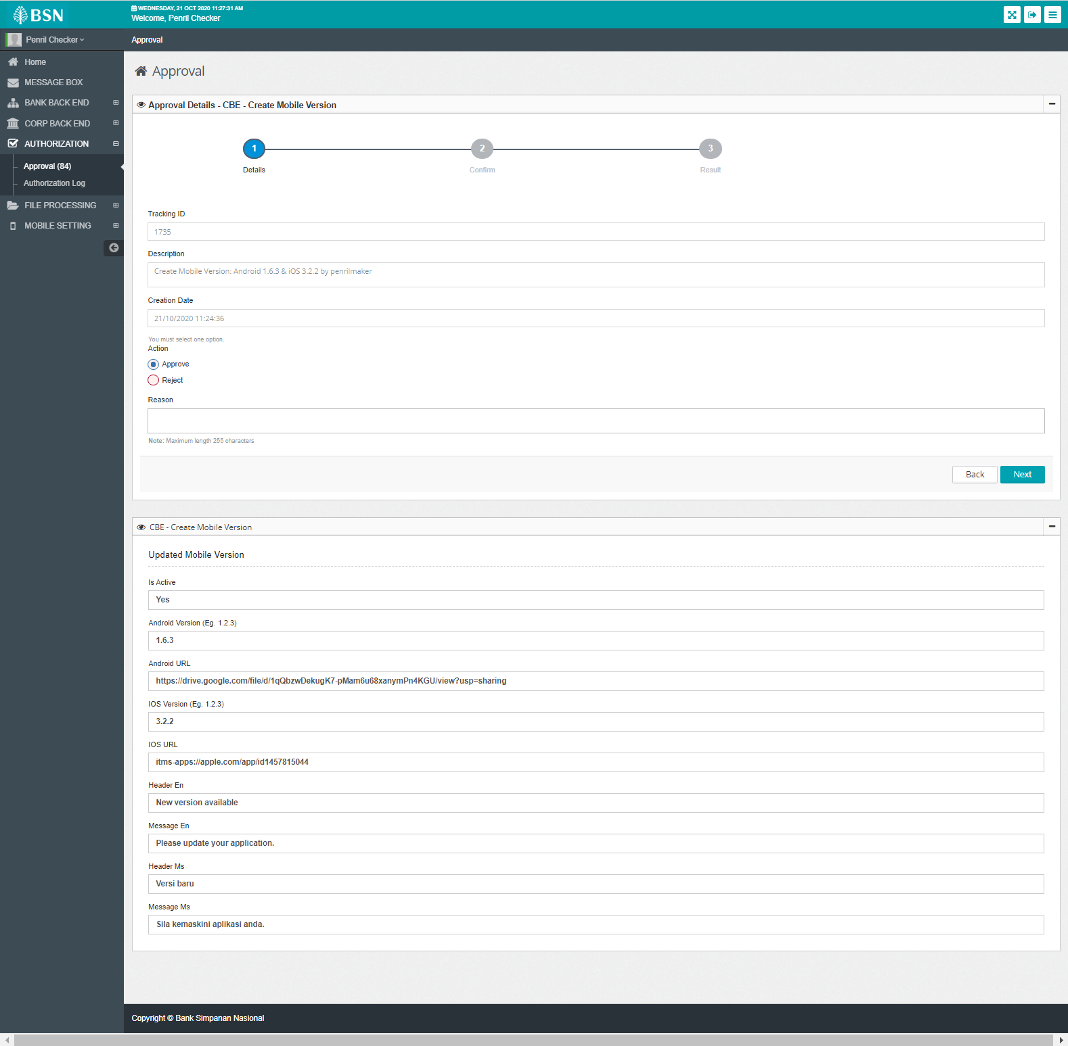

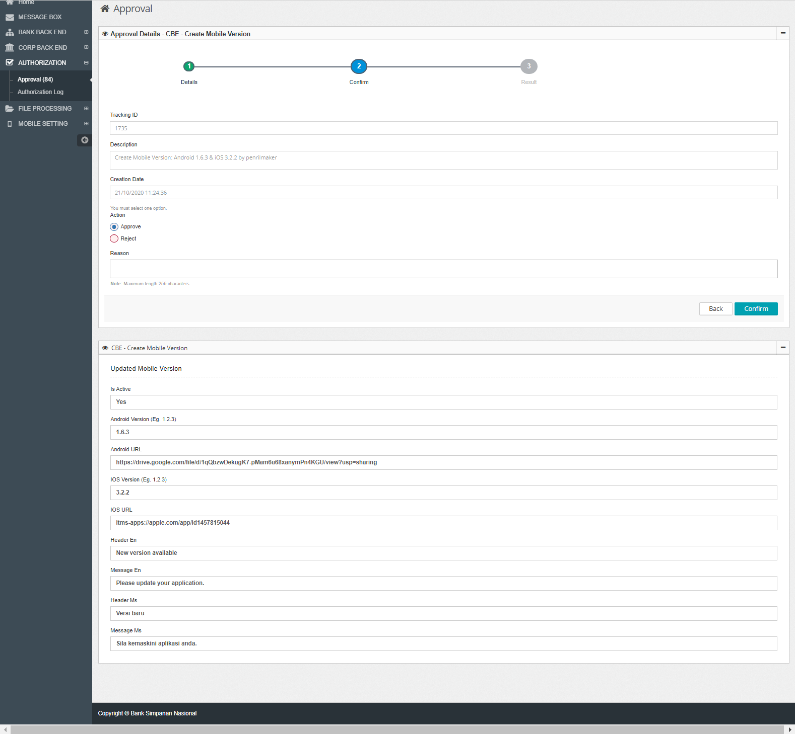

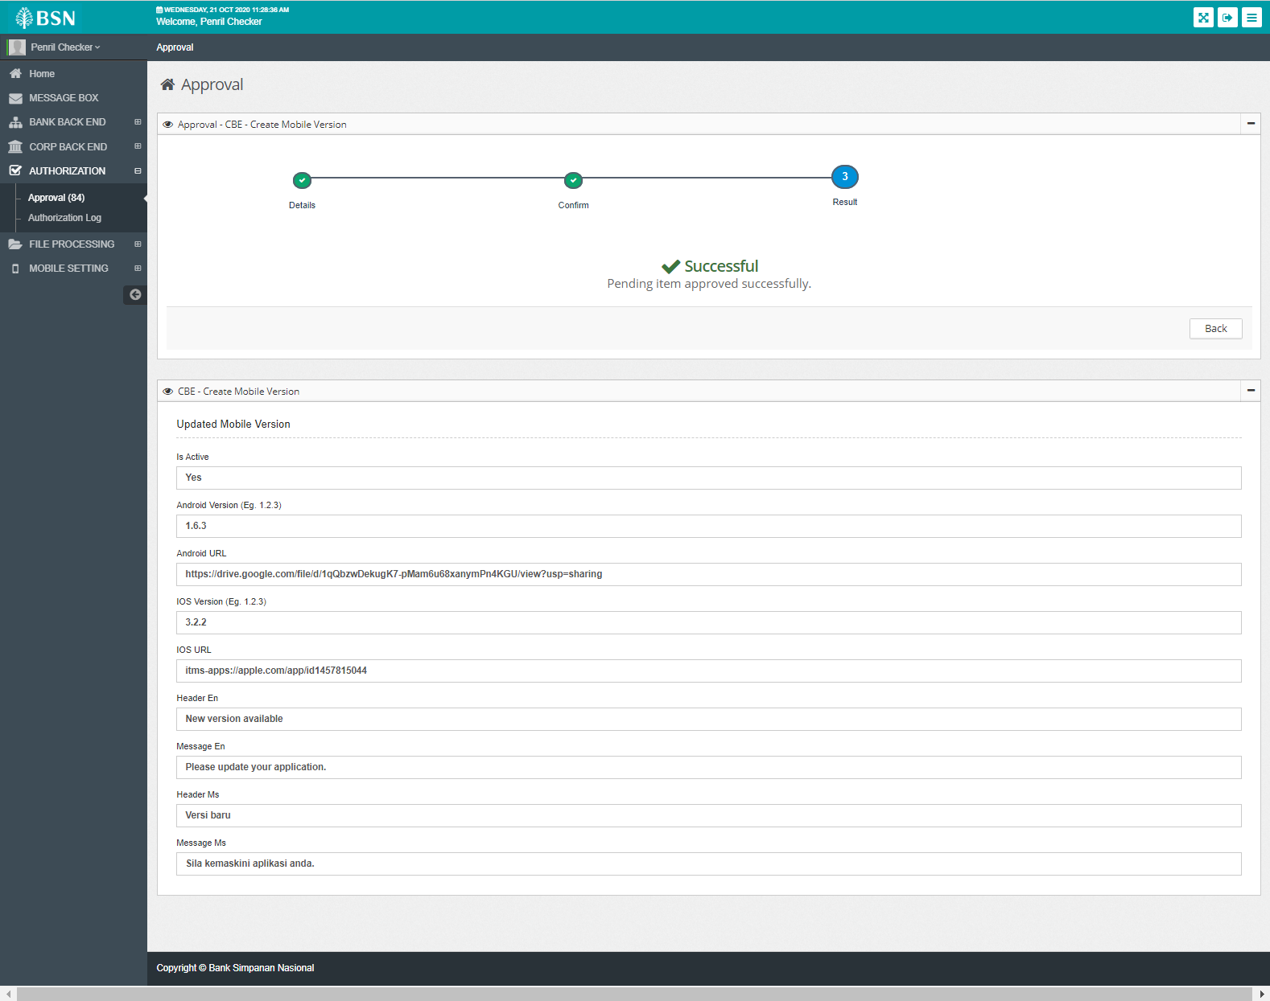

Issue found:

* 1. Change "Header Ms" and "Message Ms" to be "Header BM" and "Message BM"

3. Access Android or iOS apk

4. If the apk version is lower than IBAM version, a notification will appear

# Edit

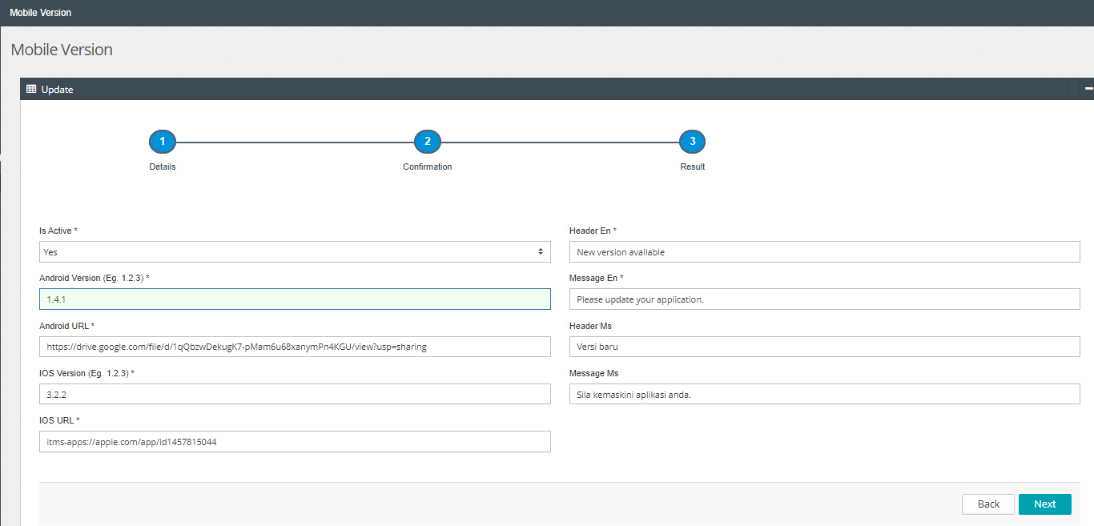

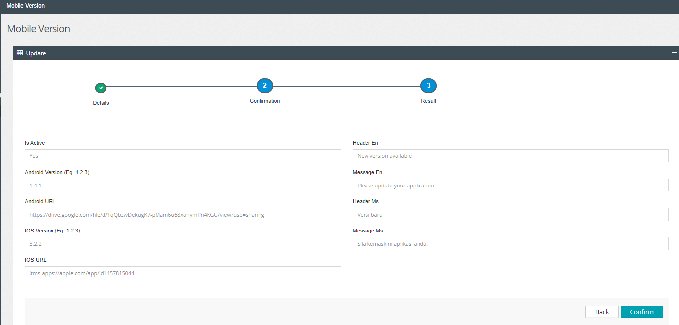

View Pending list:

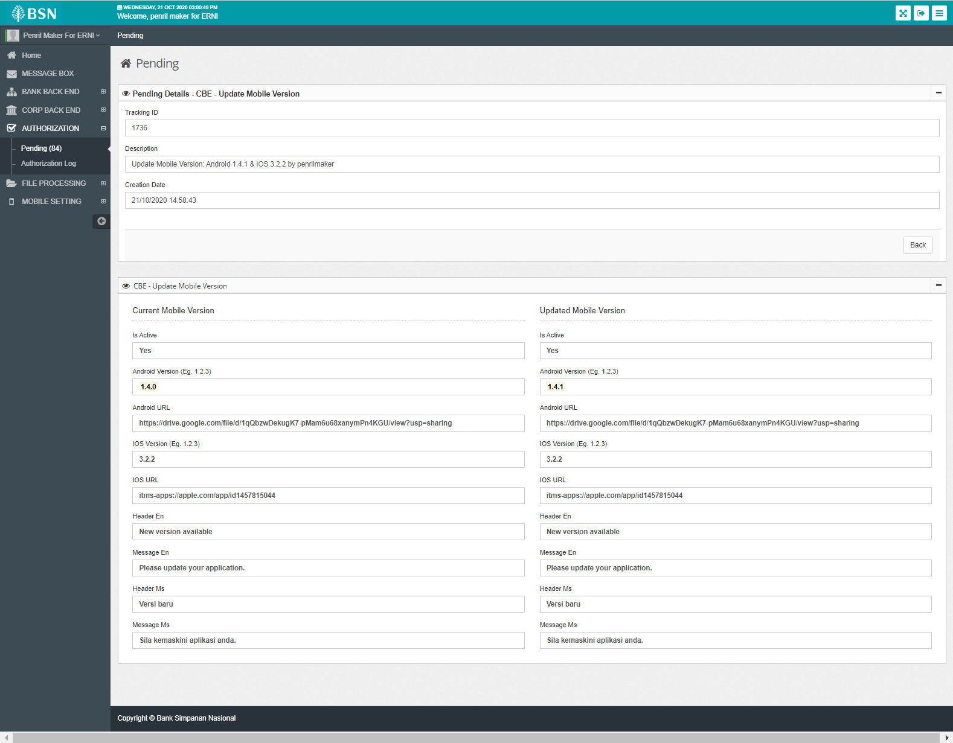  
Login as Approver to Approve

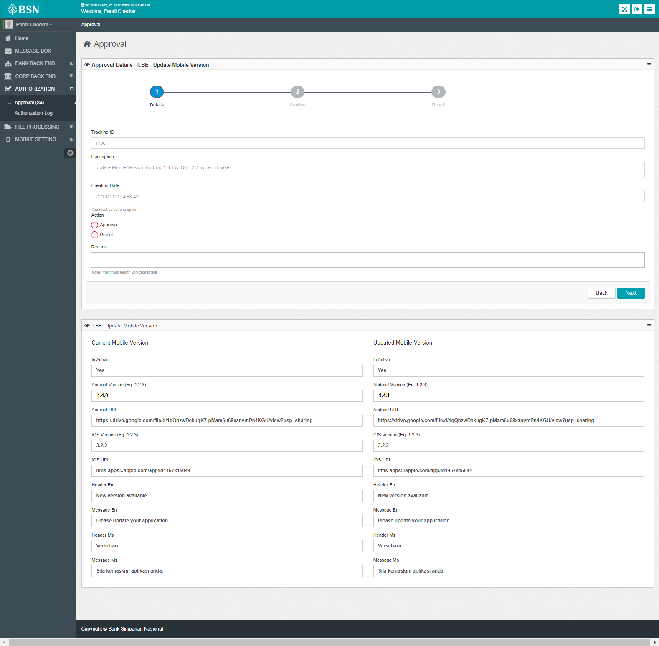

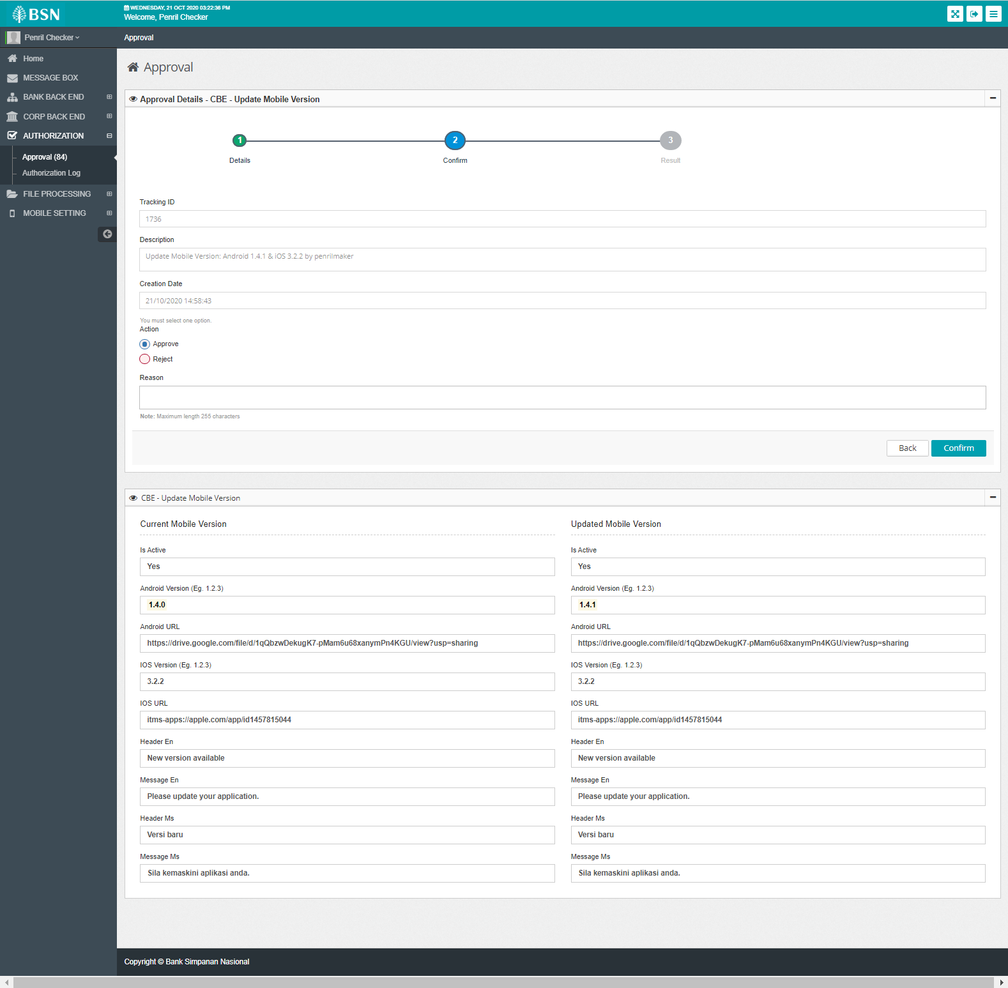

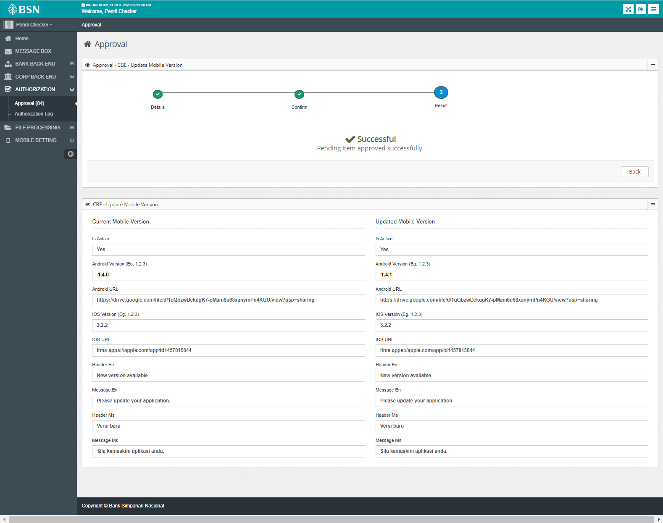

# Delete

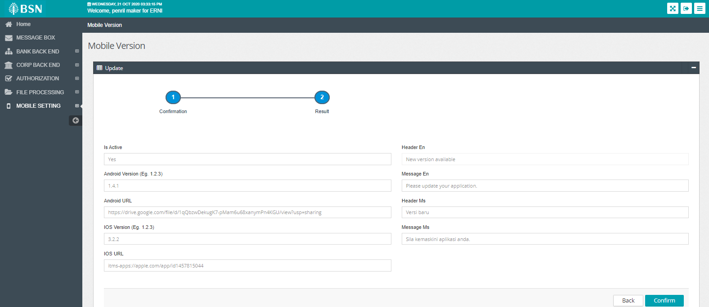

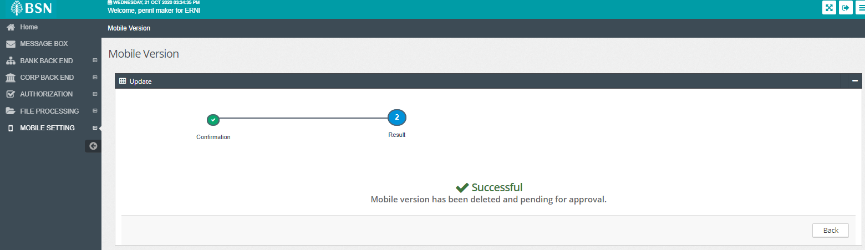

View pending list:  
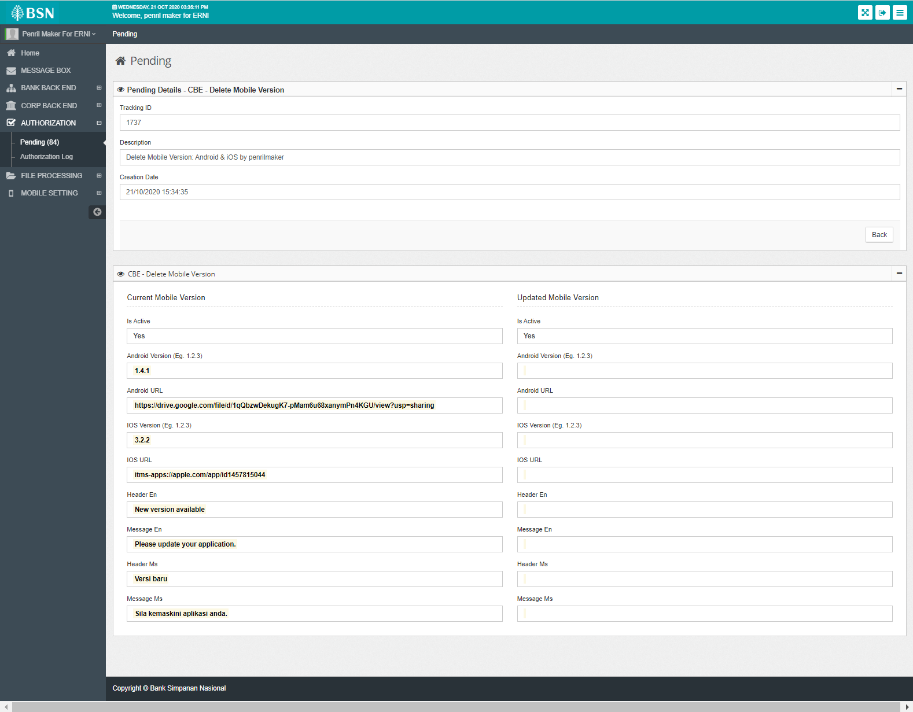

Login as Approver to approve:

