Issue:

EPF unable to stop/approve payment on same posting date (after EOD)

Expected Test Result:

|  |  |  |  |  |
| --- | --- | --- | --- | --- |
| Posting Date  EOD Service Time | Service Type | 22/10/2020  (yesterday) | 23/10/2020  (current date) | 24/10/2020 (tomorrow) |
| Before  Change:2000 Current: 1450 | EPF | X | ✓ | ✓ |
| After  Change:1300 Current: 1450 | EPF | X | X | X |
| Before  Change:2000 Current: 1450 | Bulk Payment | X | X | ✓ |
| After  Change:1300 Current: 1450 | Bulk Payment | X | X | X |

Test Case 1: Posting Date 22/10/2020

1. EPF (Before EOD Service Time)

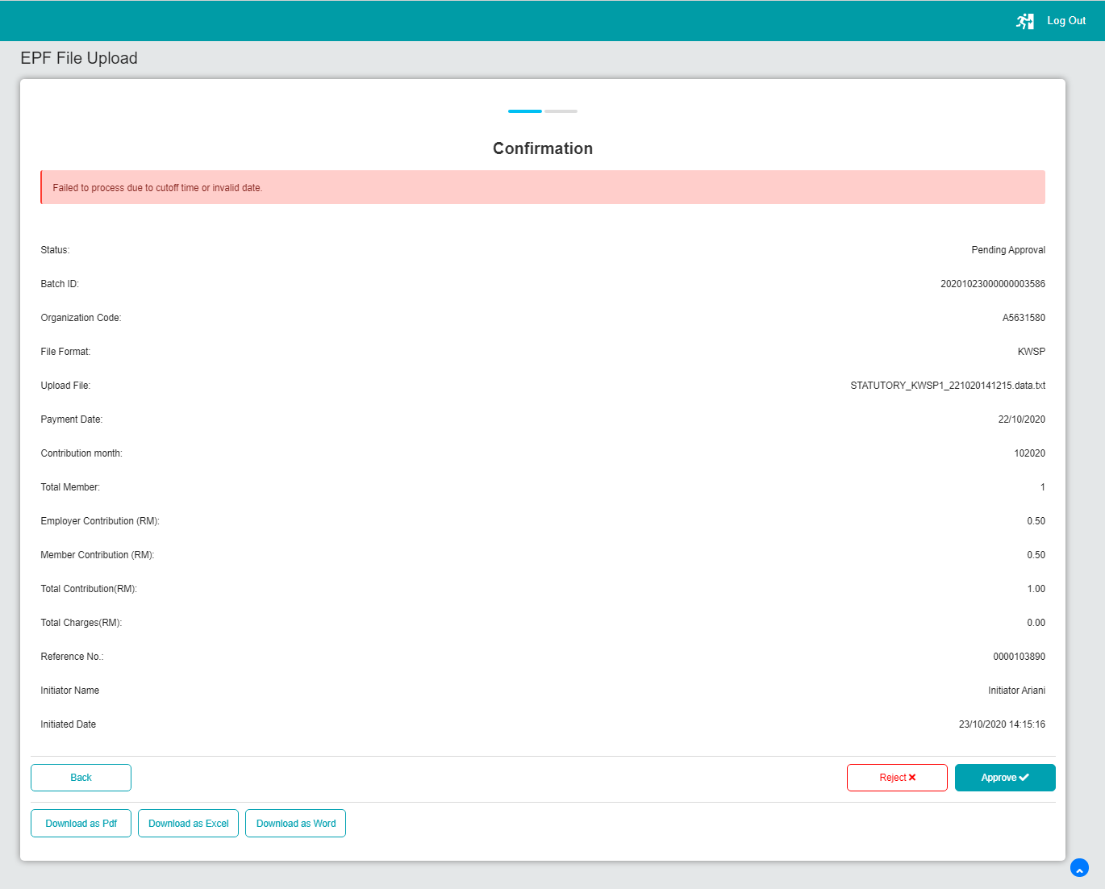

1. EPF (After EOD Service Time)

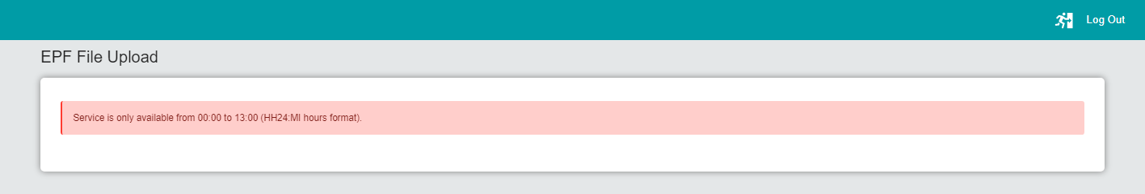

1. Bulk Payment (Before EOD Service Time)

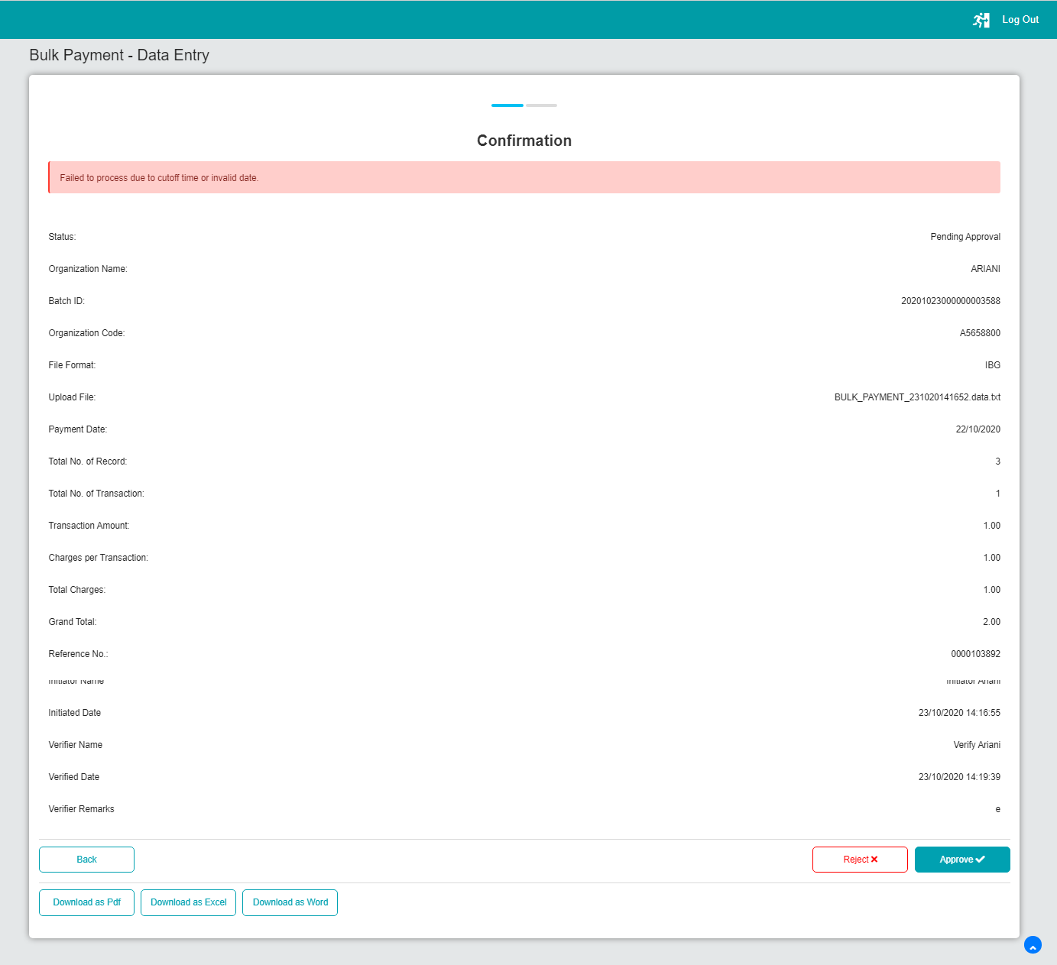

1. Bulk Payment (After EOD Service Time)

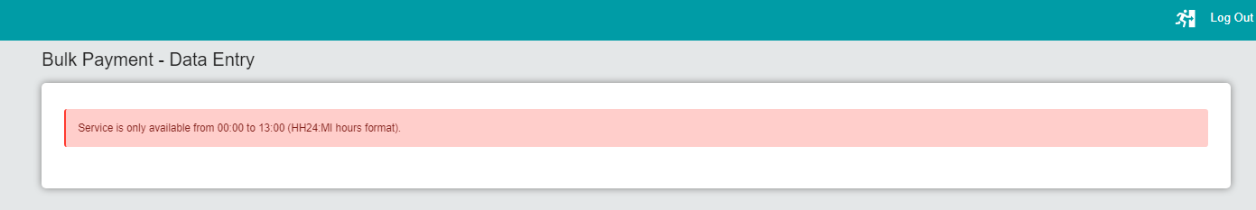

Test Case 2: Posting Date 23/10/2020 (Current Date)

1. EPF (Before EOD Service Time)

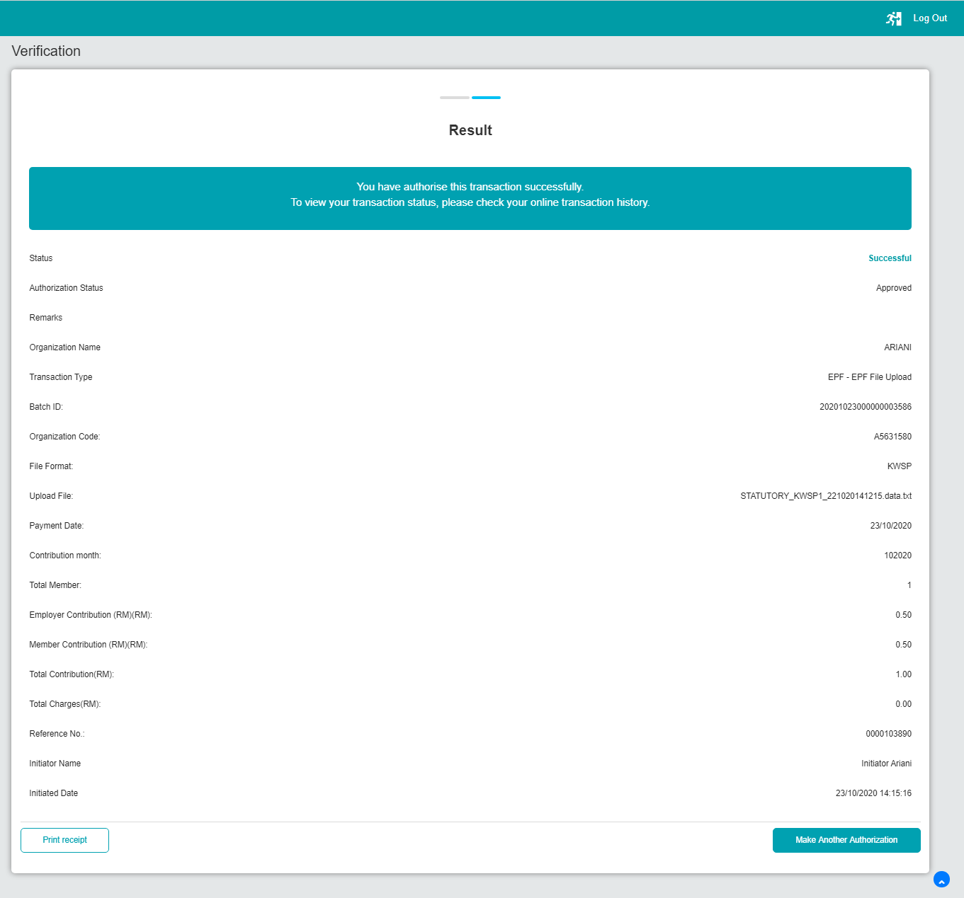

1. EPF (After EOD Service Time)

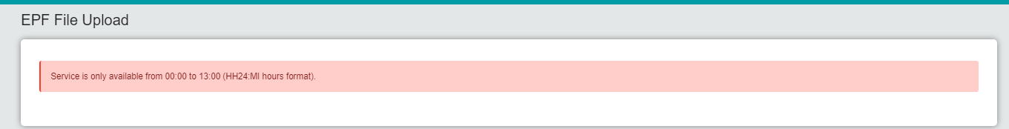

1. Bulk Payment (Before EOD Service Time)

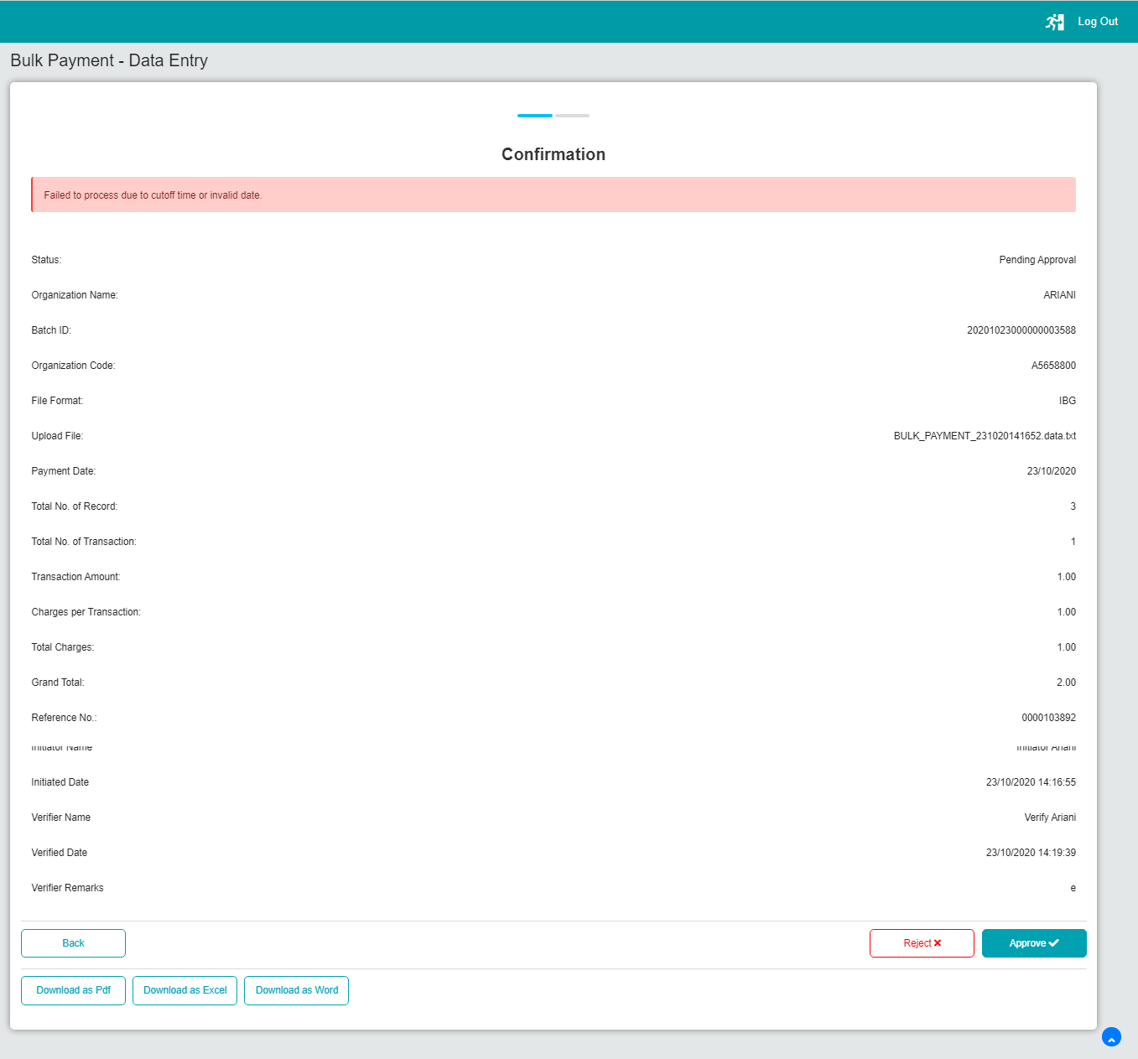

1. Bulk Payment (After EOD Service Time)

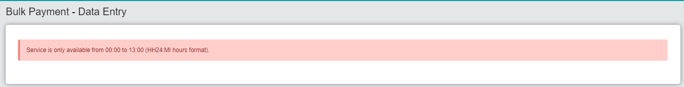

Test Case 3: Posting Date 24/10/2020

1. EPF (Before EOD Service Time)

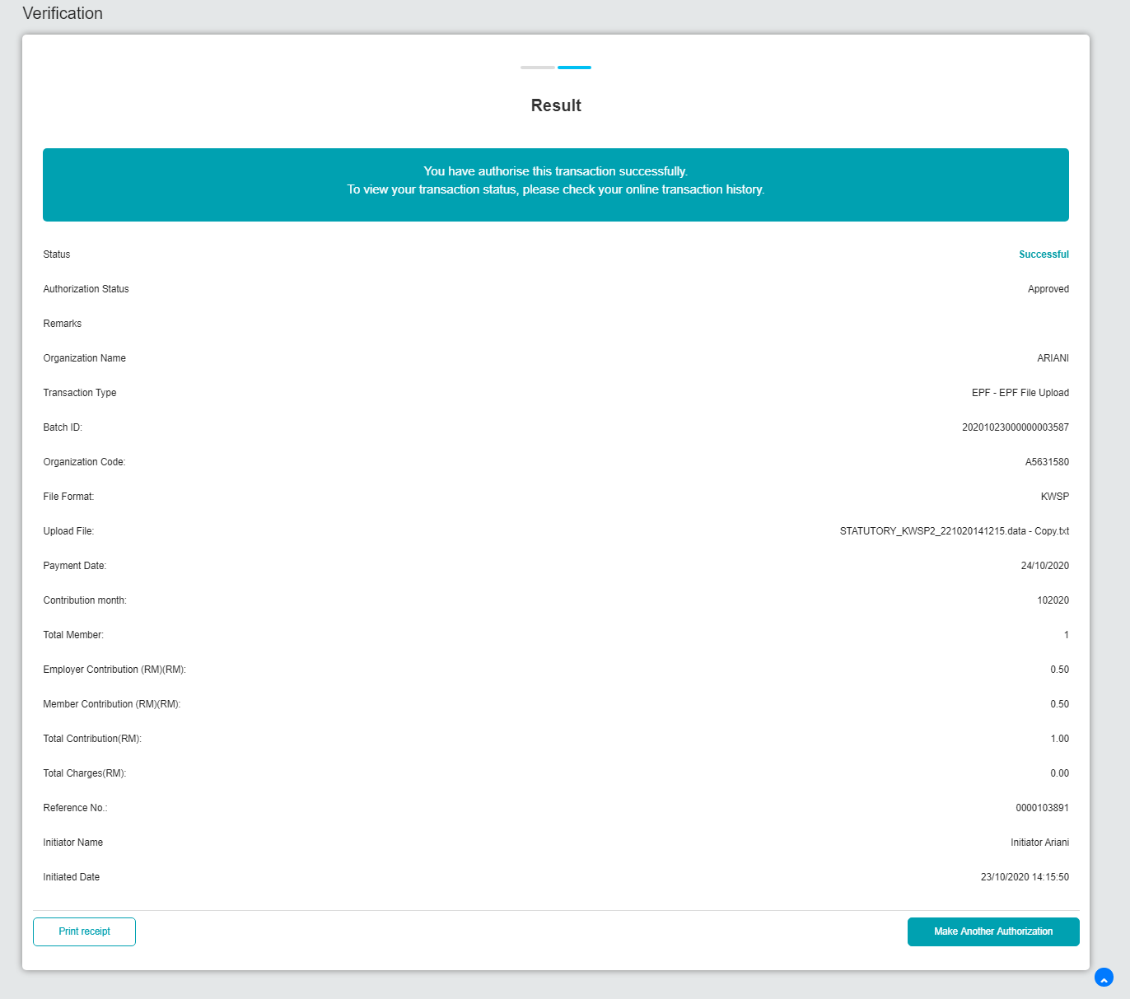

1. EPF (After EOD Service Time)

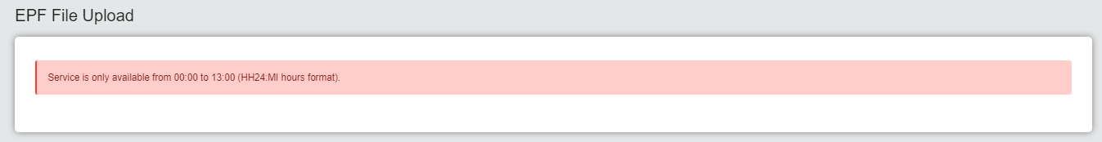

1. Bulk Payment (Before EOD Service Time)

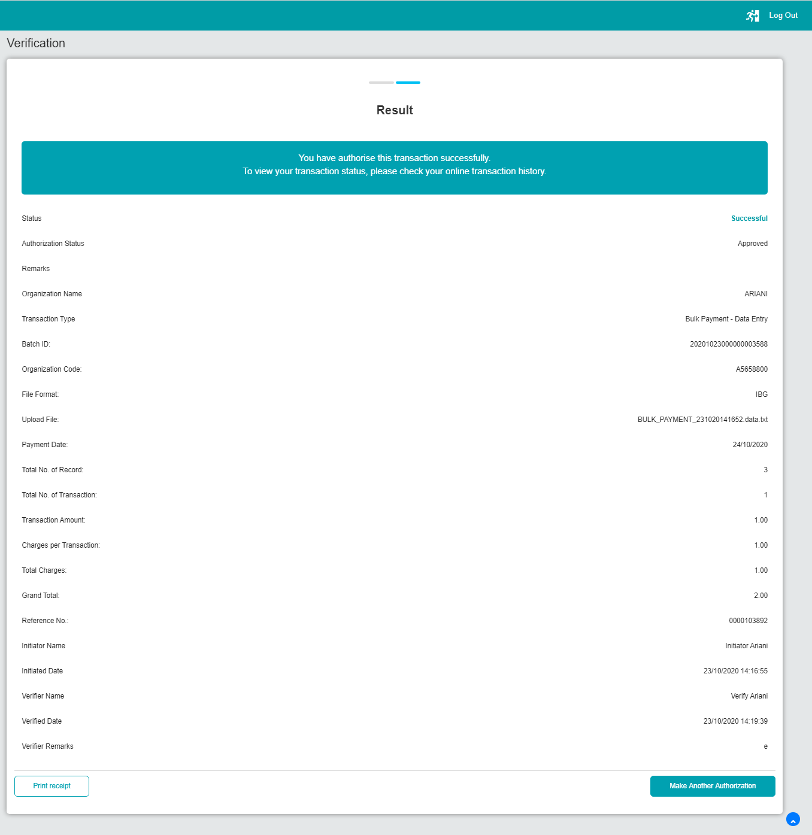

1. Bulk Payment (After EOD Service Time)

