Project Name |  |  |  |  | BSN – Corporate Digital Banking (CDB)
Project Code |  |  |  |  | BN/IP/JPD/4 JLD 2 (63) |  |  |  | Doc Ref |  |  |  | BSN/20201021/CR20002
BSN URS # |  |  |  |  | N/A |  |  |  | BSN CM#
Date |  |  |  |  | 21/10/2020 |  |  |  | Chg Req # |  |  |  | CR-20002 version 1.1
Change Description
Request:
To add new tab Daily Balance Summary that display current available balance.

Classic eBiz:
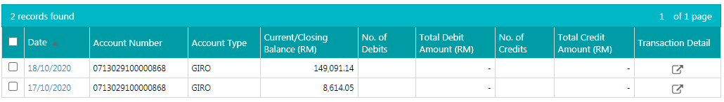
- Customer can view their closing balance for previous date.
- Can view no of debit/credit txn and the amount.
- The number and amount are coming from TSI file given by ICBS daily.
- Customer also can view their txn by clicking the button inside transaction detail column.
Flow of Balance Inquiry:
- User open the balance inquiry page. By default the page should display current available balance from balance inquiry wsdl.
- If user select date range, aside from the current balance, other balance must be query from database.
Table Structure at current eBiz:
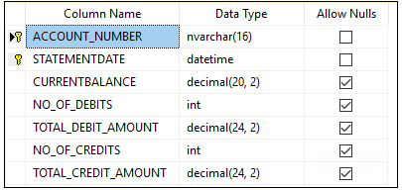
- Account number: customer account number
- Statement date: date of the balance
- Current balance: account balance of the date (to save the current balance in database, need to run cron job to capture available balance at midnight everyday)
- No of debit: No of debit txn of the day (might need to have another cron job to count number of debit txn from txn inquiry table. This cronjob should run after importhosttxn cronjob complete.)
- Total Debit amount: total of debit amount of the day (might need to have another cron job to count amount of debit txn from txn inquiry table. This cronjob should run after importhosttxn cronjob complete.)
- No of debit: No of debit txn of the day (might need to have another cron job to count number of debit txn from txn inquiry table. This cronjob should run after importhosttxn cronjob complete.)
- Total Debit amount: total of debit amount of the day (might need to have another cron job to count amount of debit txn from txn inquiry table. This cronjob should run after importhosttxn cronjob complete.)
Requested By |  |  | Munirah Othman, Eksekutif, JTM/ICBS |  |  |  |  | Initiated By |  |  | Norhaidah Md Dasuki  Project Manager, Penril Datability
Verify By |  |  | Rahmat Aris, Eksekutif JTM, BSN
Impact Analysis
1 |  | BSNeBiz |  | - Add new tab “Daily Balance Summary” at Account Summary > View Details
2 |  | Mobile Apps |  | - Add new tab “Daily Balance Summary” at “Quick Balance”
2 |  | Batch Processing |  | - Add new batch program to run every night (11.30PM – TBC)
3 |  | Database |  | - Add new database table
4 |  | Program |  | - Add migration program to migrate ebiz balance data to CDB.
Effort Analysis
# | Resource |  |  |  | Effort  (man days) |  | Unit Cost (RM) | Cost  (RM) |  |  |  | Description
1 |  |  |  |  |  |  |  |  |  |  |  | Development and internal testing
2 |  |  |  |  |  |  |  |  |  |  |  | Requirement study, SIT, UAT, Documentation and migration support
Sub Total |  |  |  |  |  |  |  | 0.00
Gov. Charges |  |  |  |  |  |  |  | 0.00
Total |  |  |  |  |  |  |  | 0.00
Total Cost |  |  |  |  |  |  |  | 0.00
Approval
Name |  |  |  |  |  | Role |  |  |  | Signature (Date)
Zamri Omar |  |  |  |  |  | Pengurus Projek  Jab. Perbankan Digital, BSN
Tan Lee Yong |  |  |  |  |  | Project Director  Penril Datability (M) Sdn Bhd

SCOPE OF WORK – SYSTEM ENHANCEMENT
SCP ID: | 5559 | Description: | To add Daily Balance Summary in BSNeBiz Transaction History

System | Modules | Description | Dev. Effort (Days)
BSNeBiz | Account Summary > View Details | - To add new tab “Daily Balance Summary”.  - Table should also display no of debit/credit transaction and the amount (get from TSI file given by ICBS daily.)  - Every transaction can view more details by click on “eye” icon.  - Include transaction only up to 30days.  - To add new batch program to run every night (11.30PM – TBC)  - To add new database table  - To add migration program to migrate ebiz balance data to CDB. | 15
BSNeBiz Mobile | Quick Balance | - To add new tab “Daily Balance Summary”  - Update restful  - Update adapter | 9

