RIB Account Logging

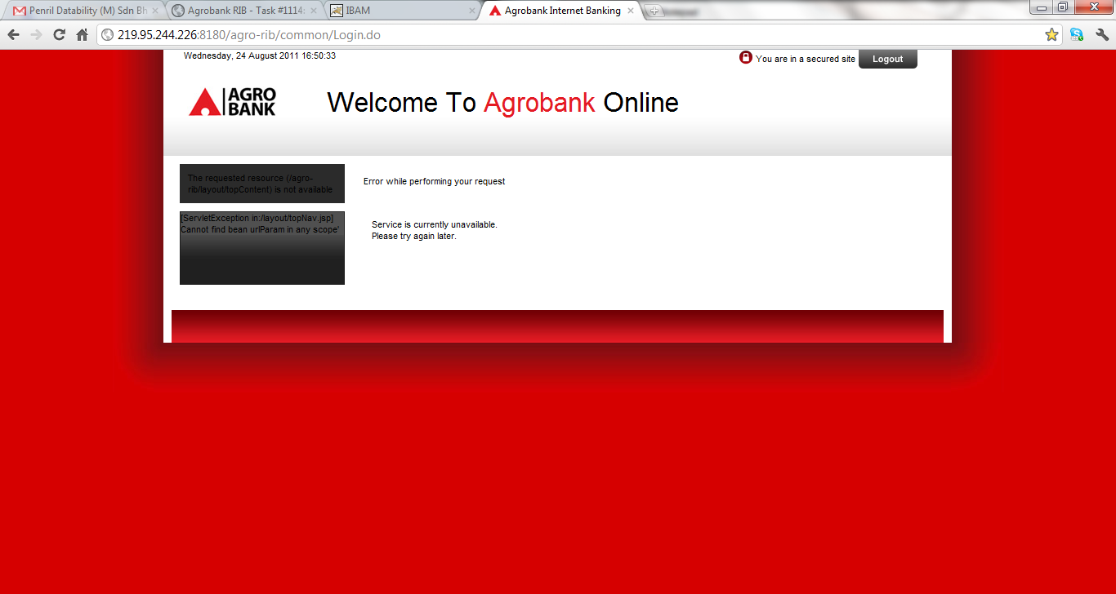

Upon account logging with successful username and password at RIB, an error appeared with following statements:

1. **Error while performing your request**
2. **[ServletException in:/layout/topNav.jsp] Cannot find bean urlParam in any scope**
3. **The requested resource (/agro-rib/layout/topContent) is not available**