Test For control BSN availability at bulk payment > IBG

1. Disable IBG Member ID at IBAM>Content>Interbank>BSN>Interbank Service Type

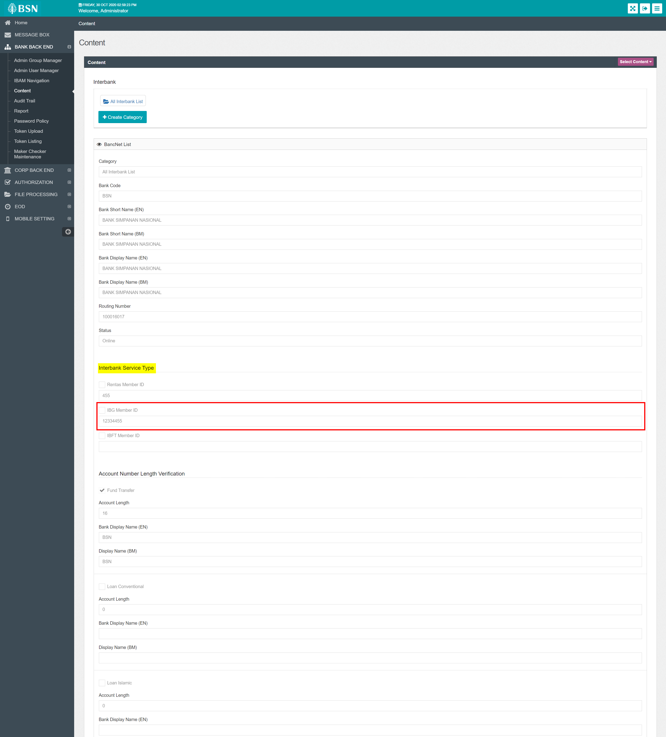

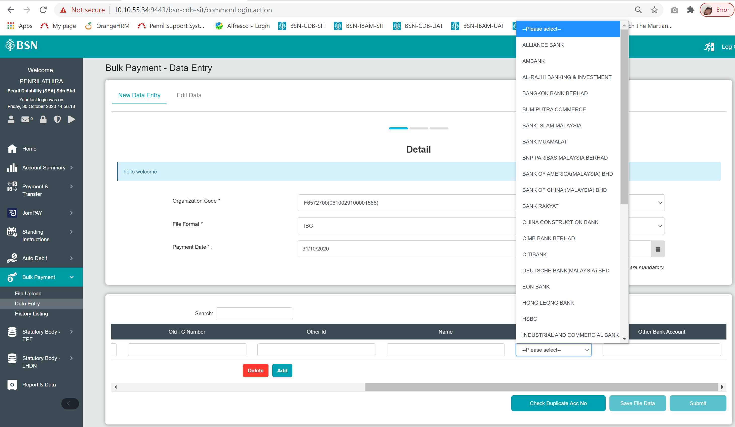

1. Enable IBG Member ID at IBAM>Content>Interbank>BSN>Interbank Service Type

