Access IBAM and CDB > Bulk Payment

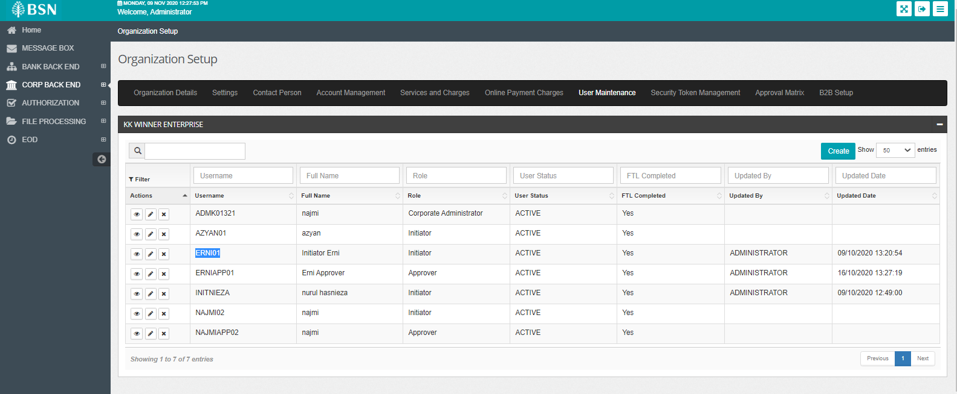

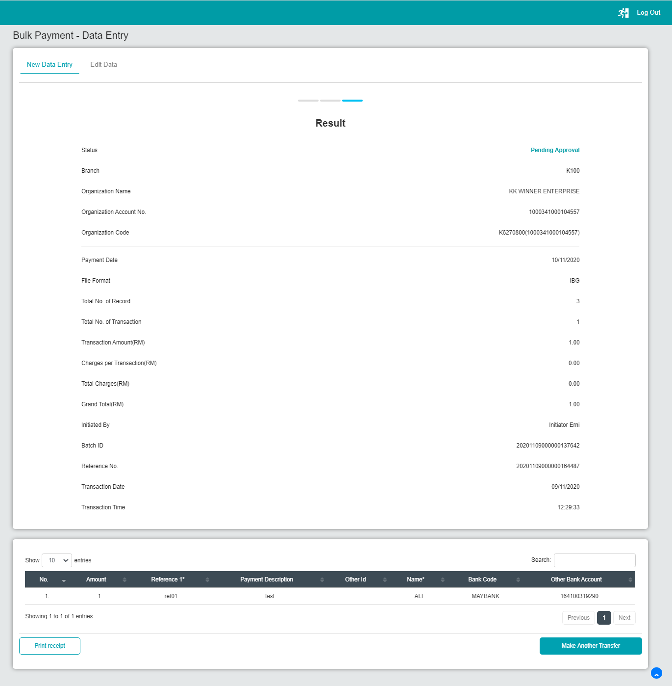

IBAM>BBE>Audit Trail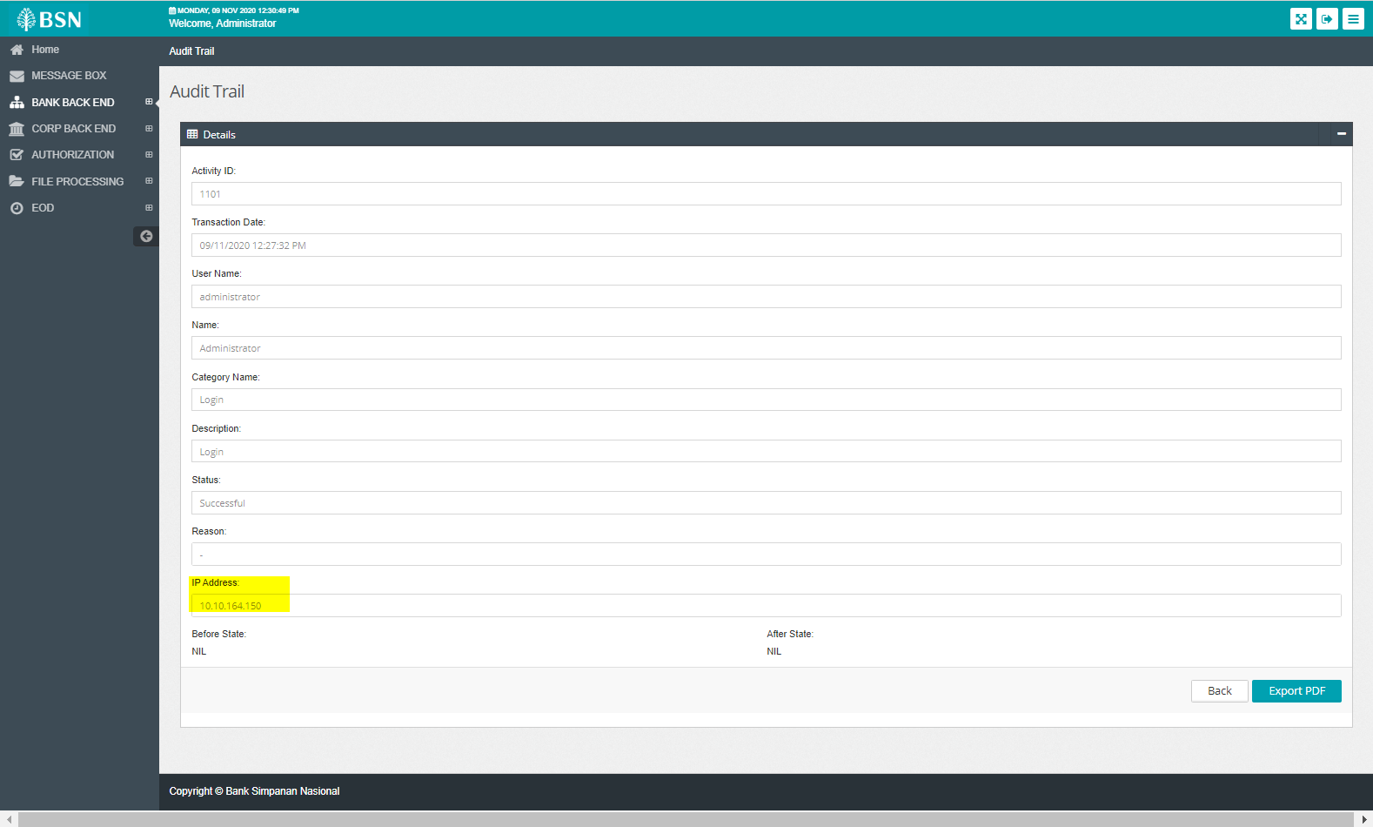

IBAM>CBE>BSNeBiz Transaction Eqnuiry

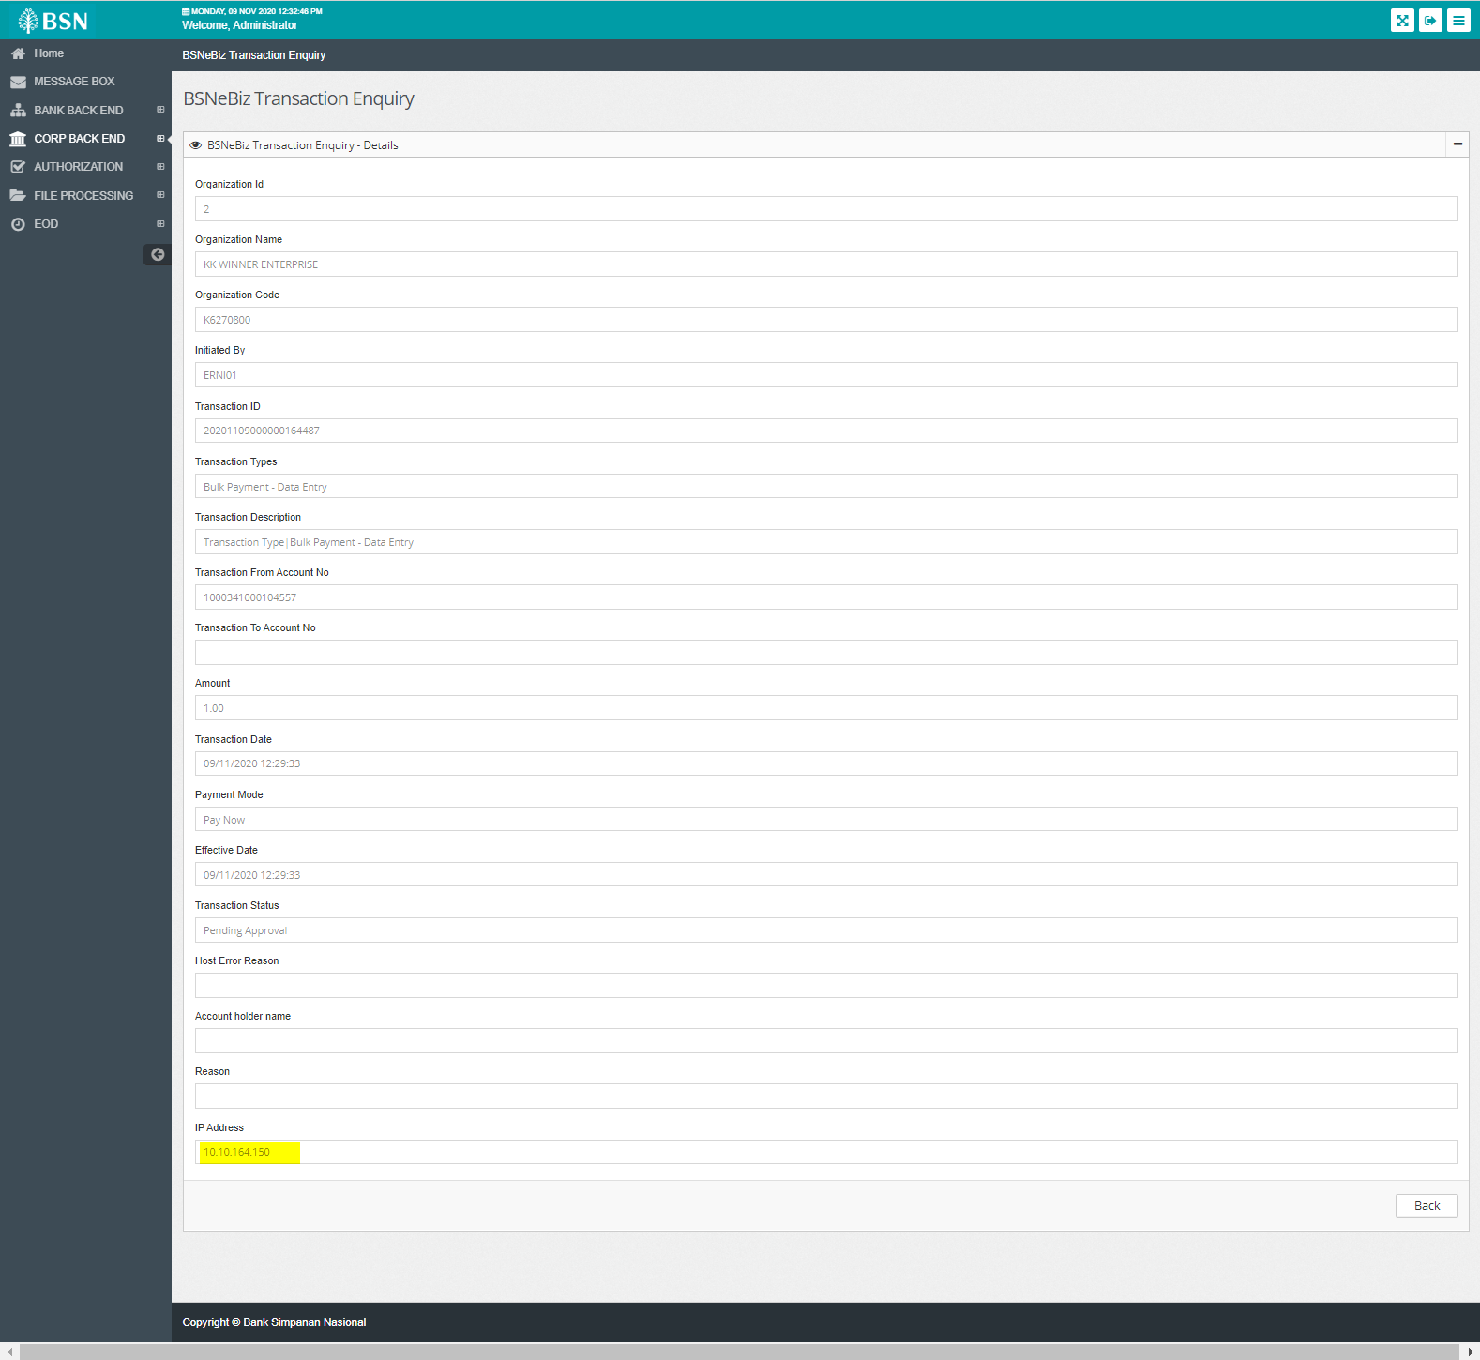

IBAM>CBE>BSNeBiz User Activity Log

