# Enter space at account no IBG

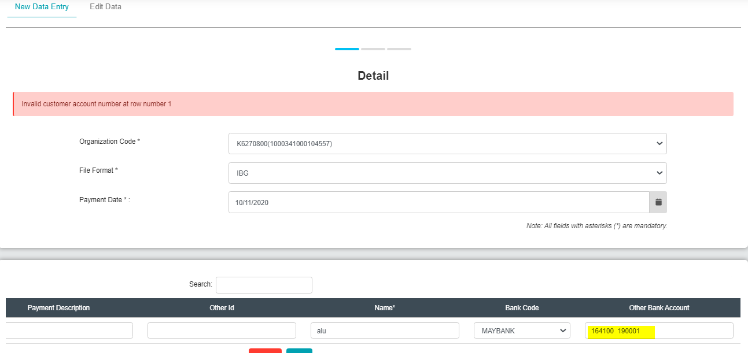

# Enter space at account no SGB

Unable to test at preprod environment due to company that able to test does not have Giro Acc. However issue has been retest at SIT & UAT and passes successfully.

# Enter less than 16 digit at customer account number SGB

Unable to test at preprod environment due to company that able to test does not have Giro Acc. However issue has been retest at SIT & UAT and passes successfully.

# Billing

## Data Entry

1. Upload with .rpt file

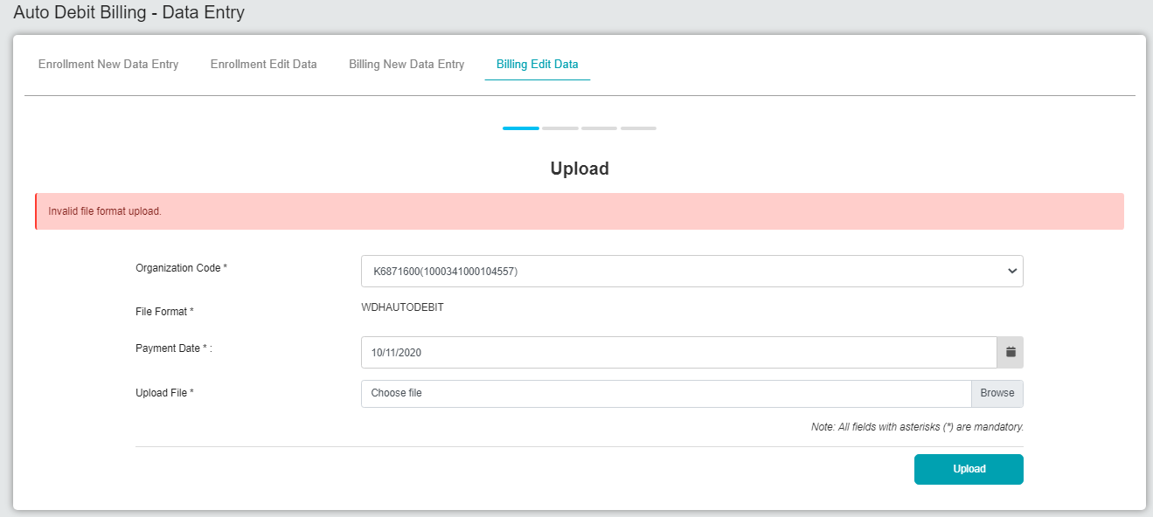

1. Upload with .summ file

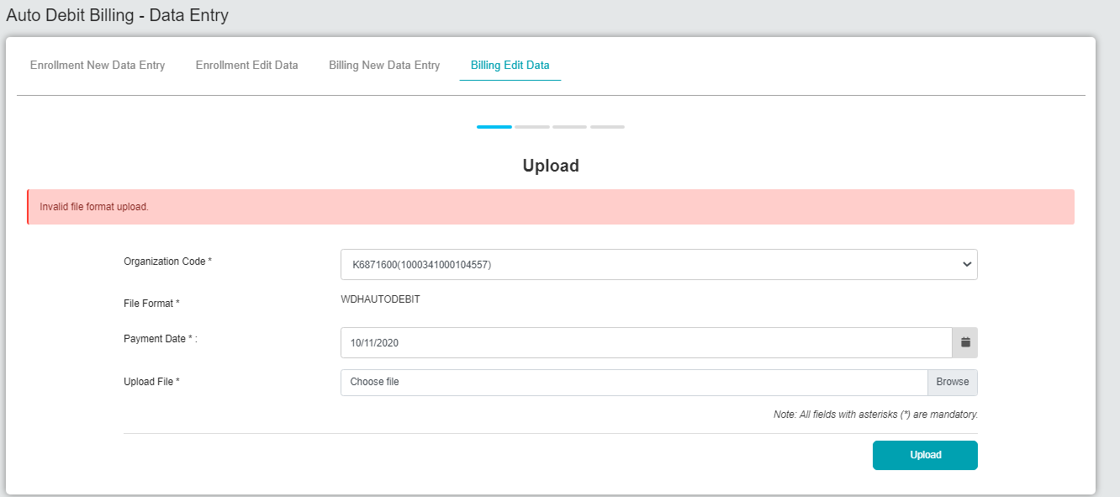

1. Upload with transmittal file



## File Upload

1. Upload with .rpt file

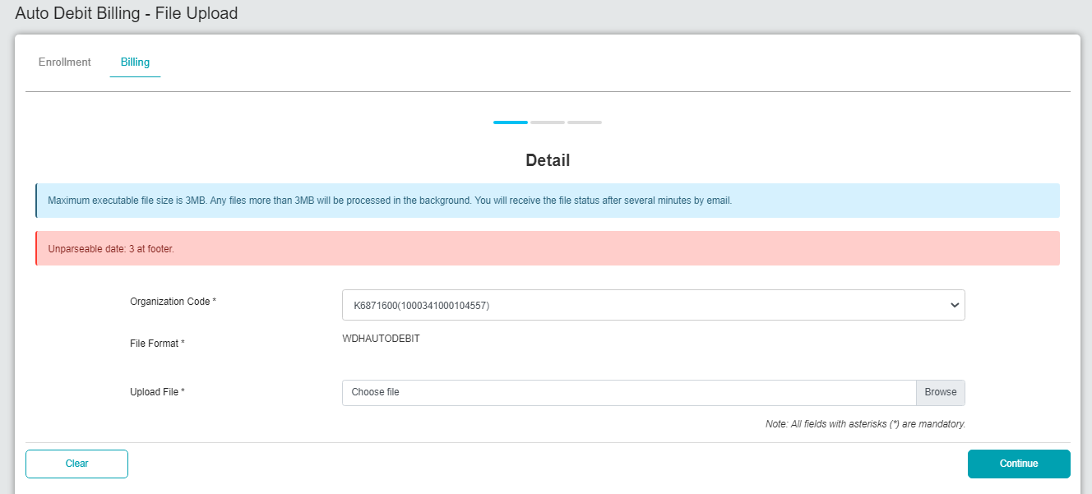

1. Upload with .summ file

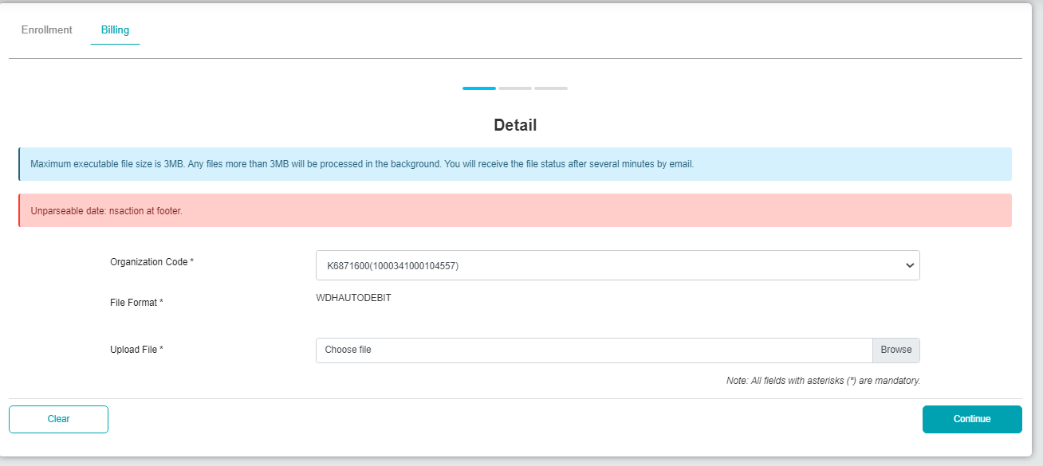

1. Upload with transmittal file

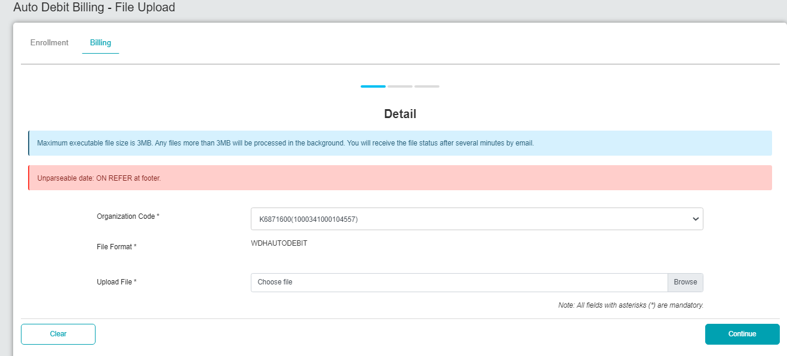

# Bulk Payment

## Data Entry

1. Upload with .rpt file

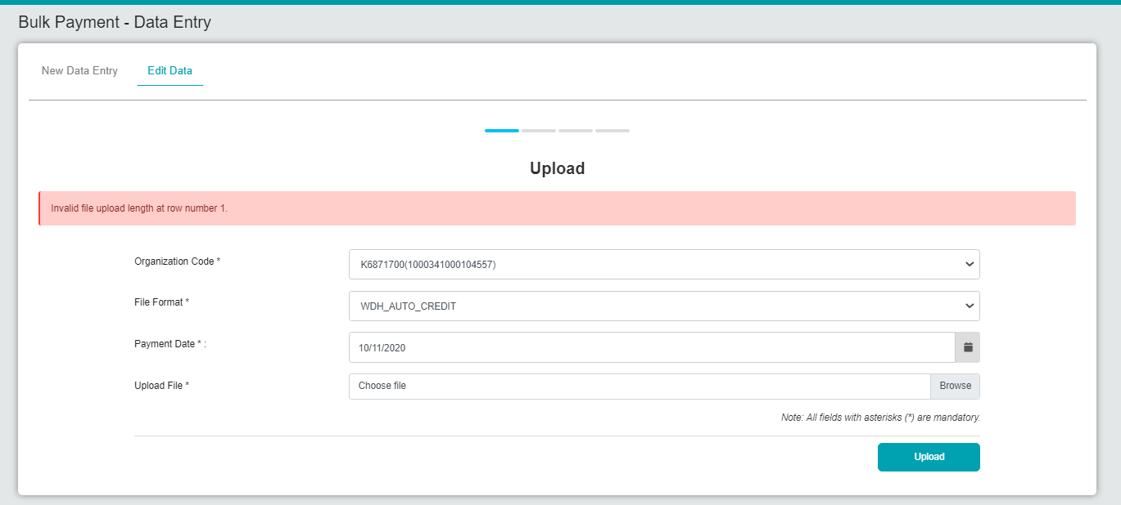

1. Upload with .summ file

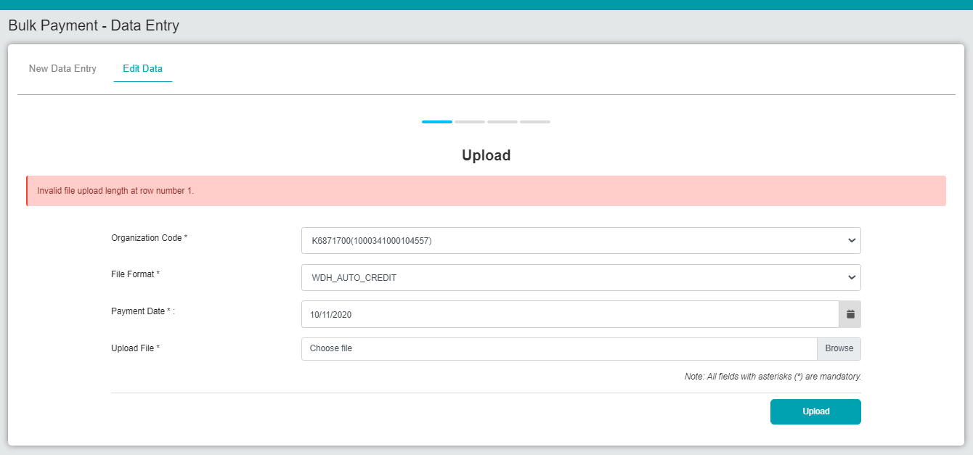

1. Upload with transmittal file

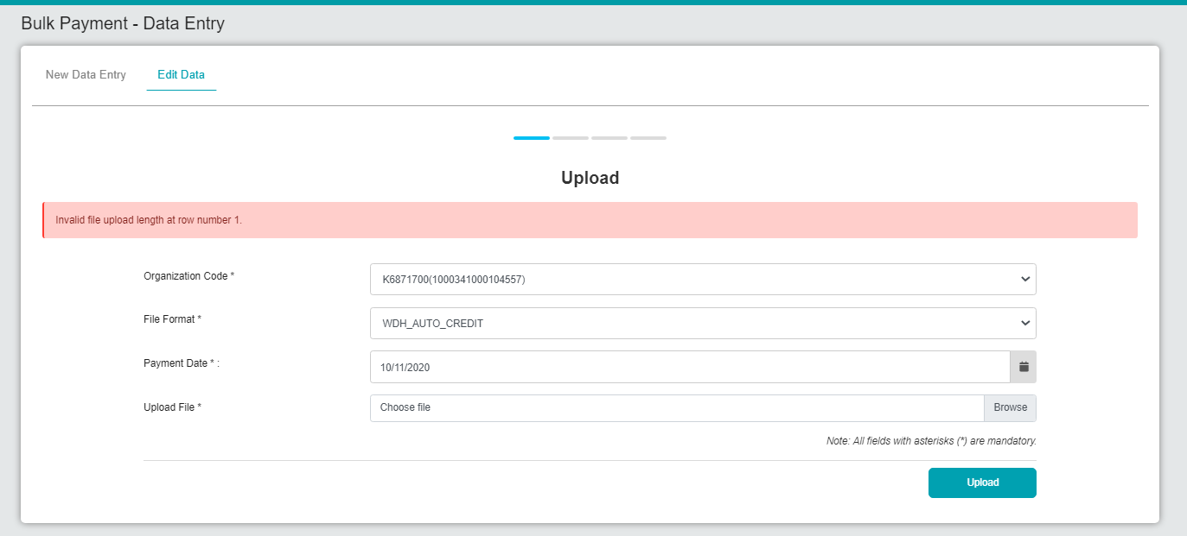

## File Upload

1. Upload with .rpt file

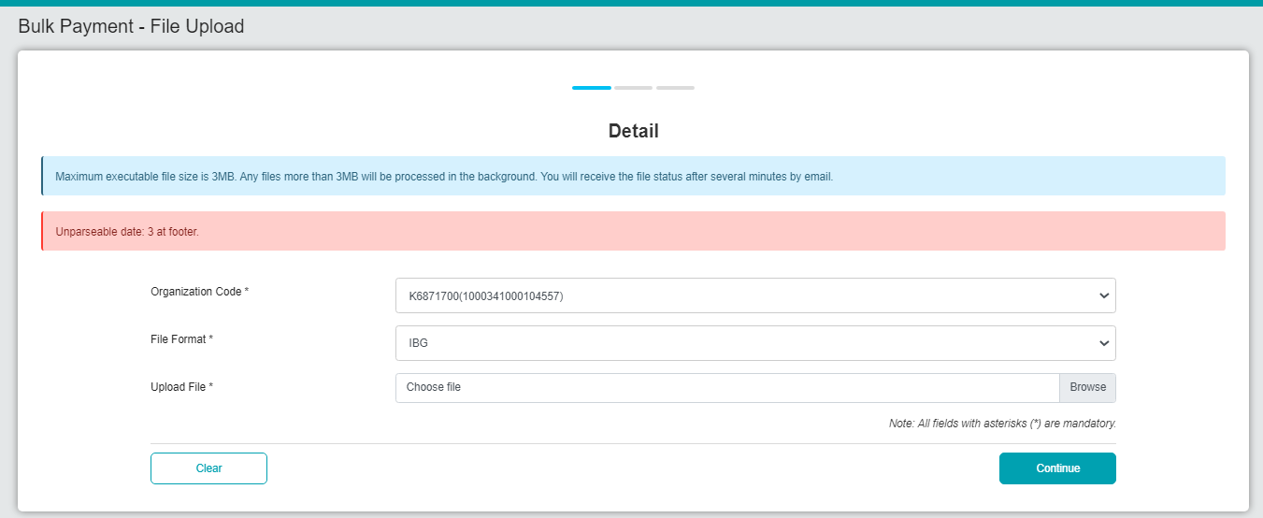

1. Upload with .summ file

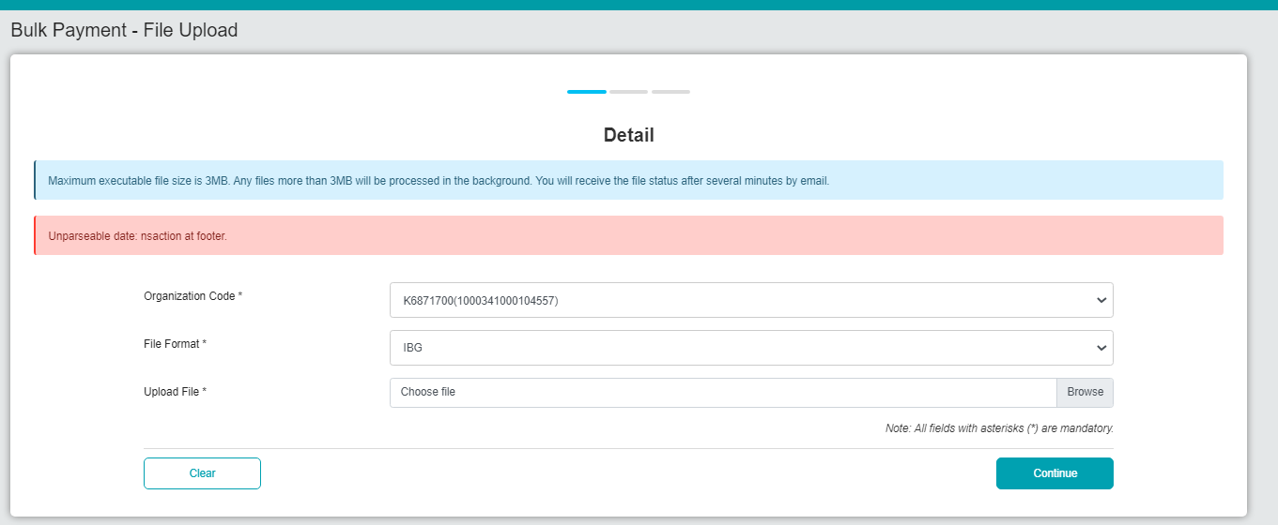

1. Upload with transmittal file

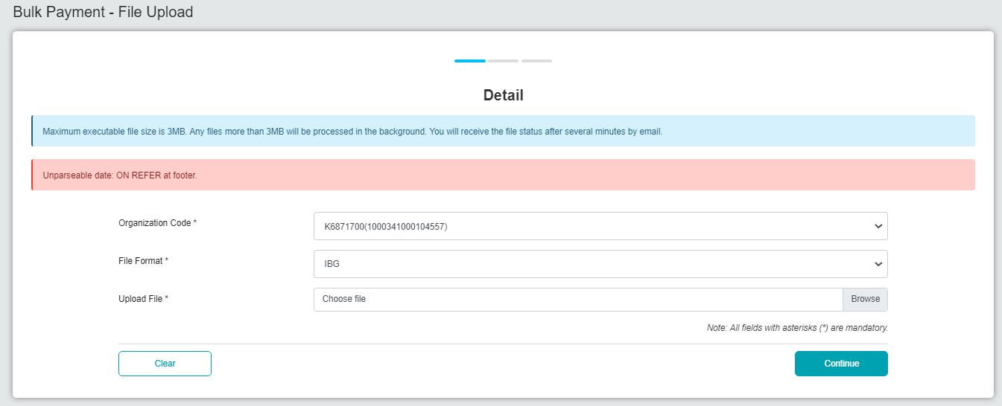

# EPF

## Data Entry

1. Upload with .rpt file

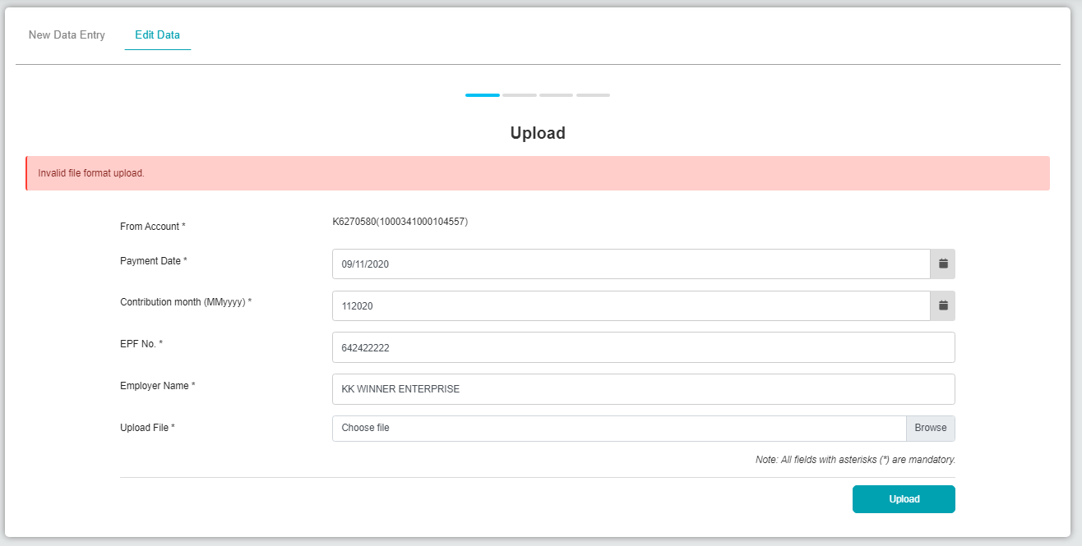

1. Upload with .summ file



1. Upload with transmittal file



## File Upload

1. Upload with .rpt file

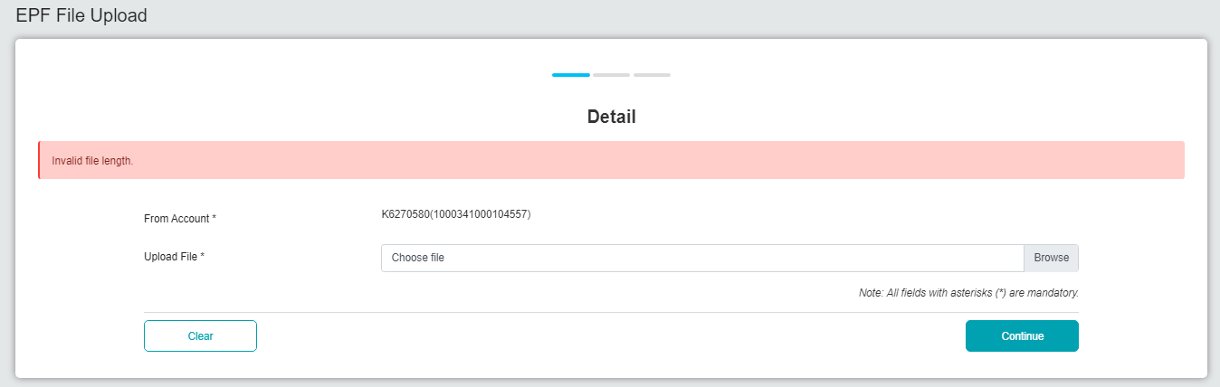

1. Upload with .summ file

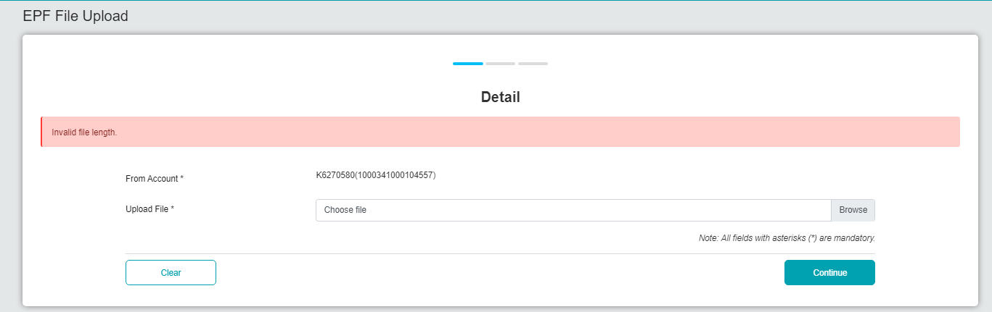

1. Upload with transmittal file

