Issue:

EPF unable to stop/approve payment on same posting date (after EOD)

Expected Test Result:

|  |  |  |  |  |
| --- | --- | --- | --- | --- |
| Posting Date  EOD Service Time | Service Type | 08/11/2020  (yesterday) | 09/11/2020  (current date) | 10/11/2020 (tomorrow) |
| Before  Change:2000 Current: 1450 | EPF | Unable to change date at preprod env. | ✓ | ✓ |
| After  Change:1300 Current: 1450 | EPF | Unable to change date at preprod env. | X | X |
| Before  Change:2000 Current: 1450 | Bulk Payment | Unable to change date at preprod env. | Unable to change date at preprod env. | ✓ |
| After  Change:1300 Current: 1450 | Bulk Payment | Unable to change date at preprod env. | Unable to change date at preprod env. | X |

Test Case 2: Posting Date 09/11/2020 (Current Date)

1. EPF (Before EOD Service Time) [RESULT: PASS]

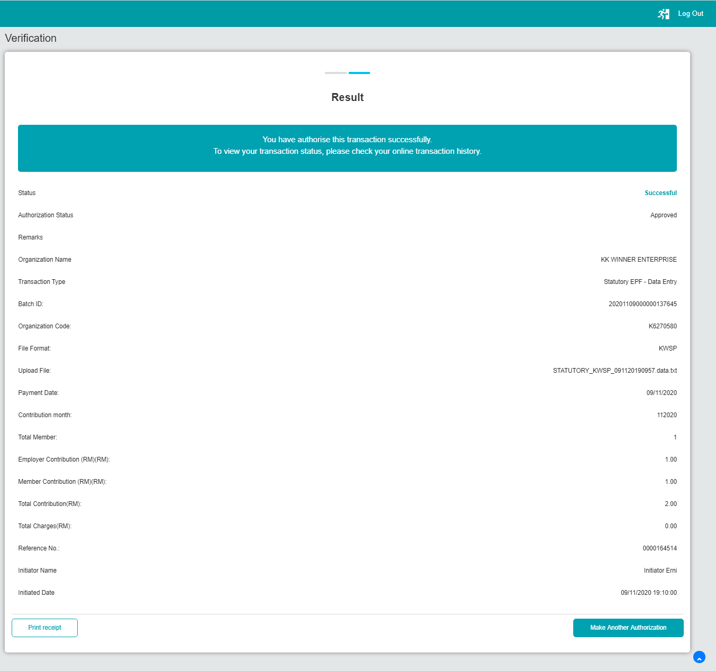

1. EPF (After EOD Service Time) [RESULT: Display error]

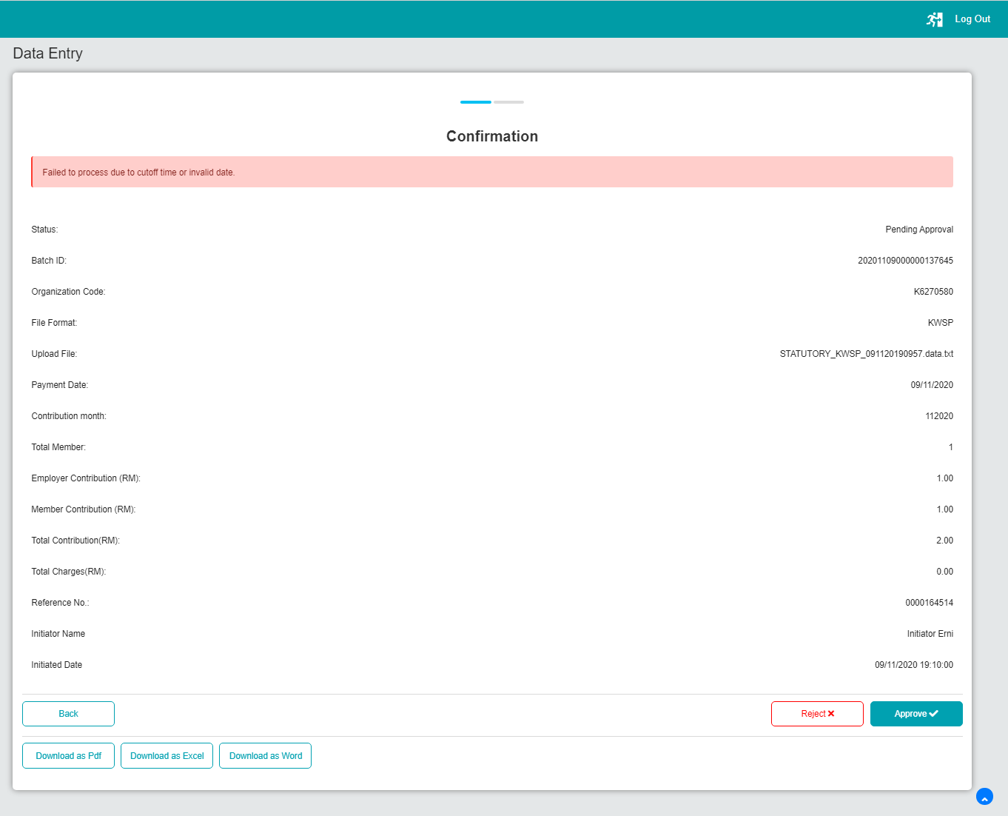

Test Case 3: Posting Date 10/11/2020

1. EPF (Before EOD Service Time) [Result: pass]

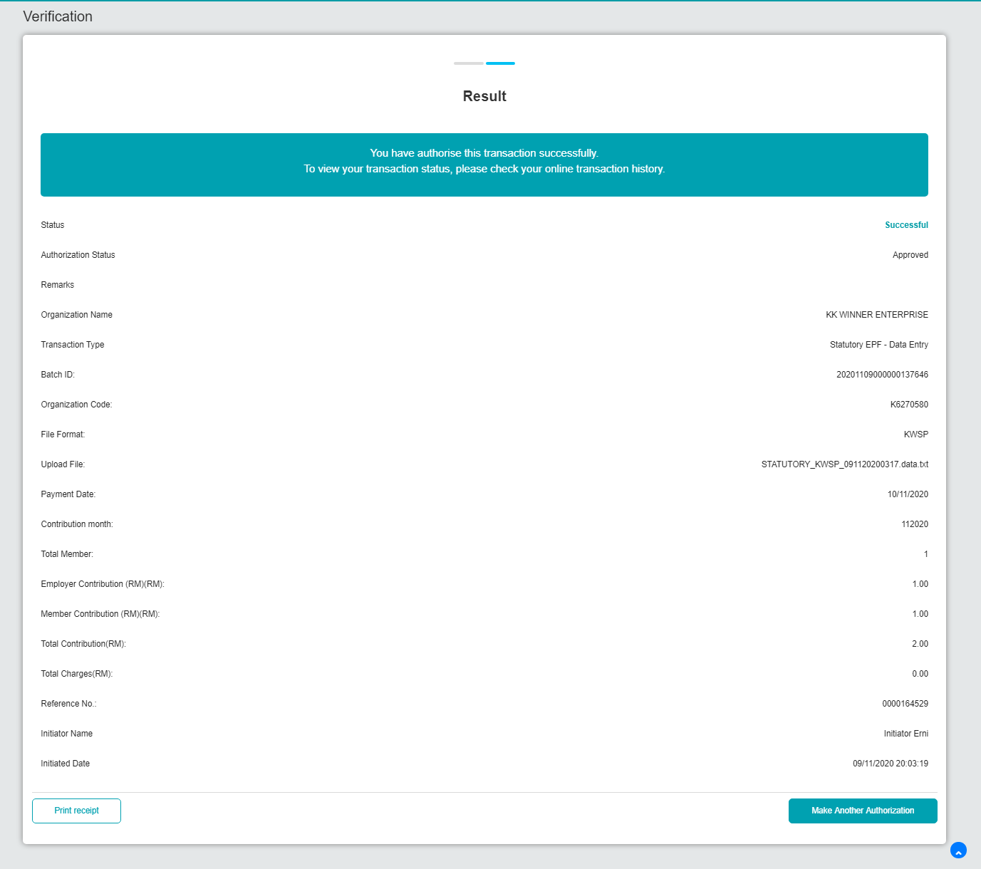

1. EPF (After EOD Service Time) [display error]

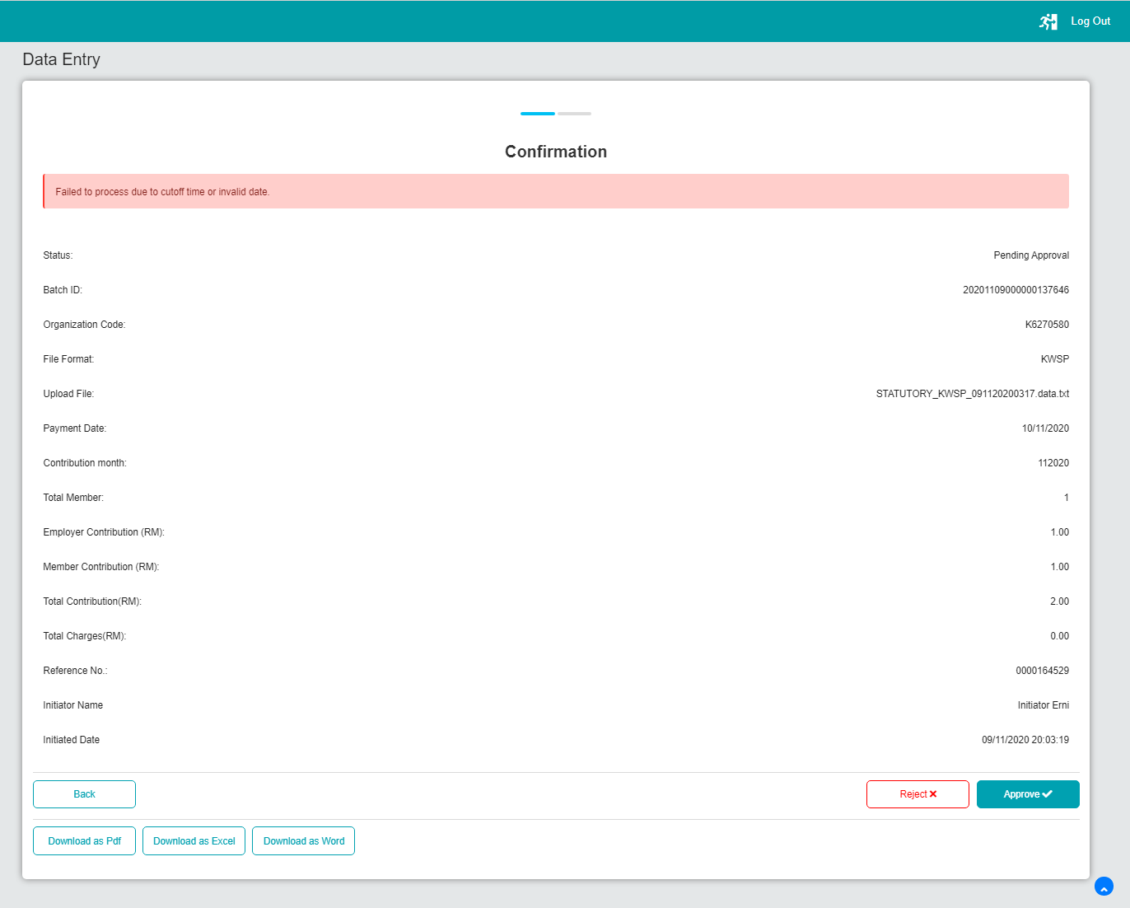

1. Bulk Payment (Before EOD Service Time)[result: pass]

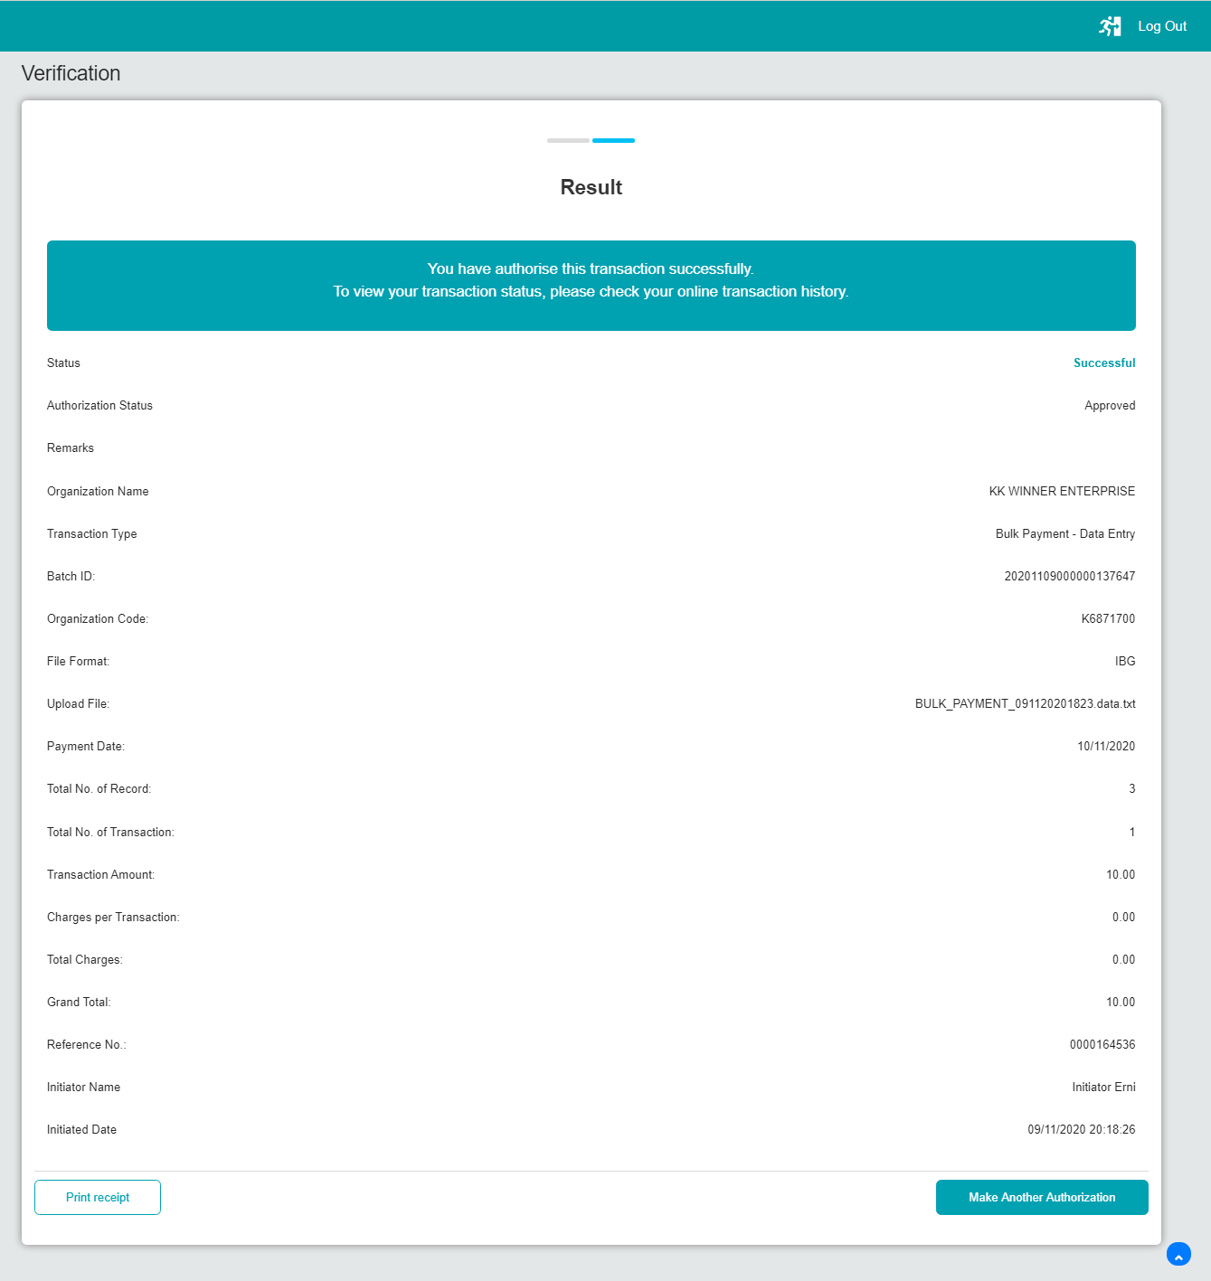

1. Bulk Payment (After EOD Service Time) [Result: display error]

