Issue: Error 'Service Currently Unavailable' when SI is disable in IBAM.

Test Step:

1. Access to IBAM > BBE > Content > Service Info

2. Select any service and disable Future Transaction Flag

3. Access to CDB > Perform the required transaction

4. Expected result: Should not display the Payment Mode pay later/recurring and able to proceed till Result Page without any error.

1. Access to IBAM > BBE > Content > Service Info

2. Select any service and disable Future Transaction Flag

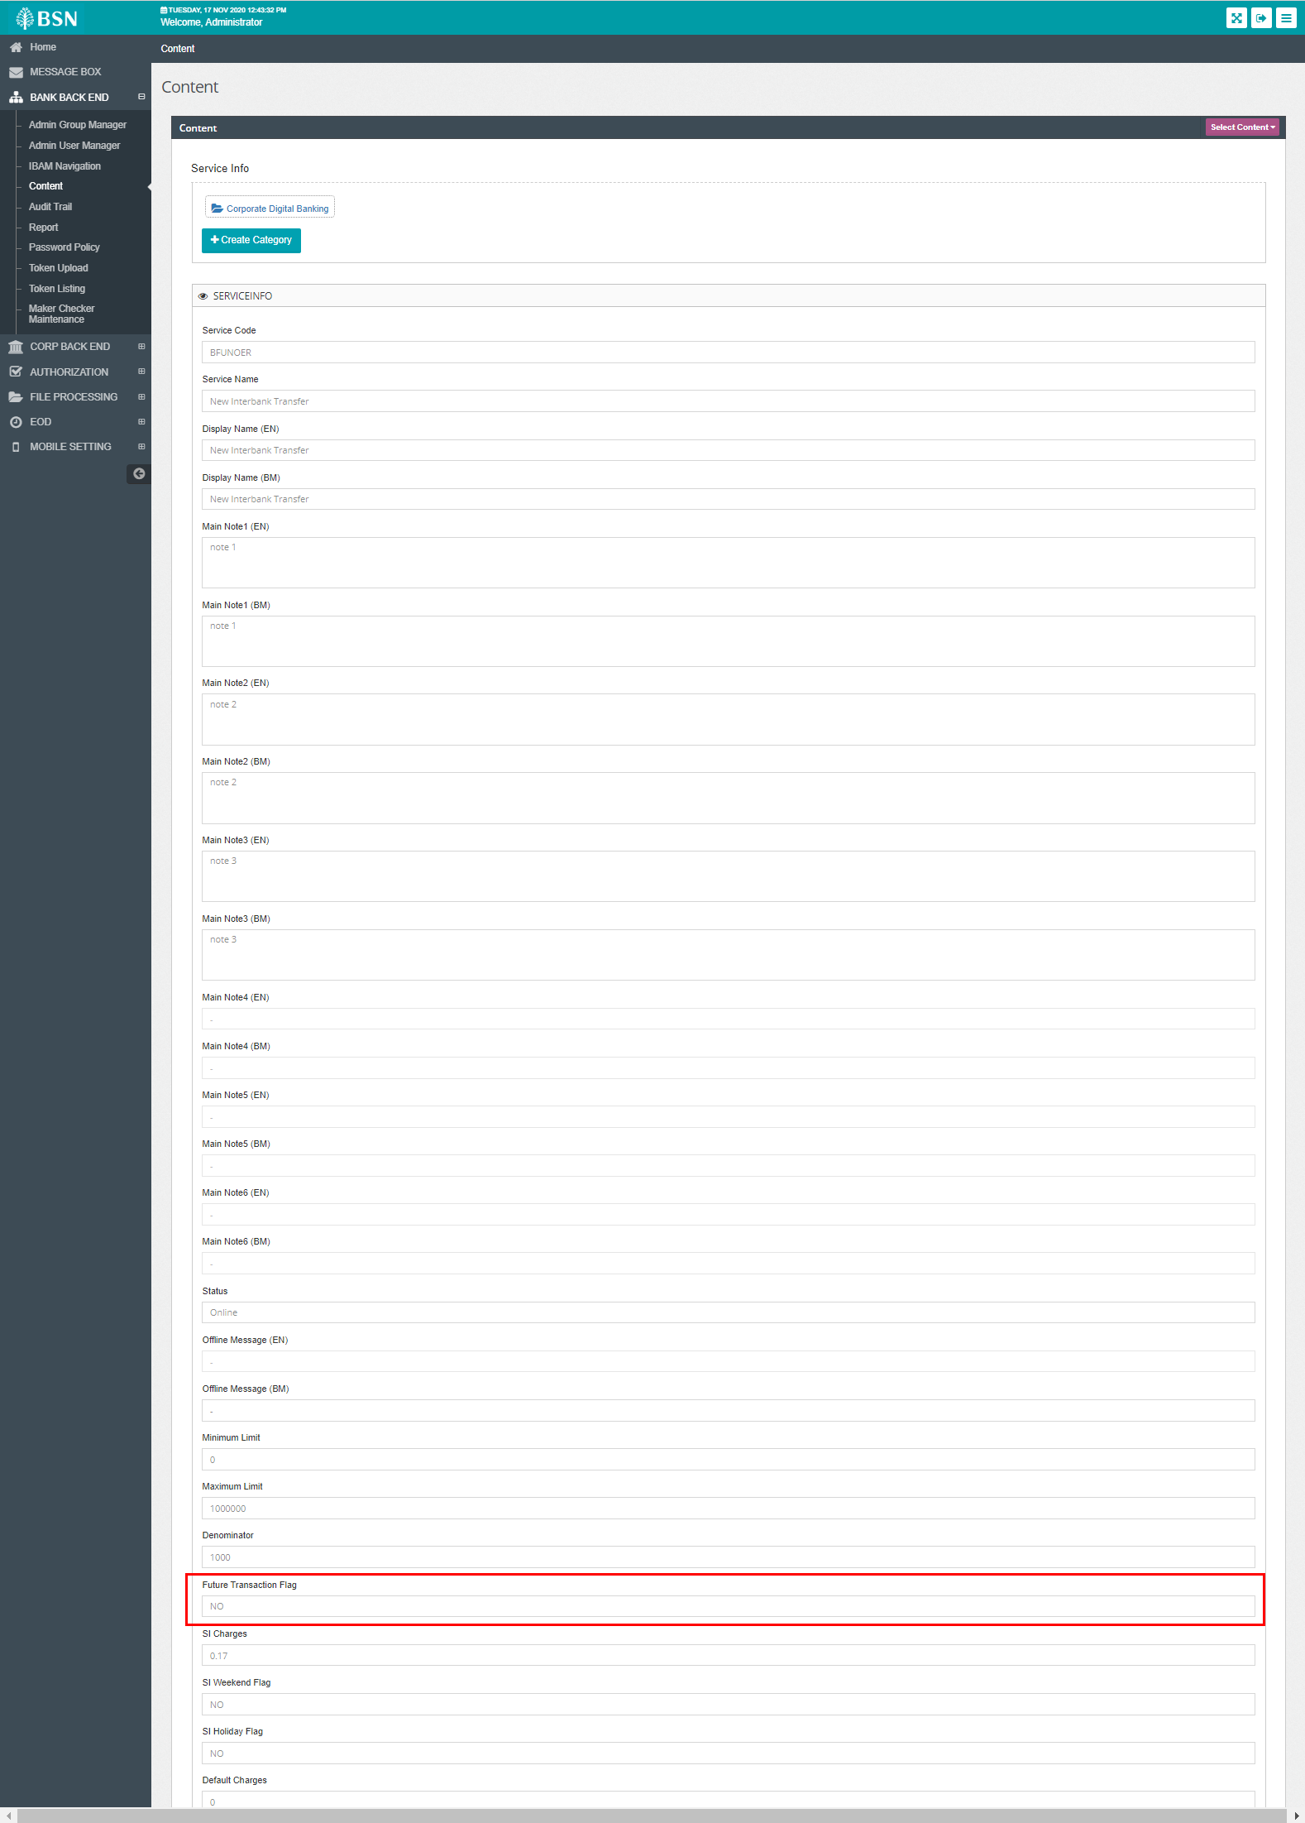

3. Access to CDB > Perform the required transaction

4. Expected result: Should not display the Payment Mode pay later/recurring and able to proceed till Result Page without any error.

