Issue:  
Rebilling program create final rebilling report at 12pm. JTM request to create rebilling report once ICBS send their report.

Finding:  
Currently Rebilling program create final rebilling report at 12pm because sometimes ICBS send their report late.

Solution:

1. Keep current Rebilling program as it is, in case final ICBS report has issue.
2. Update Data Rename program to run Rebilling program once ICBS report is ready.

Test scenario:

1. Create a Rebilling Auto Debit in CDB
2. Request developer to create a mockup ICBS report
3. Request developer to edit the Auto Debit date to create at least 3 Rebilling cycle
4. Expected result, on the final rebilling, SPP Rebilling report should be ready
5. Create a Rebilling Auto Debit in CDB

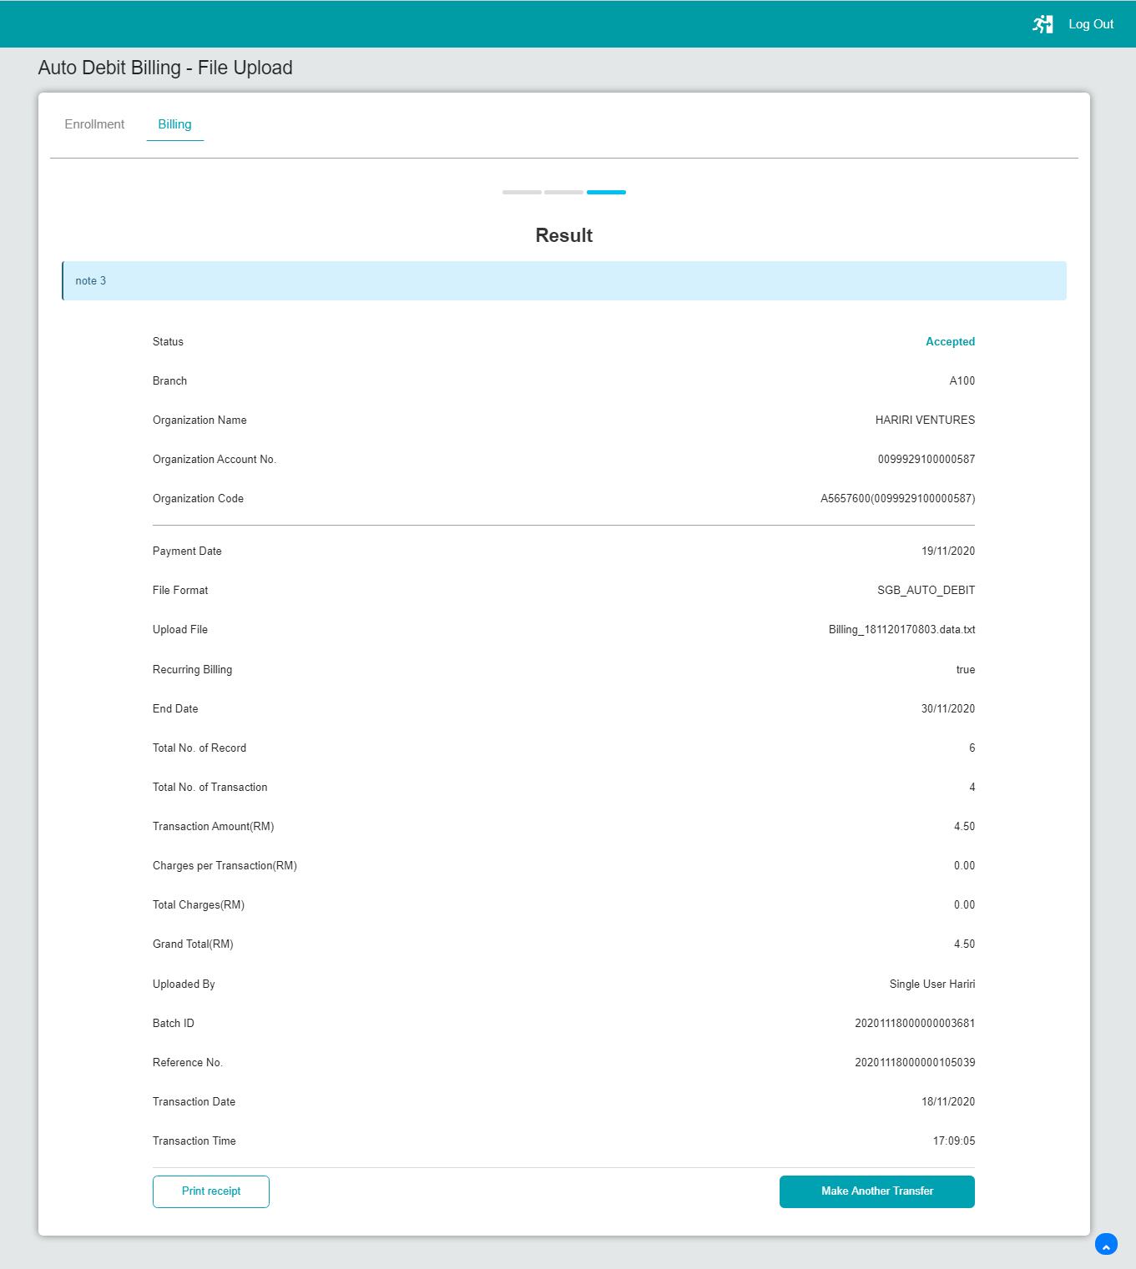

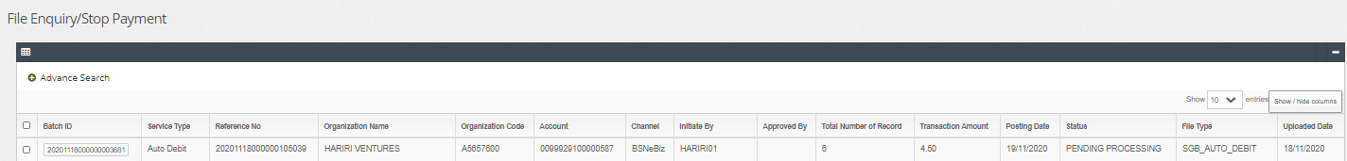

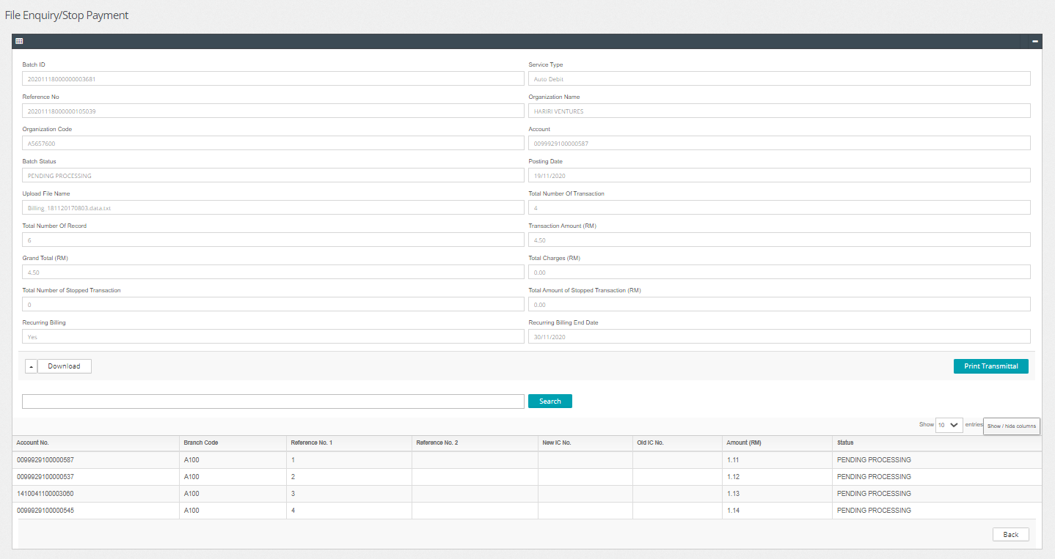

1. Request developer to create a mockup ICBS report
2. Request developer to edit the Auto Debit date to create at least 3 Rebilling cycle

Change created date to be: 15/11/2020

Change end date rebilling to be : 18/11/2020 (todays date)

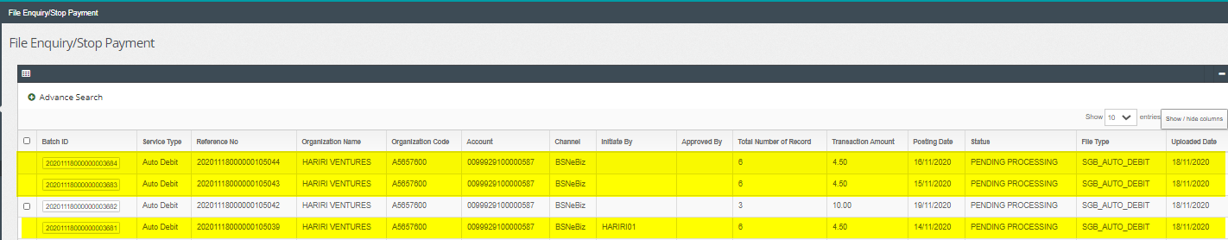

1. Expected result, on the final rebilling, SPP Rebilling report should be ready

