Issue:  
B2B setup search file name cannot differentiate between ASTRO input and output.

Finding:  
B2B setup file name search any file containing the search name.  
IE: File name search = "AST". Will search AST_input.txt and Output_AST.txt.  
Since ASTRO share input and output file, FTP program stuck in infinite loop.

Solution:  
Update B2B setup to support file name using start with.

1. "AST" search file name containing "AST"
2. "AST*" search file name start with "AST"

Test scenario:

1. Select company with B2B setup. For example ASTRO.
2. ASTRO B2B setup for file name is "AST". Update to "AST*".
3. Copy mockup ASTRO files to B2B incoming directory.
4. Name the file AST_input.txt and Output_AST.txt.
5. Expected result, B2B only process AST_input.txt
6. Select company with B2B setup. For example ASTRO.
7. ASTRO B2B setup for file name is "AST". Update to "AST*".

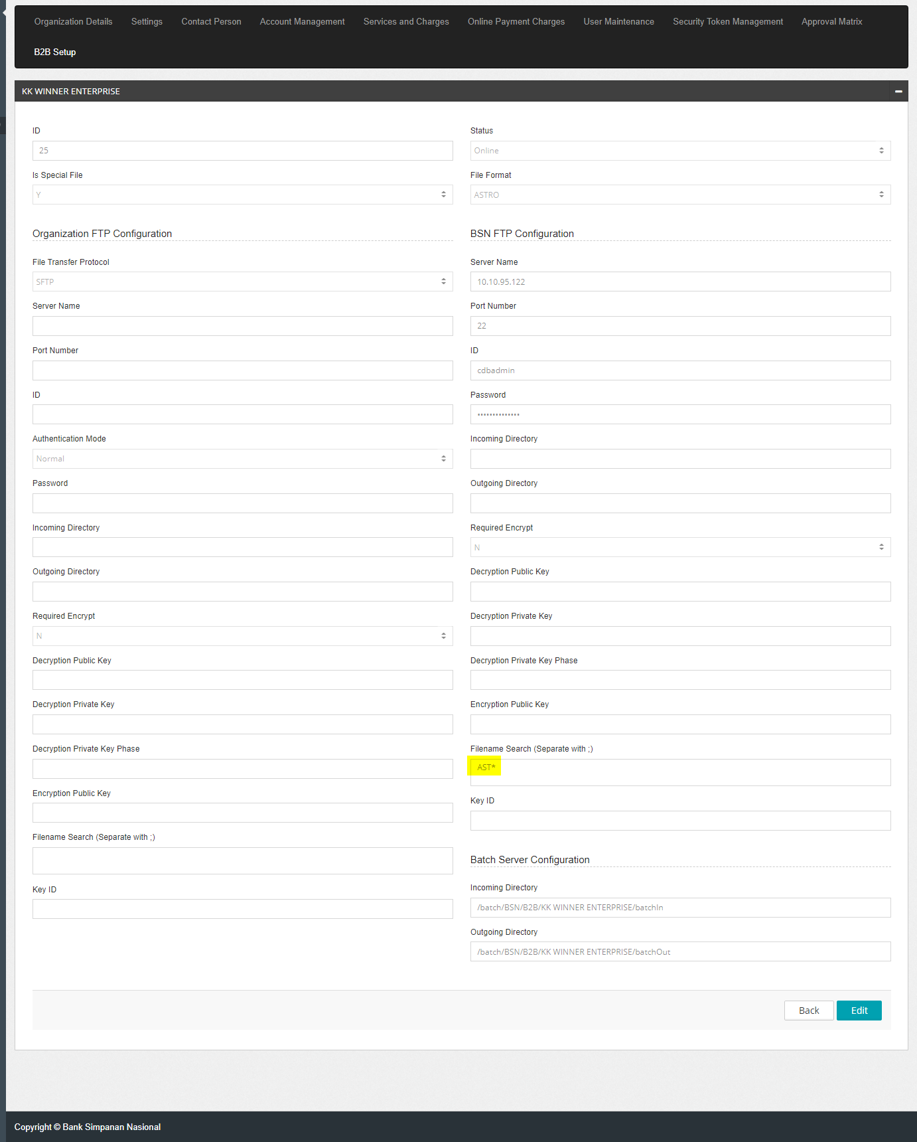

1. Copy mockup ASTRO files to B2B incoming directory.
2. Name the file AST_input.txt and Output_AST.txt.

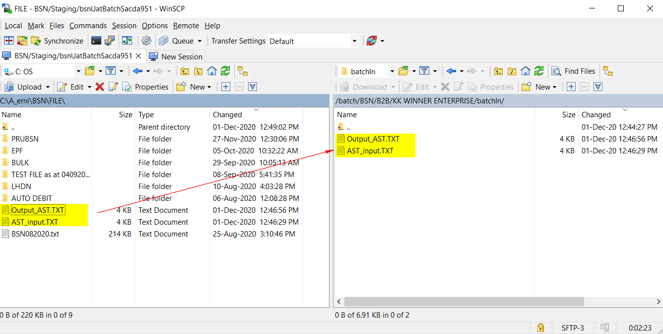

1. Expected result, B2B only process AST_input.txt

