**11393 - [SCP ID :##5660##] : Rebilling with amount 0 still process**

**Negative test. Failed transaction.**

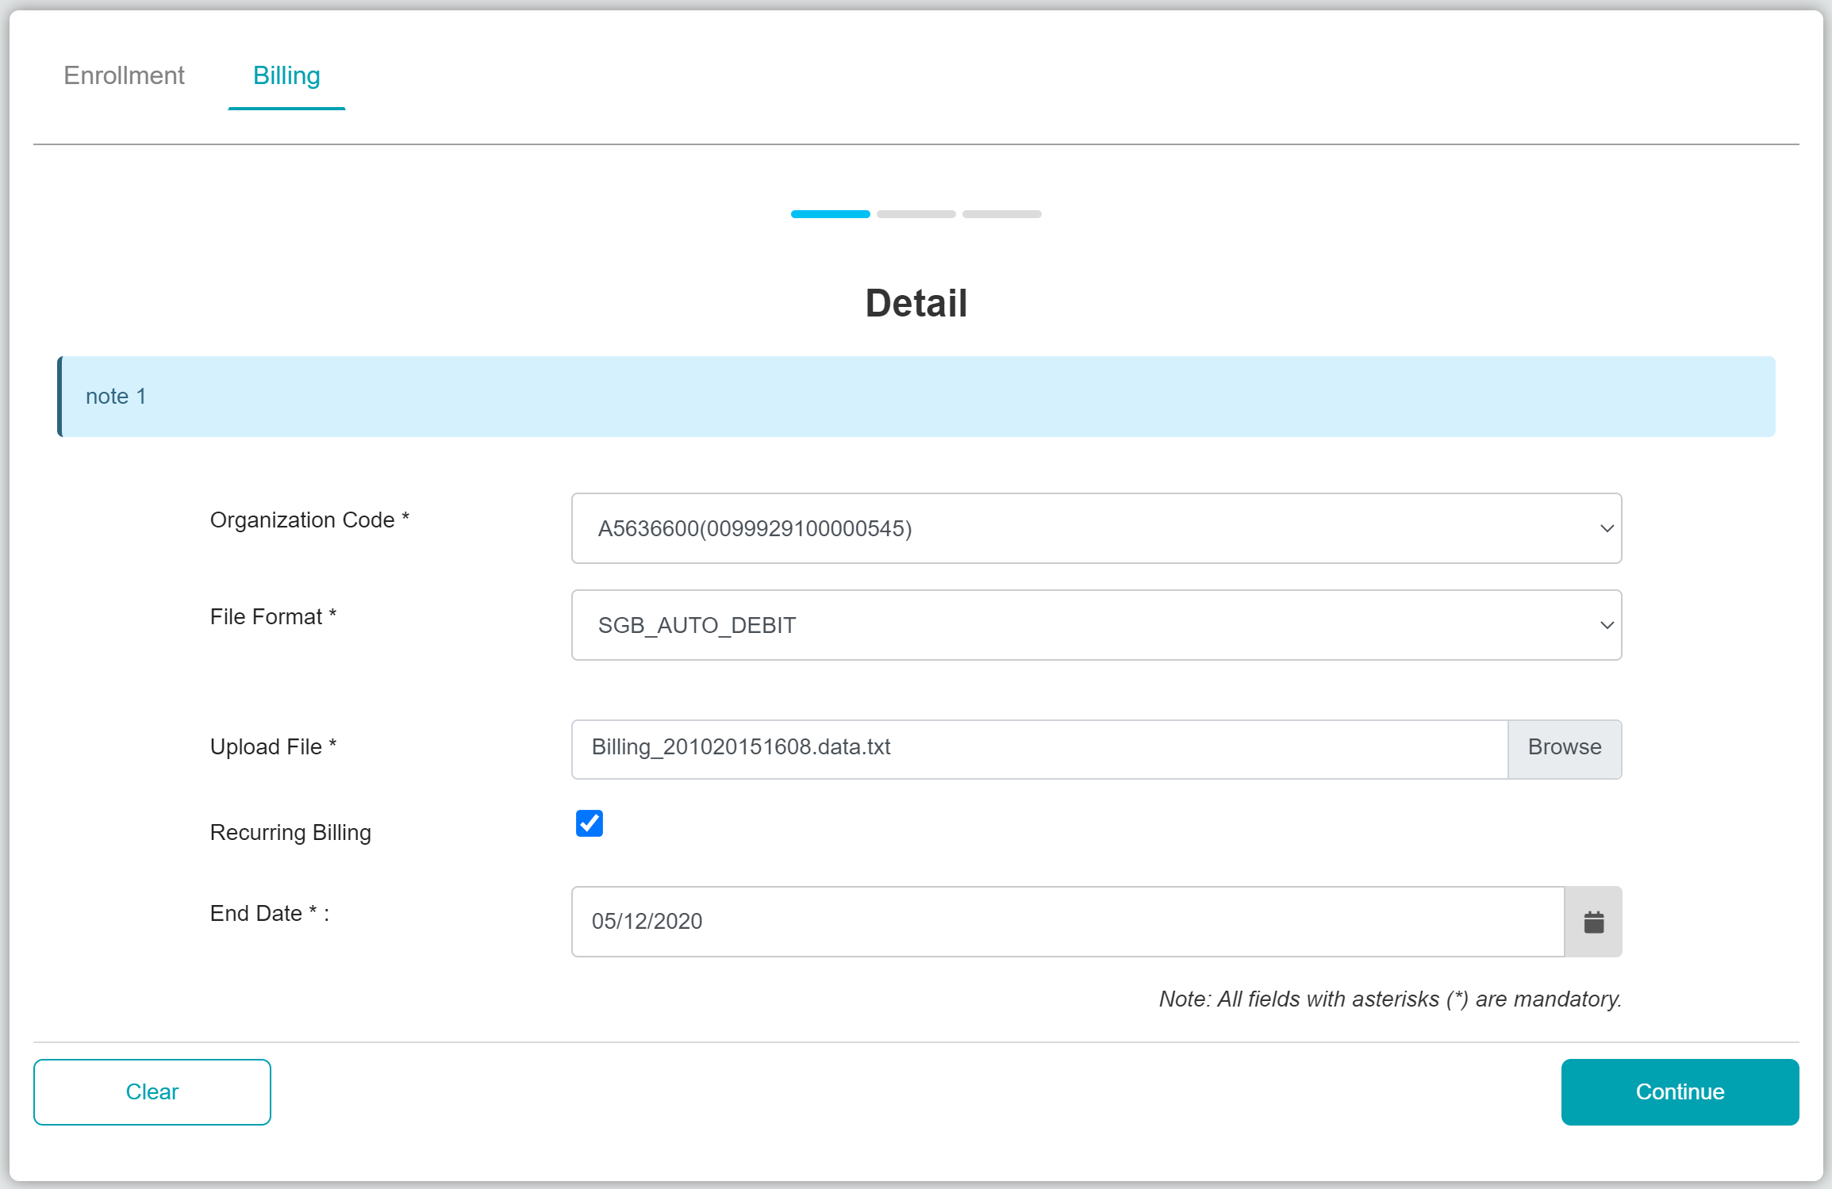

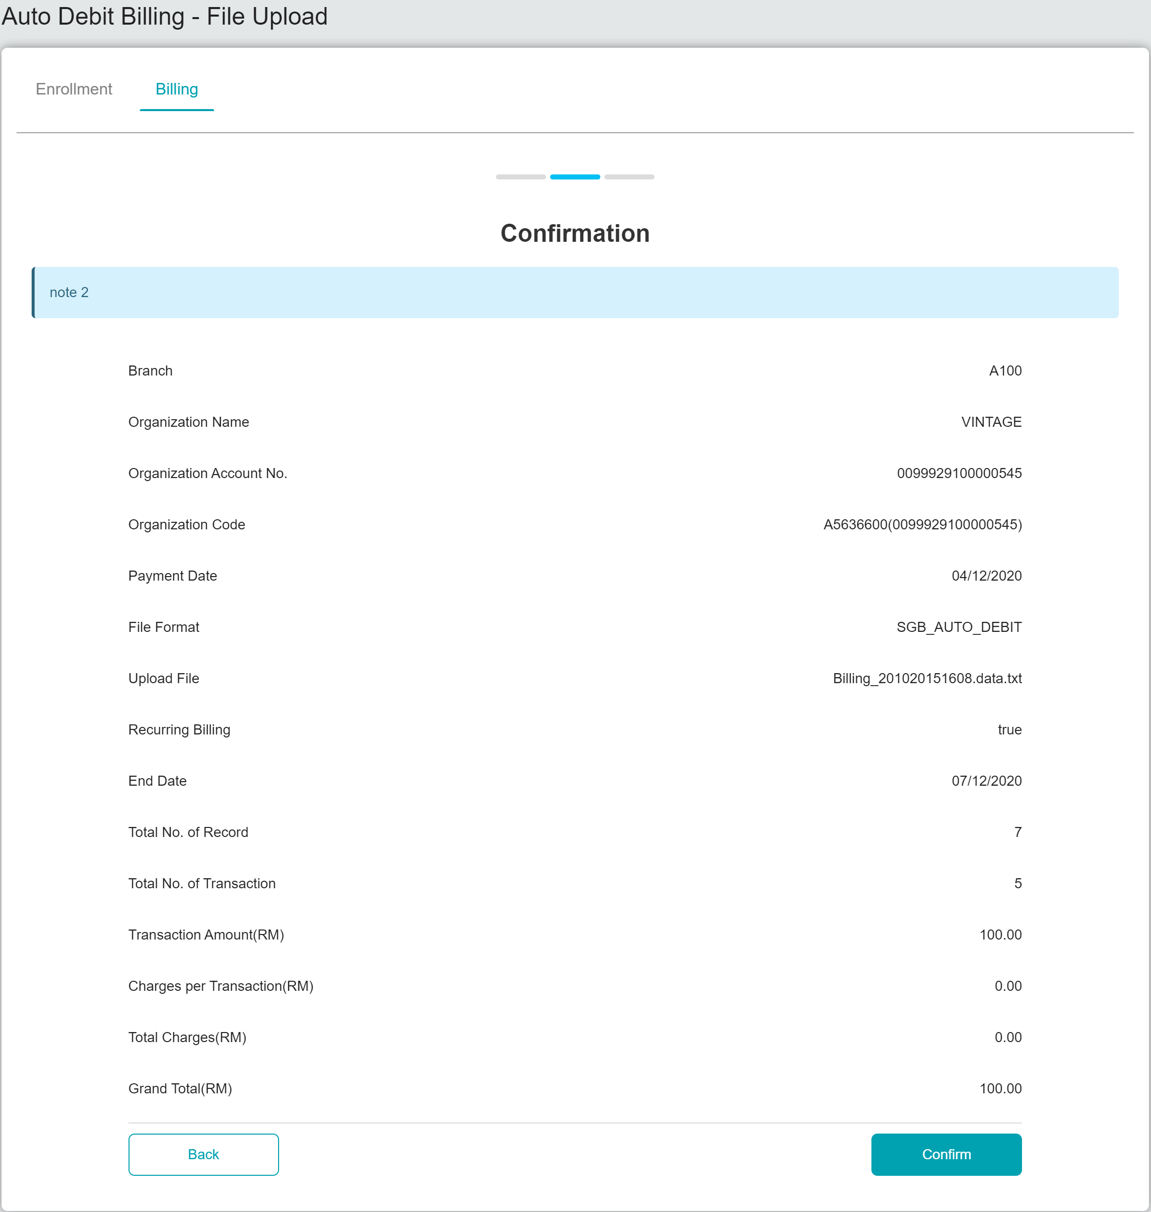

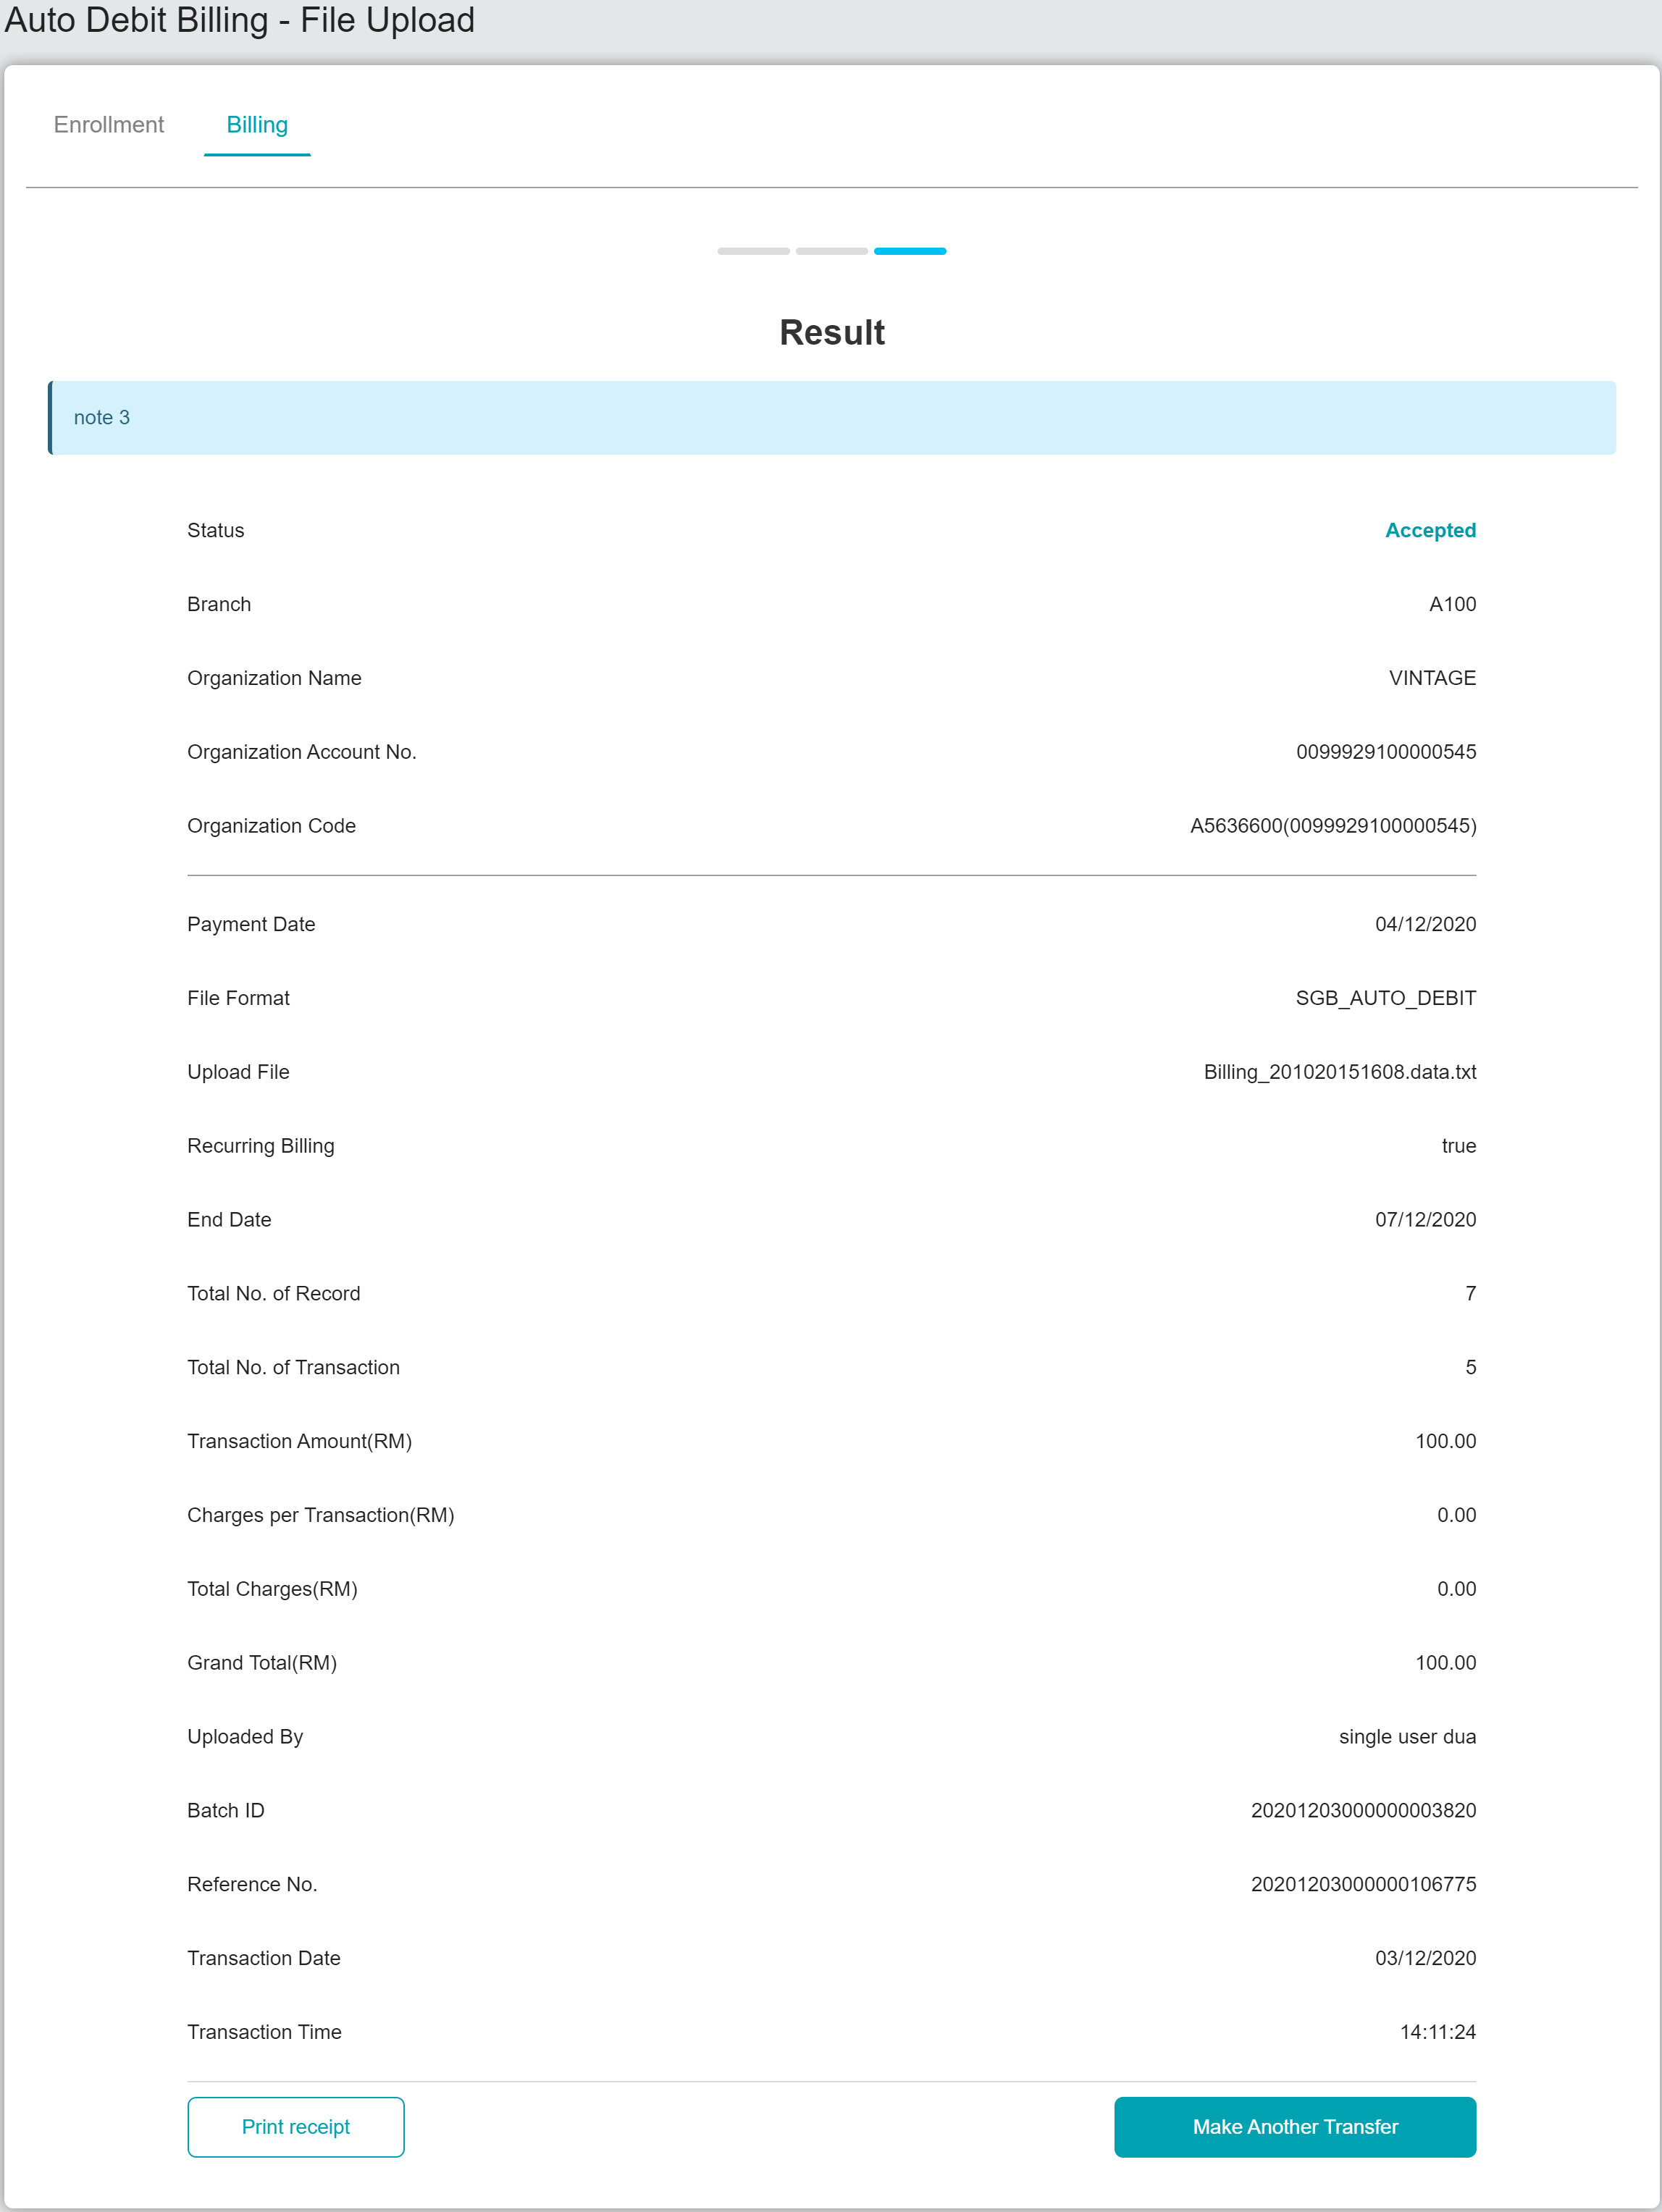

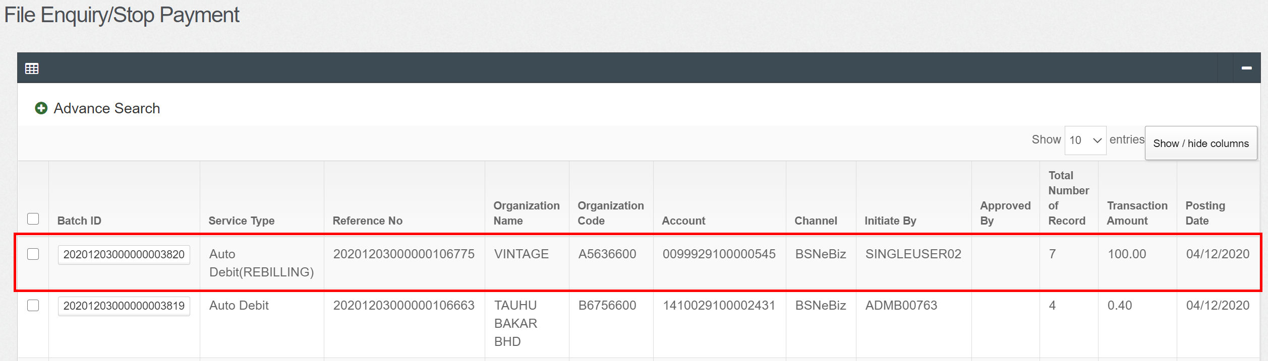

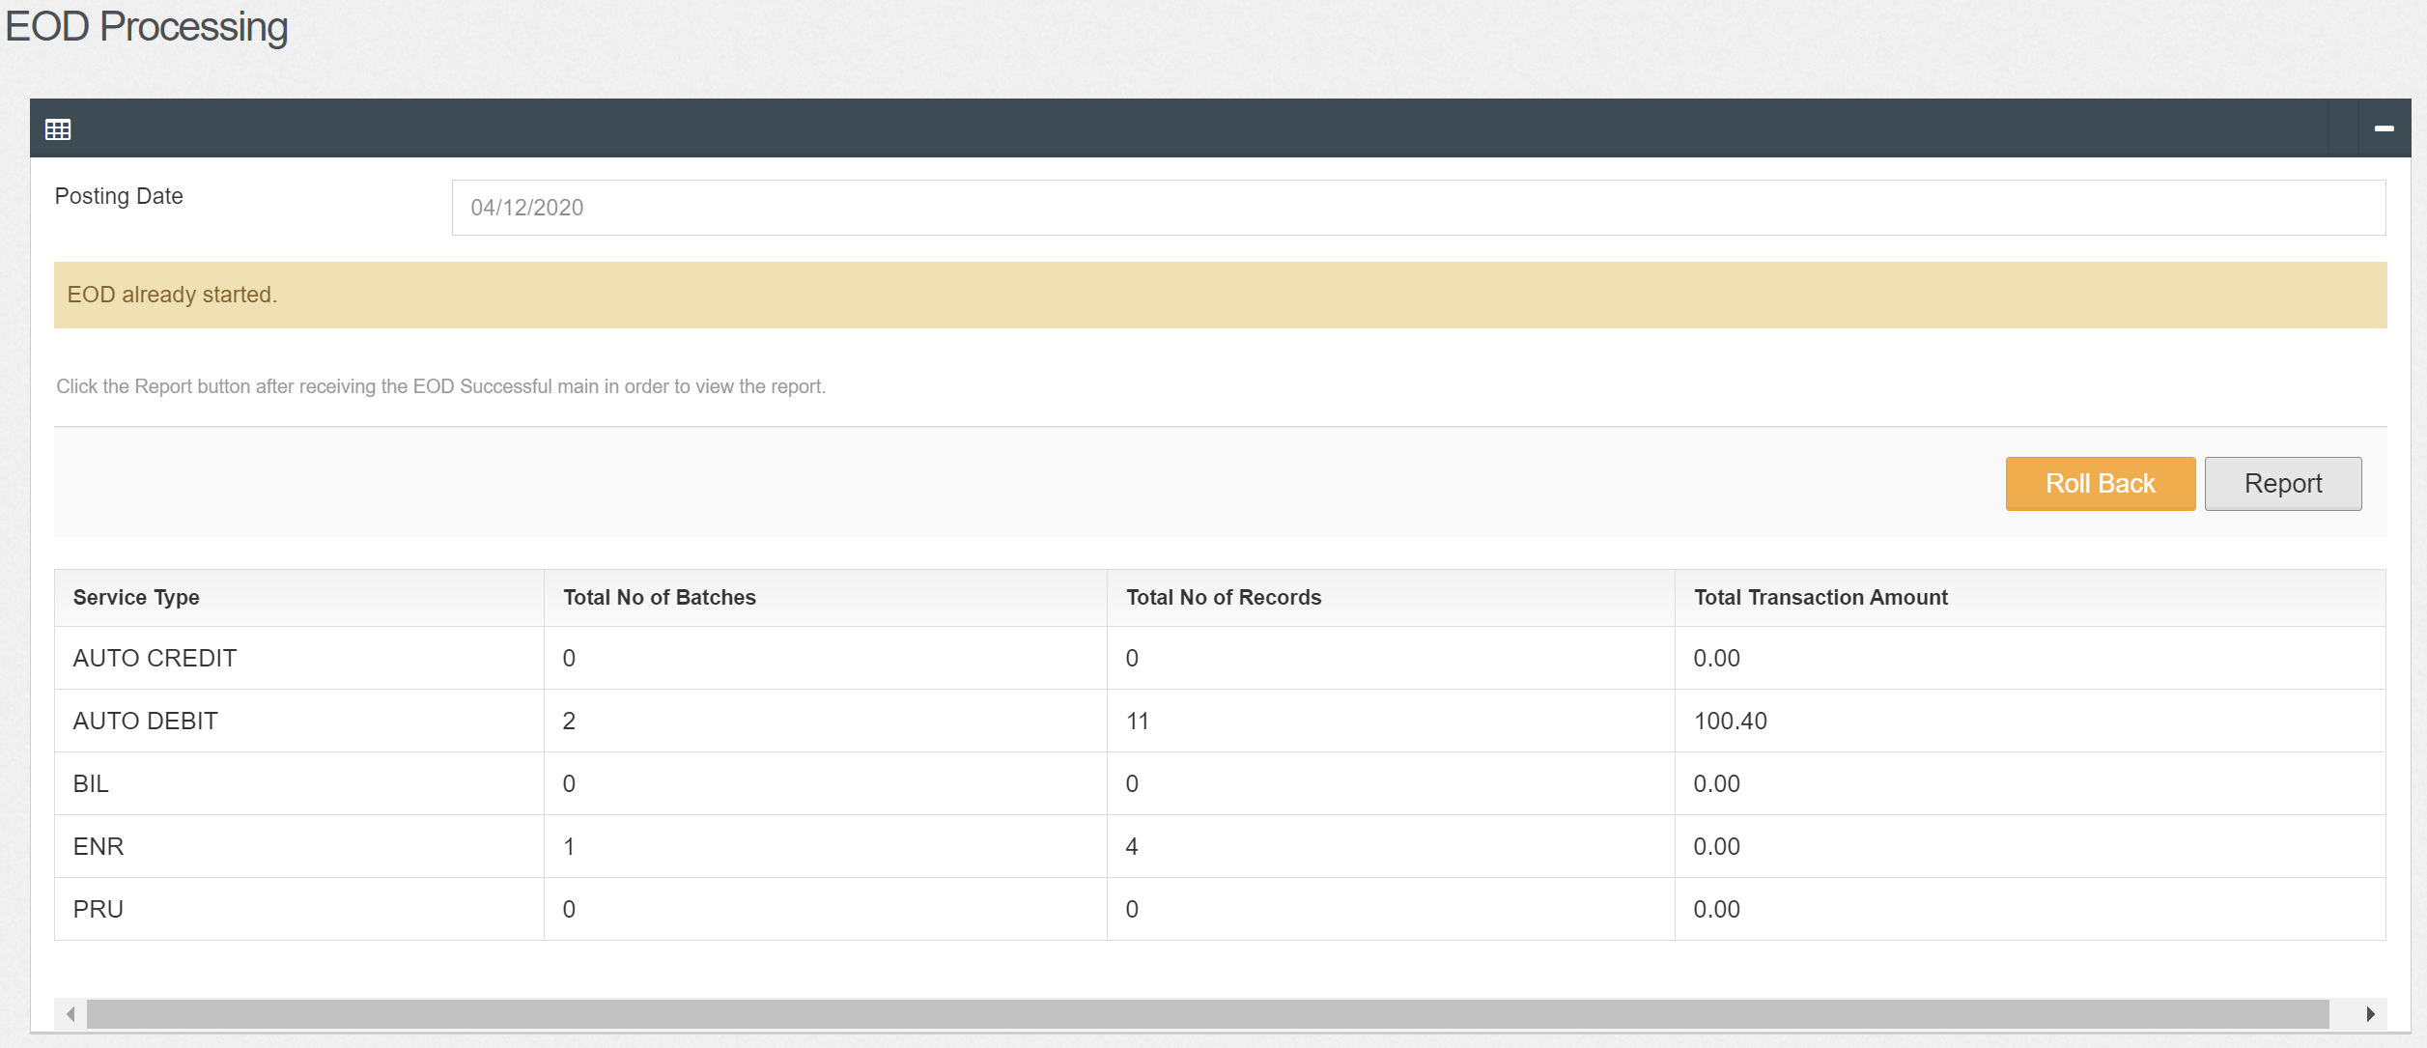

At winscp

Copy AUTO_DB file and reference 3 at eodreport and put at sample file at icbsreport

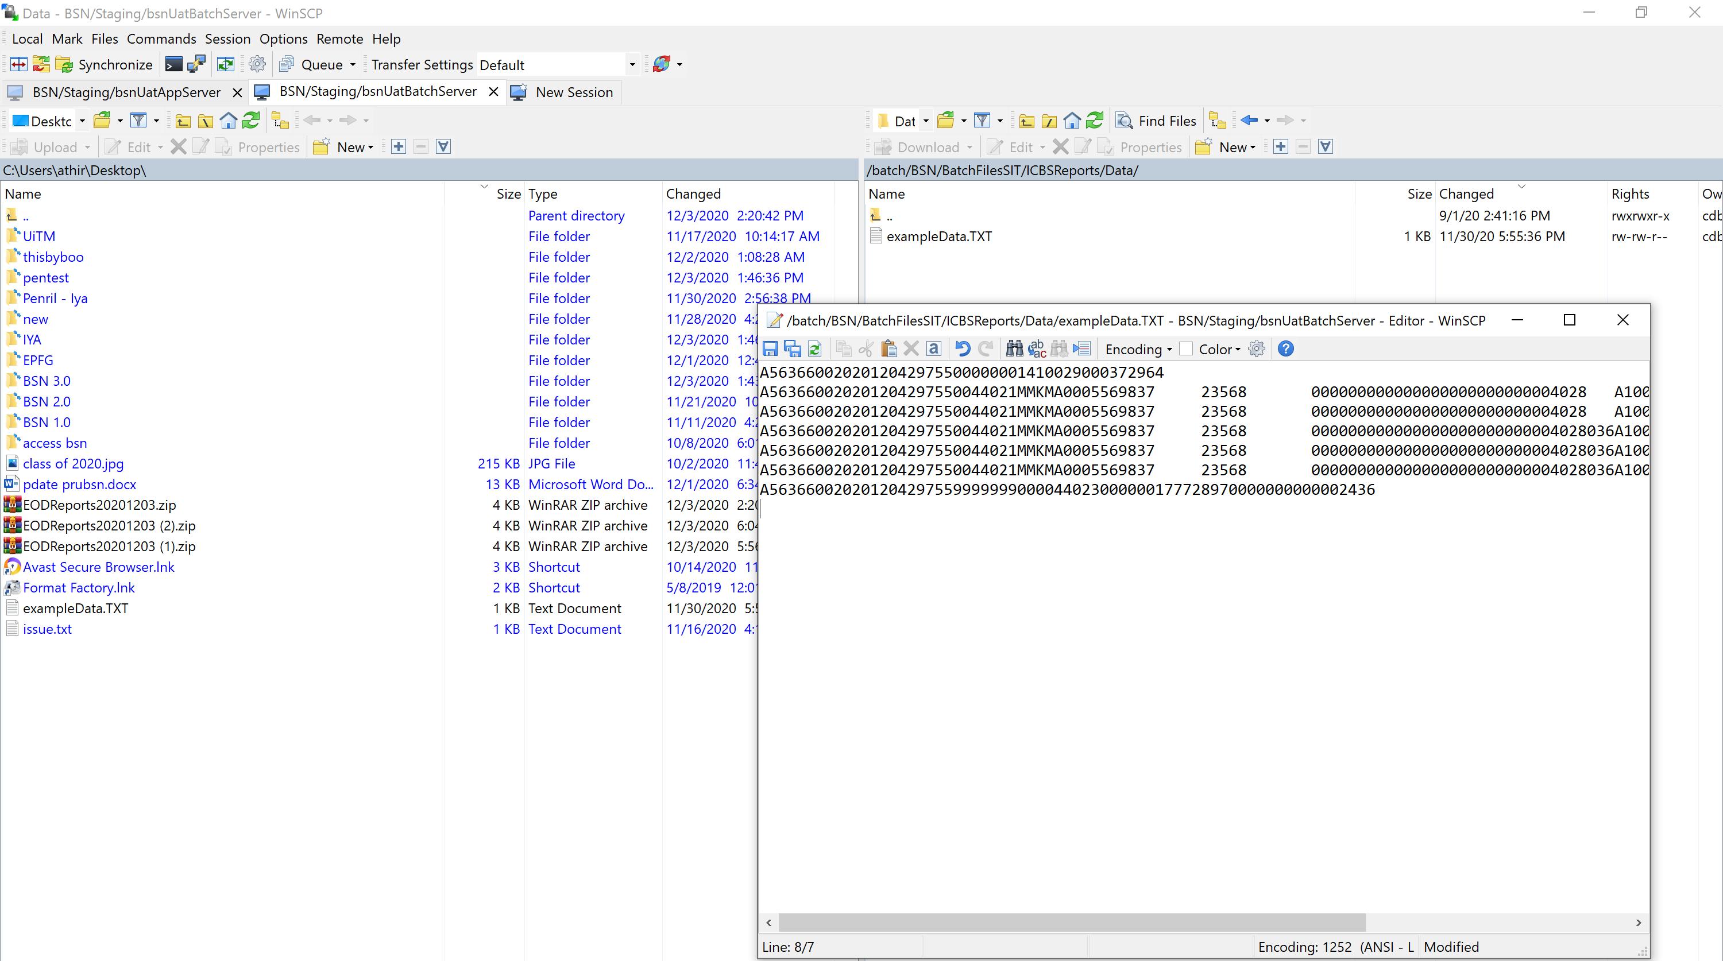

*rename file orgcodedate.txt

System rebilling 3 failed file

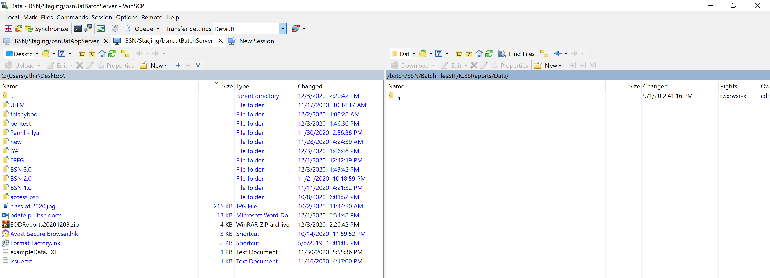

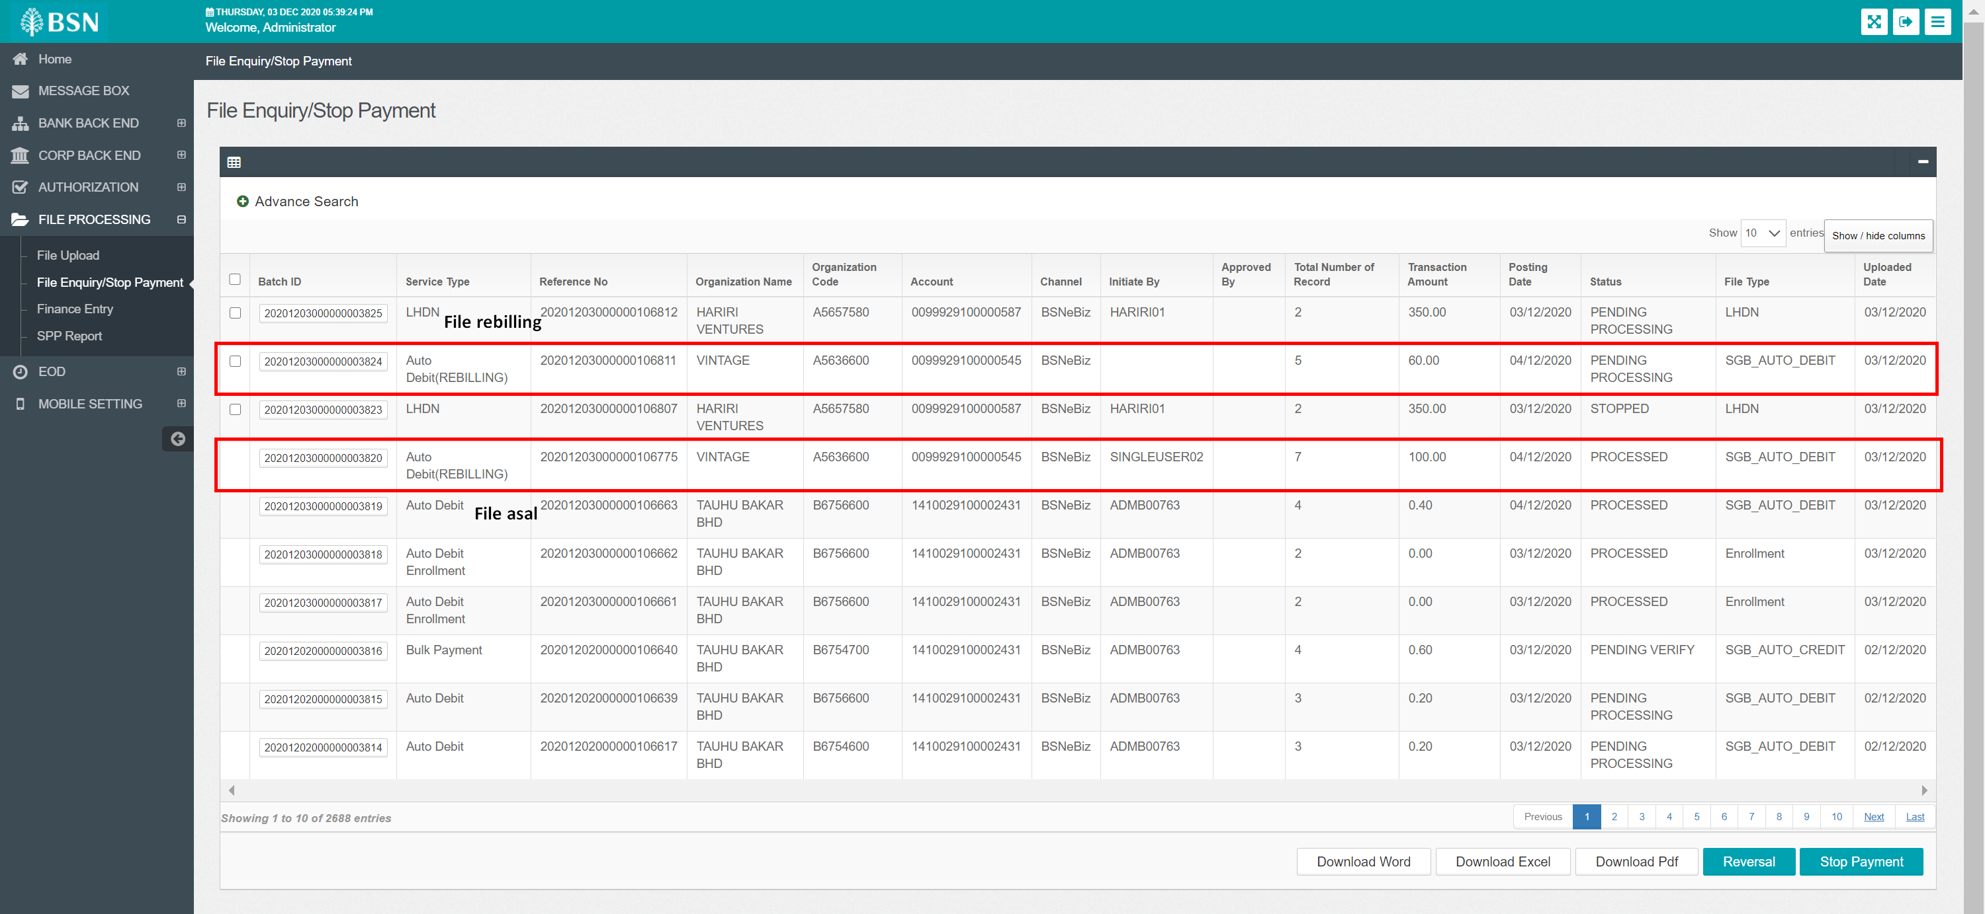

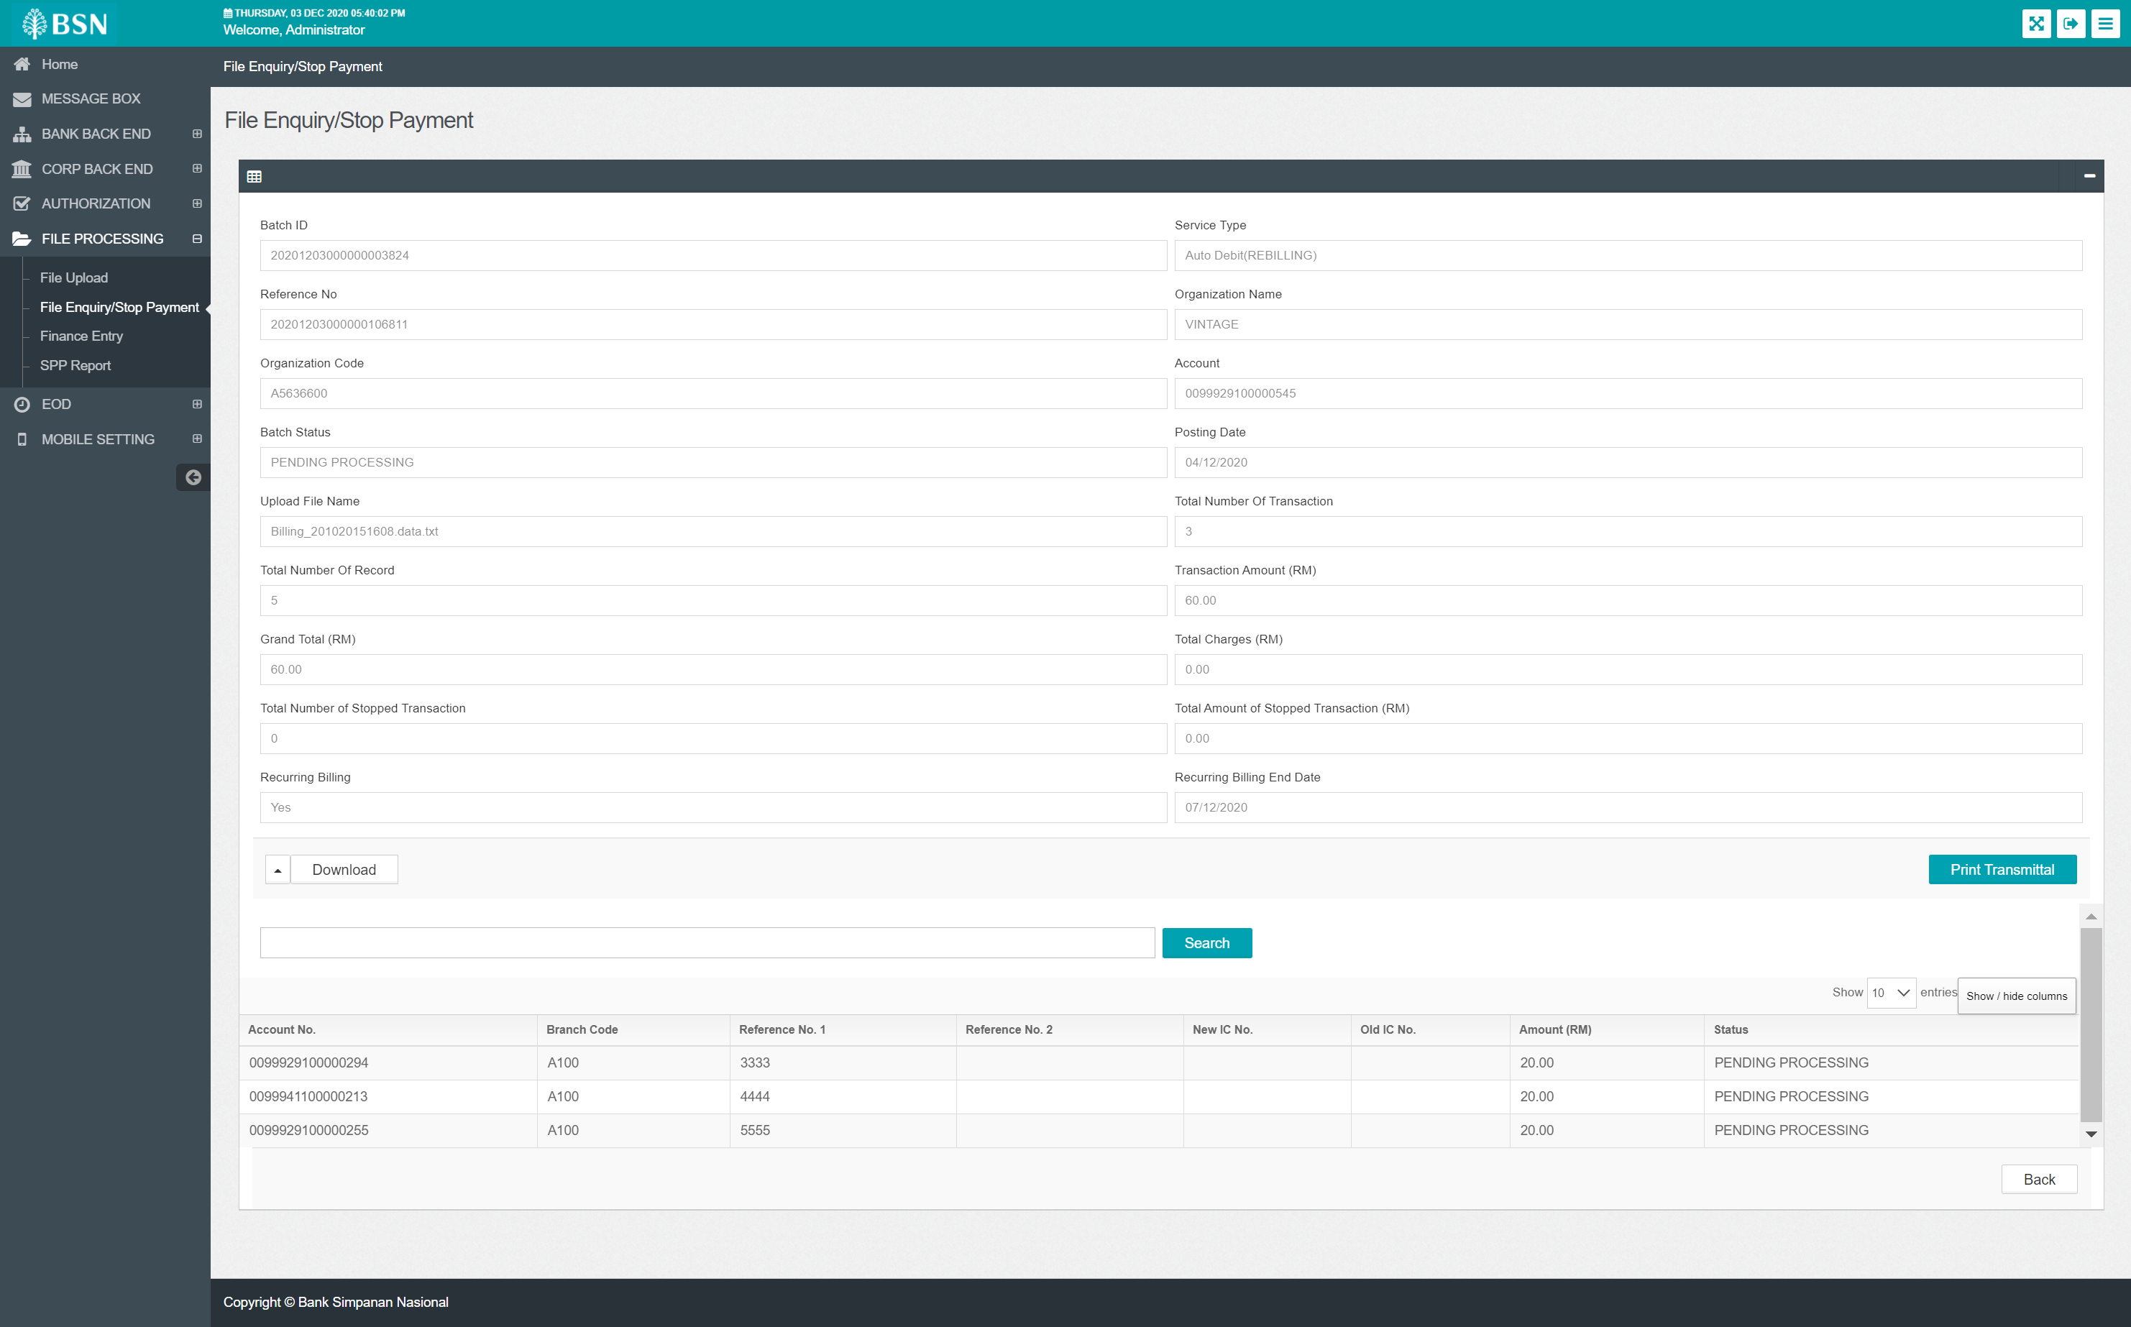

Positive Transaction.

Result : system not generate passed transaction

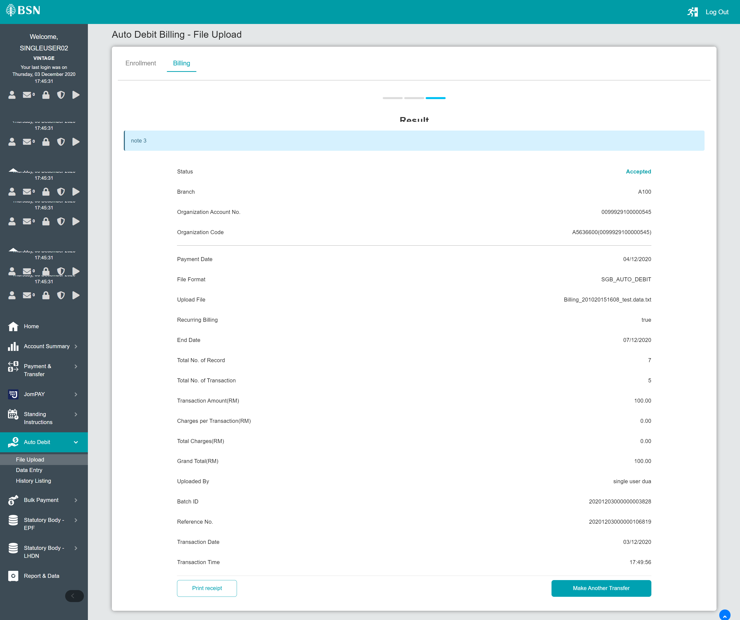

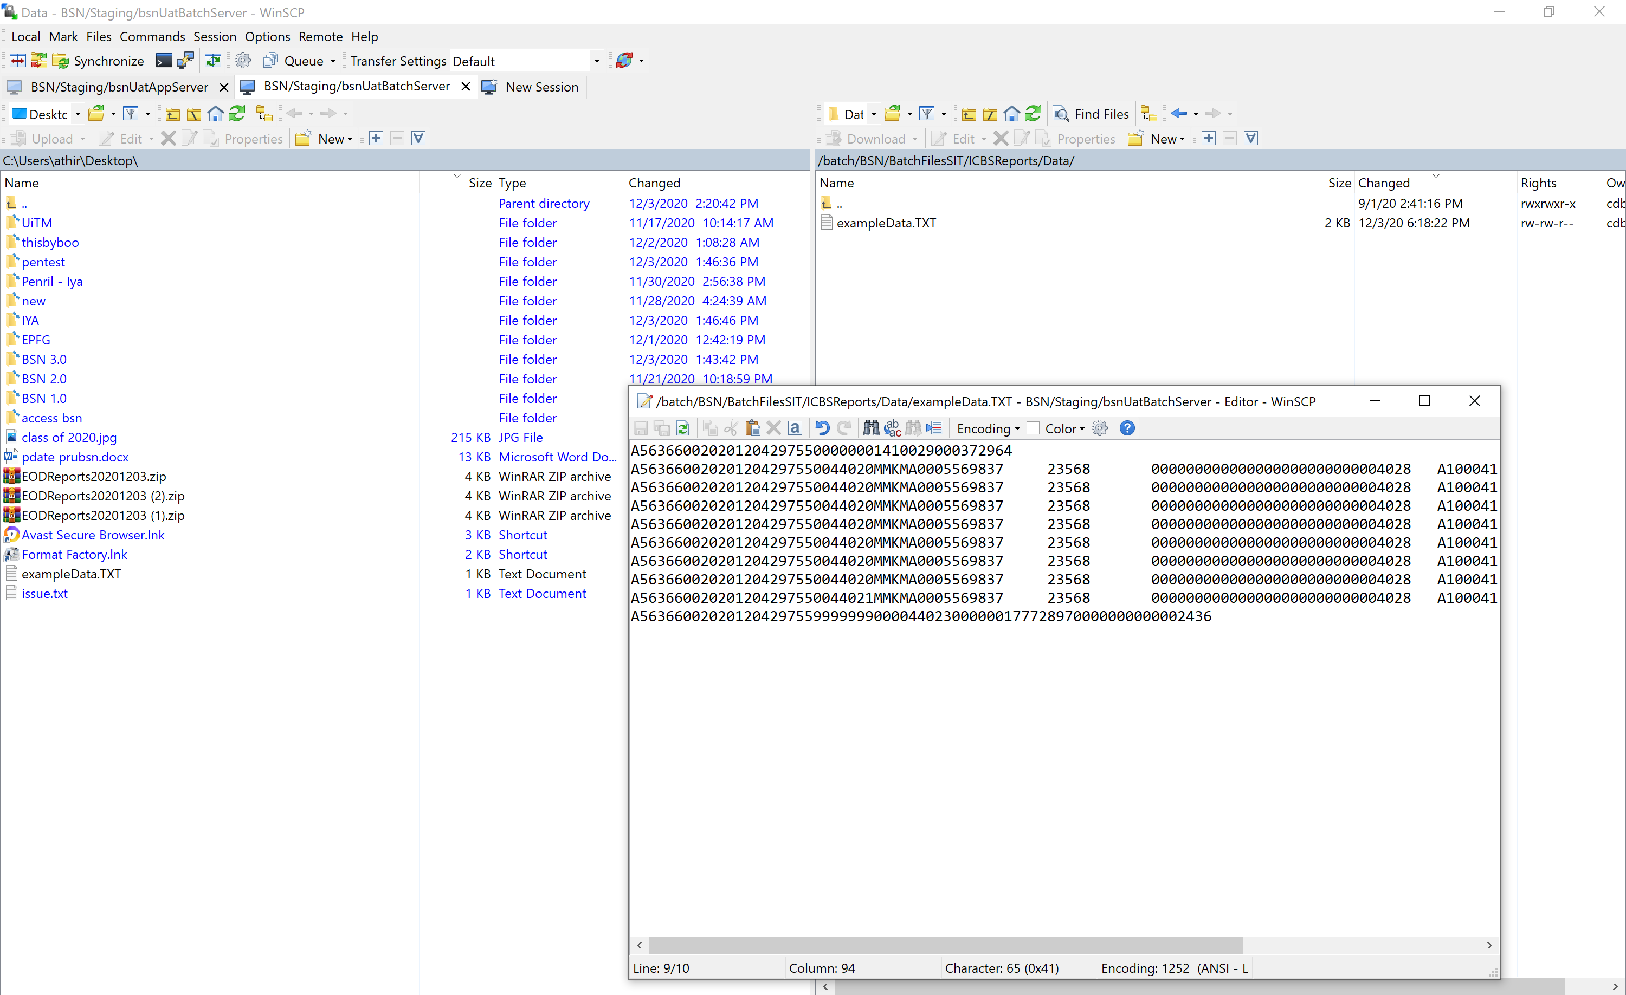

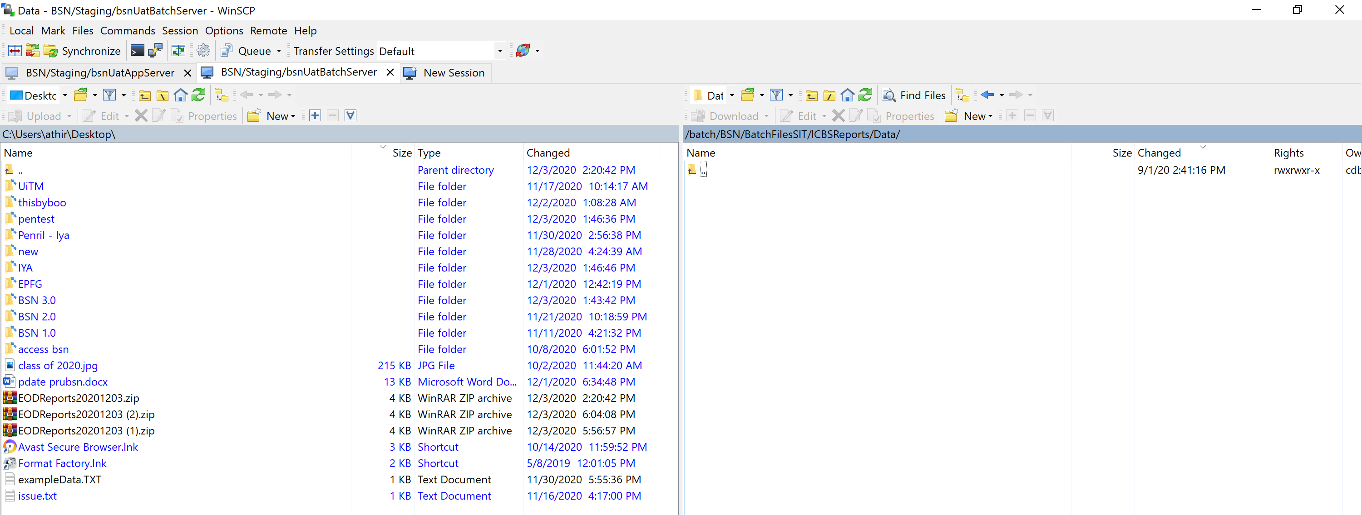

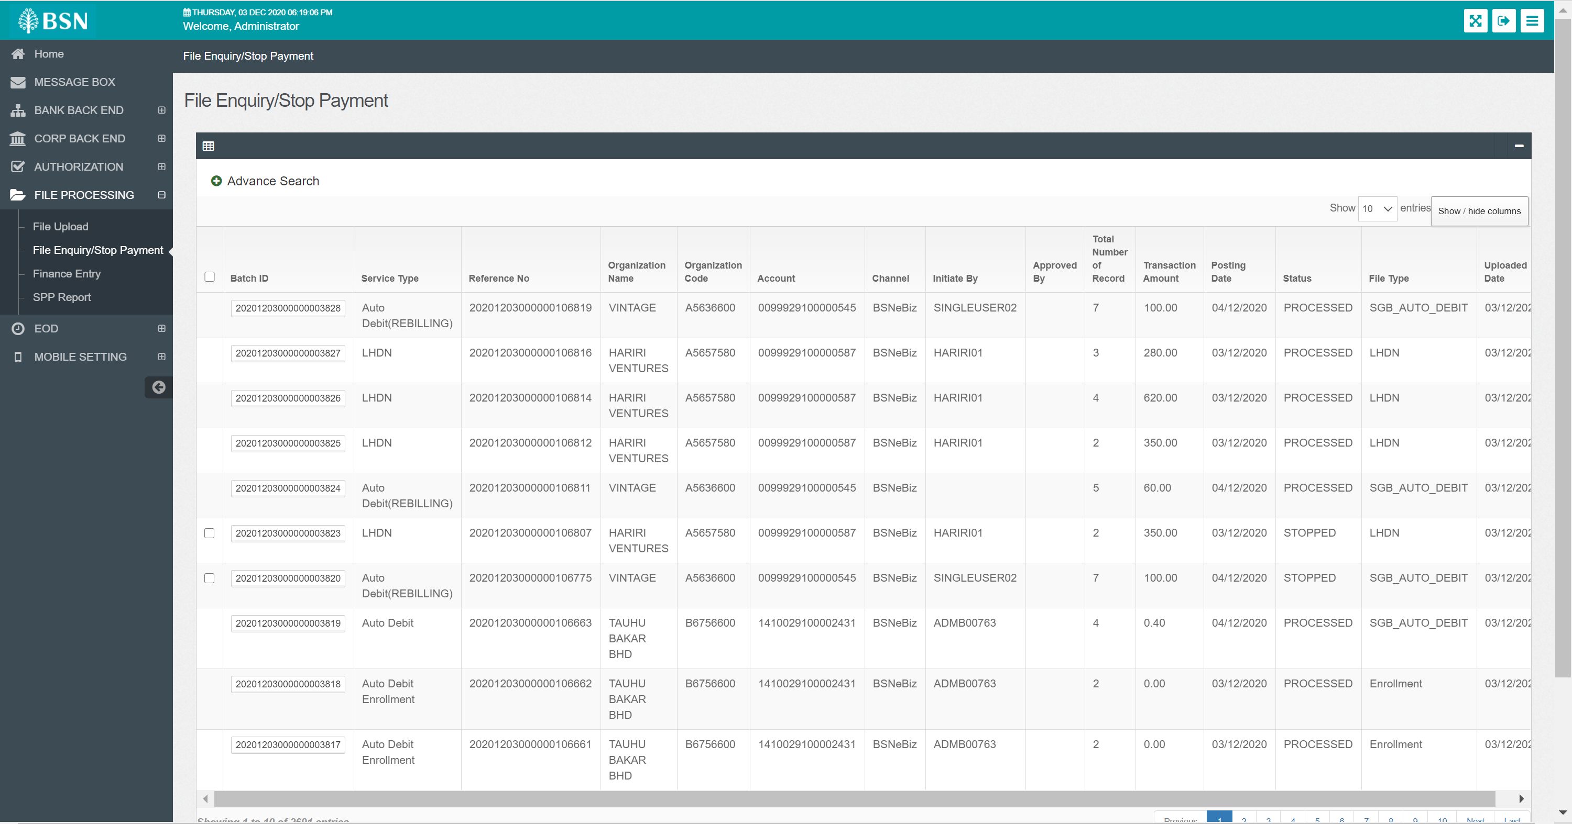

Result : No rebilling file

Test case 1:

1. Access CDB>Auto Debit>File Upload, create a new Rebilling
2. Access IBAM>EOD, submit EOD
3. Access Batch server
4. At path batch/BSN/BatchFilesSIT/EODReport, get the AUTO_DB file and reference 3
5. At path batch/BSN/BatchFilesSIT/ICBSReport/Data, create a sample of data file with the Rebilling reference 3
6. Set all reference 3 as failed
7. Expected result, NEW Rebilling will be created for the next day.

Test case 2:

1. Access CDB>Auto Debit>File Upload, create a new Rebilling
2. Access IBAM>EOD, submit EOD
3. Access Batch server
4. At path batch/BSN/BatchFilesSIT/EODReport, get the AUTO_DB file and reference 3
5. At path batch/BSN/BatchFilesSIT/ICBSReport/Data, create a sample of data file with the Rebilling reference 3
6. Set all reference 3 as successful
7. Expected result, NO Rebilling will be created for the next day.