Issue:  
After EOD rollback, Bulk Payment without account status change Processed to Pending Enter Amount

Cause:  
IBAM finance entry failed to update table BIBConsolidateBulk, column DoneEnterAmount

Solution:  
Fix IBAM to update table BIBConsolidateBulk, column DoneEnterAmount

Test scenario:

1. In CDB, create 3 Bulk Payment without account transactions
2. In IBAM>Finance Entry, enter amount for the transactions
3. In IBAM>EOD, submit EOD
4. Make sure all Bulk Payment without account are status is PROCESSED
5. In IBAM>EOD, rollback EOD
6. Make sure all Bulk Payment without account are is PENDING PROCESSING
7. In IBAM>EOD, submit EOD
8. Expected result, all Bulk Payment without account are status is PROCESSED

Test Result:

1. In CDB, create 3 Bulk Payment without account transactions

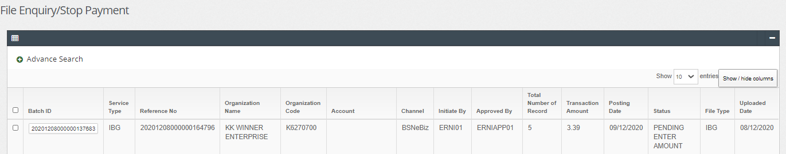

1. In IBAM>Finance Entry, enter amount for the transactions

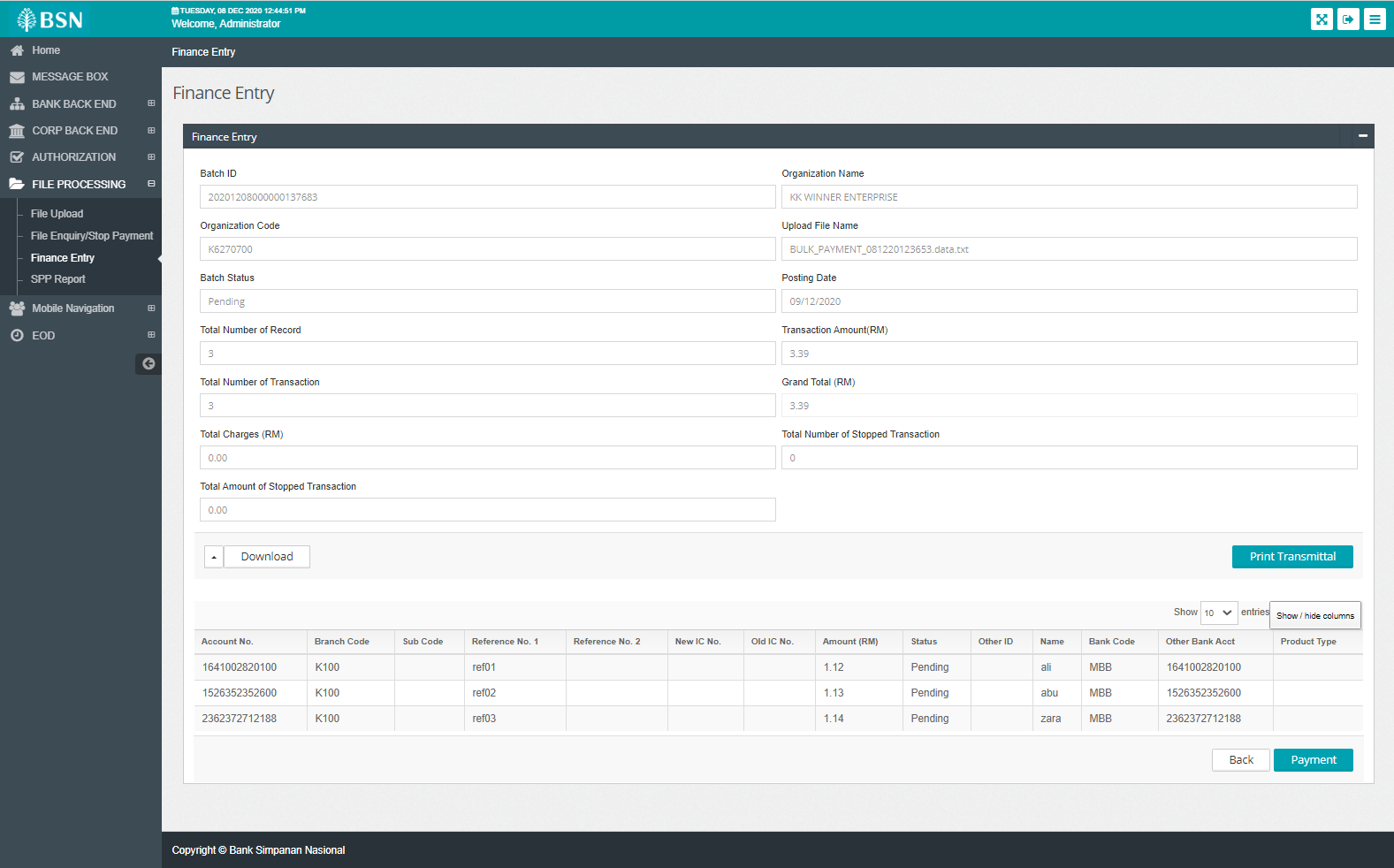

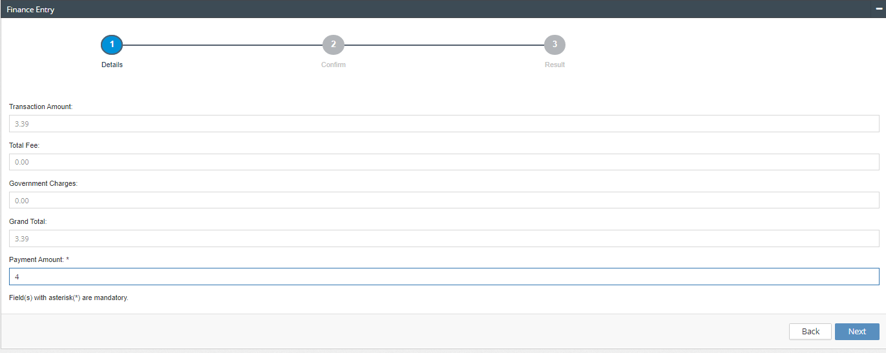

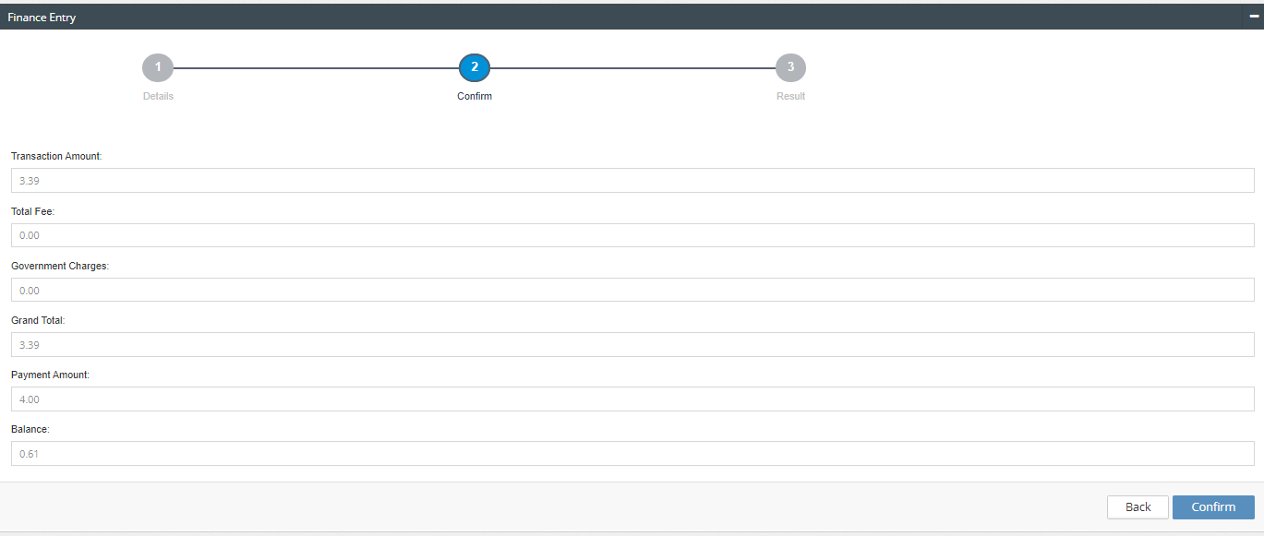

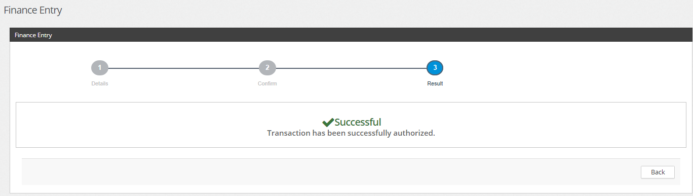

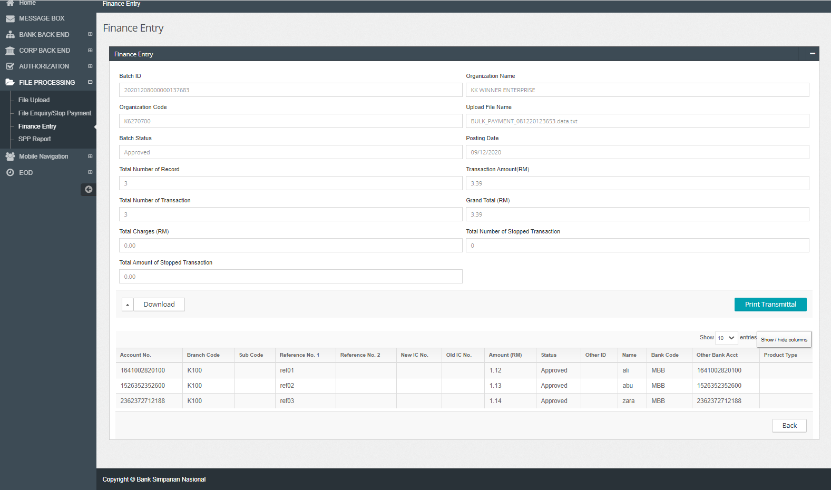

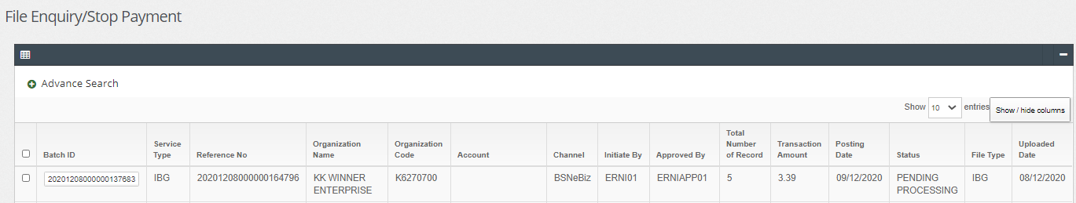

1. In IBAM>EOD, submit EOD

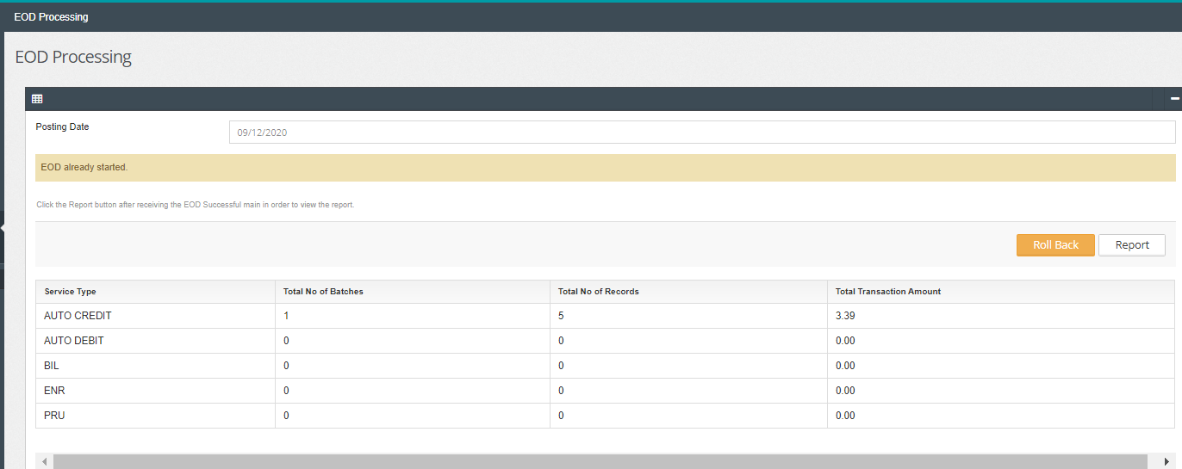

1. Make sure all Bulk Payment without account are status is PROCESSED

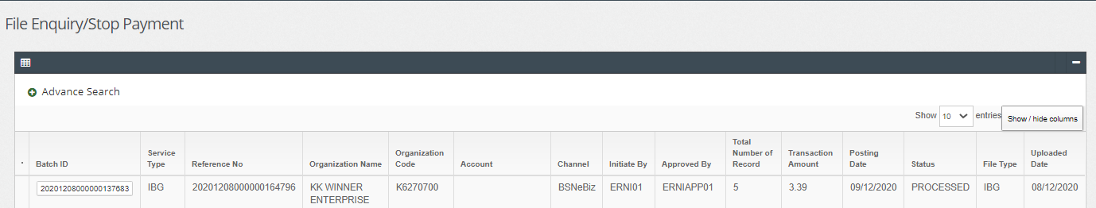

1. In IBAM>EOD, rollback EOD

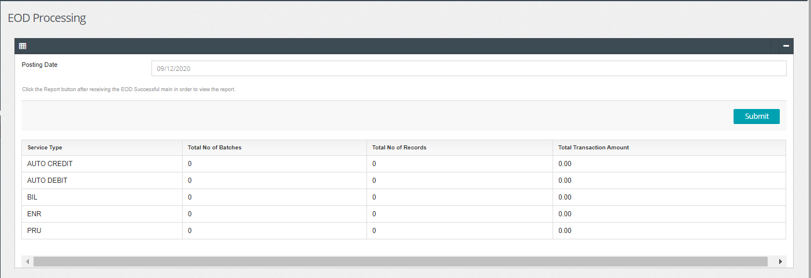

1. Make sure all Bulk Payment without account are is PENDING PROCESSING

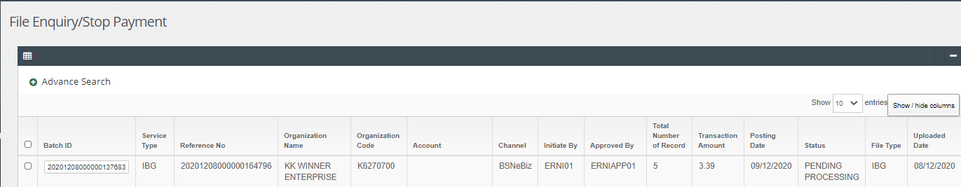

1. In IBAM>EOD, submit EOD

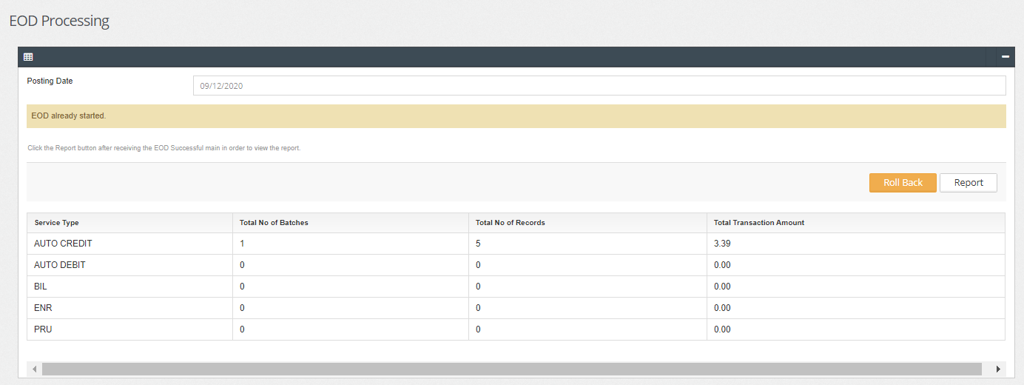

1. Expected result, all Bulk Payment without account are status is PROCESSED

