**EPFG Testing**

**New Request from JPD (Rahmat Bohari) as below :**

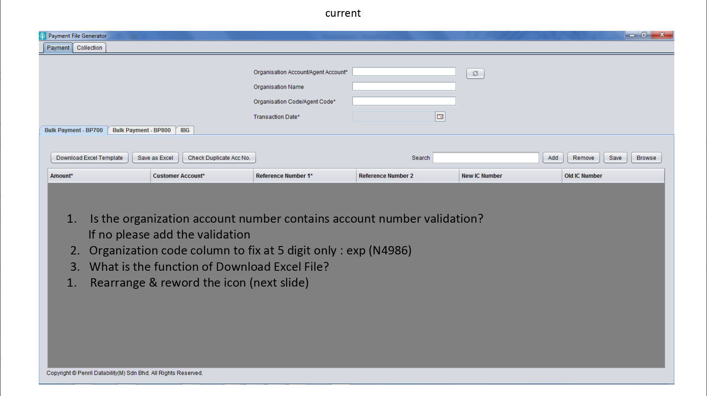

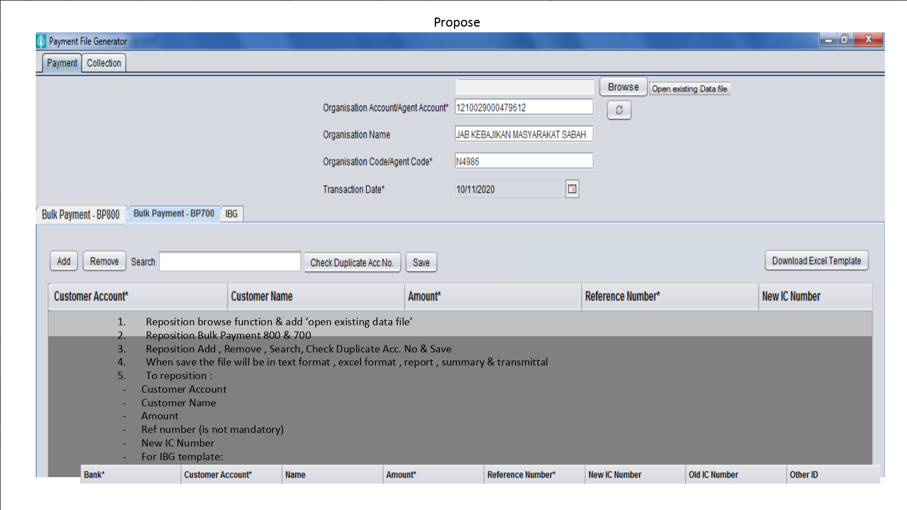

**SIT12 - ePFG -To fixed organization field to column 5 digit (11371)**

**Passed**

Organization code must contain 7 digits of number :

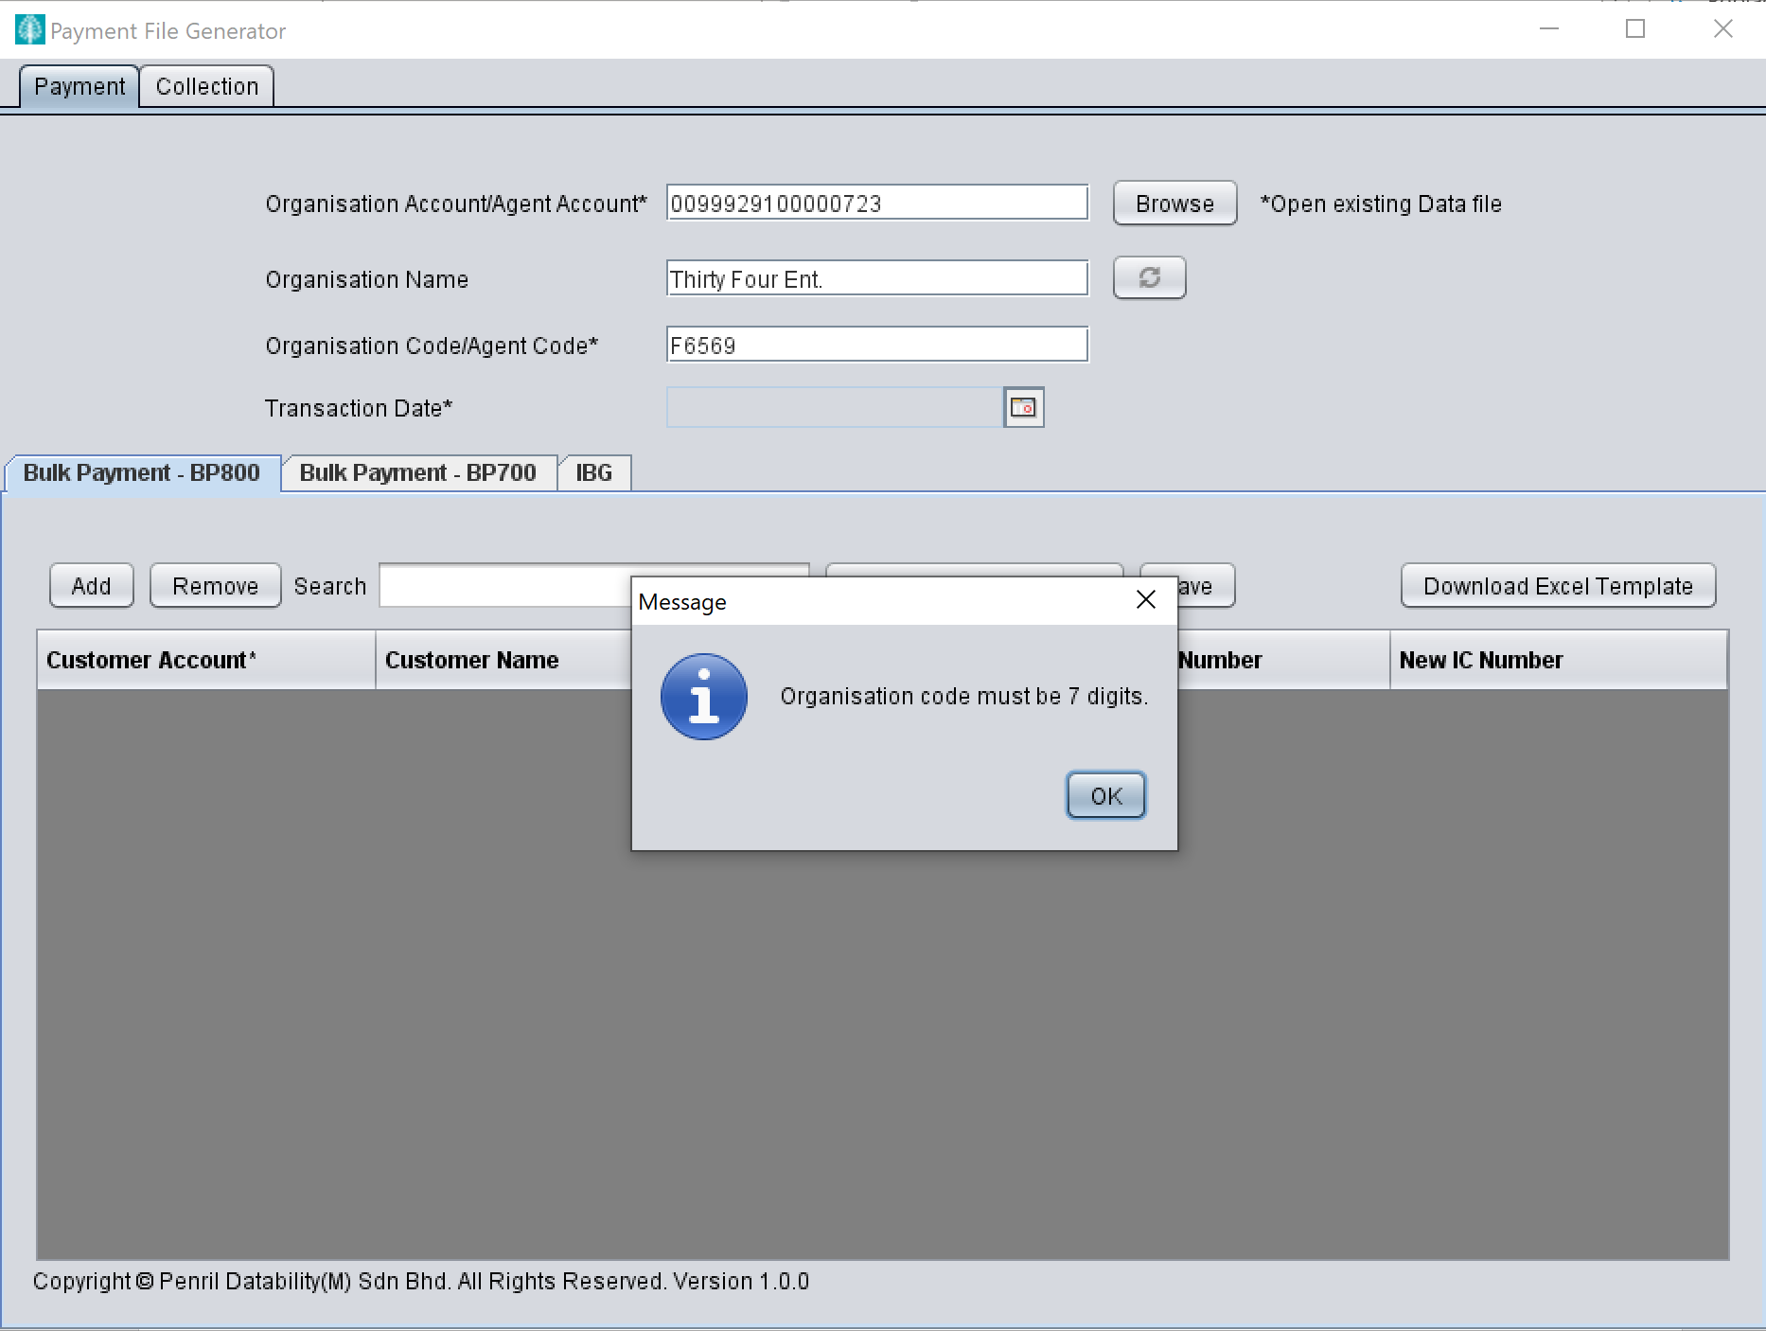

Inserted service code must be tally with selected payment service or else system will throw error :

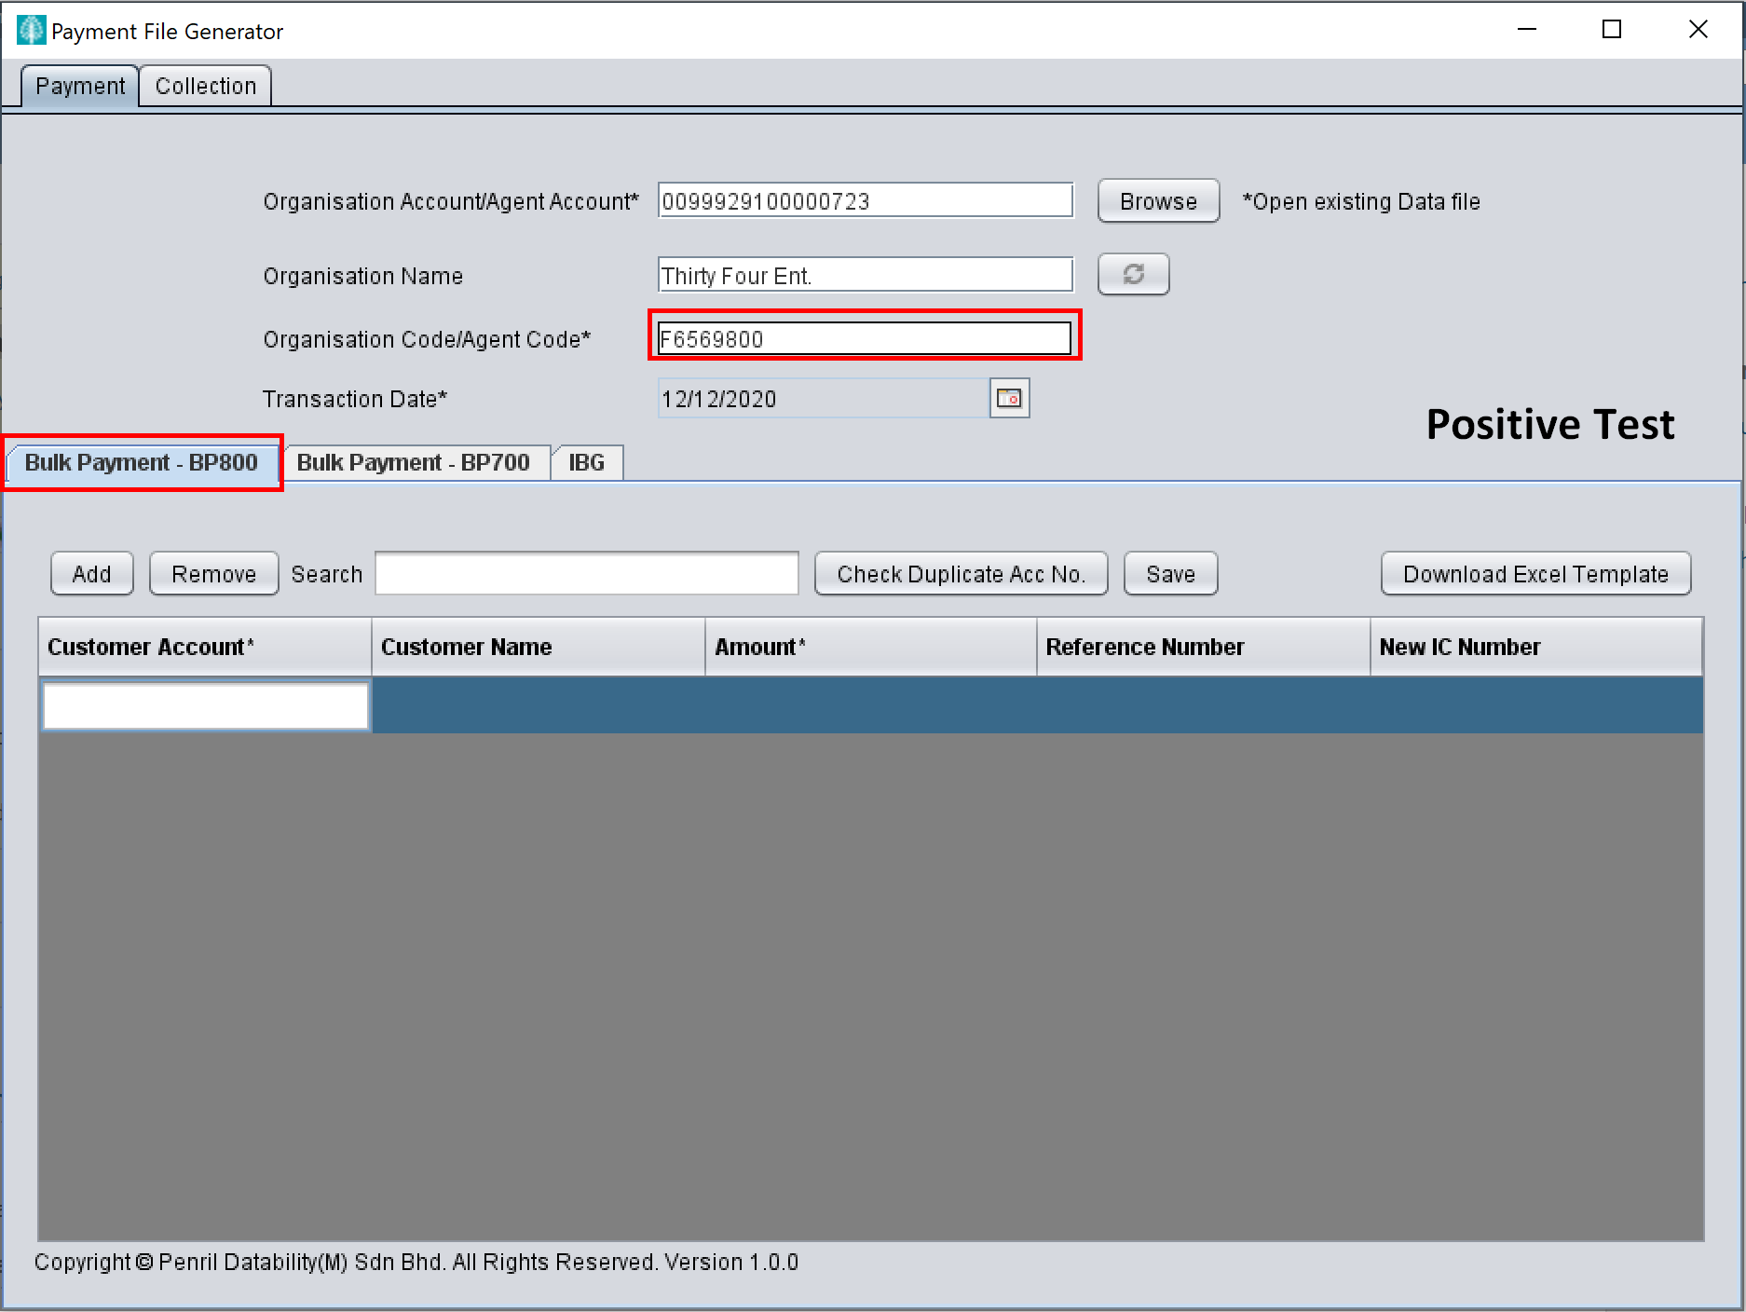 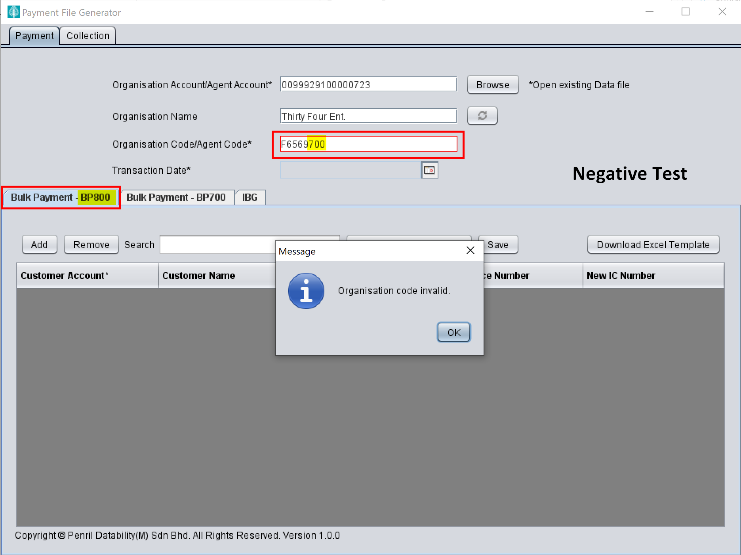

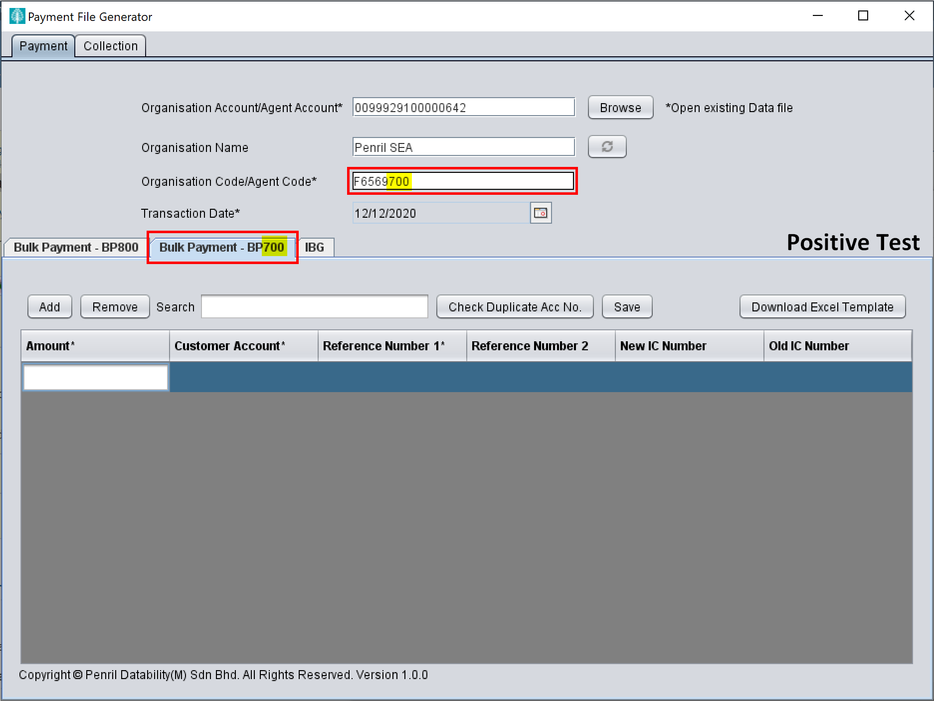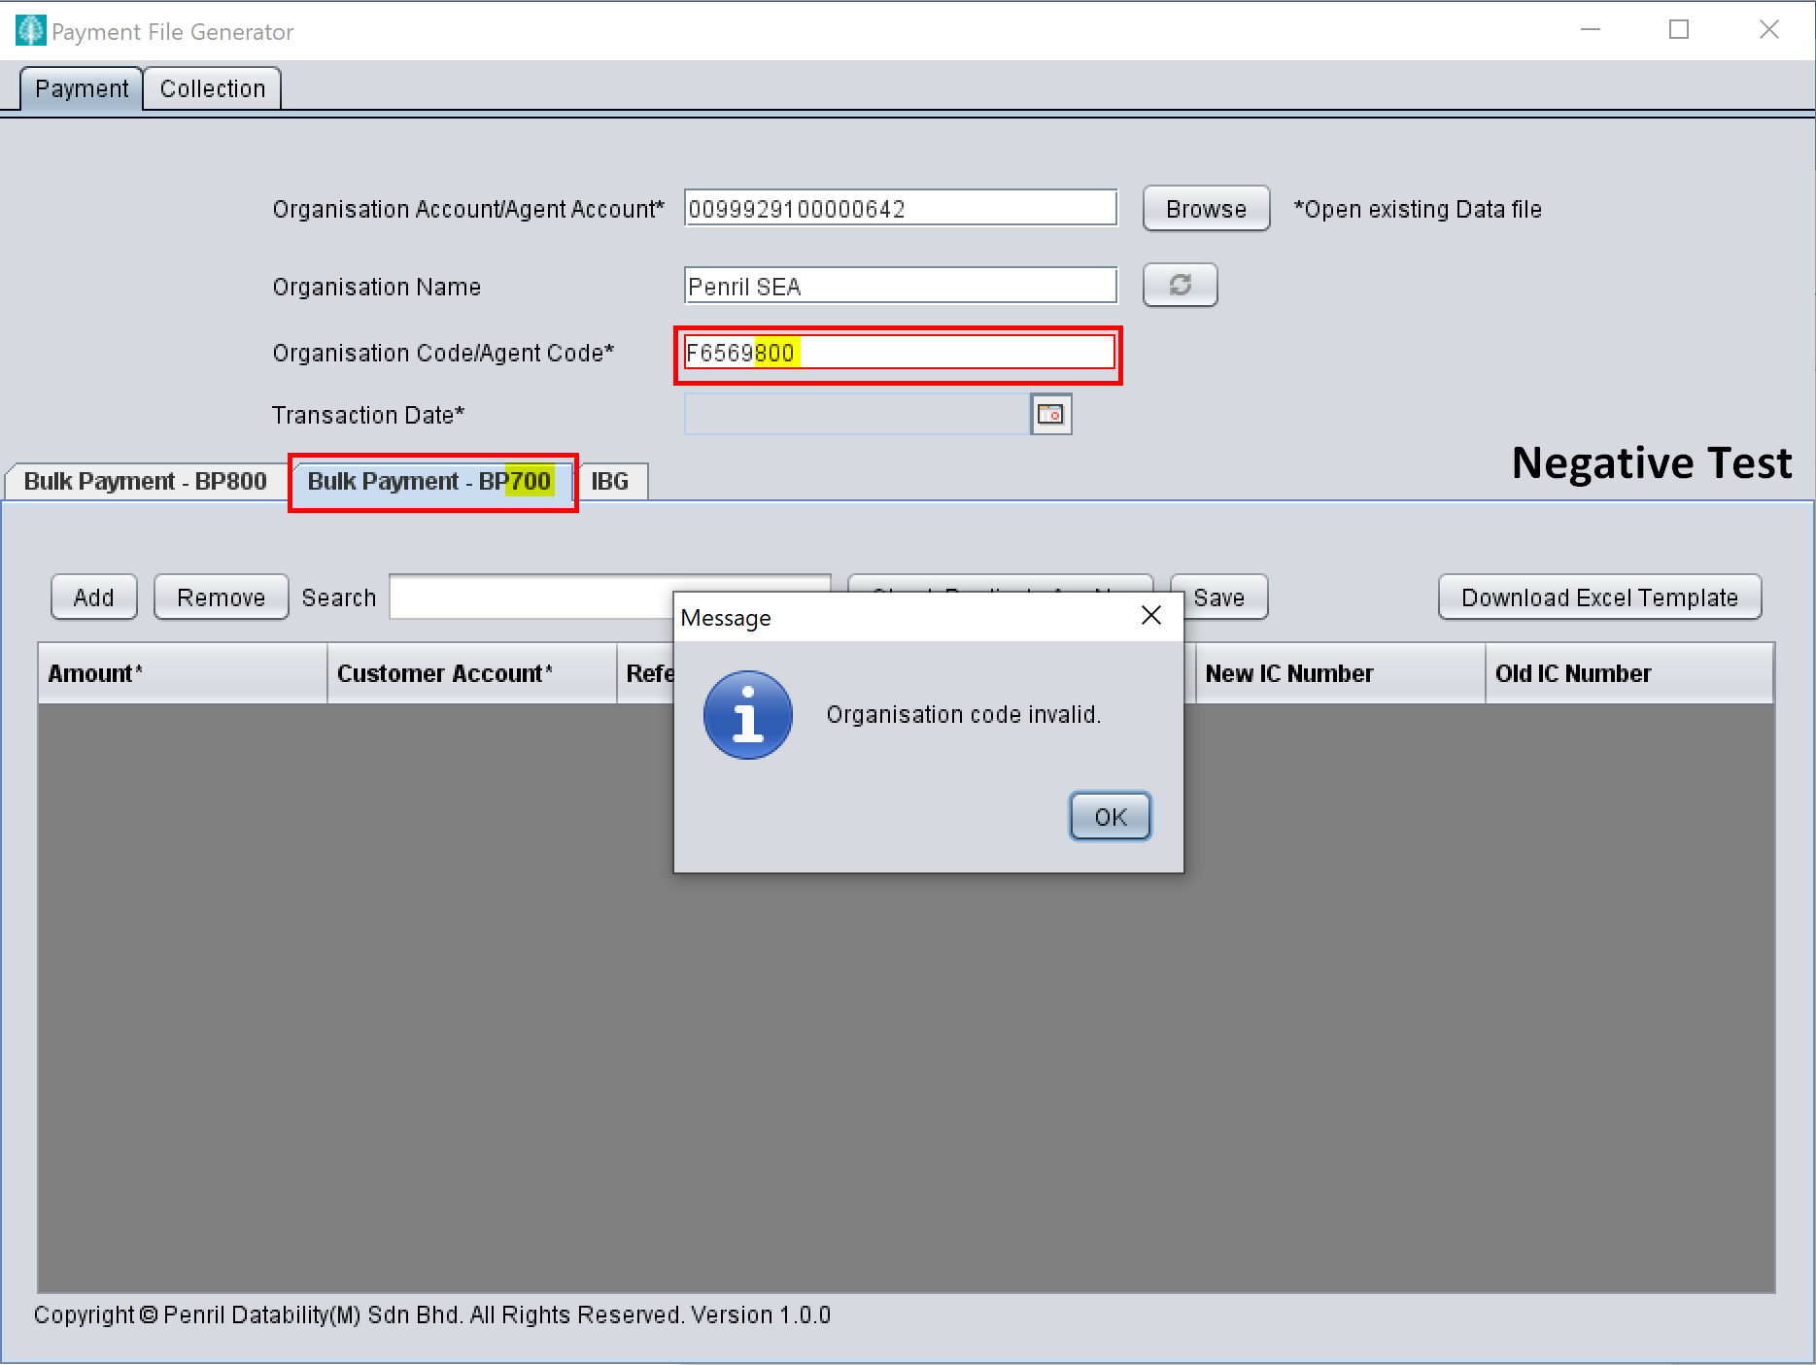

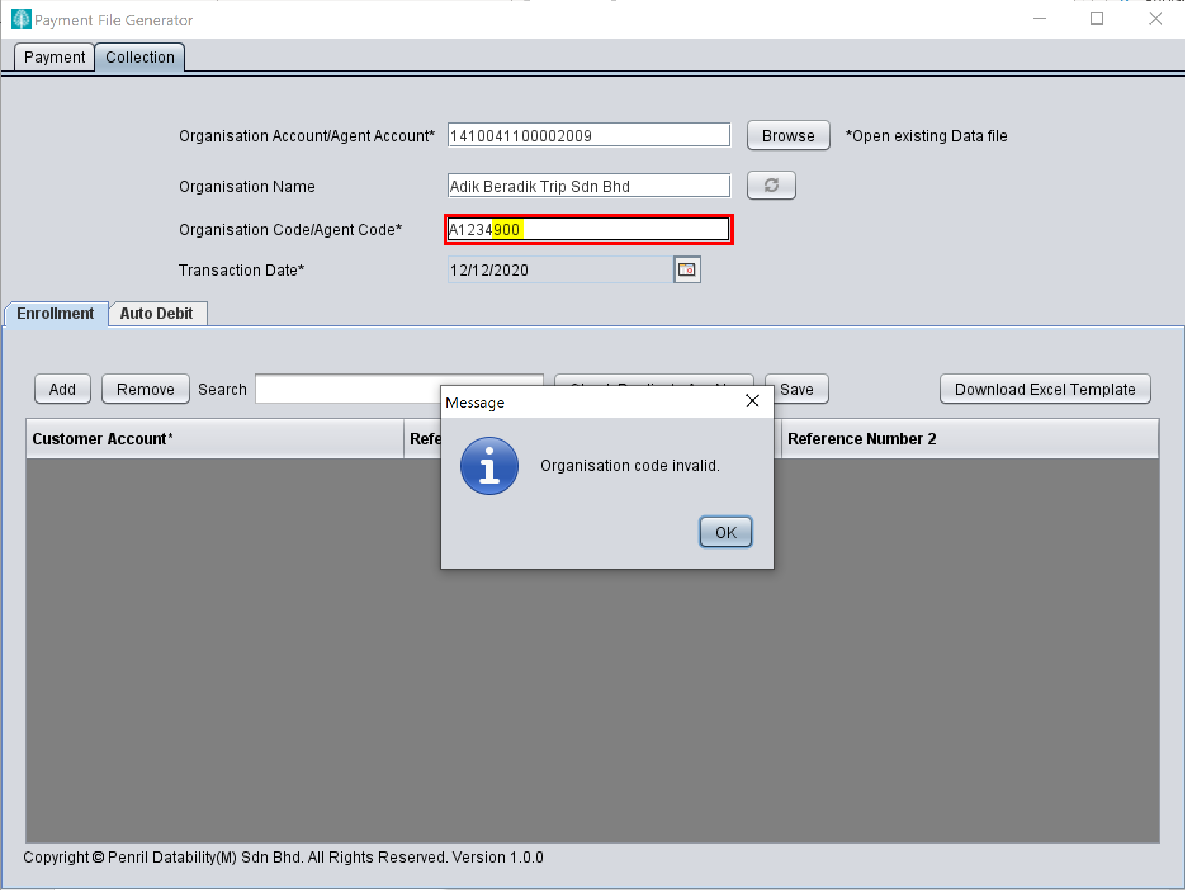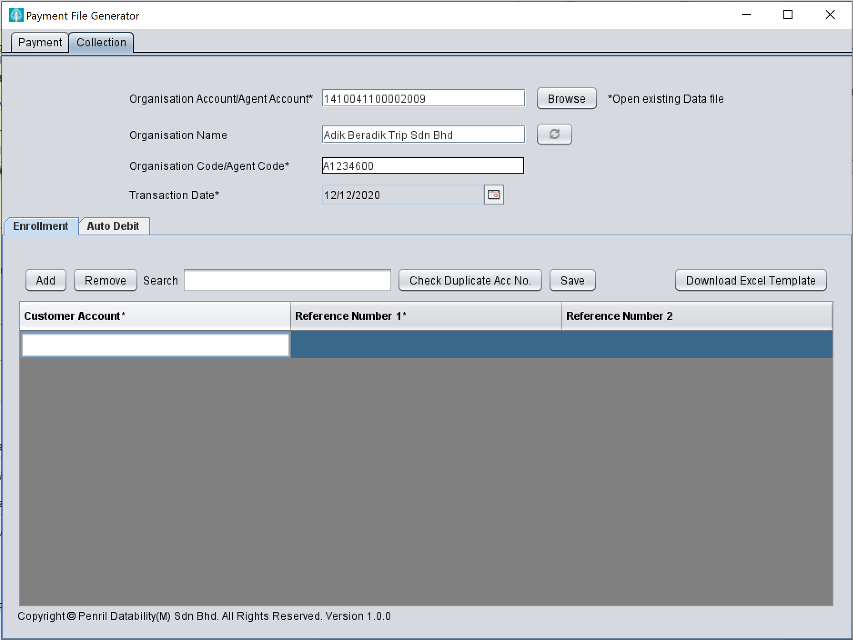

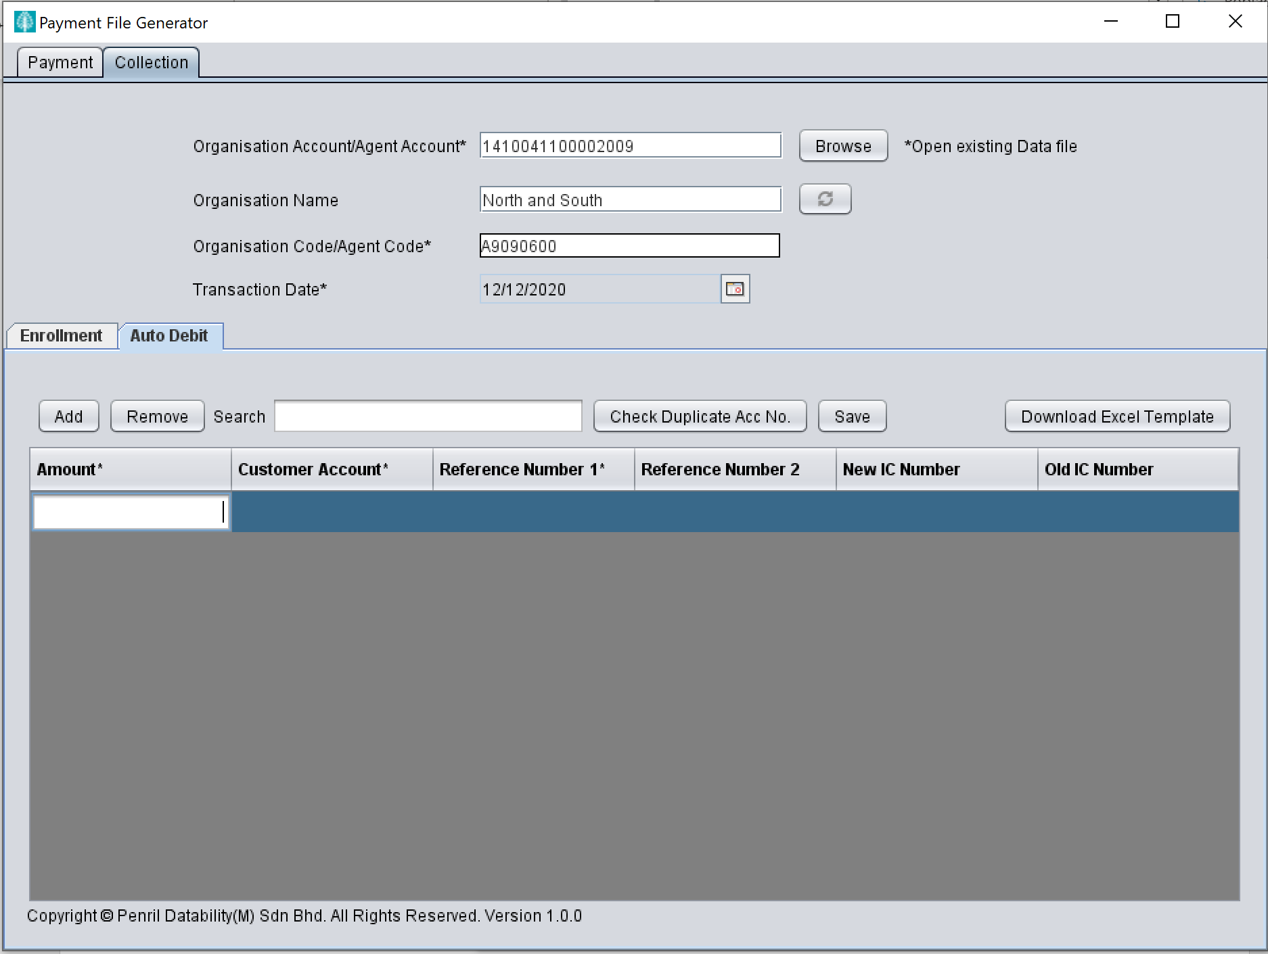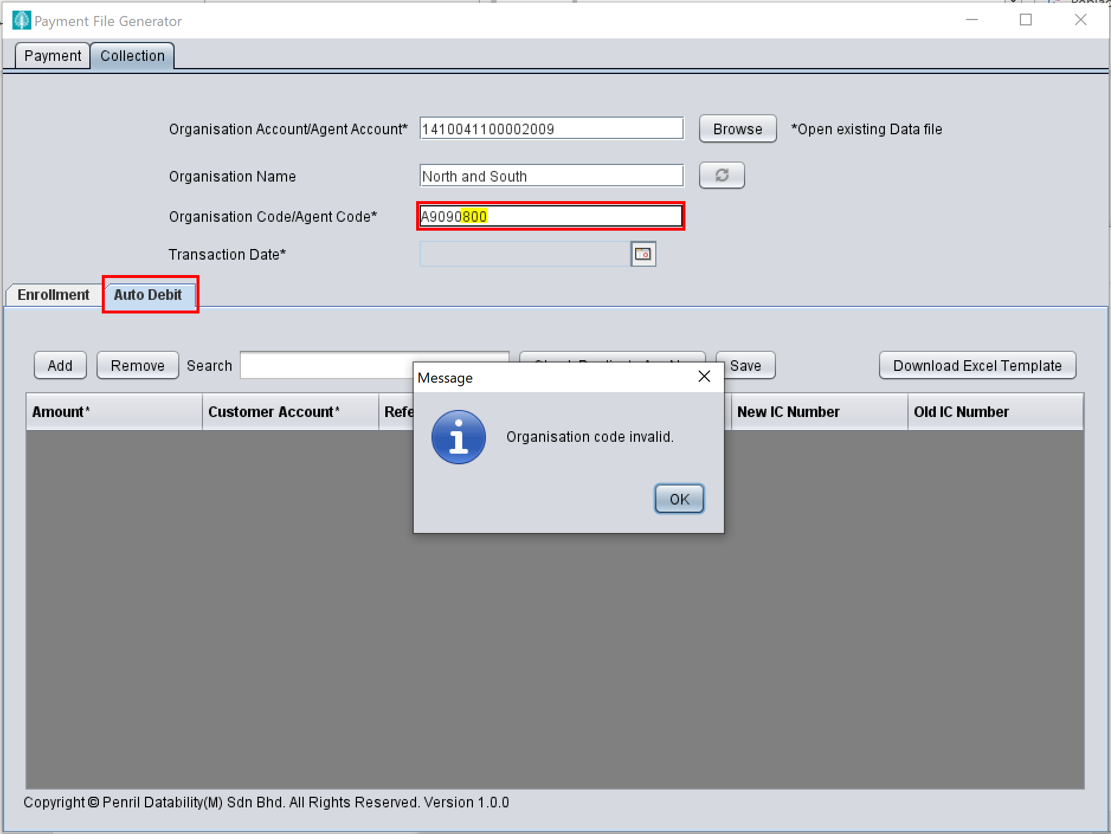

**SIT13 / SIT14 / SIT18 - ePFG -To reposition button (11372)**

**To reposition browse button and put note beside the button (Passed)**

**Before :**

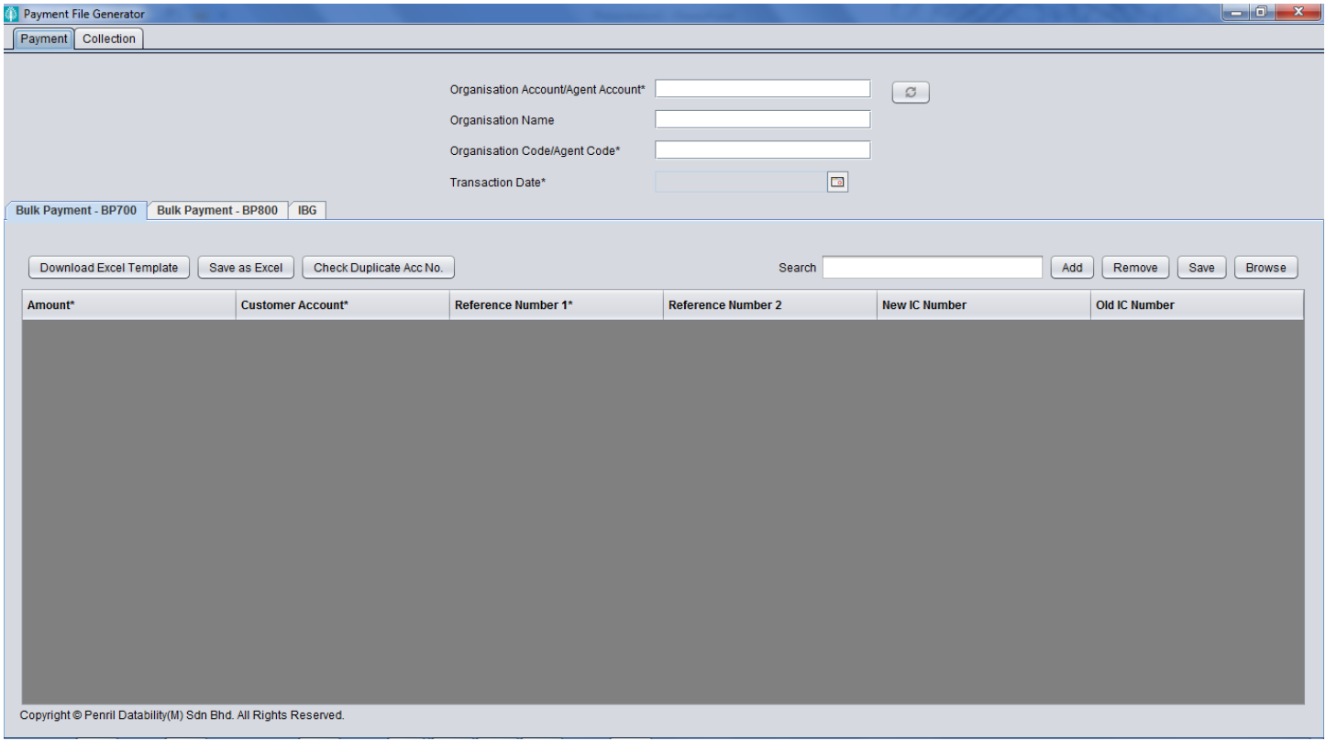

**After :**

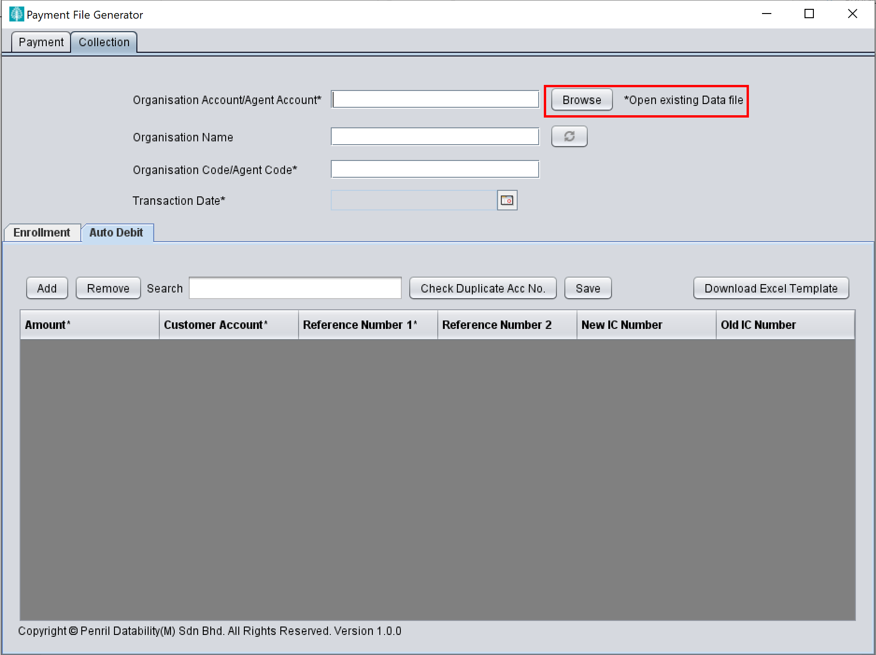

**To reposition Bulk Payment - 700 and Bulk Payment – 800** **(Passed)**

**Before :**



**After :**

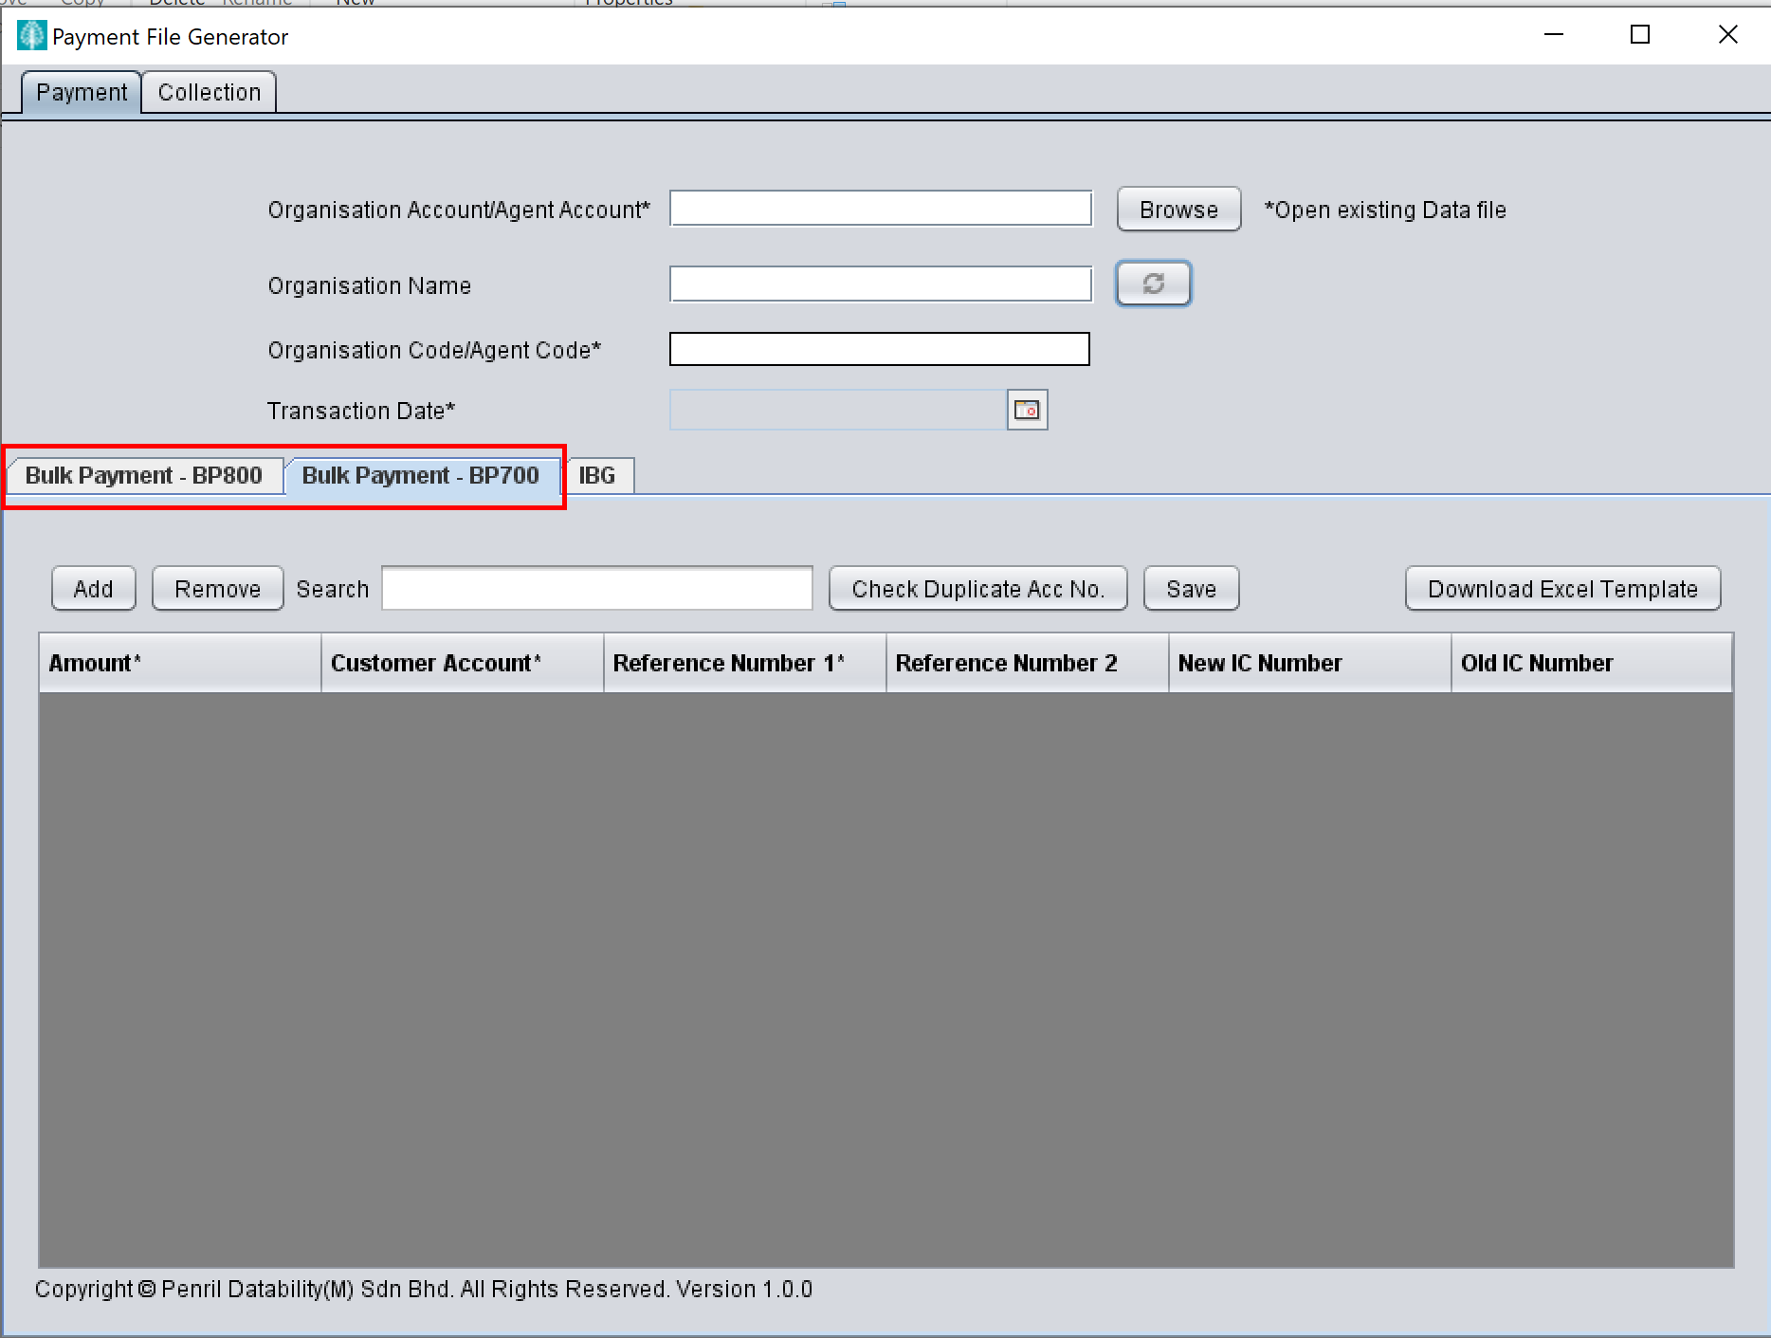

**To reposition "Add" "Remove" "Search" "Check Duplicate Acc No." and "Save" button (Passed)**

**Before :**



**After :**

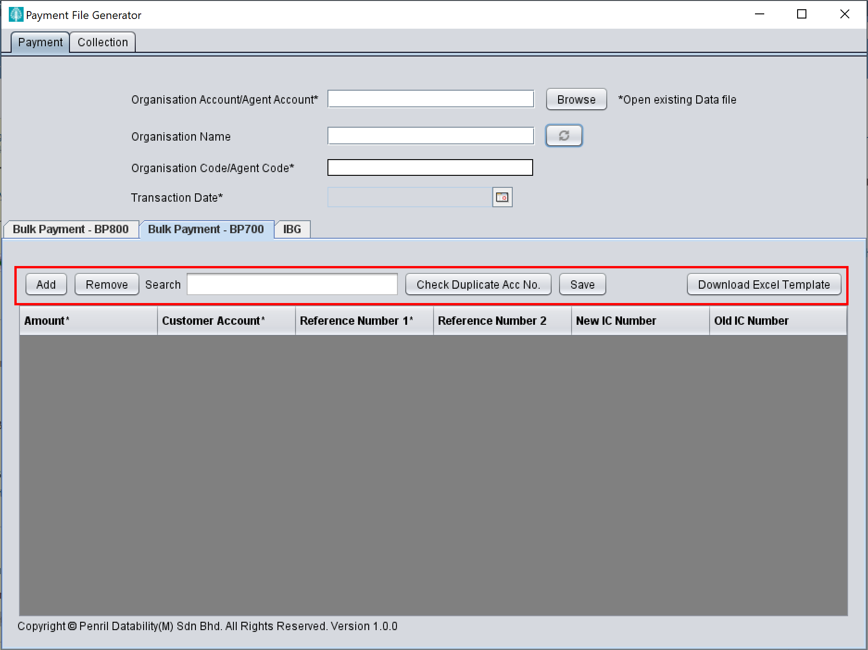

**SIT15_SIT16-ePFG-To re-arrange the details column (11373) Passed**

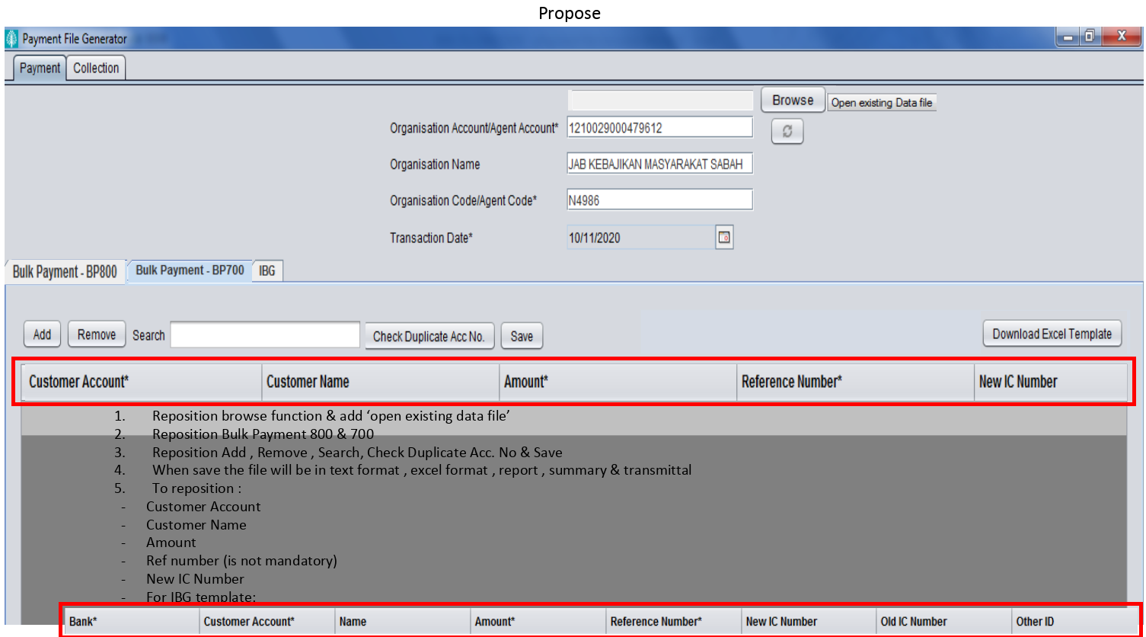

**To reposition BP 800 column and update Reference Number to be NOT MANDATORY:**

1. Customer acc no
2. Customer Name
3. Amount
4. Ref number (Set to not mandatory)
5. New IC Number

**Outcome for BP 800 :**

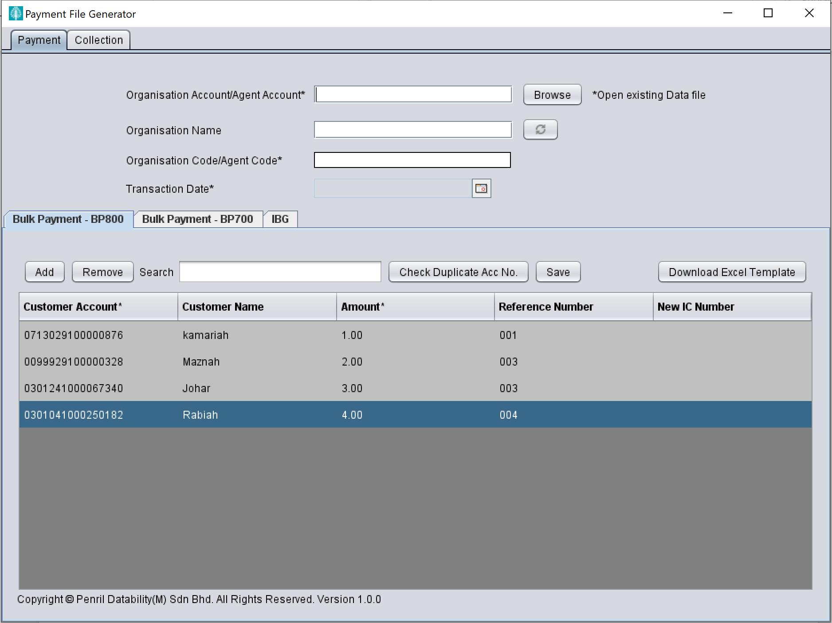

**To reposition IBG column to :**

1. Bank*
2. Customer Account*
3. Name
4. Amount*
5. Reference Number*
6. New IC Number
7. Old IC Number
8. Other ID

**Outcome for IBG :**

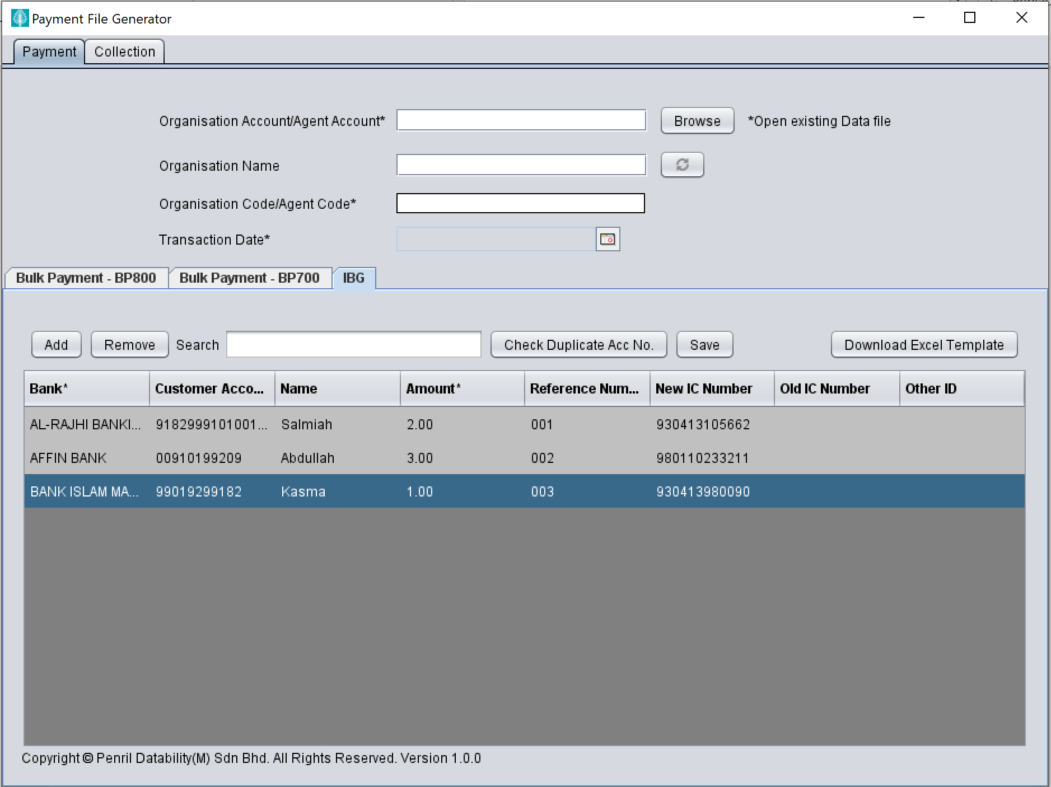

**SIT20 - ePFG -To add version (11375)**

**Passed**

