# Scenario 1: Send email notification to all Checker from same group and same state

Test Step:

1. Set all Maker and Checker to be in same group and same state

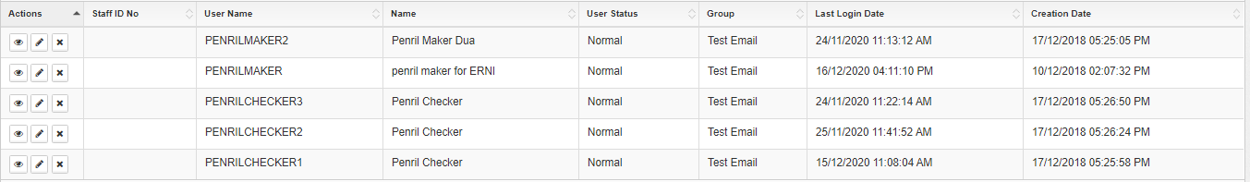

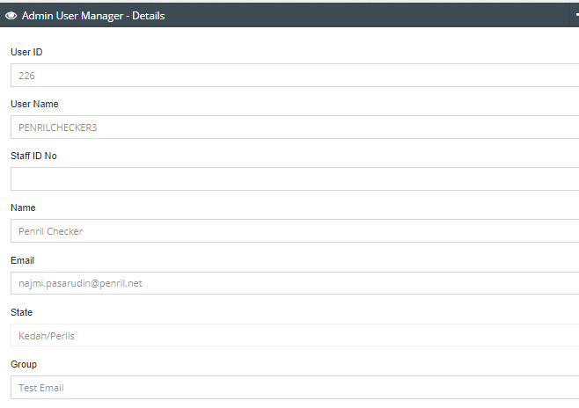

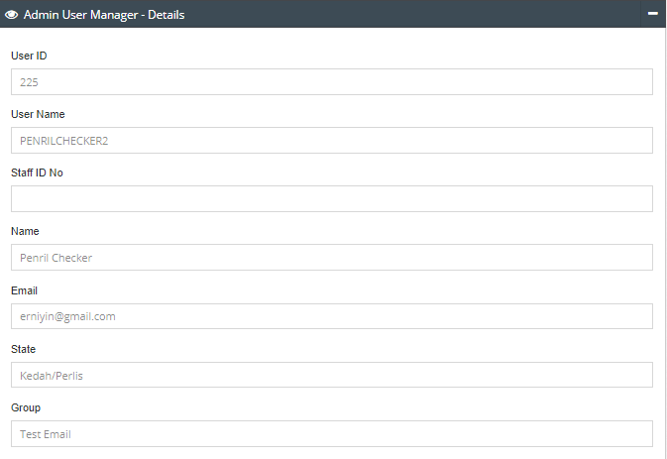

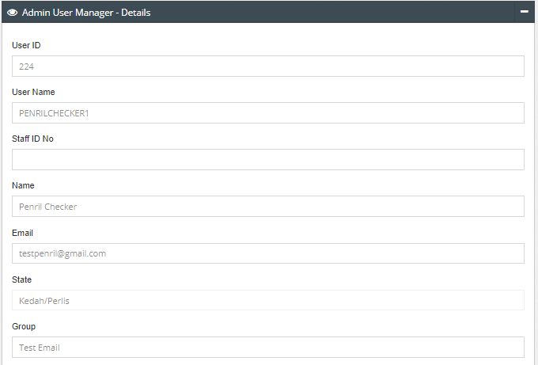

1. Using Maker with the same group and state perform changes
2. Expected Result: Email notification should send to all Checker

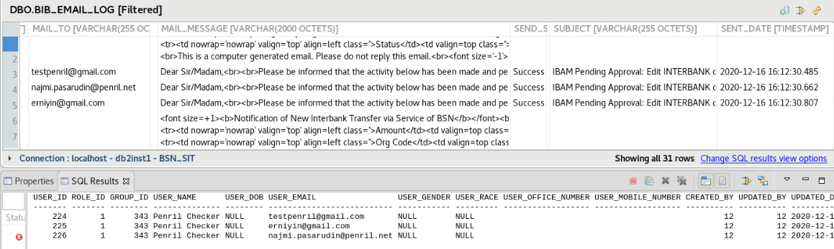

# Scenario 2: Send email notification to all Checker from same group but different state

Test Step:

1. Set all Maker and Checker to be in same group and state but one of the Checker set to be different state



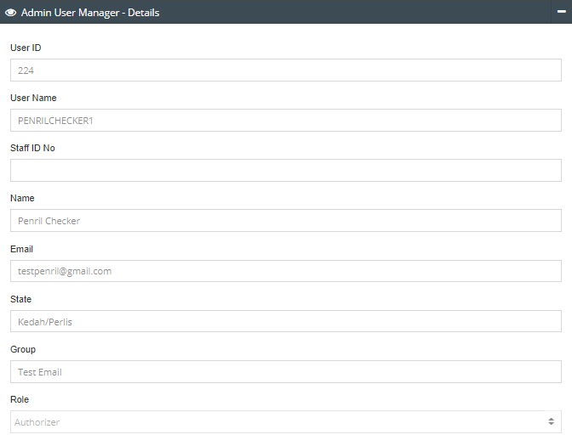

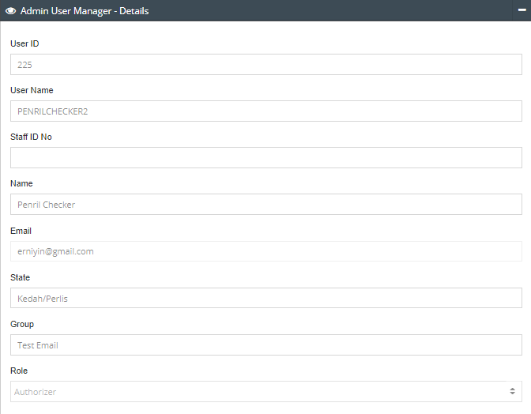

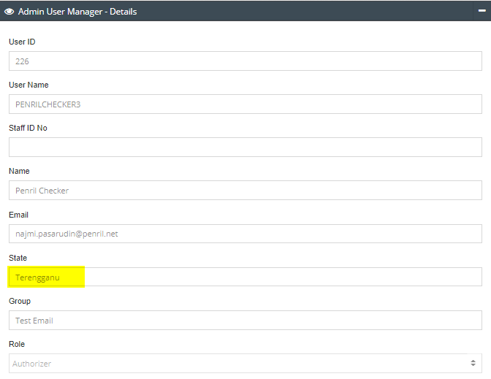

1. Using Maker with the same group and state perform changes
2. Expected Result: Email notification should only send to all Checkers with same group and state. Checker with different state does not receive the email

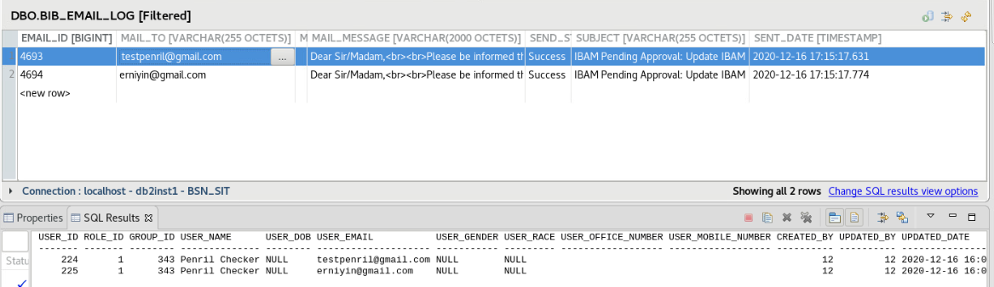

# Scenario 3: Send email notification to all Checker from different group but same state

Test Step:

1. Set all Maker and Checker to be in same group and state but one of the Checker set to be different group.

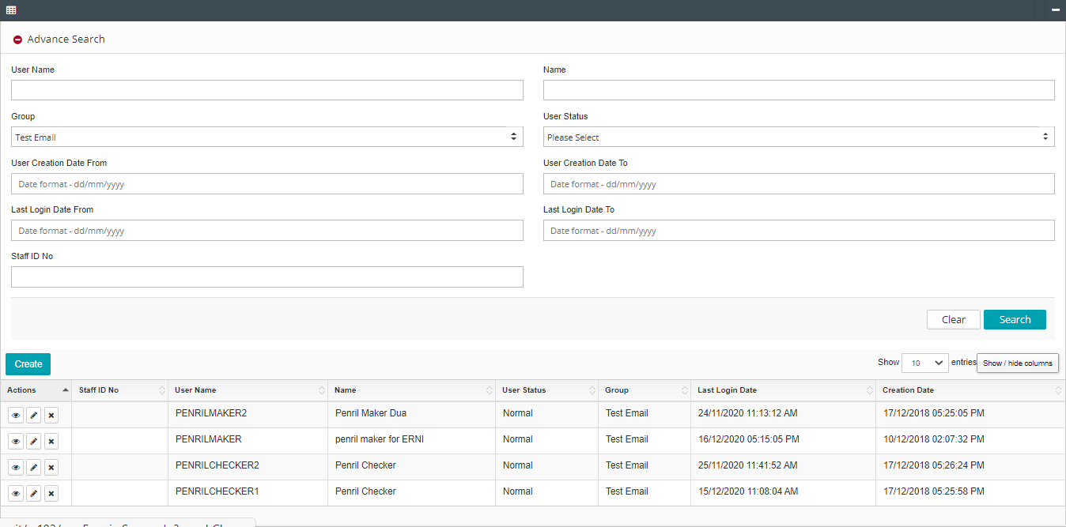

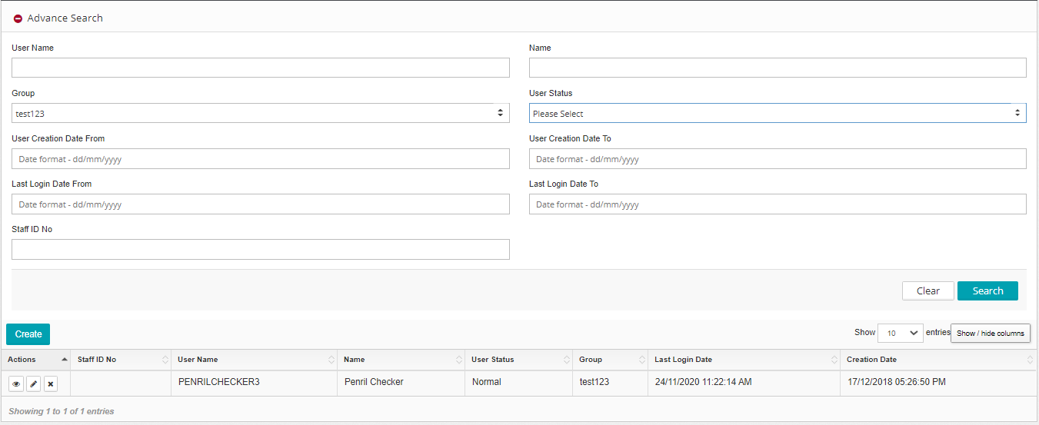

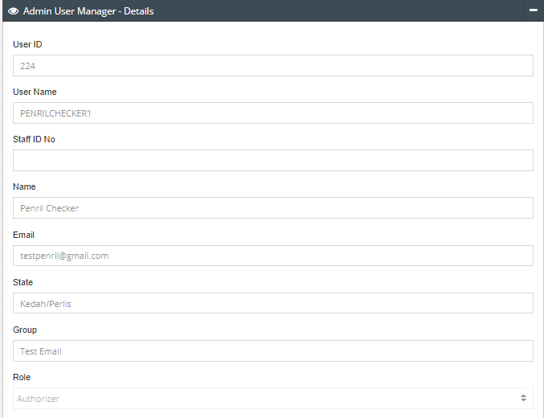

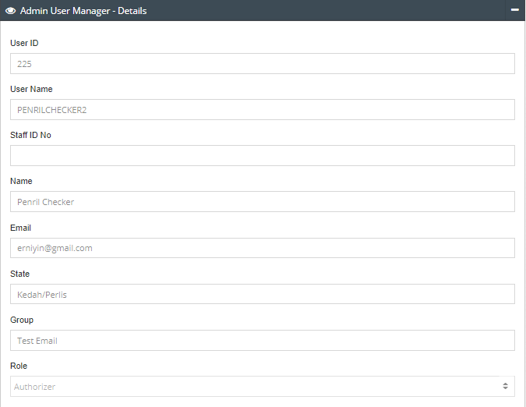

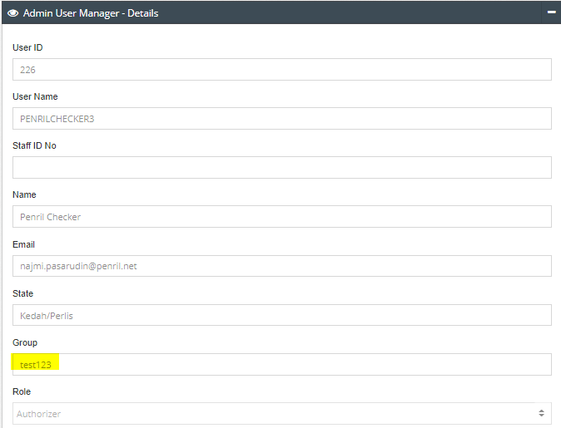

1. Using Maker with the same group and state perform changes
2. Expected Result: Email notification should only send to Checker with same group and state. Checker with different group does not receive the email

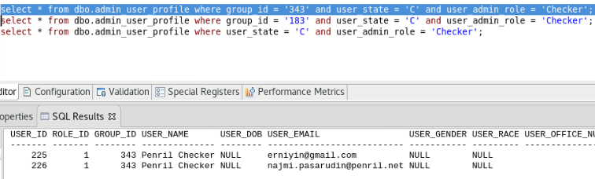

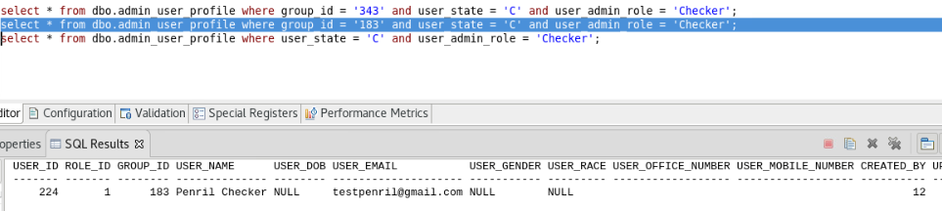

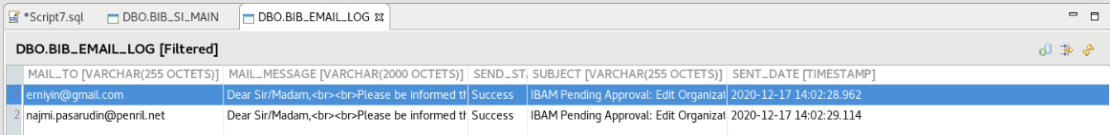

# Scenario 4: Send email notification with Maker and Checker from same group but different state

Test Step:

1. Set Maker and Checker to be in same group but different state

Set all Maker and Checker to be in Group: Test Email

Set Maker to be State: Perak

Set all Checkers to be State: Kedah/Perlis

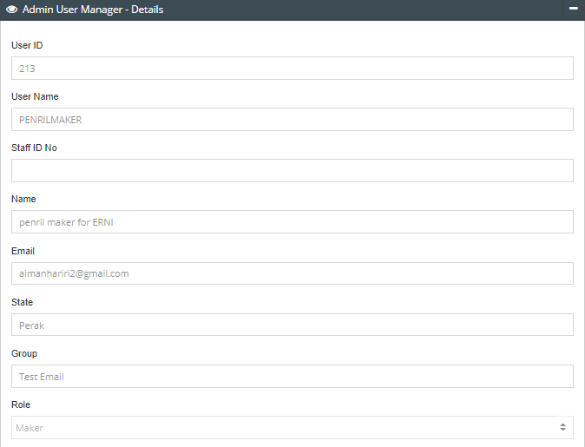

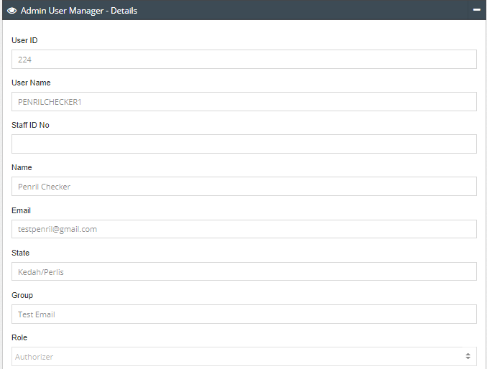

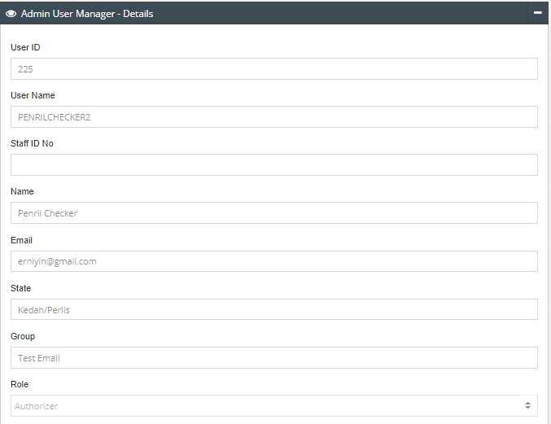

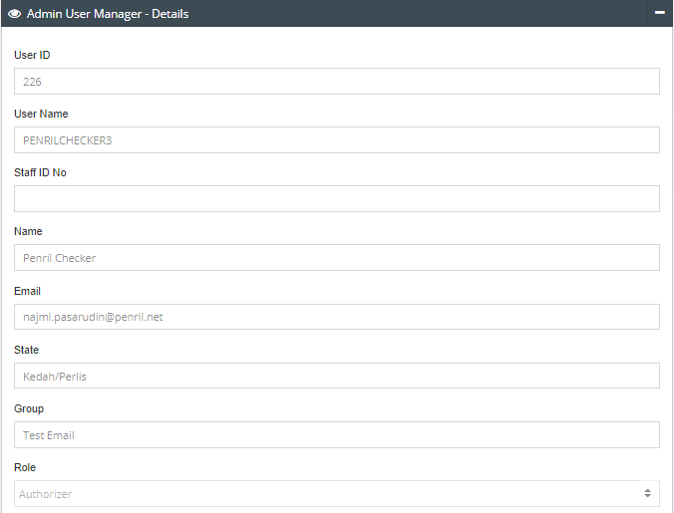

1. Maker from same group but different state perform changes
2. Expected Result: Email notification not send to all checker

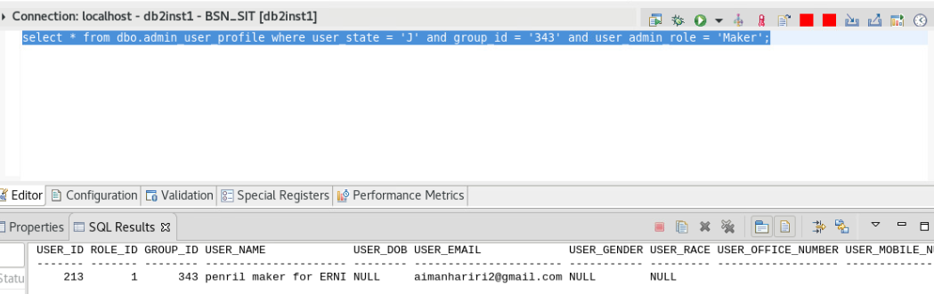

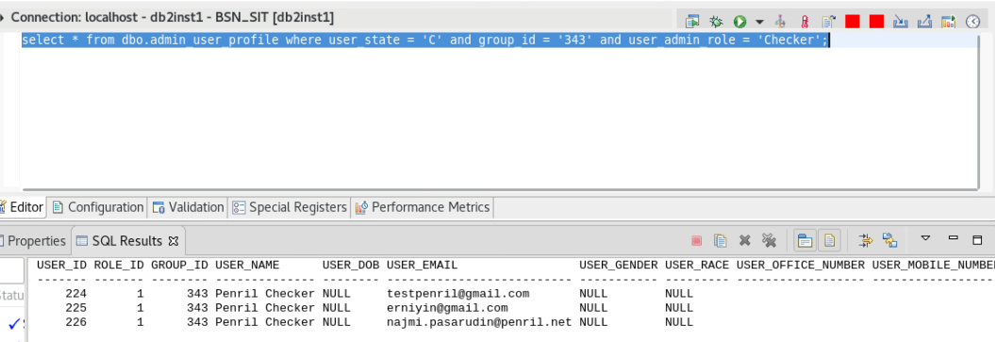

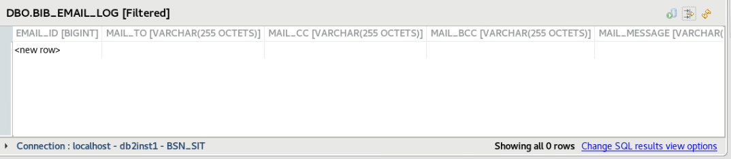

# Scenario 5: Send email notification with Maker and Checker from different group but same state

Test Step:

1. Set Maker and Checker to be in different group but same state

Set all Maker and Checker to be in State: Kedah/Perlis

Set Maker to be in Group: Test123

Set all Checkers to be in Group: Test Email

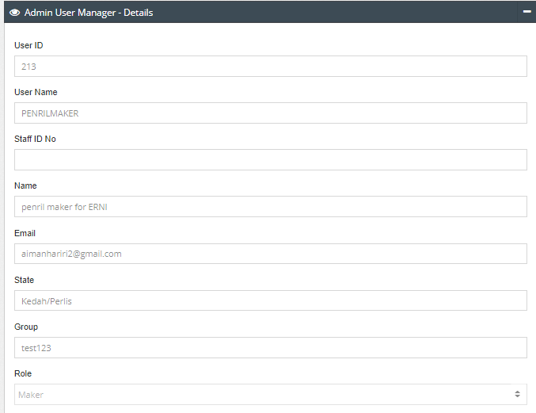

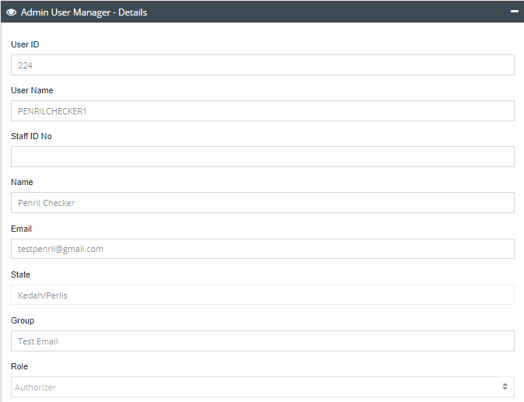

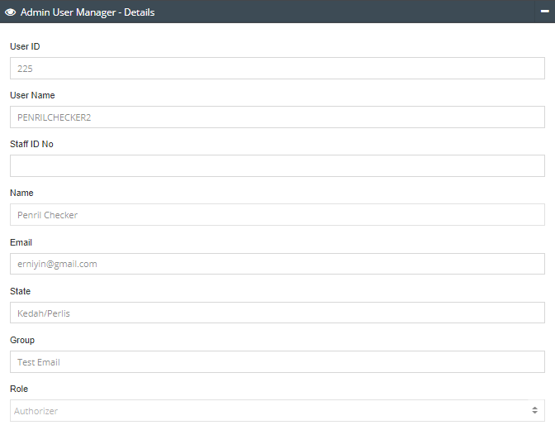

1. Maker from different group but same state perform changes
2. Expected Result: Email notification not send to all checker

